The Social Project ‘Bloc of Apartments coming instead of a Park’ and its Benefits.
Assessment 1: Community Engagement
Student Name: Georgiana Ilie
Student Number: 2024158
Module Code: LSBB4002
Contents
Introduction 3
The Social Project ‘Bloc of Apartments coming instead of a Park’ and its Benefits. 4
Relationship with stakeholders and the way of engagement 5
Different eras of the organisation and evolve in community engagement 6
Social Media Platforms in support of the Bloc of Apartments programme. 7
Training and development of employees in dealing with socio-cultural issues. 8
Adopting a forward-looking approach in training and external factors in the business relationship. 11
Conclusion 13
References 14

Figure 1: Training of employees using experimental groups pre-stage (Source: researchgate.net) 8
Figure 2: Employee training through experimental group post-stage (Source: questionpro.com) 9
Figure 3: The Zone of Proximal Development of Employees (Source: cuppacocoa.com) 10
Figure 4: Trompenaars Cultural Dimensions (Source: agents2change.typepad.com) 11

Introduction
Community engagement is the way of achieving long term sustainability, decision making, outcome and relationship by better engaging the community. It is closely related to the social programme as the social programme is the implementation of community engagement within society. The report has several parts where the first part contains information about the project of Bloc of Apartments and its benefits to the community and society. In the next part, different stakeholders of the project are identified where the next part is about skills in employees for performing the tasks of the project. The impact of the social media platform in the project is described which would be followed by the training and development needs of employees with external factors to be considered in order to develop a sustained relationship with networks.

The Social Project ‘Bloc of Apartments coming instead of a Park’ and its Benefits.
According to Bhagawan (2017), the term social programme can be expressed as an organised set of activities intended to develop the social conditions of the community where several types of social services are being provided especially to the disadvantaged people of the society for ensuring equity (Bhagwan, 2017). The selected social programme for this report is ‘Bloc of Apartments that coming up instead of a park’. Housing is being considered as one of the basic human rights as every people deserve shelter where there are many people under the poverty line and the housing problem is also increasing rapidly. The project of building apartments is of more priority for society as shelter is the basic need of society people. Putting insight into the benefits of this social project of developing Bloc of Apartments, it can be found that this social project of the apartment is of numerous benefits to society and community engagement. The first and foremost benefit of this social project is that it will ensure equity within the society where many homeless will have shelter reconstructing a balance within the society. Other benefits of this project are that it will increase the gross income of the whole society, the standard of living of society people will increase for the most vulnerable members of the society, employability, improve the economical and mental health of communities, independence of living, developing interpersonal skills would also be ensured under this social project of Bloc of Apartments (Canady, 2020).

Relationship with stakeholders and the way of engagement
In the social project of Bloc of Apartments, there would be several sorts of relations with the stakeholders as there are many stakeholders within the society. The stakeholders of the project would be the representative of the community and they are local community leaders, local businesses, community development corporations, neighbourhoods, Governments, friend groups, educational institutions, religious institutions, youths, and so on (Coulter, 2019). There should be a constructive relationship established with the stakeholders for serving a common goal of pull together. The social institution is focused on meeting the social needs of citizens like health, shelter, education, Government, etc. The way of engagement is such a vital question for the project as finding the right communication style is the first condition of realising the needs of the community. The mixed-methods approach can be used for communicating within the community. A communication schedule would be designed for keeping community members engaged in the social project of Bloc of Apartments. Posting on social media can be a good method of communication with the stakeholders where the community members would get a regular update of the project and also know that they are being heard. The other ways of engagement are posting information on the website regarding the project of Bloc of Apartments, visiting peoples, hosting fun events for the whole community and inviting them to community events, using technology like online app for text messaging to community members, etc.

Different eras of the organisation and evolve in community engagement
Community engagement has evolved with different eras of the housing associations that are non-profit making organisations intended to provide low or little cost social housing service to the citizen in need of a shelter. The term council house is a type of public housing arranged by the local authorities which mainly took place from the Housing Act 1919 (Rick, 2018). The Housing Act 1930 eventually stimulated slum clearance which intensified the need for social housing as of community engagement within the UK (Van, 2019). In the early ages, capitalism has created a monopoly of power within the UK creating a social imbalance and inequity which was the core motive of housing association as of community engagement of that time. The new era of the housing associations has evolved to solve various social issues like sustainability concerns, anti-social behaviours, environmental issues and segregation within the community. At present, the housing associations are working as an agent of the UK government for providing social housing which requires more transparency, fairness and justification within the organisation throwing a great challenge to the employees of the housing associations. The project of Bloc of Apartments should be handed over to the professional housing building parties equipped with the necessary expertise. After the completion of the project, various events should be arranged on a scheduled basis and interaction with leaders, volunteers and community members should be given with tasks under deliberate participation and proactive measures. In order to perform this job, the employees should bear some interpersonal qualities like being honest and ethical about the project, consistency and management skills for managing social events like sports, day events, travel, reunions, seasonal events, etc., rapid communication skills, educational and technical skills and knowledge for project management (Li and Wickrama, 2018). Leadership skill is also an important skill within the employees of the organisation as they have to lead the whole project and maintain the apartments with the arrangement of different community integration and engagement events within the society under the project of Bloc of Apartments effectively and efficiently.

Social Media Platforms in support of the Bloc of Apartments programme.
In a developing social project like Bloc of Apartments, social media plays an important role by offering accessible sites for availing information about a developing community engagement. For drawing supports from the outreach, electronic social media like Facebook, Twitter, Instagram, etc. would be effective in support, track, develop and mobilize social networks in enhancing the community engagement efforts under the project. As the project Bloc of Apartments that is coming instead of a park is covering a large community, these electronic social media would enable raising new issues within the community, ease of the sharing of ideas and multidirectional communication within the society. In using social media as of community engagement, the employees of the Housing Association have to be social media expert in receiving and managing various opinions from a large community situating in the Bloc of Apartments. The communication skills in the employees appointed in community engagement are vital for mobilization of the interactions and the employees have to be a very creative and good sense of humour in directing social media to high community engagement. The technical skills of managing media and flexibility to implement those opinions of community members are also required within the employees of the project Bloc of Apartments. The social media communication within the community would demonstrate transparency and openness of the project to the community members. For instance, meeting agendas, time, questions, issues can all be posted online and it also facilitates ongoing communication, social exchange of opinions, establishing collective positions, discussion on both draft and final position statements within the community covering large area as of intensifying community engagement (Gil-Glazer, 2019). The employees can also share creative contents like social awareness on breast cancer, family planning, Covid awareness, voting rights, any ongoing issues via social media for wide community engagement.

Training and development of employees in dealing with socio-cultural issues.
The socio-cultural issue is one of the most common issues that can be noticed in community engagement and social projects like Bloc of Apartments. It is a larger scale of forces of cultures and societies within the community affecting the feeling, behaviours and attitudes of community members. For dealing with the various socio-cultural issues within the community, socio-cultural competence is important within the employees of the Housing Association. Three blocks of socio-cultural competence that are vital within employees are Linguistic regional geography training which shifts the knowledge of lexical units of the UK’s cultural semantics like English, Polish, Welsh, etc. and implementation of those in intercultural communication in community engagement, Socio-psychological knowledge possession training for developing knowledge on the UK’s specific national behaviours like Hofstede’s Six Dimensional Cultural Factors like individualism, masculinity, power distance, etc., Training employees for developing knowledge on cultural of the specific community covering the members living in the Bloc of Apartment and their history, cultural and ethnic background and use them for efficient community engagement (Okyere-Kwakye and Nor, 2019).
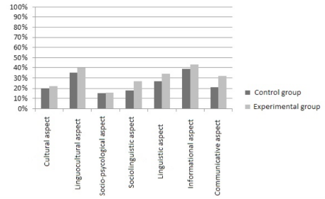

Figure 1: Training of employees using experimental groups pre-stage (Source: researchgate.net)

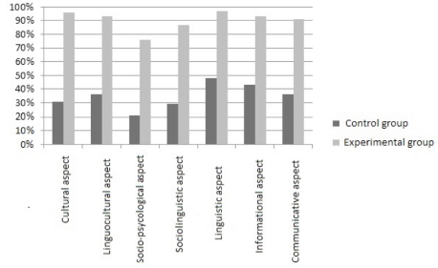
Figure 2: Employee training through experimental group post-stage (Source: questionpro.com)
Training of employees can be done by developing an experimental group within the community for developing socio-cultural knowledge and interpersonal skills of employees in order to ensure the intellectual development of mutual understanding within the community.
The employees of the Housing Association can also be trained under Lev Vygotsky’s Socio-Cultural Theory of Learning where it is believed that employees learn through social interaction and individual internalization of social behaviours of the community (Xuejiao Zhang, Huili Wang and Dan Guo, 2018). Three key themes of Sociocultural Learning Theory are Culture of the specific society living in Bloc of Apartments, Languages used by the people living in community and Zone of Proximal Development which would be ensured through problem-solving activities of employees.
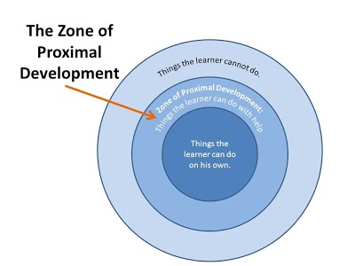
Figure 3: The Zone of Proximal Development of Employees (Source: cuppacocoa.com)
Here, it would be identified how well employees are capable of ensuring community engagement without and with assistance under training and development.

Adopting a forward-looking approach in training and external factors in the business relationship.
The rapid globalisation around the world has brought different cultures to a commonplace where there is a larger number of migrants and multinational businesses moving around the world for different purposes. In this global era, the Housing Association should be careful about cultural conflicts, cultural shocks, cultural differences that are common while people from different cultures are living in the social project Bloc of Apartments. In order to deal with this ongoing cultural issue, the Housing Association should adopt a forward-looking approach in training employees on multiculturalism. The cultural training is vital for developing cultural knowledge and skills within the employees of the Housing Association for ensuring high community engagement. The employees should be provided with accurate information on cultural differences under The Cultural Dimensions of Trompenaars.
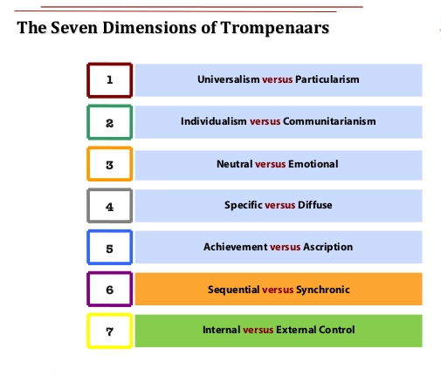
Figure 4: Trompenaars Cultural Dimensions (Source: agents2change.typepad.com)
Under this theory, the employees would come to know about cultural differences within various cultures like whether the community members are from individualist or communist, specific or diffuse, neutral or emotional society and the way to interact with them for community engagement (Lukito, 2018). Cross-cultural training could be used to equip employees with upcoming challenges and Expatriate Training could be implemented. Under expatriate training, the employees would be chosen for international assignment where pre-departure training like language training, security briefings, cross-cultural training would be provided and post-departure training like learning by experience, deeper cultural learning, enduring cultural shocks would be provided internationally for avoiding cross-cultural conflicts, improved communication, the anticipation of cultural shocks (Liu and Chen, 2020). After the successful completion of the internal assignment, the employees would come back to the Bloc of Apartment project where they will be able to initiate cross-cultural adjustments and aspire all cultured people within the Bloc of Apartments to participate in public life in their community by active citizenship practices and develop a harmonious and mutual relationship within the community. In this manner of training, the knowledge and skills of employees would also be transferred to the members of the community where the members would come to know how to avoid cultural conflicts while interacting with the stakeholders of the community like business institutions from different cultures, religious institutions within the community, educations institutions, youth groups, etc. (Lucke, 2019). The employees should also work on building a sustained relationship with the stakeholders of the Housing Association by considering external factors like socio-cultural environment, the political environment of the UK and economic influences stated between the organisation and its networks.

Conclusion
The community engagements play a pivotal role in developing connection within communities and implement policies, programs and social services for working collaboratively and addressing various social issues influencing the life of community members. The social project that is Bloc of Apartments coming instated of the park under the Housing Association would have a far-reaching positive impact on the society by high community engagement. In order to achieve competitive advantage in community engagement by Bloc of Apartments project, the employees of the Housing Association should be provided with proper training and development sessions like interpersonal skills and cross-cultural training such as Expatriate Training for better formal relation and interaction with the stakeholders of the project Bloc of Apartments and managing various cross-cultural effects from the living of different cultured people in the community.

References
Agents2Change - Smart Business Thinking. (2021). Examining Culture #3 - How Trompenaars describes the dimensions. [online] Available at: <https://agents2change.typepad.com/blog4/2012/01/examining-culture-3-how-trompenaars-describes-the-dimensions.html> [Accessed 26 March 2021].
Bhagwan, R. (2017). COMMUNITY ENGAGEMENT WITHIN A SOCIAL WORK PROGRAMME IN RURAL INDIA. Social Work, 53(3).
Canady, V. (2020). Bill would improve MH service access for BIPOC communities. Mental Health Weekly, 30(35), pp.3-5.
Coulter, B. (2019). Building kids' citizenship through community engagement.
cuppacocoa. (2021). The Zone of Proximal Development. [online] Available at: <http://www.cuppacocoa.com/the-zone-of-proximal-development/> [Accessed 26 March 2021].
Gil-Glazer, Y. (2019). Family Albums as Collective Memory of a Community: The Public Projects of “tarshiha.co.il” and “Tarshiha Nights”. The International Journal of Social, Political and Community Agendas in the Arts, 8(1), pp.65-78.
Killian, H. (2021). [online] Available at: <https://www.researchgate.net/figure/Training-design-of-the-experimental-groups-during-the-8-week-training-period_fig1_301345663> [Accessed 26 March 2021].
Li, P. and Wickrama, K. (2018). Stressful Life Events, Marital Satisfaction, and Marital Management Skills of Taiwanese Couples. Family Relations, 63(2), pp.193-205.
Liu, D. and Chen, X. (2020). Learning from Cultural Shocks: A Cross-cultural Longitudinal Study of Expatriate Creativity. Academy of Management Proceedings, 2014(1), p.14291.
Lucke, E. (2019). Social welfare project. [New York].
Lukito, Y. (2018). The urban forest project as an extension of landscape immersion and a way to support community engagement in the Ragunan Zoo, Jakarta. ASEAN Journal of Community Engagement, 2(2), p.163.
Okyere-Kwakye, E. and Nor, K. (2019). The Effect of Socio-Cultural Diversity on Knowledge Sharing. Advances in Social Sciences Research Journal, 3(2).
Question Pro. (2021). Experimental research - Definition, types of designs and advantages | Question Pro. [online] Available at: <https://www.questionpro.com/blog/experimental-research/> [Accessed 26 March 2021].
Rick, J. (2018). THE HOUSING PROBLEM. The Lancet, 193(4975), p.28.
Van, W. (2019). The housing act, 1930. Public Health, 44, pp.34-36.
Xuejiao Zhang, Huili Wang and Dan Guo, 2018. Embodied Cognition From the Perspective of Vygotsky’s Socio-cultural Theory. Philosophy Study, 8(8).

