Week 5 Presentation workshop Monday 28th October 2024

1400hrs – 1600hrs
15-minute, presentation which counts towards 50% of the available marks for this module.
- “Analyse, the impact of the 20mph speed limit in Wales, on driver behaviour and reduction in drivers reported for the National Police Chief Councils Fatal Four offences, and the change in statistics for injury Road Traffic Collisions since its introduction.”

- Please ensure that you include the following:
- 1.A reference list for your sources: Harvard Draft LP (uwtsd.ac.uk).
- 2. Please complete the disclosure of research timeline in respect of your research, challenges and methodology (see GA36b).

Review of presentation preparation:
Challenges experienced
Learning
Good practice
Mock presentations
Mock Feedback - no mark

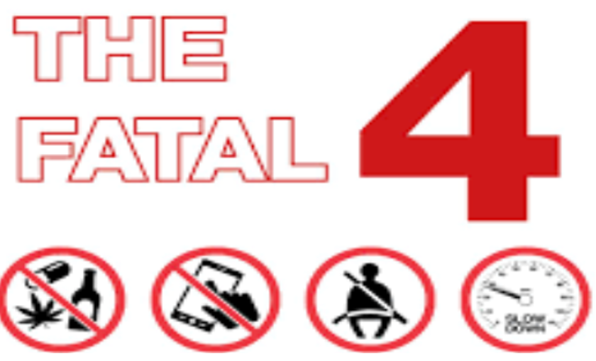

- Speeding
- Drink and drug driving
- Driving while distracted
- Non-wearing of seat-belts

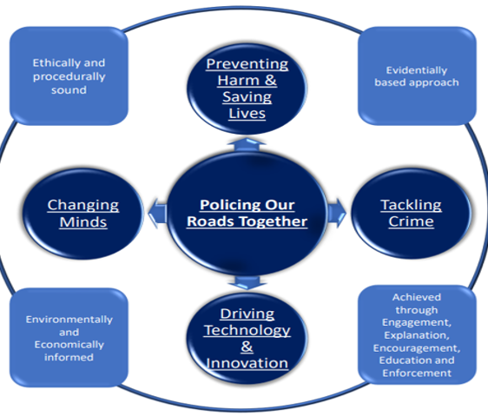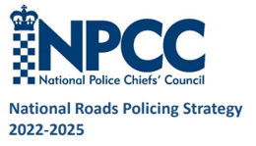

Marking

