Business Plan for

IMPLEMENTATION OF SUSTAINABLE SOLAR PANELS IN THE UK

Produced By

Student Name: Cristiana Staicu
Student No: 2026517

Module Name: Entrepreneurship
Module Code: BMIH5001
Lecturers Name: Christopher Wilkin

CONTENTS

 |  |  |  |  |  | PAGE
1. | Mission Statement |  |  |  |  | 2
2. | The Concept |  |  |  |  | 2
3. | The Team |  |  |  |  | 3
4. | The Market |  |  |  |  | 4
5. | The Marketing Strategy |  |  |  |  | 4-10
6. | SWOT Analysis |  |  |  |  | 10-11
7. | Finances and Start-Up Support |  |  |  |  | 12

1. Mission Statement

The goal is to create a sustainable and workable company plan and market the idea to potential investors in order to secure finance. Business companies in the UK are concentrating on installing solar panels that will be sustainable, cut the electricity bill, and drop down on maintenance expenses in order to combat the rising maintenance costs of businesses nowadays.

2. The Concept

The implementation of sustainable solar panels in UK business organisations, both in rural and urban areas, is a notion connected to business ideas. Since most businesses are looking to incorporate sustainable solar panels, there are many chances and resources accessible to undertake this initiative. Given the record levels of higher generation in the UK the year before, power output from all renewable sources increased once more, with about 43% of the nation's electricity coming from sources including solar, biogas, and wind, up from 37% in 2019 (RAYNER, 2021). The UK government responded to the energy crisis brought on by the war in Ukraine by announcing that it will increase "nuclear power capacity" and "renewable energy."

3. The Team

A few teams are required to create the business idea. The people who will assist in carrying out the company strategy are the financial officer, the vice president of sales, marketing, engineering, and web development. A "chief operating officer" and a production manager will also be required for the successful development of the business idea (Bland and Osterwalder, 2019).

4. The Market

In addition, in terms of showing the market potentiality it can be stated that the solar energy market of the UK is expanding more after the COVID 19 pandemic and Ukraine War situation. In the year of 2021, the production of electricity from solar PV is estimated to be 12,138 gigawatt hours. Moreover, throughout this period of effective consideration, “solar PV electricity generation” has been a massive growth and it is increasing from just 4 gigawatt hours within 2004.
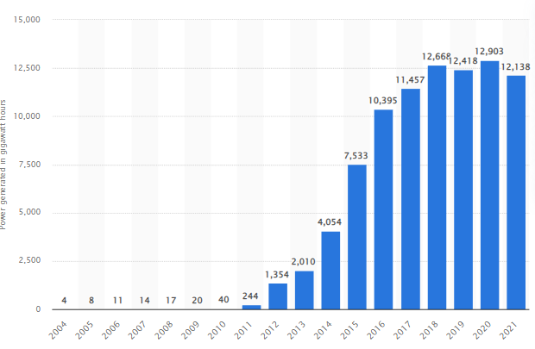
Figure 1: Production of solar PV energy in the UK
(Source: Jaganmohan, 2022)

4.1 Market Environment Considerations

Before executing the business idea, it is necessary to analyze the market otherwise without analyzing the market execution of the business idea can increase the risk of business idea failure. Therefore, to analyze the market of the UK, PESTLE analysis has been done in this section and PESTLE can be recognized as an effective business planning tool.
Factors | Significance | Impact
Political | The UK can be considered as the constitutional monarchy depending on parliamentary democracy. This is separated within four portions named constituent countries such as Northern Ireland, Wales, Scotland and England. This place is known as a unitary state with the partial devolution of power in Northern Ireland, Scotland and Wales. “The UK Space Energy Initiative” has been launched in the past year exploring options to establish a “space-based solar plant”. This initiative has supported the UK in meeting their target of “zero greenhouse gas emissions by 2050” (Indian Express, 2022). | High
Economic | The below statistics highlight the growth rate within the real GDP within the UK from 2017 up to 2020, with the support of projections up until the year of 2027. In addition, the GDP rate within the UK was at nearly 1.67% in comparison to the past year (O’Neill, 2022).  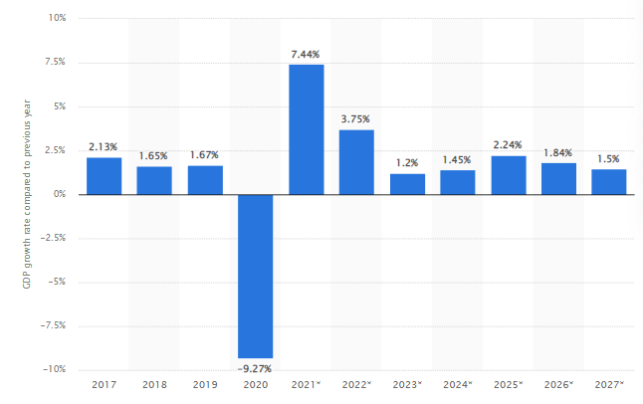  Figure 2: The GDP rate of the UK  (Source: O’Neill, 2022) | High
Social | In the year of 2018 to 2019, the “mean annual household disposable” earning within the UK was estimated to be nearly 35.33 thousand British pounds (Clark, 2022). After the year of 2013 to 2014 “average disposable income” has increased at levels as those experienced from 2000 to 2001 including 2006 to 2007.  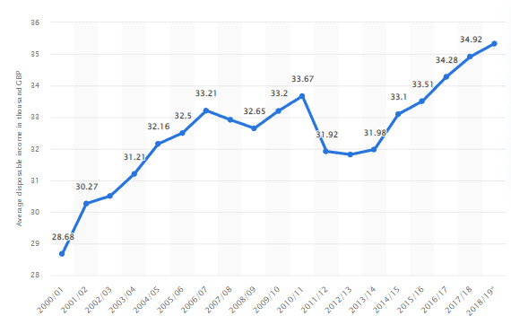  Figure 3: “Annual household disposable income within the UK”  (Source: Clark, 2022) | High
Technological | The “mobile phone” utilization within the UK has increased up to 144% points in the years between 2015 up to 2021. In addition, the percentage of adults utilizing these mobile phones increased at 95% within 2021 as this has been seen from 2019 (Laricchia, 2022).  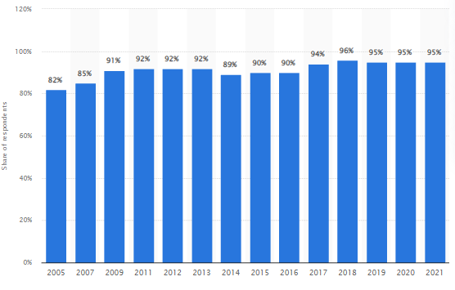  Figure 4: Mobile phone utilization rate in the UK  (Source: Laricchia, 2022) | High
Legal | “The Health and Safety at Work Act 1974” can be recognized as the basic piece of legislation that is covering up occupational safety and health within Great Britain. In addition, “The Employment Rights Act (ERA) 1996” has been set out for the employees’ rights within the situation of unfair dismissal, dismissal, redundancy, and parental leave. | High
Environmental | The average estimation of days when the ozone level was moderate or else higher within the rural areas within the United Kingdom was nearly 21.2 during 2020. On the contrary, there were nearly 17.1 polluting days with higher ozone levels within urban places (Tieso, 2021). On midpoint, there were 9.6 higher or moderate “air pollution days” within urban places of the UK and 20.4 within rural places.  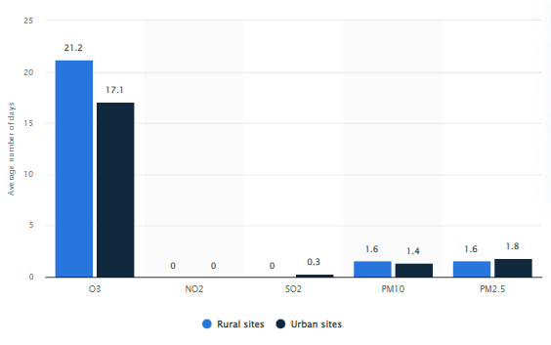  Figure 5: Air pollution rates in the UK  (Source: Tieso, 2021) | Low
Table 1: PESTLE Analysis of the UK
(Source: Learner)

4.2 Competition

“Porter’s Five Forces”
In addition, another business planning tool that is “Porter's Five Forces” has been done for analyzing where power is lying within the business situation. This can also support in analyzing the business risks and make effective business solutions according to that (Juliana and Nyoman, 2019).
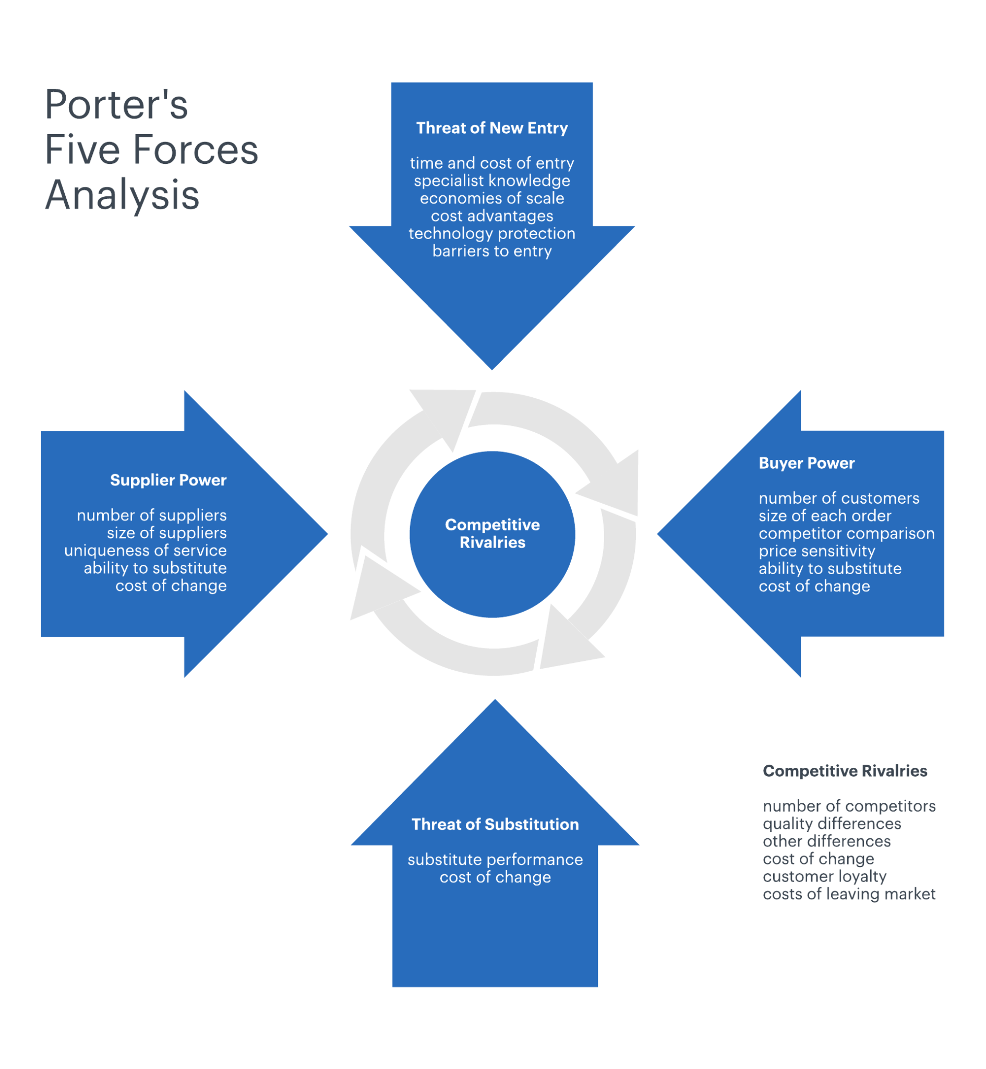
Figure 6: “Porter’s Five Forces analysis”
(Source: Juliana and Nyoman, 2019)
Industry rivalry (higher)
Rivalry within the solar industry has taken place across various factors such as primarily cost, solar panel quality, timing for completion. As the solar energy related demand has become higher after the COVID 19 pandemic and Ukraine War and more companies have entered in the UK market thus, the competition within the market has increased more.
“Threat of New Entrants” (lower)
Federal and licensing requirements, local permitting and state laws have made higher barriers for all the new entrants that are required to gain better understanding and pay fees to navigate this regulation related fees. This industry has more increased barriers for low or entry threat for the new entrants and this is due to the higher cost of capital associated with this business industry (Irfan et al. 2019).
“Threat of Substitutes” (moderate)
This industry has faced some “threat of substitutes” from the competition with the contractors of power plants for various other types of energy mainly as renewables and natural gas. On the other hand, rivalry from the contractors of “fossil fuel power plants” has diminished over the past few years due to the government's incentives regarding renewable energy.
“Bargaining power of Suppliers” (lower)
The main suppliers for this industry are mainly manufacturers of construction machinery and manufacturers of PV panels. The supplier's bargaining power varies based on the business model of the business firm and breadth power of several of the services. The renown thin manufacturer of the world, name is FirstSolar. Moreover, in this section it can be illustrated that suppliers' bargaining power is lower as within the UK there are various suppliers for supplying solar panels.
“Bargaining power of Buyers” (higher)
“Bargaining power of Buyers” is higher for the solar industry in the market of UK and there are various customer bases that are desiring to buy these solar panels. Though the buyer power is high in the range their effect on this solar energy is still lower (Anastasiu et al. 2020).

5. The Marketing Strategy
It is necessary to have an effective marketing strategy to reduce the chances of getting any kind of business risks that can lead to failure or boosting early success. During the time of implementation of solar panels in UK business firms several business risks can arise such as environmental risk, financial risks, technical risks and political risks (Birkel et al. 2019). In order to reduce financial risks, it is necessary to convenience investors and stakeholders, learning more about diversification, investing wisely and getting an effective management account. To reduce political risks, it is necessary to consult with all the local partners, monitoring global issues and also need to do risk analysis.
In addition, the most tremendous threat for solar panel installation is environmental risk and for this installation renewables, recycling, reusing, and reducing and using more efficiently. Moreover, in terms of reducing the technical risks, it is necessary to reinforce network infrastructure, securing endpoints, and monitoring and analyzing security related threats as these can be beneficial. In addition, to make this business idea more effective, setting a budget and goal is necessary and it is also necessary to focus on “4P’s of Marketing”. As per this marketing strategy, first it is necessary to choose the right place, proper promotional activities, delivering the right product to consumers and making the price more reasonable therefore, consumers can purchase the solar panels (Marcial, 2021).

Figure 7: 4 P's Marketing Mix
(Source: Marcial, 2021)
6. SWOT Analysis

It is necessary to know the weaknesses, strengths, opportunities, and threats of the solar industry for setting up the small business and the business idea and for this reason SWOT analysis has been done in this section (Benzaghta et al. 2021).
Strengths  - Higher opportunities of employment  - Deliver higher electricity any point of time  - Reasonable pricing  - Rural economic benefits  - Adequate resources availability  - Durable solar panels  - Easy to install as this does not require much space  - Sustainable panels | Weaknesses  - High installing investment  - In the stormy weather chances of power cut can happen  - PV cells’ disposal might happen environment pollution  - Solar panels might not be effectively implemented within the place where there is no sunlight
Opportunities  - The United Kingdom has embraced higher production  - For the issues of electricity business firms are becoming dependent on solar panels  - UK government is supporting and emphasizing on energy from various of the resources  - The government of UK is providing the permission to companies to implement the solar panels | Threats  - Long terms ROI  - Higher rivalry in the UK market  - Increasing dumping cases or imports from various other countries  - Threats from various other renewable energies for its “per unit production of cost”
Table 2: SWOT analysis of solar industry
(Source: Learner)
7. Finances and Start-Up Support

In case the business ideas of implementing solar panels in the UK business firms will be done effectively then approximately this new start up can gain 8% of profit margin. An effective profit margin would differ considerably through industry, though as in the UK the demand for solar panels is higher therefore, the profit margin would be higher. In addition, in case the business idea will be executed within the UK market in an effective market then the ROI of this small business will be between 15 to 25%. This small startup business can forecast the growth rate of nearly 178% within revenue for the initial year, 100% in the second year and 71% for the third year. In terms of increasing the ROI, it is necessary to increase sales and produce more revenue and this would help in pushing the ROI (Ogbariu et al. 2018). The UK business firms are demanding more solar panels therefore, it can be stated that the investors and stakeholders would get their potential “return on investment”.

Reference List
Anastasiu, L., Gavriş, O. and Maier, D., 2020. Is human capital ready for change? A strategic approach adapting Porter’s five forces to human resources. Sustainability, 12(6), p.2300. https://www.mdpi.com/665670
BELLINI, E., 2022. UK government to ramp up solar capacity. [Online]. Available at: https://www.pv-magazine.com/2022/04/07/uk-government-to-ramp-up-solar-capacity-up-to-2035/ [Accessed on: 3 December, 2022]
Benzaghta, M.A., Elwalda, A., Mousa, M.M., Erkan, I. and Rahman, M., 2021. SWOT analysis applications: An integrative literature review. Journal of Global Business Insights, 6(1), pp.55-73. https://digitalcommons.usf.edu/globe/vol6/iss1/5/
Birkel, H.S., Veile, J.W., Müller, J.M., Hartmann, E. and Voigt, K.I., 2019. Development of a risk framework for Industry 4.0 in the context of sustainability for established manufacturers. Sustainability, 11(2), p.384. https://www.mdpi.com/394788
Bland, D.J. and Osterwalder, A., 2019. Testing business ideas: A field guide for rapid experimentation. John Wiley & Sons. https://books.google.com/books?hl=en&lr=&id=AdO8DwAAQBAJ&oi=fnd&pg=PP1&dq=business+team+members&ots=6O2GLzZHoB&sig=eVBK7vxjpvGikPjRv1gMlOPeej0
Clark, D., 2022. Mean annual household disposable income in the United Kingdom (UK) from 2000 to 2019(in 1,000 GBP). [Online]. Available at: https://www.statista.com/statistics/591342/united-kingdom-uk-average-yearly-household-income/ / [Accessed on: 3 December, 2022]
Indian Express, 2022. The UK wants to build a massive solar power plant in space. [Online]. Available at: https://indianexpress.com/article/technology/science/the-uk-plans-to-build-a-solar-power-plant-in-space-and-beam-energy-back-to-earth-7913357/#:~:text=Space%20Energy%20Initiative.-,The%20UK%20Space%20Energy%20Initiative%20was%20launched%20last%20year%20to,cost%2Deffectively%20than%20existing%20technologies [Accessed on: 3 December, 2022]
Irfan, M., Zhao, Z.Y., Ahmad, M., Batool, K., Jan, A. and Mukeshimana, M.C., 2019. Competitive assessment of Indian wind power industry: A five forces model. Journal of Renewable and Sustainable Energy, 11(6), p.063301. https://aip.scitation.org/doi/abs/10.1063/1.5116237
Jaganmohan, M., 2022. Solar photovoltaic energy production in the United Kingdom 2004-2021. [Online]. Available at: https://www.statista.com/statistics/223332/uk-solar-power-generation/ [Accessed on: 3 December, 2022]
Juliana, J.P.E. and Nyoman, Y.N., 2019. Factors influencing competitiveness of small and medium industry of Bali: Porter’s five forces analysis. Russian Journal of Agricultural and Socio-Economic Sciences, 89(5), pp.45-54. https://cyberleninka.ru/article/n/factors-influencing-competitiveness-of-small-and-medium-industry-of-bali-porter-s-five-forces-analysis
Laricchia ,F., 2022. Share of mobile phone users in the United Kingdom (UK) from 2005 to 2021. [Online]. Available at: https://www.statista.com/statistics/300378/mobile-phone-usage-in-the-uk/ [Accessed on: 3 December, 2022]
Marcial, V.F., 2021. Marketing mix de servicios de información: valor e importancia de la P de producto. Bibliotecas. Anales de investigación, 11(4), pp.64-78. http://revistas.bnjm.cu/index.php/BAI/article/view/196
O’Neill, A., 2022. United Kingdom: Real gross domestic product (GDP) growth rate from 2017 to 2027(compared to the previous year).[Online]. Available at: https://www.statista.com/statistics/263613/gross-domestic-product-gdp-growth-rate-in-the-united-kingdom/ [Accessed on: 3 December, 2022]
Ogbari, M.E., Ibidunni, A.S., Ogunnaike, O.O., Olokundun, M.A. and Amaihian, A.B., 2018. A comparative analysis of small business strategic orientation: Implications for performance. Academy of Strategic Management Journal, 17(1), pp.1-15. https://www.researchgate.net/profile/Mercy-Ogbari/publication/324128951_A_comparative_analysis_of_small_business_strategic_orientation_Implications_for_performance/links/5ada3784458515c60f5c1fd4/A-comparative-analysis-of-small-business-strategic-orientation-Implications-for-performance.pdf
RAYNER, T., 2021. UK power generation in 2020: Renewables up to 43%. [Online]. Available at: https://www.pv-magazine.com/2021/07/29/uk-power-generation-in-2020-renewables-up-to-43/ [Accessed on: 3 December, 2022]
Tieso, T., 2021. Average number of moderate or higher air pollution days in rural and urban sites in the United Kingdom (UK) in 2020, by pollutant*. [Online]. Available at: https://www.statista.com/statistics/831276/number-of-air-pollution-days-by-pollutant-in-rural-and-urban-sites-united-kingdom-uk/[Accessed on: 3 December, 2022]

