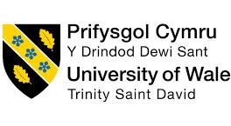

The Influence of National and International Labour Markets on HRM and IHRM Strategies

Programme Name: Master of Business Administration
Module Code and Name: LCMB7023 Human Capital Management
Lecturer's Name: Gladius Kulothungan
Student Name: Delwar Hussen Raju
Student ID: 2506700
Word Count: 2489
Submission Date: 14th November, 2025

Declaration Form

RESEARCH | For this assessment, you can use Generative AI to support you in research, including searching for bibliography, using tools to summarise, compare and interrogate materials. | No
STRUCTURE | For this assessment, you can use Generative AI to support you in structuring your submission, including creating a draft argument structure, identifying parts and headings, etc. | No
PROOFREADING | For this assessment, you can use Generative AI to check your own text/creation for grammatical and syntactical mistakes, including rephrasing of your own work within specific standards | Yes
WRITING | For this assessment, you can use Generative AI to create text for submission. | No
CREATIVE | For this assessment, you can use Generative AI to create creative materials, such as images. | No
PROGRAMING | For this assessment, you can use Generative AI to create and check code. | No
NONE | For this assessment, you are not allowed to use any type of Generative AI support. This includes research support, structure support, writing/proofreading support and creative support.

Table of Contents
Declaration Form ii
Table of Contents iii
1. Technological Advancement and Its Implications for HRM and IHRM Strategy 1
1.1 Impact of Automation 2
1.2 Remote Working Opportunities 2
1.3 Discussion Summary 3
2. Demographic and Geopolitical Factors Influencing the Employment Market 3
2.1 Factors Affecting the Labor Market 4
2.2 Summary 6
3. Addressing Skill Gaps and Talent Shortage Through Strategic HRM 6
3.1 Predictive Analytics 7
3.2 Employee Value Policies 7
3.3 Retention Framework 8
3.4 Summary 8
4. Reflection on My Capabilities and Technologically Evolving Workplace 8
4.1 Technical Skills 8
4.2 Communication Skills 9
4.3 Teamworking Skills 9
4.4 Leadership Skills 10
4.5 Self-directed Learning Skills 10
References 14

1. Technological Advancement and Its Implications for HRM and IHRM Strategy
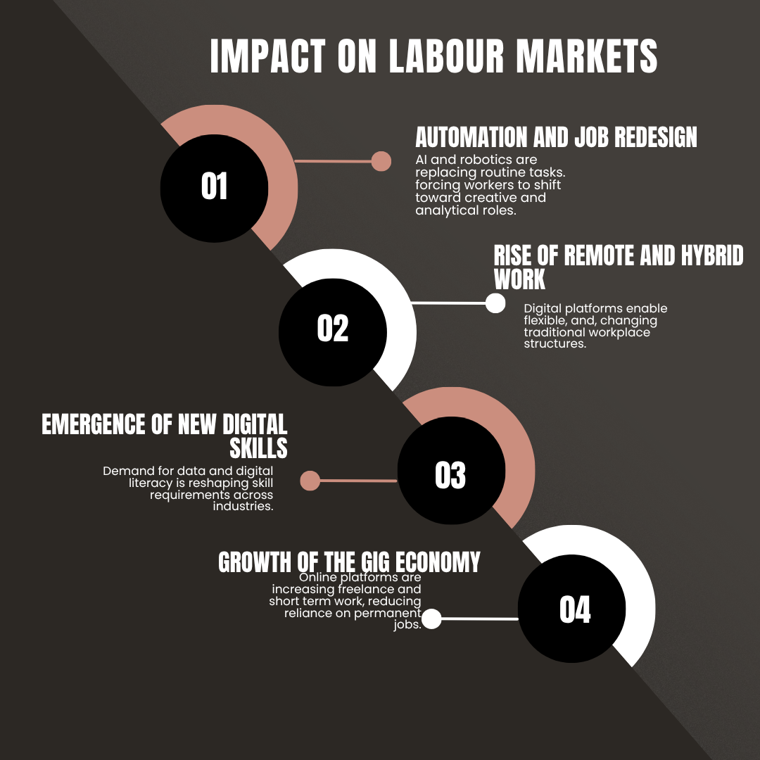
Figure 1: Impact On the Labour Market
Source: Self-Made
Technological advantages are widely restructuring the global labour market. Artificial intelligence and digital platforms are some commonly known technological advancements. These advancements are also helping to transform the strategic priorities of Human Resource Management and International Human Resource Management. The recruitment and performance management sector has created both advantages and risks for organisations by using AI. The World Economic Forum (2023) stated that approximately 44 percent of the skills workers need to change by 2027. This change will encourage AI adoption. The rapid adaptation of AI is expected to influence over 83 million jobs. HR professionals are now required to balance technology with strategic planning. The strategic planning and employee development will support maintaining competitiveness.

1.1 Impact of Automation
Automation has simplified administrative and recurring tasks. This gives access to the Human Resource department to concentrate more on strategic operations such as talent management and cultural inclusiveness (Dowling et al., 2013). Digital HR systems have structured recruitment by using algorithms to evaluate candidates' suitability for the job (Strohmeier, 2020). Such systems support virtual collaboration tools to manage a diverse team. Leveraging digital HR systems also makes IHRM more dependent on the global technological framework. Technology adaptation in HR management has also surfaced multiple issues. AI-based recruitment can use algorithmic bias and create a disadvantage for some demographic groups (Köchling and Wehner, 2020). HRM needs to combine transparent data monitoring and diverse AI strategies to reduce the impact of this issue and support equity.

1.2 Remote Working Opportunities
The rapidly evolving transformation has removed the boundaries between national and global labour markets. Remote work has improved global talent pools. This global digital transformation has challenged traditional employment designs. HRM frameworks should integrate flexible workforce models and improved employment contracts for continuous development (Franken et al., 2021). Minimisation of legal and cultural issues requires measurement from IHRM professionals. These measurements include data privacy regulation under the EU’s data protection regulations and diverse labour laws across the territory. Modern world's HR leaders are investing in a digital learning ecosystem to enable continuous learning (Cascio and Montealegre, 2016). Such investments help the HR leaders to adapt to the digitally transforming environment and restructure effectively.

1.3 Discussion Summary
In conclusion, technological evolution needs a framework change in HRM and IHRM tactics. These strategies will vary from administrative efficiency to strategic digital inclusiveness. Organisations that can control technology to maintain efficiency and human values are more likely to grow in the evolving and interconnected industry.

2. Demographic and Geopolitical Factors Influencing the Employment Market
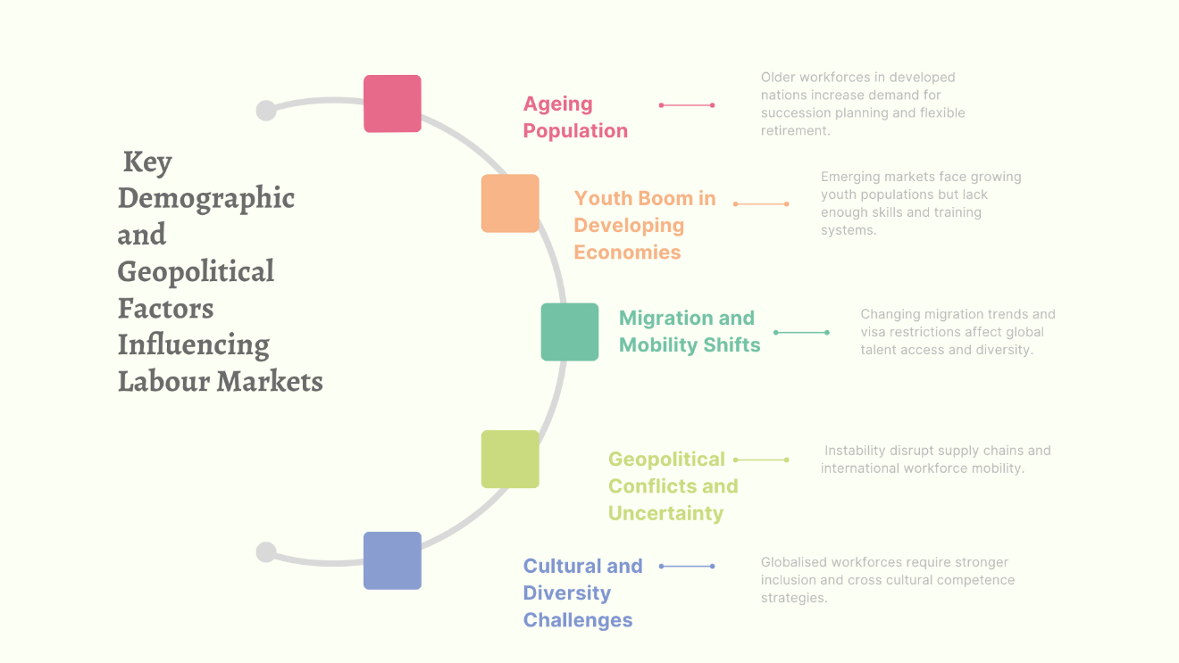
Figure 2: Key Demographic and Geopolitical Factors Influencing Labour Market
Source: Self-Made

Demographic and geopolitical elements critically design the national and international labour market. HRM and IHRM strategies face several problems of mitigation trends and political instability (Schuler et al., 2002). Comprehending these connected elements is vital for organisations seeking to attract and retain a vast global workforce. The table below gives an insight into the key demographic and geopolitical elements affecting the employment market in today's modern world and their application for HR professionals.

2.1 Factors Affecting the Labor Market
Factors | Description of Current Trends | Implications for HRM and IHRM Framework
Ageing Population | Developed countries such as Japan are facing an ageing workforce issue. Every one in six people across the globe will be over 65 by 2050 (WHO, 2025). | HRM needs to concentrate on succession planning and utilising older employees’ experiences through mentoring. This way, they can train younger employees for effective HRM usage. IHRM must maintain skill transfer across countries with diverse age profiles.
Youth Demographics in Developing Countries | Developing economies in Africa and South Asia have an increasingly younger population entering the labour market. Even with the vast labour availability, skills and education still lag behind demand. | Organisations need to invest in training and early career development initiatives to reduce the skill crisis. IHRM can initiate a global graduate programme to utilise this potential talent source.
Migration and Labour Mobility | Economic migration flows are restructuring national labour resources. Global situations such as Post-Brexit and COVID have further challenged traditional migration channels (OECD, 2021). | Fair employment practices require design-integrated programs by HRM. IHRM must evaluate visa restrictions and cross-border complications while balancing cultural sensitivity.
Geographical Conflicts | Geographic conflicts, such as Russia and Ukraine, have created issues in the supply chain and minimised workforce consistency in some regions (OECD, 2023). | HR leaders need to apply backup workforce plans and establish crisis management frameworks for employee safety.
Technological Issues and Global Unfairness | Automation and the adoption of AI are creating inconsistency in jobs due to their diversity across nations (CGD, 2024). | Reskilling initiatives should be prioritised by HRM to mitigate redundancy risks. Technology acceptance should be combined with global equity for effective cross-cultural training.
Changing Immigration and regulations | Governments are enforcing strict labour policies to protect domestic workers. This step also promotes digital visas for remote professionals. | HRM needs to stay updated on policies and regulatory strategies. IHRM needs to observe remote international dealings and hybrid work models.
Cultural and Diversity Dimensions | A multicultural workforce demands stronger combinations of frameworks and culturally effective leadership (Stahl et al., 2012). | HRM should adopt an inclusive culture by applying diversity training. On the other hand, IHRM should support cultural awareness and align global strategies with mandating local measures.
Table 1: Demographic and Geopolitical Factors Influencing the Employment Market

2.2 Summary
Demographic and geopolitical changes are defining workforce mobility and stability on a global scale. Such trends enforce flexible talent strategies. HR professionals can aim for efficiency and maintain local responsiveness by accepting these trends. Effective HRM needs a combined demographic planning with geopolitical risk evaluation. Strong cultural sensitivity and management capabilities can help IHRM to be more effective. These factors manage stability in an international environment (Farndale et al., 2017). Lead in a competitive market if organisations can match demographic situations with more detailed workforce planning. It will also help the organisation to be socially responsible in a growing market.

3. Addressing Skill Gaps and Talent Shortage Through Strategic HRM
Continuous skills gaps and talent shortage in the technology and hospitality industries are causing major challenges in sustainable workforce management. According to Manpower Group (2025), 77 percent of global employers encounter difficulty in selecting qualified candidates. This huge number gives an insight into the vast inconsistency in skills and changing work requirements. Adaptation of approaches of combined development and talent collection is required for strategic HRM to address these shortages.

3.1 Predictive Analytics
A vital initiative is the application of workforce planning by predictive analytics. HR leaders can determine future skill needs and internal abilities gaps by utilising big sets of data and AI (Rahmani and Kamberaj, 2021). Consistent learning has become crucial in the modern developing world. This has promoted a cycle of skill learning through digital platforms and professional development approaches (Mohammed, 2019). Strategic HRM has concentrated on creating career progression implementation in healthcare to identify the shortage of skilled nurses and clinicians. Modern companies have initiated a program that can provide digital literacy among candidates. These programs are supporting candidates to be more skilled while helping the technological sector expand. Evolution in such sectors can promote enhancement in leadership skills and reduce shortages in skills.

3.2 Employee Value Policies
Employee value policies and offers also play an important role in gaining skilled employees. Frameworks with enhanced flexibility and a purposeful work environment can help HR leaders operate effectively. Application of these steps will make the system more attractive to the younger generation seeking a meaningful career (Gallardo-Gallardo et al., 2020). Fair compensation ensuring while also following global regulations, can make IHRM more effective. IHRM operations can also enhance alignment with labour and balance consistency. Partnership with universities to enhance skills in students can also help to source sustainable talent. Government initiatives can also support skill enhancement initiatives for reducing the skill shortage problem. This will validate a continuous alignment in qualified candidates (Cappelli, 2009).

3.3 Retention Framework
A retention framework can help reduce skill shortages. Sectors that rely on low-wage workers suffer due to skill shortage, often caused by high turnover. Increased initiative for engagement requires being in strategic HRM. A combination of these factors will support achieving employee commitment and productivity at work. HR analytics based on data will promote understanding of the risks and improve retention if successfully combined (Marler and Boudreau, 2017).

3.4 Summary
Identifying global skills gaps requires a multi-layered HRM approach that includes technology-based planning. This initiative will also include an integrated learning system and collaboration in industry and academia. Organisations that consistently structure adaptability and have a future-centric workforce are better positioned in the market.

4. Reflection on My Capabilities and Technologically Evolving Workplace
The rapid evolution of global labour markets and internationalism has influenced my understanding of what it means to be a successful HR professional in the 21st century. I have structured a more critical awareness of my professional and personal abilities by understanding human capital management and analysing how AI works. Demographic changes that shaped HRM and IHRM strategies have also redefined my learning. This insight evaluates my skills in multiple areas. I can improve my skills and readiness to work effectively in international environments through a SMART development plan.

4.1 Technical Skills
Technological skills have become a main determinant of employability in HRM (Bondarouk and Brewster, 2016). I identify that one of my key skills is adaptability to new technologies. Digital tools such as Microsoft Teams for collaboration and performance tracking can be easily adapted by me. Academic works have also helped me to understand how AI can define recruitment and employee engagement systems. I have also recognised that my skills often remain limited when it comes to applying a high level of HR analytics. HR decisions that are based on data enhance the importance of management that works on evidence (Marler and Boudreau, 2017). Developing skills in this sector is important for my goal of effective HR system applications. This skill set includes predictive modeling and recruitment analysis. I aim to enhance my analytical skills while also expanding my digital skills within a practical environment.

4.2 Communication Skills
I have gained growth in communication as well. Some gaps also need improvement. My academic studies and projects required presenting research, discussing with my peers while debating ethical considerations. Such activities have made my capabilities clearer while creating creative ideas in intercultural settings. Communication skills are vital in IHRM because of the diversity in people and the complexity of the multinational environment (Stahl et al., 2012). I can confidently say I have achieved empathy and cultural awareness with these experiences. This has given me access to expand my communication skills effectively in different cultural environments. I find it difficult to maintain conflicts or my approach when faced with disagreement, despite my skills. This shows a need for further focus on developing more confidence in professional systems. Developed professional systems will provide me skill to listen while communicating my perspective more clearly in HR discussions.

4.3 Teamworking Skills
Teamwork is another factor that reflects successful partnership in the national and international environment. I have worked on assignments with teams that required research and creative ideas. Such experience has widened my mindset and accountability. I have also understood how to build trust and resolve differences more strategically. Lacking has been identified in my case despite these strengths. I recognised that I often defer to others when strong leadership is needed. I want to improve my ability to take approaches and lead with confidence while still validating and collaborating to resolve this issue.

4.4 Leadership Skills
I am still developing my skills in leadership. Leadership in HRM requires an integration of strategic foresight and technological literacy. I aim to lead through participation and promotion. This will create a positive group climate but can sometimes reduce decisiveness. I realise the importance of situational leadership by observing this. I aim to build a robust strategic leadership capability by gaining knowledge to make positive decisions based on data and ethical reasoning. Developing this skill will enable me to align with the leadership expectations. I want to practice these competencies by leading group tasks and seeking feedback from mentors in the future to evaluate my growth.

4.5 Self-directed Learning Skills
Self-directed learning has become one of my most important skills as a postgraduate student. I have gained a strong sense of motivation to initiate knowledge independently. This is a critical skill in an era of continuous technological issues. Staying updated on global trends and maintaining continuous learning has helped me to increase my skills in self learning. My continuous learning style has given me the advantage to combine theoretical and practical methods. The combination helps me to understand and develop skills around global HR demands. Consistently upgrading my learning strategies and setting more purposeful milestones will also help me to enhance self-directed learning skills. Learning within a vast and diverse sector will support me to thrive and gain more knowledge.
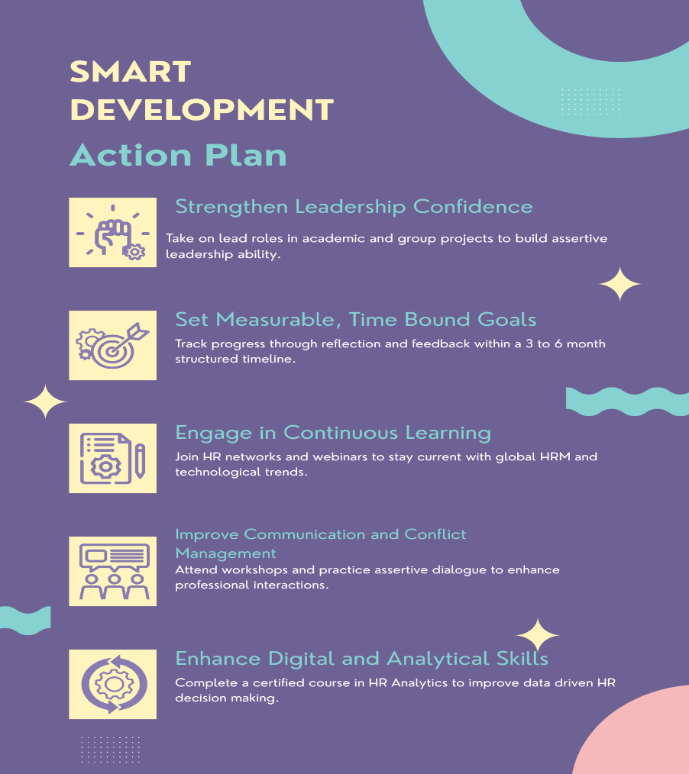
Figure 3: SMART Development Action Plan
Source: Self-Made

Development Area | Specific Goal | Measurable |  | Relevant | Time Bound
  Achievable
Digital and Analytical Proficiency | To achieve a professional course in HR analytics and digital evolution to enhance my capability to use data for decision-making | Completing the course and implementation in academic projects | I will utilise 3 to 4 hours to study and practice analytical tools | Improves my employability in HR roles | Within 6 months
Leadership Assertiveness | To build robust leadership confidence by taking lead roles in group projects. | Peer feedback and reflecting on self-outcomes | Advantages available within academic teamwork and student initiatives | Enhances skills to lead a diverse team in a global context | Within 4 months
Communication and Conflict Management | To enhance assertive communication by attending workshops. | Feedback from mentors and team members. | Workshop available through university student support services | Builds intercultural communication and negotiation skills. | Within 3 months
Continuous Learning and Industry Engagement | To communicate with HR professional networks to stay updated on HRM trends | Consistent participation in sharing insights | Needs only consistent time management | Keeps my learning current and globally relevant | Ongoing
Table 2: SMART Development Action Plan
Professional skills and readiness widen their branches beyond technical abilities. I have comprehended that being a successful HR leader needs a balance between empathy and analytical reasoning. Personal development is not limited to a finite goal. It is a continuous journey that helps a person to gain knowledge and skills. Utilising personal development will give me an advantage to apply my knowledge in a more practical setting.
This analysis has given me sources to identify my strengths and underlying weaknesses. I can now contribute to the HR system with more clarity and effectiveness. This will also help me expand my knowledge and leverage my practical skills. My goal is to define myself as a globally competent HR leader who can measure the difficulties in a changing world by enforcing strategic insights.

References
Bondarouk, T. and Brewster, C (2016) Conceptualising the future of HRM and technology research. The International Journal of Human Resource Management, 27(21), pp.2652-2671.
Cappelli, P (2009) Talent on Demand–Managing Talent in an Age of Uncertainty. Strategic Direction, 25(3).
Cascio, W.F. and Montealegre, R (2016) How Technology is Changing Work and Organizations. Annual review of organizational psychology and organizational behavior, 3(1), pp.349-375.
CGD (2024). Three Reasons Why AI May Widen Global Inequality. CGD. Available at: https://www.cgdev.org/blog/three-reasons-why-ai-may-widen-global-inequality#:~:text=Without%20targeted%20policy%20interventions%2C%20AI,towards%20the%20Sustainable%20Development%20Goals.
Dowling, P., Festing, M. and Engle, A.D (2013) International Human Resource Management.
Farndale, E., Raghuram, S., Gully, S., Liu, X., Phillips, J.M. and Vidović, M.m (2017) A Vision of International HRM Research. The International Journal of Human Resource Management, 28(12), pp.1625-1639.
Franken, E., Bentley, T., Shafaei, A., Farr-Wharton, B., Onnis, L.A. and Omari, M (2021) Forced flexibility and remote working: Opportunities and challenges in the new normal. Journal of management & organization, 27(6), pp.1131-1149.
Gallardo-Gallardo, E., Thunnissen, M. and Scullion, H (2020) Talent Management: Context Matters. The International Journal of Human Resource Management, 31(4), pp.457-473.
Köchling, A. and Wehner, M.C ( 2020) Discriminated by an Algorithm: A Systematic Review of Discrimination and Fairness by Algorithmic Decision-Making in the Context of HR Recruitment and HR Development. Business Research, 13(3), pp.795-848.
ManpowerGroup (2025). Talent Shortage Survey 2025. ManpowerGroup. Available at: https://www.manpowergroup.co.uk/b_talent-shortage-survey-2025/#:~:text=ManpowerGroup's%202025%20Talent%20Shortage%20report,down%20from%2080%25%20in%202024.
Marler, J.H. and Boudreau, J.W (2017) An Evidence-Based Review of HR Analytics. The International Journal of Human Resource Management, 28(1), pp.3-26.
Mohammed, D.A.Q (2019) HR analytics: a modern tool in HR for predictive decision making. Journal of Management, 6(3).
OECD (2021). The Impact Of COVID-19 In The Migration Area In EU And OECD Countries. OECD. Available at: https://www.oecd.org/content/dam/oecd/en/topics/policy-issues/migration/00-eu-emn-covid19-umbrella-inform-en.pdf
OECD (2023). Assessing The Impact Of Russia’s War Against Ukraine On Eastern Partner Countries. OECD. Available at: https://www.oecd.org/content/dam/oecd/en/publications/reports/2023/01/assessing-the-impact-of-russia-s-war-against-ukraine-on-eastern-partner-countries_3fdf0591/946a936c-en.pdf
Rahmani, D. and Kamberaj, H (2021) Implementation and Usage of Artificial Intelligence Powered Chatbots in Human Resources Management Systems. In Conference: International conference on social and applied sciences at: University of New York Tirana.
Schuler, R.S., Budhwar, P.S. and Florkowski, G.W. (2002) International Human Resource Management: Review and Critique. International Journal of Management Reviews, 4(1), pp.41-70.
Stahl, G.K., Björkman, I. and Morris, S. eds (2012) Handbook of Research in International Human Resource Management. Edward Elgar Publishing.
Strohmeier, S (2020) Digital human resource management: A conceptual clarification. German Journal of Human Resource Management, 34(3), pp.345-365.
World Economic Forum (2023). Future Of Jobs Report 2023: Up To A Quarter Of Jobs Expected To Change In Next Five Years. World Economic Forum. Available at: https://www.weforum.org/press/2023/04/future-of-jobs-report-2023-up-to-a-quarter-of-jobs-expected-to-change-in-next-five-years/#:~:text=Faster%20reskilling%20is%20necessary%20%E2%80%93%20and,and%20equitable%20future%20of%20work.%22
World Health Organization (2025). Ageing And Health. World Health Organization. Available at: https://www.who.int/news-room/fact-sheets/detail/ageing-and-health

