Sending data out to an excel spreadsheet
This form is built using a data grid. It allows you to build columns in a similar fashion to a spreadsheet.

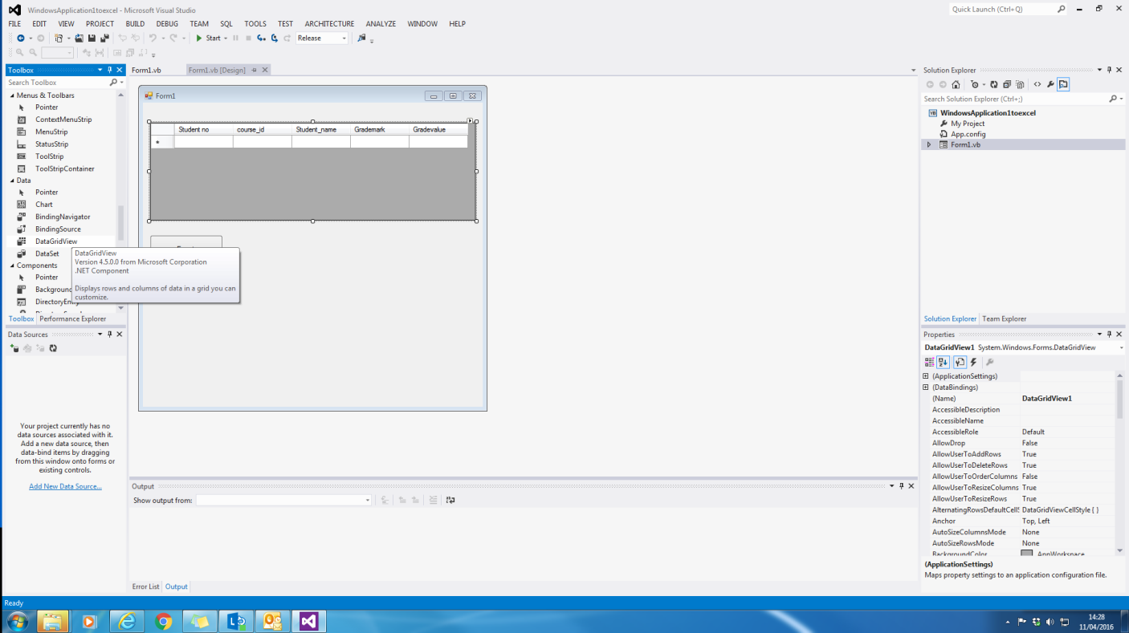
The Export button calls the necessary code to send the information to the spreadsheet. With te data grid you can count how many columns and rows you have used and this then controls the loop of the program.

Public Class Form1

' Dim connString As String = "Provider=Microsoft.ACE.OLEDB.14.0; Data Source=C:\Users\sc-bf\Documents\organising 2015 2016\Business Programming\test.accdb"
' Dim excellocation As String = "C:\Users\sc-bf\Documents\organising 2015 2016\Business Programming\testexcel2.xlsx"
Dim excellocation As String = "E:\organisong 2015 16\business programming\testexcel2.xlsx"
' Dim myss As String = "C:\Users\sc-bf\Documents\organising 2015 2016\Business Programming\testexcel2.xlsx"
Dim myss As String = "E:\organisong 2015 16\business programming\testexcel2.xlsx"
' Dim MyConn As OleDbConnection
' Dim da As OleDbConnection
Dim ds As DataSet
Dim tables As DataTableCollection
Dim source1 As New BindingSource
Dim APP As New Excel.Application
Dim worksheet As Excel.Worksheet
Dim workbook As Excel.Workbook

Private Sub Form1_Load(sender As System.Object, e As System.EventArgs) Handles MyBase.Load
Dim xl = CreateObject("Excel.Application")
workbook = APP.Workbooks.Open(excellocation)
xl.workbooks.Open(myss)
worksheet = workbook.Worksheets("sheet1")

' MyConn = New OleDbConnection
' MyConn.ConnectionString = connString
ds = New DataSet
tables = ds.Tables
'da = New OleDbDataAdapter("Select * from [Items]", MyConn) 'Change items to your database name
' (ds, "Items") 'Change items to your database name
Dim view As New DataView(tables(0))
source1.DataSource = view
DataGridView1.DataSource = view
DataGridView1.AllowUserToAddRows = False

End Sub

Private Sub Export_Click(sender As System.Object, e As System.EventArgs) Handles Export.Click

'Export Header Names Start

Dim columnsCount As Integer = DataGridView1.Columns.Count

For Each column In DataGridView1.Columns
worksheet.Cells(1, column.Index + 1).Value = column.Name
Next

'Export Header Name End
'Export Each Row Start

For i As Integer = 0 To DataGridView1.Rows.Count - 1

Dim columnIndex As Integer = 0
Do Until columnIndex = columnsCount

worksheet.Cells(i + 2, columnIndex + 1).Value = DataGridView1.Item(columnIndex, i).Value
columnIndex += 1

Loop

Next

'Export Each Row End
End Sub

Private Sub Form1_FormClosed(sender As Object, e As System.Windows.Forms.FormClosedEventArgs) Handles Me.FormClosed

workbook.Save()
workbook.Close()
' APP.Quit()

End Sub

