  Component One: | Student No:
 | Module Title: | OPERATING HOTEL FACILITIES
 | Module Code:
 | Lecturer:
A key component of the hospitality sector is housekeeping, and depending on the type of business, different abilities may be needed for a member of the housekeeping crew. All members of the cleaning team must have a few specific abilities, though. The essential abilities needed to function as a cleaning team will be discussed in this article.

Observation of details
One of the most important qualities a member of the housekeeping staff should have is attention to detail. This ability is crucial because it guarantees that every section of the facility or guest room is carefully cleaned and maintained. (Mattson and Philips,2019)Little details like stains on the carpet, dust on the furniture, or fingerprints on glass surfaces must be noticed by the housekeeping personnel. This ability also aids in spotting any faults or deficiencies in the space that should be reported to the maintenance crew(Adams,2017)
management of time
Another essential skill that employees of the cleaning staff should have is time management. The housekeeping staff is in charge of quickly and thoroughly cleaning and preparing various rooms and facilities. As a result, it's critical that team members have effective time management skills and finish their work on schedule. Prioritizing duties and making sure that the most crucial areas are cleaned and maintained first require good time management skills. (Diaz , Moral and Marques,2015)
talents in communication
Any member of the housekeeping staff needs to be able to communicate effectively. They must be able to speak clearly with their coworkers, managers, and visitors. Understanding the wants and demands of the guest and making sure that their requests are quickly met are both made possible through effective communication. In order to report any issues or problems that develop while performing their cleaning chores, effective communication is also helpful. (Kim and Kim,2017)
physical condition
It takes a lot of standing, moving around, and bending to do housekeeping, which is a physically hard profession. As a result, being physically healthy is a crucial skill for a member of the cleaning staff. They ought to be capable of handling the physical demands of the job without becoming exhausted or hurt. Maintaining the necessary degree of vigour and passion required to carry out duties successfully also benefits from physical fitness(Cliffnotes,nd)
Teamwork
To guarantee that all rooms and facilities are cleaned and kept to a high degree, housekeeping team members must collaborate closely with their coworkers. Teamwork is therefore a crucial ability that they should have. They ought to be able to collaborate well, express their demands, and help out their coworkers when necessary. Tasks are more likely to be accomplished successfully and efficiently when there is effective teamwork. (Cliffnotes,nd)
aptitude for solving issues
To recognise and resolve any issues that may develop while doing their cleaning tasks, members of the housekeeping staff must have strong problem-solving abilities. They ought to be able to pinpoint the issue's root cause and come up with a workable solution to get it taken care of right away. Strong problem-solving abilities are also helpful in spotting any future problems that might come and in devising preventative measures. (Kim, Han and Kim,2017)
Knowledge of customers
When visitors initially arrive at their hotel or facility, members of the housekeeping team are frequently their first point of contact. Hence, having strong customer service abilities is crucial. They should be able to pleasantly welcome visitors, respond to any inquiries they may have, and give them the information they require to make their stay comfortable. Also, good customer service abilities aid in making a favourable impression on visitors, which may result in recurring business and favourable evaluations. (Skift,2023)
In conclusion, while there are many different abilities needed to work in a housekeeping crew, they are all crucial for delivering top-notch customer service and upholding a high level of hygienic standards. A member of the housekeeping crew should have the following abilities: attention to detail, time management, communication skills, physical fitness, teamwork, problem-solving skills, and customer service abilities. By honing these abilities, members of the housekeeping team may make sure that visitors have a comfortable and enjoyable stay, which may result in favourable reviews and return business.

Word Count | 675

Component Two:

Problem | Why did it happen? | What are you going to do? | How will you prevent this from happening in the future? | What measures would you introduce to improve team effectiveness?
1. Room not properly cleaned | Possible human error or lack of attention to detail by the cleaning staff | Apologize to the guest and offer to have the room cleaned immediately. Offer a complimentary meal or amenity as a gesture of goodwill. Document the complaint and investigation process. | Implement a rigorous quality control process for room cleaning, including spot checks and regular training for staff on cleaning procedures. Regularly review guest feedback to identify areas for improvement. | Conduct regular team-building activities to foster a positive and collaborative team culture. Encourage open communication and feedback between team members and management.
2. Inadequate communication between staff | Lack of clear communication channels or protocols between team members | Establish clear communication channels and protocols for staff to follow, including regular team meetings and shift handovers. Implement a system for reporting and addressing issues or concerns in a timely manner. | Regularly review and update communication protocols to ensure they are effective and efficient. Provide training to staff on effective communication techniques. | Foster a culture of open communication and collaboration within the team. Encourage feedback and suggestions from staff to continuously improve communication and teamwork.
3. Poor time management | Inefficient use of time and resources by staff | Provide training to staff on time management and prioritization techniques. Implement a system for tracking and monitoring tasks and deadlines. Set clear expectations and targets for staff performance. | Regularly review and evaluate staff performance to identify areas for improvement. Provide coaching and support to help staff improve their time management skills. | Implement a system for recognizing and rewarding staff who consistently demonstrate effective time management skills. Encourage staff to share time-saving tips and best practices with their colleagues.
4. Inconsistent service quality | Lack of standardization in service delivery by staff | Develop and implement a service standard for the hotel, including specific guidelines for staff behavior, communication, and service delivery. Train staff on the service standard and regularly monitor and evaluate their performance. | Regularly review and update the service standard to ensure it reflects changing guest expectations and industry trends. Provide ongoing training and support to help staff maintain high service quality. | Implement a system for recognizing and rewarding staff who consistently demonstrate exceptional service quality. Encourage staff to share feedback and suggestions on how to improve service quality.
5. Staff morale and motivation | Low morale and motivation among staff | Provide regular opportunities for staff to provide feedback and suggestions on their work environment and job satisfaction. Implement a system for recognizing and rewarding staff for their achievements and contributions. Provide training and support to help staff develop their skills and advance their careers. | Regularly review and evaluate staff morale and motivation levels. Address any issues or concerns promptly and provide support and resources to help improve staff engagement. | Foster a positive and supportive work environment by promoting teamwork, communication, and recognition of staff achievements. Encourage staff to take ownership of their work and provide opportunities for professional development and career advancement.

Component Three:

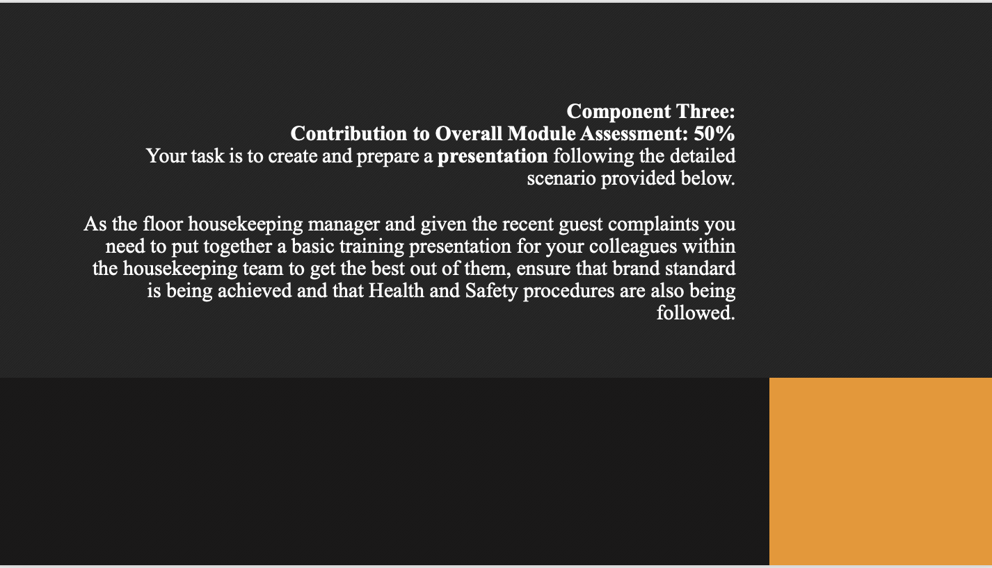

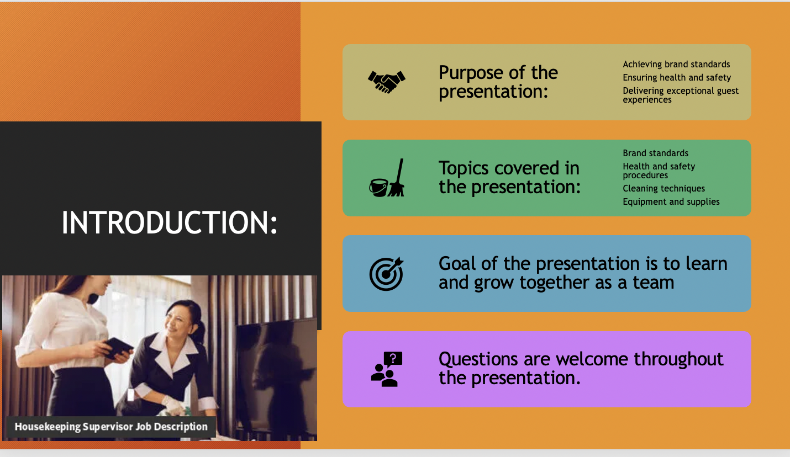
Training Notes: Good morning/afternoon everyone,

Welcome to this housekeeping training presentation. My name is FLORIN and I am the floor housekeeping manager. The purpose of this presentation is to ensure that our housekeeping team is equipped with the knowledge and skills needed to achieve brand standards, maintain health and safety, and deliver exceptional guest experiences.

During this presentation, we will review important topics such as brand standards, health and safety procedures, cleaning techniques, equipment and supplies, and more. My goal is for all of us to learn and grow together, and to work towards our shared goal of providing the highest quality service to our guests.
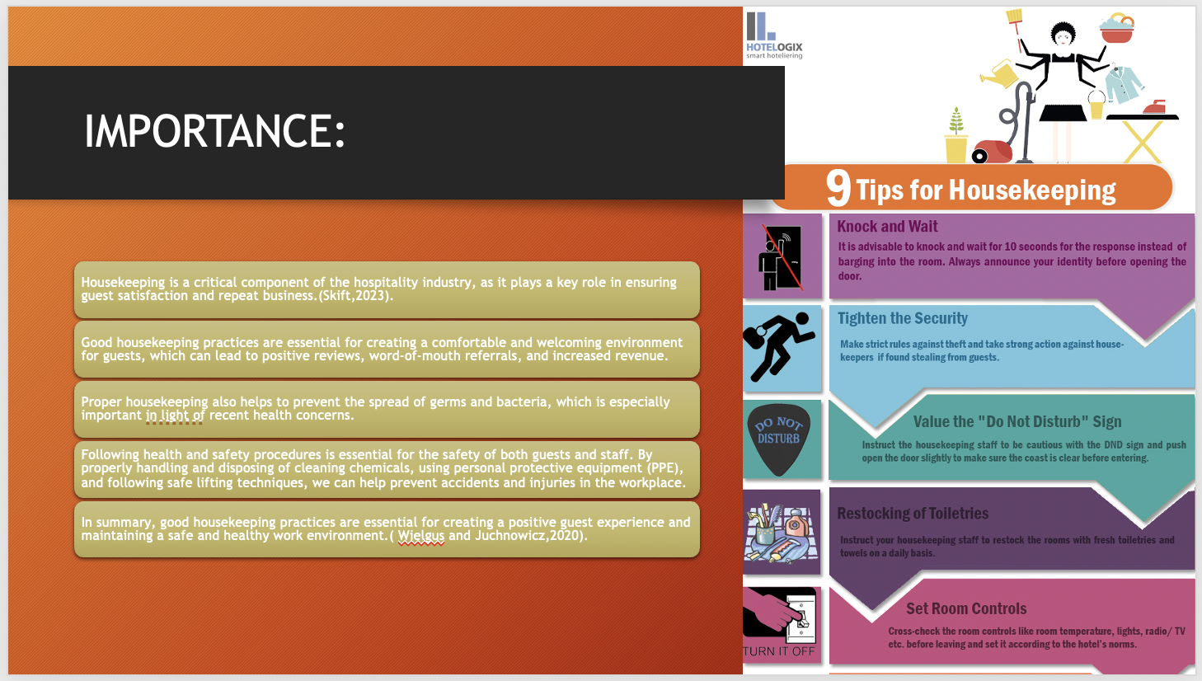

Training Notes: Housekeeping is a critical component of the hospitality industry, as it plays a key role in ensuring guest satisfaction and repeat business. Good housekeeping practices are essential for creating a comfortable and welcoming environment for guests, which can lead to positive reviews, word-of-mouth referrals, and increased revenue.

In addition to enhancing guest satisfaction, proper housekeeping also helps to prevent the spread of germs and bacteria. This is especially important in light of recent health concerns, as guests are more aware than ever of the cleanliness and safety of the hotels they choose to stay in.

Following health and safety procedures is essential for the safety of both guests and staff. By properly handling and disposing of cleaning chemicals, using personal protective equipment (PPE), and following safe lifting techniques, we can help prevent accidents and injuries in the workplace.

In summary, good housekeeping practices are essential for creating a positive guest experience and maintaining a safe and healthy work environment.
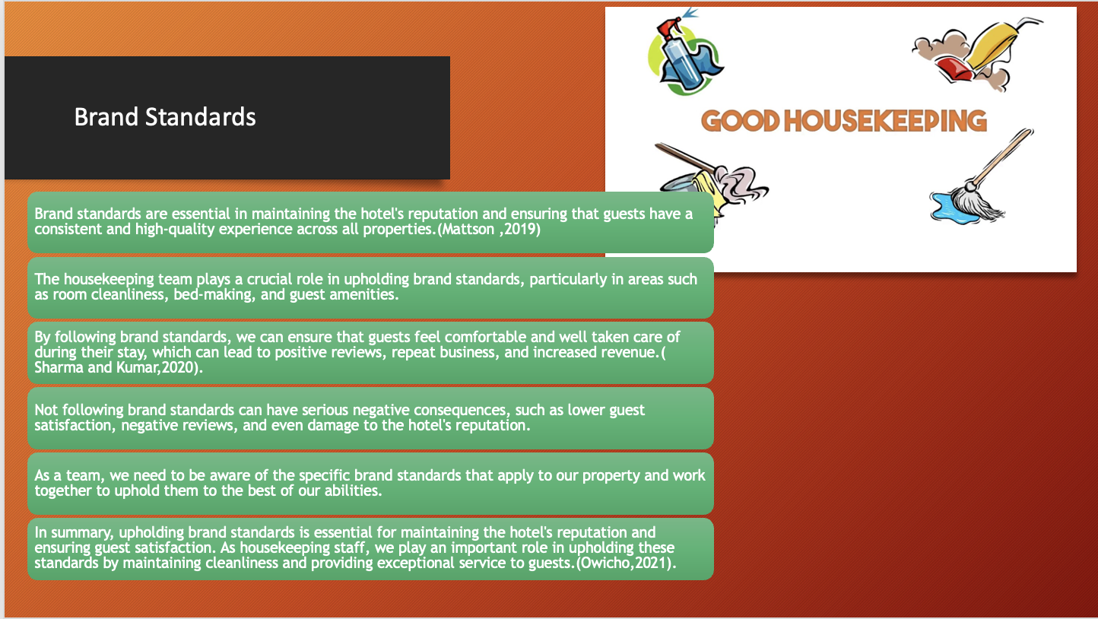

Training Notes: Slide 3: Brand Standards
Slide 3: Branding Guidelines

In order to preserve the hotel's reputation and guarantee that visitors enjoy a consistent and superior experience at all properties, brand standards are crucial.
In particular, in areas like room cleanliness, making beds, and guest amenities, the housekeeping service is essential to maintaining brand standards.
By adhering to brand standards, we can make sure that visitors are at ease and well-cared-for while they are with us, which may result in favourable evaluations, repeat business, and more revenue.
Not adhering to brand standards can have detrimental effects on the hotel's reputation, decreased visitor satisfaction, and bad reviews.
We must all work together to respect the specific brand standards that apply to our property as a team and be aware of them.
In conclusion, upholding brand standards is necessary for preserving the hotel's reputation and guaranteeing visitor happiness. By keeping the property clean and offering great guest care, the housekeeping team plays a crucial part in preserving these standards.

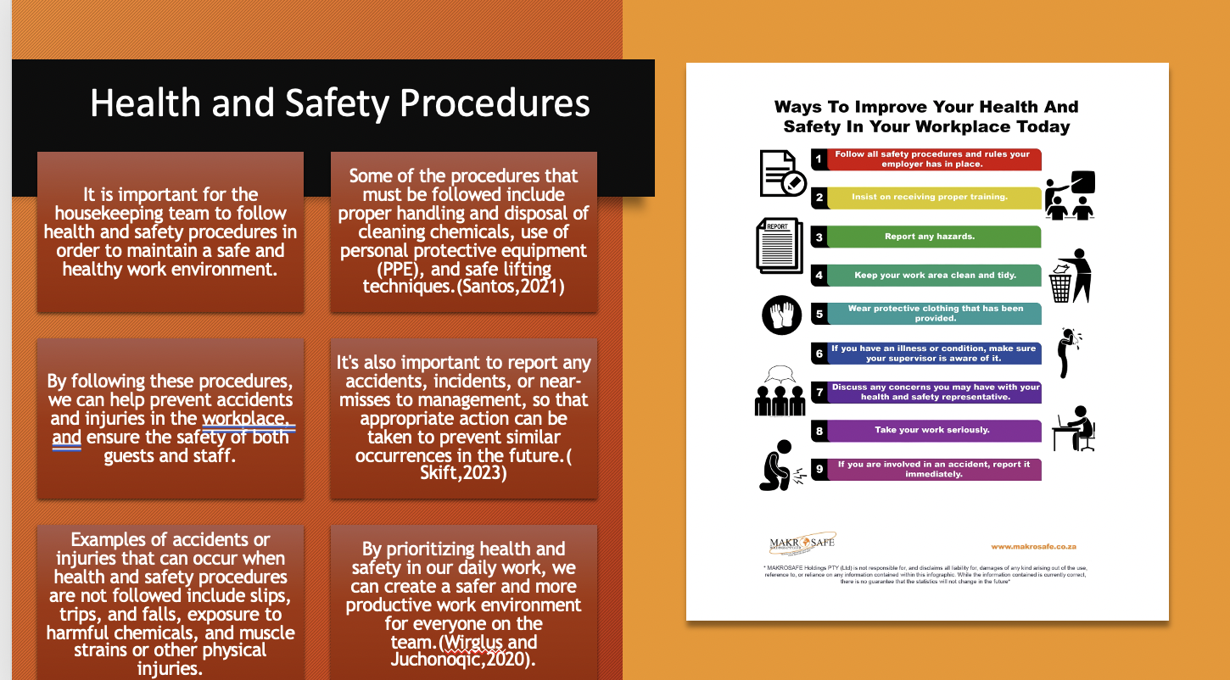

Training Notes: Protocols for health and safety, slide 4.

To ensure a safe and healthy workplace, it is crucial for the cleaning team to adhere to health and safety regulations.
Use of personal protection equipment (PPE), safe lifting techniques, and correct handling and disposal of cleaning agents are a few of the regulations that must be adhered to.
We may assist prevent workplace accidents and injuries by adhering to these protocols, thereby ensuring the security of both visitors and employees.
Also, it's crucial to inform management of any mishaps, incidents, or near-misses so that the necessary steps can be done to stop them from happening again.
Slips, stumbles, and falls, chemical exposure, muscular strains, and other physical injuries are a few incidents or injuries that can happen when health and safety protocols are not followed.
We can make the workplace safer and more effective for everyone on the team if we put health and safety first in all we do.
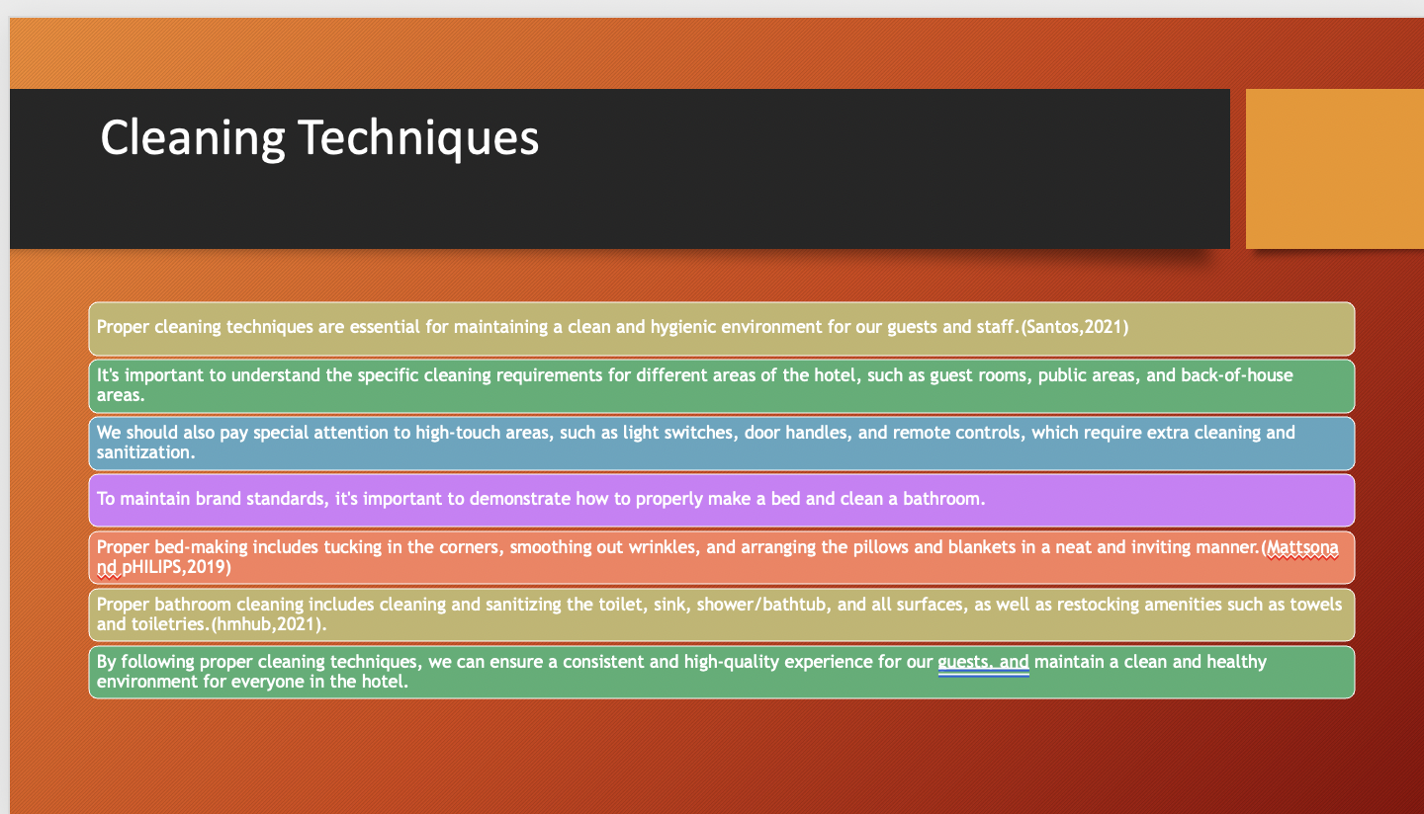

Training Notes: Cleaning Methods

Good cleaning is necessary to keep our guests and staff healthy.
Understanding the hotel's guest room, public, and back-of-house cleaning needs is crucial.
Light switches, door handles, and remote controls need extra cleaning and sanitising.
Demonstrating how to make a bed and clean a toilet maintains brand standards.
Bed-making involves tucking corners, smoothing wrinkles, and arranging pillows and blankets.
Good bathroom cleaning includes sterilising the toilet, washbasin, shower/bathtub, and other surfaces and refilling towels and toiletries.
We can provide a consistent, high-quality experience for guests and keep the hotel clean and healthy by following correct cleaning procedures.

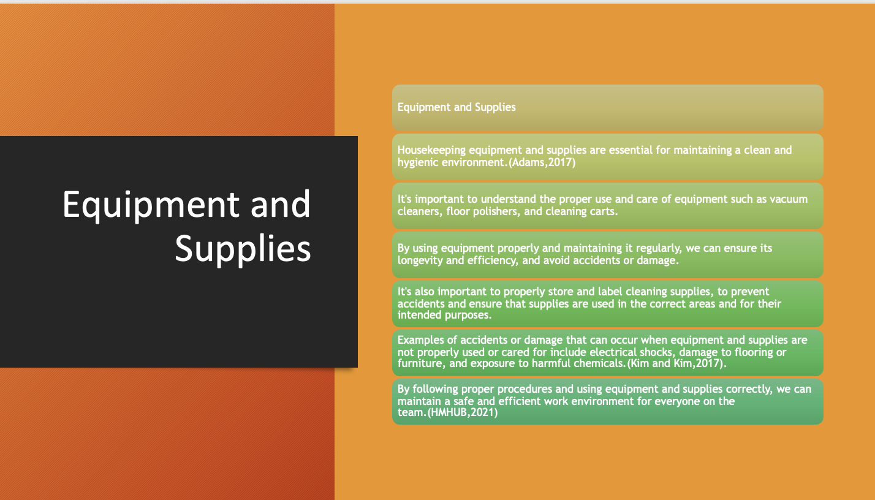

Training Notes: Slide 6: EQUIPMENT AND SUPPLIERS

Cleanliness requires housekeeping supplies.
Vacuum cleaners, floor polishers, and cleaning carts need correct use and maintenance.
.
To minimise mishaps and ensure supplies are utilised appropriately, cleaning materials should be properly stored and labelled.
Electrical shocks, flooring or furniture damage, and chemical exposure can result from improper equipment and supply use.
We can keep the team safe and productive by following processes and using resources properly.
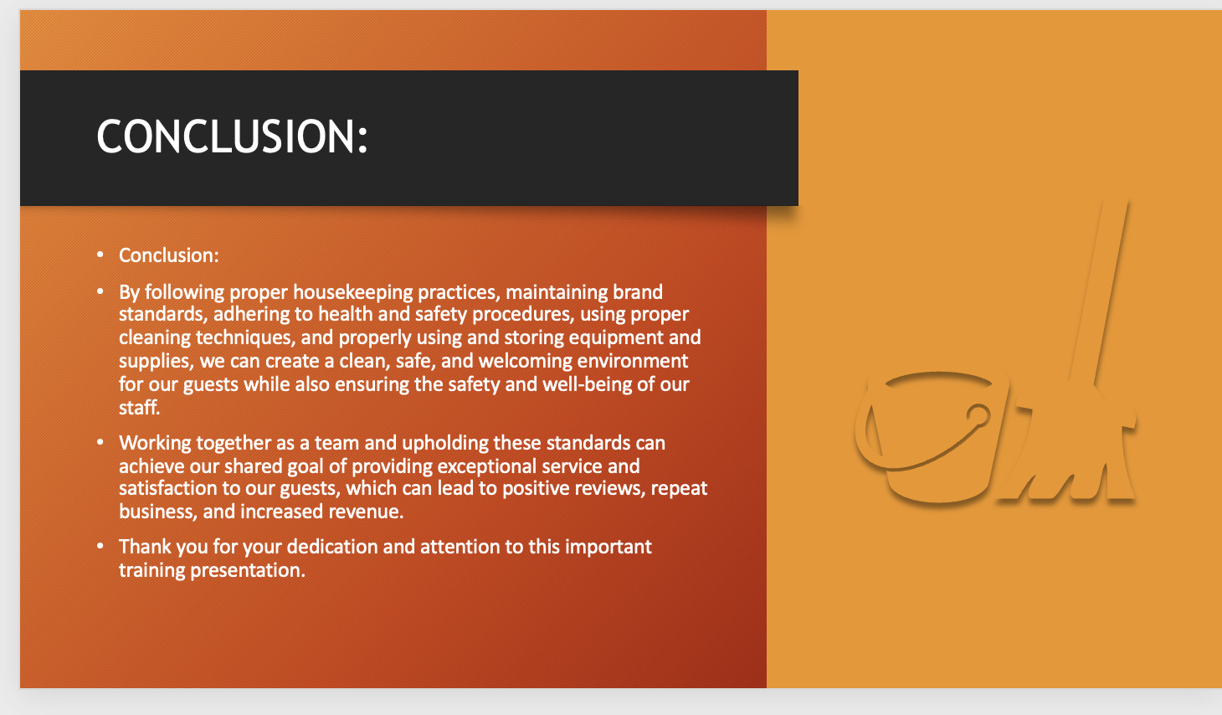

Training Notes:
Conclusion:

In conclusion, by following proper housekeeping practices, maintaining brand standards, adhering to health and safety procedures, using proper cleaning techniques, and properly using and storing equipment and supplies, we can create a clean, safe, and welcoming environment for our guests while also ensuring the safety and well-being of our staff. By working together as a team and upholding these standards, we can achieve our shared goal of providing exceptional service and satisfaction to our guests, which can lead to positive reviews, repeat business, and increased revenue. Thank you for your dedication and attention to this important training presentation.

Training Notes:
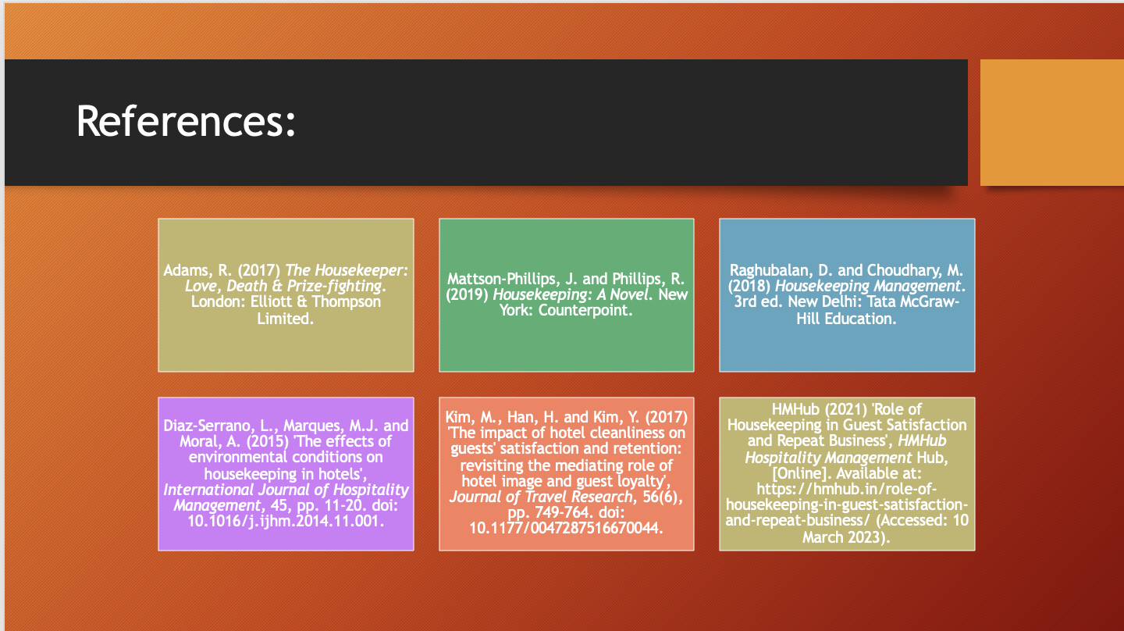

Training Notes:
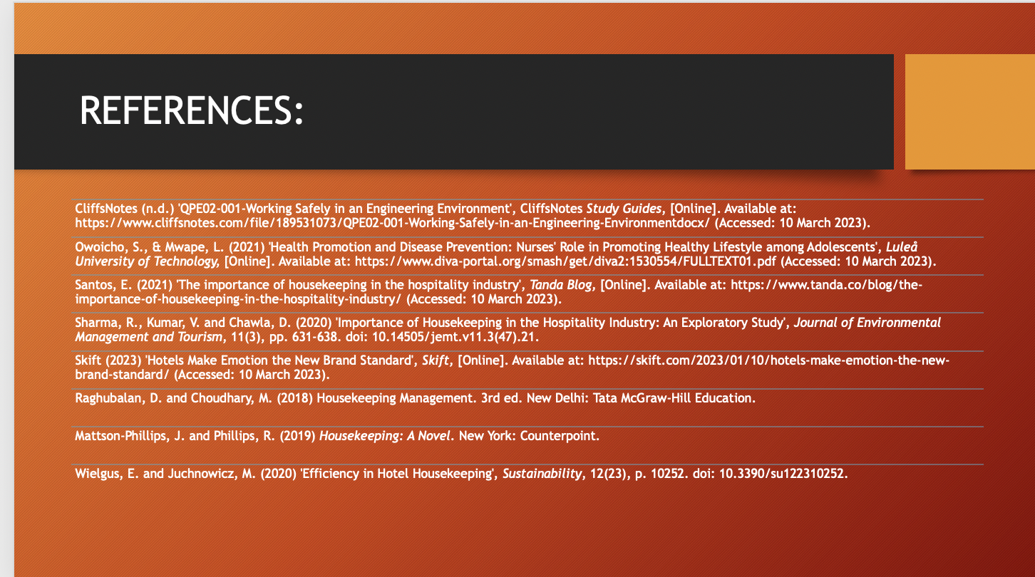

Training Notes:

References

Adams, R. (2017) The Housekeeper: Love, Death & Prize-fighting. London: Elliott & Thompson Limited.

Mattson-Phillips, J. and Phillips, R. (2019) Housekeeping: A Novel. New York: Counterpoint.

Raghubalan, D. and Choudhary, M. (2018) Housekeeping Management. 3rd ed. New Delhi: Tata McGraw-Hill Education.

Diaz-Serrano, L., Marques, M.J. and Moral, A. (2015) 'The effects of environmental conditions on housekeeping in hotels', International Journal of Hospitality Management, 45, pp. 11-20. doi: 10.1016/j.ijhm.2014.11.001.

Kim, M., Han, H. and Kim, Y. (2017) 'The impact of hotel cleanliness on guests' satisfaction and retention: revisiting the mediating role of hotel image and guest loyalty', Journal of Travel Research, 56(6), pp. 749-764. doi: 10.1177/0047287516670044.
HMHub (2021) 'Role of Housekeeping in Guest Satisfaction and Repeat Business', HMHub Hospitality Management Hub, [Online]. Available at: https://hmhub.in/role-of-housekeeping-in-guest-satisfaction-and-repeat-business/ (Accessed: 10 March 2023).

CliffsNotes (n.d.) 'QPE02-001-Working Safely in an Engineering Environment', CliffsNotes Study Guides, [Online]. Available at: https://www.cliffsnotes.com/file/189531073/QPE02-001-Working-Safely-in-an-Engineering-Environmentdocx/ (Accessed: 10 March 2023).

Owoicho, S., & Mwape, L. (2021) 'Health Promotion and Disease Prevention: Nurses' Role in Promoting Healthy Lifestyle among Adolescents', Luleå University of Technology, [Online]. Available at: https://www.diva-portal.org/smash/get/diva2:1530554/FULLTEXT01.pdf (Accessed: 10 March 2023).

Santos, E. (2021) 'The importance of housekeeping in the hospitality industry', Tanda Blog, [Online]. Available at: https://www.tanda.co/blog/the-importance-of-housekeeping-in-the-hospitality-industry/ (Accessed: 10 March 2023).

Sharma, R., Kumar, V. and Chawla, D. (2020) 'Importance of Housekeeping in the Hospitality Industry: An Exploratory Study', Journal of Environmental Management and Tourism, 11(3), pp. 631-638. doi: 10.14505/jemt.v11.3(47).21.

Skift (2023) 'Hotels Make Emotion the New Brand Standard', Skift, [Online]. Available at: https://skift.com/2023/01/10/hotels-make-emotion-the-new-brand-standard/ (Accessed: 10 March 2023).
Raghubalan, D. and Choudhary, M. (2018) Housekeeping Management. 3rd ed. New Delhi: Tata McGraw-Hill Education.
Mattson-Phillips, J. and Phillips, R. (2019) Housekeeping: A Novel. New York: Counterpoint.
Wielgus, E. and Juchnowicz, M. (2020) 'Efficiency in Hotel Housekeeping', Sustainability, 12(23), p. 10252. doi: 10.3390/su122310252.

