IMPROVING THE EFFICIENCY OF A DC MOTOR

Andrew Prescott (P145780)
2018

Abstract
In this set of tests, the aim was to improve the efficiency of a DC motor model with 36% efficiency within FEMM software. Only certain aspects of the stator design could be changed; therefore, it was decided to change three variables: stator inner diameter, stator armature width, and adding fishtails; each of these variables could be changed from the original in two ways. An orthogonal array was used as fewer tests could be done to obtain the relevant information. It was found an increase in efficiency of 5.5% was possible if the inner stator radius was increased from 40mm to 48mm, this was due to the increased reluctances between the armature and the stator.

Introduction
The aim is to improve evaluate the areas of inefficiencies in DC motors, then improve the efficiency of a DC motor model created within FEMM. Specific aspects of the model will be changed this will then be evaluated to obtain the efficiency of the system, the different improvements will be compared in effectiveness.

Efficiency and improvement methods
The aim is to improve the overall efficiency of the system the term efficiency must be understood. Efficiency is a measure of how much energy is conserved during a process, a perfect process would conserve 100% of the energy provided e.g. 100% efficient; efficiency follows the equation $Efficiency=\frac{Energy out}{Energy in}×100\%$ [1]. In the case of a DC motor the energy provided to the system is in the form of electrical current in the coils (enhanced by stator), the used energy is the mechanical energy produced on by the rotor (Figure 1) [2].
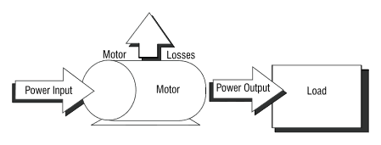
Figure 1 [2] Motor efficiency.
There are many factors which affect the efficiency of a DC motor, some of these losses are through sound and heat produced by the mechanical movement of the system (friction of the brushes etc.), heat is also produced within the electrical components of the system these are sometimes called ohmic losses [3]. Losses are created within the core material; these losses are in the form of hysteresis losses and eddy currents. Hysteresis losses are caused by the stator storing remnants of the magnetic field applied when the field changes polarity to enable rotation, therefore opposing the desired field direction [4]; the size of these losses depend on the volume and type of material the core is constructed (usually iron). Below in figure 2 is an example of a hysteresis curve with labels at key points it shows the magnetization force (H) required to produce a given flux density (B) in the material [5], the losses in the motor are produced between points b-c and e-f as some amount of magnetization force (coercive force) is needed to remove the residual magnetism and change the polarity of flux in the material. These losses can be improved by selecting the material with a narrow B.H curve [6].
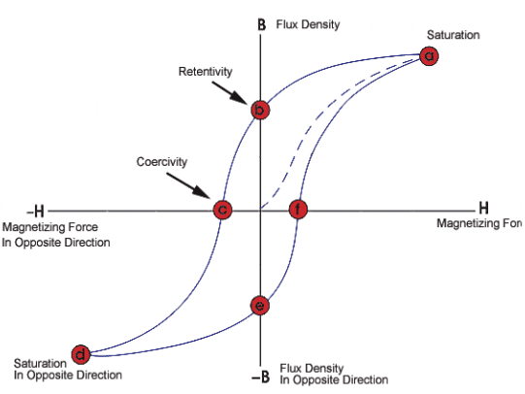
Figure 2 [5] BH hysteresis loop example.
As the stator core is constructed of conducting material a voltage is induced by changing flux (Lenz’s law) therefore currents are also produced in the stator; these are called eddy currents and the size of these currents is dependent on the rate of change of flux and the resistance of the path, this causes a loss of energy as some is expended as heat. The method commonly used to counteract eddy currents is laminating the core of the stator this changes its resistance and prevents large currents forming [6]. As this task is a magneto statics problem most of these inefficiencies can be ignored, the design of the stator is the focus of this task.

Summary of initial DC motor (task 1)
The DC motor initially created within FEMM is about 36% efficient with 2.39E-04 Wb of total flux, it consists of a pair of 500 turn coils running at 1A, these coils are wrapped around stator arms that are 20mm thick and are 2mm away from the rotor (22mm radius) at each end. The initial model is shown below in figure 3.
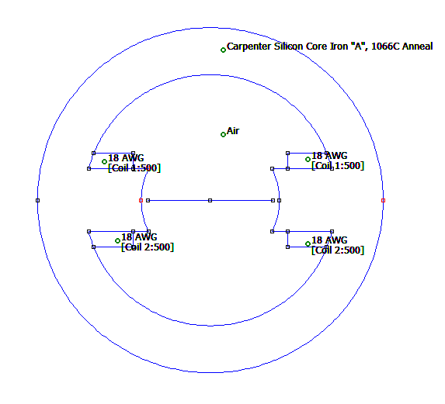
Figure 3 DC motor model from previous experiment.
Inefficiencies can be seen in the lines of flux shown when the model is evaluated and a flux density plot is applied (figure 4).
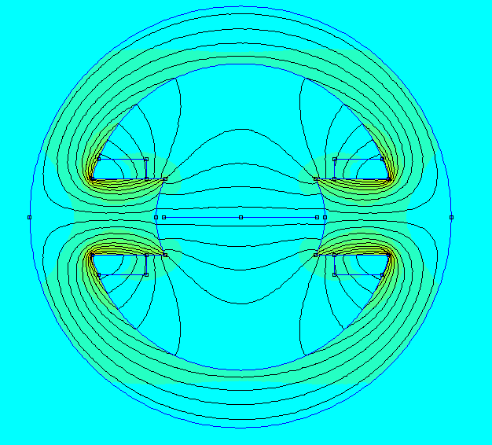
Figure 4 Flux density plot of original model.
At first glance it can be seen most of the flux is not directed through the rotor, this is due to the way the stator directs these lines of flux and the reluctances within the system. The density plot shows the stator has areas which have very low flux density meaning most of the material is not being used to its full potential.

Improvements and testing
Only some aspects of the motor can be changed, the features that can and cannot be changed are listed below:
Can change | Can’t change
- Stator inner radius  - Armature dimensions  - Winding position  - Armature face | - Electrical properties e.g. turns, current, winding area.  - Any materials  - Rotor properties  - Outer radius  - Armature radius

Method
There are many changes that could be applied to this model, to ensure a wide variety of changes were tested in the most efficient way an orthogonal test was done. Orthogonal array testing (OATS) uses the number of independent variables and the number of states these variables can have to produce the minimum number of tests to obtain the most amount of information [7].
In this case three different variables were changed, each with three possible states this gave a nine-level orthogonal array meaning only nine experiments needed to be conducted not 27 (every possible combination). Below are the three variables and their three states (Table 1) and the nine tests that were conducted (Table 2).

Stator radius (R1) |  | Armature width (R2) |  | Fishtail (R3)
1)Original 40mm |  | 1) Original 20 mm wide |  | 1) None
2) 45mm |  | 2) 15mm |  | 2) Big
3) 48mm |  | 3) 10mm |  | 3) Small
Table 1 Stator variables and their states.
These variables were chosen as they gave a good range of changes that were possible within the specification of allowed changes.
Experiment | R1 | R2 | R3
1 | 1 | 1 | 3
2 | 1 | 2 | 2
3 | 1 | 3 | 1
4 | 2 | 1 | 2
5 | 2 | 2 | 1
6 | 2 | 3 | 3
7 | 3 | 1 | 1
8 | 3 | 2 | 2
9 | 3 | 3 | 3
Table 2 Orthogonal array for experiments.
For each of these experiments a model with the appropriate properties was created and then values of total flux and flux cutting the rotor from 0-90° in steps of 10° were taken, the efficiency of each model was then calculated.

Results
Below in table 3 are the summarised results for each model and each experiment from table 2. All results and models can be found in the index.
R1 | R2 | R3 | Total flux / Wb | Max used in rotor / Wb | Flux wasted %
1 | 1 | 3 | 3.06E-04 | 1.10E-04 | 64.053
1 | 2 | 2 | 0.0004659 | 0.000154418 | 66.856
1 | 3 | 1 | 0.00019491 | 6.46685E-05 | 66.821
2 | 1 | 2 | 0.00041385 | 0.000155041 | 62.536
2 | 2 | 1 | 0.00018461 | 7.48351E-05 | 59.462
2 | 3 | 3 | 0.0003034 | 0.000110506 | 63.578
3 | 1 | 1 | 0.00020438 | 8.57362E-05 | 58.05
3 | 2 | 2 | 0.00040775 | 0.000155012 | 61.983
3 | 3 | 3 | 0.00029212 | 0.000110815 | 62.065
Table 3 Table of results.

Calculations
From the results in table 3 the average flux lost and total flux for each variable at each state were calculated below in table 4.
Stator radius (R1) | R1 | Mean max flux used | Mean Total flux / Wb | Mean Flux lost %
Original 40mm | 1 | 0.000109725 | 0.000322355 | 65.910
45mm | 2 | 0.000113461 | 0.000300618 | 61.859
48mm | 3 | 0.000117188 | 0.000301414 | 60.699
Armature width(R2) | R2 | Mean max flux used | Mean Total flux / Wb | Mean Flux lost %
Original 20mm wide | 1 | 0.000116955 | 0.000308159 | 61.547
15mm | 2 | 0.000128088 | 0.000352750 | 62.767
10mm | 3 | 0.000095330 | 0.000263477 | 64.155
Fishtail (R3) | R3 | Mean max flux used | Mean Total flux / Wb | Mean Flux lost %
None | 1 | 0.000075080 | 0.000194631 | 61.445
Big | 2 | 0.000154824 | 0.000429163 | 63.792
Small | 3 | 0.000110470 | 0.000300592 | 63.232
Table 4 Variable flux lost and total flux average.
A table can be plotted showing the average efficiency of each variable at each state could be plotted (Figure 5).

Figure 5 Average Flux leakage for each variable

For further analysis the maximum flux and used flux can be plotted (Figure 6).
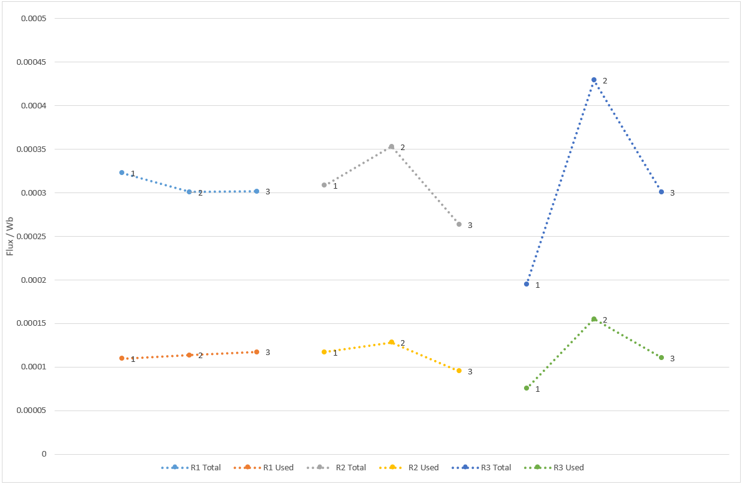
Figure 6 total flux compared to used flux for each variable.
The aim of the task was to create the most efficient motor, therefore the model with the least percentage of flux lost would be the most preferable. It is apparent from these results (Figure 5) that the best combination of changes of those that were tested is original model with an inner radius on the stator of 48 (R1=3, R2=1, R3=1). This model had an overall efficiency of 41.5% an improvement of 5.5% from the original model.

Discussion
It can be seen from figure 6 that manipulating variables changed the total flux in the system as well as its efficiency, this is because flux can be seen the magnetic equivalent of current; when the shape of the stator is changed the reluctances (magnetic equivalent of resistance) of the system are altered, changing where the flux is flows. In cases where the total flux is larger indicates an overall lower reluctance of the system, however, it was seen from these experiments that increases in total flux are not directly related to an increase in efficiency, this is down to how the flux is directed; if the path through the rotor is of a higher reluctance than another path the flux will follow the path of lesser reluctance. In these tests for example changing R2 and R3 did increase the total flux in some cases but did not direct the flux through the rotor enough to improve overall efficiency.
These equivalences between flux and current, reluctance and resistance, and magnetomotive force and voltage (not measured) can be seen using the following equation:
$$R_{m}=\frac{mmf}{φ} \sim magnetic equivalent of R=\frac{V}{I}$$
In the case of the most efficient model (Figure 8) it can be seen a large amount of flux is directed through and near the rotor this is because there is a higher reluctance between the armature and the outer loop due to a larger air gap caused by the increase in outer radius.
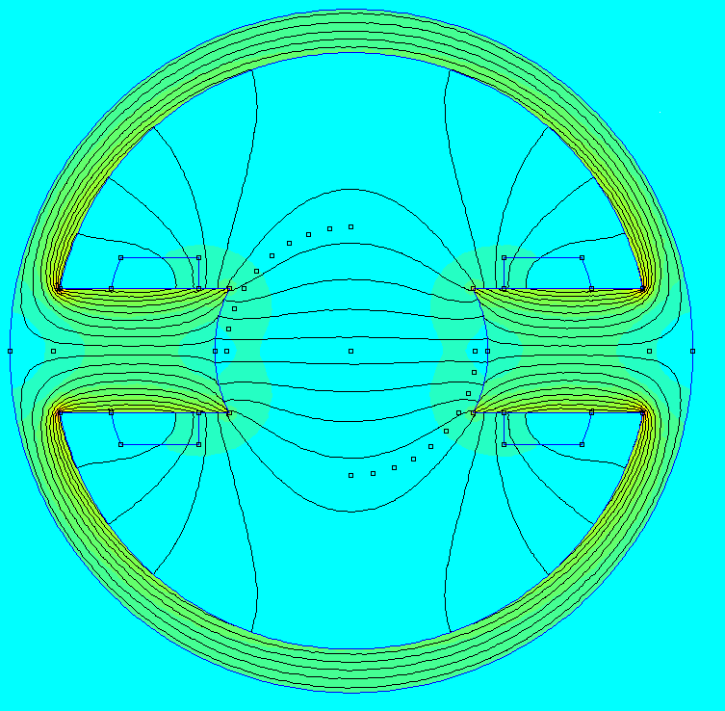
Figure 7 Flux density plot for most efficient model
If the theoretically least efficient configuration (Figure 8) (R1=1, R2=3, R3=2) is constructed it can be seen that although there is a greater total flux the very little of the total flux is directed through the rotor as the air-gap between the fishtails and inner radius of the rotor is very small therefore the path has a lower reluctance than the path through the rotor.
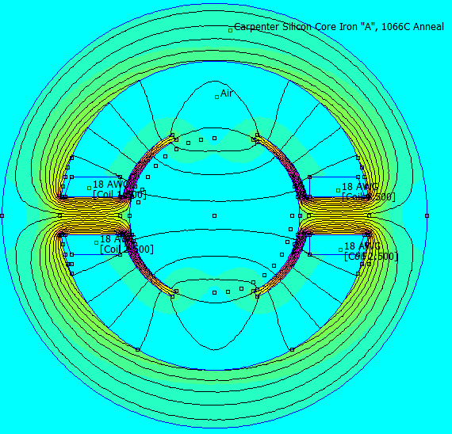
Figure 8 Flux density plot for least efficient model

Conclusion
The OATS method was extremely useful as it gave a range of reliable and relevant results in a third of the maximum possible tests, these results could then be used to deduce the effects of the changed variables on efficiency. An improvement on this test would have been to test changing the variables in different ways e.g. a wider armature as opposed to only testing thinner armatures, and different forms of fishtails. Overall the tests were a success as an increase in efficiency was achieved, although the improvement was marginal at only a 5.5% increase in efficiency; this could have possibly been improved if different changes were made. It was found also that how the flux is directed due to the reluctances in the system has more of an impact on efficiency than the total amount of flux.

Bibliography

[1] | Soft Schools, “Efficiency Formula,” Soft Schools, 2018. [Online]. Available: http://www.softschools.com/formulas/physics/efficiency_formula/29/. [Accessed 20 02 2018].
[2] | U.S. Department of Energy, “DETERMINING ELECTRIC MOTOR EFFICIENCY,” U.S. Department of Energy, [Online]. Available: https://energy.gov/sites/prod/files/2014/04/f15/10097517.pdf. [Accessed 20 02 2018].
[3] | Groschopp, “Understanding Electric Motor Efficiency Losses,” Groschopp, 24 03 2015. [Online]. Available: https://www.groschopp.com/blog/efficiency-and-losses-in-electric-motors/. [Accessed 21 02 2018].
[4] | K. Daware, “Losses in a DC generator and DC motor,” [Online]. Available: http://www.electricaleasy.com/2014/01/losses-in-dc-machine.html. [Accessed 21 02 2018].
[5] | NDT resource center, “The Hysteresis Loop and Magnetic Properties,” [Online]. Available: https://www.nde-ed.org/EducationResources/CommunityCollege/MagParticle/Physics/HysteresisLoop.htm. [Accessed 21 02 2018].
[6] | P. P.Parthasaradhy and D. S.V.Ranganayakulu, “Hysteresis and eddy current losses of magnetic material by,” The International Journal Of Engineering And Science, pp. 85-93, 2014.
[7] | Montana Tech University, “Orthoganal Arrays,” 2003. [Online]. Available: http://pages.mtu.edu/~jwsuther/doe2005/notes/orth_arrays.pdf. [Accessed 22 02 2108].

Index

Experiment 1
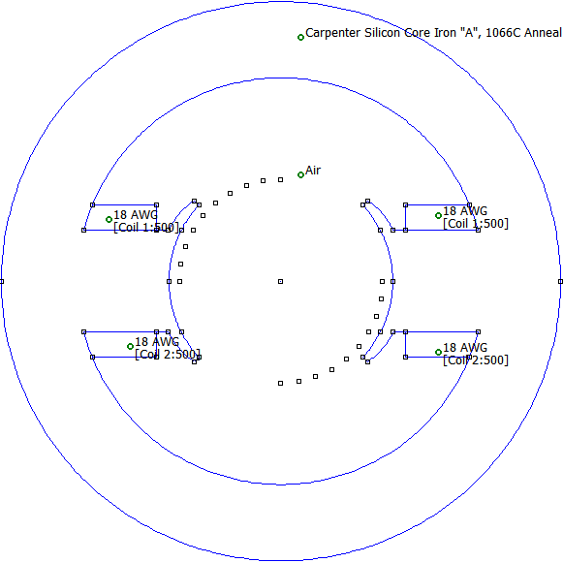
113
Angle | X | Y | Normal Flux (Wb)
0 | 20 | 0 | 4.5030E-09
10 | 19.696155 | 3.472964 | 1.71E-05
20 | 18.793852 | 6.840403 | 3.5405E-05
30 | 17.320508 | 10 | 5.6629E-05
40 | 15.320889 | 12.85575 | 8.4061E-05
50 | 12.855752 | 15.32089 | 1.0579E-04
60 | 10 | 17.32051 | 1.1009E-04
70 | 6.8404029 | 18.79385 | 1.1001E-04
80 | 3.4729636 | 19.69616 | 1.0930E-04
90 | 1.225E-15 | 20 | 1.0897E-04
Total flux / Wb |  | 0.000306256

Experiment 2
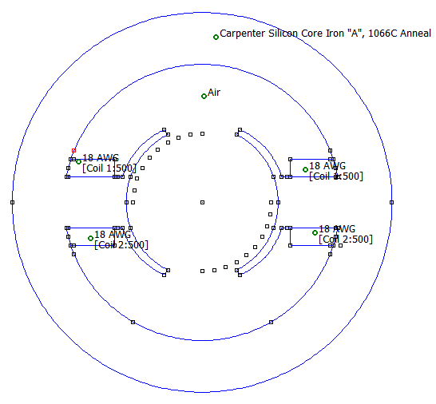
122
Angle | X | Y | Normal Flux (Wb)
0 | 20 | 0 | 9.7817E-11
10 | 19.69615506 | 3.472964 | 1.47E-05
20 | 18.79385242 | 6.840403 | 3.0009E-05
30 | 17.32050808 | 10 | 4.6547E-05
40 | 15.32088886 | 12.85575 | 6.5385E-05
50 | 12.85575219 | 15.32089 | 8.8537E-05
60 | 10 | 17.32051 | 1.2001E-04
70 | 6.840402867 | 18.79385 | 1.4669E-04
80 | 3.472963553 | 19.69616 | 1.5325E-04
90 | 1.22515E-15 | 20 | 1.5442E-04
Total flux /Wb |  | 0.0004659

Experiment 3
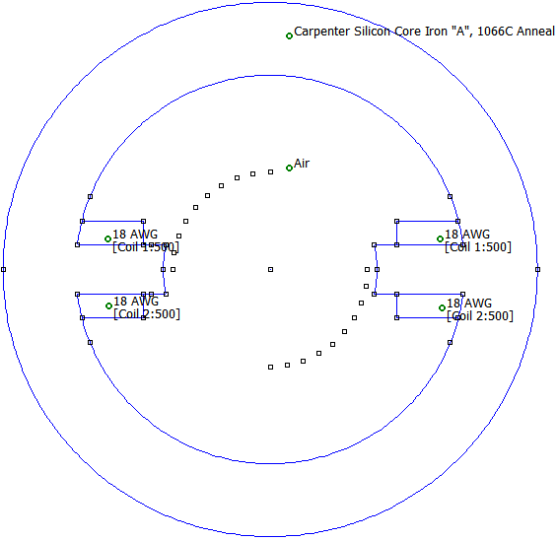
131
Angle | X | Y | Normal Flux (Wb)
0 | 20 | 0 | 1.8231E-09
10 | 19.69615506 | 3.472964 | 1.39E-06
20 | 18.79385242 | 6.840403 | 5.6132E-05
30 | 17.32050808 | 10 | 6.3572E-05
40 | 15.32088886 | 12.85575 | 6.4669E-05
50 | 12.85575219 | 15.32089 | 3.6832E-06
60 | 10 | 17.32051 | 6.2197E-05
70 | 6.840402867 | 18.79385 | 6.0869E-05
80 | 3.472963553 | 19.69616 | 5.9998E-05
90 | 1.22515E-15 | 20 | 5.9701E-05
Total flux /Wb |  | 0.00019491

Experiment 4
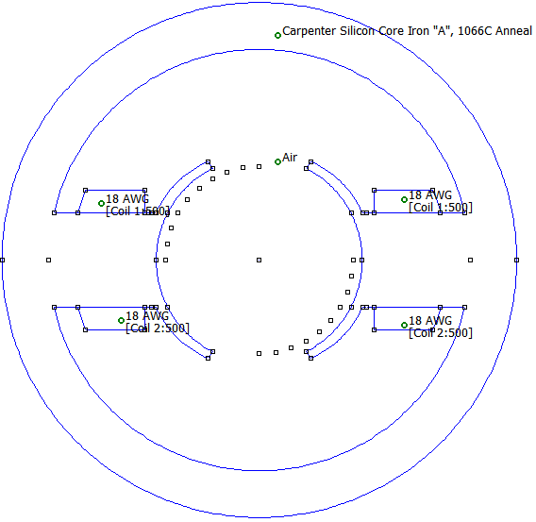
212
Angle | X | Y | Normal Flux (Wb)
0 | 20 | 0 | 4.1130E-09
10 | 19.69615506 | 3.472964 | 1.47E-05
20 | 18.79385242 | 6.840403 | 2.9959E-05
30 | 17.32050808 | 10 | 4.6471E-05
40 | 15.32088886 | 12.85575 | 6.5290E-05
50 | 12.85575219 | 15.32089 | 8.8382E-05
60 | 10 | 17.32051 | 1.1977E-04
70 | 6.840402867 | 18.79385 | 1.4651E-04
80 | 3.472963553 | 19.69616 | 1.5367E-04
90 | 1.22515E-15 | 20 | 1.5504E-04
Total flux / Wb |  | 0.00019491

Experiment 5
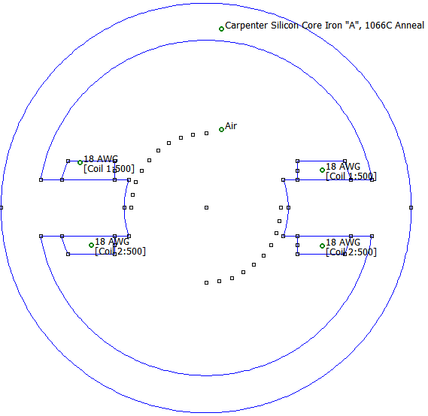
221
Angle | X | Y | Normal Flux (Wb)
0 | 20 | 0 | 3.8087E-09
10 | 19.69615506 | 3.472964 | 2.53E-05
20 | 18.79385242 | 6.840403 | 5.4286E-05
30 | 17.32050808 | 10 | 7.0602E-05
40 | 15.32088886 | 12.85575 | 7.4571E-05
50 | 12.85575219 | 15.32089 | 7.4835E-05
60 | 10 | 17.32051 | 7.4025E-05
70 | 6.840402867 | 18.79385 | 7.3082E-05
80 | 3.472963553 | 19.69616 | 7.2424E-05
90 | 1.22515E-15 | 20 | 7.2183E-05
Total flux / Wb |  | 0.000184606

Experiment 6
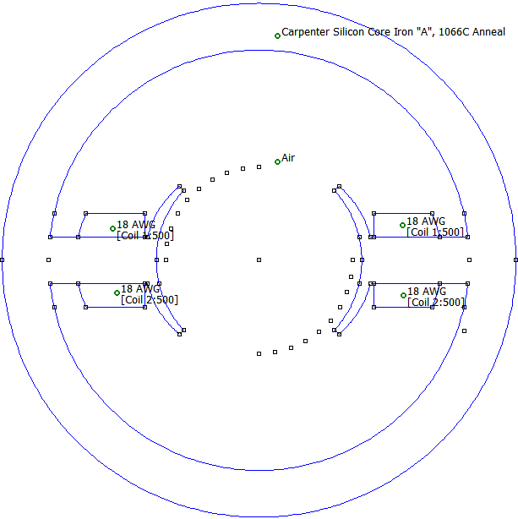
233
Angle | X | Y | Normal Flux (Wb)
0 | 20 | 0 | 5.2210E-09
10 | 19.69615506 | 3.472964 | 1.70E-05
20 | 18.79385242 | 6.840403 | 3.5210E-05
30 | 17.32050808 | 10 | 5.6259E-05
40 | 15.32088886 | 12.85575 | 8.3443E-05
50 | 12.85575219 | 15.32089 | 1.0512E-04
60 | 10 | 17.32051 | 1.0995E-04
70 | 6.840402867 | 18.79385 | 1.1051E-04
80 | 3.472963553 | 19.69616 | 1.1025E-04
90 | 1.22515E-15 | 20 | 1.1009E-04
Total flux / Wb |  | 0.000303402

Experiment 7
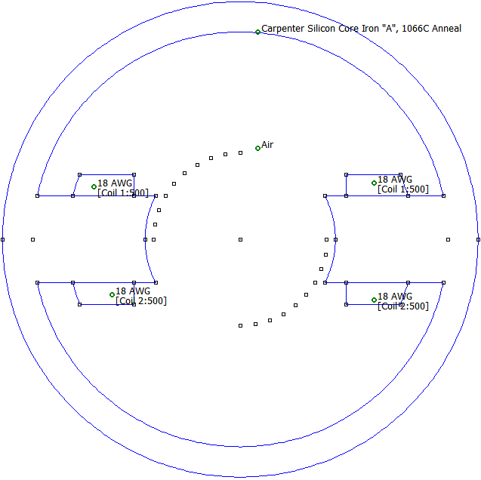
311
Angle | X | Y | Normal Flux (Wb)
0 | 20 | 0 | 3.5001E-10
10 | 19.69615506 | 3.472964 | 2.13E-05
20 | 18.79385242 | 6.840403 | 4.5751E-05
30 | 17.32050808 | 10 | 7.2556E-05
40 | 15.32088886 | 12.85575 | 8.3097E-05
50 | 12.85575219 | 15.32089 | 8.5625E-05
60 | 10 | 17.32051 | 8.5736E-05
70 | 6.840402867 | 18.79385 | 8.5251E-05
80 | 3.472963553 | 19.69616 | 8.4793E-05
90 | 1.22515E-15 | 20 | 8.4614E-05
Total flux / Wb |  | 0.000204377

Experiment 8
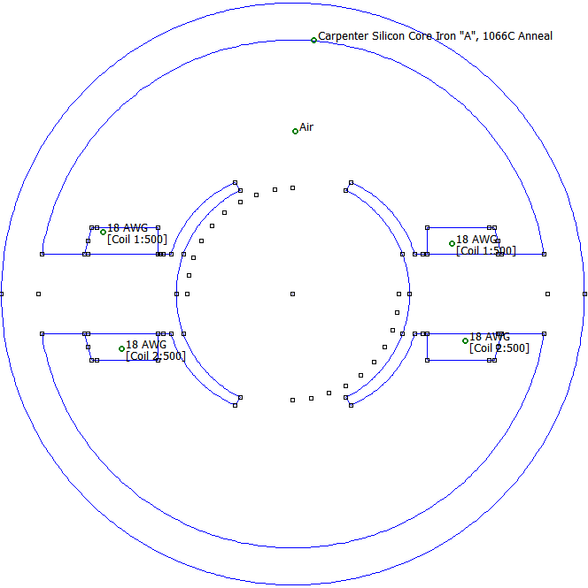
322
Angle | X | Y | Normal Flux (Wb)
0 | 20 | 0 | 8.5890E-09
10 | 19.69615506 | 3.472964 | 1.47E-05
20 | 18.79385242 | 6.840403 | 2.9939E-05
30 | 17.32050808 | 10 | 4.6422E-05
40 | 15.32088886 | 12.85575 | 6.5191E-05
50 | 12.85575219 | 15.32089 | 8.8230E-05
60 | 10 | 17.32051 | 1.1951E-04
70 | 6.840402867 | 18.79385 | 1.4634E-04
80 | 3.472963553 | 19.69616 | 1.5356E-04
90 | 1.22515E-15 | 20 | 1.5501E-04
Total flux / Wb |  | 0.000407745

Experiment 9
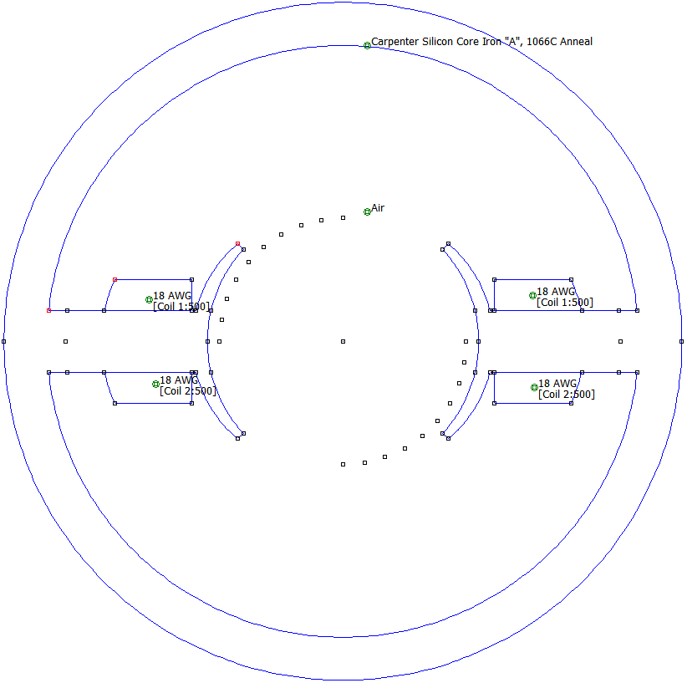
333
Angle | X | Y | Normal Flux (Wb)
0 | 20 | 0 | 8.5759E-09
10 | 19.69615506 | 3.472964 | 1.70E-05
20 | 18.79385242 | 6.840403 | 3.5110E-05
30 | 17.32050808 | 10 | 5.6110E-05
40 | 15.32088886 | 12.85575 | 8.3196E-05
50 | 12.85575219 | 15.32089 | 1.0482E-04
60 | 10 | 17.32051 | 1.0998E-04
70 | 6.840402867 | 18.79385 | 1.1082E-04
80 | 3.472963553 | 19.69616 | 1.1076E-04
90 | 1.22515E-15 | 20 | 1.1068E-04
Total flux / Wb |  | 0.000292119

