Based on your visit, consider how the museum promotes public understanding of the archaeological record.

Situated in the west of Carmarthenshire, Whitland abbey is a charming site with tremendous historical significance for Wales. Founded in 1151 under Anglo-Norman patronage, it was headed by a Welsh abbot by the late 1160s and for a short time after 1189 came directly under the control of the Lord Rhys. Although their founders were Norman, Whitland and its daughter abbey Strata Florida became the significant landholders they were under the patronage of the Lord Rhys. One of the first Cistercian houses in Wales, it became the key to further monastic expansion in the country and to a movement that would become identified with the native Welsh Princes. The site today is a ruin with little visible of its former grandeur other than its foundations. a portion of the site is also located on private property. Despite this, the archaeological significance of Whitland Abbey is considerable and it has been excavated twice, in 1929 and 1995. Promoting an understanding of Whitland’s archaeological record is challenging, and with the site in such a state of ruin, digital tools become essential. The Friends of Whitland Abbey website, makes an impressive effort toward this goal. This report on the Whitland Abbey website will focus on the creation of ‘aura,’ the encouragement of interpretation, the use of space, and the promotion of the wider archaeological record.

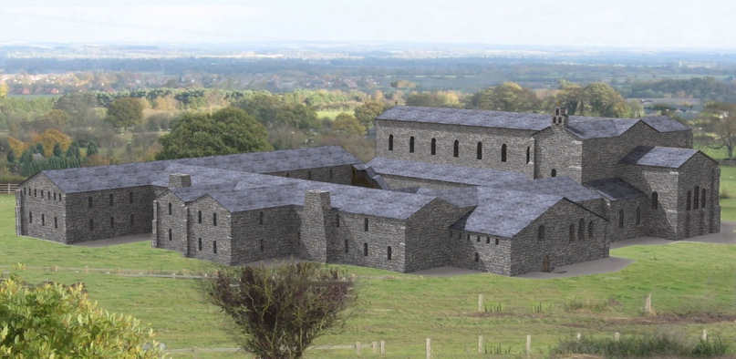
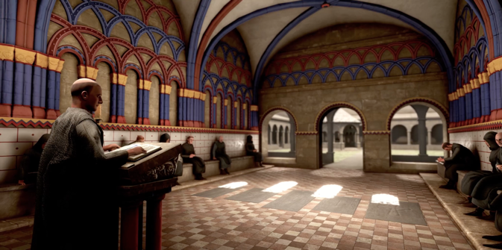
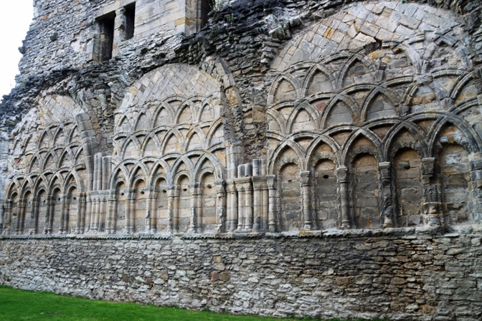
Although not a traditional museum: the curatorial decisions, conservation, and promotion of historic sites has much in common with that of the museum. The artefact displayed is the site itself, and the representation of that artefact is just as important. Curatorial decisions can affect how the archaeology is interpreted and understood, and the promotion of that site is paramount. Without effective promotion of the archaeological record, the ongoing deterioration of these sites is assured. To tackle the challenges of promotion and understanding, especially with digital tools, conservators must consider how to create a sense of historic aura and relevance. When opening the webpage for Whitland abbey, the first image that greets the eye is not a photograph of the abbey ruins but a digital reconstruction (fig. 1.). The use of mechanical reproduction has long been a controversial topic in museum studies. In his seminal 1935 essay on the subject, Walter Benjamin makes clear his view that the presence held by a reproduction is always depreciated in comparison to the original; in fact, he defines the term ‘aura’ as this missing element. Further than this, he reasons that the plurality created by mechanical reproductions devalues the aura of the original itself. If taken at face value, Benjamin’s theory is rather damning for the concept of the digital museum. It presents a quandary where the promotion of artefacts itself challenges traditional custodianship. There is certainly something inescapably powerful in the aura of the physical ruin. A sense of the passage of time, and of loss, creates an emotive response from visitors. This charged potency and the ability for places and objects to inspire reverence and awe was termed ‘numinosity’ by Maines and Glynn in their 1993 article on the subject. Interestingly however, this response does not seem to require or provoke a knowledge of the site’s historical or archaeological context. To truly promote an understanding of the archaeological record, more than aura or numinosity alone is required.
Figure 1. Digital reconstruction of Whitland Abbey by John Branderick, Friends of Whitland Abbey, Whitland Abbey (2025) https://whitlandabbey.wales [accessed 10th January 2026].
Figure 2. (above) Three-Dimensional reconstruction of the chapter house at Wenlock Priory, English Heritage, History of Wenlock Priory, https://www.english-heritage.org.uk/visit/places/wenlock-priory/history [accessed: 10th January 2026].
Figure 3. Wenlock Priory Chapter house, Based in Churton, Day trip: Architectural expression in the Cluniac Wenlock Priory in Much Wenlock, Shropshire, https://basedinchurton.co.uk/2024/12/27/day-trip-architectural-expression-in-the-cluniac-wenlock-priory-in-much-wenlock-shropshire [accessed: 10th January 2026].

Digital reconstructions facilitate interpretation on the part of the viewer that can generate a ‘lived-in’ feel. Three-dimensional digital models allow for new dynamic ways of providing access to the past and give new approaches to its visualisation. Whitland is not the first site to use digital reconstruction for this purpose. The above images are from Wenlock Priory in Shropshire and are a fantastic representation of digital reconstruction done well. with the use of three-dimensional imagery, the ruin is brought to life and made much more tangible. The viewer is persuaded to interpret the ruin differently, leading to a greater understanding of the archaeological record and an understanding of how the site was lived in. This is unfortunately where the digital reconstructions of the Whitland Abbey site fall short.

While Whitland’s digital reconstructions help the viewer conceptualise that an abbey once stood on the site, they do little to indicate how the abbey functioned or how the reconstruction maps on to the visible foundations. Through a drop-down menu accessible from the homepage, it is possible to access a page titled “Drawings.” This page contains a collection of floor plans and digital models of the site; if curated with more care, these drawings would allow the viewer to easily map them together and generate a better understanding of the site. This page also contains no aerial views of the actual ruin, this seems something of a missed opportunity to preserve the aura of the original whilst also allowing the viewer to truly visualise the site. This materiality is the key to promoting imagination and emotive understanding. However, there is no such perceivable order to these images and the floor plan images must be opened first to be viewed in full. The built environment of the Cistercian abbey is itself fascinating and a representation of their philosophy and reform to the monastic world. The buildings were generally structured around the cloister, each side was linked to a particular aspect of Cistercian life, namely: liturgy, discipline, domesticity, and labour. This leaves considerable scope for a more interactive approach where users can navigate the abbey virtually, developing a greater understanding of the ruined foundations and the history of the site through a tangible means. After reaching out to the Friends of Whitland Abbey, John Branderick, the designer behind the 3D images sent me an email detailing some of the extensive research he conducted in their creation. It is a great shame that this research has not been made more accessible to users and another missed opportunity for the site to promote archaeological understanding through an engaging means.

Use of space is just as important when it comes to the digital environment as it is for the physical. When utilised effectively the museum or heritage site can awake curiosity and encourage greater community involvement and awareness with the site. It does however represent a new challenge in the promotion of archaeology. Space syntax theory is a good reference point in identifying the changing role of architecture in virtual museums. Space syntax is a theory of space originating in architecture, it contains a set of theories and tools for analysing the layout of space in buildings. The theory is based on the principle that space is an intrinsic element to human experience and that how space works for users is based upon the relations between the different spaces that make up a layout. Simply put, the architecture of the website profoundly shapes the users experience and can be utilised to promote certain reactions or thoughts. The Whitland Abbey website gives the user a range of options for movement, but some aspects are poorly designed. The opening page is structured like an artefact description within a museum: a wide-view image, title, subtitle, and description. This works effectively at drawing in the cursory viewer into a foundational understanding of the object. The top menu places ‘History’, and ‘What to see’ in a central position, left to right respectively. This directs the viewers primary attention to the pages that best promote an archaeological understanding. By clicking the ‘History’ title, it takes the viewer to a small page that gives the user an easily palatable and simple description of the site. This page is however making a poor use of space: when the mouse is moved over the ‘History’ icon, a drop-down menu loads immediately, under which the aforementioned page is not listed. This obscures the more palatable page and directs the user to the two far more information heavy: ‘Timeline’, and ‘Drawings’ pages. It took me as a user some considerable time using the website to notice that a third page even existed, far more time than most cursory viewers – to whom the simplified page is directed – would be likely to spend on the site.

This may appear to be a minor point in the promotion of the archaeological record; however, it is an example of tools not being utilised to their potential. It is not a timeline of dates and figures that conjures the imagination of the general public visiting or intending to visit a historic site, it is a search for the tangible past and numinosity. It is unlikely that most viewers looking for an understanding of the site would have the time to read through 42 entries, and therefore their interest would be lost.

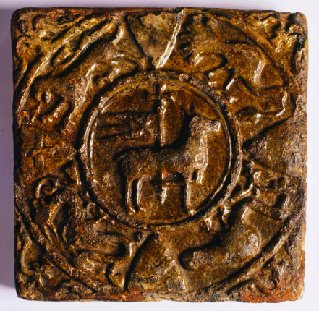
Notably absent from the site is any mention of significant related artefacts. Viewable in the nearby Hywel Dda Centre is a truly spectacular medieval tile found at Whitland Abbey depicting the Agnus Dei (fig. 4). It is artefacts like this that allow the viewer to understand the site as a building rather than a ruin. Compare this with the ‘Visit Us’ page of the Strata Florida Trust, a group associated with that most famous daughter house of Whitland. the opening slides show images of the museum, mostly dedicated to the Strata Florida farm. Although there is also plenty of room for improvement here, artefacts bring us closer to the structure, they give us a glimpse into human life in a way that the walls and foundations alone cannot do. It is this understanding of buildings as places for people that brings out what Kate Gregory and Andrea Witcomb term “audience participation in meaning making.”
Figure 4. Agnus Dei decorated floor tile from Whitland Abbey, Owned by the Carmarthenshire County Museum, Peoples Collection Wales, Medieval decorated floor tile (Agnus Dei) from Whitland Abbey (2009) https://www.peoplescollection.wales/items/1885 [accessed: 11th January 2026].

Another missed opportunity when compared to Strata Florida, is the lack of emphasis on the importance of Whitland as a Welsh site. The Cadw page for Strata Florida abbey focuses in on Welshness; subtitling its page ‘Grand medieval abbey where generations of Welsh princes are buried’. Using Strata Florida’s undeniable importance in Welsh culture generates an intrigue that cannot be replicated. What could easily pass viewers of the Whitland abbey website by, is that Whitland was the abbey from which a revolution of Cistercian houses spread through the native Welsh kingdoms. Like Strata Florida’s princely burials, in 1239 Whitland became the burial place of Maredudd Ddall, blind son of the Lord Rhys and several of his kinsmen of the house of Dinefwr. Maredudd a former hostage of Henry II had been entrusted to the care of the abbey by his father in the late 1160’s. This wealth of history is barely touched on by the abbey website that appears mostly focused upon the sites foundation. It is a significant missed opportunity for the abbey in generating public interest. Exposing the history of the site gives the site relevance and meaning to the viewer in a way that connects them with both the archaeological and historical method and impacts their understanding.

Heritage sites like Whitland desperately require effective promotion to generate an understanding of the archaeological record. While the original buildings are all but demolished, the site remains a well of archaeological and historical importance. Without suitable presentation and appreciation of what is being conserved however, sites like Whitland fade into obscurity and meaninglessness. The Friends of Whitland Abbey site is effective in many ways at promoting archaeological understanding. Its digital reconstructions flesh out the scant ruins that survives and it effectively encourages the viewer to visit the site in person. For such a small community group, it does a fantastic job at promoting itself. However, it’s main issues lie in its lack of connectivity to the wider archaeological record. Through officially partnering with and linking sites like the Monastic Wales Project, a site that already has a page dedicated to Whitland and which aims to make the scholarship of its founders accessible to the public, Whitland could give its viewers access to a wealth of archaeological and historical research. Through promoting the larger archaeological record of artefacts associated with Whitland, the site would be able to give its users a far better understanding of the archaeology they conserve.

Bibliography
Secondary Sources:

- Walter Benjamin, Walter, ‘The Work of Art in the Age of Mechanical Reproduction’, in Illuminations, ed. Hannah Arendt, trans. Harry Zohn (New York: Schocken Books, 1969).

- Burton, Janet, & Stöber, Karen, ‘The ‘Monastic Wales Project’’, Imago temporis medium Aevum, X (2016) pp.339-355.

- Burton, Janet, The Monastic and Religious Orders in Britain, 1000-1300. (Cambridge: Cambridge University Press, 1994).

- Cameron, Catherine M., & Gatewood, John, B., ‘Excursions into the Un-Remembered Past: What People Want from Visits to Historical Sites’, The Public Historian, 22.3 (2000), pp. 107-127.

- Gregory, Kate, & Witcomb, Andrea, ‘Beyond nostalgia: the role of affect in generating historical understanding at heritage sites’, in Museum Revolutions: how museums change and are changed, ed. Simon Knell, Suzanna Macleod, & Sheila Watson (London: Routledge, 2007) pp. 263-275.

- Grimwade, Gordon, & Carter, Bill, ‘Managing Small Heritage Sites with Interpretation and Community’, International Journal of Heritage Studies, 6.1 (2000), pp. 33-48.

- Hillier, Bill, & Tzortzi, Kali, ‘Space Syntax’, in A Companion to Museum Studies, Ed. Sharon Mcdonald (E-Book: Blackwell Publishing, 2006).

- Kenderdine, Sarah, & Yip, Andrew, ‘The Proliferation of Aura: Facsimiles, Authenticity, and Digital Objects’, in The Routledge Handbook of Museums, Media, and Communication, ed. Kirsten Drotner, Vince Dziekan, Ross Parry, Kim Christian Schrøder (London: Routledge, 2018) pp. 274-289.

- Maines, Rachel, P., & Glynn, James, J., ‘Numinous Objects’, The Public Historian, 15.1 (1993) pp. 8-25.

- Means, Bernard, K., ‘Promoting a More Interactive Public Archaeology: Archaeological Visualisation and Reflexivity through Virtual Artifact Curation’, Advances in Archaeological Practice, 3.3 (2015) pp. 235-248.

- Sfintes, Anda-Iona, ‘The Architecture of Virtual Space Museums’, European Scientific Journal, Special edition. 3 (2013) pp.238-244.

- Sternberg, Maximillian, Cistercian Architecture and Medieval Society (Boston: Brill, 2013).

- Turvey, Roger, The Lord Rhys : Prince of Deheubarth (Llandysul: Gomer, 1996).

- Williams, David, H., The Welsh Cistercians. Vol. 1 (Tenby: Cyhoeddiadau Sistersiaidd, 1984).

- Woltz, Catherine, ‘Ruin and Reconstruction: Understanding the Constructed past’, Muséologies, 4.2 (2010) pp.112-131.

Internet Sources:

- Based in Churton, Day trip: Architectural expression in the Cluniac Wenlock Priory in Much Wenlock, Shropshire, https://basedinchurton.co.uk/2024/12/27/day-trip-architectural-expression-in-the-cluniac-wenlock-priory-in-much-wenlock-shropshire [accessed: 10th January 2026].
- Cadw, Strata Florida Abbey, https://cadw.gov.wales/visit/places-to-visit/strata-florida-abbey [accessed: 10th January 2026].

- English Heritage, History of Wenlock Priory, https://www.english-heritage.org.uk/visit/places/wenlock-priory/history [accessed: 10th January 2026].

- Friends of Whitland Abbey, Whitland Abbey (2025) https://whitlandabbey.wales [accessed 10th January 2026].

- Monastic Wales, Whitland Abbey, https://monasticwales.org/site/36 [accessed: 11th January 2026].

- Peoples Collection Wales, Medieval decorated floor tile (Agnus Dei) from Whitland Abbey (2009) https://www.peoplescollection.wales/items/1885 [accessed: 11th January 2026].

- Strata Florida Trust, Visit Us, https://www.strataflorida.org.uk/visit-us.html [accessed: 11th January 2026].

Private communications:

- Branderick, John, email sent to Caradoc Ewing, 13th January 2026.

Roger Turvey, The Lord Rhys : Prince of Deheubarth. (Llandysul: Gomer, 1996) p. 85.
David H. Williams, The Welsh Cistercians. Vol. 1 (Tenby: Cyhoeddiadau Sistersiaidd, 1984) p. 3-4.
Janet Burton, The Monastic and Religious Orders in Britain, 1000-1300. (Cambridge: Cambridge University Press, 1994) p.75.
Friends of Whitland Abbey, What to See (2025) https://whitlandabbey.wales/?page_id=56 [accessed 10th January 2026].
Friends of Whitland Abbey, Whitland Abbey (2025) https://whitlandabbey.wales [accessed 10th January 2026].
Gordon Grimwade & Bill Carter, ‘Managing Small Heritage Sites with Interpretation and Community’, International Journal of Heritage Studies, 6.1 (2000), pp. 33-48 (p.44).
Walter Benjamin, ‘The Work of Art in the Age of Mechanical Reproduction’, in Illuminations, ed. Hannah Arendt, trans. Harry Zohn (New York: Schocken Books, 1969) p. 4.
Ibid.
Sarah Kenderdine, & Andrew Yip, ‘The Proliferation of Aura: Facsimiles, Authenticity, and Digital Objects’, in The Routledge Handbook of Museums, Media, and Communication, ed. Kirsten Drotner, Vince Dziekan, Ross Parry, Kim Christian Schrøder (London: Routledge, 2018) pp. 274-289, p. 275.
Catherine Woltz, ‘Ruin and Reconstruction: Understanding the Constructed past’, Muséologies, 4.2 (2010) pp.112-131 (p.118).
Rachel P. Maines, & James J. Glynn, ‘Numinous Objects’, The Public Historian, 15.1 (1993) pp. 8-25.
Catherine M. Cameron, & John B. Gatewood, ‘Excursions into the Un-Remembered Past: What People Want from Visits to Historical Sites’, The Public Historian, 22.3 (2000), pp. 107-127 (p. 108).
Woltz, ‘Ruin and Reconstruction’, p. 124.
Bernard K. Means, ‘Promoting a More Interactive Public Archaeology: Archaeological Visualisation and Reflexivity through Virtual Artifact Curation’, Advances in Archaeological Practice, 3.3 (2015) pp. 235-248.
Woltz, ‘Ruin and Reconstruction’, p. 118-119.
Maximillian Sternberg, Cistercian Architecture and Medieval Society (Boston: Brill, 2013) p. 5.
Ibid., p. 181-182.
John Branderick, email to Caradoc Ewing, 13th January 2026.
Anda-Iona Sfintes, ‘The Architecture of Virtual Space Museums’, European Scientific Journal, Special edition. 3 (2013) pp.238-244 (p. 238).
Ibid. p. 221.
Bill Hillier & Kali Tzortzi, ‘Space Syntax’, in A Companion to Museum Studies, Ed. Sharon Mcdonald (E-Book: Blackwell Publishing, 2006). p. 282.
Ibid. p.283.
Cameron & Gatewood, ‘Excursions into the Un-Remembered Past’, p. 109.
Strata Florida Trust, Visit Us, https://www.strataflorida.org.uk/visit-us.html [accessed: 11th January 2026].
Kate Gregory, & Andrea Witcomb, ‘Beyond nostalgia: the role of affect in generating historical understanding at heritage sites’, in Museum Revolutions: how museums change and are changed, ed. Simon Knell, Suzanna Macleod, & Sheila Watson (London: Routledge, 2007) pp. 263-275, p. 265.
Cadw, Strata Florida Abbey, https://cadw.gov.wales/visit/places-to-visit/strata-florida-abbey [accessed: 10th January 2026].
Turvey, The Lord Rhys, p. 85.
Ibid.
Woltz, ‘Ruin and Reconstruction’, p. 124.
Grimwade and Carter, ‘Managing Small Heritage Sites’, p. 34.
Monastic Wales, Whitland Abbey, https://monasticwales.org/site/36 [accessed: 11th January 2026]; Janet Burton, & Stöber Karen, ‘The ‘Monastic Wales Project’’, Imago temporis medium Aevum, X (2016) pp.339-355.

