Introduction to Web and Database Concepts (ACCA4023_LON)
3/21/2026
University of Wales Trinity Saint David
London Campus

Module Name: Introduction to Web and Database Concepts (Assessment 1)
Module Code: ACCA4023_LON

Student Name: ADEYINKA ADEWUMI
Student ID: 2519143

Lecturer’s Name: Anum Paracha

Contents
1. Introduction 2
2. Scenario Explanation 2
3. Scenario Analysis 2
3.1 Entities 2
3.2 Attributes 3
3.3 Relationships 3
4. Entity Relationship Diagram (ERD) 3
5. Database Design 4
6. Normalisation (3NF) 8
7. Sample Data Population 9
8.Query Development 10
9. Forms 11
10. Reports 13
11. Validation and Testing 13
12. Reflection (Design Decisions) 14
References (IEEE Style) 15

1. Introduction
This report explains the design and implementation of a relational database system for MediLink Pharmacy. The pharmacy currently relies on manual methods to manage key information such as medicines, customer records, prescriptions, and sales transactions. Manual systems are often associated with errors, data redundancy, and inefficiencies, which can negatively affect organisational performance [1].
To address these challenges, a database system was developed using Microsoft Access to improve data accuracy, organisation, and accessibility. Relational databases provide a structured approach to storing and managing data, enabling efficient retrieval and improved decision-making [8]. The system is designed to support key pharmacy operations, including stock control, supplier management, and sales monitoring, ultimately enhancing service delivery.

2. Scenario Explanation
MediLink Pharmacy operates as a growing community pharmacy that requires an efficient system to manage its daily activities. The current manual approach to handling records such as stock levels, customer details, prescriptions, and sales transactions increases the likelihood of errors, data loss, and duplication. These issues can affect the accuracy of information and reduce the overall efficiency of the organisation [1].
Implementing a relational database system provides a structured and reliable solution for managing large volumes of data. Database systems allow for better organisation, secure storage, and quick retrieval of information, which supports effective decision-making and operational efficiency [2]. In this project, the database was designed to manage medicines, suppliers, customers, prescriptions, and sales in an integrated manner. This ensures that all relevant data is connected and easily accessible, improving both internal processes and customer service.

3. Scenario Analysis

3.1 Entities
The database system for MediLink Pharmacy is built around several key entities that represent the main components of the organisation. These include Customers, Medicines, Suppliers, Prescriptions, and Sales. Each entity represents a real-world object or concept that the system needs to store information about. For example, the Customers entity stores details about individuals purchasing medicines, while the Medicines entity contains information about available drugs. Identifying these entities is essential for structuring a relational database effectively [9].

3.2 Attributes
Each entity contains a set of attributes that define the specific details stored within it. For instance, the Customers entity includes attributes such as CustomerID, FirstName, LastName, Phone, and Address. Similarly, the Medicines entity includes MedicineID, MedicineName, Price, and StockQuantity. Attributes are important because they describe the properties of each entity and ensure that relevant data is captured accurately. Proper selection of attributes helps maintain data consistency and supports efficient data retrieval [2].

3.3 Relationships
Relationships define how the entities are connected within the database. In this system, several one-to-many relationships exist. For example, one customer can have multiple sales transactions, while one supplier can supply many medicines. Similarly, medicines can appear in multiple prescriptions and sales records. These relationships are implemented using primary and foreign keys to maintain referential integrity. Establishing clear relationships ensures that the database reflects real-world interactions and supports accurate data management [1].

4. Entity Relationship Diagram (ERD)
The Entity Relationship Diagram (ERD) provides a visual representation of the database structure, showing the entities, their attributes, and the relationships between them. It is an essential tool in database design as it helps to clearly illustrate how data is organised and connected within the system [5].
In this project, the ERD includes the main entities: Customers, Medicines, Suppliers, Prescriptions, and Sales. Each entity is represented with its primary key, which uniquely identifies each record. Relationships between entities are also shown, including one-to-many relationships such as a single customer having multiple sales transactions and a supplier providing multiple medicines. These relationships are implemented using foreign keys to ensure referential integrity and maintain consistency within the database [1].
The ERD ensures that the database structure accurately reflects real-world processes within MediLink Pharmacy and provides a clear blueprint for implementation in Microsoft Access. The relationships and structure of the database are illustrated in Figure 1, which shows how each entity is connected through primary and foreign keys.
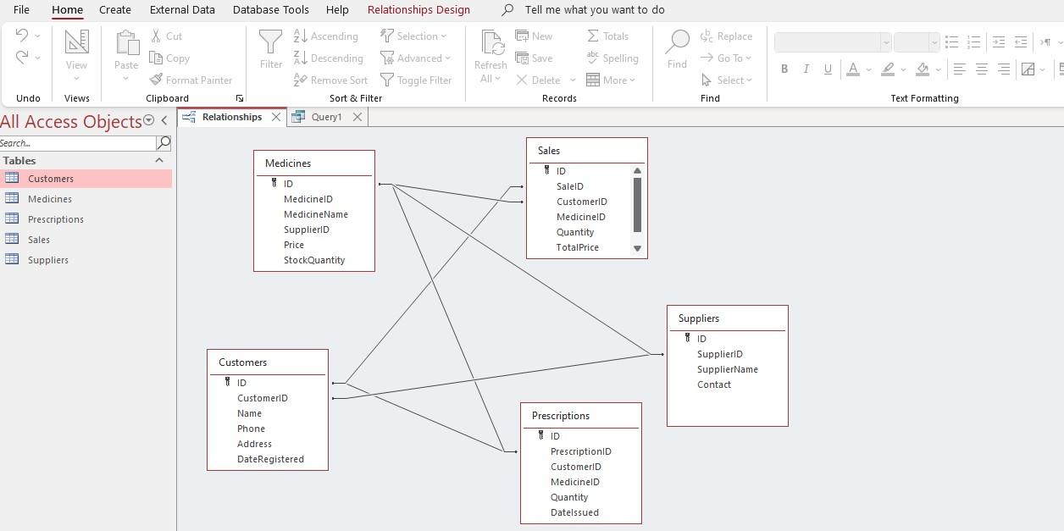
Figure 1: Entity Relationship Diagram of MediLink Pharmacy Database

5. Database Design

Table Structures
The database was implemented in Microsoft Access by creating tables that represent each of the identified entities. Each table was designed with appropriate fields, data types, and primary keys to ensure accurate data storage. For example, the Customers table includes fields such as CustomerID, FirstName, LastName, Phone, and Address, while the Medicines table includes MedicineID, MedicineName, Price, and StockQuantity.
Primary keys were assigned to each table to uniquely identify records, ensuring that no duplicate entries exist. The selection of suitable data types, such as text, number, and date/time, helps maintain data integrity and improves system performance. Proper table design is essential in relational databases as it supports efficient data management and retrieval [7].

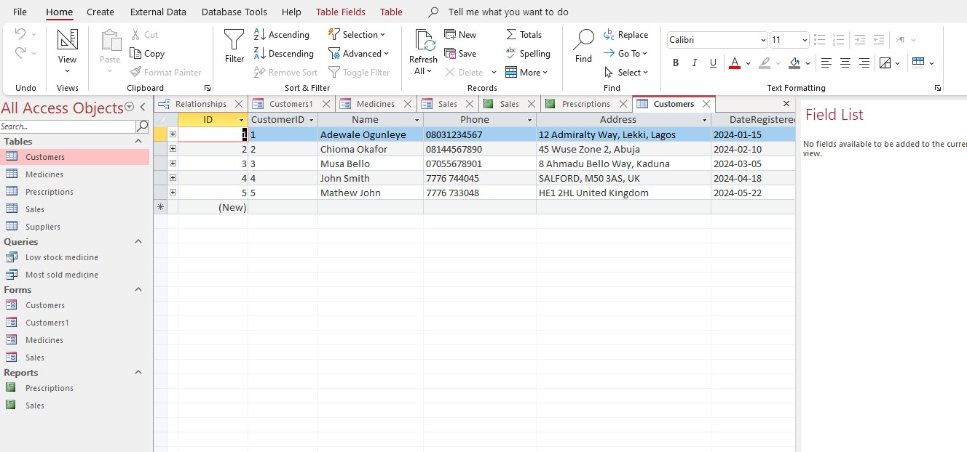

Figure 2: Customers Table Structure

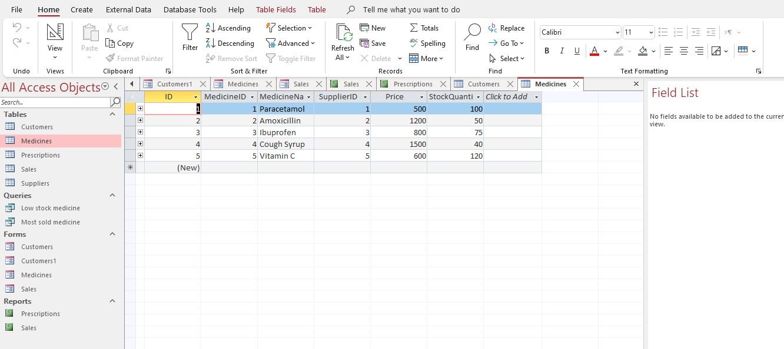

Figure 3: Medicines Table Structure

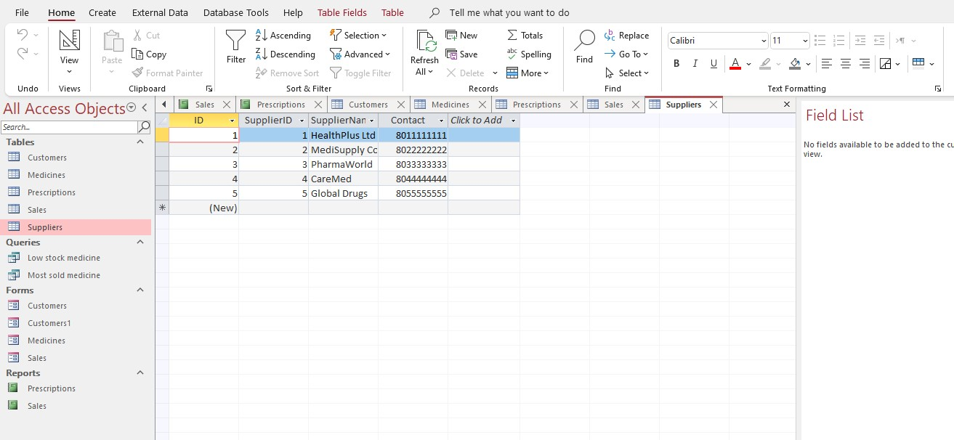

Figure 4: Suppliers Table Structure

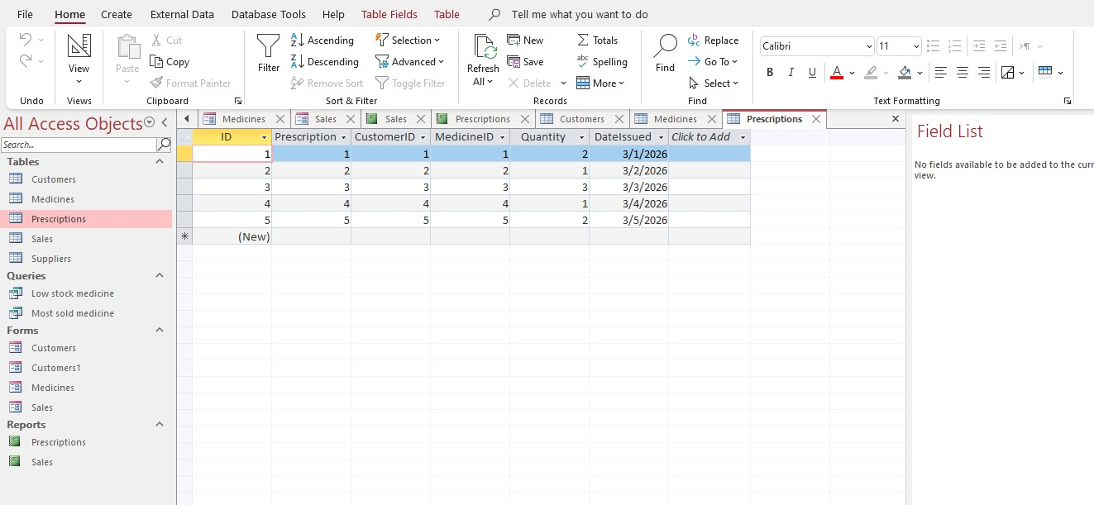

Figure 5: Prescriptions Table Structure

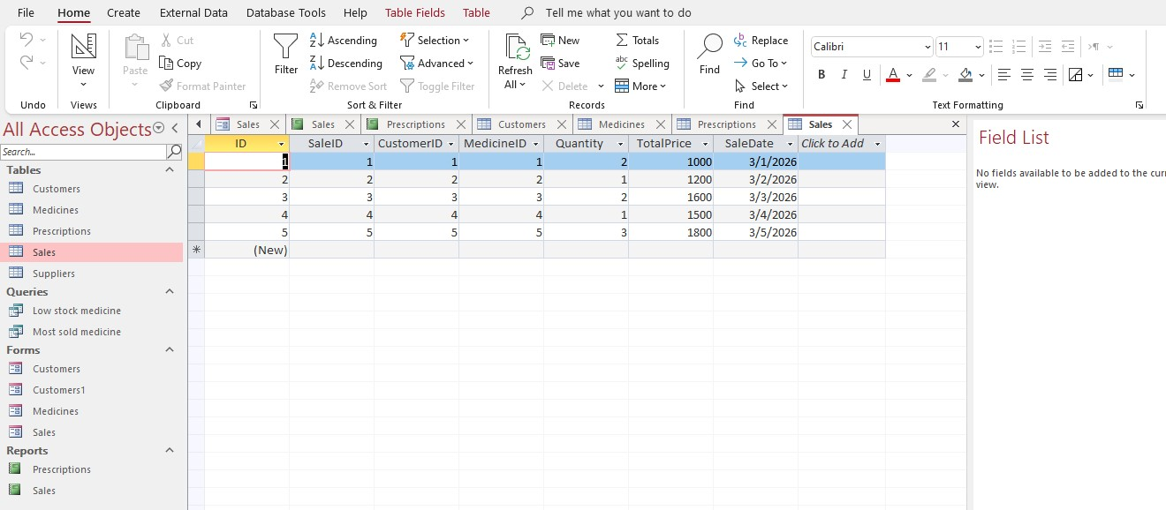
Figure 6: Sales Table Structure

Relationships
Relationships were established between the tables to ensure that data is logically connected and consistent across the database. These relationships were created using primary and foreign keys. For instance, the CustomerID in the Sales and Prescriptions tables links back to the Customers table, while the MedicineID connects the Medicines table to both Sales and Prescriptions. Similarly, SupplierID links the Suppliers and Medicines tables.
Referential integrity was enforced to ensure that related records remain consistent and to prevent invalid data entry. This means that a record cannot exist in a related table without a corresponding record in the parent table. Establishing relationships is a fundamental aspect of relational database design as it ensures data accuracy and consistency [3].
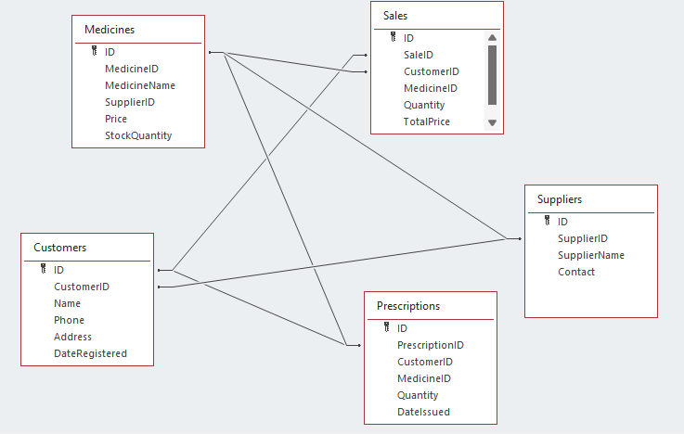
Figure 7: Relationships Between Tables

6. Normalisation (3NF)
Normalisation is the process of organising data within a database to reduce redundancy and improve data integrity. It involves structuring tables and relationships so that each piece of data is stored only once, which helps to avoid duplication and inconsistency [3].
In this project, the database was normalised to Third Normal Form (3NF). This means that each table contains data related to a single entity, and all non-key attributes depend only on the primary key. For example, supplier information is stored in a separate Suppliers table instead of being repeated in the Medicines table. This ensures that updates to supplier details are made in one place without affecting other records.
Additionally, there are no partial or transitive dependencies in the database, meaning that all attributes are directly dependent on the primary key. This improves the efficiency, accuracy, and maintainability of the database system [4].

7. Sample Data Population
After designing the database structure, sample data was added to each table to simulate real-world operations within MediLink Pharmacy. Populating the database with sample records allows the system to be tested and demonstrates how data flows between related tables. It also helps to verify that relationships and constraints are functioning correctly [1].
Each table was populated with at least five records, including customer details, medicine information, supplier data, prescriptions, and sales transactions. The data was designed to reflect realistic scenarios, such as customers purchasing medicines and suppliers providing stock. This ensures that the database can support typical pharmacy activities and allows queries and reports to generate meaningful results [4].
Figures 8 and 9 show examples of the sample data entered into the database tables, demonstrating how the system stores and manages real-world information.

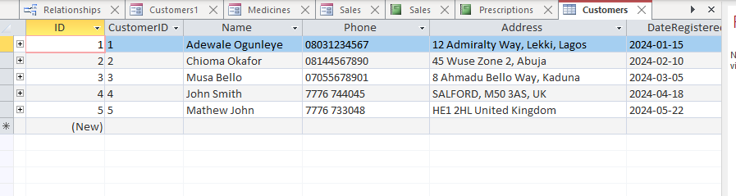
Figure 8: Sample Data in Customers Table

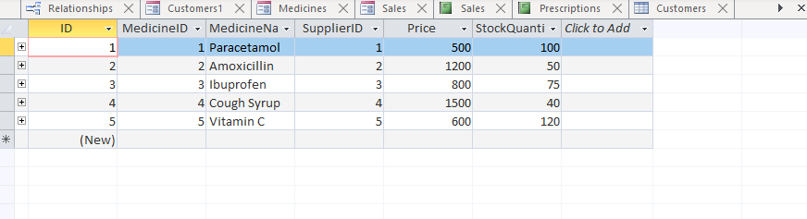
Figure 9: Sample Data in Medicines Table

8.Query Development
Queries are used in database systems to retrieve, filter, and analyse data based on specific conditions. They allow users to extract meaningful information from large datasets, supporting decision-making and operational efficiency [2]. In this project, several queries were developed to demonstrate how the MediLink Pharmacy database can be used to manage stock, monitor sales, and analyse customer activity.

Low Stock Medicines Query
This query was designed to identify medicines with low stock levels. It helps the pharmacy ensure that essential medicines are restocked on time, preventing shortages and improving service delivery. By filtering medicines with quantities below a specified threshold, staff can quickly take action to replenish stock [1].
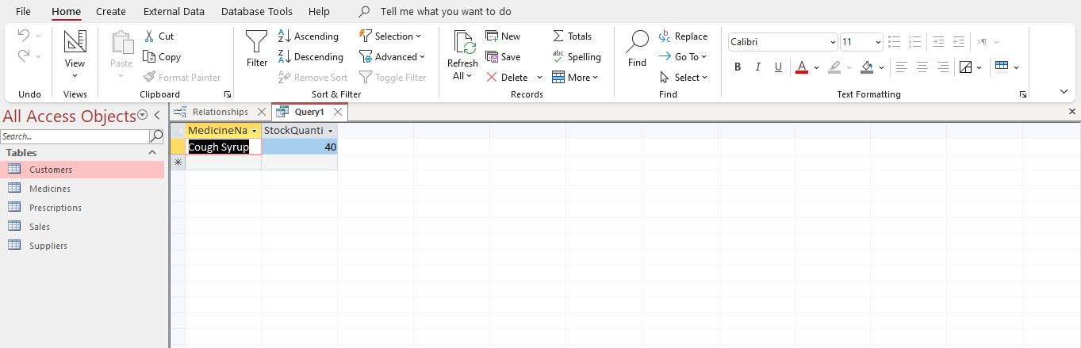
Figure 10: Low Stock Medicines Query Result

Most Sold Medicines Query
This query identifies the medicines that are sold most frequently by calculating the total quantity sold for each medicine. It helps the pharmacy understand demand patterns and manage inventory more effectively. By identifying popular medicines, the pharmacy can ensure that these items are always in stock [1].
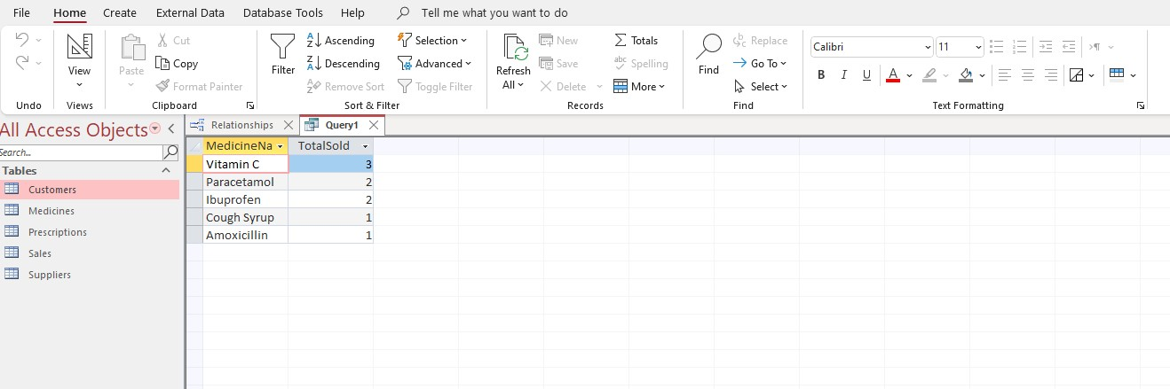
Figure 11: Most Sold Medicines Query
Figures 10 and 11 demonstrate how queries were used to retrieve meaningful information from the database, supporting efficient decision-making and operational management.

9. Forms
Forms are used in database systems to provide a user-friendly interface for entering, editing, and viewing data. They simplify interaction with the database by allowing users to input information without directly accessing the underlying tables. This reduces the risk of data entry errors and improves overall usability [2].
In this project, forms were created to support efficient data entry and management within MediLink Pharmacy. These forms allow users to easily add new customer details, record sales transactions, and manage medicine information. By using forms, the system becomes more accessible to users who may not have technical knowledge of database structures.

Customer Form
The Customer Form was designed to allow users to enter and manage customer information efficiently. It includes fields such as CustomerID, FirstName, LastName, Phone, and Address. This form ensures that customer data is captured accurately and consistently.
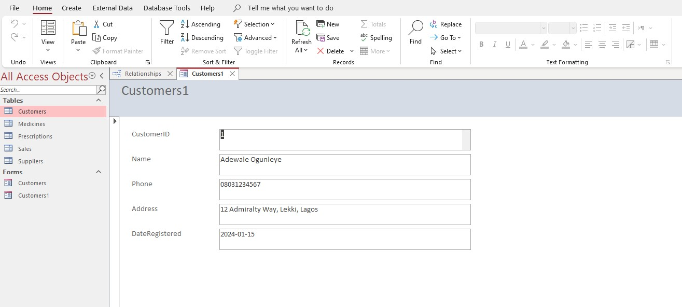
Figure 12: Customer Data Entry Form

Sales Form
The Sales Form enables users to record sales transactions, including customer details, medicines purchased, quantities, and total price. This form simplifies the process of recording transactions and ensures that all required data is entered correctly.
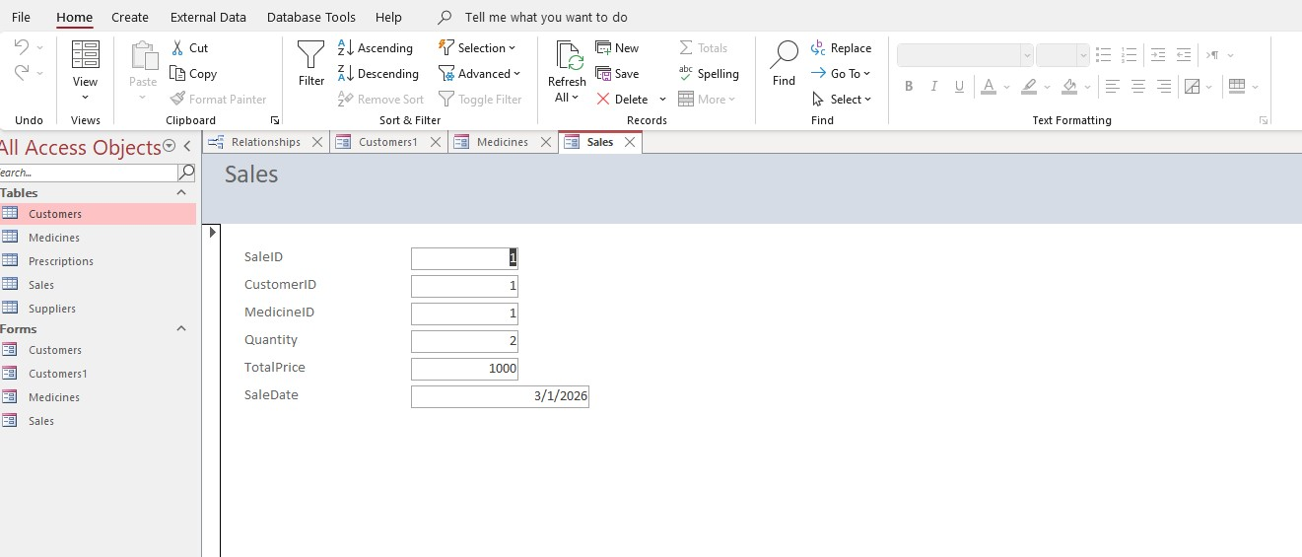
Figure 13: Sales Data Entry Form

Figures 12 and 13 show how forms were used to improve user interaction with the database, making data entry more efficient and reducing the likelihood of errors.

10. Reports
Reports are used in database systems to present data in a structured and organised format that is easy to read and interpret. They allow users to summarise large amounts of data and generate insights that support decision-making. Reports are particularly useful for management purposes, such as monitoring sales performance and tracking stock levels [2].
In this project, reports were created to display key information from the database, helping the pharmacy manage its operations more effectively. These reports provide a clear overview of sales transactions and stock availability.

Sales Report
The Sales Report was designed to display details of sales transactions, including customer information, medicines purchased, quantities, and total sales value. This report helps the pharmacy track revenue and analyse customer purchasing patterns. It also supports financial monitoring and business decision-making.
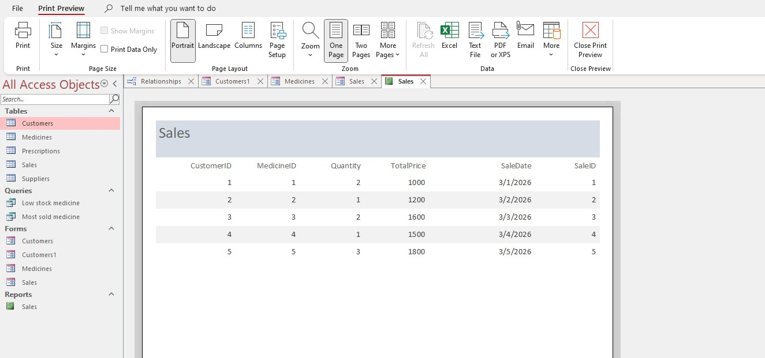
Figure 14: Sales Report

11. Validation and Testing

In this project, several validation and testing methods were applied to confirm that the database system for MediLink Pharmacy works efficiently. These processes helped to identify and correct any errors, ensuring data accuracy and system reliability.

Testing Procedures

The database was tested by performing a range of operations, including data entry, updating records, and running queries. For example, new customer records were added using forms to ensure that data was stored correctly in the tables. Queries were executed to verify that accurate results were returned, such as identifying low stock medicines and calculating total sales per customer.

Validation Techniques

Validation techniques were applied to ensure that only valid data is entered into the system. For instance, appropriate data types were assigned to each field, such as numeric fields for quantities and currency fields for prices. Required fields were also enforced to prevent missing data, and input formats were used where necessary to maintain consistency. These validation measures help improve data quality and reduce errors during data entry [2].

12. Reflection (Design Decisions)

The database system for MediLink Pharmacy was designed with a focus on simplicity, efficiency, and scalability. The use of separate tables for Customers, Medicines, Suppliers, Prescriptions, and Sales ensures that data is well organised and easy to manage. This structure follows relational database principles, which improve data integrity and reduce redundancy [6].
Primary and foreign keys were carefully implemented to establish relationships between tables, ensuring that data remains consistent across the system.
Challenges Encountered
One of the main challenges faced during the development of the database was establishing correct relationships between tables while maintaining referential integrity. Initially, linking tables such as Sales and Customers required careful attention to ensure that foreign keys were correctly assigned [7].
Another challenge was designing queries that produced accurate and meaningful results. This required a clear understanding of how data is structured and how tables are related. Additionally, ensuring that all tables were properly normalised to Third Normal Form (3NF) required careful planning to avoid redundancy.
Improvements for Future Development
Although the database meets the current requirements, there are several improvements that could be made in the future. For example, additional features such as user authentication could be implemented to enhance security and restrict access to authorised users only.
Furthermore, the system could be expanded to include automated alerts for low stock levels, helping staff respond more quickly to inventory needs. Integration with barcode scanning technology could also improve efficiency during sales transactions. These improvements would make the system more advanced and better suited for real-world application [2].

References (IEEE Style)

[1] T. Connolly and C. Begg, Database Systems: A Practical Approach to Design, Implementation, and Management, 6th ed. Harlow, UK: Pearson, 2015.
[2] R. Elmasri and S. B. Navathe, Fundamentals of Database Systems, 7th ed. Boston, MA: Pearson, 2016.
[3] Microsoft, “Introduction to databases,” Microsoft Support. [Online]. Available: https://support.microsoft.com
[4] IBM, “What is a relational database?,” IBM. [Online]. Available: https://www.ibm.com
[5] J. Eckstein and B. R. Schultz, Introductory Relational Database Design for Business, with Microsoft Access. Hoboken, NJ: John Wiley & Sons, 2018.
[6] K. A. Lewis, J. Tzilivakis, D. J. Warner, and A. Green, “An international database for pesticide risk assessments and management,” Human and Ecological Risk Assessment: An International Journal, vol. 22, no. 4, pp. 1050–1064, 2016.
[7] J. Letkowski, “Challenges in database design with Microsoft Access,” Journal of Instructional Pedagogies, vol. 15, 2014.
[8] M. Ron, Relational Databases and Microsoft Access. 2016.
[9] S. M. Hwang et al., “Design and management of database using Microsoft Access program: Application in neurointerventional unit,” Journal of the Korean Radiological Society, vol. 53, no. 4, pp. 295–303, 2005.

