

Leadership and Decision Making in Complex Environments

Name: Akina Limbu
Student ID: 2014849

Contents
Blog 1. Interview of Leader............................................................................................................3
Blog 2. Outcome of the Interview with Leader...............................................................................7
Blog3. #LeadershipDilemmas......................................................................................................12
Blog 4. Network Map...................................................................................................................17
Blog 5. ‘Management Era is Over’ Debate...................................................................................20
Blog 6. Cynefin Framework Application to Diversity, Equality and Inclusion in the Workplace....................................................................................................................................23
Blog 7. Spiritful Leadership Framework......................................................................................29

Blog 1. Interview of Leader
I would like to interview a good friend. Her name is Aruna Phago, and she owns a business which has been operating successfully for over 10 years. Her traits as an entrepreneur and a leader are remarkable and she manages her employees and company efficiently in complex environments. Adaptability and crisis management are her greatest assets, while her ability to inspire, valuing equality in the workplace, and appreciation of compassion and affability are her greatest assets. Below are the interview questions that was sent out.
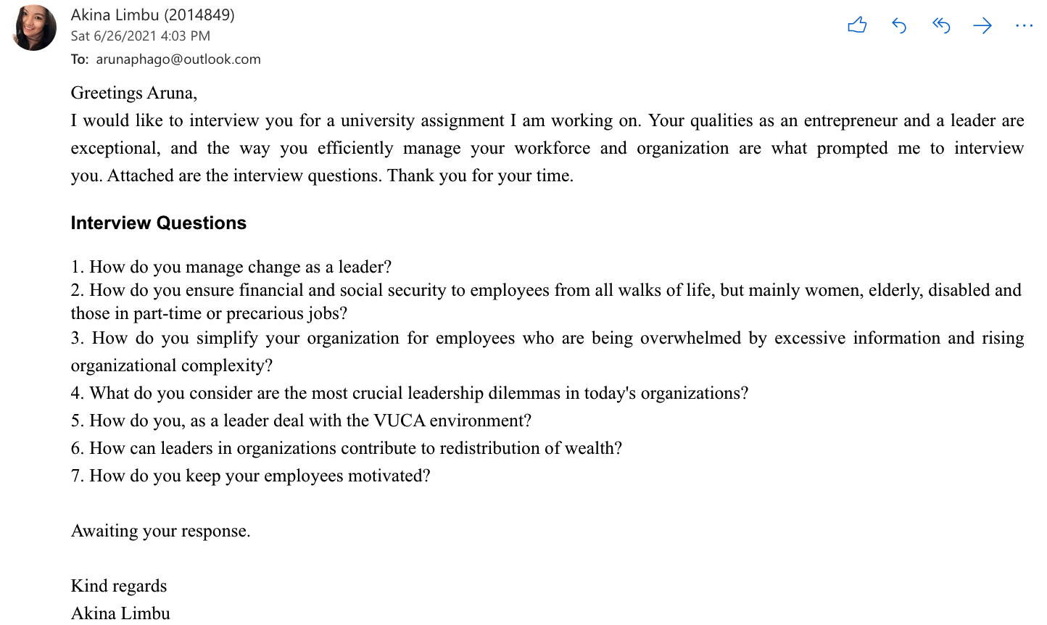

Bibliography:
Austin, D. (2019). Leaders Simplify the Complex. [online] Digital Dealer. Available at: https://www.digitaldealer.com/latest-news/leaders-simplify-the-complex/ [Accessed 25 Jun. 2021].
Burgis, N. (2018). Helping Leaders Simplify Leadership. [online] C-Suite Network Advisors. Available at: https://c-suitenetwork.com/advisors/helping-leaders-simplify-leadership/ [Accessed 25 Jun. 2021].
Cashman, K. (2017). The Global Leadership Dilemma: to Be Inclusive or Not to Be Inclusive? [online] Forbes. Available at: https://www.forbes.com/sites/kevincashman/2017/01/30/the-global-leadership-dilemma-to-be-inclusive-or-not-to-be-inclusive/?sh=2a53ff4bc2b3 [Accessed 26 Jun. 2021].
Kiran, C.S. and Tripathi, P. (2018). Leadership Development through Change Management: a Neuroscience Perspective. NHRD Network Journal, 11(4), pp.42–48.
Kolovou, T. (2018). Communicating across Cultures Online Class | LinkedIn Learning, Formerly Lynda.com. [online] LinkedIn. Available at: https://www.linkedin.com/learning/communicating-across-cultures-2.
Millar, C.C.J.M., Groth, O. and Mahon, J.F. (2018). Management Innovation in a VUCA World: Challenges and Recommendations. California Management Review, 61(1), pp.5–14.
OECD. (2020). COVID-19: Protecting People and Societies. [online] Available at: https://www.oecd.org/coronavirus/policy-responses/covid-19-protecting-people-and-societies-e5c9de1a/ [Accessed 26 Jun. 2021].
Othman, A.H.A., Musa Alhabshi, S., Kassim, S., Abdullah, A. and Haron, R. (2020). The Impact of Monetary Systems on Income Inequity and Wealth Distribution. International Journal of Emerging Markets, 15(6), pp.1161–1183.
Powell, J. (2013). Six Policies to Reduce Economic Inequality | Othering & Belonging Institute. [online] Berkeley.edu. Available at: https://belonging.berkeley.edu/six-policies-reduce-economic-inequality.
Singh, P. (2017). Leadership Development Issues ( Challenges. NHRD Network Journal, 10(4), pp.7–9.

Blog 2. Outcome of the Interview with Leader
I had an email interview with a leader and from her responses, I’ve highlighted the leadership dilemmas faced by leaders and organisation today and identified a call to action.
The turbulence, both internally such as complex operations and externally, rapid technological change is affecting leaders and businesses worldwide.
Managing Change as a Leader during Turbulent Times
As leaders, we must be the first to adopt and adapt to change since those around us look up to us. If a company wants to advance, expand, and remain relevant, it must welcome development, innovation, and progress (Gaston, 2021). By employing the Kurt Lewin model, a devised three-step change model: unfreezing, changing, and refreezing, leaders can triumph to change. The process of change, according to Lewin, includes first, establishing the idea that a change is required, then advancing toward the new, optimal level of performance, and lastly anchoring that new development as the standard (Crosby, 2021). It is achievable if we array ourselves by ensuring that we are ready to face the obstacles and that we have the tools and techniques to solve challenges and move forward through the transition (Hussain et al., 2018). Others' concerns about the changes are recognized, and leaders could aid them in making the structural changes in the workplace.
Ensuring Financial and Social Security to Employees, Mainly Women, Elderly, Disabled and those in Part-time or Precarious Jobs
It is critical for leaders to undertake immediate action and countermeasures in the lives of their employees, primarily those who are most vulnerable. Employee welfare can be addressed in a unified and holistic manner (Allan, Autin and Wilkins-Yel, 2021), such as in dealing with the COVID-19 predicament. Leaders are responsible for their employees in these economic externalities by providing support and assistance in the form of financial hardship funds to assist with living expenses, as well as making work available virtually to employees. Leaders understand that failing to do so creates more inequities, consequently creating social barriers and weakening society's resilience (Olding et al., 2021).
Simplify the Organization for Employees Who are Being Overwhelmed by Excessive Information and Rising Organizational Complexity
Leaders should address complexities by sensemaking, which intends to bring clarity and understanding to enigmatic phenomenon (Weick, 1995, 2008) and establishing initiatives that stimulate growth of the employees and the organization, responding to workplace issues, offering support, and devising work structures that sustain the organization and allow it to function prolifically (Worren, 2018). The leader is responsible for simplifying the complex, ensuring transparency to employees in organisational processes, duties, tasks, policies and practices (Namvar et al., 2018).
Most Crucial Leadership Dilemmas in Today's Organizations
Organizations today have a number of critical leadership dilemmas. As stated by (Scarborough, Lambouths and Holbrook, 2019), diversity and inclusion in the workplace are an essential element and our distinctive differences for a more friendly work culture should be further embraced. In addition, technological developments are continuous, which is costly to the organization for training and adoption for its workforce, however, as argued by (Fu et al., 2018), it is mandatory for the organisation to evolve and to maximize the productivity and efficiency of numerous work activities.
Dealing with the VUCA environment
Understanding the environment and adopting approaches for emerging possibilities, as well as refining organizational strategy to improve agility could help leaders deal with the VUCA environment (Bennis and Nanus, 2007). Furthermore, to enhance organizational competencies, leaders could integrate business processes and procedures (Deepika and Chitranshi, 2020). Moreover, critical reflection on performance management through the development of transformational capabilities in employees is essential (Rimita, Hoon and Levasseur, 2020).

Leaders in Organisations Can Aid in Contributing to Redistribution of Wealth
Increasing the minimum wage is one way for organizations and leaders to contribute to the redistribution of wealth, as it has no negative effect on jobs or economic and social advancement (McInroy, 2018). Another approach is to provide additional financial aid to the poor and working class, primarily single parent families who are entering the workforce (Brown-Iannuzzi et al., 2019). Furthermore, companies could partner with financial institutions to give lower-income families with credit and home property rights, both of which are important pathways to wealth (Cooley, Brown-Iannuzzi and Boudreau, 2019).

Keeping Employees Motivated
Organizations and leaders should explore what motivates and inspires employees to perform better at work, and then address how they may be recognized, whether through a job promotion or pay rise (Sinclair et al., 2021). As attested by (Nikolova, Schaufeli and Notelaers, 2019), leaders should also provide constructive feedback and encouragement to their subordinates in order to help them work efficiently. Employees would be motivated to work hard if leaders are supportive, honest and transparent.

Embrace change in your organization - Simplify, diversify, Motivate!

References:
Allan, B.A., Autin, K.L. and Wilkins-Yel, K.G. (2021). Precarious Work in the 21st century: a Psychological Perspective. Journal of Vocational Behavior, 126(50), p.103491.
Bennis, W.G. and Nanus, B. (2007). Leaders Strategies for Taking Charge. New York, Ny Harper Collins.
Brown-Iannuzzi, J.L., Cooley, E., McKee, S.E. and Hyden, C. (2019). Wealthy Whites and Poor Blacks: Implicit Associations between Racial Groups and Wealth Predict Explicit Opposition toward Helping the Poor. Journal of Experimental Social Psychology, 82, pp.26–34.
Cooley, E., Brown-Iannuzzi, J.L. and Boudreau, C. (2019). Shifting Stereotypes of Welfare Recipients Can Reverse Racial Biases in Support for Wealth Redistribution. Social Psychological and Personality Science, 10(8), pp.1065–1074.
Crosby, G. (2021). Planned Change : Why Kurt Lewin’s Social Science Is Still Best Practice for Business results, Change Management and Human Progress. Boca Raton ; London ; New York Crc Press.
Deepika and Chitranshi, J. (2020). Leader Readiness of Gen Z in VUCA Business Environment. Foresight, 23(2).
Fu, Y., Kok, R.A.W., Dankbaar, B., Ligthart, P.E.M. and van Riel, A.C.R. (2018). Factors Affecting Sustainable Process Technology adoption: a Systematic Literature Review. Journal of Cleaner Production, 205, pp.226–251.
Gaston, D.W. (2021). The Transformational Leader: Managing Organizational Trauma through Seasons of Change. Advances in Human Resources Management and Organizational Development, pp.41–58.
Hussain, S.T., Lei, S., Akram, T., Haider, M.J., Hussain, S.H. and Ali, M. (2018). Kurt Lewin’s Change model: a Critical Review of the Role of Leadership and Employee Involvement in
McInroy, N. (2018). Wealth for all: Building New Local Economies. Local Economy: the Journal of the Local Economy Policy Unit, 33(6), pp.678–687.
Namvar, M., Cybulski, J.L., Phang, C.S.C., Ee, Y.S. and Tan, K.T.L. (2018). Simplifying Sensemaking: Concept, Process, Strengths, Shortcomings, and Ways Forward for Information Systems in Contemporary Business Environments. Australasian Journal of Information Systems, 22.
Nikolova, I., Schaufeli, W. and Notelaers, G. (2019). Engaging Leader – Engaged employees? a cross-lagged Study on Employee Engagement. European Management Journal, 37(6).
Olding, M., Barker, A., McNeil, R. and Boyd, J. (2021). Essential work, Precarious labour: the Need for Safer and Equitable Harm Reduction Work in the Era of COVID-19. International Journal of Drug Policy, 90, p.103076.
Organizational Change. Journal of Innovation & Knowledge, [online] 3(3), pp.123–127. Available at: https://www.sciencedirect.com/science/article/pii/S2444569X16300087 [Accessed 27 Jun. 2021].
Rimita, K., Hoon, S.N. and Levasseur, R. (2020). Leader Readiness in a Volatile, Uncertain, Complex, and Ambiguous Business Environment. Journal of Social Change, 12(1).
Scarborough, W.J., Lambouths, D.L. and Holbrook, A.L. (2019). Support of Workplace Diversity policies: the Role of race, gender, and Beliefs about Inequality. Social Science Research, 79, pp.194–210.
Sinclair, M.A., Stephens, K., Whiteman, K., Swanson-Biearman, B. and Clark, J. (2021). Managing and Motivating the Remote Employee Using the Transformational Leadership Model. Nurse Leader, 19(3).
Weick, K. E. (2008). Sensemaking. In Clegg, S. R., & Bailey, J. R., International Encyclopaedia of Organization Studies(pp. 1404-1406). Thousand Oaks, CA: Sage Publications.
Weick, K.E. (1995). Sensemaking in Organizations. Thousand Oaks: Sage Publications.
Worren, N. (2018). Organization Design : Simplifying Complex Systems. London ; New York: Routledge, Taylor & Francis Group.

Blog 3. #LeadershipDilemmas
The objective of this reflective blog is to reflect on what I have learned and to evaluate my experience on sharing and expressing my insights on leadership through the forum.
I will be employing the Kolb's learning cycle. To quote (Kolb, 1984), "The process whereby knowledge is created through the transformation of experience. Knowledge results from the combination of grasping and transforming experience."
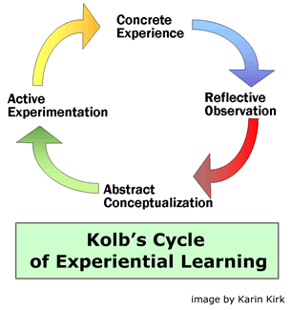
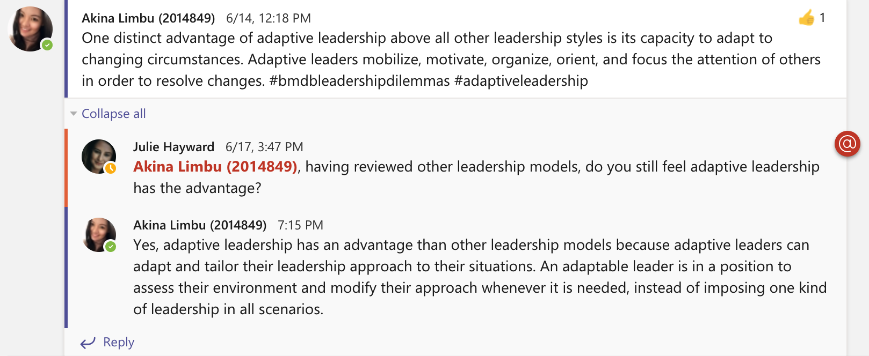
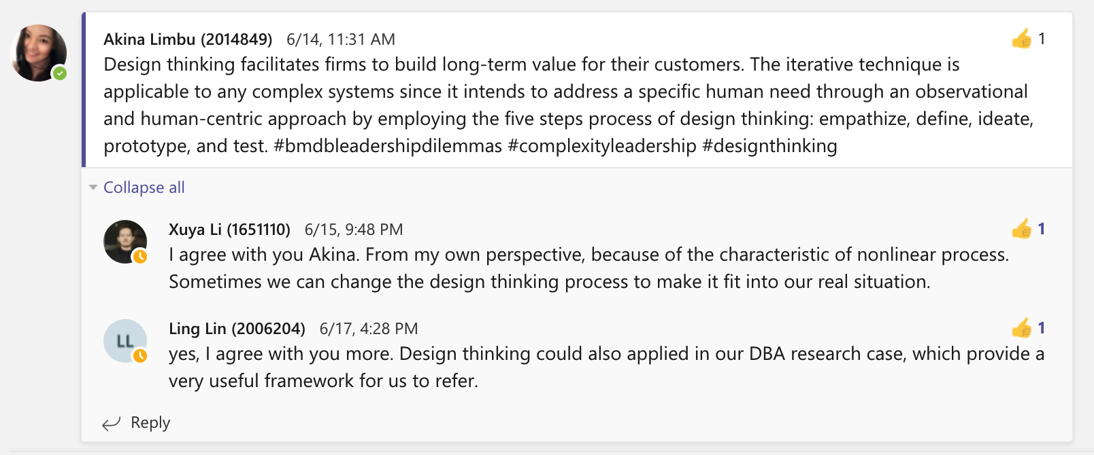
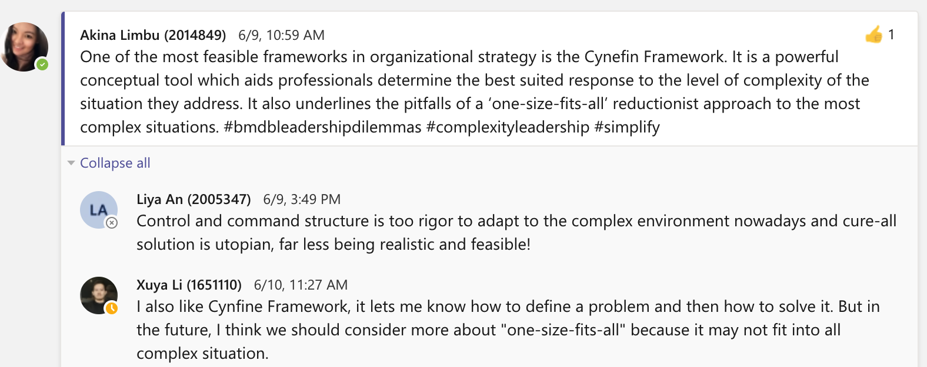
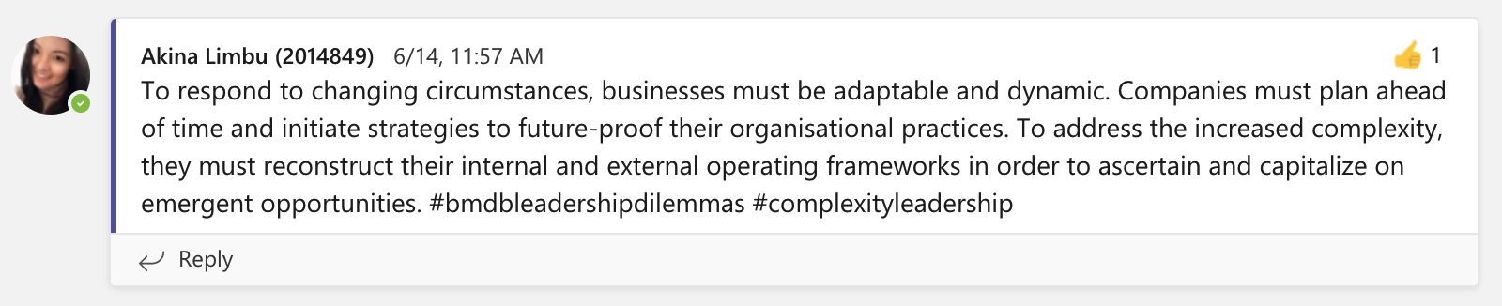
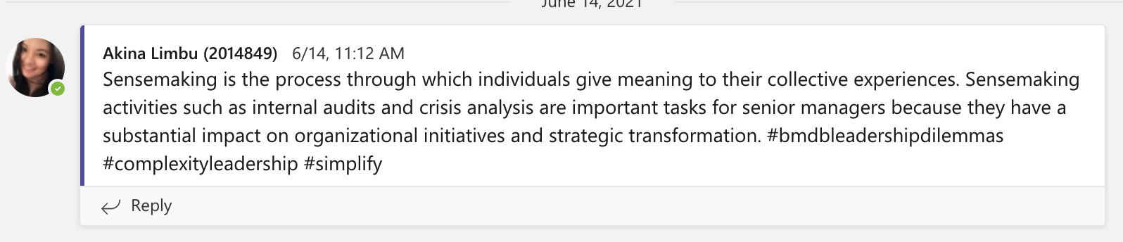

Analysis of what I have Learnt from the #LeadershipDilemmas Forum

Concrete Experience: I had participated in the forum for 10 weeks and have selected 5 of my tweets to be discussed. Writing and expressing my ideas on the forum and responding to classmates was an interactive experience. I was perplexed when the class was first instructed to produce a series of ‘tweet' style social media postings that brought attention to relevant leadership dilemmas. I had a Twitter and LinkedIn account, but it was inactive, and I had never posted a 'tweet' prior. After discussing with classmates, I realized that they were in the same predicament. Fortunately, Julie, our lecturer, had set up a leadership dilemmas forum on Teams and it was there that we began posting our 'tweets' and responses.

Reflective Observation: I will utilise the leadership competencies I've learned, such as leadership development and the acquisition of new skills as a leader which will enable me to address leadership dilemmas faced by organisations and gain more expertise that will lead to a better professional career. Composing this blog is essential because it has allowed me to implement what I have learned into practice and how it would aid me in achieving my long-term leadership and organisational goals.
Abstract Conceptualisation: One of the frameworks that resonated most with me was adaptable leadership as it has an edge over other leadership models, in that adaptive leaders can adjust their leadership style to their surroundings, instead of enforcing one style of leadership in all situations (Rajiah and Bhargava, 2020). Furthermore, I appreciated learning the design thinking method since the iterative process is scalable to any complex system as it seeks to solve a specific human need through an observable and human-centric approach (IDEO, 2021), which is relevant to my thesis. Moreover, the cynefin framework is a useful conceptual tool for determining the appropriate response to the degree of complexity of a problem (Rosenhead et al., 2019) which would enable me to make better decisions in both my professional and personal life. Also, I recognise that sensemaking is a method for transforming complexity into a context that can be articulated clearly and utilized as a springboard for action (Weick, Sutcliffe and Obstfeld, 2005), which is a beneficial approach that organizations should use to prepare for and manage complexity.

Active Experimentation: I have realised that due to my inactivity on social medias such as Twitter and LinkedIn, had made my ‘tweets’ limited and only reachable to my classmates and not to the wider audiences. As a result, I have begun to publish and utilize Twitter and LinkedIn more frequently as the role that social media networking sites perform in our networks as non-human actors is significant and engaging with like-minded people will broaden my understanding and knowledge. Also, I can connect and network with my latent ties, as networking is essential to leadership that enables us in identifying career possibilities, projecting organizational changes, and staying current with industry trends (Stobierski, 2019).

References:
IDEO (2021). IDEO Design Thinking. [online] IDEO | Design Thinking. Available at: https://designthinking.ideo.com/ [Accessed 30 Jun. 2021].
Kolb, D. 1984. Experiential learning. Prentice-Hall, Englewood Cliffs, NJ.
Rajiah, P. and Bhargava, P. (2020). Adaptive Leadership: Tips from the Business World. Journal of the American College of Radiology, 17(4), pp.554–556.
Rosenhead, J., Franco, L.A., Grint, K. and Friedland, B. (2019). Complexity Theory and Leadership practice: a review, a critique, and Some Recommendations. The Leadership Quarterly, 30(5), p.101304.
Stobierski, T. (2019). How Leaders Develop and Use Their Network | HBS Online. [online] Business Insights - Blog. Available at: https://online.hbs.edu/blog/post/importance-of-networking-in-leadership [Accessed 30 Jun. 2021].
Weick, K.E., Sutcliffe, K.M. and Obstfeld, D. (2005). Organizing and the Process of Sensemaking. Organization Science, 16(4), pp.409–421.
Blog 4. Network Map
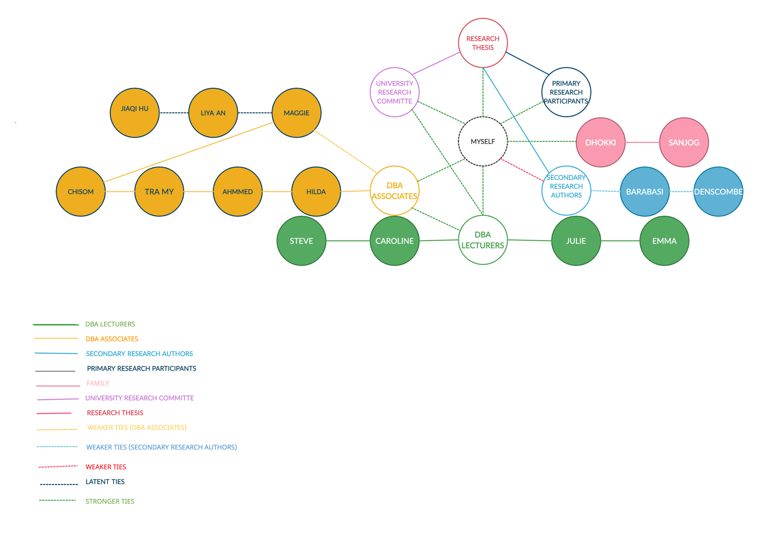

A network consists of a collection of nodes and ties between the actants, both human and non-human and the connections that bind the actors together (Latour, 2005). The type and degree of links amongst actors have an impact on the formation of cognitive beliefs, merits, and activities inside the network (Bouwer, Pasquini and Baudoin, 2021).
An effective network makes it easier to connect with individuals, ideas, and opportunities. It entails more than simply knowing or connecting with a large number of individuals. It is about being capable of making use of those relationships to handle situations efficiently and creation of possibilities for ourselves.
My network map can be seen above. It is a map for me to reach my objectives of completing my research thesis successfully.
As stated on (Center for Creative Leadership, 2021), with resources such as feedbacks, opportunities and access, it would help to develop and build our networks. Thus, it is vital to engage in class and with our lecturers to take into account of their feedbacks to improve on our assessments and consequently perform better in our research thesis.
Additionally, we should also try and build stronger relationships with our weaker and latent ties. As shown on the map, my weaker tie is Maggie, as I know her from the DBA program, and we are also connected on WeChat. However, she is on her 5th module, and I am on my 3rd module. Making Maggie my stronger tie would enable me to be clearer of the DBA program and what may come as she is a couple of modules ahead of me. Also, reciprocity is vital as it is regarded as the starting mechanism for the formation of interpersonal relationships (Gouldner, 1960), thus it is important to note to establish a positive reputation as somebody who gives and not just who receives, who utilizes information responsibly rather than breaking trust; otherwise, our networks could eventually be discontinued (Krämer, Sauer and Ellison, 2021).
From Maggie, there is a connection to Liya An and Jiaqi Hu, who are my latent ties as I am aware of them being in the same program, but they are from Maggie’s cohort, and I have never collaborated with them in the same tasks in class. It is important that I make both of them stronger ties as they have families who are in the e-commerce business sector, which is the subject of my research thesis, and perhaps I can interview the family members as research participants.
It is also important to sustain stronger ties as it is required to provide the highest flow of information across various components of the network while remaining in sync with one another and the purpose of the network (Anwar, Rehman and Shah, 2018). My family and I have strong bonds, and they are supportive in providing moral support, which is critical for me to keep moving forward when I am stressed and want to give up. Currently, I have good ties with my DBA associates, DBA lecturers, university research committee and primary research participants whom I am planning on interviewing, and it is best to keep them maintained. However, I do need to read and research more on relevant authors, such as Barabasi and Denscombe etc, in order to acquire more knowledge in the sector as they are an integral part to my research thesis.

References:
Anwar, M., Rehman, A.U. and Shah, S.Z.A. (2018). Networking and New Venture’s performance: Mediating Role of Competitive Advantage. International Journal of Emerging Markets, 13(5), pp.998–1025.
Bouwer, R., Pasquini, L. and Baudoin, M.A. (2021). Breaking down the silos: Building Resilience through Cohesive and Collaborative Social Networks. Environmental Development, 38, p.100646.
Center for Creative Leadership. (2021). The Top 6 Rules of Leadership Networking. [online] Available at: https://www.ccl.org/articles/leading-effectively-articles/top-6-rules-leadership-networking/ [Accessed 2 Jul. 2021].
Gouldner, A.W. (1960). The Norm of Reciprocity: a Preliminary Statement. American Sociological Review, 25(2), p.161.
Krämer, N.C., Sauer, V. and Ellison, N. (2021). The Strength of Weak Ties Revisited: Further Evidence of the Role of Strong Ties in the Provision of Online Social Support. Social Media + Society, 7(2), p.205630512110249.
Latour, B. (2005). Reassembling the Social: an Introduction to actor-network-theory. Oxford: Oxford University Press.

Blog 5. ‘Management Era is Over’ Debate
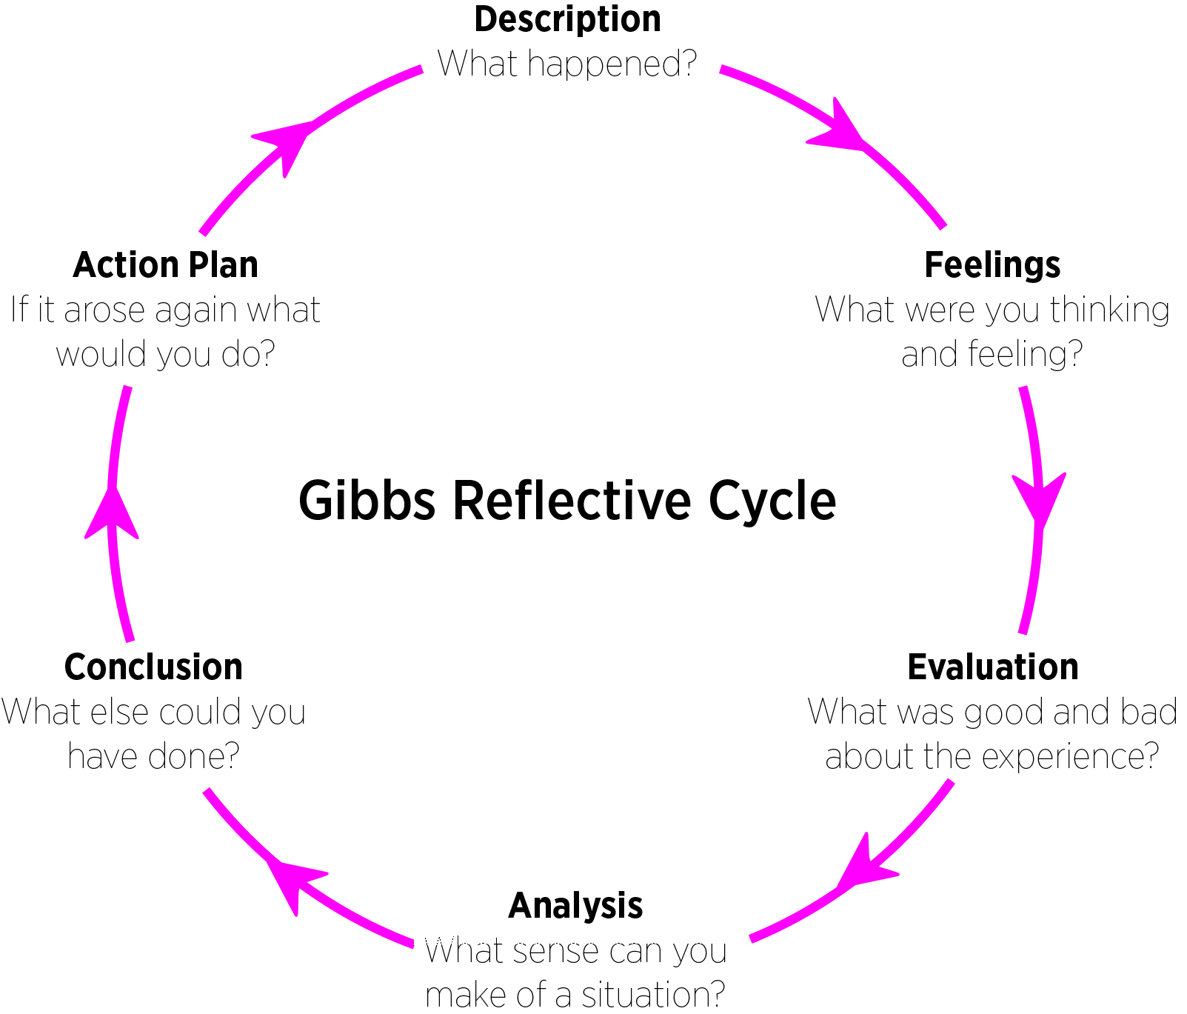

My objective in writing this blog is to reflect on what I have learned while debating the topic, 'Management Era is Over' with my classmates, and to evaluate my experience of sharing and expressing my viewpoints on it. I will employ Gibb's learning cycle as it offers an excellent framework for examining experiences, and its cyclical nature enables it to be applied to experiences, giving us the chance to learn and improve (Gibbs, 1988).
It has 6 stages.
Description: Inter-Group debate
My group, four others in my course and I decided to split into two debating groups. I was in the debate against why ‘Management Era is over’. I had 3 members in my group and the other had 2 members, and the group members were formed on what we genuinely believed on. We then researched about our debates and got ready to spar in class the following week. We had given ourselves enough time before the dateline to individually write our own sections.
Feelings: On the day of the debate, we joined together on WhatsApp call, half an hour prior to the debate and realized we had a misunderstanding. We had thought we had divided the tasks properly. I became agitated when we realized we did not even know who should speak first because no one wanted to start. I was confident the plan would work, so had not given any consideration to who would say what and when. Thankfully, we were able to organise who would speak and rebut in what order.
Evaluation: What worked well, was that each group member delivered high-quality work by the dateline and good energy put into the debate. Furthermore, two members of the opposing side were providing articles that would be useful to us pushed us to work harder on our preparation for our debate. This strengthened the group's work ethic. The aspects that did not work were that we all had similar responses to those in our rebuttal group, and there was a general mismanagement of the group's time frame as to who spoke when, and that could have been managed better.
Analysis: We had divided the group based on each individual's self-identified interest, so each of us was able to participate in the portion of the debate that was of interest to us. Having done this previously, I realized that when working independently, I am more comfortable working on topics that are familiar and reassuring. Our misunderstanding was not looking into it carefully, as we assumed this technique would save us time when combining the parts in the end. In actuality, everything took longer than planned as we had similar answers which led us to worry and speed through making changes at the last minute. We got into this situation because we did not plan well for the composition and arrangement of the individual parts. The success of group work is predominantly determined by creating and building a team in which the shared task is clear, and responsibilities and roles are understood and complied with (Nipp and Palenque, 2017).
Conclusion: When a group decides to split tasks, I learnt that we must first consider how each segment would feel and appear as it would have been easy to put the portions together and present them without any realtering, thus saving time. Additionally, I learnt that we sometimes have to refute the judgments we have and look at the perspectives of the other group to understand the situation clearly.
Action Plan: When I work with a group again, and we decide to divide work, I will insist on planning out what we expect from each other ahead. I would recommend that the first portion should be put together beforehand so that if we write our own sections, we have a baseline. I am certain that this present experience will suffice to remind me if someone proposes hereafter, we should share the task.

References:
Gibbs, G. (1988). Learning by Doing: a Guide to Teaching and Learning Methods. 1st ed. London: Further Education Unit.
Nipp, M.B. and Palenque, S.M. (2017). Strategies for Successful Group Work. Journal of Instructional Research, 6(1).
Bibliography:
Birmingham.ac.uk. (2019). Tips for Effective Group Working - University of Birmingham. [online] Available at: https://www.birmingham.ac.uk/schools/metallurgy-materials/about/cases/group-work/tips.aspx.
Chakhoyan, A. (2017). Is the Era of Management over? [online] World Economic Forum. Available at: https://www.weforum.org/agenda/2017/12/is-management-era-over/ [Accessed 5 Jul. 2021].
De Wilde, T.R.W., Ten Velden, F.S. and De Dreu, C.K.W. (2018). The anchoring-bias in Groups. Journal of Experimental Social Psychology, 76, pp.116–126.
Emmerling, T. and Rooders, D. (2020). 7 Strategies for Better Group Decision-Making. [online] Harvard Business Review. Available at: https://hbr.org/2020/09/7-strategies-for-better-group-decision-making [Accessed 6 Jul. 2021].
Ludwig, D. (2001). The Era of Management Is over. Ecosystems, 4(8), pp.758–764.
Shankman, P. (2013). Nice Companies Finish First: Why Cutthroat Management Is over--and Collaboration Is in. New York: Palgrave Macmillan.
Zheng, Y., Li, C., Liu, S. and Lu, W. (2018). An Improved Genetic Approach for Composing Optimal Collaborative Learning Groups. Knowledge-Based Systems, 139, pp.214–225.
Blog 6. Cynefin Framework Application to Diversity, Equality and Inclusion in the Workplace
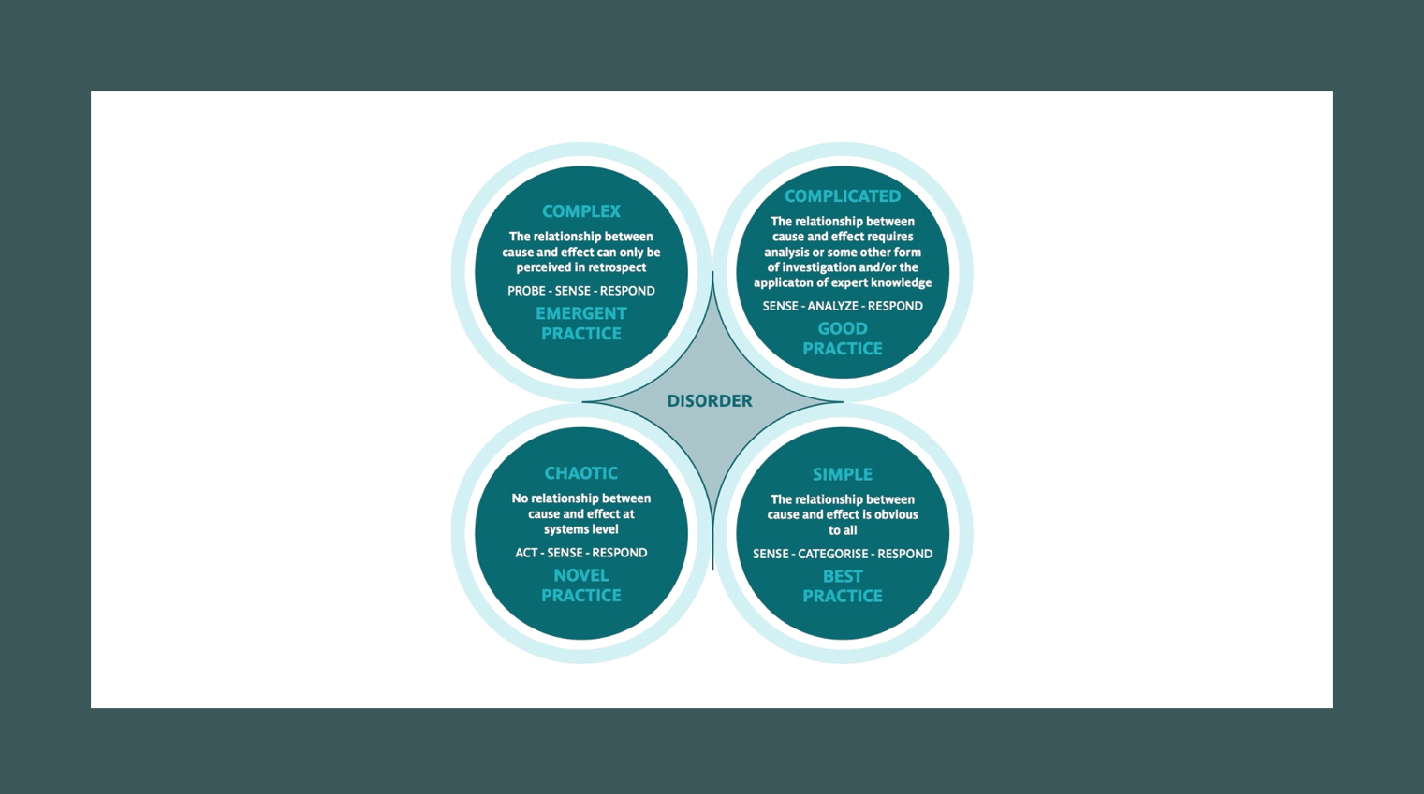
Slide 1: The Cynefin model is proposed by (Snowden and Boone, 2007) as a framework to help leaders in aligning their leadership approach to the environment in which they are facing. Simple, complicated, complex, and chaotic domains are distinguished, implying that the former two are orderly systems receptive to classification and analysis, whereas the following two could only be comprehended by direct involvement and investigation.
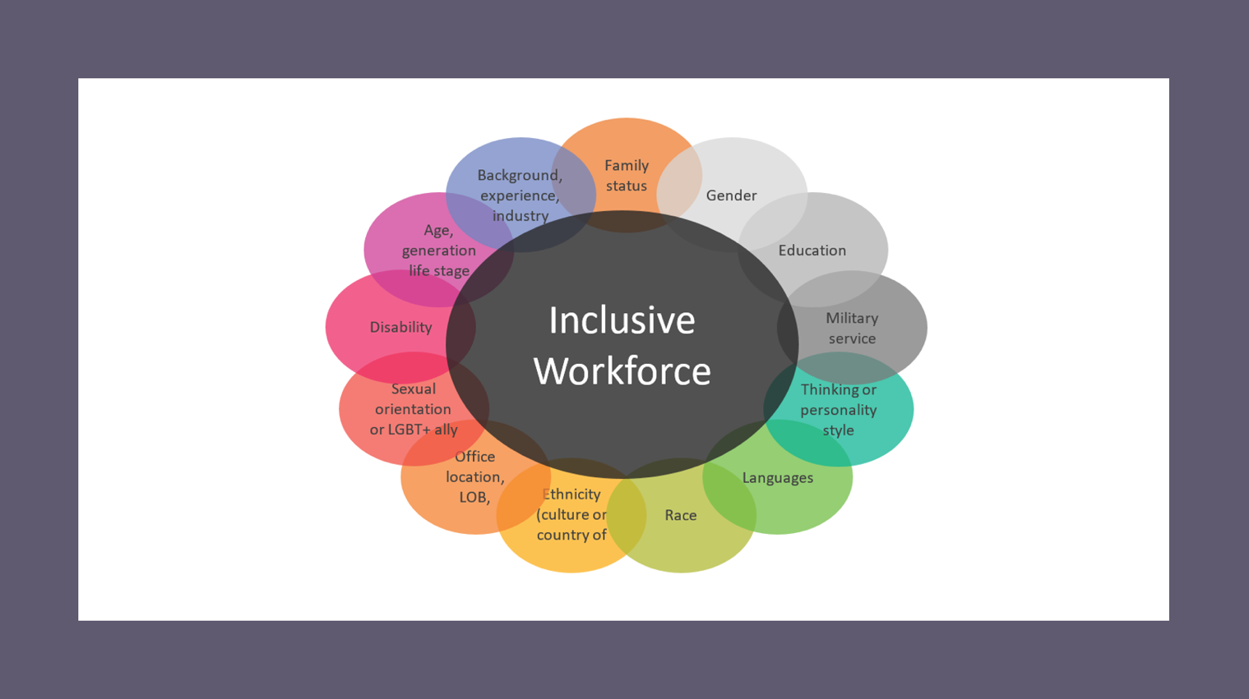
Slide 2: Leaders and organisations are continually being challenged and enhanced by the heterogeneity of its workforces and have clearly emphasized the significance of an empathetic and inclusive leadership strategy, given the beneficial effect this could have on employee engagement and organizational productivity. The issue of diversity and inclusiveness is neither a simple nor complicated issue, but rather a complex issue which may become chaotic. True diversity involves more than simply acknowledging the advantages of a more multicultural workplace; it necessitates active involvement with regulations and practical methods of fair rights and opportunities, social equality, justice, and civil liberties (Shore, Cleveland and Sanchez, 2018).
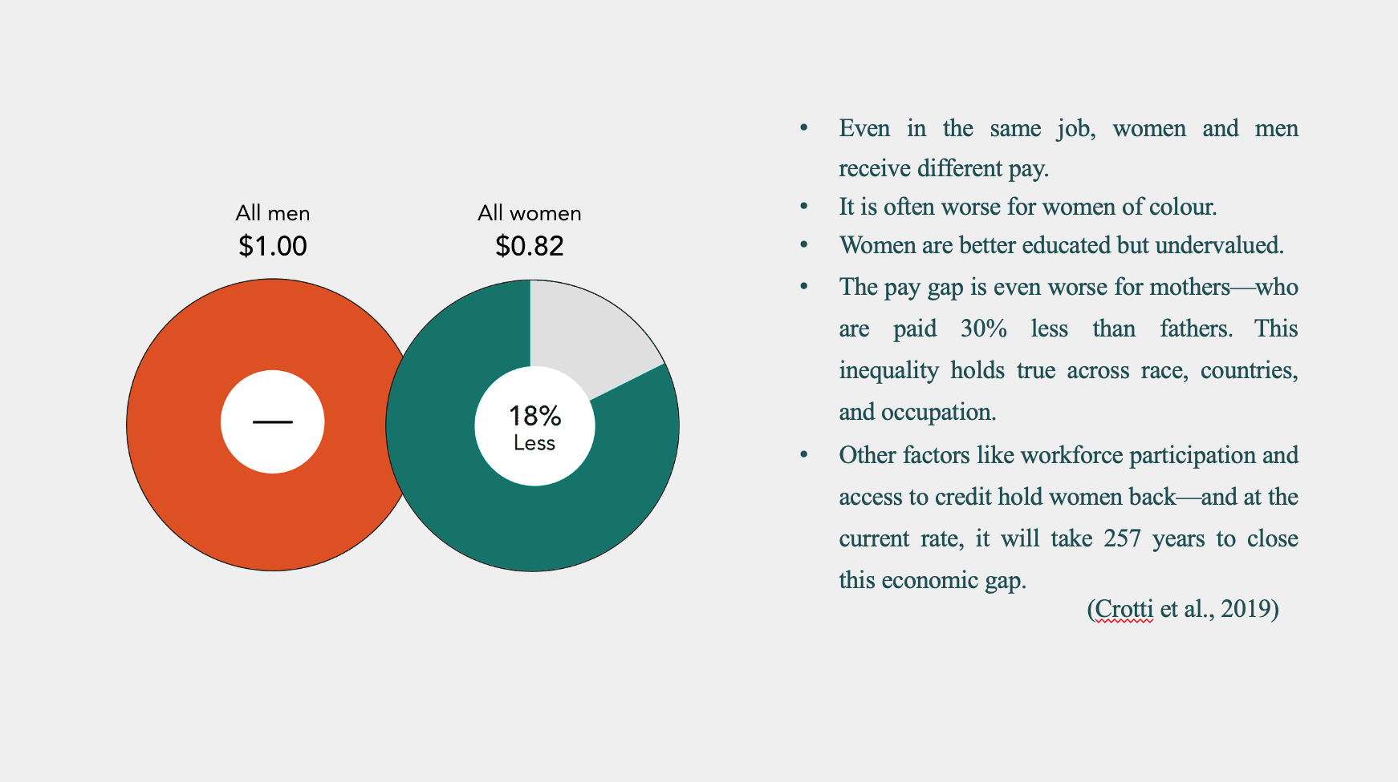
Slide 3: Simple situations are categorised by predictability and unambiguous connections between cause and effect (Nachbagauer, 2021), nevertheless, it is seldom straightforward when dealing with problems relating to inclusiveness measures. For instance, the gender salary gap snapshot shows an 18% difference between female and male average pay (Spiggle, 2021). On the surface, this data may appear to suggest an easy fix, that genders are not compensated fairly, therefore pay females more, but the actuality of the situation is more complex.
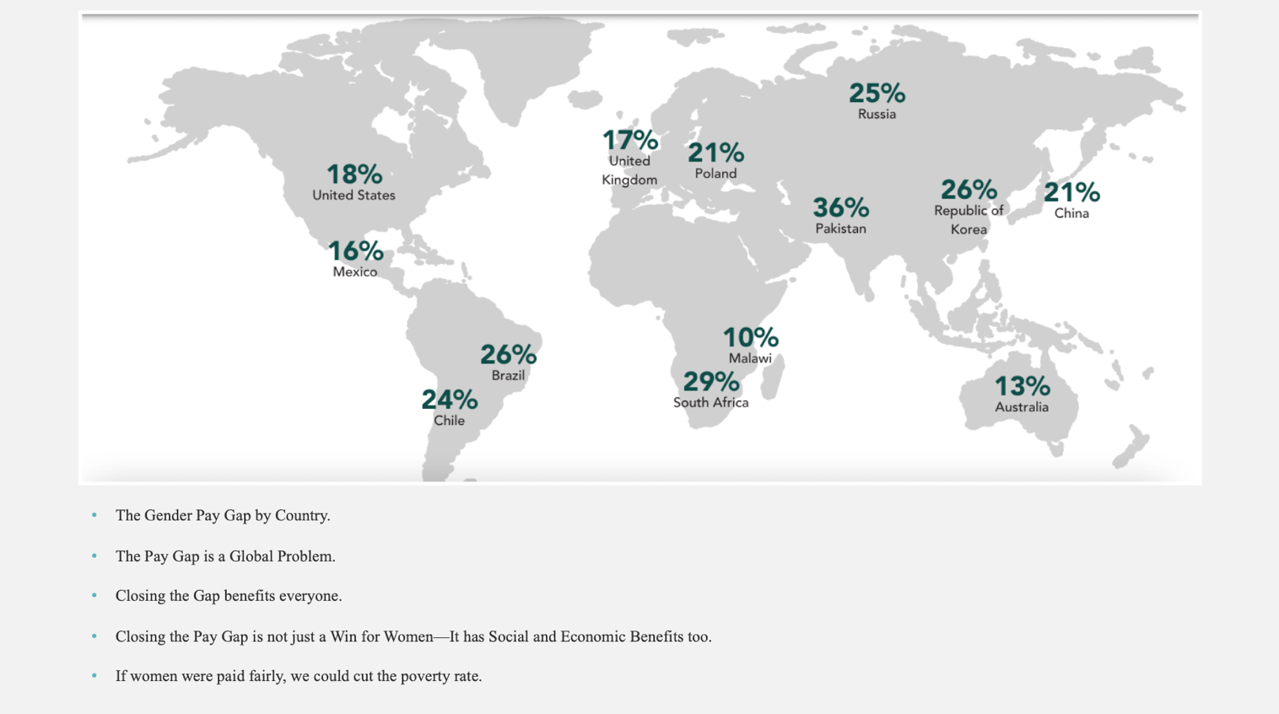
Slide 4: The pay gap is a global issue. Analysing the gender pay gap implies that we do not perceive inclusion and equality in the complicated environment as a simple situation. Complicated situations could have numerous solutions, as opposed to simple contexts, and while there is an obvious link among cause and effect, not everybody can perceive this (Snowden, 2020). Although programs like leadership development, bias awareness workshops have provided good examples and the initiatives had a certain influence, significant changes were not constant and the effectiveness of these approaches and its unintentional implications was increasingly criticized (Day et al., 2021). This implies that the situation is not just complicated but rather complex.
Complex settings are generally unknown, therefore the ideal approach is to ‘Probe – Sense – Respond.’ Instead of attempting to control the environment or pushing on a course of actions, it is generally preferable to be passive, seek for trends, and allow a solution to develop (Salimi and Salimi, 2018). Addressing a complex problem as though it was simple or complicated is probably going to exacerbate the issue and drive the situation into chaotic. Complex issues are best solved by eliminating additional levels of complexities while addressing the underlying ambiguity (Stuart, 2020, p.22).
It is typical for leaders who favour a command-and-control strategy to characterize problems as 'chaotic' and requiring immediate action, while criticizing those who advocate for an integrated effort as weaker (Ilieva, Anguelov and Nikolov, 2018). However, a command-and-control method will not address a severe crisis and will put considerable strain on everybody concerned. In this situation of diversity, equality and inclusiveness, the leadership task is to increase awareness and to help individuals to address the problem holistically, if it means to implement stabilizing procedures and to enable effective sensemaking in the face of challenging protracted dilemmas, a more systematic approach is best suited (Eldridge, 2019).

References:
Crotti, R., Schwab, K., Geiger, T. and Ratcheva, V. (2019). Global Gender Gap Report 2020 : Insight report. Geneva: World Economic Forum.
Day, D.V., Riggio, R.E., Tan, S.J. and Conger, J.A. (2021). Advancing the Science of 21st-century Leadership development: Theory, research, and Practice. The Leadership Quarterly, 32(3), p.101557.
Eldridge, D. (2019). A Case to Remain in the Complex and Complicated: Design Thinking within the Cynefin Framework. [online] www.linkedin.com. Available at: https://www.linkedin.com/pulse/case-remain-complex-complicated-design-thinking-within-eldridge/ [Accessed 6 Jul. 2021].
Ilieva, R., Anguelov, K. and Nikolov, M. (2018). A Cynefin Framework for Agile Decision Making of AI BOTS. 2018 International Conference on High Technology for Sustainable Development (HiTech).
Nachbagauer, A. (2021). Managing Complexity in projects: Extending the Cynefin Framework. Project Leadership and Society, 2, p.100017.
Salimi, F. and Salimi, F. (2018). Fundamentals of the Complexity. A Systems Approach to Managing the Complexities of Process Industries, pp.181–219.
Shore, L.M., Cleveland, J.N. and Sanchez, D. (2018). Inclusive workplaces: a Review and Model. Human Resource Management Review, [online] 28(2), pp.176–189. Available at: https://www.sciencedirect.com/science/article/abs/pii/S1053482217300529 [Accessed 6 Jul. 2021].
Snowden, D. and Boone, M. (2007). A Leader’s Framework for Decision Making. [online] Harvard Business Review. Available at: https://hbr.org/2007/11/a-leaders-framework-for-decision-making [Accessed 6 Jul. 2021].
Snowden, D. (2020). Cynefin® Weaving sense-making into the Fabric of Our World. Singapore: Cognitive Edge - The Cynefin Co.
Spiggle, T. (2021). The Gender Pay Gap: Why It’s Still Here. [online] Forbes. Available at: https://www.forbes.com/sites/tomspiggle/2021/05/25/the-gender-pay-gap-why-its-still-here/?sh=3047f0667baf [Accessed 6 Jul. 2021].
Stuart, C.E. (2020). Cynefin-Framework as a Guide to Agile Leadership Which Project Management Method for Which Type of Project? - Waterfall, Scrum, Kanban? Norderstedt Bod - Books on Demand, p.22.

Blog 7. Spiritful Leadership Framework
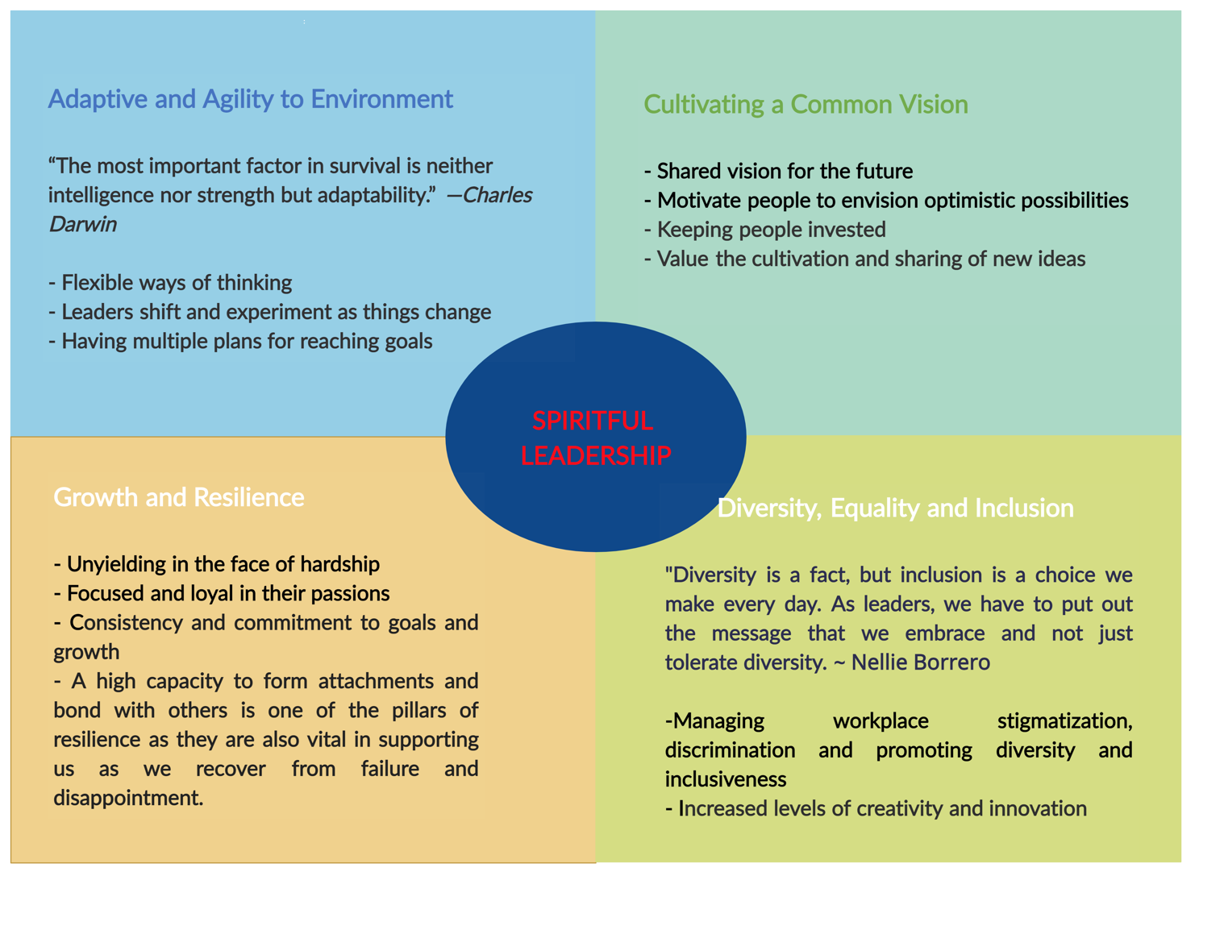
Complex adaptive systems (CAS) have been characterized as difficult to fathom, consisting of many interconnected elements working collectively with overlapping roles, aiming at adjusting to external forces (Dooley, 1997). To lead on such complex environment, (Reicher, Haslam and Platow, 2018) emphasized facilitating leadership for collaborative approach, stating that leadership's purpose is to create conditions that promote people' social connections. (Asrar-ul-Haq and Anwar, 2018) described the leaders' function as one that enhances connection for the improvement of collaboration and training across organisational contexts.
One of the important traits for leaders are as follows:
Adaptive and Agility to Environment - In a dynamically evolving environment, leadership agility and adaptability is defined as the capacity to make sensible and practical solutions. It is being able to predict the optimal course of actions, understanding how to motivate the workforce, transforming knowledge and viewpoints into practical actions and assessing outcomes for advantages.
Cultivating a Common Vision - When leaders can successfully imagine and communicate the future to others in a manner that evokes enthusiasm, they create a shared vision for the future. The desire to make an impact is apparent, and leaders should motivate people to envision optimistic possibilities, ensuring that everyone is on the same page, in terms of objectives and mission (V. Milić et al., 2020).
Growth and Resilience - Resilience refers to a person's ability to overcome hardship, failures, and dilemmas to sustain ourselves. Leaders that are resilient are able to maintain their energies under hardship, endure with disruptive innovations, and adjust. They rebuild and grow from adversities. Top performing leaders must have the ability to be resilient in the face of adversity; to progress and prosper, leaders must nurture it within oneself (Uhl-Bien and Arena, 2018). They are also in charge of supporting in the protection of the energies and spirit of the individuals in their organizations.
Diversity, Equality and Inclusion - Diversity provides a plethora of qualities that could not be present in a homogenized leadership context. Multiculturalism entails gaining access to it from inside, as well as maintaining and building the understanding and beliefs surrounding inclusivity that could only be provided by a genuinely true diversity and inclusive ideology (Morris, 2021).

References:
Asrar-ul-Haq, M. and Anwar, S. (2018). The Many Faces of leadership: Proposing Research Agenda through a Review of Literature. Future Business Journal, 4(2), pp.179–188.
Dooley, K.J. (1997). A Complex Adaptive Systems Model of Organization Change. Nonlinear Dynamics, Psychology, and Life Sciences, [online] 1(1), pp.69–97. Available at: https://link.springer.com/article/10.1023%2FA%3A1022375910940 [Accessed 7 Jul. 2021].
Morris, C. (2021). 5 Points for Building an Inclusive Leadership Culture That You Should Not Ignore. [online] Forbes. Available at: https://www.forbes.com/sites/carmenmorris/2021/01/28/5-points-for-building-an-inclusive-leadership-culture-that-you-should-not-ignore/?sh=58a3129a8cef [Accessed 7 Jul. 2021].
Reicher, S.D., Haslam, S.A. and Platow, M.J. (2018). Shared Social Identity in Leadership. Current Opinion in Psychology, 23, pp.129–133.
Uhl-Bien, M. and Arena, M. (2018). Leadership for Organizational adaptability: a Theoretical Synthesis and Integrative Framework. The Leadership Quarterly, 29(1), pp.89–104.
V. Milić, J., Ehnbom, A., Garedew, M., Vincent-Ruz, P., Schloemer, T.H., Hodgson, G.K., Oakley, M.S., Sasaki, K., Chander, S., Légaré, M.-A., Callmann, C.E., Bismillah, A.N., van Osch, D.J.G.P., Sanchez, V., Boase, N.R.B., Mambwe, D., Coley, C.W., Deng, Y., Betz, K.N. and Sanjosé-Orduna, J. (2020). The Future of Scientific Leadership Is Interdisciplinary: the 2019 CAS Future Leaders Share Their Vision. IScience, 23(9), p.101442.
Bibliography:
Craig, W. (2019). How to Create a Shared Vision in Your Organization. [online] Forbes. Available at: https://www.forbes.com/sites/williamcraig/2019/08/27/how-to-create-a-shared-vision-in-your-organization/?sh=20b1946a6a91 [Accessed 7 Jul. 2021].
Keating, K. (2021). 3 Traits of Adaptable Leaders. [online] Td.org. Available at: https://www.td.org/insights/3-traits-of-adaptable-leaders [Accessed 7 Jul. 2021].
Kohlrieser, G., Perrinjaquet, M. and Orlick, A.L. (2015). Resilient leadership: Navigating the Pressures of Modern Working Life. [online] IMD Business School. Available at: https://www.imd.org/research-knowledge/articles/resilient-leadership-navigating-the-pressures-of-modern-working-life/ [Accessed 7 Jul. 2021].

