Changemakers: Creativity and Value Creation

Introduction
Within this module each of us had to find a problem, either inside or outside of the university, which we could then develop a possible solution for.
My original idea was to change the entrance to the car park near the accommodation blocks on the Carmarthen campus. Currently the road stops at the sports centre and so cars have to navigate coming back up that narrow car park and try to squeeze out of the same entrance. I had in mind to make another section of road which stretches around the buildings so that it becomes a one-way system, adding in another entry/exit point. Therefore, only one entrance and one exit would be needed. And although I did not think that it was too ambitious, and therefore had the potential to be developed successfully, I had another idea later on, which I felt more passionate about and so I left my road idea and pressed ahead with my second one.
This document will explain the problem I saw, and how and why I personally wanted to fix it. It will show what steps I took to get support for my idea, and who I will be presenting it to.

Summary of Problem
As a Set Design and Production student, my days are mainly spent in construction, or working up a sweat making a production come to life. This means that by the time our working day has ended, many of us are incredibly tired. However, our day is not yet done, as we have to take care of ourselves, prepare and cook dinner.
I also work closely with the Acting students, whose lessons sometimes end at 6pm. Their day can consist of physical tasks and often result in physical and mental exhaustion, which Set Design and Production students can also experience. I am on a campus which has many other students from other degrees, who if I had contact with, may feel the same way as myself. This exhaustion is then brought back with us to our accommodation meaning that the task of starting to prepare a nourishing evening meal can be off-putting.
A lot of a student’s spare time gets eaten up by coursework and studying, and so taking that time out to go and buy fresh fruit, vegetables and healthy meal options can be difficult. The result of this is that many of us turn to more convenient options, like ready meals and take outs, which is not ideal for your health. Eating lots of ready meals and takeaways can be a contributing factor in obesity, high blood pressure, cardiovascular disease and diabetes, due to them being high in saturated fats and salts. I was able to find plenty of articles advising against consuming supermarket ready meals as they do not have a healthful nutritional profile. And even if you buy the more expensive ones thinking they are better for you, you are sadly mistaken (Remnant and Adams, 2015; Stanford, 2022).
‘Common barriers to healthy eating were time constraints, unhealthy snacking, convenience high-calorie food, stress, high prices of healthy food, and easy access to junk food.’ (Sogari, Velez-Argumedo, Gómez, and Mora, 2018). This is from another article talking about the raising levels in obesity in young adults. They explain that unhealthy dietary habits are the main causes and can have irreversible effects later in life. The article suggested educating and improving young people’s knowledge on bad foods, as well as meal planning and being physically active.
The financial implications of more convenient food – whether in the ready meal or take away variety – are also vast. Students are on a tight budget and whilst they may want to eat healthier options that is not always financially possible when cooking individually. After reading the above article I feel the problem just goes back to students not having enough time, and the pressure for them to be healthy in their eating is not helping their situation. So, I had the idea, that instead or pressuring students to make healthy meals, healthy meals should be provided for them.

Proposal of Solution
My idea is for the university's canteen called Merlin/Myrddin, to stay open longer, so that they can provide evening meals for both students and staff later in the day. My reasoning behind this idea is the canteen is currently only open on Mondays to Fridays from 9am to 2:30pm, providing a meal for breakfast, multiple options for lunch and a wide range of hot and cold drinks and snacks.
I believe that extending the opening times would be a social benefit for everyone on my campus as it would not only benefit students, but staff as well. For those who live a far distance from campus, the option of having a good, hot and healthy meal before setting off home after a long, hard day of work has to be beneficial.
Likewise, I believe that is will decrease the feeling of loneliness some students may experience during their time at university, as they will be in a communal space open throughout the day, and unlike the library, can be as loud as they want. They could also develop a stronger bond between staff and students, as when I visit the canteen, I see that the majority of staff and students are sat separately. However, I feel that when the evening meals are being served, they could be the possibility of breaking this and having staff and students mingle together.

Survey
To see if there would be an interest in my idea, I decided to conduct a survey and release it to the students and staff on campus. I would then collect the results from the survey (see Appendix 1).
My survey included questions about when lessons ended (the time) and if students and staff would be interested in evening meals. I also asked what kind of meals people would be interested in having for their evening meals, so that if I took this idea further, I could show what people would be interested in eating.
I made the decision to make the majority of my questions multiple choice, as when I take surveys, I personally prefer to have the options open to me. I purposely made it 7 questions long, so that it would not bore the person taking the survey, and not take up too much of their time. And just for fun, I added a funny question at the end!
When I was happy with my survey I sent it to every student contact I had. I also contacted our universities Student Union, asking if they can send it to all students. Unfortunately, they are not allowed to send surveys by students unless they are officers or reps. However, they suggested that I contact accommodation and ask them. And so, I sent an email to accommodation asking if they could do it. Though they responded quite quickly, saying they would be more than happy to send my suvey to all resident students, they failed on their promise. After nearly 2 months of chasing them up, my survey was never sent out.

Meeting with the Canteen Manager
I wasn’t going to let that hinder my survey, and so while I waited for the results of my survey, I managed to arrange a meeting with one of the managers of the Merlin/Myrddin canteen. I spoke of my idea of having the canteen stay open longer, and to my surprise they were on board with my idea. They discussed with me that a few years ago, there was catering available for accommodation students, which provided both breakfast and dinners.
They explained that the numbers drastically dropped one year, and since then it never rose back up. They said that if my idea was to go ahead, they would need a large number of students who would be generally interested in this idea.
I explained that my idea is also being directed towards staff, to which the manager was pleased to hear. They are awaiting my survey results with much interest.

Feedback and Findings
After a month of the survey being disseminated, I decided to have a look at the results. If I had to guess, my survey went out to at least 40 people, and as of right now I have 21 responses. Even though this is a smaller number than I had hoped, I still feel that this is a good start, especially when I saw the results. As mentioned previously, I had requested my survey to be emailed to all students by Student Union, and then accommodation. Though it is a shame that neither helped me, I still tried to find other ways to get my survey out. If I could change one thing, I wish I had more courage to put up QR codes of my survey around campus, specifically in Merlin/Myrddin canteen and the university accommodations. I was unsure whether I would be allowed to do this,
From the answers of my survey, I am relieved to say that 75% of people think that the canteen should stay open longer.
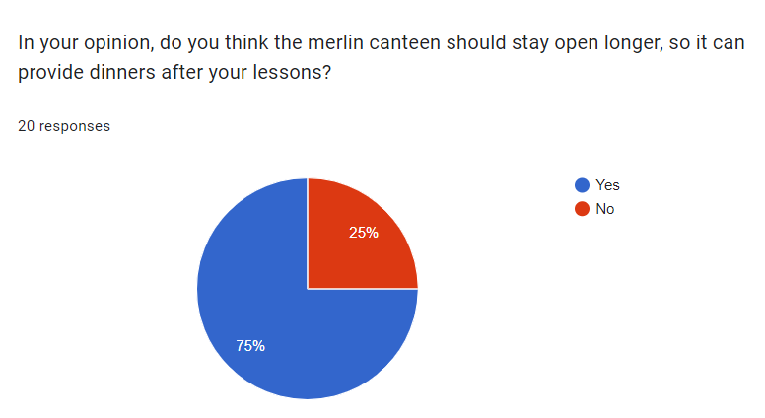

Furthermore, I found out that 80% of people use the canteen at lunch to have a meal prepared for them.
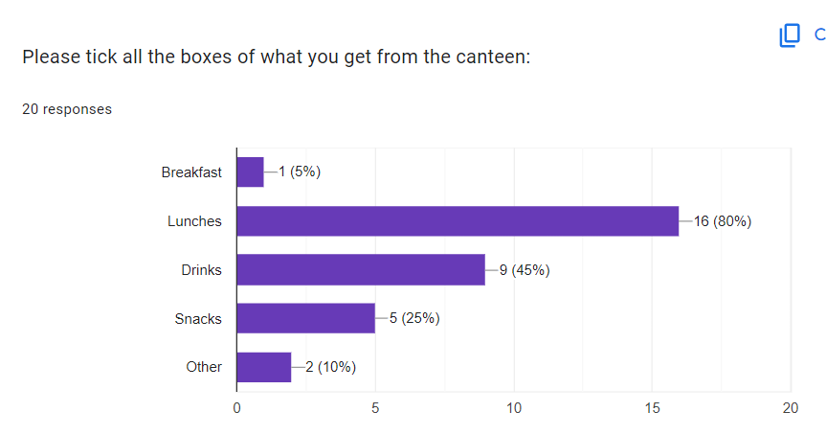

Another interesting piece of information is 45% of people finish their lessons latest 5pm, the rest range from 6pm to 7pm.
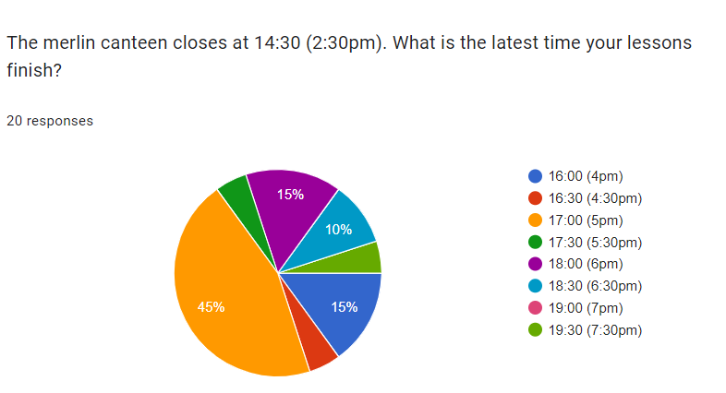

One participant commented that: ‘On the set design course we sometimes finish really late so it would be nice to be able to have that option and I also think it should be open at weekends’. This idea of potentially having the canteen stay open on the weekends is something I had not considered until I saw this comment. I personally think that might be too much of a leap right now, but if we can get evenings available for students, I don’t see why not to try and get the weekends open as well.
Another participant stated: ‘I feel that some courses, notably Acting and Set Design and Production often have lectures up to 6 and even later. Therefore, a later dinner menu would be ideal for these students’.
One question on reflection that would have been useful to include is regarding the potential financial benefits that the provision of an evening meal would be.

What’s Next?
From these results, I can say with some confidence that there is an eagerness for the canteen to stay open in the evenings. I truly believe that my idea is worthy of being brought to the attention of the university, as they have shown interest in my survey. I will present the results to them and discuss what our next move can be!
My proposal is that the Merlin/Myrddin canteen should stay open longer, so when students and staff finish their lessons, they can be provided with a good, hot or cold healthy meal. My pitch could also encourage students to lead a healthier eating lifestyle while promoting a wider sense of community on campus, for both staff and students. The financial benefits would be obvious for both customers and the canteen as students would be saving money and the canteen would be increasing their turnover.

Reference List

Remnant, J. and Adams, J. (2015) The nutritional content and cost of supermarket ready-meals. Cross-sectional analysis. Available at: https://www.ncbi.nlm.nih.gov/pmc/articles/PMC4509783/ (Accessed: 18th January 2024)

Stanford, A. (2022) Eat- The truth about ready meals. Available at: https://www.bupa.co.uk/newsroom/ourviews/ready-meals (Accessed: 18th January 2024)

Sogari, G. Velez-Argumedo, C. Gómez, M. and Mora, M. (2018) College Students and Eating Habits: A Study Using An Ecological Model for Healthy Behavior. Available at: https://www.ncbi.nlm.nih.gov/pmc/articles/PMC6315356/ (Accessed: 16th January 2024)

Appendix

1 - Copy of Canteen Opening Times Survey



