GROUP 4- COOL RUNNINGS

AIM
Integrating Project Part 1 M4X01506

UNIVERSITY OF WALES TRINITY SAINT DAVID SCHOOL OF ENGINEERING
Our aim was to split the research equally between the five members of our group and then to all come together and put our research of each different parts of the car to come to conclusion of the final product. We are to meet on a regular basis to show everyone our progress and discuss where we can improve. Then we will come together in the last week to merge all our research to produce our design.

DESIGN
For the design of our ‘soapbox’ rally car we all researched online together and came up with a few good ideas of what the chassis and the exterior bodywork of the car should look like. Our final and best designs of the car are the following:

Chassis and interior bodywork
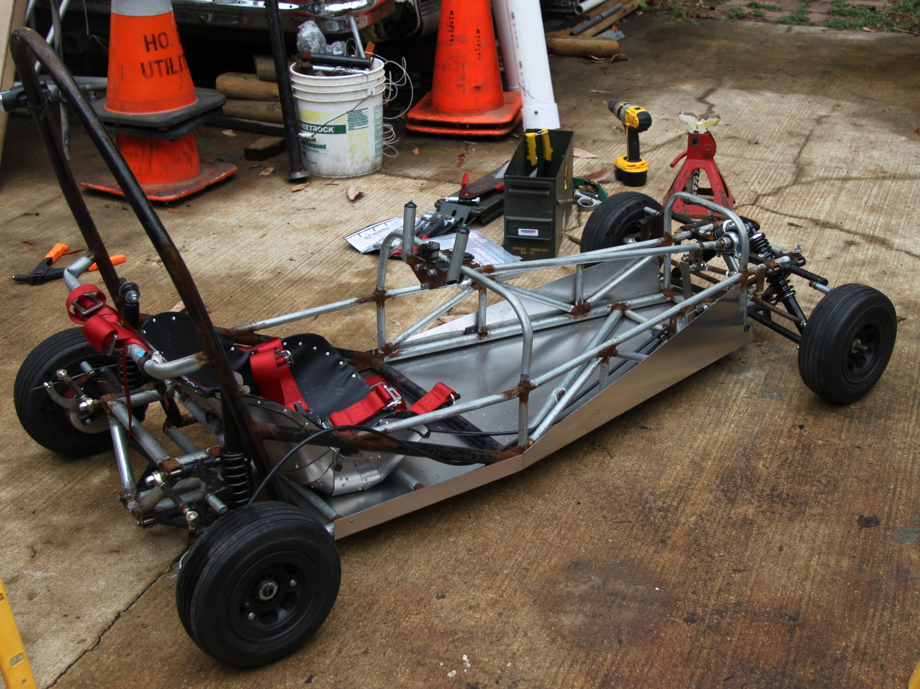

Figure 1 (L) and Figure 2 (R)

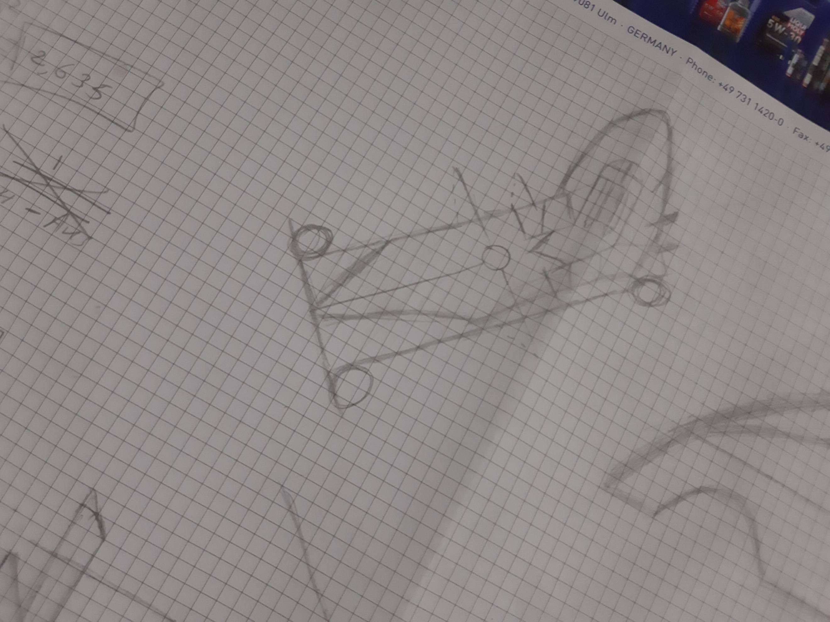

We found a few ideas online but ultimately decided on our design, figure 3, which is based on Figures 1 and 2. We found these images online and decided this was a good template to base our design of our car on. The chassis and bodywork resembles a Caterham 7 track car, which is known for its good handling and accerlerartion. It looks very light and sturdy and is a good base on to which we can add all our good ideas of each specific parts of the car. Our design also has extended roll bar at the back to protect the driver if the car was to roll. Which meets the safety precautions given to us.
Figure 3

Exterior
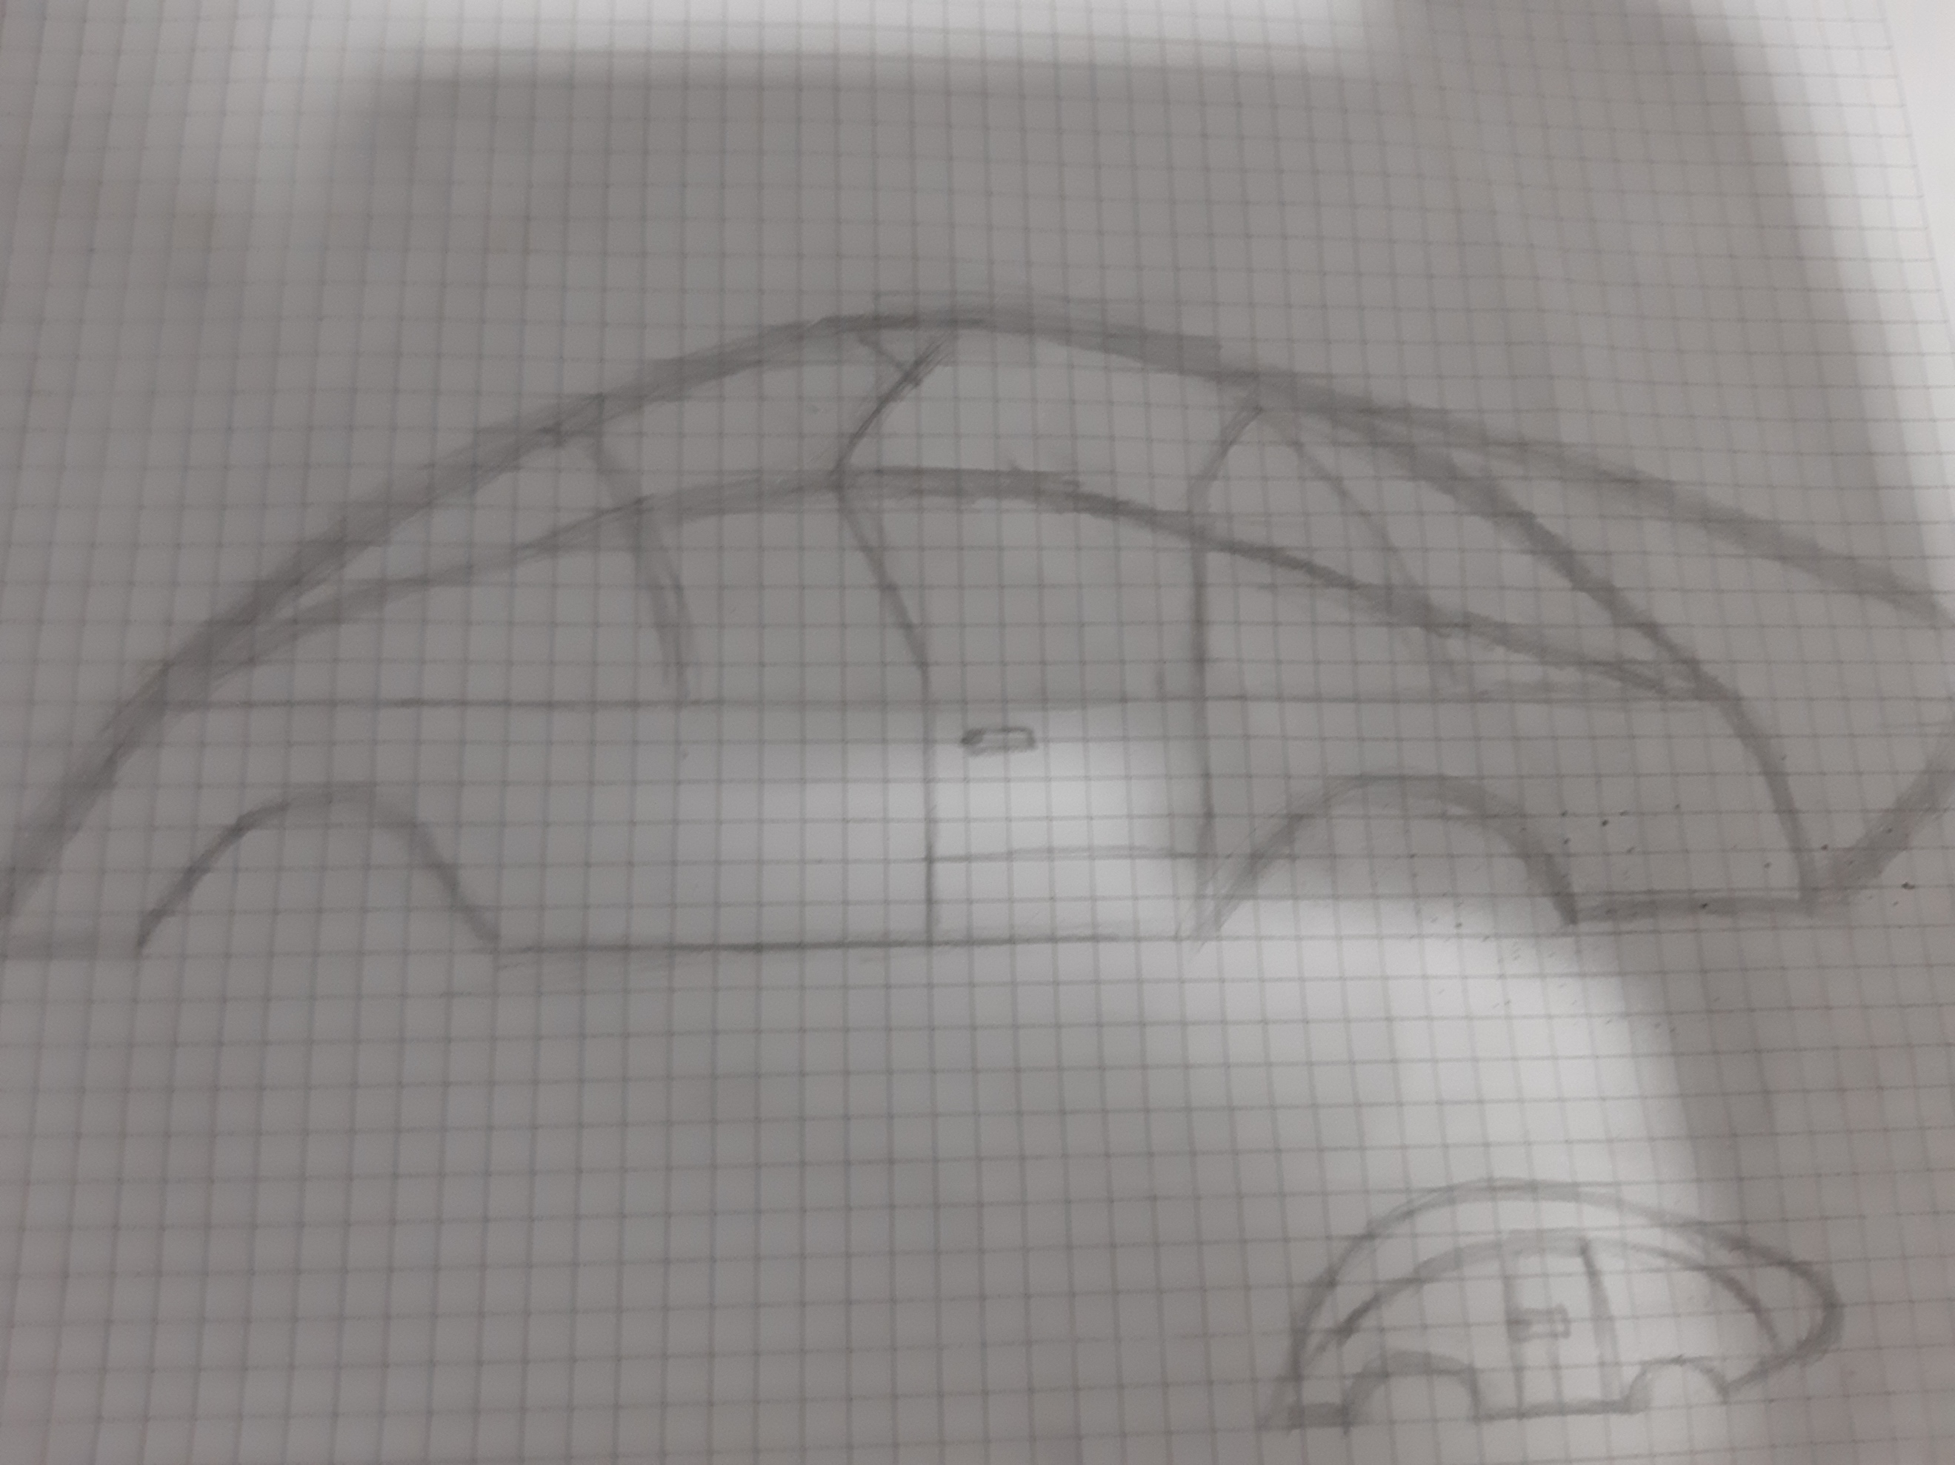

Figure 4 (L) and Figure 5 (R)

As you can see we ultimately decided to base our exterior design on a bobsleigh. Bobsleighs are known for their extremely good aerodynamics and so this, we thought, was a good idea to base the exterior design or our car to be on. Due to it primarily being used for the aerodynamics, to decrease air resistance on the rigid design of the chassis and interior. Figure 5 is what we came up with.

Steering
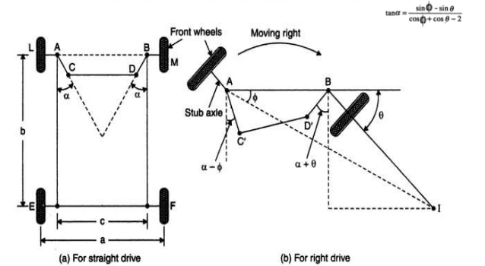

Figure 6

For the steering mechanism, we have chosen Ackerman’s design because it allows a flexibility of mounting positions because it utilises stub axels at a shorter length as appose to solid single front axle, this also enables the front wheels to move at different speeds through cornering to limit the reduction of speed through friction. Regarding the diagram above you can see that you can the longer you have the stub axels the more range you have in your steering angle making it possible to steer sharply in order to take a more effective racing line.
However due to the style of framework rods; AC, CD and DB will need to offer some rigidity to prevent the wheels facing the wrong way when in the air, therefor I aim to be using a hollow metal material such as scaffolding pole so it can be both rigid and light, Shaikusmanshag (2016).

Suspension
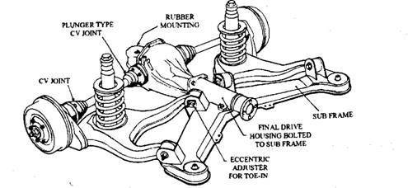

Figure 7

For the suspension element of the box we have chosen to isolate the rear suspension and use an independent rear suspension setup that would have large plywood wishbones that can hold a recycled shock absorber which will have a coil mounted over it, the axels will be able to withhold independent cycle speeds meaning the weight of the soapbox will be more efficient when pushing the soapbox round corners. The above diagram is the most accurate representation of the construction of the suspension however because we do not require a drive train we can eliminate the differential and final drive housing, What-when-how (2018).

Brakes
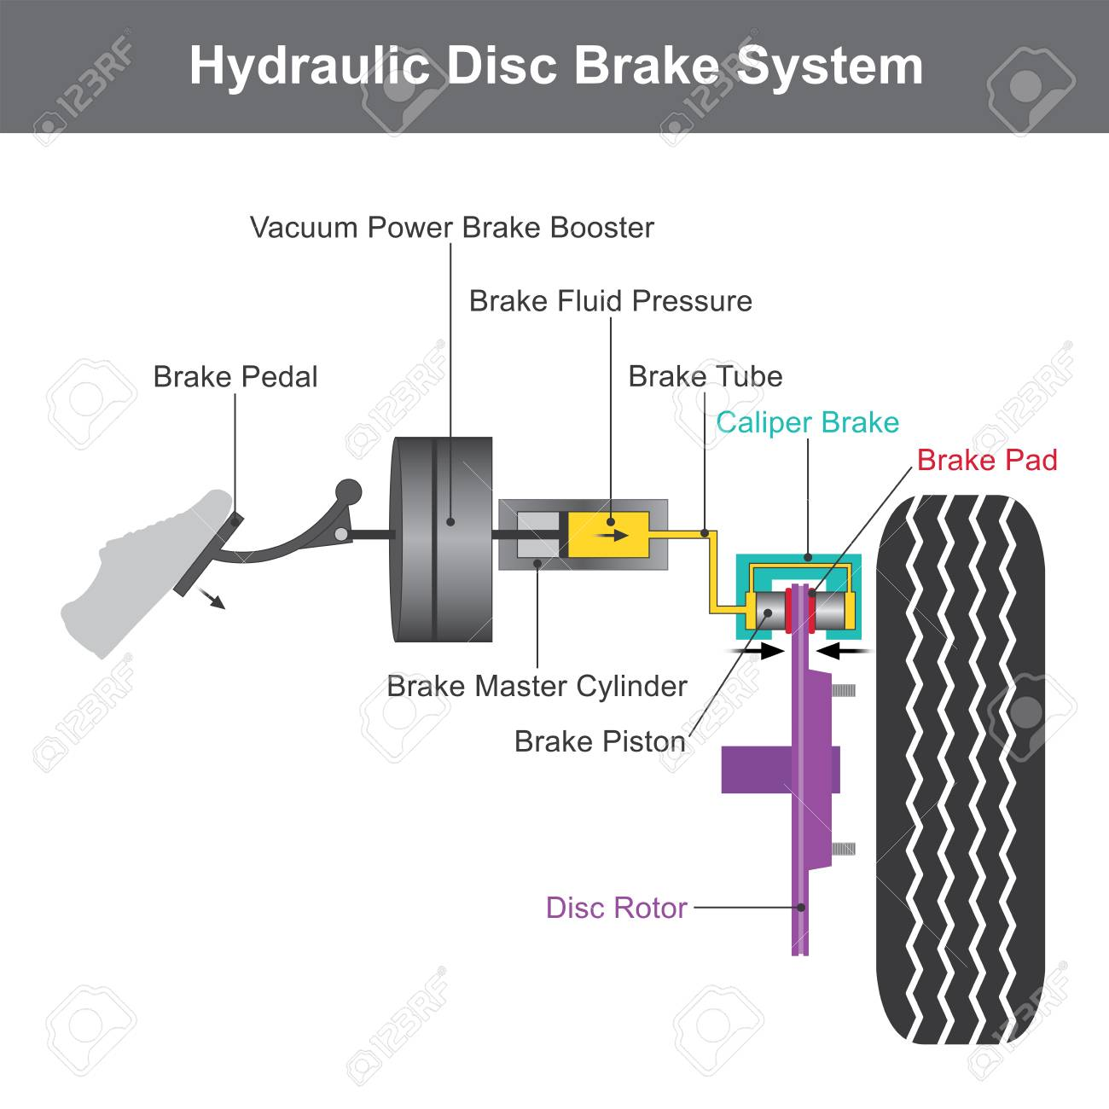

Figure 8

For the breaks, we have decided to go with a simple calliper breaking system. This we feel is more effective than drum brakes. This system works by when a brake pedal is pressed it moves a piston which in turn increases the pressure of the brake fluid. This pressure is transferred down the break tubes to the break piston. This pressure pushes the piston onto the brake pad which causes friction and slows the vehicle down, Chompipat (2019).

Materials
For the materials in order to make the car we decided the best thing was to get the metals needed to create the chassis and the body work was to get them from a scrap yard. This is because we can get the raw metals we need at cheap prices and can influence them in a way to t suit our needs.
Our research has found that in the Swansea area you can get aluminium for £0.60 per kilo, cast iron and steel for £0.08 per kilo and stainless steel for £0.70 per kilo.
We would then require welding to create the chassis from the scrap metal.

REFERENCES

Shaikusmanshag (2016) Steering Mechanisms Available at: https://www.slideshare.net/shaikusmanshag/7-steering-mechanisms (accessed 2nd January 2019)

What-when-how (2018) Independent rear suspension Available at: http://what-when-how.com/automobile/independent-rear-suspension-automobile/ (accessed 10th December 2018)

Pattarawit Chompipat (2019) Hydraulic Disc Brake system Available at: https://www.123rf.com/photo_98082209_stock-vector-hydraulic-brake-system-when-the-brake-pedal-is-pressed-a-push-rod-exerts-force-on-the-piston-in-the-.html (assessed 20th January 2019)

