

Reflective review on Employability skills
  - (Task 2: Reflective report)
Student name:
Student ID number:
Program: | Certificate in Higher Education Skills for the Workplace and Health and Social Care
Module: | Academic and Employability Skills
Module code: | BMSW 4001

Table of Contents
Introduction 3
Apply a reflective model and explain how the feedbacks collected on task 1 Assignment draft 4
Explanation of how we are developing the chosen skills and the tool we are using 5
4D for time management 5
CRAAP test for information search 6
RADAR Framework 6
Generating a Personal Development Plan (PDP) on each skill. 7
Prepare a presentation 7
What is time management? 7
Identify and list Donna’s time management problems. 8
Explain how Donna could use the 4D (Do, Dump, Delay. Delegate) time management strategy and other strategies to overcome her time management problems. 9
Conclusion: 11
References 12

Introduction
The very first three stages come to terms with much of what happened because during interactions. In contrast, the fourth through sixth phases deal with how the user may improve the experiences & consequences throughout the prospective. Another example of something like this is provided below, together with the installation of the Gibbs reflective model in action. Both 4D exams for time management and the CRAAP test for information search are important for diagnosing our capabilities and skills. Students provide much more premium on intellectual capabilities, including time management, note-keeping, team working ability, planning and organisation, & presenting skills, amongst many others (Jayaprakash, 2016). Several of them ought to be evolved, while others also have to be safeguarded in the same way as the previous, which was described with Donna’s case study at the end.

Apply a reflective model and explain how the feedbacks collected on task 1 Assignment draft
Reflective operators participate in a continual process of self-justification and self-evaluation to better understand their behaviours and the emotions they elicit in others. Gibbs claims. It is insufficient to have experiences from life to understand. Without reflection on this event, it could be swiftly ignored, or its possibilities for learning diminished. General conclusions or ideas may be produced from the sensations and ideas elicited by this introspection, and it is universal and applicable that enable new circumstances to be successfully addressed. This six-step strategy should assist learners in identifying their capabilities, possibilities for improvement, and activities they may take to improve their professional abilities (Sidell and Smiley, 2014). The first three phases address what occurred during the encounter. In contrast, the fourth through sixth steps address how the user may enhance the experience and result in the future, which is given below with the implementation of the Gibbs reflective model.
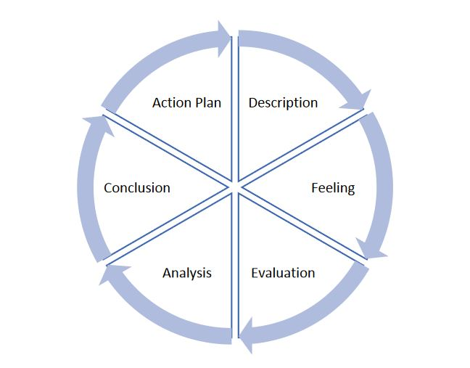
Figure.1: Steps of Gibbs reflective model (Lillyman and Merrix, 2012)
Description: This section should briefly describe the encounter or occurrence to establish the setting and provide clarity. While I was continuing to work during my first assignment, I managed to run into a myriad of problems. The knowledge and skills, including time management, note-taking, teamwork, planning and organisation, and presentation, are now important.
Feelings: I'm able to resume all my work promptly because of completing tasks. Afterwards, I presently keep a record of just about everything I do on a regular schedule. Previously, I was awful at conducting demonstrations (Linneman, 2017). My capability to manage & plan has still not been disrupted as a direct consequence of just this assignment. The technique of cooperative work and team was more overwhelmingly successful. There seems to be no modification to any of these specific skills.
Evaluation: Whenever I walk back and look at every one of my shortcomings, it has become clear that I would have a variety of serious shortcomings inside the categories of completing tasks, note-taking, & public speaking. The capacity to function in communities, develop a strategy, and maintain law and order have already been increased by the presence of something like this.
Analysis: It must have been vital for me to monitor my achievements regarding time management, note-keeping, teamwork, & presenting skills to become a success throughout my self-development. Teamwork, planning, and organisation are just the same, and they are often executed inside the work.
Conclusion: This experience has helped me approach my psychological restrictions as a supervisor and comprehend what needs ongoing advancement. Nonetheless, it affected my faith, which would have been a terrible outcome. I have also seen that my teamwork, planning, and organisation abilities have improved and might even be upgraded significantly.
Action Plan: My subsequent behaviours may well be classified into corporate strategy & temporary options based on the circumstances(Sidell and Smiley, 2014). First and foremost, I have to work on my time management, note-taking, and public speaking skills. The next is that I must endeavour to develop my capabilities inside teamwork, planning, and organisation.

Explanation of how we are developing the chosen skills and the tool we are using
4D for time management
By using the 4-D framework, we can discover out yet how to react to applications instantaneously. Delegate, Defer, and Drop are the four Ds. Accessing a framework inside the exact opposite way of the list of recommendations might well be effective. To get out in front of our limited time, it’s important to organise each assignment or endeavour through different headings.

CRAAP test for information search
The acronyms CRAAP represents meaning Currency, Relevance, Authority, Accuracy, & Purpose, which is used to identify the essential specifications(Sidell and Smiley, 2014). This furnishes us with a sequence of issues that will guide us in analysing the information that we encounter on the worldwide web. We will feel more confident in our capacity to identify materials that will meet the requirements of our assignments.

RADAR Framework
As students assess a source for information for integrity & applicability, the RADAR Framework will assist students in recalling whatever follow up questions(Tynjälä, Välimaa and Boulton-Lewis, 2012).
Rationale: Articles, journals, & internet sites are developed to satisfy a reason. Understand that perhaps the article's positionality constantly influences subjective observations.
Authority: While considering the believability of such a made by the author remarks, it's essential to consider their legitimacy.
Date: It's indeed essential to keep control of both the current or even the denomination because the material may quickly be already out of expiry. Statistics that have already been supplanted by recent information or current circumstances damage the credibility of their investigation &, consequently, overall reasoning.
Accuracy: Inconsistencies & omissions affect an argumentation. Consequently, accuracy is essential. Supplying wrong information affects their influence & credibility.
Relevance: It is vital always to have relevant information to back up their accusations.

Generating a Personal Development Plan (PDP) on each skill.
Personal development benefits both individuals and companies, as well as civilisation as a whole. As Benjamin Franklin famously stated, failure to prepare is intending to lose. Developing a personal development plan (PDP) is an easy and efficient approach to maintain a record of their progress (Allen, 2011). Without a plan, it will be challenging to maintain concentrate, and individuals will be incapable of achieving their objectives – whatever they could be.
The skills I want to acquire | The tasks I must complete | The services and support I need | Measure my success | The target date for the deadline
Gain Time Management skills in higher education | Used 4D tool for better time management | Gain skills for more time management | Follow evaluation and review on all coursework | Three months
Acquire note-taking skills | Attend all classes more attentively | Connect with professors and classmates to understand lectures better | Check all my notes end of every week | Six months or one term
Improve my presentation skills | Start taking more courses on presentation-based | Try to make more presentation skills | Take feedback on my teachers | One year

Prepare a presentation

What is time management?
The term "time management" refers to the practice of arranging and scheduling how one's time will be divided between various tasks. Effective time management helps people operate better, not tougher, enabling individuals to accomplish more in little time when time is limited and intense demands (Williams and Reid, 2016). Inability to handle their time effectively reduces their productivity and increases their tension. There rarely appears to be sufficient time in the day. "Time management" is a term that relates to the way people arrange and organise their time spent on various tasks.

While it can appear counter-intuitive to devote valuable time studying about multitasking rather than working, the rewards are massive:
- Increased accuracy and production.
- A more favourable professional image.
- Reduced strain.
- Greater promotion prospects.
- Increased opportunity to accomplish significant personal and professional objectives.
The top performers are masters of time management. By implementing the time management practices described in this part, anyone may increase overall capacity to work successfully, even with limited time and intense demands (Bowes, 2015). Productive time management demands a significant change in attention from operations to outcomes: keeping engaged is not synonymous with success.

Identify and list Donna’s time management problems.
The opportunity allowed in a college setting might hinder individuals who have not acquired time management capabilities. After leaving behind the tight timetables of high school, students frequently struggle to combine educational, recreational, and job responsibilities once they get into the university (Levin, 2015). When confronted with so many conflicting requirements on their schedule, many academics give up and allow events to unfold naturally, just as described in the given case study. Without the assistance of an instructor or guardian, it isn’t very certain that a student would accomplish without proper time management and organisation skills.
From the description, it is clear Donna had a lot of time management and planning as well as organisation programme. She had no time management skills since she left her work for her future self without planning. But it is not the only reason what effecting her schedule. Her lack of organising skills also drawback her swiftly working skills. Since she wastes a lot of time finding her things since she does not keep her room organised to find everything in definite places to find everything quickly, and doing her present work in a more organising manner, in university life, students need to multitask and manage their activities by giving all tasks of equal importance. But Donna found it very challenging to finish all her work properly and enjoy her university life.
As a result, decreased educational attainment results from weak time management, such as excessively high rigorous coursework or juggling employment responsibilities (Correa, 2012). Inability to uphold a grade point average, on the other hand, may result in Donna being placed on a track to graduate – a notice to enhance her productivity or face eviction from the organisation. While an excessively scheduled timetable can persuade people that enough rest is less important, which is not true. Neglecting solid time management skills also raises the risk that Donna will not satisfactorily finish her university experience.

Explain how Donna could use the 4D (Do, Dump, Delay. Delegate) time management strategy and other strategies to overcome her time management problems.
Many students find the educational environment daunting, particularly once they enrol for the same debut period at a university. They are constantly reacting and incapable of completing their responsibilities on time. Time management is critical in the academic lives of students. The four Ds of time management, usually known as the four Ds of efficiency, are a common technique for determining if work or effort is worth Donna's commitment (Popov, 2015). It entails generating a split-second choice on what to accomplish now, whether by herself or transferring to somebody else, what to do in the upcoming, and what to eliminate from her to-do list in order to be more productive.
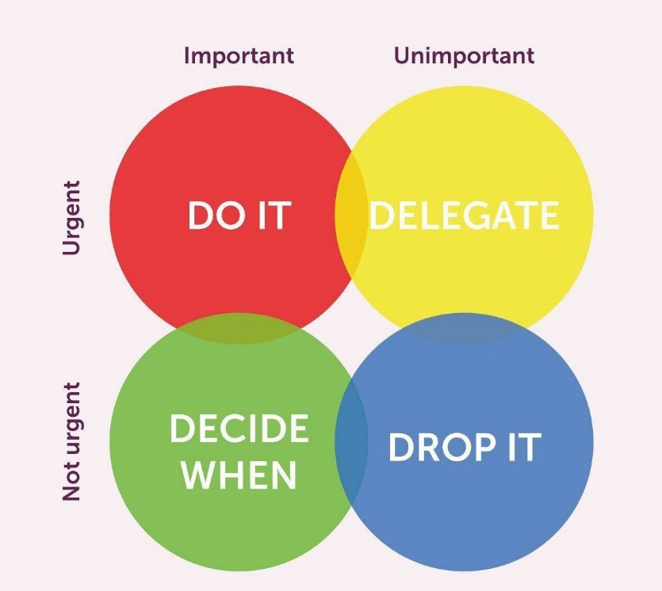
Figure.2: The 4D's of Time Management (Allen, 2011)
The 4 Ds are, as previously mentioned, Do, Defer, Delegate, and Delete. Donna may control her limited time more efficiently and concentrate on what interests her most by categorising a work or activity. Donna, like all other students, must maintain an ever-growing to-do list. Because students' obligations and expectations restrict their time, she must utilise it wisely in order to ensure that Donna's tasks correspond with their bigger aims.
Apart from that, Donna must create a daily timetable for her activities. To obtain the maximum benefits of this basic but effective time management strategy, create a list of her daily tasks and keep track of them. It is the only method to get insight into how people spend their time. And, perhaps more significantly, where it is being squandered. Moreover, Donna may monitor her time using a manual time log, her notebook, or programs.

Conclusion:
Students should be using these steps technique to help students recognise their personal qualities, along with potential areas for improvement & exercises which students may partake in to strengthen their core competencies (Jayaprakash, 2016). Cultivating a Gibbs reflective good project management structure is important. Regarding time electronic records management retrieval, 4D and the CRAAP test are excellent resources. Time management, note-taking, teamwork, planning and organisation, & presenting abilities seem to be the most significant parts of overall effectiveness that need to be appraised. This report also adds a presentation on a case study about Donna’s time management issues and how to solve her problems.

References
Allen, A., 2011. Time Management and Personal Development. Thorogood Publishing.
Bowes, C., 2015. Time management for students. Peterborough: First & Best in Education.
Correa, R., 2012. Weak and Strong Time Consistency. Theoretical Economics Letters, 02(01), pp.79-82.
Levin, P., 2015. Skilful time management!. Maidenhead: Open University Press.
Popov, A., 2015. Static sphercally symmetric solutions in 4D Einstein-Maxwell-anti-dilaton theory. SPACE, TIME AND FUNDAMENTAL INTERACTIONS, 1, pp.24-38.
Williams, K. and Reid, M., 2016. Time management. New York, NY: Palgrave Macmillan.
Jayaprakash, S., 2016. Interview Skills: Presenting Yourself With Confidence. Himalaya Pub. House.
Lillyman, S. and Merrix, P., 2012. Portfolios and reflective practice. Harlow, England: Pearson Education.
Linneman, T., 2017. Social Statistics. Milton: Taylor and Francis.
Sidell, N. and Smiley, D., 2014. Professional communication skills in social work. Boston: Allyn & Bacon/Pearson.
Tynjälä, P., Välimaa, J. and Boulton-Lewis, G., 2012. Higher education and working life. Bingley, U.K.: Emerald.

Appendix
Task 1 activity feedback template activities
Generic Assessment Criteria | Marks available | Marks  awarded
1. Engagement with Literature Skills
.
Task 1  Task 2 | 10
Task 1  Task 2 | 10
2. Knowledge and Understanding Skills

Task 1  Task 2 | 10
Task 1  Task 2 | 10
3. Cognitive and Intellectual Skills

Task 1  Task 2 | 10
Task 1  Task 2 | 10
4. Practical Application Skills

Task 1  Task 2 | 10
Task 1  Task 2 | 10
5. Transferable Skills for Life and Professional Practice

Task 1  Task 2 | 10
Task 1  Task 2 | 10

