Methodology Poster
The role of digital communication tools in mitigating social isolation among older adults in residential care
Study Aim
This study looks at whether digital communication tools like video calls and messaging apps can help mitigate social isolation among older adults in residential care. I also want to understand what makes residents more or less likely to use these tools, especially newer features like voice assistants or automated reminders.
Research Approach
I chose a qualitative approach because I am interested in people's real experiences and what they think about using technology. Numbers and statistics would not tell me the whole story here. It is the best way to understand how residents really feel about using technology. (Creswell and Poth, 2018; Braun and Clarke, 2021).
Purposive sampling
I am not picking people at random. I will deliberately look for residents and staff who can give me useful insights. I plan to speak with three different groups, so I get a range of views (Patton, 2015):
Participants | Justification | Sample size
Residents who already use digital tools | To hear about what works for them and what they get out of it | 4–7
Residents who choose not to use digital tools | To understand what puts them off – fear, confidence, or something else | 4–7
Staff (carers, activities coordinators, managers) | To get their perspective on what helps and what gets in the way | 4–7

Talking to different groups like this helps me build a fuller picture rather than just hearing one side of the story.
Data Collection
Semi-structured interviews: Most of my data will come from interviews. I have a rough set of questions to guide me, but I will also follow up on things that come up naturally during the conversation (Kallio et al., 2016). Interviews last 20–45 minutes for residents, 30–60 minutes for staff. I will record and transcribe everything.
Observation and informal chats: I will use thematic analysis following Braun and Clarke (2021). I will read through transcripts, look for patterns, group similar ideas into themes, and write up my findings with quotes from participants.
Thematic analysis
I will use thematic analysis, following the six steps outlined by Braun and Clarke (2021). This means I will read through all the transcripts carefully, look for patterns, and group similar ideas into themes. I am taking an inductive approach, which means I will let the themes come from the data rather than forcing them into a pre-existing framework.
Ethics
Consent – For residents with cognitive difficulties, I will use a process consent model, checking in regularly (Dewing, 2007).
Anonymity – I will use pseudonyms for everyone and store data securely.
Wellbeing – Talking about loneliness can be upsetting. I will let people stop at any time and offer a debrief afterwards.
Approval – I will get ethical approval before starting.
Ethical approval
Any data collection will have full compliance and approval from the authorities.
Making sure the study is trustworthy
I have thought about how to make sure my findings are believable and useful. I am using the framework from Lincoln and Guba (1985):
Criteria | Approach
Credibility | Talk to different groups of people (residents and staff), spend enough time in the setting to really understand it, and, where possible, check back with participants to make sure I have understood them correctly.
Transferability | Describe the care home and the participants in enough detail so that readers can decide for themselves if the findings feel relevant to other settings.
Dependability | Keep a clear record of every decision I make along the way, who I talked to, why I made certain choices, and how I analysed the data.
Confirmability | Keep a reflective journal where I write down my own thoughts and assumptions. This helps me stay aware of how my own background might be shaping what I see.

Visual Summary of Methodology poster
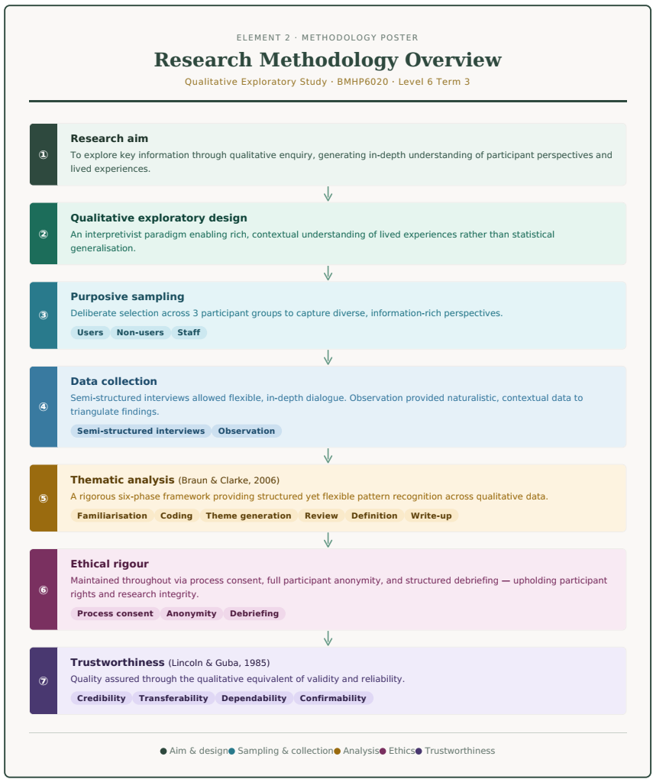

References
Braun, V. and Clarke, V. (2021) Thematic Analysis: A Practical Guide. London: SAGE.
Creswell, J.W. and Poth, C.N. (2018) Qualitative Inquiry and Research Design. 4th edn. London: SAGE.
Dewing, J. (2007) 'Participatory research: A method for process consent with persons with dementia', Dementia, 6(1), pp. 11-25.
Kallio, H. et al. (2016) 'A guide to conducting semi-structured interviews', Scandinavian Journal of Caring Sciences, 30(2), pp. 336-344.
Lincoln, Y.S. and Guba, E.G. (1985) Naturalistic Inquiry. Beverly Hills, CA: SAGE.
Patton, M.Q. (2015) Qualitative Research & Evaluation Methods. 4th edn. London: SAGE.
Spradley, J.P. (1980) Participant Observation. New York: Holt, Rinehart and Winston.

