 | University of Trinity Saint David

PgCert Teaching in Higher Education – Swansea
(February - Part Time)

Portfolio submission

Module: UNHE7008
Student: Hoang Dang Nguyen
Student ID: 2237970
Director of Studies: Mark Flagg

Submission date: …
Table of Contents
1. TEACHING INTERVENTION 3
Introduction 3
Description 3
Student engagement 3
The context 4
The intervention and the result 5
Feeling 9
Evaluation 9
Analysis 10
Conclusion 15
Action plan 15
References 16
2. TEACHING INTERVENTION – POSTER 18
3. TEACHING OBSERVATION 19
3.1. Teaching observation 1 19
3.2. Teaching observation 2 23
3.3. Teaching observation 3 27
4. CPD EVENT REFLECTION 28
4.1. CPD event 1 - KNOWLEDGE EXCHANGE SYMPOSIUM 2023 28
4.2. CPD event 2 – STORYTELLING COURSE 30
4.3. CPD event 3 – EMOTIONAL INTELLIGENCE 32
5. ASSESSMENT OF MY DEVELOPMENT AS A REFLECTIVE PRACTITIONER 34
6. EVIDENCE OF 100 TEACHING HOURS 36

1. TEACHING INTERVENTION – 4k words – now 5599

Introduction

This report provides a teaching intervention cycle which was developed to address issues related to student engagement (SE). SE is one important factor which help students to learn (Biggs and Tang, 2011, p.5; Brooks et al., 2023).
This teaching intervention is structured by Gibbs’ reflective cycle (Gibbs, 1988), a well-known tool which is useful to examine a concerned experience, identify the reasons, and develop solutions to improve it the next time. The data used in this report is identified through my observation and feelings. It is also reflected from discussions with students, which is a normal practice that I always do to enhance my performance.

Description
In this description, the notion of student engagement is examined. After that, the context of the teaching intervention is explained. Finally, the intervention is presented.

Student engagement
The concept of SE can be understood in many different ways (Groccia, 2018). Kuh (2009) suggests the term engagement can be used to characterise the quality of effort and participation in productive learning activities. It is also defined as “the energy and effort that students employ within their learning community, observable via any number of behavioural, cognitive or affective indicators across a continuum” (Bond et al., 2020, p. 3). According to Almulla (2023), Coates (2007, p.122) suggests SE is related to “active learning, participation in challenging academic activities, formative communication with academic staff, involvement in enriching educational experiences, and feeling legitimated and supported by university learning communities”. In addition, the active learning component can be further divided, for example by Petress (2008) into 10 indicators, ranging from asking questions and having enthusiastic attitude to be highly collaborative. On the other hand, Prince (2004) suggest active learning refers to student’s conscious attempts to do meaningful learning activities. Michael (2006) defines the concept very similarly to Prince’s, except he also includes the self-reflective activities by which students can evaluate their own understandings.
From the various definitions of SE, it is clear that it is related to conscious, meaningful learning activities that student practice both inside and outside the class which significantly affect their learning effectiveness. In addition, due to SE’s nature, it can be guided through proper motivation and suitable in-class activities (Biggs and Tang, 2011; Race, 2020). Therefore, this teaching intervention focuses on SE and what I did to promote SE. For the purpose of this study, SE is defined as the observable activities of students which express their focus on the learning during the class and their active engagement with the knowledge, other students, and I during the class. These are significant and highly observable characteristics of SE (Kuh, 2009; Coates, 2007 as cited in Almulla (2023); Petress, 2008; Biggs and Tang, 2011; Race, 2020) where I can directly make a difference.

The context
This intervention report focuses on the Introducing the Modern Workplace module. In this module, there were 13 students who were in their first term at the university. In addition, some students were adult learners. Students came from different parts of the world, including. Romania, India, and Bulgaria. To many of them, the UK education system was new.
The module was organised into ten weeks, with four class hours each week, divided into two two-hour sessions on Wednesday and Friday. The module required them to have 160 self-study hours in addition to the 40 class hours.
The first dimension, student’s focus during the class, was problematic in my class. Many students did focus well in the class. Mobile phones were frequently used by the students. When asked to put the phones away, some students replied that they need their phones to translate the new words (displayed in the slides). Some students casually went to the room’s corner to charge their phone during the lecture, sometimes even while another student was answering a question from me.
The second dimension, student’s active engagement, was low in my class. While some students actively engaged with the class, most students did not engage with the lecture. They stayed silent for most of the time or may have non-academic chat with nearby students. For example, four male, Indian students tended to sit together and frequently whispering to one another, only to be reminded by me from time to time. When asked, students mostly asked to repeat, sometimes also to explain, the questions. The following conversation typically happened during the first few weeks:
Lecturer: Do you have any questions?
Students: (Most stayed silent. One or two “No” weakly pronounced)
Lecturer: OK. So, what is the meaning of this (concept)?
Students: (Silent)
Lecturer: (a student’s name), what do you think about this question?
(The named student): I don’t know. (or “Can you please repeat the question?”)
The engagement was better during class activities, such as group discussions or case studies.
Therefore, the overall SE was low. Interventions were needed to enhance the students’ performance.

The intervention and the result
From the context, I identified aspects of SE in the classroom and developed solutions to handle them (A1, K1). There were seven main interventions provided in my class. They were late arrival, phone distraction, small talks, confusion, lost interest/focus, low engagement with the assigned tasks, and dominating students. In anticipating these issues, the students and I jointly developed a set of ground rules and the students’ personal goals in the first lecture. The ground rules included items designed to handle the anticipated issues late arrival, phone distraction, small talks, and low engagement with the assigned task. The two items of lost interest/focus and confusion were mentioned, as I encouraged students to raise questions whenever they have one. I also mentioned that students would be asked frequently and they would be expected to handle the questions properly. In addition, in the goal-setting session, students were encouraged to share their personal goals which were both long term (e.g., to be a manager) and short term (e.g., to improve confidence and communication skills). I clarified which and how certain short-term goals can be achieved in my class. These rules and goals, included in the appendices, laid a strong foundation for my intervention activities. (A1, A2).
Firstly, the lateness was an issue as many students did not attend the class on time. Many also re-joined the class late after the 10-minute break. I found out that some students returned late for the class because they were playing snooker or had food. I asked students individual of their reasons for being late and asked them to manage their time better as no valid reasons were provided. I explained that snooker and food were not valid reasons to be late. Also, I reminded students that time management was one key employability skill and how it could affect their quality as professionals. After my consistent efforts, the lateness was somewhat alleviated. In particularly, most students returned after the break on time. (A2, A4).
Secondly, regarding the phone, it was required by the ground rules to be put away unless it was to be used academically. In practice, many students were found having phone in their hands most of the time. Noticeably, they used the phone for unclear purposes. I usually asked students, who was using the phone, a question related to the current topic. Regardless of whether that student could answer the question, I reminded them of the ground rule. While the first few applications of this intervention have an immediate effect, they did not have a long-lasting one. Eventually, I had to ask students to put their phone away, either in their pocket or in their bag. After this stronger requirement, the phone distraction issue was reduced noticeably. On the other hand, as the ubiquitous digital technology can be used to enhance pedagogical practices (Biggs and Tang, 70), I designed some activities to encourage students to use technology responsibly. For example, students were asked to voice their opinion anonymously using their phones on Mentimeter platform. I believed this approach had a positive impact on students’ attitude regarding the phone. (A4).
Thirdly, there were considerable small talks among some groups of students who usually sat together. I first reminded them of the ground rule which discourages small talks. However, this only worked temporarily. Therefore, I asked them to sit separately. Also, I stopped talking whenever small talk occurred. In addition, several activities were designed to help students to communicate responsibly. For example, “teach your friend a concept” activity which required a student to explain a newly learned concept to a partner, who then would take their turn to teach later. In addition, group activities were routinely introduced so students can communicate academically in the class. I also took the opportunities to change group members frequently, providing students the opportunities to communicate meaningfully with other members of the class. I felt this intervention allowed students to communicate more responsibly in the classroom, as the small talks were reduced significantly. (A4).
Fourthly, confusion was identified as one reason which lowered SE. This issue was anticipated by an item in the ground rule which said, “There are no stupid questions”. In addition, I actively observed students during the class and provided interventions whenever confusion was detected. In such situations, I would first ask if any student was confused and then require them to provide explanations or examples for the concerned topic. To address confusions, I provided different and relevant explanation and examples. If necessary, further discussion and activities could be provided to ensure the confusion was alleviated. For example, a case study could be provided, and students would be required to analyse the case study using the concerned concepts. Usually, the problem was resolved without using any cases. After addressing the confusion, I reminded students that there was no stupid question, and the discussion had enhanced the understanding of all students. In addition, I showed students I did not hesitate to ask if I did not know the answer, and showed my appreciation. For example, I asked students to explain their national culture and workplace culture, and said “Thank you! I did not know that! What you said is a great example for this topic!”. After this intervention, students were more confident in asking question. They vocally pointed out their confusion and demonstrated their enthusiasm when their comments were positively received and resolved by me. The confusion was considerably reduced after this intervention. (A1, A2, A3, A4).
The fifth issue was the lack of interest and focus. I gained students’ attention by asking them to co-review last lecture’s concepts and theories and linked them to the module’s learning outcomes and students’ goals. During the class, I anticipated and frequently looked for the signs of the issue. When such issues are identified, I would attempt to connect the tasks with the learning outcomes and the personal objectives of students which were set in the first lecture. In some situations, I directed the discussion toward the topic’s relevance and its meaningful values. As students are highly diverse (age, working experience, interest, etc.), I provided suitable explanation and requirements for them. For example, for young, inexperienced students, case studies and videos are provided; while for adult and experienced learner, I challenged them to find examples and explain phenomenon in their own workplace. Also, I asked students to take notes and encouraged them to use their notes while answering questions from me. Finally, I had some one-on-one talks with the related students to resolve the issue. After the intervention, the issue was significantly alleviated. (A1, A2, A3, A4). (K1, K2, K3, K4, K5, K6).
The sixth issue was the students’ low engagement with the assigned tasks. To address the issue, I investigated students’ wellbeing and whether they were ready for the assigned task. This was done by direct communication which was delivered in a friendly and caring way. Whenever necessary, students were provided a two-minute break without leaving the class so they could prepare themselves for the tasks. Also, I clearly explained the purposes and relevance of the task before asking students to perform them. In addition, the tasks were designed to be more interactive and interesting. This is important because interactive learning is one of the best ways to foster effective learning (Illeris, 2007). For example, some tasks required students to communicate in pair or group, while some others required them to write the answer down or to present. Students were made aware that I expected them to deliver results, either in written form or by providing answer vocally. Moreover, I monitored students’ performance during class activities closely. As students worked on their assigned tasks, I moved about observing and providing support proactively. Students were provided tasks relative to their perceived capabilities. Slowly, students’ learning skills and confidence were built. After the intervention, the engagement rate was enhanced significantly (A1, A2, A3, A4). (K1, K2, K3, K4, K5, K6).
The seventh and final issue was dominating students. Sometimes, some students dominated the class’s activities, such as group discussion or handling short questions. In such situation, I intervened by purposefully direct the discussion to other students, and to emphasize the importance of inclusivity and diversity in group work. For example, I said “It is a good idea. Now let’s explore other ideas and options…”. This approach worked very well and significantly reduced the dominating student issue. (A2, A3, A4). (K1, K2, K3, K4, K5, K6).
In all interventions, I maintained a positive and caring attitude. Respect and consideration were always demonstrated. Feedback was provided as suggested by Petty (2009, p.66), i.e., to recognise achievement and performance, to provide specific guidance which enable actions, and to complete the feedback with a positive ending whenever possible. In addition, I was quick to recognise the difficulties and achievements of students. As such, the classroom atmosphere was changed significantly during the term. While it was formal and somewhat tense at first, gradually the students were more relaxing, they communicated more freely and openly, and were considerably more collaborative. Most students were motivated to engage with the learning activities. SE was enhanced significantly as students paid more attention, asked more questions, and handled questions better than before. At the beginning there were several groups of students – each groups seem to be not connected to the other groups. After the interventions, most students were able to engage with other students, for example by providing his or her feedback to the answer provided by other students. At the end of the term, most students were more conscious of their behaviours, and the class was considerably more friendly and active. In addition, some students developed and demonstrated their genuine interests in the learning by actively engage with the learning material, the lecturer, and other students. As such, near the end of the term, most issues were considerably resolved. (V1, V2, V3, V4).

Feeling
At various points during the term, I felt rejected, incompetent, disappointed, and also happy and motivated. I had the negative emotions as my efforts did not bring results, as I saw students exhibiting undesirable behaviours despite my efforts. On the other hand, I realised that some intervention attempts may take sometimes to work, and the students’ personal characteristics and situations can significantly affect the interventions’ effectiveness. As I learned to be more patient and to understand students better, I felt motivated and happy as more and more students gradually demonstrated desirable behaviour. Some of them proactively approached me asking for feedback and advise, which motivated me to keep trying. Now that the term has ended, I realised I was too impatient with students’ progress despite knowing of their difficulties. Many of them were not confident of their language skills. Many of them were struggling with cultural differences inside and outside of the classroom. This is a lesson that I learned this term.

Evaluation
//More citation needed. Combine evaluation and analysis.
There were some important improvements made throughout the intervention efforts. The feedback received, together with the information acquired through observation and break-time conversations with students demonstrated a high level of progress made since the intervention. The class’s atmosphere was improved considerably. Most students demonstrated goodwill and showed efforts to improve their engagement. On the other hand, the improvements were slow regarding the time management, especially the late arrival at the beginning of the class. The reasons are examined in the next step, analysis.

Analysis
My primary theoretical approaches combine constructive alignment (Biggs and Tang, 2011), Ramsden (2003), Illeris, 2007), and andragogy view of Knowles et al. (2020). Following constructive alignment, the learning occurs when the lecturer sets up a learning environment which encourage students’ learning activities, and the teaching and assessment must be aligned with the intended learning outcomes. The focus is on what and how students are to learn. Building on that, Ramsden (2003, p. 65) points out that student interest, knowledge base and previous experience affect their approaches to study. In addition, Illeris (2007) suggests that the content, the incentive, and the environment are crucial to enable effective learning.
Also, as many students in the class were adult learner, the six assumptions of andragogy (Knowles et al., 2020, p.32) were examined. This andragogy model is a well-known theory and preferred learning approach for adult learners (El-Amin, 2020). As shown in figure 1 below, they are (1) the need to know, (2) the learner’s self-concept, (3) the role of experience, (4) readiness to learn, (5) orientation to learning, and (6) motivation.
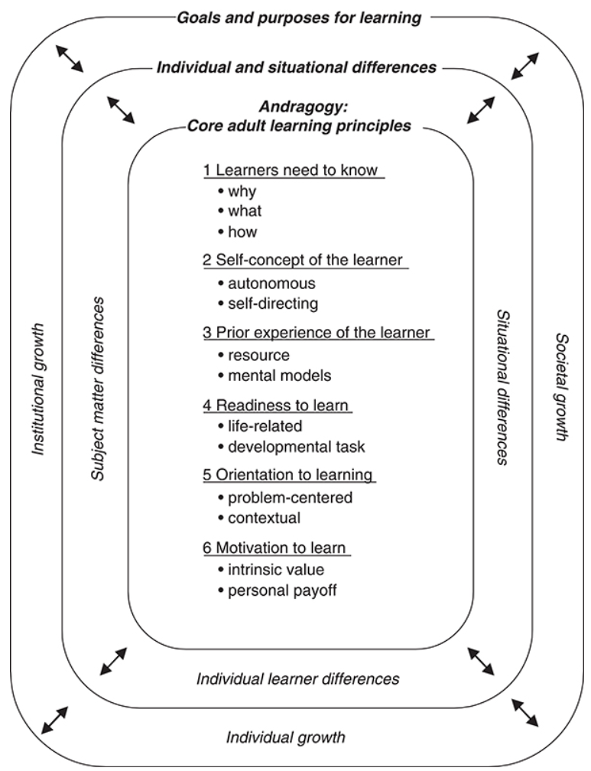
Figure 1 – Andragogy in practice model (Source: Knowles et al., 2020, p. 72)
In addition, this module has a small number of students. According to Ramsden (2003, p.149), six issues could happen in this context: A lecture is provided, not a dialogue; the lecturer talks too much; students respond to questions from the tutor, but otherwise do not talk; students do not prepare for the class; one student dominates the discussion; and the students want solutions, not discussing them.
By adapting the effective learning model and the constructive alignment to the andragogy model, and to avoid the issues identified by Ramsden, a theoretical approach to enhance SE can be attained. The next step in the analysis is to examine the characteristics of the students and the context and how it fits with the adapted andragogy framework. The constructive alignment approach can be seen in my interventions, as I set up the learning environment to enable the learning activities which are aligned with the learning objectives.
As my students were mostly international students who were adult learners and had not experienced the UK education system before. These characteristics significantly affect the andragogy framework. The first assumptions, learners need to know, means students would want to learn when they believe the learning is useful to them (Knowles et al., 2020; Petty, 2009, p. 47). In my class, many students did not clearly understand why the module was important and how it was relevant to their academic and personal goals. They also did not have a clear understanding of what are expected of their behaviours in the class and how to engage with the academic works. This issue occurred at the lower level as well, for example a specific topic or concept of a lecture.
To enable this assumption, I always supplemented the what with the why during the course. The justification and clarifications were provided to explain how concepts, theories and frameworks were relevant to the aims of the course. The clear links between the content of the course and the actual situations of management and organisation were clearly identified. The performance expectations were clearly communicated and justified. Also, I emphasized the importance of developing and understanding solutions, rather than solution themselves.
In addition, I asked for feedback regarding the learning and teaching activities whenever appropriate. Also, my clear intention to learn more would also positively reinforce students’ learning intention (“I is keen to learn from us!”, “the lecturer told me he learned something from me today!”, “He is learning everyday even though he is a lecturer!”). (A1, A2, A3, A4, A5, K1, K2, K3, K4, K5, K6, V1, V2, V3, V4).
The learner’s self-concept was another challenge, as many students were used to with their personal perceptions and expectations (Knowles et al., 2020; Purwati et al., 2022; Knapke et al., 2024) which were significantly different from my classroom. For example, when I asked students to do their homework from the next time, one student openly and immediately replied that this was a higher education environment, not a high school. He further emphasized that as an adult, his time was limited, and he would do the homework if he could arrange it, however he would not prioritise it nor committed to it. Also, to many students, it was unusual to be required to revise last lecture’s contents, to not have small talks, and to not use their phones. They were highly resistant to my attempt to manage and direct the academic activities. This was further exacerbated by the language and culture differences.
To handle this assumption, I used carefully crafted sentences to enhance the sense of objectivity and self-direction of the learner. For example, “Do you think it would be beneficial for us to understand this concept? Why?”, or “What would the employer want from the employees regarding this issue?”. In addition, to enhance the sense of ownership, my approach was clearly framed and communicated as a collaborated, student-centric efforts to enable student’s development. For example, in the first lecture, students were asked to collaborate with the lecturer to develop the ground rules and their own developmental goals. Another example is when students were asked to choose a case study out of two. They were also asked to be mindful of their own behaviour, and to identify and call out inappropriate behaviours in the class. In addition, students were encouraged to ask questions, including requiring me to speak slower or to pronounce clearer, as English was not their first language. To further emphasize the point, I frequently asked if the students were still following the lecture, and if anything need to be repeated. In addition, positive feedback was provided whenever appropriate so students could capitalise their strengths and build their confidence and engagement. (A2, A3, A4, K1, K2, K3, K4, V1, V2, V3, V4).
On the other hand, the learner’s experience played an important role in fostering effective learning in my class (Knowles et al., 2020). The international adult learners in my class were highly diverse in terms of knowledge, experience and skills. They would be motivated to focus and engage if their views were appreciated. That means they were happy to share their unique perspective and had the chances to learn other’s different viewpoints. This also means I need to individualise the teaching contents effectively and to overcome different biases and presuppositions (Lewis and Bryan, 2021).
To take advantage of this factor, I took notes if the students were having part time jobs or had working experience in the first class. During the module, I attempted to connect the content of the lecture to the students’ experience. In addition, students were often asked to use their working experience to provide examples for the lecture. In addition, I used many case studies, group discussion, and peer-helping activities during the course. Students with relevant knowledge and experience were encouraged to discuss and share their views regarding the matters, ensuring I did not speak more than required, and help students to develop their self-esteem and peer-helping activities. Formative and positive feedback was provided whenever appropriate. (A1, A2, A3, A4, K1, K2, K3, K4, V1, V2, V3, V4).
Next, the readiness to learn refers to whether students were well prepared to handle the new learning content and whether the new learning content was relevant to students at the time (Knowles et al., 2020; Knapke et al., 2020). For example, if students believed they were not ready to do presentation, and presentation was not important to learn at the time, then they would not be motivated to engage with the presentation task. Therefore, it is important that the tasks were provided timely, when they were able to do the task and believed the tasks were important.
To enhance student’s readiness to learn, I connected the learning contents, the aims and learning outcomes of the module, and student’s personal goals clearly. In addition, new concepts, frameworks, and tasks were introduced in ways that related them clearly with the learner’s personal goals. To facilitate this, I asked the learners to set clear career and personal goals for themselves from the beginning. In addition, I frequently used reputable websites in real time to show clearly the learning content were relevant to their professional goals. Constructive alignment was used and demonstrated thoroughly during the course. Furthermore, to ensure students were capable to learning the new knowledge, I provided multiple different activities, individualised student’s learning experience, and closely monitor their performance in order to provide support whenever necessary. Also, students were given tasks to perform in their own time, which help them to understand and prepare better for the next lecture. (A1, A2, A3, A4, K1, K2, K3, K4, V1, V2, V3, V4).
The fifth element, orientation to learning, focuses on how the learning could help students to address their real-life situations (Knowles et al., 2020; El-Amin, 2020). To this end, the activities should be named appropriately, for example “Writing better business letters” rather than “Composition I” (Knowles et al., 2020, p.33). This is especially important to international, adult students who may understand the term “composition I” differently and are motivated to learn solutions to their real-life, work-related tasks.
To enable this element, the learned contents were connected to the real-life experience of the topic. In addition, the tasks were named meaningfully and clearly, for example, “How to motivate your employees” instead of “Activity 1”. Moreover, I asked students to come up with their real-life personal or work-related situation tasks and position the learning contents in a way that help developing solutions for those tasks. (A1, A2, A3, A4, K1, K2, K3, K4, V1, V2, V3, V4).
The six and final element, motivation, suggests that adult learners are motivated more by internal pressure (job satisfaction, self-esteem, etc.) rather than external ones (better jobs, promotions, etc.) (Knowles et al., 2020, p.33). In addition, Petty (2009, p.45) believe that students will be motivated if they believe engaging with the learning activities will earn them acceptance from peers and the lecturers and the learning activities are fun. For my class, Adult students may feel marginalized, due to race, class, ability, and age differences (Flynn et al., 2011). In addition, there were issues of language challenges, cultural differences, and social integration (Barnett, 2013). On the other hand, regarding feedback, Petty (2009, p. 66) suggests that feedback should be motivational by pointing out the parts that students did well, then identify the issue, and finally provide complements when the students fixed the issue.
Various approaches mentioned earlier, such as ground rules, goal-setting, encouraging students to share their real life experience and tasks, and especially showing students respects and encouragement, played an important role in motivating my students. For example, I always encouraged students to perform, e.g. “I am sure you can do this!”, “you did a great job!”, “your experience was highly appropriate for this case”. I aimed to have specific compliments which praise specific attitudes, behaviours, or performance of students. In particular, I provided compliments which address the perceived weaknesses of students, such as their language skill or the relevance of their experience. In addition, I designed tasks which were motivational, for example each student was asked to provide one unique answer to the question. I also asked students to review performance of their peers with request such as “What did the student do well?” or “What could the student do differently the next time?”. For group work, I identified members to take advantages of the diversity, enhance the inclusion, and improve the class cohesion. Moreover, I also provided students with clear expectation, allowed them to have sometimes for preparation, and approached them individually to offer support if needed. As such, students were supported to perform well, and were motivated because they could see that I trusted them and genuinely tried to support them. (A1, A2, A3, A4, K1, K2, K3, K4, V1, V2, V3, V4).
By combining these six elements together, I was able to develop significant improvements regarding the seven identified issues. The combination the learner’s self-concept, orientation to learning, the role of experience, and motivation are used to resolve all issues. In particular, the late arrival, phone distraction, small talks, and dominating students were resolved by these four elements. By combining these elements, I explained to students why these issues must be resolved, they could and should resolve the issues, how those issues can affect their real-life situations and tasks; and motivated them to do so.
The issues of lost interest or focus, confusion, and low engagement were resolved by using all the elements. The addition of the readiness to learn and orientation to learning helped students to reevaluate their focus, connect the learning activities with their goals and experience, and develop a need to handle the tasks. It was crucial to motivate students and to provide individualised learning experience so students could reach the expected level of performance.
Due to the strong links among theories, the context, and the implementation, significance improvements were achieved in most areas, except the late arrival. The open communication showed that it was due to reasons such as traffics or students’ personal situations. Nevertheless, students who were late were much more positive and active in the class, especially in comparison to their behaviours prior to the intervention. In addition, after the intervention, the students behaved much more responsibly in my class: they used limited small talks and sometimes phones to check their understandings and handle the language issues. The interventions were implemented effectively and therefore not only reduce resistance, but also streamlined the learning and teaching activities and encouraged students’ participation. As I was able to relate to students in a more positive way, students were significantly more receptive to feedback from me and their peers. After the intervention, the classroom was much more positive and more interactive.

Conclusion
In summary, my intervention activities were highly effective in addressing most of the identified issues. A strong theoretical foundation and a good understanding of the situation were the keys to this.
In addition, by examining the situation, I learned new valuable lesson. For my interventions to work, my efforts must be accepted by the students and must be suitable to their situations. Moreover, the activities could have been more abundant, as they could have address different students’ diverse needs and attract their interest more effectively. In addition, brief down-time, i.e., the time when students are not required to perform, should have been introduced to help students to internalise what they had learned and promote their independent learning behaviors. Finally, I could have done better by being more patient. I need to learn when to push and when to wait, as some students may need more time than others in order to improve their behaviours.
On the other hand, SE are affected by other factors as well. For example, their involvement in enriching educational experiences (e.g., extra-curriculum activities), and if they feel legitimated and supported by university learning communities. A more comprehensive approach toward SE would bring more benefits to the learners and the institute.

Action plan
As demonstrated in the conclusions, two main issues are identified. They are orientation and engagement activities.
The orientation activities are geared toward helping students to develop their sense of belongingness and self-esteem. They should feel safe and be accepted. Therefore, activities such as finding common values and sharing common goals are to be included more prominently. In addition, I will keep providing students relevant tasks which encourage them to use their knowledge, skills and abilities. Successful completion of those tasks would help boosting their self-esteem and ultimately improve their engagements.
From the work of Brigg and Tang (2011), (Race, 2020), Petty (2009), Davis and Arend (no date) and Ramsden (2003), I developed a list of intervention activities to promote SE in the future. First, I should provide more questions which encourage students to make use of their unique background and experience. Second, a 5-minute reflective report-writing activity is to be organised at the end of each lecture. In this exercise, students are required to write at least three interesting concepts that they have just learned. They are also required to explain and provide one example for each of them. Third, more online interaction will be organised. Students will be required to provide their answers to the online forums, ranging from developing multiple-choice questions to answering case studies’ questions. Fourth, students will be able to demonstrate their knowledge and understanding by taking short quizzes. And finally, I will examine the incorporation of the flipped classroom approach (Bergmann and Sams, 2012) which are suitable to my adult students.
In addition, I need to improve their patience. To do so, I need to learn more about students and set more realistic expectations. In addition, I would also continue to follow relevant pedagogical research and open to new teaching and learning approaches, as they are the means to achieve the goal: to enable students to have effective and efficient learning experience and practices. SE will be enhanced significantly and allow students to perform learning activities well when these activities are implemented. (A5, K5, K6).

New
El-Amin, A., 2020. Andragogy: A theory in practice in higher education. Journal of Research in Higher Education, 4(2).
Lewis, N. and Bryan, V., 2021. Andragogy and teaching techniques to enhance adult learners’ experience. Journal of Nursing Education and Practice, 11(11), pp.31-40.
Purwati, D., Mardhiah, A., Nurhasanah, E. and Ramli, R., 2022. The six characteristics of andragogy and future research directions in EFL: A Literature Review. Elsya: Journal of English Language Studies, 4(1), pp.86-95.
Knapke, J.M., Hildreth, L., Molano, J.R., Schuckman, S.M., Blackard, J.T., Johnstone, M., Kopras, E.J., Lamkin, M.K., Lee, R.C., Kues, J.R. and Mendell, A., 2024. Andragogy in Practice: Applying a Theoretical Framework to Team Science Training in Biomedical Research. British Journal of Biomedical Science, 81, p.12651.

Not yet
Roessger, K.M., Roumell, E.A. and Weese, J., 2022. Rethinking andragogical assumptions in the global age: How preferences for andragogical learning vary across people and cultures. Studies in continuing education, 44(1), pp.14-38.

References
Almulla, M.A. (2023) ‘Constructivism learning theory: A paradigm for students’ critical thinking, creativity, and problem solving to affect academic performance in higher education’, Cogent Education, 10(1), p.2172929.
Barnett, J.A. (2013) ‘The adult learner: From a narrative perspective’, Journal of Adult and Continuing Education, 19(2), pp.66-80.
Bergman, J. and Sams, A. (2012) Flip your classroom : Reach every student every day. International Society for Technology in Education.
Biggs, J. and Tang, C. (2011) Teaching for quality learning at university. Open University Press, McGraw Hill.
Bond, M., Buntins, K., Bedenlier, S., Zawacki-Richter, O. and Kerres, M., (2020) ‘Mapping research in student engagement and educational technology in higher education: A systematic evidence map’, International journal of educational technology in higher education, 17, pp.1-30.
Davis, J.R. and Aren, B.D. (no date) Seven ways of learning
Flynn, S., Brown, J., Johnson, A. and Rodger, S. (2011) ‘Barriers to education for the marginalized adult learner’. Alberta Journal of Educational Research, 57(1), p.43.
Gibbs, G. (1988) Learning by Doing: A guide to teaching and learning methods. Further Education Unit. Oxford Polytechnic: Oxford.
Groccia, J.E. (2018) ‘What is student engagement?’, New directions for teaching and learning, 154, pp.11-20.
Illeris, K. (2007) How we learn: Learning and non-learning in school and beyond. Routledge.
Knowles, M.S., Holton III, E.F., Swanson, R.A., and Robinson, P.A. (2020) The adult learner: The definitive classic in adult education and human resource development. 9th ed. Routledge.
Kuh, G.D. (2009) The national survey of student engagement: Conceptual and empirical foundations. New directions for institutional research, 141, pp.5-20.
Michael, J. (2006) ‘Where's the evidence that active learning works?’, Advances in physiology education.
Petress, K. (2008) ‘What is meant by" active learning?"’, Education, 128(4).
Petty, G. (2009) Teaching today; A practical guide. 4th edn. Nelson Thornes.
Prince, M. (2004) ‘Does active learning work? A review of the research’, Journal of engineering education, 93(3), pp.223-231.
Race, P. (2020) The lecturer's toolkit: A practical guide to assessment, learning and teaching. Routledge.
Ramsden, P. (2003) Learning to teach in higher education. Routledge.
Sims, H. and Barnett, D.R. (2015). ‘Devalued, misunderstood, and marginalized: Why nontraditional students’ experiences should be included in the diversity discourse’, Online Journal for Workforce Education and Development, 8(1), p.2.

Altymurat, A., Muhai, M. and Saparow, T. (2021) ‘Human behavior in organizations related to Abraham Maslow's hierarchy of needs theory’, Interdisciplinary Journal Papier Human Review, 2(1), pp.12-16.
Min, H., Tan, P.X., Kamioka, E. and Sharif, K.Y. (2020) ‘Enhancement of study motivation model by introducing expectancy theory’, International Journal of Learning and Teaching, 6(1), pp.28-32.

Appendices

A1: The ground rules
- Be timely (arrivals, break time, leaving the class).
- Treat others the way you want to be treated, with kindness and respect.
- Raise your hand if you want to speak. One person speaking at a time. Do not have small talk.
- Ask if you have any questions. There are no stupid questions.
- In the class, only work on things related to the lecture.
- Complete the assigned tasks, both in-class and homework.
- No eating during classes.
- Use mobile phones and electronic devices academically.
- The lecturer should speak clearly, loudly, and use examples to explain.
Note: the ground rules were jointly developed. The rules must be well justified in order to be included. Students were explicitly asked to develop ground rules for the lecturer.

A2: Goal-setting: some sample goals
- I want to be a manager in the next five years. I want to improve my time management and communication skills this term.
- I want to work in the field of marketing. I want to enhance my presentation and networking skills this term.

A3: Motivational theories

My intervention could also be explained by using Maslow’s hierarchy of needs (Altymurat, Muhai and Saparow, 2021) and the expectancy theory (Min et al., 2020).
First, Maslow’s hierarchy of needs shows that many students are unsure about themselves and whether they can perform well due to their lack of confidence. They are level 4, adult, international students who have little experience with the British education system. As such, they have needs for belongingness and self-esteem. In the first few weeks, the lack of belongingness and self-esteem possibly caused some of them to stick to their own perceived group (e.g., most Indian students sat together in one place, and most Romanian students sat together elsewhere). In addition, they mostly communicated to one another who belongs to the same group, sometime by using their national languages instead of English. Furthermore, most students were reluctant to ask questions, even when it was clear that they did not understand the topic at hand.
Therefore, it was of utmost important that I approached the situation and offered the intervention with respect, care and consideration. I made it clear to them of my role as an academic in the class, and what their roles entailed. I recognised their cultural differences, academic and non-academic challenges, and offered support. As such, I was able to have them sharing their questions, their confusions, and their challenges. I showed them that having difficulties were normal, and those can be addressed. It was important that students felt accepted and their difficulties were recognised and respected by the lecturer. I gave students the directions and the time they need to explore the options and to adjust themselves, such as the issues with time management and the lack interest/focus. In addition, I understood that certain behaviours take time to be adjusted, and I told students my expectations clearly. I chose his words carefully because language barrier could be a potential issue.
On the other hand, adult students bring valuable prior experiences and skills (Knowles et al., 2020). Race (2020, p. 152) demonstrates that turning unconscious competence, the lack of awareness that one is good at doing something, to conscious competence enhances students’ confidence and self-esteem. Therefore, whenever appropriate, I recognized and promoted experience sharing among students. For example, in the culture topic, I asked students what values they perceived in their current/previous company at their home countries, how they were developed, and how they affected the organisations’ performance. Such activities can boost students’ self-confidence and enhance their communication skills. A combination of feedback and formative feedforward were able to support students’ development in this area, as suggested by Race (2020).
Second, once the challenges of belongingness and self-esteem had been addressed, the student engagement (with the learning content) can be examined. The purpose is to encourage deep learning which is about making sense of the topic and link it with other things (Race, 2020, p.7). Deep learning is important because it allowed students to reach aims of the module. In contrast, surface learning is about remembering (Race, 2020) and thus will not allow students to reach the module’s aims. To facilitate encourage deep learning, I used the expectancy theory (Vroom, 1964) which suggests that motivations will be presented if there are links between efforts – performance (expectancy), performance – outcome (instrumentality), and outcome - personal goals (valence). This is an implementation of the constructive alignment approach (Biggs and Tang, 2011). Following this theory, I guided students through learning content and learning activities so they can perform well, so the expectancy link could be established. I also developed the instrumentality link by connecting learning content, learning activities, and learning outcomes, so students can see clearly how their efforts can lead to the desired outcomes. Finally, I built the valence link by showing students the link between learning outcomes and learning activities with student’s professional and personal goals.
Specifically, to develop the expectancy link, I monitor student’s performance carefully. When students faced difficulties in engaging with learning materials and activities, I walked them through so that they can see it is possible to reach the expected performance level. Therefore, the expectancy was developed. In addition, I set up certain ground rules which were clearly linked with the expected performance. I also identified the issues (time management, lack of focus, etc.) and made it clear to students how their performance could be improved if the issues were resolved. I treated students with respect, and showed them that they can do better. This helped students to set more challenging (but achievable) expectations for themselves. In addition, Race (2020, p.130) believe that formative feedback is instrumental in helping students to reach their maximum potential. Therefore, I took all the opportunities to provide feedback to ensure students would be able to perform well.
This expectancy link was found to be difficult to established. One notable example was about the student’s expectation. They were asked to set performance target for their presentation assessment in week 7. There were three groups who set the target of 75%, 80% and 85% respectively. These targets were contrastive to the overall class performance at that point. Upon retrospection, those targets were overly ambitious and underwhelmingly delivered. It showed the students perceived the relationship between their capabilities and the standard of the module unrealistically, assuming their targets were set for real.

//to be deleted

// The focus of the class was also distracted due to students coming late to the class.
//Some of them lacked confident in communicating in English, or otherwise were not used to with direct communication with me, their lecturer. As they were not used to with the learning environment provided, significant challenges are expected, including both their academic skills and their own expectations.

2. TEACHING INTERVENTION – POSTER
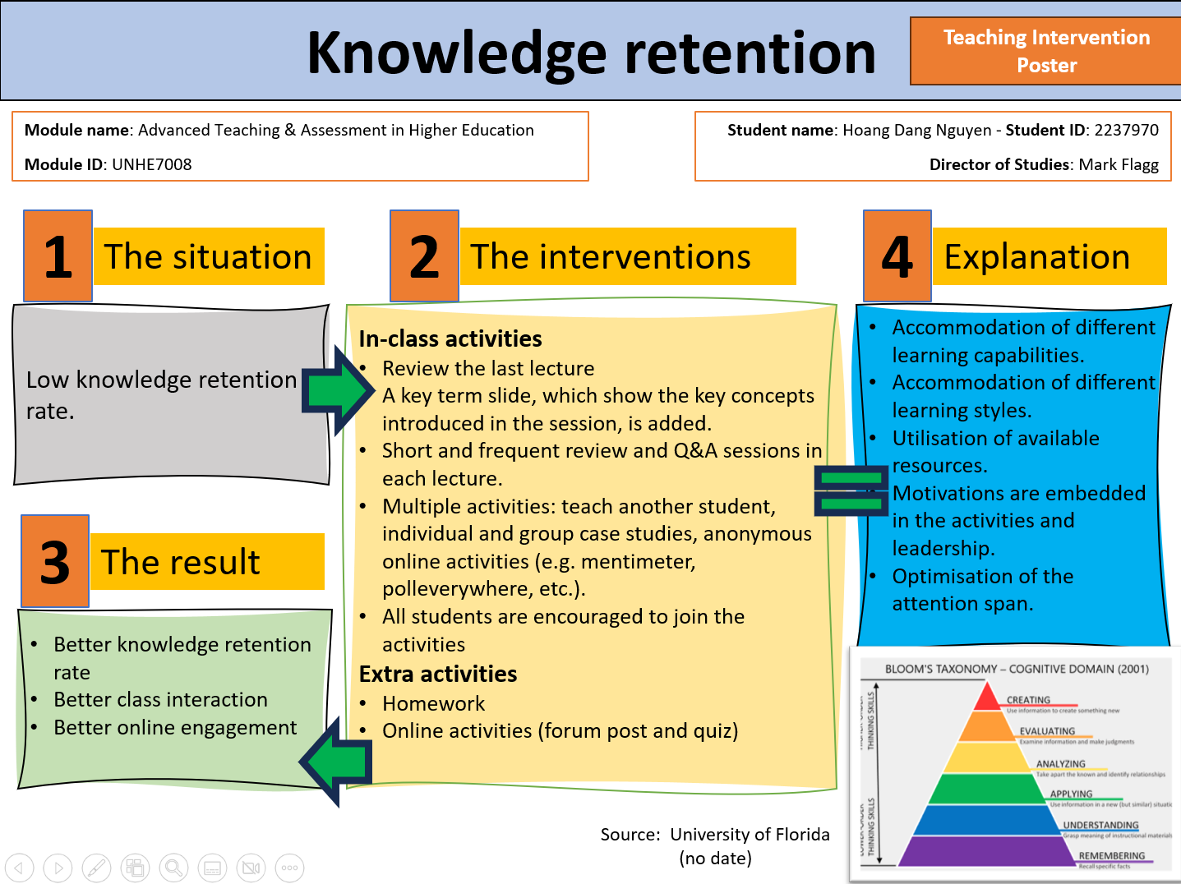

3. TEACHING OBSERVATION

3.1. Teaching observation 1
PGCert tHE OBSERVATION FORM


Details of the Observation
Observee | Hoang Nguyen
Practice Advisor / Expert peer observer | Eleni Koutsogeorgou-Andreou
Date of the Observation | 8th November 2023
Campus / Location | London
Date, Time, Duration | 13:45-14:45 (one hour)
Subject Speciality | Managing Performance
Type of activity | Lecture
This observation will contribute to the participant’s portfolio of evidence to satisfy the assessment of the PGCert tHE and should be undertaken by an experienced academic colleague. Observation by a fellow participant on the programme is not permissible as a means of authenticating practice.

Teaching/Support preparation [A1: Design and plan learning activities]
i.e. Preparation, selection and organisation of content. Choice of teaching/learning methods.

Comments
- I provided a well-organised Lesson Plan prior to the peer observation date, with appropriate time and content for learning and teaching for the session.
- Nevertheless, the observed part of the session was mainly focused on a group activity of students, rather than presenting information on the topic of that week.
- The choice of teaching and learning methods were appropriate, demonstrating an active learning approach. However, during the observed part of the session, I did not use a wide range of techniques for teaching, e.g. use of more resources.
- I appeared well-prepared for the session with very good knowledge on the taught subject.

Teaching [A2: Teach and/or support learning.]
i.e. Beginning class, introduction, continuity with other sessions, students’ prior knowledge. Clarity of presentation. Pace. Attitude to the subject matter. Use of appropriate reinforcement. Ending the session – summary, future work etc. Technique and Aids: General apparatus – board, data projector, use of handouts. Was effective communication achieved? Was there good student–teacher rapport? Were the aims/outcomes achieved? Appropriateness of teaching/learning methods.
Comments
- At the beginning of the session, I assessed the prior knowledge of students by recapping with students what was learned in the previous session, using direct questions and encouragement to students to share their ideas and notes about the main points from the previous session.
- I introduced briefly the topic of that week to students in a clear manner.
- Most of the time of the observed part of the session was devoted to a group activity, so was not enough time on presentation of the topic by I prior to the group activity. So the pace and clarity of presentation, could not be assessed fully.
- Nevertheless, for the part that was observed, the information presented to students were clear and I had a good pace when presenting the activity and clarifications on the students’ answers.
- Appropriate reinforcement and encouragement were used by I verbally, and when working in groups, providing to students clarifications and additional guidance about the task.
- I mainly used slides with a projector; no handouts or other platforms/web information.
- Effective communication was achieved between I and the students.
- The teaching and learning methods used were appropriate. However, could have used more information and resources, for example, to write on a whiteboard the answers of students from their group activity or when they recapped what was learned in the previous session.

Effective Learning Environments [A4:Develop effective learning environments and approaches to student support and guidance.]
i.e General class atmosphere, level of participation, attention, and interest. Student attitude and ability to carry out classwork. Were learning problems identified and overcome? Awareness of individual needs. Attitude to students.
Comments
- Very good class atmosphere, students appeared relaxed and quiet, with a positive attitude. No disruption in the class.
- Students’ attention retention was very good, with high engagement during the class.
- I tried to engage students who were quieter compared to their fellow students, by asking them their opinion on the topic as well.
- To students who did not remember what was discussed in the previous session, I gave them an explanation of what was discussed and asked them to revise the material/slides of the previous week to find more information.
- When the students did not understand the question or did not answer, I rephrased the question to students.
- Most of the students understood the information, and performed well in the task.
- I had a positive attitude towards students and appeared enthusiastic on the subject matter.
- Prompted students to share their own experiences in a work environment, related to the topic. Some of the students exchanged views and brief comments about the experiences of others.
Assessment [A3: Assess and give learners feedback]
i.e Formative/summative assessment examples , Question and answer technique. Other evaluation procedures, class management, instructions to students005C.
Comments
- I used formative assessment, with a group activity on the topic of the week.
- Used question-answer technique multiple times, and effectively.
- Managed the class in a satisfactory degree; no disruption and attention retention.
- The attitude of I was appropriate towards students when managing the class, e.g. establishing class rules for talking, using a name tag on their desk, etc.
- To the students who were answering correctly, I expressed positive remarks for example, “well done”.
- The instructions provided for the group activity were clear, although the activity took more time than it was stated in the Lesson Plan.
- Summarised verbally the responses from each group.
Core Knowledge
- Subject knowledge
- Teaching methods
- Student learning
- Learning technologies
- Evaluation
- Teaching effectiveness
- Quality assurance

Comments
- I demonstrated good subject knowledge and active listening skills.
- The teaching methods were appropriate, effective, but could have demonstrated more breadth of resources and learning technologies.
- I demonstrated skills for evaluation of responses of students, from recapping and the group task.
- The teaching part observed appeared effective for students.
- The lecturers provided clear guidance to students on the task discussed, and for the group activity.
- Formative assessment methods, learning techniques, and conduct during the class were appropriate and in line with the Academic Quality Handbook of the University.
Professional values
- Respect for learners
- Promote participation
- Evidence informed approaches
- Wider context of HE
Comments
- I demonstrated respect for learners and their views, providing support to those who did not understand the question or did not remember what was discussed.
- Promoted participation and encouraged all students to engage with the discussion/activity.
- Used evidence-informed approaches, although did not state the evidence they derived from, but the Lesson Plan was comprehensive and appropriate, using scaffolding to build on the previous knowledge and professional experiences of students relevant to the topic.
- Demonstrated an attitude of inclusivity and diversity towards students.

Examples of good practice:
- Promoted an active learning approach during the class.
- Very good skills as a lecturer in terms of learning and teaching practice.
- High engagement of students during the class.
- Encouragement to students to participate.
- Clarifications and guidance provided to any students who required additional support for their learning.

Action points:
- To provide more information on a topic before asking students to engage in group activity about it.
- To use more resources for teaching and learning (e.g. whiteboard, online resources, etc.)

Observer: Dr Eleni Koutsogeorgou-Andreou Date: 15/11/2023

Observee .....Hoang Nguyen................................. Date : 17/11/2023

PGCert PARTICIPANTS
On completion of the peer observation reports for each module, compose a short reflective paragraph on your observation experiences for inclusion in your portfolio along with the observation sheets.

Teaching observation 2
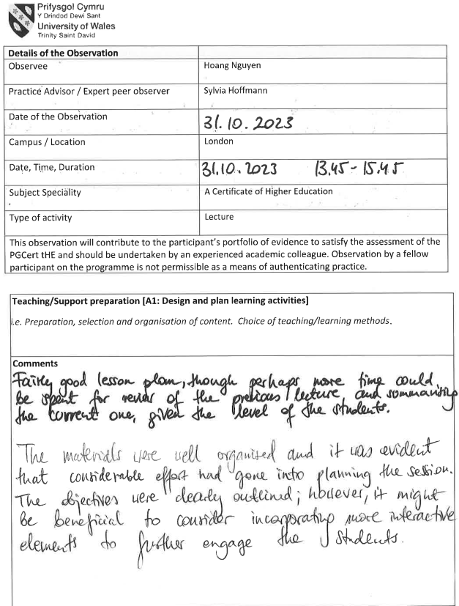

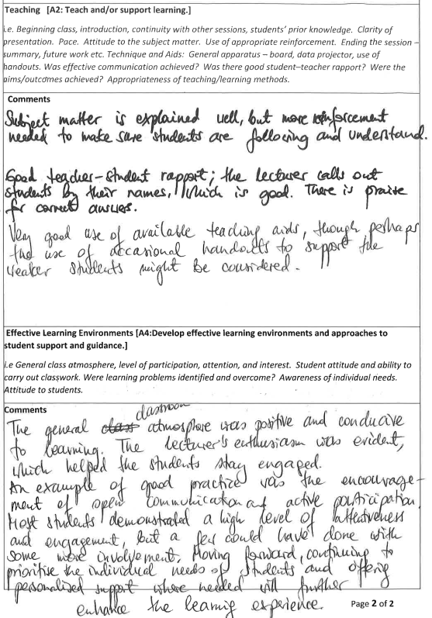
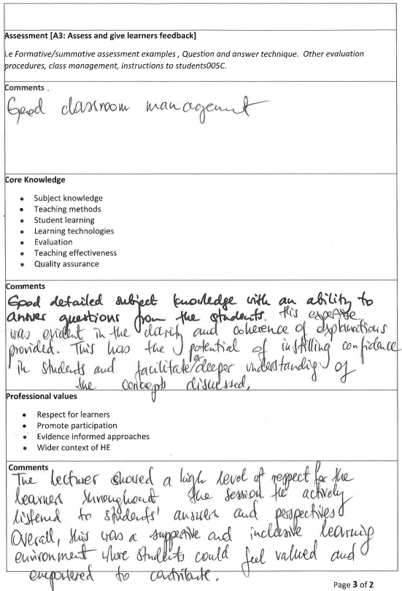
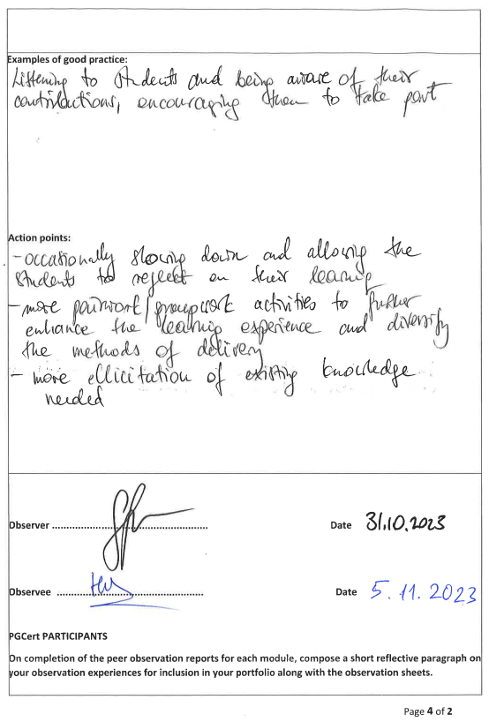

Teaching observation 3
PGCert tHE OBSERVATION FORM

Details of the Observation
Observee | Hoang Nguyen
Practice Advisor / Expert peer observer | Amit Naik
Date of the Observation | 22nd November 2023
Campus / Location | London
Date, Time, Duration | 22nd November 2023, 13.45-15.45, 2hrs
Subject Speciality | Managing Performance
Type of activity | Lecture
This observation will contribute to the participant’s portfolio of evidence to satisfy the assessment of the PGCert tHE and should be undertaken by an experienced academic colleague. Observation by a fellow participant on the programme is not permissible as a means of authenticating practice.

Teaching/Support preparation [A1: Design and plan learning activities]
i.e. Preparation, selection and organisation of content. Choice of teaching/learning methods.

Comments
I provided a well-organised Lesson Plan prior to the peer observation date, with appropriate time and content for learning and teaching for the session.
The choice of teaching and learning methods were appropriate, demonstrating an active learning approach.
I appeared well-prepared for the session with very good knowledge on the taught subject.

Teaching [A2: Teach and/or support learning.]
i.e. Beginning class, introduction, continuity with other sessions, students’ prior knowledge. Clarity of presentation. Pace. Attitude to the subject matter. Use of appropriate reinforcement. Ending the session – summary, future work etc. Technique and Aids: General apparatus – board, data projector, use of handouts. Was effective communication achieved? Was there good student–teacher rapport? Were the aims/outcomes achieved? Appropriateness of teaching/learning methods.
Comments
At the beginning of the session, I assessed the prior knowledge of students by recapping with students what was learned in the previous session.
I introduced briefly the topic of that week to students in a clear manner.
Appropriate reinforcement and encouragement were used by I verbally.
I mainly used slides with a projector.
Effective communication was achieved between I and the students. I observed good student interaction in the class.
The teaching and learning methods used were appropriate for the lesson.

Effective Learning Environments [A4:Develop effective learning environments and approaches to student support and guidance.]
i.e General class atmosphere, level of participation, attention, and interest. Student attitude and ability to carry out classwork. Were learning problems identified and overcome? Awareness of individual needs. Attitude to students.
Comments
Very good class atmosphere, students appeared relaxed and engaged with I and with the lesson well. Good decipline was obsereved and there was no disruption in the class.
Students’ attention retention was very good, with high engagement during the class.
I tried to engage students who were quieter, encouraging them to participate.
I gave appropripriate explanation of what was discussed and asked them to revise the material/slides of the previous week to find more information.
When the students did not understand the question or did not answer, I rephrased the question to students.
I had a positive attitude towards students and appeared enthusiastic on the subject matter.
Assessment [A3: Assess and give learners feedback]
i.e Formative/summative assessment examples , Question and answer technique. Other evaluation procedures, class management, instructions to students005C.
Comments
During the session I used formative assessment, asking questions to check if the students understoon the concepts delivered.
Managed the class in a satisfactory degree; no disruption and attention retention.
The attitude of I was appropriate towards students when managing the class, e.g. establishing class rules for talking, using a name tag on their desk, etc.
To the students who were answering correctly, I expressed positive remarks for example, “well done”.
Core Knowledge
- Subject knowledge
- Teaching methods
- Student learning
- Learning technologies
- Evaluation
- Teaching effectiveness
- Quality assurance

Comments
I demonstrated good subject knowledge and active listening skills.
The teaching methods were appropriate, effective for the lesson.
I demonstrated skills for evaluation of responses of students.
The teaching part observed appeared effective for students.
Formative assessment methods, learning techniques, and conduct during the class were appropriate and in line with the Academic Quality Handbook of the University
Professional values
- Respect for learners
- Promote participation
- Evidence informed approaches
- Wider context of HE
Comments
I demonstrated respect for learners and their views, providing support to those who did not understand the question or did not remember what was discussed.
The Lesson Plan was comprehensive and appropriate, using scaffolding to build on the previous knowledge and professional experiences of students relevant to the topic. There was evidence of informed approached.
Demonstrated an attitude of inclusivity and diversity towards students.

Examples of good practice:
Promoted an active learning approach during the class.
Very good skills as a lecturer in terms of learning and teaching practice.
High engagement of students during the class.
Encouragement to students to participate.
Clarifications and guidance provided to any students who required additional support.

Action points:
Overall the delivery and conduct of I and students was appropriate for the lesson planned. No additional actions need to be taken.
Observer Dr Amit Naik Date 22/11/23

Observee .Hoang Nguyen........................... Date 24/11/2023

PGCert PARTICIPANTS
On completion of the peer observation reports for each module, compose a short reflective paragraph on your observation experiences for inclusion in your portfolio along with the observation sheets.

CPD EVENT REFLECTION

4.1. CPD event 1 - KNOWLEDGE EXCHANGE SYMPOSIUM 2023

The Knowledge Exchange Symposium 2023 – UWTSD London was an opportunity for me to expand my knowledge and develop my network. In this short evaluation, I describe the experience through six steps: description, feeling, evaluation, analysis, conclusion, and action plan, as suggested by Gibbs’ reflective cycle (Gibbs, 1988).
Firstly, to describe the experience, the symposium was held at UWTSD London in 27th September 2023. There were more than 30 participants who came from different institutes and organisations. There were many interesting topics introduced in the symposium, ranging from cryptocurrency to emotional intelligence.
After that, the feeling about the experience is provided. I was happy because there were many interesting research.
To evaluate the experience is the next step. The symposium was well organised. The presenters were professional and knowledgeable. The audience was attentive and asked many interesting questions.
The fourth step is to analyse and understand the situation. The symposium was a good event for academics to exchange knowledge and enhance their networks. Overall, the symposium was well organised. Speakers were given sufficient time to present their work and handle questions.
Next, a conclusion is provided to describe what I learned from the experience and how I could have learned better. I observed closely how the speakers delivered their presentations, including their slide content and style, word choice, verbal and nonverbal communications, and their interaction with the audience. I can see that by showing genuine interest in the topic, the speakers could draw much attention from the audience and enhance the quality of the presentation. In addition, there were some up to date topics and good sharing of business practices which are useful for me as they can be incorporated to my teaching. On the other hand, I could have read the symposium’s handbook more critically and develop questions in advance. Moreover, I could have taken the opportunity to expand my network more effectively.
Finally, I developed an action plan to enhance my learning effectiveness. As mentioned by the conclusion, there are two action points to be considered. First, I will need to examine the topics more critically and prepare to participate more effectively. Second, I will develop my contacts and network more proactively.

References
Gibbs, G. (1988) Learning by Doing: A guide to teaching and learning methods. Further Education Unit. Oxford Polytechnic: Oxford.

CPD event 2 – STORYTELLING COURSE

This reflective evaluation is developed using Gibbs’ reflective cycle (Gibbs, 1988). Therefore, the experience is examined following six steps: description, feeling, evaluation, analysis, conclusion, and action plan, as suggested by the cycle.
The first step is to describe the experience. This Storytelling course was delivered by Shane Snow as an online course on Linkedin. The course started with describing how and why storytelling is important. After that, elements of good storytelling were examined. Next, I discussed several valuable techniques to be good storytellers. Finally, a conclusion was provided.
The second step of the cycle is to discuss the feeling about the experience. I was happy to participate in the course. In addition, I was intrigued by some interesting insights and stories provided by the course.
The next step is to evaluate the experience. The course went well as the explanation and examples were easy to understand. However, there could have been more examples. In addition, it would have been useful to have some exercises for learners to practice.
Then, an analysis is conducted to examine and understand the situation. The course went well due to a number of reasons. First, it is highly relevant to my teaching and learning. Second, the course was well designed, the delivery was good, and the pace was appropriate. The presenter articulated his ideas, concepts, and explanation with clarity, which motivate me and enhance my understanding. Third, as it was an online course, I was able to pause it whenever necessary, developed notes and remarks, therefore was able to follow it effectively. The course leader also incorporated elements of the course itself to his structure and explanation, therefore reinforce the learning experience. On the other hand, more examples and some practice exercises would have helped to boost the skills and knowledge retention.
The fifth step of Gibb’s reflective cycle is to develop a conclusion to explain what was learned and what should be done differently the next time. In my case, the idea of taking notes to retain knowledge is reinforced. I also find out that it is more efficient to go through the course in one sit.
Finally, I developed an action plan to enhance my learning effectiveness. There are three action points identified. First, I will find examples and practice exercises as needed, as the online course can be paused easily at any time. Second, I will apply the knowledge provided by the course on my own teaching and learning activities, as this is the opportunity for me to enhance my practice. Finally, I will actively benchmark other’s teaching and learning practices and compare them to the storytelling theories and insights. These action points will allow me to improve my capabilities as an academic.

References
Gibbs, G. (1988) Learning by Doing: A guide to teaching and learning methods. Further Education Unit. Oxford Polytechnic: Oxford.

CPD event 3 – EMOTIONAL INTELLIGENCE

Emotional Intelligence is considered an important aspect which could significantly affect teaching and learning effectiveness. In this reflective evaluation, I use Gibbs’ reflective cycle (Gibbs, 1988) to examine my experience learning this course.
Firstly, the experience is to be described. The course was led by Dr Gemma Leigh Roberts as a LinkedIn online course. The course was organised into five parts which examined the concept of Emotional Intelligence, its components, how it affected the workplace, and how to improve it.
Secondly, the feeling about the experience is examined. I found the course to be interesting and it was pleasant to participate in.
Thirdly, the experience is evaluated. The course was interesting and easy to follow. However, more exercises would have been helpful to students.
Fourthly, the experience is analysed. The course was generally well structured and properly led. Dr Gemma maintained a pleasant speaking speed. The pacing was right, not too slow nor too fast. The examples were well selected as they illustrate the ideas clearly and really support the points discussed. As the examples were taken from the workplace, they demonstrated the relevance of emotional intelligence in the business context. Nevertheless, it would have been more effective if students were provided some exercises to help them internalise the new understandings.
Fifthly, a conclusion is developed to summarise the experience. This was a good experience which not only help me to handle my own emotions but also to support students better emotionally. I found that by examining the course’ content, I was able to motivate myself to participate in, as it is highly relevant to my situation both personally and professionally. This is probably true with all students – if the learning activities are relevant to them, they will be motivated to engage.
Finally, from the experience, an action plan is developed to improve my learning effectiveness. I intend to spend more time to prepare for the learning course, for example by investigating the topic in advance. Such preparation allows me to receive the course better as they are not brand new. Furthermore, I can compare and contrast the course’s content with the other sources in order to understand the topic better. Finally, I can apply the new knowledge to the situations found earlier. By preparing in advance, I would be able to learn effectively.

References
Gibbs, G. (1988) Learning by Doing: A guide to teaching and learning methods. Further Education Unit. Oxford Polytechnic: Oxford.

ASSESSMENT OF MY DEVELOPMENT AS A REFLECTIVE PRACTITIONER

Reflective practitioner looks back to move forward (Daniels, 2002). It means to analyse one’s experience to improve one’s skill (Schon, 1987, as cited in Plack and Greenberg, 2005). This self-reflection process has been the key to develop my capabilities as an educator and as a student of the Post Graduate Certificate in Teaching in Higher Education programme.
The conscious awareness of my teaching philosophy has been greatly enhanced due to this reflective exercise. While I have been active in the higher education scene for many years, I did not have a very clear understanding of my teaching approaches. They were developed through my own preferences and observations. However, by actively exploring pedagogical theories and engage in pedagogical conversations with my peers and the tutor, I began to discern the underlying theories that shape my teaching practices. As such, I was able to see the link between the theories and my values, and thus enhancing my authenticity. I became more confident as I am aware of the solid theoretical foundation of my practices, and therefore allow me to act more purposefully and intentionally in the educational environment.
The various reflective tools, such as reflective writing and peer observation, have been helpful in enhancing my teaching techniques. I was more conscious of my pedagogical activities as they were documented, analysed, and observed by my peers. In addition, I was significantly more active in locating feedback from students through direct communication and meaningful observations. Finally, I was support effectively by my tutor. Receiving both subjective and objective feedback, I was able to quickly identify the successful approaches to replicate, and to review areas to be enhanced. I was very thankful of the fresh perspectives and support from my colleagues who were instrumental in helping me to develop better as a reflective practitioner. The collaborative environment for professional growth has been instrumental in supporting my development as an educator.
While I was able to develop myself significantly as a reflective practitioner, there are much more to be learned. This is an ongoing process as improvement opportunities always presented due to the depth of the field as well as its changing landscape. For example, inclusivity and diversity in teaching and learning have always been challenging, rewarding, and at the same time changing. They are parts of the areas that I need to develop further. Other than that, there are also exciting changes related to technological integration such as virtual learning environments or the use of Artificial Intelligence. Life have been changing, and the educators can only be relevant if they can adapt to the new developments. Or, possibly, lead the changes.
In conclusion, my development as a reflective practitioner has been a transformative experience. The combination of theoretical understanding, practical application and subjective and objective reflections has enhanced the authenticity and quality of my teaching and learning practices. As I continue the development, I am confident of the challenges that I will face, believing that the best teachers are those who never stop studying. My commitment to professional growth and my desire to bring the best to my students are one and the same, and thus I am thankful for the opportunity that I have, and I strive to make a meaningful contribution to the developments of my students.

References
Plack, M.M. and Greenberg, L. (2005) ‘The reflective practitioner: reaching for excellence in practice’, Pediatrics, 116(6), pp.1546-1552.
Daniels, D.C. (2002) ‘Becoming a reflective practitioner’, Middle School Journal, 33(5), pp.52-56.

EVIDENCE OF 100 TEACHING HOURS





