The Effect of Salt Combinations on the Mummification Process of a Pear.

Abstract.
Katherina and Ros’s students in ancient lives in death held a lab experiment about the mummification process on varying items. Students had the choice of a storebought edible item, as well as the desired combination of salts for a controlled experiment on the aging process during the module. Students analysed and reported every Thursday during the mummification process to give a detailed report on their choices for the experiment.

Introduction.
Starting on the first Thursday of the module, students had the choice over a satsuma, hotdog, tomato, or pear. With this chosen item to mummify, students gathered in groups or individually and learned the simplified process of mummification to carry out over three weeks. After choosing an item, a salt combination was also chosen, this was up to the groups; Combinations might include table salt, Epson salt, and bicarbonate soda. With both features chosen, two halves of the item are separated into a control and experiment to compare various data points including height, weight, width etc. Every following week the two halves are cleaned and re-examined until the experiment is over, this is to evaluate the process (in a larger experiment it could be a time to adjust any levels or amounts of ingredients before too late) and track any updates. Lastly the experiment will be discussed based on the information and knowledge the students have gained during the module to give an accurate report of the mummification experiment.

Methodology.
See appendix 1 for full list of resources and items used.
March 5, 2026
A ripe, storebought pear was used for this experiment. Once picked, the pear as a whole was photographed from the top, bottom and side then measured with electronic calipers set in mm. The height and width were recorded using the calipers at 74.9mm and 58.45, the width was found from the largest section of the pear (base). Second the weight of the whole pear was found on a kitchen scale set in grammes before cutting into two halves, the weight was 112.6g. Lastly, before the pear was cut in two, the texture and colour were closely analysed and jotted down to have a starting point of the experiment for following examinations (for a description of the pears colours, see the tables in appendix 2).
The pear was cut in two halves length wise with a kitchen knife atop a cutting board, cutting two equal sides was done by eyeballing. With the pear cut, another level of examinations was done. One half of the pear was given the label of Control and the other, Experiment. Each side was weighed again with the control half being 48.0 g and the experiment - 64.3g, the experiment is 33.96% larger, but works in the favour of the experiment, helping visualize results on a larger half. Height of the pear remains the same, so this was not measured again, as well as width from side to side, but a new width measurement was taken from the cut edge to the widest point (the base area) with the control being 25.8mm and the experiment being 32.4mm. Both halves of the pear were then photographed and recorded as a week one baseline (see appendix 3). The control half of the pear was placed inside a quart sized Ziploc bag, all the air was pressed out before sealing the bag up and labelled, this was set aside. As for the experiment half, the Ziploc bag was filled with a combination of cooking salt – 160 grammes and bicarbonate soda – 40 grammes, this totals 200 grammes of salts within the Ziploc bag. The experiment half of the pear was shaken through the salt and covered completely, the pear was rolled up within the bag and at the same time the air was squeezed out and the bag sealed. Both bags labelled and put aside to sit for the next week.
March 12, 2026
In the second week of the experiment results were not finalized but the same recording process was completed (To read the findings of week two see the results paragraph below). The experiment half of the pear was taken out of its Ziploc bag and uncovered from the salt, medical gloves were worn just in case of aging and fermentation. Because of the salt drawing the moisture out of the pear, it had clumped up and found its way into the many new wrinkles of the pear, so the pear had to be cleaned off before weighing to give the group an accurate reading; A spoon was used first to get the bulk of the salt off, then a bone scraper was used next to clean out the small crevasses of the pear. Lasty the pear was brushed off with a small handheld brush until the pear looked to be clean and prepped for weighing. Now the same measurements were taken for both the control and experiment halves as the first week, after the preparations were made. This is also the same process necessary for the third week, please see the results paragraph to read the discoveries.

Results.
After the first week of the pear halves being sealed, the control half had gone through a minimal aging process. The control half lost most of its’ colour, turning mostly into a beige tone with small hints of green leftover, as well as the freckles seen in appendix three, “week one” growing larger and darker. The skin of the pear kept its smooth touch and glossy feel with 4 fingertip sized bruises or blemishes (likely the indentations grown over size from managing it in week one) that held water under the skin, making it squishy. On the cut side of the pear a thin dark aging ring wrapped the border and the core stretching from stem to pit had browned over. The interior was much grittier than the original time it was cut open, but overall, the control pear kept its structure and smell likewise. The control pear now measured in as 71.53mm in height, 47.6g in weight, 25.7mm in width from the cut side out and 57.95mm from side to side. Week three for the control pear showed more aging although not as much as speculated for three weeks. The colour of the control pear had gone more golden, starting to brown but not there yet; The skin has a rubbery feel besides the bruised areas. The bruises had grown large, one on the back and two on either side of the pear. Underneath the skin the bruises were very soft and mushy, showing a darker moss colour and the skin was loose and wrinkled over top. The skin was moist to the touch and also flakey with it smelling almost identical to the first two weeks. Over the three weeks experiment the control pear looked the same as it would sitting in your fridge during only one week; enticing to bite into. The control pear now measured in as 72.06mm in height, 46.9g in weight, 25.85mm in width from the cut side out and 57.60mm in width from side to side.
After the first week sealed up, the experiment pear had aged much more than the control before signs of mummification. The skin was very dry, salt definitely dried it out like the skin itself was still hard. The skin had shrunk or compressed making it look tight with slight wrinkles and a tanned skin appearance in all but one area; a circle area directly on the back of the pear had remained green with little aging. Around the edges of the pear, it had gone softer, easier to squeeze together but closer to the center it was still firm. On the cut side of the experiment pear the fruit had sunken down, losing its mass from the loss of water and the skin held its height creating a wall around the border. Interior has a sandpaper like feel with the appearance almost of a dead man’s body, it has a pale ghastly colour with dark vein streaks throughout. The experiment pear has a bland smell to it, in-between ripe and old. In the second week the experiment pear weighed in at 69.25mm in height, 41.30g in weight, 25.14mm in width from the cut side out and 51mm in width from side to side. In the third week is when the experiment half really transforms, giving a successful and ideal mummification look. The inside of the Ziploc bag looked wet, absorbing a surplus of moisture from the pear and there was a pooling of liquid; salt now had a look like mashed potatoes and smelt like tangy apple sauce. After removing the pear from the salt and scraping off most excess, the air had climatized it and the experiment pear was very dry. The experiment pear had aged significantly and shown an ideal mummification; dark and tan leathery look with deep wrinkles and most mass has gone; it almost looked like human skin after unwrapping a mummy. Salt was deep in the crevasses of the pear as well as the salt drying out amazingly fast on the tools used to scrape out the salt from the experiment pear. The experiment pear was relatively firm, with little squish and a scaley texture on the dry back of the pear. The interior still had moisture, just not to the touch, but held the same texture as the week prior. The experiment half as a whole was very dark in colour but still a neutral scent. The pear now measured in as 69.96mm in height, 34.5g in weight, 21.24mm in width from the cut side out and 47.89mm from side to side.

Discussion.
Within week two the control pear had barely aged, like it sat out on the counter for three days and I would say this is because of squeezing out all the air from the Ziploc bag. With no air in the Ziploc, the pear did not have much of a chance to start immediate decay, so after the first week it had a better delayed aging effect than the experiment half, but that is different from preservation. The control half still smelt and looked the same but after only a week it is normal compared to the experiment half. The experiment half had undergone the first portion of the mummification process, it still held a lot of water weight, and I was sceptical it would work because the pear was squishy, maybe it was fermenting rather than aging? All but that one circle area on the back; I believe it was the area that was sat on the counter during the week in-between and maybe the pear had wiggled through the salt, leaving a bare spot that was not covered, resulting in the one area that wasn’t mummifying. At this stage I felt like I had to be careful handling the experiment half because it was quite soft, and the “wall” border of pear skin around the interior fruit could cave in easily. The fruit had lost mass, but the core center of the pear hardened and kept its height because it is an area that is not holding water, the core is much harder to begin with. The first week had me questioning my salt combination and the amount I used which led to me being more worried come the following week. Int the last week of the experiment when I had grabbed my Ziploc bag holding the experiment half, I could visibly see water blotches and squish the bag very easily, let alone when I opened it up the salt looked like mashed potatoes or a slushie, making me wonder if I used enough salt to soak up all the moisture of the pear, and I probably could have used more in hindsight but it still worked out. After sitting out for a few minutes the pear had dried off and I believed it was a success, also remarkably familiar to the look of real mummies, it had a lot of wrinkles and was very satisfying to run the back of my hand over. As for the control half within the last week, it only looked a week old, still at the core having youthful firmness. I was happy with my results in the mummification experiment, I would have added both more cooking salt and bicarbonate soda to fully capture the pear and store in a dryer environment. The weight of the experiment pear was dropping rapidly and within a few more weeks I believe it would have felt hollow with how light it was getting.

Conclusion.
After three weeks, this experiment really showed how salt-based mummification works compared to just keeping something airtight. The pear half covered in salt and bicarbonate soda lost 29.8g in weight, shriveled up, dried out, and ended up with that tough, leathery skin. The control pear, on the other hand, barely changed. It kept its shape, stayed moist, and looks similar. That tells you that just limiting air slows things down but does not come close to stopping decay the way mummification does. The experiment hit its goal, using real fruit to model ancient mummification. To take a step further, the use of more salt mixture to cover the pear better or let it sit longer to see what happens over a larger stretch of time might yield enhanced results. Overall, this project gave a solid look at how the environment and chemicals like salt can change the way things break down.

Appendix 1.
- Cutting board
- Paper towel
- Kitchen knife
- Electronic calipers
- Kitchen scale
- 7” x 8” Ziploc bag (quart)
- Cooking salt (160g)
- Bicarbonate soda (40g)
- Scotch tape
- Wooden spoon
- Handheld brush
- Bone scraper
- Medical gloves
- Phone
- Pear
- Ruler
- Sharpie

Appendix 2.

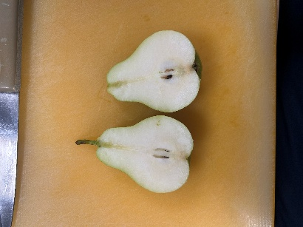
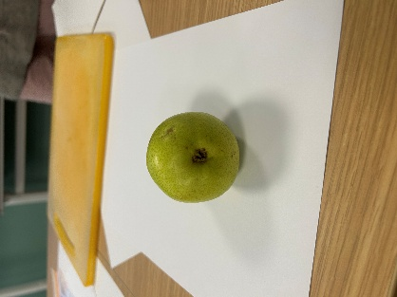
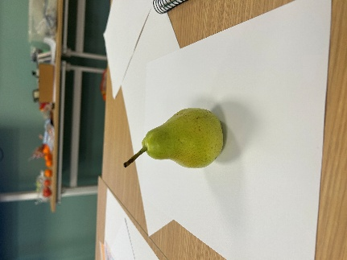
Week one,

Week two,

Control
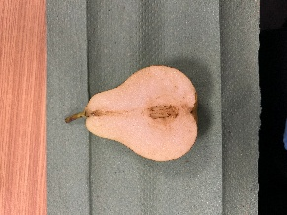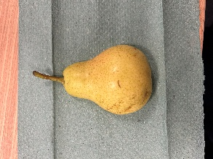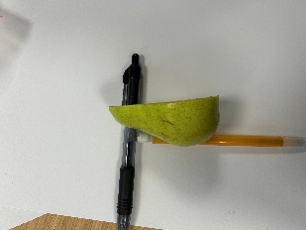

Experiment
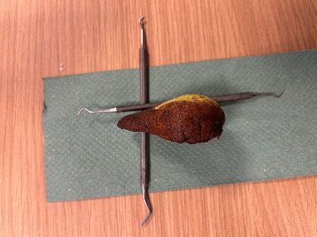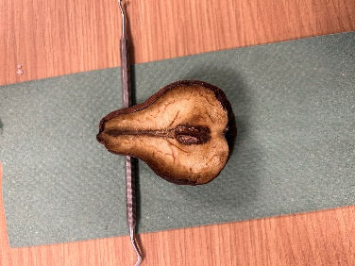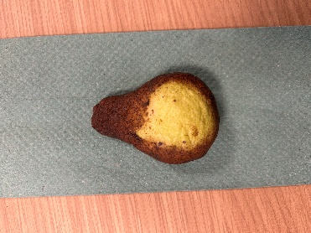

Week three,

Control
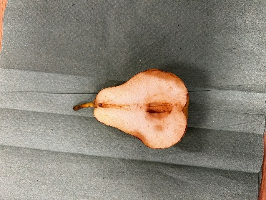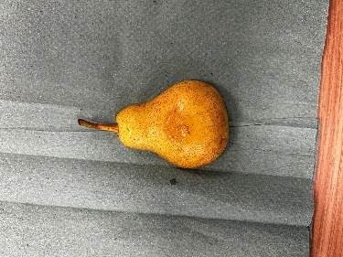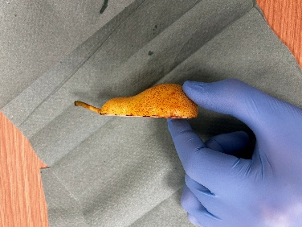

Experiment
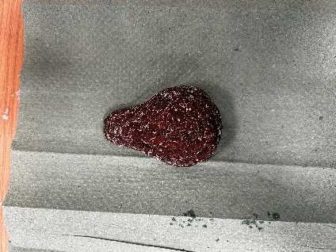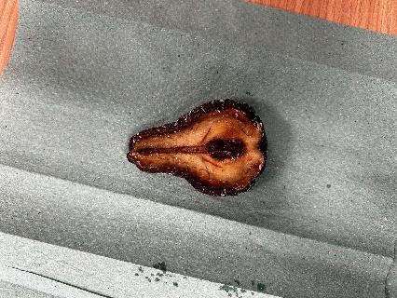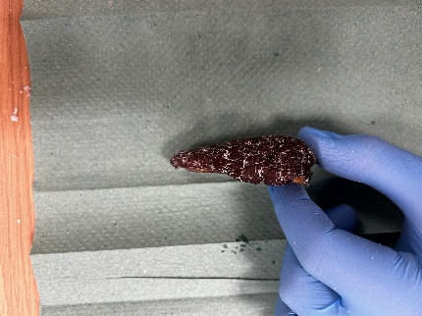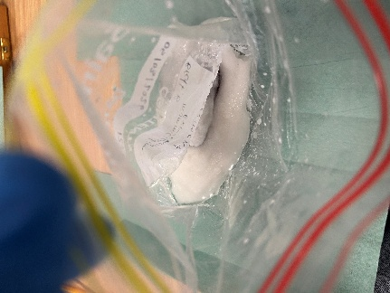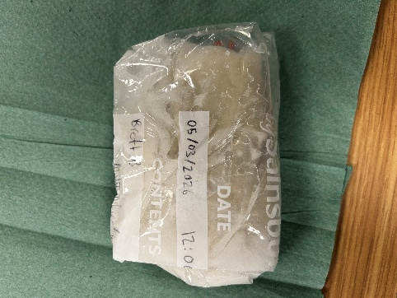

Tables,

