Down syndrome continues to be the most common chromosomal disorder. Each year, about 6,000 babies are born with Down syndrome, which is about 1 in every 700 babies born.
Down syndrome: - in particular I have chosen to research down syndrome as it is often not used in academic assignments as people often go for the more familiar everyday issues like ASD, Autism, ADHD.
Down syndrome is a chromosome 21 duplicate is the generic aetiology of this condition, because of their genetic make up people with down syndrome frequently have special learning requirements, here are some essential details regarding learning and down syndrome.
Identifying needs; - in England a child or young person has a disability that keeps them from using facilities offered in mainstream schools, or if they have a disability that makes learning substantially more difficult for them.
Then that it is for majority of people their age, they are classified as having special needs and disabilities (send) Wales defines sen similarly to England but since 2018, this has expanded to include support for children and teens with additional learning needs (aln), which includes learning disabilities or difficulties. This is made possible by the additional learning needs and tribunal a(wales)cts.
They frequently detect behavioural changes in the child as well as at home.
With fine motor skills, social difficulties, or strange behaviour, should cause alarm. Cooperation is crucial for parents, educators, and medical experts to work together, when teachers watch a child in a classroom.
Determining and identifying a child with additional needs is an important procedure that entails knowing the child’s particular needs and offering the right kind of assistance. Let’s look closely at this subject when having concerns of a child.
That a practitioner is caring for early identification, allows a practitioners, educators, and parents are essential. They keep an eye on the child’s relationships, behaviour and growth milestones. Red flags would show sign of some indicators, such as delayed speech, problems.
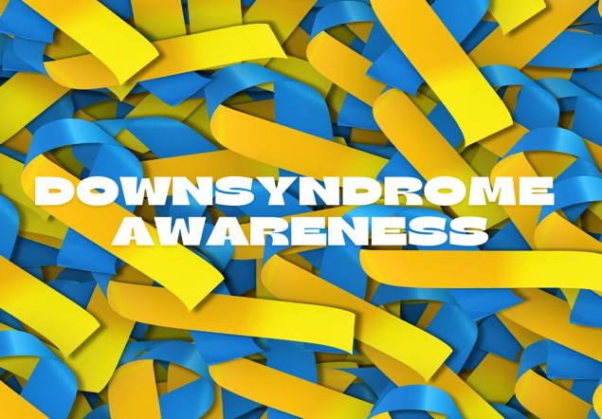

Social awareness and empathy; - people with down syndrome frequently have a high level of social awareness and empathy.
An in-depth exploration into an appropriate support strategy again for the same additional learning need.
The down syndrome associations 1.4 educational guidelines for learners with down syndrome contain additional in-depth information.
In conclusion supporting inclusive education and removing obstacles are essential for helping students with down syndrome. We can improve their educational experiences and general quality of life by putting evidence- based strategies into practice and fighting equal chances.
Parents frequently report having trouble deciding between mainstream and special school settings, getting access to speech and language treatment. Although there has been progress towards inclusion in normal schools, difficulties still exist.
Over the last forty years, research has emphasized how down syndrome affects learning and development. Recognising these variations facilitates the development of successful educational and remedial plans. The goal of advocacy work is to guarantee that all children and young people with down syndrome can get an education in classrooms that are completely inclusive.
Speech and language treatment can be difficult to get access to, learning and social interaction, both depend on effective communication. Selecting between special education and regular education settings choosing between mainstream and special education for their child can be difficult for parents to make. (https://www.ncbi.nlm.nihgov/pmc/articles/pmc829178
Down syndrome people’s learning strengths: - a significant predilection for visual learning is seen in many children with down syndrome. Their comprehension can be improved by utilising visual aids like diagrams, images and movies.
Slower learning process: compared to their classmates, people with down syndrome typically require more time to learn new things. To aid in learning, new abilities might need to be divided into smaller segments in order to remember new skills, repetition is frequently required, organisation approach, a more organised learning environment maybe advantageous for children with down syndrome. They can function more autonomously in the classroom if they are defined routines and constant expectations.
An analysis of impact barriers; examine how obstacles affect the educational experiences of people who have down syndrome obstacles to education for children with down syndrome; the downs syndrome association (DSA) has released a through report outlining the difficulties children with down syndrome have in the classroom. The following are some salient points; Declarations of unmet educational needs; getting adequate declarations of special education needs for their children can be a challenge for parents. These claims are essential to obtaining the required assistance.

(No date a) Bing. Available at: https://www.bing.com/videos/search?q=down%2Bsyndrome%2Bchildrens%2Bstrengths%2Band%2Bweaknesses&qpvt=down%2Bsyndrome%2Bchildrens%2Bstrengths%2Band%2Bweaknesses&FORM=VDRE (Accessed: 12 May 2024).
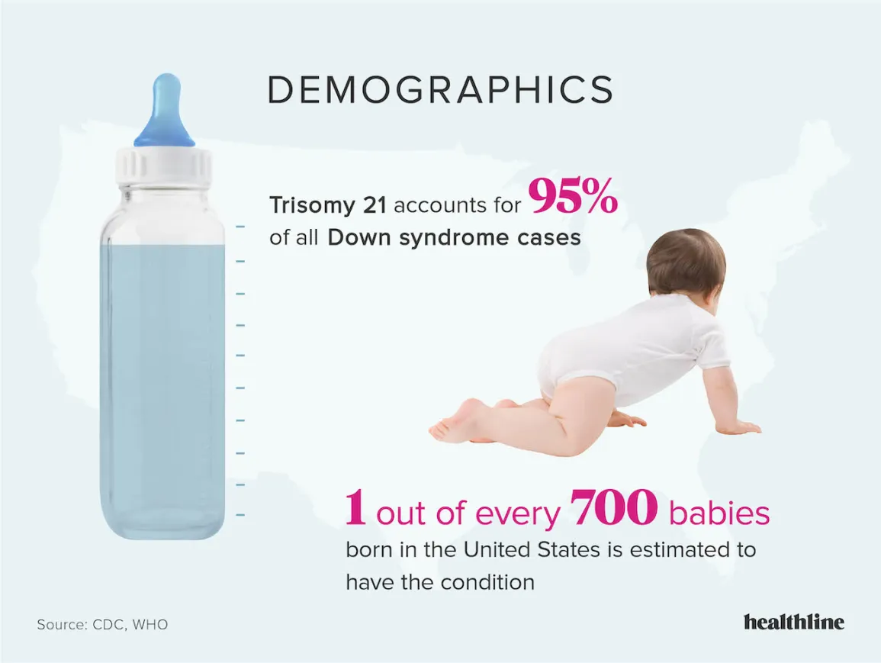
Gradual acquiring or vocabulary; - although they can require more time to acquire new terms, their lexicon increases gradually. Continually expose yourself to words and concepts to promote language development. Daily living and age-appropriate self-help skills. Encourage self-reliance.
Natural Comfort and Aptitude with Technology: A lot of them exhibit a natural ease and proficiency with technology, which makes it a useful instrument for their communication and education.
Learning Difficulties and Challenges Related to Down Syndrome
Weakness in Hearing and Vision: Children with Down syndrome may have problems with their hearing and vision, which can affect their ability to learn. It is essential to address these issues with the proper interventions.
Fine Motor Skill Impairment: They may find it difficult to do fine motor skills (such writing, drawing, or buttoning garments) because of their low muscle tone.
Weak Auditory Memory: It may be difficult for them to recall spoken content or to follow verbal instructions.
Limited Attention Span and Distractibility: It can be difficult to stay focused during educational sessions. Offering well-organized and captivating educational opportunities is beneficial.

Excellent short term visual memory: - they often have an excellent short-term visual memory to help reinforce learning, use visual cues and repetition.
Promote co-operation in the classroom and social relationships.
(No date a) Bing. Available at: https://www.bing.com/videos/search?q=down%2Bsyndrome%2Bchildrens%2Bstrengths%2Band%2Bweaknesses&qpvt=down%2Bsyndrome%2Bchildrens%2Bstrengths%2Band%2Bweaknesses&FORM=VDRE (Accessed: 12 May 2024).

(No date a) Access to education - down syndrome association of greater ... Available at: https://dsagsl.org/wp-content/uploads/2019/02/access_to_education.pdf (Accessed: 30 April 2024).
(No date b) (PDF) The Home Learning Environment of Primary School children with down syndrome and those with Williams syndrome. Available at: https://www.researchgate.net/publication/352021446_The_Home_Learning_Environment_of_Primary_School_Children_with_Down_Syndrome_and_Those_with_Williams_Syndrome (Accessed: 29 April 2024).
Altan Akin, N.T. and Gokturk, M. (2016) ‘Order interface model for individuals with down sydrome and emotion analysis’, 2016 IEEE International Conference on Systems, Man, and Cybernetics (SMC) [Preprint]. doi:10.1109/smc.2016.7844393.
Bayarri, V. (2006) ‘Promoting personal independence and the social protection of dependence: Challenges and opportunities’, International Medical Review on Down Syndrome, 10(3), p. 33. doi:10.1016/s2171-9748(06)70066-
6. Emily Bartsch et al. (2023) Author response for ‘Advanced imaging use and delays among inpatients with psychiatric comorbidity’ [Preprint]. doi:10.1002/brb3.3425/v2/response1.

Hendrix, J.A. et al. (2021) Opportunities, barriers, and recommendations in Down Syndrome Research,
Translational Science of Rare Diseases. Available at: https://escholarship.org/uc/item/5p99m1rw (Accessed: 11 May 2024).
Hendrix, J.A. et al. (no date) Opportunities, barriers, and recommendations in Down Syndrome Research., SHARE @ Children’s Mercy. Available at: https://scholarlyexchange.childrensmercy.org/papers/3585/ (Accessed: 11 May 2024).
Homeschooling a child with down syndrome (no date a) Time4Learning. Available at: https://www.time4learning.com/homeschooling/special-needs/down-syndrome/ (Accessed: 12 May 2024).
Homeschooling a child with down syndrome (no date) Time4Learning. Available at: https://www.time4learning.com/homeschooling/special-needs/down-syndrome/ (Accessed: 12 May 2024).

Parry, S. (2024) The challenges of teaching climate change within the School Science Curriculum [Preprint]. doi:10.5194/egusphere-egu24-13130.
Potter, K. (2023) New Educational Guidelines for learners who have Down’s syndrome, Downs Syndrome Association. Available at: https://www.downs-syndrome.org.uk/news/resources-information-training/resources/new-educational-guidelines-for-learners-who-have-downs-syndrome/ (Accessed: 11 May 2024).
Ranzato, E., Tolmie, A. and Van Herwegen, J. (2021) The Home Learning Environment of Primary School children with down syndrome and those with Williams syndrome, Brain sciences. Available at: https://www.ncbi.nlm.nih.gov/pmc/articles/PMC8229284/ (Accessed: 29 April 2024).
Strengths and challenges of students with down syndrome (no date) Time4Learning. Available at: https://www.time4learning.com/homeschooling/special-needs/down-syndrome/strengths-challenges.html (Accessed: 12 May 2024).

Valls Gubern, T. (2010) ‘School stage and students with Down Syndrome’, International Medical Review on Down Syndrome, 14(2), pp. 31–33. doi:10.1016/s2171-9748(10)70009-x.

