Conference Presentation
Student Name: Catrianna Di Muzio
Student Number: 2021889
Module Code: BMIH6001
Lecturer: Giulia Chifari

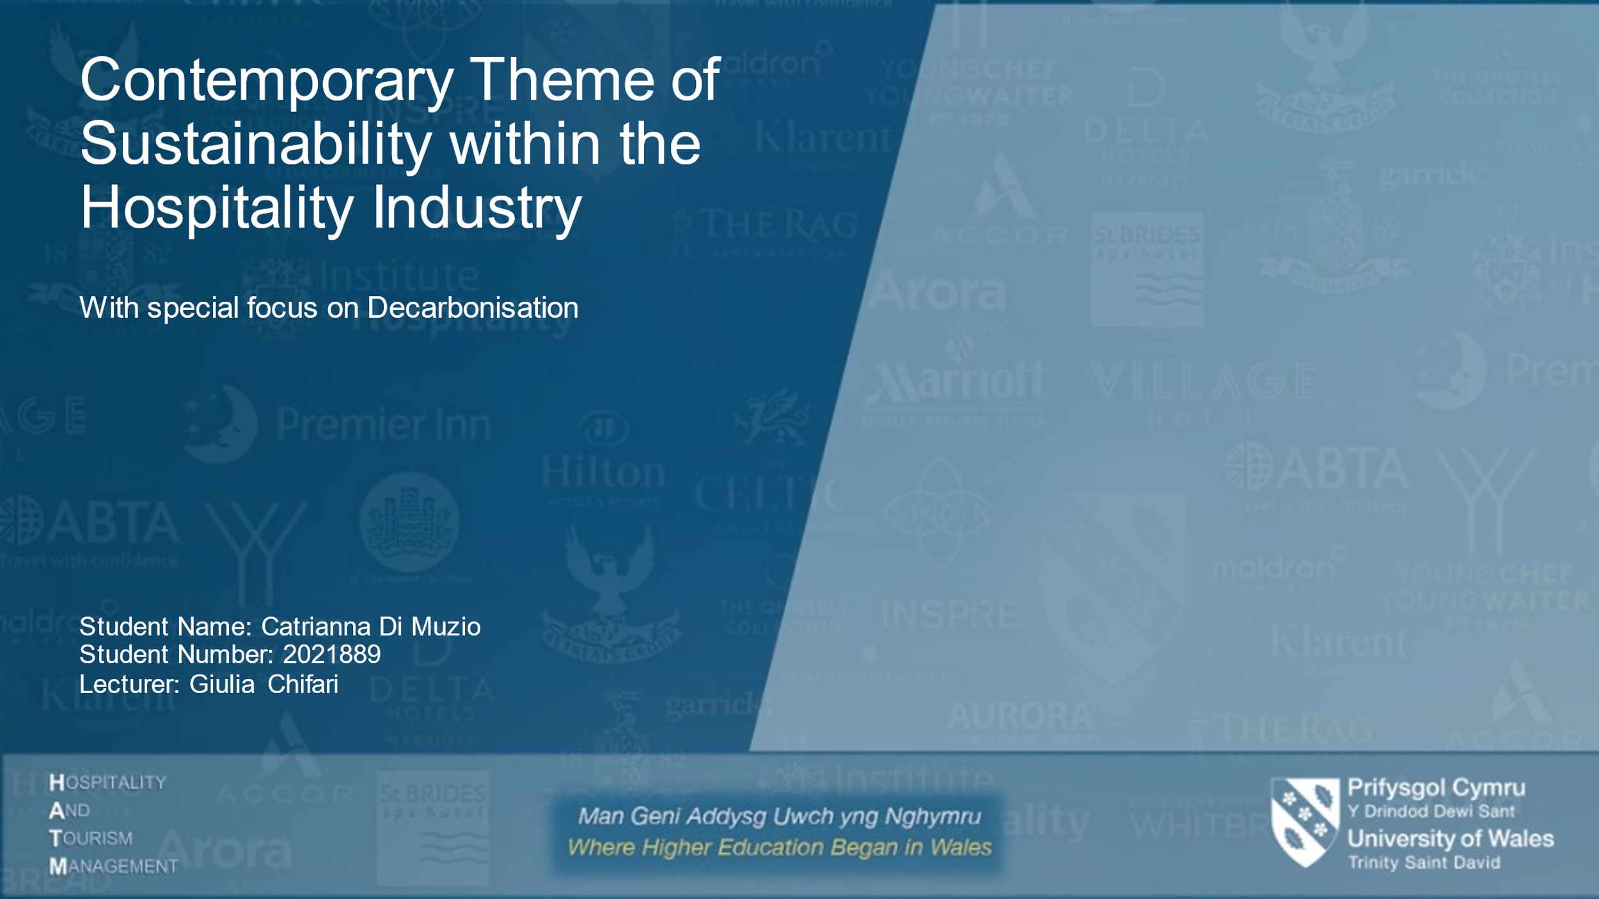
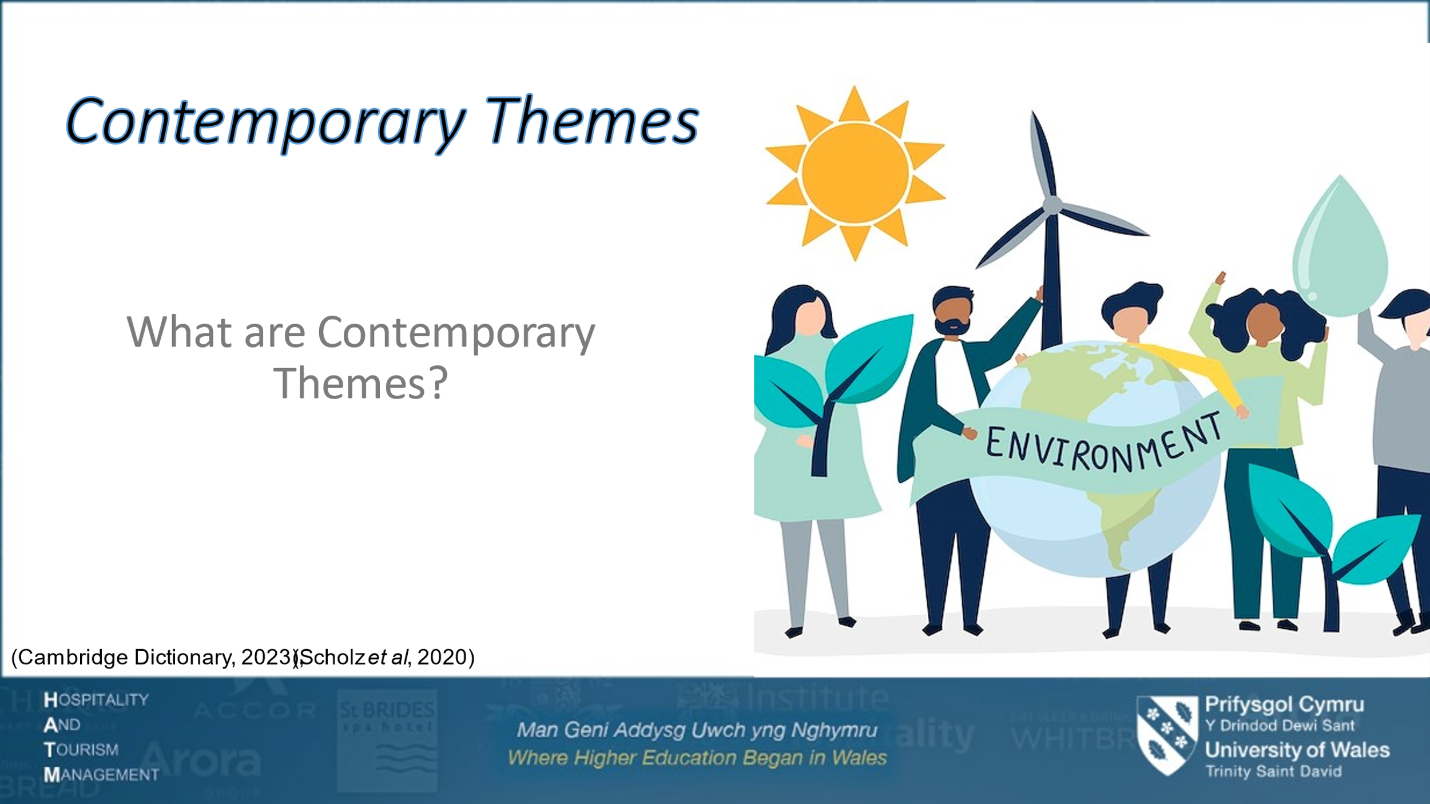
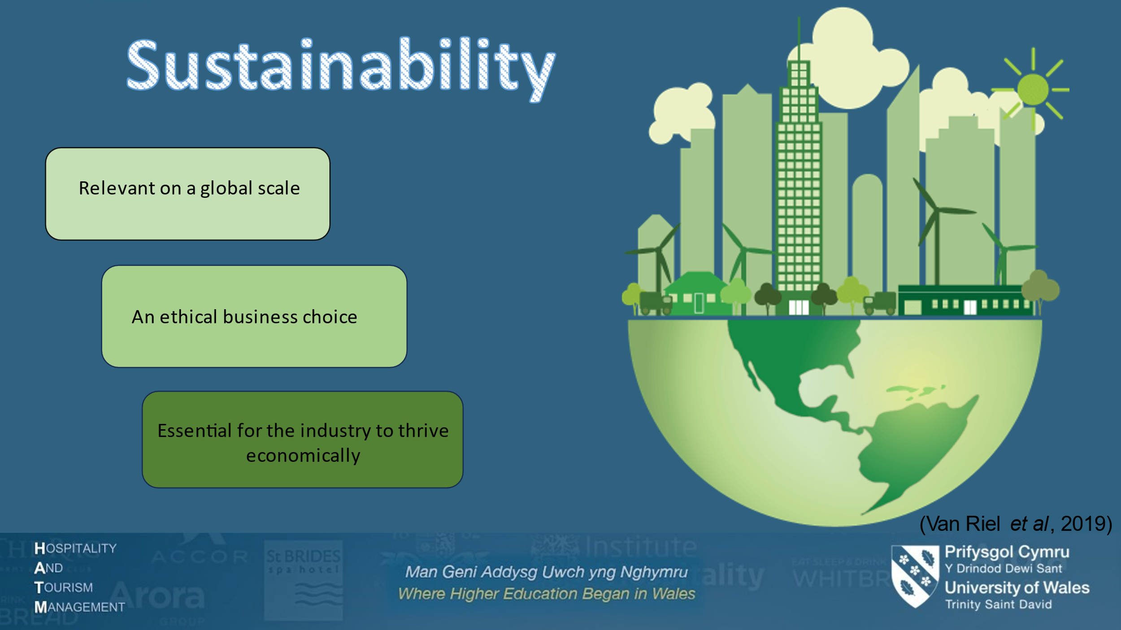
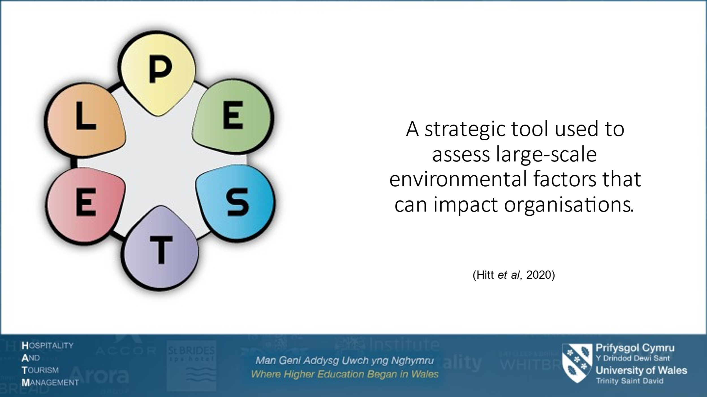
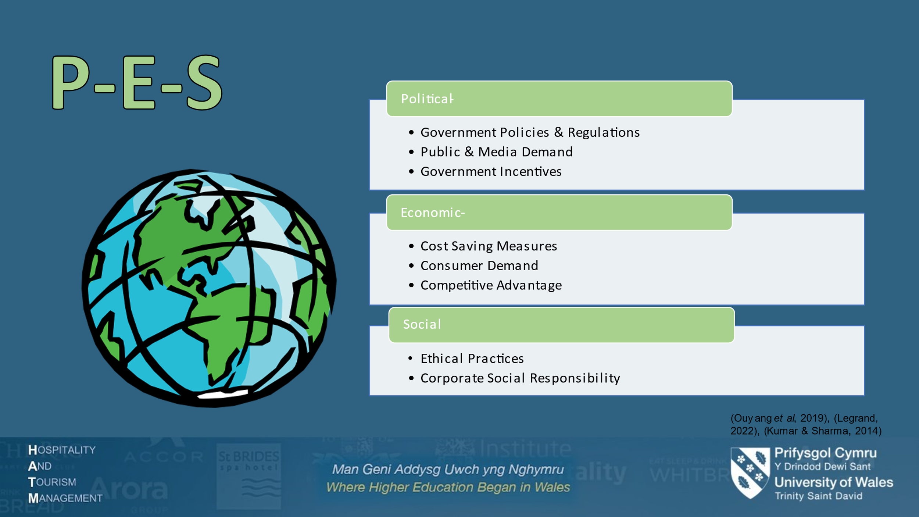
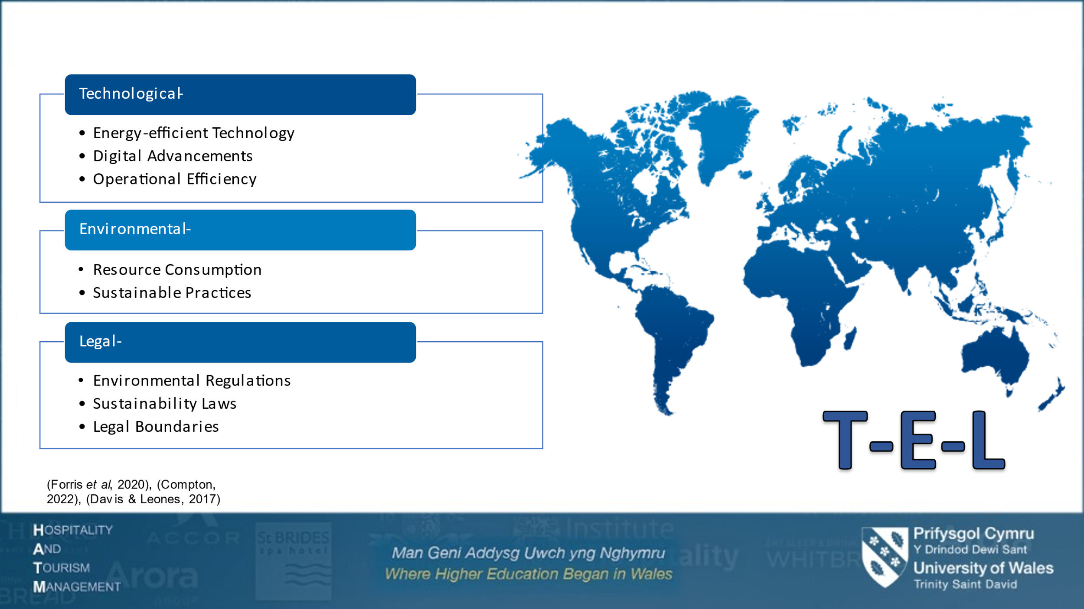
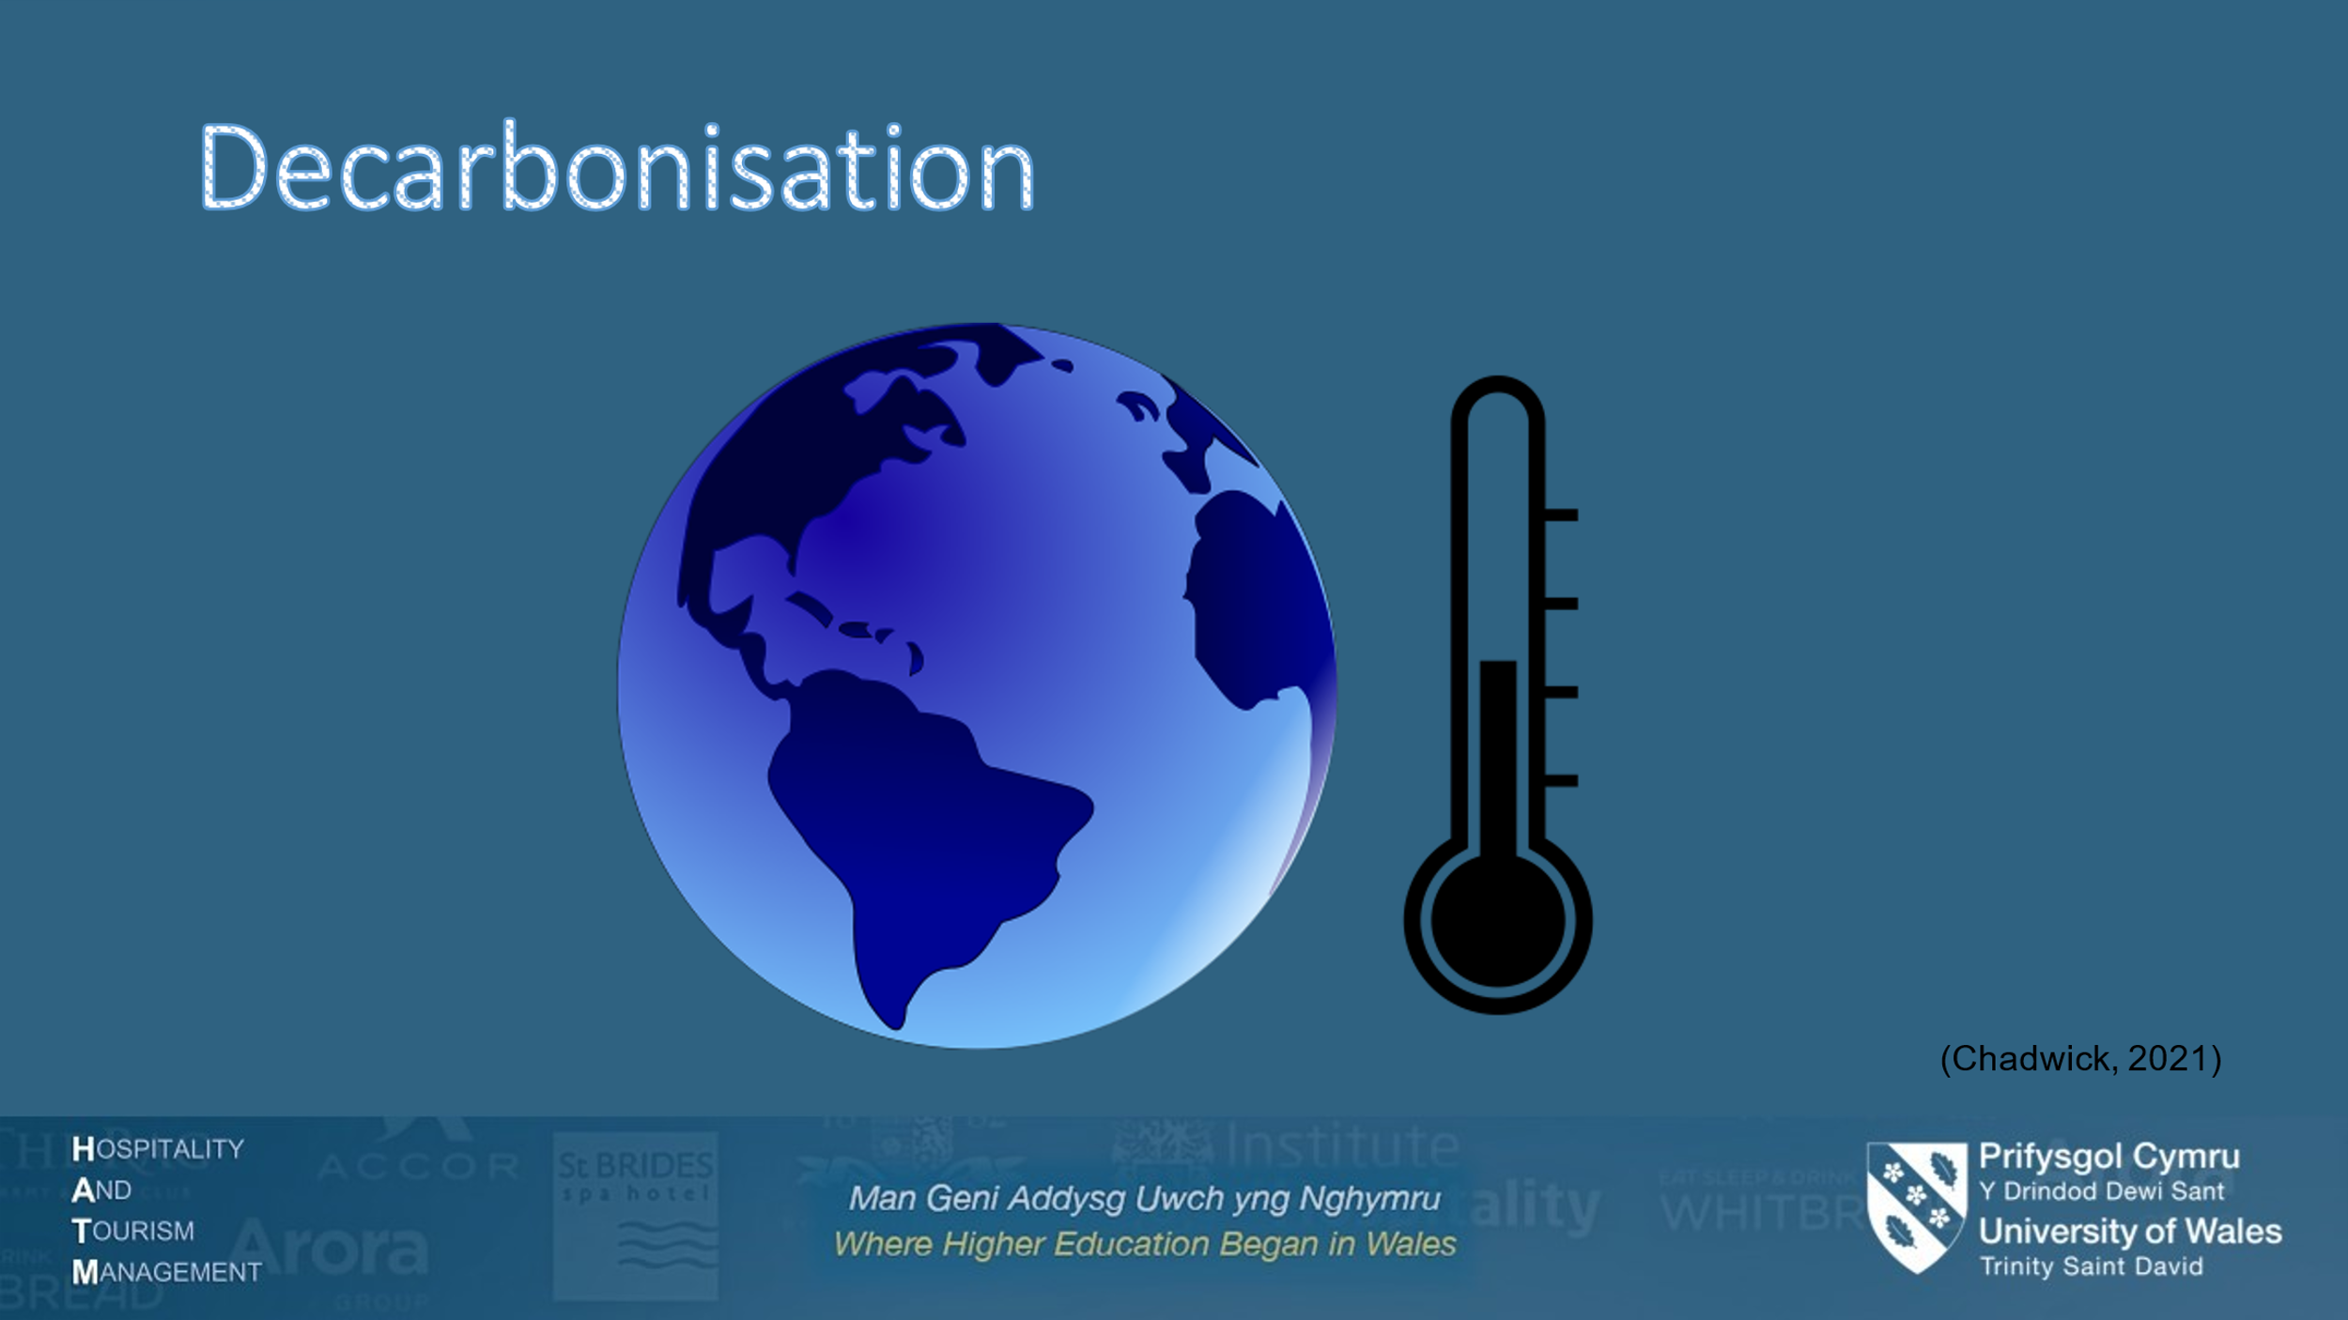
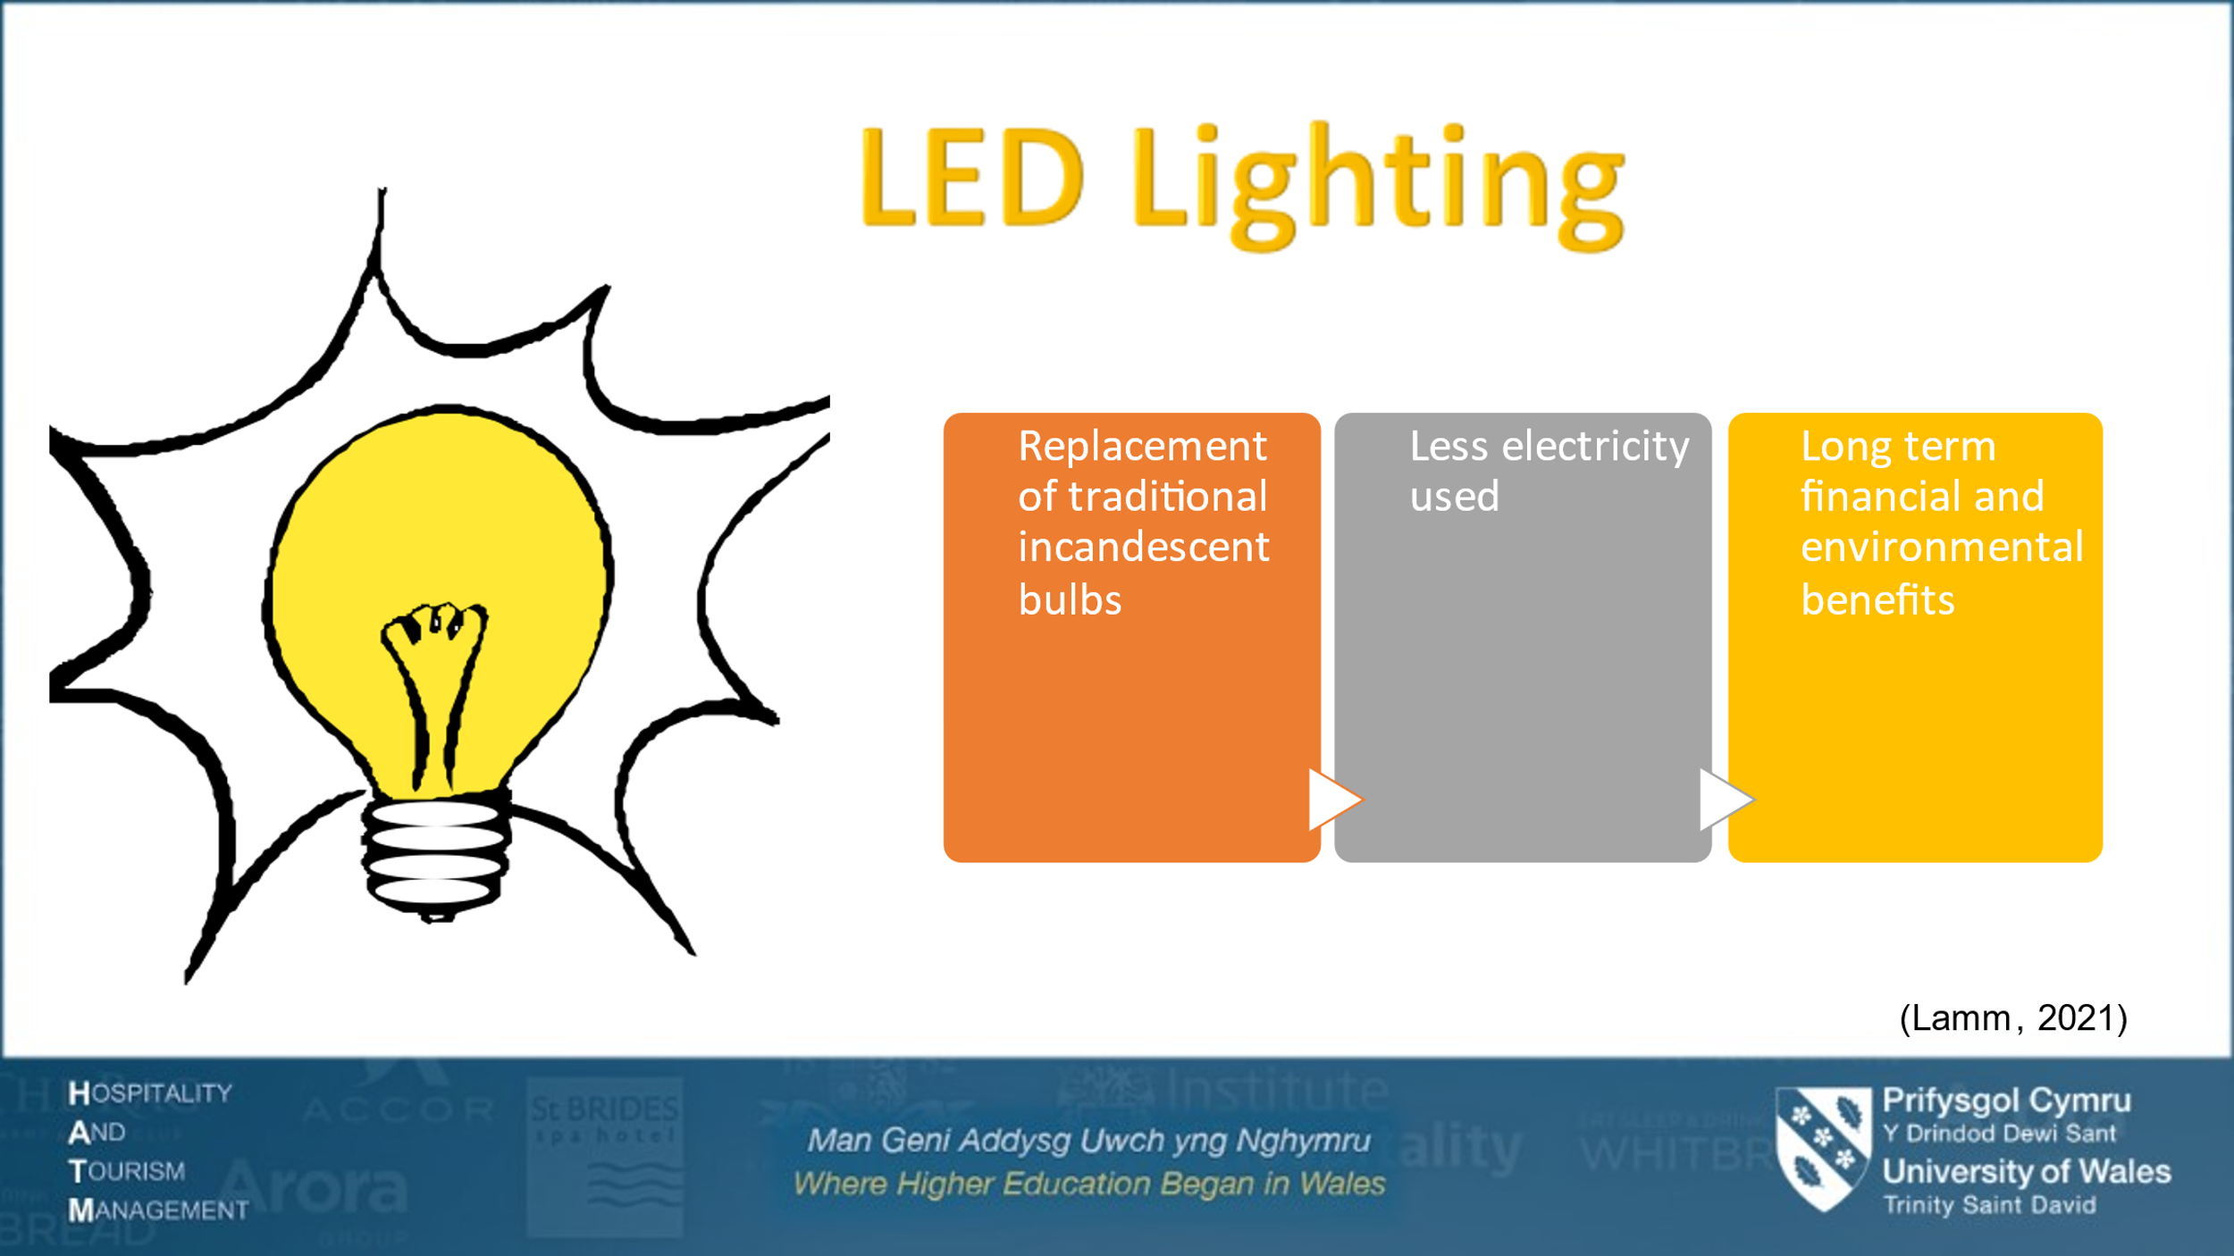
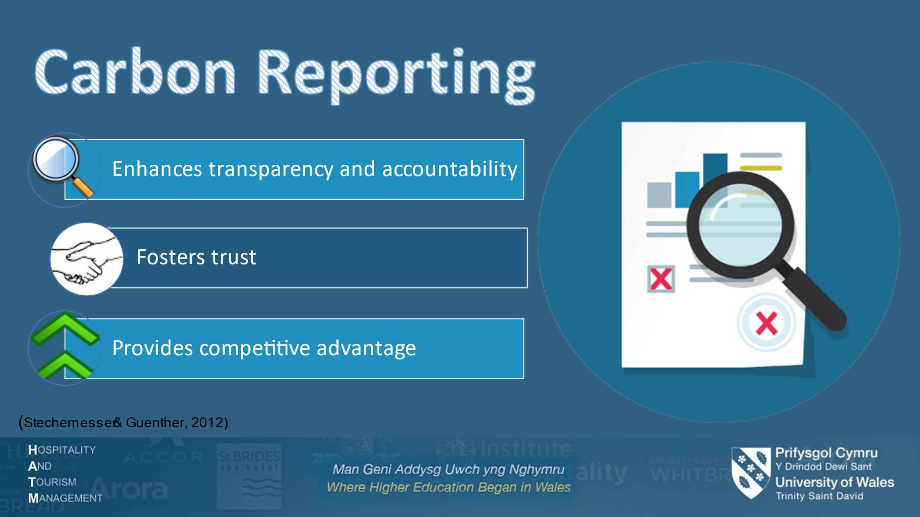
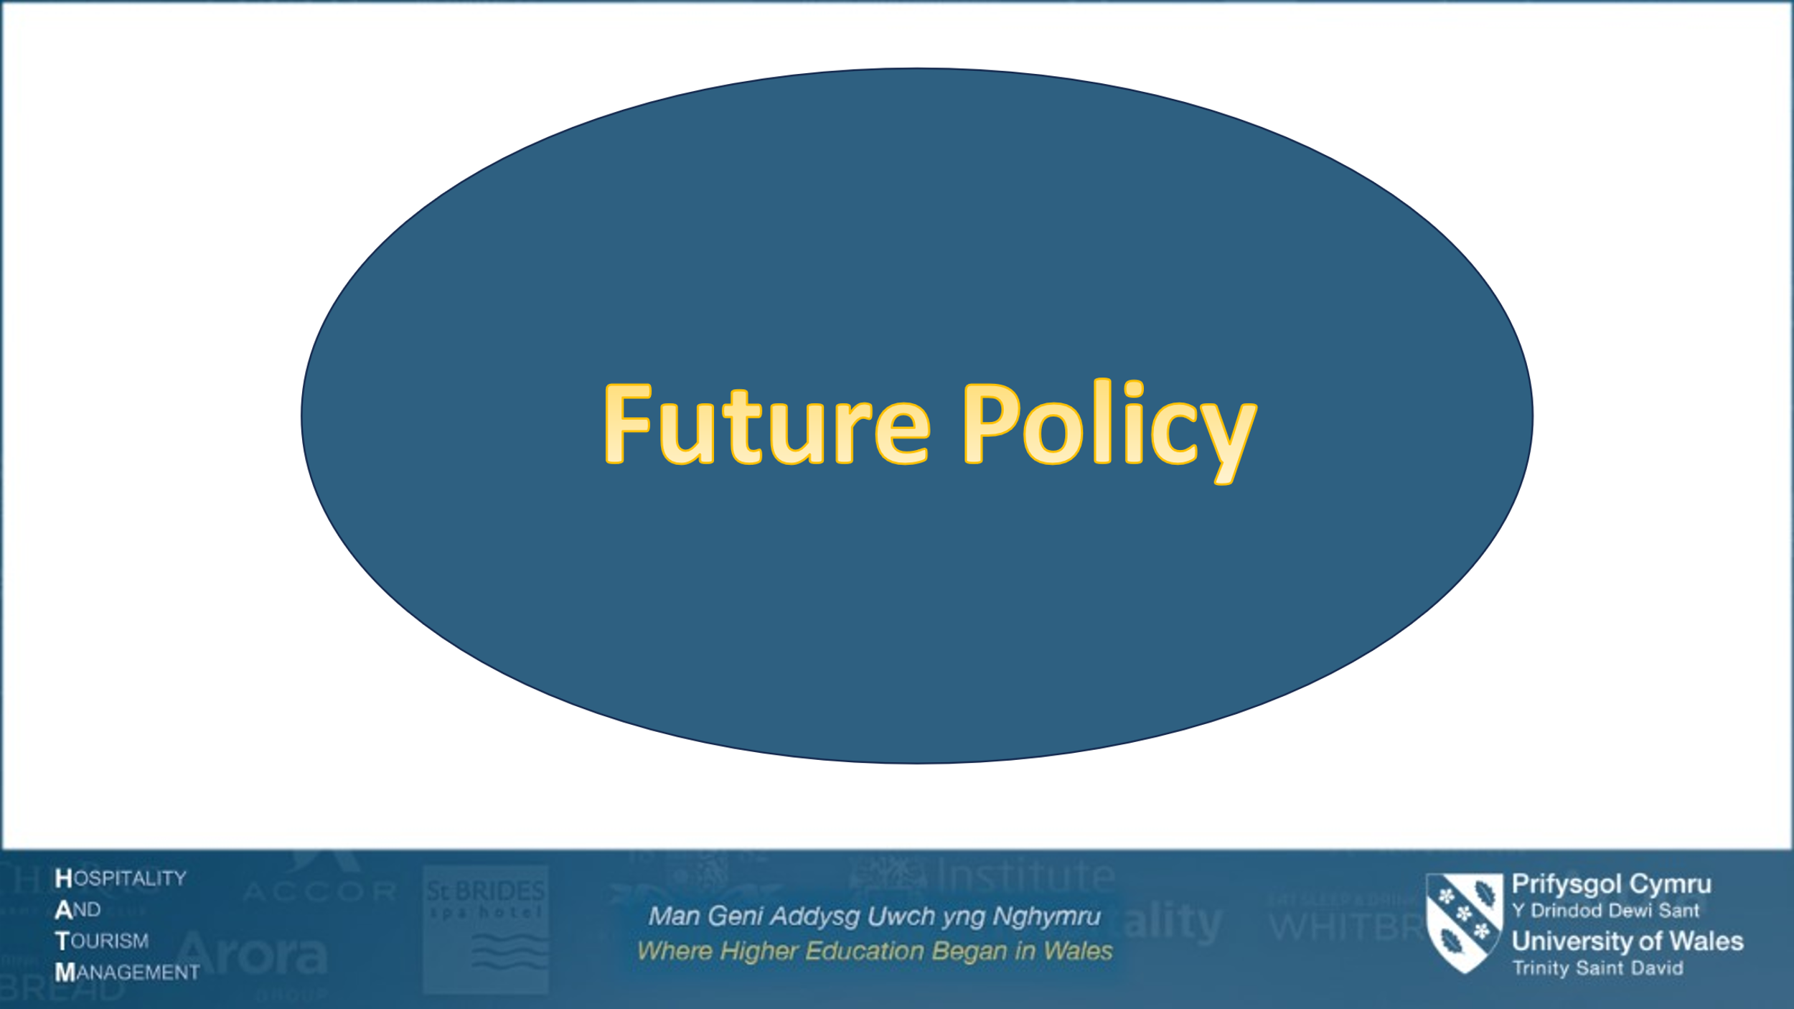
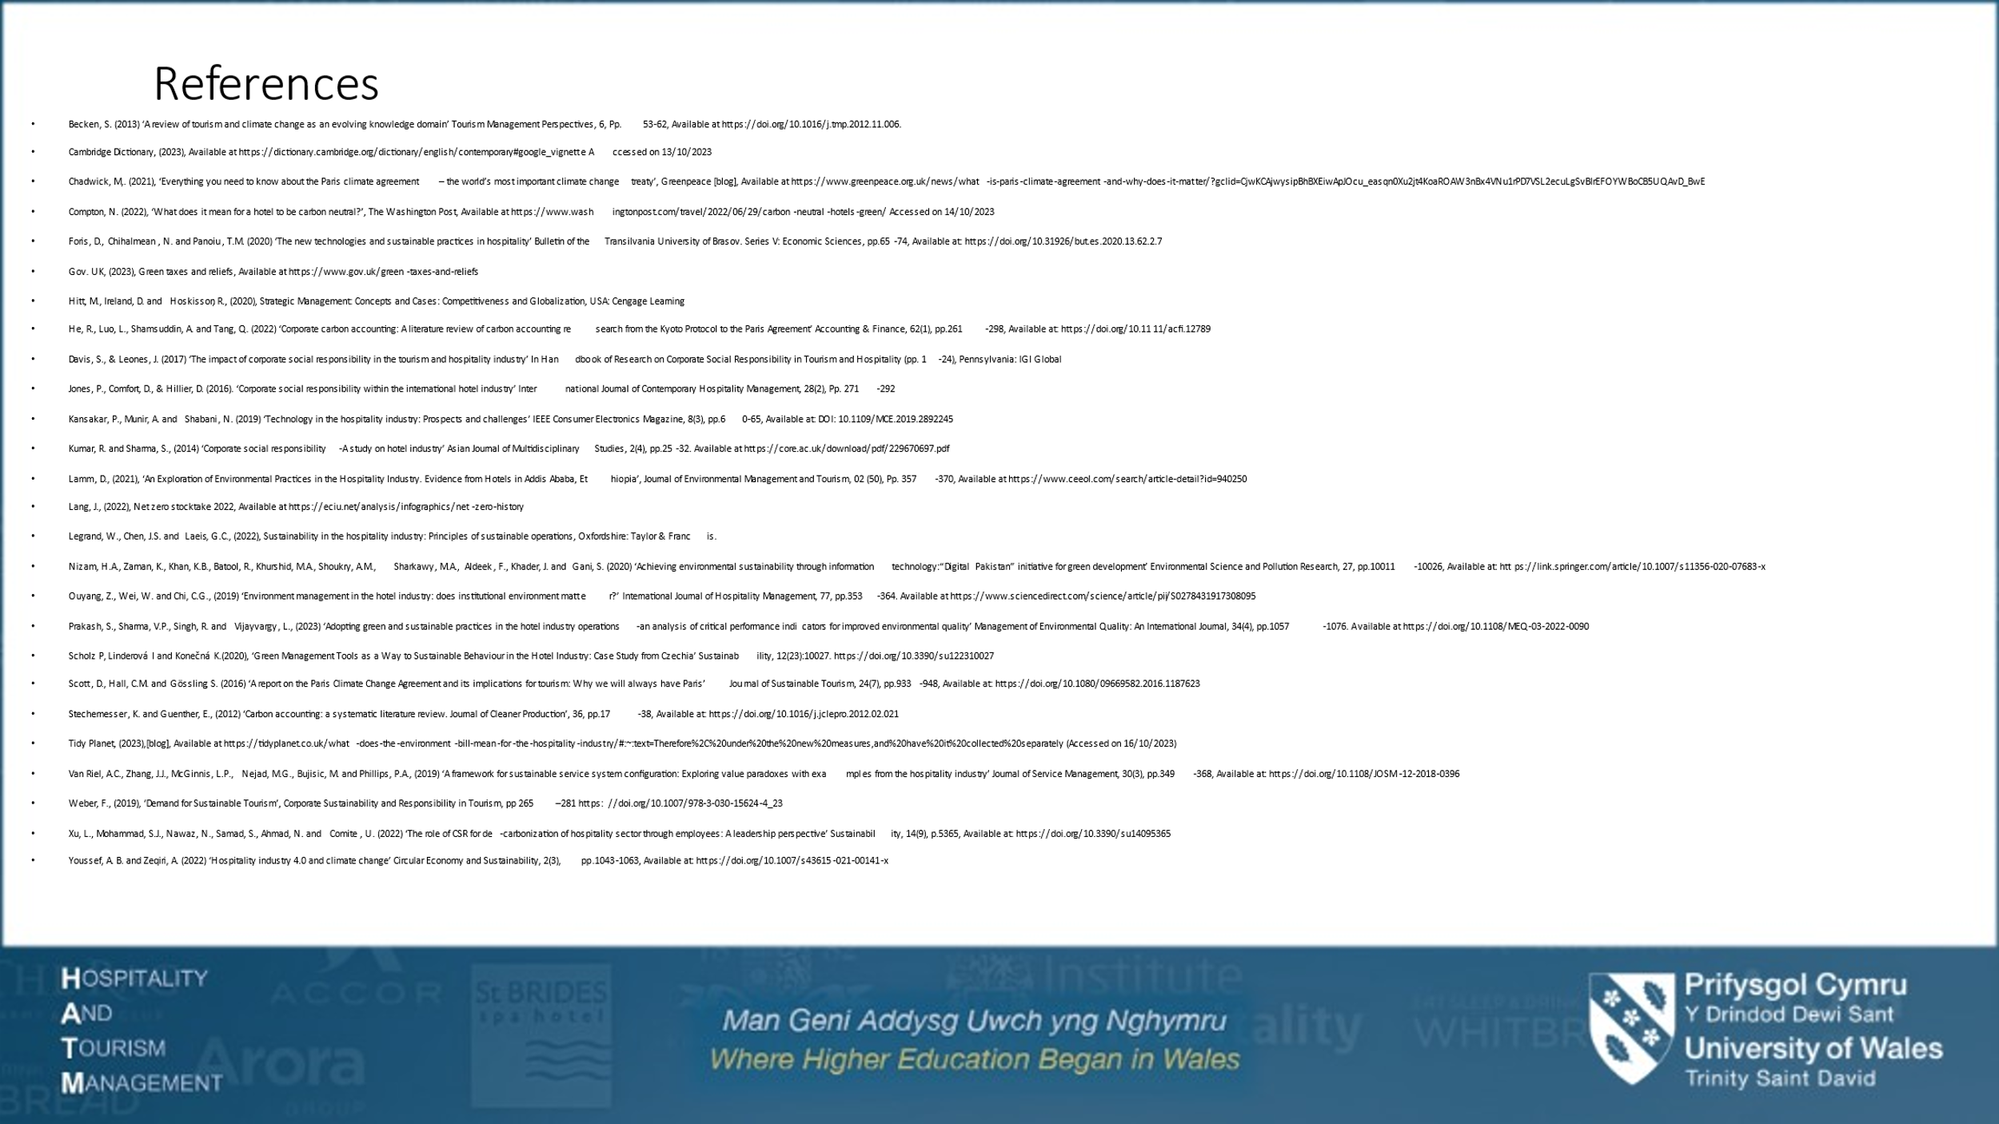

References
Becken, S. (2013) ‘A review of tourism and climate change as an evolving knowledge domain’ Tourism Management Perspectives, 6, Pp. 53-62, Available at https://doi.org/10.1016/j.tmp.2012.11.006.
Cambridge Dictionary, (2023), Available at https://dictionary.cambridge.org/dictionary/english/contemporary#google_vignette Accessed on 13/10/2023
Chadwick, M,. (2021), ‘Everything you need to know about the Paris climate agreement – the world’s most important climate change treaty’, Greenpeace [blog], Available at https://www.greenpeace.org.uk/news/what-is-paris-climate-agreement-and-why-does-it-matter/?gclid=CjwKCAjwysipBhBXEiwApJOcu_easqn0Xu2jt4KoaROAW3nBx4VNu1rPD7VSL2ecuLgSvBlrEFOYWBoCB5UQAvD_BwE
Compton, N. (2022), ‘What does it mean for a hotel to be carbon neutral?’, The Washington Post, Available at https://www.washingtonpost.com/travel/2022/06/29/carbon-neutral-hotels-green/ Accessed on 14/10/2023
Foris, D., Chihalmean, N. and Panoiu, T.M. (2020) ‘The new technologies and sustainable practices in hospitality’ Bulletin of the Transilvania University of Brasov. Series V: Economic Sciences, pp.65-74, Available at: https://doi.org/10.31926/but.es.2020.13.62.2.7
Gov. UK, (2023), Green taxes and reliefs, Available at https://www.gov.uk/green-taxes-and-reliefs
Hitt, M., Ireland, D. and Hoskisson, R., (2020), Strategic Management: Concepts and Cases: Competitiveness and Globalization, USA: Cengage Learning
He, R., Luo, L., Shamsuddin, A. and Tang, Q. (2022) ‘Corporate carbon accounting: A literature review of carbon accounting research from the Kyoto Protocol to the Paris Agreement’ Accounting & Finance, 62(1), pp.261-298, Available at: https://doi.org/10.1111/acfi.12789
Davis, S., & Leones, J. (2017) ‘The impact of corporate social responsibility in the tourism and hospitality industry’ In Handbook of Research on Corporate Social Responsibility in Tourism and Hospitality (pp. 1-24), Pennsylvania: IGI Global
Jones, P., Comfort, D., & Hillier, D. (2016). ‘Corporate social responsibility within the international hotel industry’ International Journal of Contemporary Hospitality Management, 28(2), Pp. 271-292
Kansakar, P., Munir, A. and Shabani, N. (2019) ‘Technology in the hospitality industry: Prospects and challenges’ IEEE Consumer Electronics Magazine, 8(3), pp.60-65, Available at: DOI: 10.1109/MCE.2019.2892245
Kumar, R. and Sharma, S., (2014) ‘Corporate social responsibility-A study on hotel industry’ Asian Journal of Multidisciplinary Studies, 2(4), pp.25-32. Available at https://core.ac.uk/download/pdf/229670697.pdf
Lamm, D., (2021), ‘An Exploration of Environmental Practices in the Hospitality Industry. Evidence from Hotels in Addis Ababa, Ethiopia’, Journal of Environmental Management and Tourism, 02 (50), Pp. 357-370, Available at https://www.ceeol.com/search/article-detail?id=940250
Lang, J., (2022), Net zero stocktake 2022, Available at https://eciu.net/analysis/infographics/net-zero-history
Legrand, W., Chen, J.S. and Laeis, G.C., (2022), Sustainability in the hospitality industry: Principles of sustainable operations, Oxfordshire: Taylor & Francis.
Nizam, H.A., Zaman, K., Khan, K.B., Batool, R., Khurshid, M.A., Shoukry, A.M., Sharkawy, M.A., Aldeek, F., Khader, J. and Gani, S. (2020) ‘Achieving environmental sustainability through information technology:“Digital Pakistan” initiative for green development’ Environmental Science and Pollution Research, 27, pp.10011-10026, Available at: https://link.springer.com/article/10.1007/s11356-020-07683-x
Ouyang, Z., Wei, W. and Chi, C.G., (2019) ‘Environment management in the hotel industry: does institutional environment matter?’ International Journal of Hospitality Management, 77, pp.353-364. Available at https://www.sciencedirect.com/science/article/pii/S0278431917308095
Prakash, S., Sharma, V.P., Singh, R. and Vijayvargy, L., (2023) ‘Adopting green and sustainable practices in the hotel industry operations-an analysis of critical performance indicators for improved environmental quality’ Management of Environmental Quality: An International Journal, 34(4), pp.1057-1076. Available at https://doi.org/10.1108/MEQ-03-2022-0090
Scholz P, Linderová I and Konečná K.(2020), ‘Green Management Tools as a Way to Sustainable Behaviour in the Hotel Industry: Case Study from Czechia’ Sustainability, 12(23):10027. https://doi.org/10.3390/su122310027
Scott, D., Hall, C.M. and Gössling, S. (2016) ‘A report on the Paris Climate Change Agreement and its implications for tourism: Why we will always have Paris’ Journal of Sustainable Tourism, 24(7), pp.933-948, Available at: https://doi.org/10.1080/09669582.2016.1187623
Stechemesser, K. and Guenther, E., (2012) ‘Carbon accounting: a systematic literature review. Journal of Cleaner Production’, 36, pp.17-38, Available at: https://doi.org/10.1016/j.jclepro.2012.02.021
Tidy Planet, (2023),[blog], Available at https://tidyplanet.co.uk/what-does-the-environment-bill-mean-for-the-hospitality-industry/#:~:text=Therefore%2C%20under%20the%20new%20measures,and%20have%20it%20collected%20separately (Accessed on 16/10/2023)
Van Riel, A.C., Zhang, J.J., McGinnis, L.P., Nejad, M.G., Bujisic, M. and Phillips, P.A., (2019) ‘A framework for sustainable service system configuration: Exploring value paradoxes with examples from the hospitality industry’ Journal of Service Management, 30(3), pp.349-368, Available at: https://doi.org/10.1108/JOSM-12-2018-0396
Weber, F., (2019), ‘Demand for Sustainable Tourism’, Corporate Sustainability and Responsibility in Tourism, pp 265–281 https://doi.org/10.1007/978-3-030-15624-4_23
Xu, L., Mohammad, S.J., Nawaz, N., Samad, S., Ahmad, N. and Comite, U. (2022) ‘The role of CSR for de-carbonization of hospitality sector through employees: A leadership perspective’ Sustainability, 14(9), p.5365, Available at: https://doi.org/10.3390/su14095365
Youssef, A. B. and Zeqiri, A. (2022) ‘Hospitality industry 4.0 and climate change’ Circular Economy and Sustainability, 2(3), pp.1043-1063, Available at: https://doi.org/10.1007/s43615-021-00141-x

