ACDB 4011: Stoichiometry Test; Determination of Magnesium Oxide Formula - Laboratory Report

Simon Shepherdson
Student Number: 2309878

Date: July 2024

Contents
Keywords 3
1 Introduction 3
1.1 Theory and Background Information 3
2 Results 6
3 Discussion 8
3.1 Interpretation 8
3.2 Relevance to OME 8
4 Conclusions 9
5 Annex A 10
5.1 Associated CoSHH hazards for the materials to be tested in the current study. 10
5.2 List of equipment utilised in current study. 10
5.3 Experimental Procedure. 11
5.4 Scans of Laboratory Data Sheet 12
6 Annex B 14
6.1 References 14

Figure 1 – The Periodic Table. 3
Figure 2 – Physical properties of Magnesium 4
Figure 3 - Physical properties of Oxygen 4
Figure 4 - Schematic of test apparatus 10
Figure 5 - Page 1 of Laboratory Data 12
Figure 6 - Page 2 of Laboratory Data 13

Table 1 - Raw data from experimentation 6
Table 2 - Moles of reactants 7
Table 3 - Mass of products 7
Table 4 - Molar Ratio 7
Table 5 - CoSHH data [9] 10

Keywords
Laboratory testing, Stoichiometry, Magnesium Oxide, Combustion

Introduction

This report sets out the experimental procedure and resulting determination of the chemical formula for Magnesium Oxide. The aim of the experiment is to show the law of conservation of mass in action, where mass is transferred and not destroyed. To do this, magnesium chips will be oxidised in a combustion reaction with oxygen to create Magnesium Oxide.
To adequately and satisfactorily determine the formula for Magnesium Oxide, the experimental design in Annex A was followed. Current chemistry knowledge of the author is limited, however, the chemical formula for Magnesium oxide is known, MgO.
Prior to the experiment taking place, it is expected that when a sufficient heat stimulus is provided to the magnesium metal in a semi-sealed crucible that the magnesium will react with the atmospheric oxygen present in the air. Once this reaction is complete, the mass of the magnesium in the crucible will have increased due to the intake of the oxygen atoms in the transmogrification from magnesium to magnesium oxide [1].

Theory and Background Information

Combustion reactions are utilised in many facets of life ranging from domestic uses such as heating through to uses in industry from energy reclamation and pyrotechnic disposal operations [2].
The efficiency of any combustion reaction is referred to as its stoichiometry; a stoichiometric reaction is one where the relationship between reactants and products before, during and after the reaction are equal as part of a balanced equation. This is all in relation to the law of conservation of mass, where for any defined system, the mass contained within cannot change, it can only be transferred.
The elements used in the experiment are taken from the full collection that is currently known to us [3] and represented in Figure 1 below;
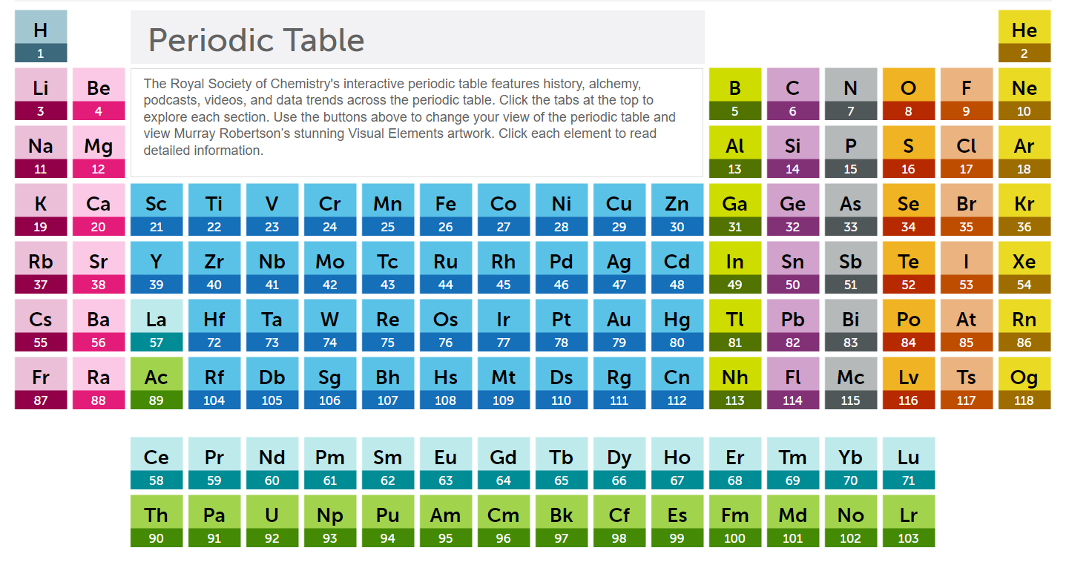

Figure 1 – The Periodic Table.
Specifically, the reactant element of interest is Magnesium, which is a Group IIA metal, a solid at room temperature and has the following properties;
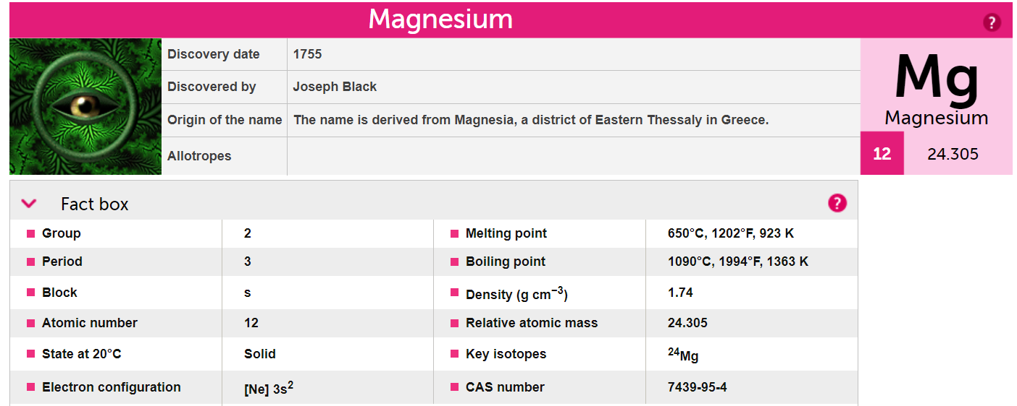
Figure 2 – Physical properties of Magnesium
The other reactant of the experiment is Oxygen, which is a Group VIA element and is in gaseous form at room temperature. It has the following physical properties;
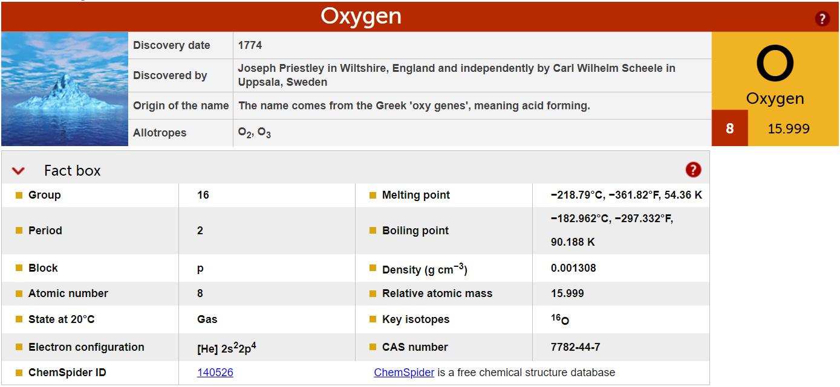
Figure 3 - Physical properties of Oxygen

To determine some of the output values, the following equations were used;

$$Moles (n)=\frac{Mass (g)}{Molar Mass (g.{mol}^{-1})}$$
Equation 1 - Relationship between Mol, Mass & Molar Mass

Equation 1 can be re-arranged as necessary using basic algebra if mass or molar mass is the desired output. Another required equation is below as Equation 2;

$$Percent by mass \left(\%\right)=\frac{Mass before reaction\left(g\right)}{Mass after reaction \left(g\right)}*100$$
Equation 2- Percent by mass
Equation 3 below will allow for the chemical formula to be evaluated for the ratio of each element in the compound.

$$\frac{Moles of B}{Moles of A}= \frac{Coefficient of B}{Coefficient of A}$$
Equation 3 - Molar ratio
Where:
Coefficient of X = quantity of molecules of reactant in a balanced stoichiometric equation.
Moles = Number of moles of each reactant

Whilst the reaction with Oxygen is the preferred option, it is not the only reactant that Magnesium can react with in the ambient air to be used in the experimental design. Magnesium may also react with nitrogen to form magnesium nitride (Mg3N₂), this aspect will not be evaluated in the current study. There is also the possibility that magnesium may react with Carbon Dioxide (CO₂) in the air, whereby the reactivity of magnesium means that oxygen can be removed from the CO₂ and leave behind carbon [4].

Results

Two experimental test runs were performed in a laboratory setting following the procedure outline in Section 5.3. The first test was left to heat under the Bunsen for a 13.5 minute duration, at which point the flame was removed and left to cool sufficiently before being weighed on a microbalance and calculations performed to ascertain the extent of the oxidation reaction. The cooled crucible was cleaned as best as possible with the available equipment before a second experiment was performed using approximately double the amount of Magnesium chips. This second test was heated for a longer duration of 19.5 minutes. At which point it was removed from the flame, and agitated so that unexposed pieces of magnesium could react with the ambient air. It was then reheated for a further 5 minute duration before being cooled and analysed in the manner of the first experiment.
An overview of the resultant information is recreated below, the scanned original data can be found in Section 5.4.

 | Experimental Trial 1 | Experimental Trial 2
Mass of Crucible & Cover (g) | 67.5143 | 67.5212
Mass of Crucible, Cover & Magnesium (g) | 68.5144 | 69.5132
Mass of Magnesium before heating (g) | 1.001 | 1.992
Mass of Crucible, Cover and Product post-heating (g) | 69.0544 | 70.6181
Mass of Product post-heating (g) | 1.5401 | 3.0969
Mass of Oxygen reacted with Magnesium (g) | 0.5391 | 1.1049
Moles of Oxygen (B) | 0.0169 | 0.0345
Moles of Magnesium (A) | 0.0412 | 0.0820
Mole Ratio of Mg : O [B / A] | 0.4078 | 0.4207
Determined formula of the oxide | 2MgO (s) | 2MgO (s)
Percent by mass of Magnesium in the oxide | 65.00 (2dp) | 64.32 (2dp)
Percent by mass of Oxygen in the oxide | 35.00 (2dp) | 35.68 (2dp)
Balanced chemical Equation | 2Mg (s)+ O₂ (g) = MgO (s)
Table 1 - Raw data from experimentation
Trials 1 & 2 were conducted as a group exercise, the group consisting of the Author, A. Clarke & S. Deane

To determine the molar content of each element in the experimental reaction, using Equation 1, is presented in Table 2 below;
 | Experimental Trial 1 | Experimental Trial 2
Moles of Oxygen | $$\frac{0.5391}{32.0}=0.0168$$ | $$\frac{1.1049}{32.0}=0.0820$$
Moles of Magnesium | $$\frac{1.001}{24.3}=0.0412$$ | $$\frac{1.992}{24.3}=0.4208$$
Table 2 - Moles of reactants
Similarly, using Equation 2 the mass of each element may be calculated;
 | Experimental Trial 1 | Experimental Trial 2
Mass of magnesium before heating (g) | 1.001 | 1.992
Mass of product after heating (g) | 1.5401 | 3.0969
Mass of oxygen reacted with magnesium (g) | 0.5391 | 1.1049
% by mass of Mg in the oxide | $$\frac{1.001}{1.5401}*100=65.00 (2dp)$$ | $$\frac{1.992}{3.0969}*100=64.32 (2dp)$$
% by mass of O in the oxide | $$\frac{0.5391}{1.5401}*100=35.00 (2dp)$$ | $$\frac{1.1049}{3.0969}*100=35.68 (2dp)$$
Table 3 - Mass of products
As seen in Equation 3, the Molar ratio can be calculated thusly;
 | Experimental Trial 1 | Experimental Trial 2
Chemical Formula | 2Mg (s)+ O₂ (g) = MgO (s)
Moles of element | $$\frac{Moles of B (O)}{Moles of A (Mg)}= \frac{1}{2}$$ | $$\frac{Moles of B (O)}{Moles of A (Mg)}= \frac{1}{2}$$
Substitution of numbers | $$\frac{0.0168}{0.0412}= \frac{1}{2}$$ | $$\frac{0.0345}{0.0820}= \frac{1}{2}$$
Substitution of numbers | $$0.4076= \frac{1}{2}$$ | $$0.4207= \frac{1}{2}$$
Substitution of numbers | $$2\left(0.4076\right)= 1$$ | $$2(0.4207)= 1$$
Molar Ratio | $$0.8152=1.0$$ | 0.8414 = 1.0
Table 4 - Molar Ratio

Discussion

Interpretation

From the two experimental trials on heating magnesium to oxidation, the data are broadly inline with predictions made before the experiment. From the theory, and in a perfect system, we would expect that the oxidation of magnesium to magnesium oxide would be in the ratio of 2:1, whilst this was not completely achieved, it is consistent with such a crude experimental procedure.
Conservation of mass law followed by Oxygen being added to Magnesium, definite proportion of 2:1 observed.
As stated above, the experiment conducted in this study is crude. Because of this there are a number of potential sources of error within this experimental setup and subsequent evaluation, a non-exhaustive list is below;
- Particle size of magnesium
- Purity of magnesium chips
- Impurities present in the gaseous atmosphere (i.e., formation of unwanted products)
- Insufficient heat to fuel a full reaction (i.e., crucible too far from heat source)
- Measurement accuracy of mass determination
- Duration of each experiment
- Pre-weighed magnesium not measured by experimental group.
- Balance was not levelled or calibrated.
- Second trial conducted using crucible from Trial # 1
- Unreacted Magnesium still present at end of experiment.
- Unwanted reactions (e.g., magnesium with nitrogen or carbon dioxide)
Any one or more of the list above would obviously reduce the efficiency of the oxidation reaction from the theoretical 2 magnesium atoms to one oxygen atom. With 65% & 64.3% magnesium in the experiments being 97.5% & 96.5% efficient respectively.

Relevance to OME

The use of stoichiometry is utilised in different ways in the OME world, predominantly in the use of disposals and neutralisation. Typically, these disposals are conducted in open air for safety, with the amount of air calculated for the combustion disposal. For some flares that contain magnesium (such as MTV Flares [5, 6]), a fluorinated polymer is used as the reactant to safely reduce the reactivity of magnesium, this reaction creates a magnesium fluoride salt.
For compositions that contain aluminium where it is used to improve heats of reaction and increase the blast parameters (e.g., Torpex [7, 8]), the experimental setup described could be utilised to ascertain the level of aluminium oxide present in relation for potential aging effects in stockpile surveillance operations. In both cases of Magnesium and Aluminium, if exposed to air they can react leaving a single layer of oxide coating, which may help reduce the risks associated with spontaneous combustion.

Conclusions

It can be seen that in laboratory scale experiments that the formation of magnesium oxide can be evaluated for the efficiency of reaction and how this can be related to OME. It also shows that the laws of conservation of mass and proportionality are broadly followed. It is believed that the discrepancies observed occur from the differences between theoretical conversion and real world drawbacks as outlined in Section 3.1, it was not immediately clear which was the prevalent force driving the source of error as each one could can contribute in its own way. This is something that could be investigated further at a later date.
As discussed in Section 3.2, the creation of oxidised layers on metallic components of compositions could be a real-world concern when it is applied to surveillance and ageing observations. Trials such as described herein could be applied in these scenarios and the author is interested in exploring this further.

Annex A

Associated CoSHH hazards for the materials to be tested in the current study.

Chemical | Symbology | Hazards
Magnesium | 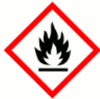 | Flammable solid  Flammable gases generated when in contact with water
Table 5 - CoSHH data [9]

List of equipment utilised in current study.

Below is a list of the apparatus to be used in the laboratory experimental determination of Magnesium Oxide., it is also represented in Figure 4
- Bunsen burner
- Heat-resistant baseplate
- Matches
- Ceramic crucible and lid cover
- Ring stand
- Clay triangle
- Crucible tongs
- Analytical balance
- Magnesium Chips, 1.0 – 2.0g
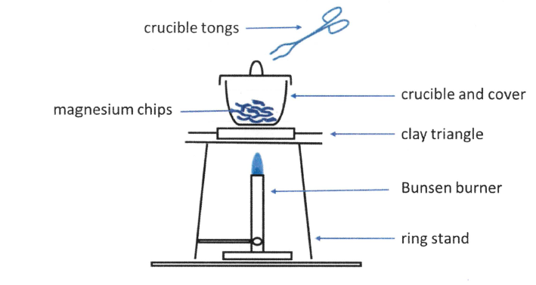
Figure 4 - Schematic of test apparatus

Experimental Procedure.
1 Set up the ring stand and Bunsen burner on the surface of the heat resistant mat. Place the clay triangle on the top of the ring.
2 Light the Bunsen burner and open the air vent to obtain a non-luminous flame with two blue cones. Ensure that the safety yellow flame is on when the Bunsen burner is not in use.
3 Make sure that the crucible and lid are clean and dry, then weigh them on an analytical balance and record the value in your data table.
4 Add approximately 1.0 – 2.0g of magnesium chips to the crucible, weigh it and record the combined mass of the crucible, lid and magnesium.
5 Place the crucible on the clay triangle. Set the lid slightly off-centre on the crucible to allow air to enter but to prevent the magnesium oxide from escaping.
6 Start gently heating the crucible, cover and magnesium by brushing the bottom of the crucible with the flame for about 1 minute; then, place the burner under the crucible and heat strongly.
7 Heat until all the magnesium turns into grey-white powder (probably around 10 minutes).
8 Allow the crucible to cool and then record the mass of the crucible, cover and product of the reaction.
9 Repeat the procedure for a 2nd measured amount of magnesium chips.

Scans of Laboratory Data Sheet
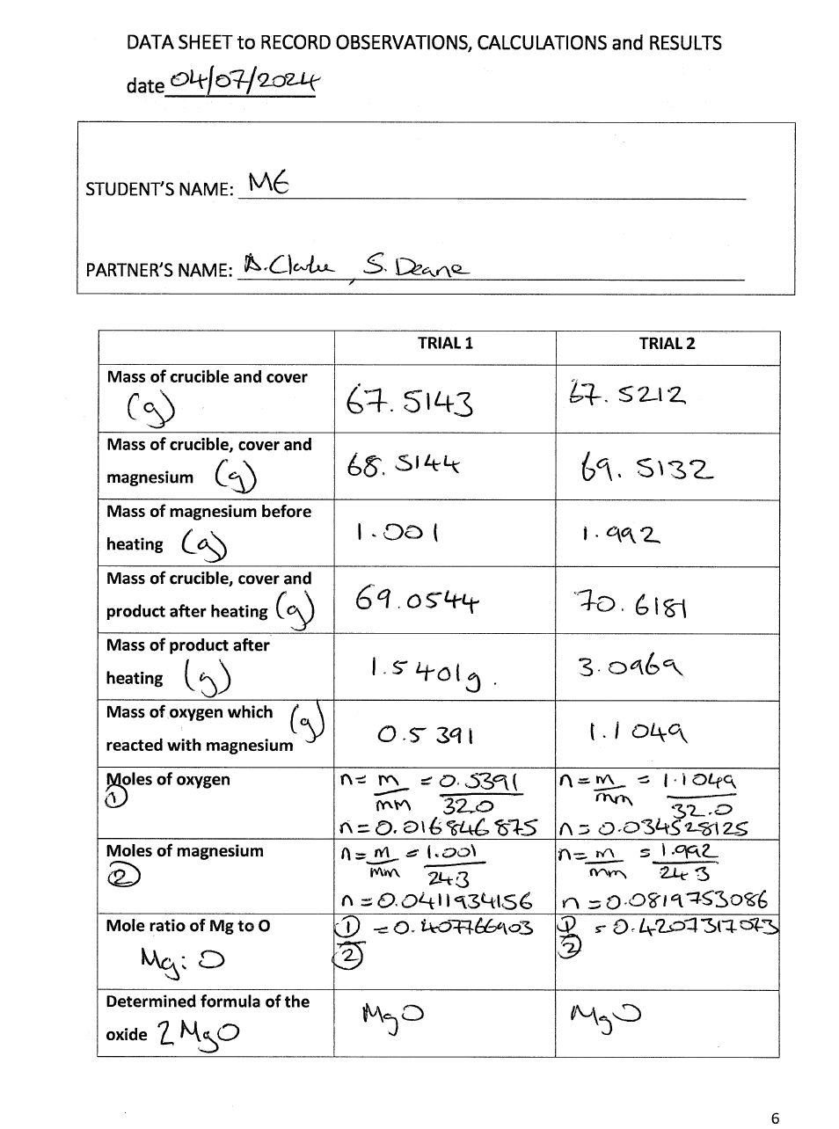
Figure 5 - Page 1 of Laboratory Data

Figure 6 - Page 2 of Laboratory Data
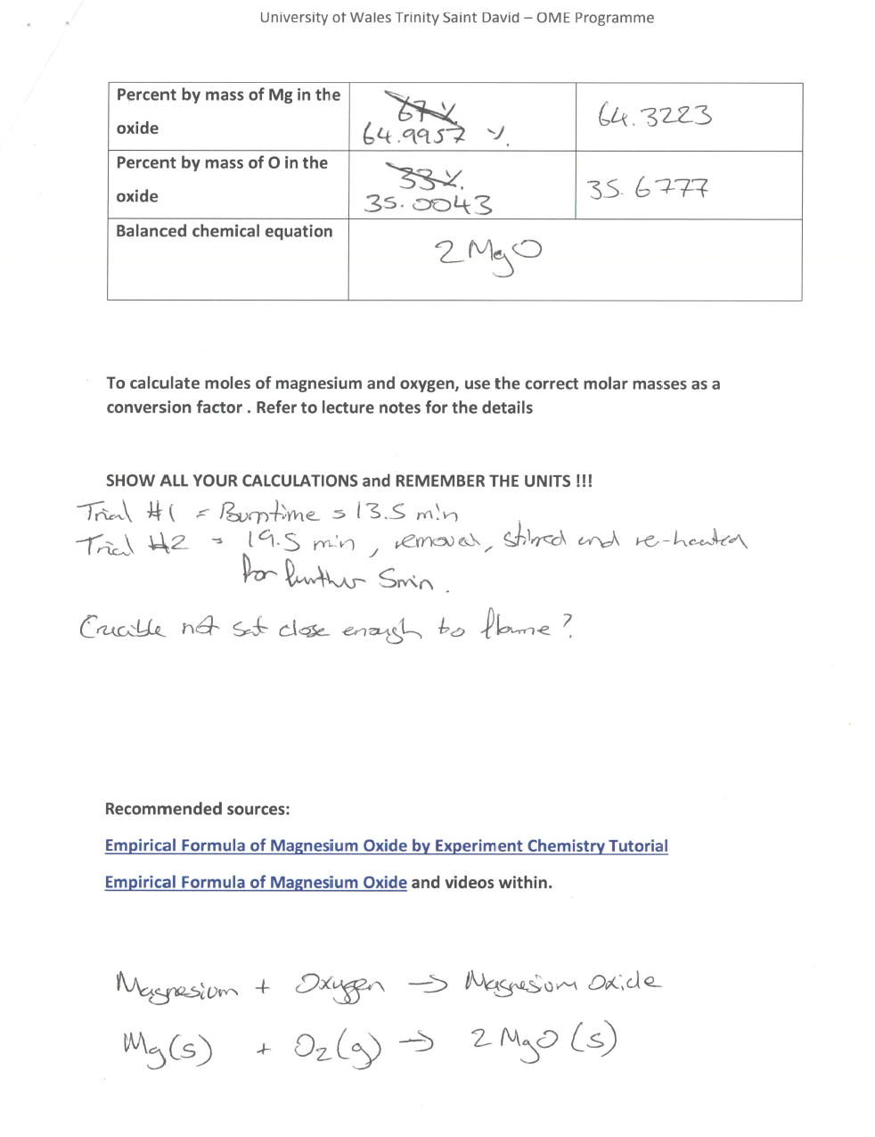

Annex B

References

- The Chemistry of Explosives, 4th Edition, Jacqueline Akhaven, 2022 The Royal Society of Chemistry. ISBN 978-1-83916-618-1
- Giovanni Begue, Lionel Aufauvre. Explosive and pyrotechnic wastes management practices. 44. International Pyrotechnics Society seminar (EUROPYRO 2019), Jun 2019, Tours, France. pp.394-399. ⟨ineris-03237729⟩
- Genesis of infrared decoy flares, 1st Edition, B. Douda, Naval service warfare center, 26 January 2009
- Royal Society of Chemistry website, www.rsc.org/periodic-table, Accessed 16 July 2024
- Fundamentals of Organic Chemistry, Fifth Edition, John McMurry, 2003. ISBN 0-534-39573-2
- Infrared spectra of customised MTV decoy flares, S. Elbasuney et al, Published in Fizika Goreniya i Vzryva, Vol. 55, No. 5, pp. 93–100, September–October, 2019
- Energetic Materials – Particle Processing and Characterisation, Ulrich Teipel, 2005 Wiley-VCH, Weinhelm. ISBN 3-527-30240-9
- The Secret History of RDX, Colin. F. Baxter, University Press of Kentucky, 18 October 2017
- Health & Safety Executive Website, Hazard Pictograms, Hazard symbols and hazard pictograms - Chemical classification (hse.gov.uk), Accessed 12/06/2024.

