Title Page

Name: Abdus Sufan

Student ID: 2437819

Module: Employability and Career Development

Module Code: LCLM4005

Assignment Title: Portfolio of Written Task

Lecturer: Rejwan Bin Sulaiman

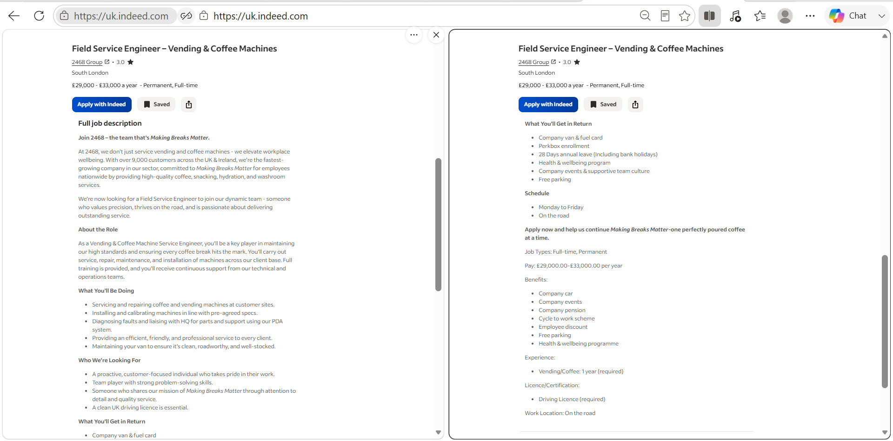
Job Advert 1:
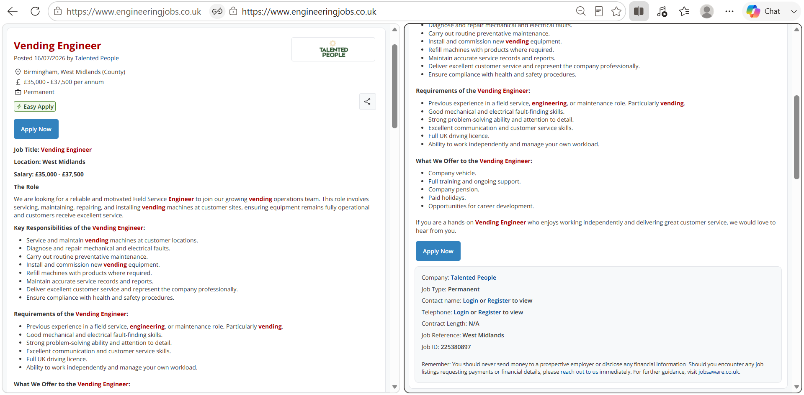
Job Advert 2:

Task 1
Comparison of Two Job Adverts: Skill and Knowledge required
After comparing the job adverts, I found out that they both require several similar important skills and areas of knowledge needed for a vending engineer role. The skills mentioned in both adverts are maintenance, customer service, communication, problem solving and Faults-Finding.

Area | Job 1. Field Service Engineer-Vending Machine | Job 2. Vending Engineer | Commons skills and knowledge
Machine repair and servicing | Service and repair vending machines. | Service, maintain and repair vending machines. | Both job adverts require servicing and repairing vending machines to keep them running properly.
Installation and maintenance | Install and calibrate vending machines and carry out regular maintenance work. | Install and commission vending equipment and carry out regular preventive maintenance. | Both job adverts require installing machines and regular maintenance to prevent breakdowns.
Fault finding and problem solving | Find and diagnose machine problems and use problem solving skills to fix faults. | Diagnose and identify mechanical and electrical faults. Fault-Finding skills required. | Both adverts require Fault Finding, problem solving and repairing machines efficiently.
Communication and customer service | Provide excellent customer service in a professional manner. | Deliver excellent customer service and represent the company in a professional way. | Both job adverts require excellent customer service and good communication skills when dealing with customers.
Both job adverts offer benefits such as company cars and pension schemes, while job 1 offers health and wellbeing programs and job 2 offers training and opportunities for career development. There is also paid holidays offered by both jobs and are full time permanent positions.
Skills in Future Employment
One of the key skills I can use in my future employment is Fault-Finding. As a service engineer, I would use these skills to identify the cause of machine problems and repair them quickly. It would allow me to inspect equipment, diagnose problems and carry out repairs efficiently. This would help me maintain high service standards, minimise machine downtime and reduce the amount of time that machines are out of order. Having strong Fault-Finding skills with technical knowledge I would be able to provide a reliable service, work safely and help ensure that the vending machines remain in good working condition for customers. Engineers regularly interact with customers and provide professional support. Strong communication ensures customers are happy with the service they receive.
Task 2
Self-assessment of SWOT Analysis (Strengths, Weaknesses, Opportunities, Threats)
Strengths | Weaknesses
Previous experience as a Vending Engineer.  Excellent customer service skills.  Experience in ordering parts, handling stock, cash management and customer enquiring.  27 years of driving experience.  Hardworking, reliable, trustworthy and able to work independently or as a team player. | Long gap since working directly in the vending industry and working as a driver since 2011.  Limited experience with things such as electrical Fault-Findings and newer machine software.  May require refreshing technical knowledge and training of modern vending machine technology and system.  Additional training in current industry standard and equipment.
Opportunities | Threats
Previous vending machine engineer experience gives a strong foundation for returning to the same industry.  Additional electric course and completing current studies could improve employability.  Driving experience and customer service background match key requirements.  Opportunity to progress further and achieve promotions. | Technological changes in vending machine may require continuous and updated learning.  Competition from candidates with more recent experience in vending industry.  Employers are inclined to prefer applicants with electrical or engineering qualifications.  Physical demands for installing machines may become more challenging over time.  Company restructuring and economic changes could reduce job opportunities.

Strength:
I have over 3 years of experience in the Vending Engineering sector while I was working at Mass International. My role involved; refurbishing machines and parts; covering engineers and operators’ holidays and sicknesses and installing machines on sites. I have worked for Mass International for 10 years, from Operator to an engineer.
I have gained excellent customer service experience over the years. As a licensed PHV driver and customer service assistant in Sainsburys, I am always dealing with customers and providing excellent customer service.
Weakness:
I have not worked in vending machine industry for several years since 2011. However, the technology has advanced rapidly. I may need to refresh my technical knowledge as I have been working as a PHV driver since I left the vending industry.
My electrical and engineering skills need updating. Although I repaired vending machines in the past, I would require more training on modern technology and complete an electrician course.
Opportunity:
Training offered by companies can help me modernise my skills. Both job adverts offer training and support. This would allow opportunities to learn about new vending machine systems and technology.
I Have over 27 years of experience in driving and excellent knowledge of London’s roads and traffic restrictions. This is valuable because service engineers spend a lot of time travelling between customers sites and need to plan routes.
Threats:
Employers may prefer applicants with qualifications; currently I do not have engineering or electrician qualifications and would need to do additional courses and trainings to upskill myself.
Other candidates may have more recent experience in vending machine industry as they may have worked as a vending machine engineer and have more up to date technical knowledge.

Reliability and ability to work independently
I am a hardworking and reliable person who can manage workload and complete daily tasks professionally. Vending Engineers often work alone and need to plan their day. They travel to different locations and complete jobs without supervision. My previous work experience helped me gain these skills and helped me understand the importance of being organised, punctual and responsible.
As a City Sprint Courier, I was responsible for managing multiple deliveries each day, planning routes, meeting deadlines and ensuring parcels are delivered safely and on time.

Evidence of readiness
I have gained experience working in different industries, including customer service, finance and hospitality. Feedback from customers and employers throughout my career has shown that I am hardworking, trustworthy and professional. My current role as a PHV Driver has strengthened my communication skills. Each day, I interact with different customers, providing a professional service. In addition, I am also studying a Certificate of Higher Education on Business Skills, which shows my commitment to learning and improving my knowledge to support my future career development. These roles have helped me become adaptable, reliable and confident when working with people from different backgrounds. My ability to build positive relationships with customers and colleagues demonstrates that I am prepared for future employment and personal advancement.
My strongest assets for a Vending Machine Engineer role are my previous vending machine experience, excellent customer service skills, reliability and ability to manage work independently. These strengths closely match the skills and knowledge required in both job adverts and would help me perform well in the role.
Task 3
Short-Term, Mid-Term and Long-Term Employment Goals
Goal Horizon | Action Steps | Resources Needed | Measure of Success
Short-Term (0-1 year) | Learn to repair and service machines, improve Fault-Findings and basic health and safety rules. | Using training materials, online learning resources and work experience. | Complete training, show confidence in carrying out basic repairs and maintenance.
Mid-Term (1-3 years) | Get a job or an apprenticeship. Improve skills in mechanical, electrical and machine installation. | Company manuals and electrical training course. On the job training experience. | Complete repairs independently and positive feedback from customers and supervisors.
Long-Term (3-5+ years) | Develop advanced Fault-Finding skills. Become an experienced service engineer and work towards a senior role. | Advance training course, mentoring and professional development opportunities. | Complete repairs confidently and become a trusted member of the engineering team.

Short-term learn how to repair and service machines.
Mid-term get a job or apprenticeship, improve skills and complete repairs independently.
Long-term advance training, mentoring and become trusted members of the team.

Personal Development Plan
To identify the weaknesses mentioned in my SWOT Analysis, I will focus on updating my technical knowledge and concentrate on achieving a certificate on an electrician course. I will complete relevant training courses, including vending machine maintenance training, to improve my understanding on Fault-Findings techniques and modern vending equipment. I will take opportunities for practical work experience or an apprenticeship in the vending industry. I would measure my progress and increase my confidence in carrying out repairs and maintenance tasks.
Achieving these goals will help me return to the vending machine industry, improve my employability and progress towards a successful career. This supports my career ambitions of becoming a successful engineer and progressing into more senior roles. This also aligns with my career goal building a long term career in the vending industry and build confidence in working with modern vending machines. I have also trained new employees in my previous roles, showing that I can work well with others and share my knowledge.

