

SBMA7123D
MBA Dissertation
University of Wales Trinity Saint David

Effective marketing and recruitment techniques in the UK higher education sector: a focus on the University of Wales Trinity Saint David

Jordan Evans
Student number: 1705691
Email address: 1705691@student.uwtsd.ac.uk

August 2020
Contents
Content | Page
Executive Summary | 3
1.0 Introduction | 8
2.0 Background Information | 9
2.1 The Business Environment | 9
2.2 PESTLE Analysis | 11
2.3 Competitors and Porter’s Five Forces | 19
2.4 Customer Analysis | 21
2.5 Employees | 26
2.6 Media | 26
2.7 General Public | 27
2.8 SWOT Analysis of UWTSD | 27
3.0 Literature Review | 29
3.1 UCAS – Through the Lens of Students | 29
3.2 SPCE Labs – Important Factors When Choosing a University | 32
3.3 Hobsons - International Student Survey | 33
3.4 SMRS – The Student Journey | 34
3.5.1 The Student Room – Options 2018/19 Report | 37
3.5.2 The Student Room – Widening Participation | 39
3.6 Unite Students – Insight Report 2019 | 41
3.7 Sussex Learning Network and Aimhigher Sussex | 43
4.0 Methodology | 45
5.0 Data Analysis | 50
5.1 Surveys | 50
5.1.1 UWTSD Acceptor Survey | 50
5.1.2 UWTSD Decliner & Withdrawer Survey | 76
5.2 Interviews | 102
6.0 Discussions & Conclusions | 104
7.0 Recommendations | 107
References | 110
Appendix | 117
Executive Summary
Higher education (HE) is “big business” in the UK – the collective total income of UK HE providers in 2018/19 was over £40 billion, with just under £20 billion of that amount being a result of tuition fees and training contracts.
The University of Wales Trinity Saint David (UWTSD) is a higher education institution with three main campuses in south west Wales – Carmarthen, Lampeter and Swansea, as well as a campus in London and learning centres in Cardiff and Birmingham.
Achievement of specific recruitment targets is referenced as a measure of success in each of the four UWTSD strategic priorities, outlining the importance of marketing and recruitment to the overall success of the strategic plan, and ultimately the University.
The primary and secondary research in this report focuses on ascertaining the most effective marketing and recruitment techniques used by universities (and UWTSD in particular as a case study) in order to attract students, coupled with the key factors that influence student decision-making, while linking core marketing theory but tailoring to the HE sector.
The entire scope of this research project covers the following:
- Review and synthesis of previous sector reports in relation to motivations for HE, decision-making in HE, marketing in HE and student recruitment in the UK HE sector, as has been covered in the literature review.
- Online surveys targeted at UWTSD applicants who have either accepted a place to study (via an acceptor survey), or those who have declined or withdrawn their offer/application (via a decliner and withdrawer survey) to gather the perspective directly from the target market. This primary research will cover the 15/16, 16/17, 17/18, 18/19 and 19/20 recruitment cycles. The design and implementation of these surveys is attributed to the researcher, during my capacity as Principal Marketing Intelligence Officer at UWTSD since January 2015 to date.
- Both the acceptor and decliner survey have been fully designed by the researcher in the work capacity as Principal Marketing Intelligence Officer at UWTSD. The surveys were designed to be comprehensive and cover the full application journey, including sources of research used when applying and the various decision-making factors that are in place for prospective students.
- Both surveys were designed so that they could be cross-referenced with each other when undertaking analysis, gathering insight as to why an applicant both accepts and declines a place to study at UWTSD, to draw conclusions from both cohorts as to the most important aspects of HE marketing and recruitment. This data is very useful in continually understanding trends in HE decision-making and effective recruitment techniques in relation to UWTSD.
- Both surveys are optional and separate to any application process; an automated email is sent to applicants on decision which contains a link to a relevant survey, asking individuals to state why such a decision has been made via a survey. There is a potential financial incentive for completing the survey. Before completing the online survey (provided by SurveyMonkey), applicants are informed that the information will help UWTSD target its marketing activities. No personal information will be disclosed and individuals will not be able to be identified in the amalgamated data.
- This quantitative research will be the main focus of the research.
- In order to complement the quantitative research, a small-scale qualitative research project will be undertaken alongside in a mixed-methods approach. Three, short interviews will be undertaken with higher education marketing staff currently employed in the sector to gather their views about what they see as the key activities that result in the maximum recruitment of students, which can be cross-referenced with the results of the online surveys. Their names will not be disclosed but the job titles will.
- Where appropriate, core marketing theory will be referenced to further enhance the research findings.
This report culminates in consolidated theory, research and analysis that can be used to create a research-informed, evidence-based marketing and recruitment strategy, not just for UWTSD as a case study, but for the UK HE sector as a whole, geared towards to maximisation of student recruitment.
Synthesising the primary and secondary research undertaken in this report yields the following important conclusions:
Important reasons why people choose to study at UWTSD (and universities in general):
- The course and its contents. The specific course title can also be very important.
- The location, including factors such as transport links, infrastructure and social life. Some of UWTSD’s locations could be perceived as ‘hidden gems’ to many prospective students.
- Reputation, both institutional and departmental – linked to history, survey and league table highlights.
- A good atmosphere on campus, linked to a positive visit to the various UWTSD locations, in the form of Open, Visit and Taster Days.
- The student support available (academic and otherwise), linked to small class sizes, few (if any) large lecture theatres, and being a ‘name and not a number’.
- The employment prospects of an individual after completing the courses, linked to the practical teaching element of a lot of the courses, industry connections, employment rates, graduate success stories and guest lectures.
- The quality of facilities available to students.
- The quality and amount of accommodation available to students.
Important sources of information for prospective students:
- Institutional website – the site should be optimised for desktop, tablet and mobile. Information should be available clearly and concisely, as well as being accurate and engaging.
- UCAS website – this stresses the importance of all courses being listed on the site, and all information being accurate and up-to-date, just like an institutional website.
- Open, Visit and Taster Days – these are imperative experiences (both physical and virtual) where staff (both academic and professional) must be engaging, charismatic and informative – the customer service prospective students receive here must be of the highest standard for the entire journey, from booking to attending, and follow-up communications.
- Friends, family and teaching staff – these key influencers have a strong bearing on individual decision-making, and as such should be targeted and communicated with accordingly.
- Social media – Facebook, YouTube, Instagram, Snapchat, Twitter etc. Content must be engaging, informative, relevant and visual.
- Prospectus and printed collateral – again, the content must be informative, engaging and relevant. As such, there is scope for Institute/subject/campus productions sitting underneath the core prospectuses to complement the portfolio.
- External forums – The Student Room, Which? University, Complete University Guide, Whatuni etc. An institution’s profile on these websites should be appealing, engaging and concise, as well as continually updated to ensure that they are correct.
- Advertising – paid advertising (both online and offline) should focus on driving engagement with/to the sources listed above, utilising the reasons why individuals want to study for a degree as content copy.
Other important considerations for UWTSD (and universities in general):
- The one-to-one teaching and support available to students, along with small class sizes and physical rooms (i.e. no, if any, large lecture theatres) is a huge USP for UWTSD – this should be communicated very strongly to prospective students and their influencers, and is something truly different to a lot of universities, particularly in south Wales. Students are known by staff, can address staff by their first name, can ask questions during lectures and can quite easily contact staff outside of lectures. This is what makes UWTSD different to its competitors, with true differentiation being difficult to achieve in the HE sector, and therefore should be a key focus in marketing, communications and messaging. The phrase ‘a name and not a number’ is a true statement for UWTSD. This could also be linked to better value for money at UWTSD.
- Each UWTSD campus/sub-campus/Institute is unique in their own right – these entities should be bold and proud of their USPs, with these points being communicated strongly to the relevant profile of potential student, rather than trying to cater and appeal to all.
- UWTSD still has some identity issues in local schools and colleges, and the local area. The University should continue to build its identity, and each campus location, through targeted liaison work, and paid advertising, both online and offline.
- There is a feeling amongst some mature students that returning to education is making something of oneself, or ‘being somebody’ – this is something the University could press forward with, given the potential size of the mature market.
- The Welsh language can be very important to some Welsh speakers – either learning through the medium of Welsh or even communicating with other students or residents. Given the University’s heritage, it can leverage this to its advantage.
- The University should communicate its postgraduate courses, along with funding options, far more strongly to its undergraduate cohort.
- Information about societies and the social side of each location, including the campus and town/city, should be more clearly communicated to prospective students.
- All enquirer and applicant interactions with a university have an impact on their perception of the institution – a poor website, unsatisfactory conversation with a staff member or not receiving a reply to an email could all negatively impact this perception, and lead potential students to think this will filter through to their academic experience. It’s imperative that future student customer experience is of the highest standard through the various touchpoints of the recruitment cycle.
- Mission statements have a very limited positive impact on recruitment, but may have an impact on the influencer group of parents.
- With regards to enquirer email communications, information should be personalised in the sense of relevant to their interests and needs e.g. course or subject.
1.0 Introduction
Higher education (HE) is “big business” in the UK – the collective total income of UK HE providers in 2018/19 was over £40 billion, with just under £20 billion of that amount being a result of tuition fees and training contracts (HESA 2018/19).
The lifting of the cap on how many students universities could accept in 2015/16 (Adams and Weale, 2015) has led to the increased marketisation of the sector, leading to the unprecedented importance of marketing and recruitment for universities, in order to maximise income and remain competitive.
Furthermore, the advent of unconditional offer making and higher tariff institutions lowering their entry requirements has fuelled a highly fierce and competitive sector (Weale, 2019). While this further adds to the marketisation of the sector, this can also bring in to question ethical considerations in the sense that some students may not be at the “right” institution for their needs, or studying the “correct” course.
The primary and secondary research in this report focuses on ascertaining the most effective marketing and recruitment techniques used by universities (and UWTSD in particular as a case study) in order to attract students, coupled with the key factors that influence student decision-making, while linking core marketing theory but tailoring to the HE sector.
Universities have become particularly effective at leveraging prospective student needs and tailoring marketing and recruitment activities accordingly (Inge, 2018), hence the dual focus of the research. Understanding choice, as well as the target market, is crucial to a successful marketing strategy (Olenski, 2017).
Organisations that can meet the needs of customers (or students) more effectively than competitors will be more successful (Doyle, 2002); the importance of marketing communications in communicating such fulfilment of needs to prospective students is therefore evident.
However, the HE sector is still in its infancy with regards to being a private-public sector enterprise with the student cap only being lifted in 2015/16 as stated above (Adams and Weale, 2015), and this research will attempt to unpick the most effective ways to maximise the recruitment of students (i.e. the customer).
This report culminates in consolidated theory, research and analysis that can be used to create a research-informed, evidence-based marketing and recruitment strategy, not just for UWTSD as a case study, but for the UK HE sector as a whole, geared towards to maximisation of student recruitment.
2.0 Background Information
The University of Wales Trinity Saint David (UWTSD) is a higher education institution with three main campuses in south west Wales – Carmarthen, Lampeter and Swansea, as well as a campus in London and learning centres in Cardiff and Birmingham. Each offers a different kind of student experience while all share a friendly, community atmosphere (UWTSD, 2020).
UWTSD’s current strategic plan covers the period 2017-2022, and outlines the institution’s mission, vision, values, strategic priorities, measures of success, key performance indicators and enablers. The four strategic priorities set out in the plan are:
- Putting learners first;
- Excellence in teaching, scholarship and applied research;
- Creation of opportunities through partnerships;
- A university for Wales (UWTSD, 2018).
Achievement of specific recruitment targets is referenced as a measure of success in each of the four strategic priorities (UWTSD, 2018), outlining the importance of marketing and recruitment to the overall success of the strategic plan, and ultimately the University.
2.1 The Business Environment
It is vital to consider the environment (both external and internal) in which UWTSD is operating in when focusing on effective marketing and recruitment to have a firm grasp of all the factors that can affect and influence the business:

Figure 1: The Business Environment

Source: Adapted from Oxford College of Marketing, Business Jargons & Toppr (2020)
Micro and macro environments have a significant impact on the success of marketing activities, and therefore such environmental factors must be considered in great detail during the process of creating a marketing strategy. Considering these factors will improve the success of UWTSD’s marketing campaigns and the reputation of the University brand in the long term (Oxford College of Marketing, 2020).
This section will analyse both the external environment (macro and micro) in which the University is currently operating in, as well as the internal environment of UWTSD itself.
2.2 PESTLE Analysis
A PESTLE analysis is a framework to analyse the macroenvironment which influence an organisation from the outside. This framework facilitates an understanding of the wider business environment, develops strategic thinking and will allow UWTSD to identify business opportunities in order to exploit them fully, as well as minimise any threats that may arise (CIPD, 2020).
The following information is a current PESTLE analysis for UWTSD:
Political factors
- Devolution: higher education is a devolved area in Wales, which means that most decisions that are made about HE in Wales are taken by the Welsh Government (HEFCW, 2020). However, policy in England has a huge impact on the Welsh HE sector, and therefore UWTSD needs to monitor both administrations for policy developments and subsequent implications – both opportunities and threats. An example in recent times is when the UK government lifted a cap on university places in England, allowing universities to recruit as many students as they see fit, leading many colleges and universities to increase their intake (Adams & Weale, 2015), thus massively increasing competition in the sector. Naturally, higher tariff institutions have taken a larger share of the market, which has impacted on recruitment in the middle and lower tariff institutions: in 2018, lower-tariff institutions have accepted 5,000 fewer undergraduates compared with previous year, with the total dropping to 148,000. Acceptances at mid-tariff universities also declined by more than 2,000 (Adams, 2018).

- Diamond Review: the recent Diamond Review in Wales, which aims to remove the barrier of living costs for people wanting to go to university (Lewis, 2016), is a prime example of devolved policy. While the impact of such reform is still in its infancy, it is an example of how UWTSD can maximise changes in the political landscape to its advantage, with potentially more Welsh-domiciled people accessing HE, either on a full-time or part-time basis, and at both undergraduate and postgraduate levels.

- Augur Review: an independent panel given the task of examining post-18 education and funding options in England has recently published its report, recommending reducing the cap on student tuition fees from £9,250 to £7,500, with central government making up the shortfall in university funding (The Times, 2019). While this is an English policy, the impact would naturally have a significant impact on Welsh HE and UWTSD, which is a threat the University must monitor closely and react accordingly to.

- Degree apprenticeships: the Education Minister for Wales recently officially launched a pilot degree apprenticeship scheme in Wales, supported by £20m of Welsh Government funding. Courses will be available in key sectors for economic growth identified by the Welsh Government, including IT, Engineering and Advanced Manufacturing (Welsh Government, 2019), and provide an opportunity for UWTSD to expand its portfolio and develop a competitive advantage.

- Brexit: the recent exit from the European Union could have a significant impact on the UK HE sector, particularly in terms of recruitment from the EU which must be continually monitored. Fortunately for UWTSD, only 2% of student enrolments in 2018/19 were from those in the EU, whereas the figure was as high as 11% in Aberystwyth University (HESA, 2018/19), a local competitor institution.

- Changes in government and policy: based on the information above, it is apparent that higher education is powerful political topic, one which is often an important part of a political party’s manifesto which holds significant sway with voters; the political landscape can therefore often change relatively quickly, which UWTSD must continually monitor and react to with regular horizon scanning at local, national and international levels.
Economic factors
- Labour market: demand for HE generally decreases once the economy and jobs market is on an upward trajectory, due to availability of employment. As showed by the graph below, the financial collapse in 2009 increased older application rates, but as the job market recovered, rates have declined. In 2017, a strong job market coincided with increased wages, and application rates fell further (UCAS, 2017). UWTSD should therefore consider this and future labour market projections in its planning. The economic impact of the coronavirus pandemic is also yet to be fully understood in the long term (Jones, Brown & Palumbo, 2020), but could result in more people accessing HE if the jobs market is less appealing, which could be an opportunity for the University.
Figure 2: Demand for HE
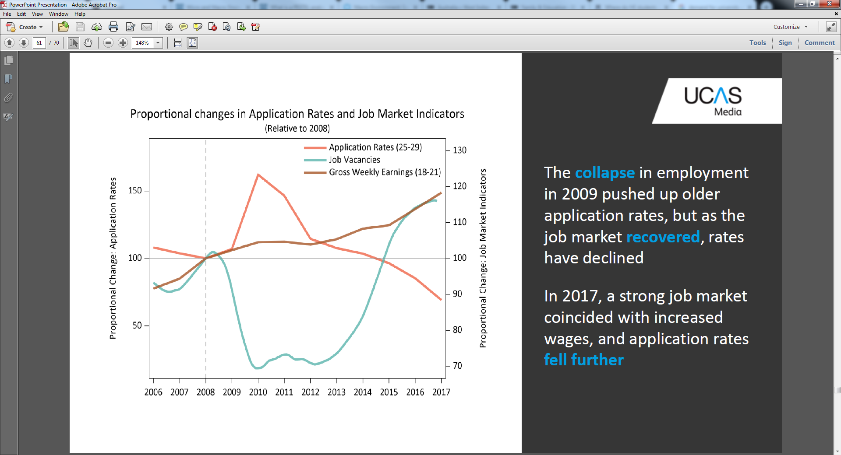Source: UCAS, 2017
- Sector projections: UCAS produce insightful application projections based on a variety of factors, which can be analysed by UWTSD and relevant action taken; an example can be seen below, showing the anticipated continued decline in applications to UCAS for the sector until 2020, before the sector starts to recover:
Figure 3: Application Projections
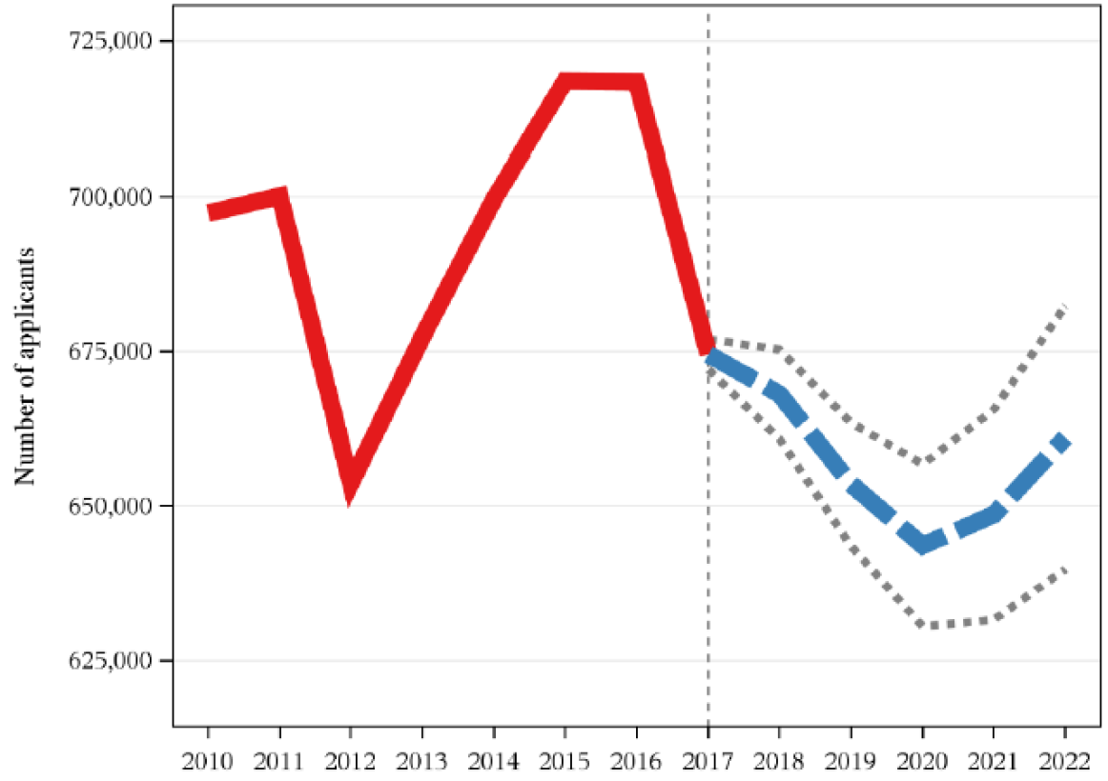Source: UCAS, 2017
- Labour market intelligence (LMI): an important aspect of universities is that they produce graduates that are work ready in relevant sectors that require higher level skills. Agile universities are those that leverage LMI, responding with courses that can fulfil local, regional and national demand. Organisations such as sector skills councils often produce LMI highlighting future skill needs and shortages, which can be analysed by UWTSD and provision made to satisfy such demand.

- Changes to student funding: finance is often a huge barrier to higher education for a large majority of people (Adams, 2013). Changes that lower this barrier such as the Diamond Review in Wales, and changes to postgraduate funding (Wightwick, 2019) can be capitalised on, with potentially more people accessing higher education. For example, Welsh-domiciled students starting a full-time or part-time postgraduate master’s course (taught or research-based) from 1 August 2020 can receive up to £17,489 as a combination of grant and loan (Student Finance Wales, 2020). With the majority of UWTSD’s postgraduate taught courses costing £7,500 for the 2020/21 academic year (UWTSD, 2020), this is a huge opportunity for the University to capitalise on the funding available to prospective students.
Social factors
- Perceptions of higher education: HE is often subject to debate in the press and the public domain, and can sometimes be negatively represented with negative rhetoric, with factors such as Vice-Chancellor pay (Adams, 2019), value for money (Coughlan, 2020), gagging orders (Croxford, 2019), restructures and job losses (Adams, 2018). All of these can negatively affect perceptions of HE and ultimately recruitment, thus highlighting the importance of sharing positive news stories, strong PR outlining the benefits of HE and the civic mission universities undertake in their local communities.

- Decline in the number of 18 year olds: in the middle of 2017, there were 766,000 people in the UK aged 18. At the start of the millennium the number of 18-year-olds in the UK was rising – but since 2009 it’s been going down, with the most likely explanation is that fewer people were born in the first place (ONS, 2018). With 18 year olds being a key market for every higher education institution, the decline has been felt across the sector, linking back to the application projections shown in Figure 3. It is also important for UWTSD to focus on the Welsh projections, as the Welsh market is a key recruitment hotspot for the University (see Section 2.4). UK projections can be seen below which shows the continued decline to 2020 before increasing again:
Figure 4: UK 18 Year Old Population Projections
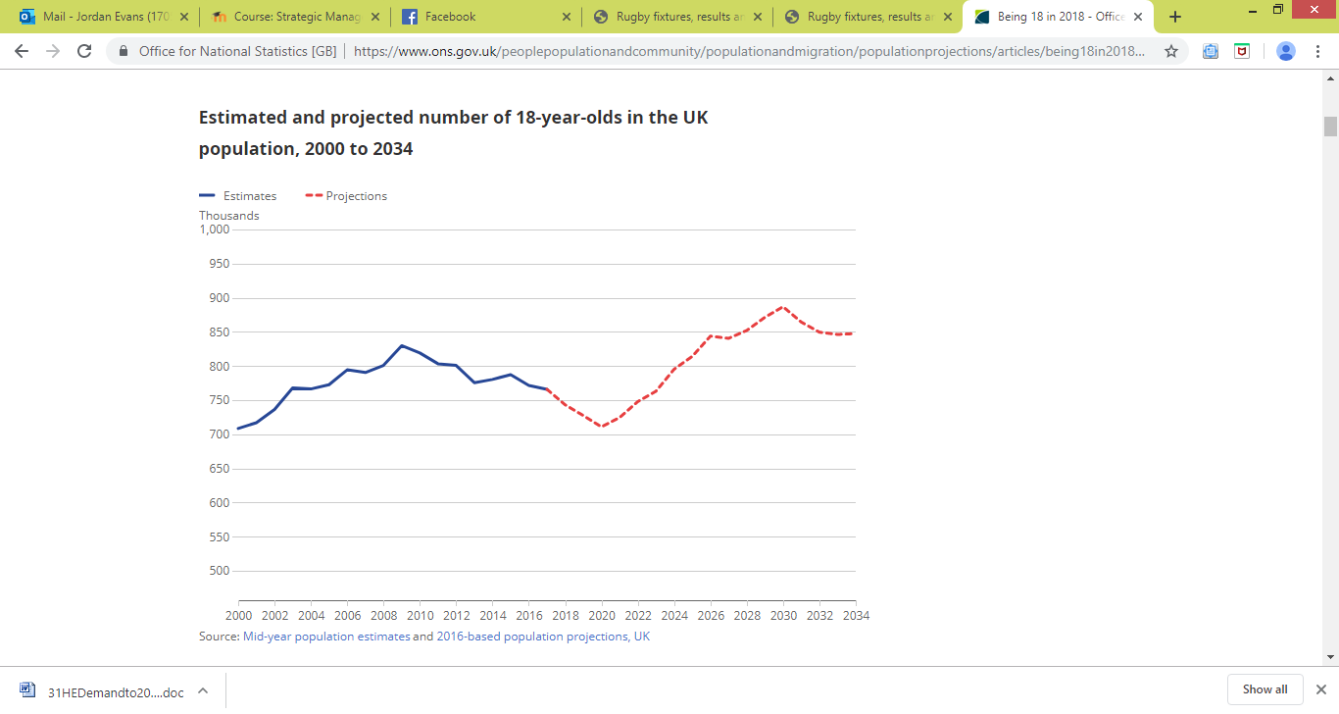 Source: ONS, 2018
The Wales projections, which follow a similar trajectory to the UK, can be seen below:
Figure 5: Wales 18 Year Old Population Projections
Source: ONS, 2018
Technological factors
- Online and distance learning: developments in technology are allowing for higher education providers to offer courses via online and distance learning (Coughlan, 2016), which can diversify their income streams; some also create their own separate online/distance learning brands to distinguish themselves from the core brand (e.g. University of Essex Online). Online and distance learning can also provide the flexibility that some individuals are seeking also (Wakefield, 2017). UWTSD has online and distance learning provision with the potential to expand the portfolio where there is evidence of demand; however, competition could increase significantly in the years to come also, particularly due to the Covid-19 pandemic (Bothwell, 2020), and the advent of blended learning at many UK universities from September 2020 (Weale, 2020).

- Social media and digital marketing: in 2020, an estimated 3.6 billion people were using social media worldwide, a number projected to increase to almost 4.41 billion in 2025. (Statista, 2020). This huge platform provides universities with the chance to share their values and success stories, as well as attract new students and engage with various stakeholders in the global marketplace. Digital marketing is also a tactic used by universities to entice new students, offering various avenues in order to reach prospective students, often spending millions (Weale, 2019). UWTSD currently has dedicated resources to manage social media and digital marketing, but may not have the significant budget available at other institutions.

- CRM and customer experience: the increased marketisation of HE has led to a customer-focused approach to student recruitment, given a significant proportion of students now see themselves as customers (Universities UK, 2017). Technologies that assist in improving the customer experience and help to ascertain a return on investment on recruitment activities can prove to be very powerful, such as a CRM (Salesforce, 2020). UWTSD does not currently have a central CRM system in order to maximise every enquiry it receives from the various points of contact, from enquirer to applicant to current student and beyond, although other methods are employed to counter for this. Ultimately, a CRM system can be a major factor in achieving a competitive advantage (McDonald, 2009), and is something the University could explore in the future in order to improve efficiency.
Legal factors
- GDPR, ASA and other regulatory responsibilities: recent introductions of policy have meant that universities must be very careful with regards to data protection (Cormack, 2017), as well as adhering to advertising standards (Coughlan, 2017). A recent news story which showed how a graduate received a £60k pay out over a 'false advertising' claim (BBC, 2019) is an example of how universities can be at risk for not adhering to such responsibilities. UWTSD must be careful not to fall foul of such responsibilities, as failing to do so could result in a fine and a damage of reputation, which could ultimately impact student recruitment.

- International students: while international students provide an attractive income stream, paying higher fees than home/EU students, universities must be careful that the relevant administration has been completed and conditions satisfied (UKCISA, 2019), again to avoid any fine or damage of reputation, and UWTSD is no different. The coronavirus pandemic could also negatively affect international student recruitment in the short-term, with universities having to seek out prospective students more aggressively than ever before (Bothwell, 2020).
Environmental factors
- Covid-19 pandemic: while the full impact of the global pandemic is still unknown, a post-coronavirus recession could drive higher university enrolment (as stated above) and enhance human capital (Hillman, 2020); this is an opportunity UWTSD could potentially exploit, with greater demand for higher education from domestic school leavers.
- UWTSD’s impact on environment: universities are often expected to lead the way on the sustainability and environmental agenda (Porritt, 2012). UWTSD has several sustainability-related strategies, while also being quoted considerably in its current strategic plan, and was awarded 1st class status in the 2017 People and Planet University league table.
UWTSD can never hope to understand every aspect of the macroenvironment in which it operates, as there will always be surprises and shocks that occur, as has been evident with the Covid-19 pandemic. However, it is important that the University capitalises more on the trends and changes than its competitors (Hooley, Saunders and Piercy, 2004), both exploiting opportunities and minimising threats.
2.3 Competitors and Porter’s Five Forces
UWTSD’s current competitors for the 2019/20 academic cycle at an institutional level as defined by UCAS are:
- Aberystwyth University;
- University of the West of England (UWE);
- Cardiff University;
- Cardiff Metropolitan University;
- Swansea University;
- University of South Wales.
These key institutions exist in UWTSD’s microenvironment and must be continually monitored in a strategic context to gain/maintain any competitive advantage that could occur.
In 1980, Michael Porter proposed five main forces that shape competition, with a systematic analysis of each helping managers identify the keys to competiveness in their particularly industry; each of the five forces is discussed below in the context of UWTSD (Hooley, Saunders and Piercy, 2004):
1. Rivalry among existing firms in the industry

- There’s currently an abundance of competition in the sector, from other HE providers, HE provision in further education (FE) colleges, private providers and online/distance learning.
- There’s particular competition in south Wales, where there are a lot of providers – both HE and FE.
- Due to similar provision in most institutions and fixed undergraduate fees, it can be difficult for HEIs to differentiate from competitors (SMRS, 2016). UWTSD differentiates from its competitors with its more personal approach to teaching and learning, and smaller class sizes, which can be reinforced with survey and league table results (UWTSD, 2020).
- With both market growth and product differentiation low, the rivalry amongst competitors is currently intense (Hooley, Saunders and Piercy, 2004).
2. Threat of new entrants
- There is a threat of new entrants in the HE sector with new alternative providers, and FE colleges offering HE provision (essentially utilising their current infrastructure and distribution channels), as well as HE competitors replicating provision in order to directly compete.
- With differentiation relatively low in areas, competitive retaliation unlikely and potential gaps in the market (either by location, delivery method and/or course content), entry barriers for are relatively low (Hooley, Saunders and Piercy, 2004).
3. Bargaining power of suppliers
- Defining suppliers of potential students as ‘suppliers’: schools, colleges and businesses, then due to the current fierce competition for students, these ‘suppliers’ have significant power. For example, a school or college could only allow one university to engage with its students.
4. Bargaining power of buyers
- If we define students as customers or buyers, then they have significant power, as most universities have lowered their entry requirements, allowing for the majority of students to pick which institution they want to attend, which may not have been the case prior to the lifting of the student caps as has been previously discussed.
- Students will also wait until much later in the recruitment cycle to apply, safe in the knowledge that they will likely achieve their first choice place via Clearing (Hall, 2019).
- With readily available alternate suppliers and switching costs minimal, buyer power is currently high in the sector (Hooley, Saunders and Piercy, 2004).
5. Threat of substitutes
- New, innovative courses could be created by competitors that could be more popular than core provision.
- Degree apprenticeships are a good example of a new product that could be more popular than core provision (Telegraph, 2019).
- Also, if the labour market is favourable, professional, shorter courses could become more popular.
- Technological advances and subsequent innovations, as well as incremental product improvement, could increase competitiveness in the sector (Hooley, Saunders and Piercy, 2004).
One of the most successful ways that UWTSD can counter this highly competitive environment is to differentiate from competitors, in a way of value to students and other stakeholders; this will help create a defensible position in the market (Hooley, Saunders and Piercy, 2004). This differentiation doesn’t necessarily refer to its product strategy (although differentiation in course content can be key), but to wider aspects such as a personal approach to teaching and learning.
2.4 Customer Analysis
Analysing UWTSD’s applications from UCAS for 2019 entry (up to 23/6/19) provides a firm understanding of the University’s customer base:
Location
- 68% of applications come from those domiciled in Wales;
- 25% of applications come from those domiciled in England.

The following applicant mapping provides further insight:
Figure 6: UWTSD Applicant Mapping, 23/6/19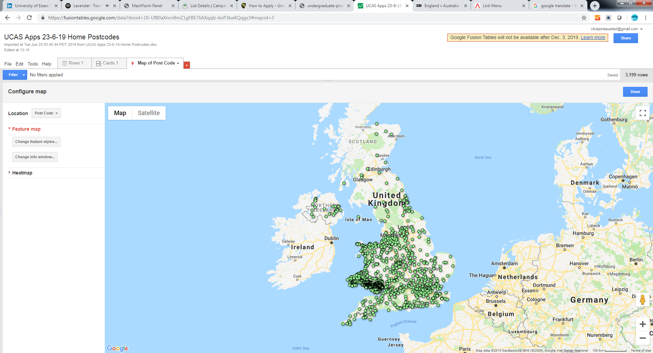
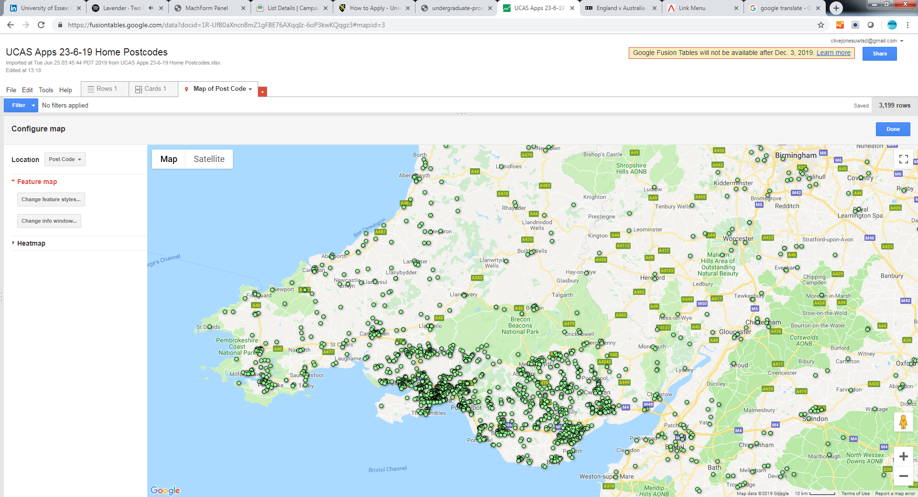Source: UCAS
The importance of the south Wales market is therefore evident. Further focusing on the firm applicants reinforces this:
Figure 7: UWTSD Firm Mapping, 23/6/19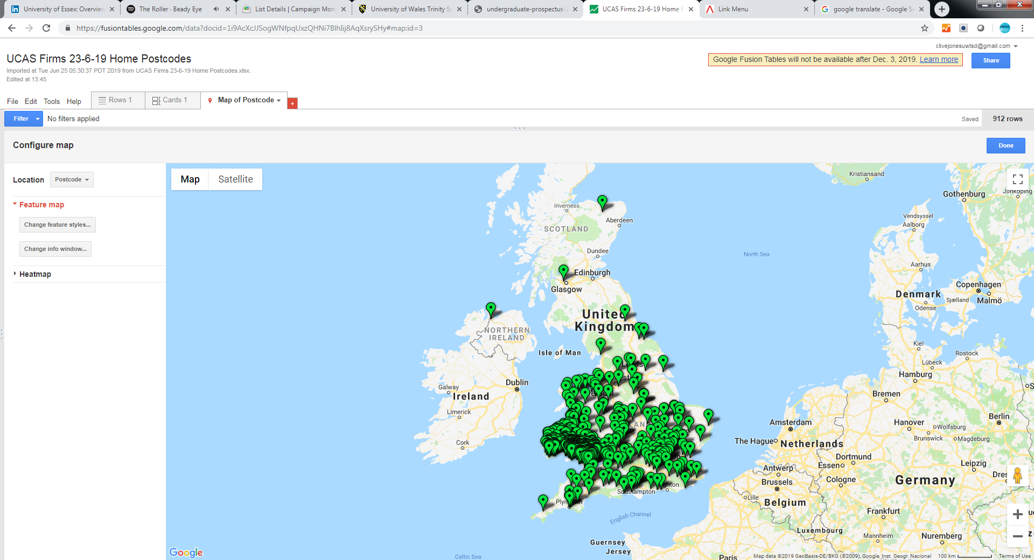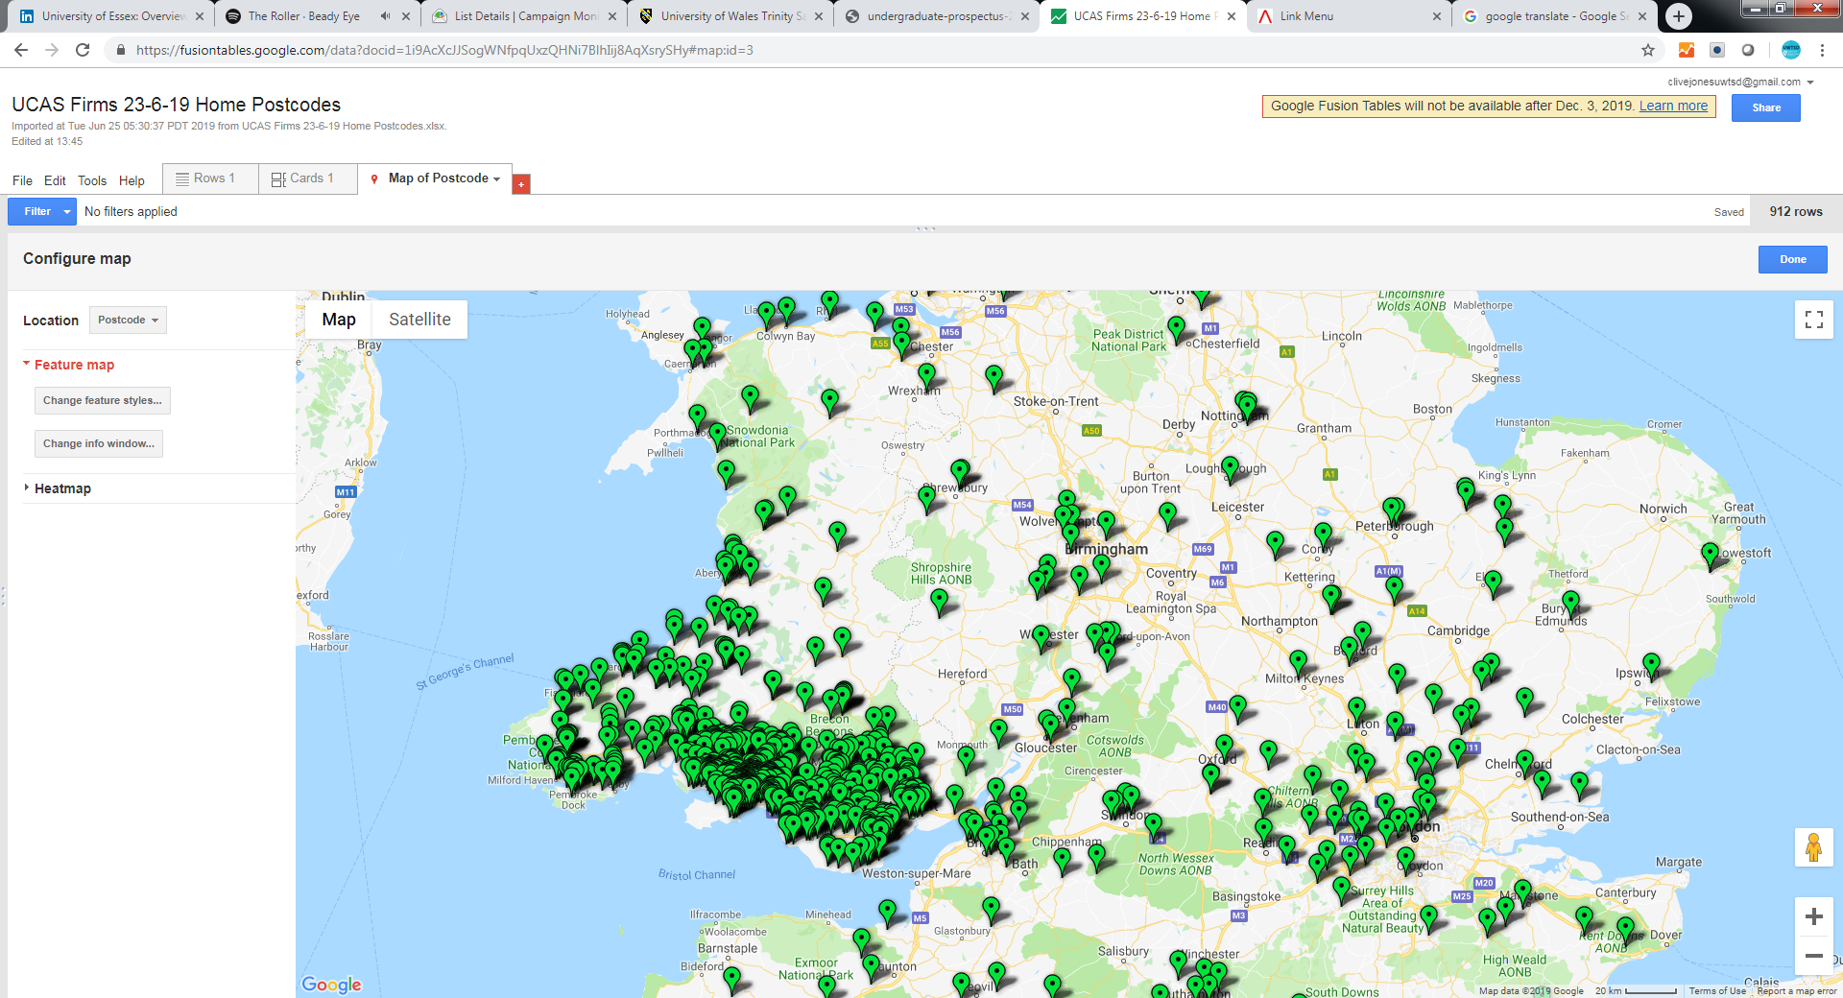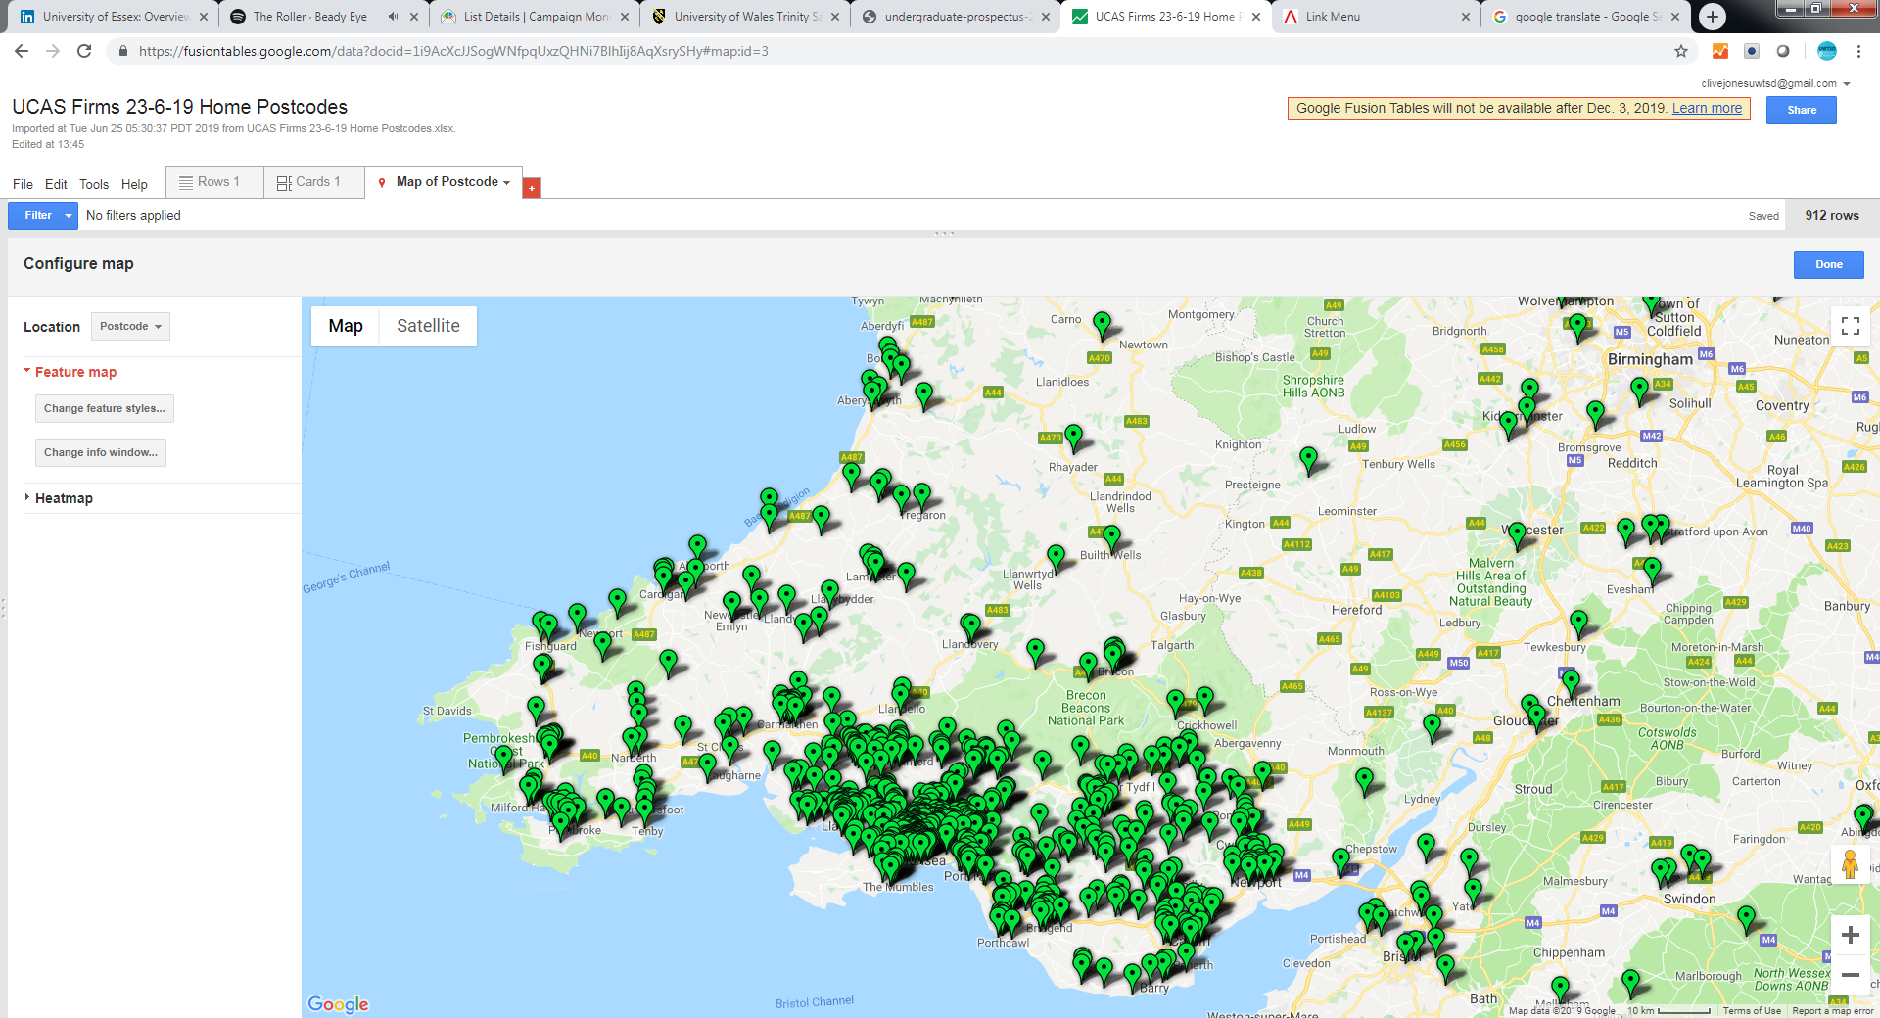Source: UCAS
Feeder schools and colleges
Analysing the current/previous school/college of applicants aged 19 and below provides a firm understanding of the key feeder institutions for UWTSD:
Table 1: UWTSD top feeder institutions by applicants aged 19 & below, up to 23/6/19
Institution | Applicants (>15)
Gower College Swansea | 172
Coleg Sir Gar / Carmarthenshire College | 120
NPTC Group of Colleges | 117
Coleg Gwent, Crosskeys Campus | 70
Bridgend College | 57
Bishop Vaughan R C School | 47
Coleg y Cymoedd | 46
Pembrokeshire College | 38
Ysgol Dyffryn Aman | 36
St David’s Catholic College, Penylan | 30
Ysgol Gyfun Y Strade | 26
Merthyr Tydfil College | 25
Ysgol Maes y Gwendraeth | 23
Ysgol Gyfun Gymraeg Bryn Tawe | 22
Ysgol Gymraeg Ystalyfera | 22
Coleg Gwent, Ebbw Vale Campus | 21
Cardiff and Vale College | 20
Olchfa School | 19
Source: UCAS
All the above institutions are based in south Wales, again reiterating the importance of this market. Engagement with these institutions is therefore paramount in the continued recruitment of students. These key institutions can be viewed as ‘suppliers’ in the context of analysing the microenvironment.
Age
The age distribution of applicants can be seen below, which highlights the importance of the mature market to UWTSD, and not just those aged under 21:
Table 2: age distribution of applicants, up to 23/6/19
Age | %
18 & under | 50.6
19 | 22.1
20 | 8.7
21-29 | 14.0
>30 | 4.6
Source: UCAS
Sex
The gender distribution of applicants up to 23/6/19 was:
- 56% of applications came from females
- 44% of applications came from males.
2.5 Employees
In 2018/19, UWTSD had just approximately 1,515 staff: 760 professional (non-academic) staff and 750 academic staff. Of the 750 academic staff, 150 had a doctorate qualification (HESA, 2018/19). Dedicated staff is one of the key strengths of the institution, as evidenced by the Whatuni Student Choice Awards where UWTSD won the coveted ‘Course & Lecturers’ category in both 2019 and 2020 (UWTSD, 2020).
UWTSD workers outside the executive ranks seek a combination of employment security, compensation and job satisfaction; failure to meet their minimum expectations may curtail their commitment to provide high levels of quality and service to current and prospective students (Doyle, 2002). Recent institutional restructuring to future-proof the University (Lewis, 2019) and the subsequent impact of this could negatively impact staff commitment levels, and must be monitored by the various levels of management.
2.6 Media
Both positive and negative media attention can have a huge impact on a university. Institutions therefore need to manage the media so that the media help to promote the positive aspects about the organisation and reduce the impact of a negative occurance on their reputation (Learn Marketing, 2020).
UWTSD has a dedicated Corporate Communications & PR department (separate to the Marketing department) to manage elements of the media and press, which is particularly important in the spectrum of higher education which is often a ‘political football’ in both Wales and the UK, as has been previously discussed in the PESTLE analysis.
2.7 General Public
Organisations have a duty to satisfy the public, and actions of a company must be considered from the angle of the general public and how they are affected. The public has the power to help organisation’s reach goals, just as they can also prevent them from achieving them (Oxford College of Marketing, 2020).
UWTSD puts a great deal of effort in to community and stakeholder engagement in order to make it clear to the public of the positive impact that the University has on the local economy and communities of south Wales and beyond.
2.8 SWOT Analysis of UWTSD
The opportunities and threats in the external environment relevant to UWTSD have been covered in the previous sections; as such, this section will focus on the strengths and weakness of the University which are internal to the institution:
Strengths
- In general, very dedicated staff, both academic and professional.
- Some excellent new buildings and facilities such as the Swansea SA1 campus and Canolfan S4C Yr Egin.
- Small class sizes compared to some competitors, which provides a more supportive learning environment.
- Excellent courses and lecturers, as evidenced by recent surveys and league table results.
- Good levels and standards of corporate governance.
- Clear strategic plan which is ambitious and realistic. The plan clearly lists the University’s vision, mission, values and objectives.
- A dual-sector educational system which allows for progression from level 1 to level 7.
- A diverse range of study locations and courses available.
Weaknesses
- Multiple campus locations which can lead to brand and identify confusion amongst key stakeholders.
- A name which doesn’t have the campus locations within it, which again can lead to identity issues.
- A relatively small marketing team compared with competitors.
- Some aspects of the academic portfolio compete with each other in different campus locations.
- Some accommodation standards are not of the highest standard which can negatively influence prospective students.
- Similarly, some facilities and locations are not of the highest standard.
- In some areas, a lack of key business processes, infrastructure and planning. This includes organisational structures, physical resources and technological resources such as a central relationship management (CRM) system.
- Legacy issues from the merging of previous institutions, and the subsequent cultural issues this brings, including the University brand and name.
- In some instances, poor communication between departments and a ‘silo mentality’. This can lead to a poor corporate culture at times.
UWTSD management should next clearly identify the key issues or options available to the business, exploring avenues which exploit the strengths and pursue the opportunities that have been identified, while simultaneously taking action to counter the threats and weaknesses that have been perceived (Doyle, 2002).

3.0 Literature Review
A literature review is an important task in order to situate the primary research undertaken in this project in the context of the wider higher education community. This section will report a critical analysis of the relevant secondary research that has already been undertaken, which will complement this research project (University of Leicester, 2020).
3.1 UCAS – Through the Lens of Students
The UCAS report titled ‘Through the lens of students: how perceptions of higher education influence applicants’ choices’, released in July 2016, provides an insightful and balanced understanding into the student decision-making journey for those individuals who apply via the admissions service UCAS.
UCAS’ mission is to inspire and facilitate progression in education through information and admissions services, enabling everyone who has the potential to benefit from HE to have the opportunity to do so, meaning their research is generally unbiased with regards to favouring particular types or groups of providers. Therefore, UCAS can be relied upon to continually produce robust and unbiased research which can be trusted.
The report is based on an online survey carried out by UCAS in early 2016 to UK-domiciled applicants from the 2015 recruitment cycle who were aged 18 or 19, whether or not they were ultimately accepted to HE. The research therefore focuses on the traditional market with regards to age, which should be noted.
A total of 18,100 people responded, 16,600 of which answered all the questions, which represents a 4.5% response rate. The survey was UK-wide and the report therefore reflects the views of applicants from all four home nations, which is an important consideration with devolved education systems. Furthermore, EU and international students were not surveyed, which should also be noted.
The primary purpose of the survey was to explore the factors that motivate young people to apply to HE, and what they perceive as the barriers to progression to HE.
It should be noted that the survey was conducted in early 2016 and therefore is over four years old now, but the insight remains a useful source of research.
The research concluded that applicants have a clear idea about what they think makes a university good:
- Quality of teaching, appropriate delivery, and assessment;
- Academic reputation, and commitment to research;
- A good record for graduate job prospects;
- Facilities – academic, social, and accommodation.
The research also uncovered the main reasons why individuals don’t go to university:
- Financial concerns and worry about debt;
- Lack of clarity about the real entry requirements for a course;
- Understanding the full range of degree courses available and lack of visibility of employment opportunities as part of the degree;
- Confidence in the graduate job market;
- Variable quality of advice from schools and colleges – in particular, respondents reported a lack of support for those not interested in higher tariff universities;
- Limited access to widening participation programmes.
The research also highlighted the importance of open days and visits in helping applicants make well-informed choices about what and where to study, with the following pertinent points:
- The timing of open days and visits – it is more expensive to travel in the week and at peak times, and parents and carers may be unable to take time off from work;
- Lack of advice on transport arrangements;
- Lack of coordinated travel and organised trips.
Finally, the report offered the following recommendations to universities and colleges; institutions should:
- Explain the progression pathways from degree programmes into graduate employment, particularly in relation to degree programmes with more academic titles, where it may be harder for some learners to link these courses to future career opportunities;
- Explain and promote how employers are involved in shaping their degree programmes, and the opportunities available for students to gain work experience as part of their programme of study;
- Be clear and transparent about the actual entry requirements for their courses, and any additional evidence necessary beyond academic achievement;
- Raise awareness of the support available to new undergraduates to help them succeed in studying at a higher level, before and after the transition to HE;
- Provide easily accessible information about the costs of living and studying at their course provider, particularly information about accommodation, transport, and day-to-day living costs, alongside advice on budgeting;
- Reach out to a wider cohort of prospective students to demonstrate that they are inclusive course providers;
- Schedule open days, interviews, and any tests at times when it is easiest and cheapest for applicants to attend, and provide more information to make attending as simple as possible, as well as considering alternatives such as virtual tours, regional events, and providing transport solutions;
- Consider financial incentives to encourage applicants to attend more open days, for example, travel vouchers.
This research and insight is extremely valuable to universities, particularly those working in marketing and student recruitment. The following factors are crucial in the recruitment of students, which need to be leveraged in marketing activities:
- The quality of teaching is paramount and should be clearly communicated;
- Employment prospects and work experience are critical factors, and the main reason why students attend university;
- Accommodation is a huge concern to prospective students - a factor which universities can often overlook;
- Work must be done to allay financial concerns and fears;
- Open days and visits are crucial in the successful recruitment of students.

3.2 SPCE Labs – Important Factors When Choosing a University
SPCE Labs, the research arm of student lettings app SPCE, commissioned independent research in March 2018, and surveyed more than 2,000 people across the UK in order to ascertain the most important factors for prospective students when choosing which university to attend (Bhardwa, 2018).
The respondents were current undergraduate students at UK universities and people who have graduated in the past decade, and were asked to score a range of factors from one to ten, with one being not important at all and 10 being extremely important.
The following table summarises the results:
Table 3: Most important factors when choosing a university, 2018
Rank | Factor | Mean score
1 | The course on offer: its curriculum, assessment type and structure | 8.4
2 | The reputation of the university | 7.7
3 | The university’s perceived ability to boost later career opportunities | 7.1
4 | How accessible the university is by major transport links | 6.7
5 | The university’s facilities: gym, library, IT and science labs | 6.3
6 | The university’s distance from my family home | 6.1
7 | Affordability: how cheap or expensive the town/city is | 6.1
8 | The student accommodation available: halls and private rentals | 5.9
9 | The support services: counselling, enrichment and diversity programs | 5.8
10 | Culture of the university or region: arts, food and attractions | 5.7
11 | The size of the town or city that the university is located in or near | 5.6
12 | The nightlife on offer in the area | 4.6
13 | The sports you can play or watch either at the university or in the area | 3.9
14 | Having family or friends at the university or previously attended it | 3.9
15 | The weather in the region | 3.6
Source: SPCE via Times Higher Education
The research shows that the course is clearly the most important factor as to why students choose to go to university, followed by reputation and the ability to boost career prospects, as was evident with the UCAS research outlined previously.
To further validate this research, Open Access Government, University Business and Times Higher Education published this information on their respective websites.

3.3 Hobsons – International Student Survey
In 2017, educational consultants Hobsons carried out an international student survey which questioned 62,366 students from 65 universities around the world; of these, 27,955 students were considering studying in the UK (Bhardwa, 2017). The research therefore covers both home and overseas students, which provides an additional level of research and insight.
Students were asked a variety of questions about higher education including which factors were most likely to influence their choice of university, and why they chose to attend university in the first place.
Students had to rank these factors in order of importance when choosing a university. The two reasons rated most important were high-quality teaching (30%) and whether universities offered scholarships (29.9%).
The position of a university within rankings came third, with 23.5% of students stating that this was the most important factor.
Students were also given a list of factors with regards to reasons for going to university, and had to list their top three reasons. The main reason was revealed as being passionate about their subject, with the continuation of learning and development coming in second.
Finally, respondents were asked to rank factors which indicate to them a good quality of teaching.
Nearly 70% of students strongly agreed that having highly qualified teaching staff indicates that a university provides good-quality teaching. Respondents felt less strongly that high graduate starting salaries were an indicator of good-quality teaching (31%), compared with those ranking a high graduate employment rate as a key indicator of good teaching (52%).
This piece of research covers the international market, which gives a wider perspective to the project. It’s interesting to note the interest in the course, employment prospects and teaching were highly regarded once again, reiterating the importance of these factors in the decision-making process for prospective students.
3.4 SMRS – The Student Journey
SMRS are a UK-based education marketing company who work with a number of university clients. In 2016, the company released the research document ‘Revisions and Decisions: The Student Journey. An ongoing programme of research that maps the student journey from school through to university or the workplace’.
The report is the culmination of a research project that started in 2013, when the company built their own community of 50 year 12 students and followed them for two years, all the way from further to higher education or work.
Over the two years, SMRS engaged with the individuals via discussion groups, quick polls and forums, and every week they provided real insight into their decision-making processes through video uploads, blogs, Q&As and surveys, through a dedicated community portal.
The cohort was made as inclusive as possible, with a mix of gender, socio-economic groups, locations, course types and target higher education institutions.
For most students, the decision to progress into higher education was made well in advance of sixth form/college, with students having already decided that they were going to university as early as years 10 and 11, which is an important consideration in terms of when to start targeting prospective students with relevant content.
With the decision to attend university already made, students were looking for information and guidance to help them solidify their decision as soon as they entered year 12; however, the information received from their school/college was felt to be inadequate (which has been stated previously in the UCAS research). Students commented that they would have liked more information regarding:
- The application process;
- University life;
- Courses and their associated career paths;
- Alternatives to university (although university was the preferred option with most students, they still liked to read up on the alternatives so they could feel they had made a fully informed decision).
In summer term of year 12, the decision-making process increased in intensity, with students drawing up university shortlists, guided largely by reputation; while some students looked at the reputation of the university, others were guided by course reputation.
It was discovered that league table rankings were only one of a number of factors that collectively formed a university’s reputation in the opinion of the panel: entry requirements, the demand for places, the history/back story of the university and course quality all played their part in establishing an institution’s reputation.
Students consulted a variety of university owned, paid and earned media, as well as influencers:
- Owned: university websites; prospectuses; other printed material and open days;
- Paid: UCAS fairs; university guides and online forums;
- Earned: university guides and online forums;
- Influencers: teachers.
By November of year 13, almost everyone that hoped to go to university had submitted their UCAS application, with colleges and universities rising to the occasion. Support and advice received from college and universities during the application process was said to have turned an initially daunting and confusing application process into a straightforward and relatively painless one. Universities were said to have responded promptly to general enquiries and submissions.
Whilst largely happy with this application process, students do feel the process needs explaining clearly to applicants, which would help manage expectations about when they can expect to receive updates and decisions.
A university’s ability to connect with potential undergraduates and differentiate itself is of great importance and key to recruitment success. When asked to rate hard facts and softer information on a scale, half of students rated hard facts as very important, more than double the proportion that rated softer information very important. When asked to rate the importance of direct images and creative images, more than half of students rated direct images very important and only one student rated creative images very important.
For the parents of the student panel, university is a chance for their child to gain valuable life and social skills, achieve their chosen career path, increase their options later in life and increase their job prospects. For universities, making sure parents can see the potential to deliver on these aspects is important.
As with students, parents looked at reputation to help them draw up a shortlist of universities, as well as league table rankings, facilities, social life and location. Most had seen a number of university prospectuses and half had referred to a league table guide and various university websites. The students were generally happy with the content of the prospectuses but thought the websites had the edge, being more accessible and more comprehensive.
A significant number of parents attended an open day with their child, armed with a clear list of objectives. Encouragingly, all found open days worthwhile. Their main drivers for attending were to:
- Get a feel for the town or campus;
- Obtain further course information;
- See the accommodation.
This longitudinal piece of research is very effective in understanding perceptions over a longer period of time, and in greater detail than from a one-off survey, with a smaller pool of individuals.

3.5.1 The Student Room – Options 2018/19 Report
The Student Room is an online student community based in the UK with 10 million monthly users who seek information, advice and support on their educational journey and life around learning.
The Options 2018/19 report, published in 2019, presents the results of a survey of over 10,000 UK students aged 16-20, and uncovers student perceptions of the options available after school, college or university, and provides a unique insight into the decision-making journey. Similarly to the UCAS report, this research focuses on the traditional market within the UK.
The decision to go to university was predominantly motivated by improved career prospects and the respondent’s interest in the chosen subject, as we have seen in the previous research findings.
Course content, location and university ranking were the top three considerations when choosing universities. Those individuals whose parents had been to university were particularly interested in university ranking, which is a thought-provoking consideration. The full results can be seen in the graph below:

Figure 8: Accounting Factors When Choosing a University, TSR 2018/19
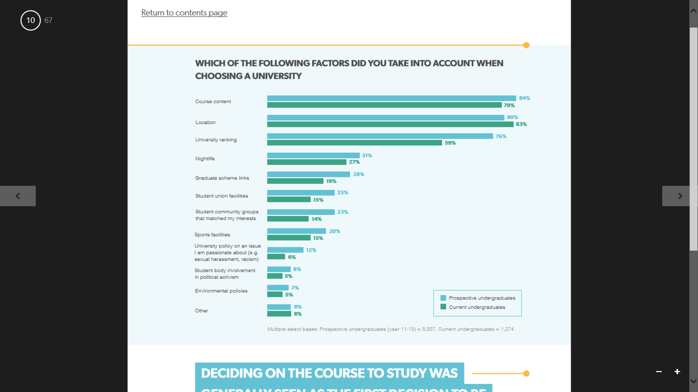Source: The Student Room
Deciding what to study was the first step for prospective students considering university, which was followed by deciding on a career and a university. Decisions around affordability and where to live generally came at a later period.
Prospective student respondents used a range of information sources when choosing a university; open days were considered the most useful but websites were the most used, including both the UCAS website and the relevant institution’s website.
Family members were the most influential source when deciding on a shortlist of universities, and their influence remained high throughout the decision-making process. Teachers and careers advisors were particularly influential early in the university decision-making process but their influence decreased as respondents progressed from year 11 to year 13.
Choosing not to go to university was mostly motivated by financial factors, and was not always perceived to be a permanent decision. The expense and a desire to start earning money were the main barriers to university among respondents who had chosen other pathways. One in three thought they could go back to university in the future if they wanted to.
3.5.2 The Student Room – Widening Participation
Linked to the above research, The Student Room have also published a report into how widening access students think, feel and behave when making decisions about higher education, titled ‘How Widening Participation students think, feel and behave’.
The research, published in 2017, suggests that students from all backgrounds share the same chronological decision making journey, forming key rational decisions at the same time.
When polled on their motivations for applying to university, the widening participation (WP) focus group students outlined that their love for learning and the passion for doing something that they love was the primary reason, second to job prospects. The WP audience clearly demonstrates anxiety around cost and debt; however, the research also indicates a passion for learning, as well as receptiveness to aspirational and inspirational messaging.
Parents, and even grandparents, are strong influencers on WP students, as might be expected. These key influencers would like a better, more affluent future for their children and grandchildren, naturally.
Behaving in a similar way to the mainstream audience, and with largely similar motivations, tailoring communications and outreach to this community is a balancing act.
The challenge lies in amplifying messages around specific WP wants and needs, while maintaining the elements that resonate with all audiences. In practical terms, the theme of reassurance comes out of the research around anxiety. This reassurance is equally valuable to influencers as to applicants, and can help to allay key concerns around affordability and debt.
However, the WP audience can’t be characterised as timid or nervous as a whole. Their social and educational aspiration is greater than their non-WP counterparts, and they demonstrate an admirable robustness and determination. This facet of marketing and student recruitment must be noted by UWTSD.

3.6 Unite Students – Insight Report 2019
Founded in 1991, Unite Students was the UK’s first private provider of purpose-built student accommodation. Since then, the company has provided a home for over 600,000 students as they make their way through university.
The organisation’s 2019 insight report titled ‘The New Realists’ set out to understand the motivations of applicants and first year students. Three findings emerged strongly from the research undertaken:
- Future stability is a dominant motivator for current and prospective students within the context of a world that they perceive as uncertain and risky. As such, for many students, an undergraduate degree appears to provide an important and valuable period of transition between a secure and familiar past and a stable future;
- The current generation of applicants and students is the most diverse ever, in terms not only of traditional demographics, but individual identity. The cohort needs a broad, inclusive and flexible higher education experience that reflects this and meets demands;
- Student friendships are highly significant to this generation of students and play a practical as well as an emotional role in their lives. Friends and peers are seen by students as fundamental to a successful student experience and play a clear role at specific points on the journey.
The top motivations for going to university can be seen in the graph below:

Figure 9: Top Motivations for Going to University, 2019
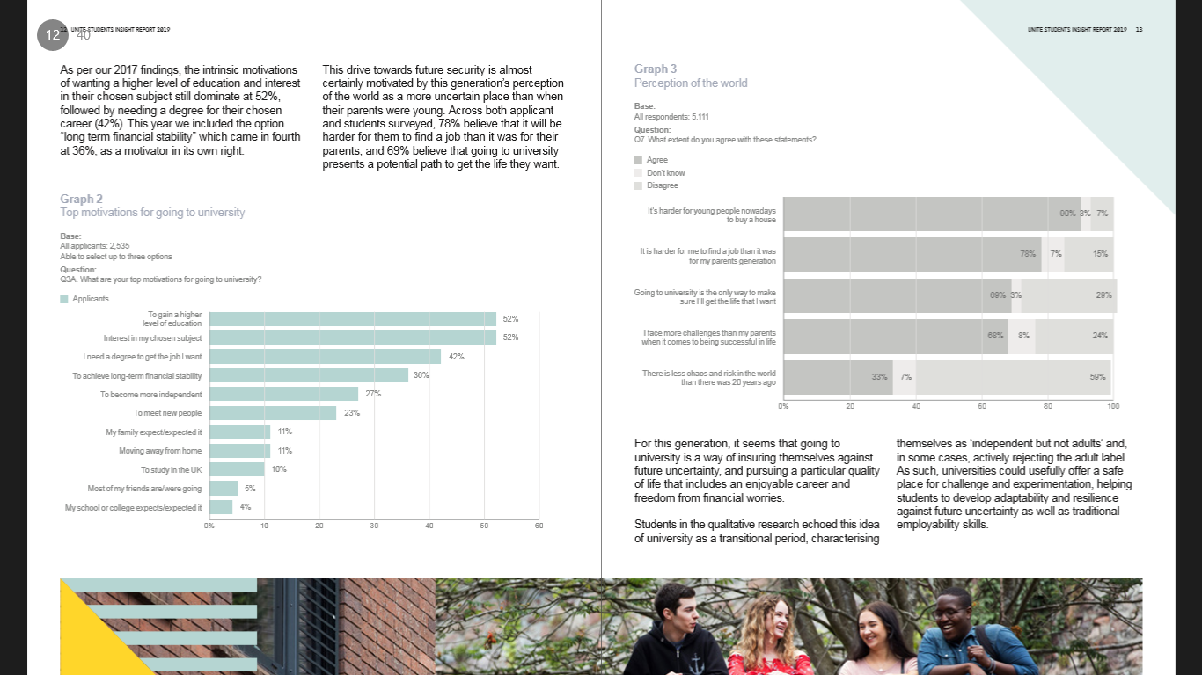Source: Unite Students
With interest in a particular courses and employment prospects proving to be significant motivating factors, this study again confirms and reiterates the research shown in previous sections.
3.7 Sussex Learning Network and Aimhigher Sussex
Susan Bishop and Dan Bennett of the University of Brighton were commissioned in 2009 by the Sussex Learning Network and Aimhigher Sussex to gain insight into, and understanding of, choices made by Sussex-based students about a future in HE.
The students, in years 12 and 13 and in FE institutions, were surveyed about choices relating to their future: whether to go into HE or straight into employment.
The main aim of the research study was to better understand the key influencing factors affecting the decisions of Sussex-based students in years 12 and 13 (aged 16–19 years old), and also of students following programmes at FE institutions.
The majority of students who participated in the research were emphatic about their ambition for good employment prospects and improved pay as a result of taking a degree in HE. Employment prospects ranked third in the criteria for choosing an academic institution and, for many students, future earnings and career progression were closely linked to this.
Students voiced concerns about the cost of studying in HE and there was some indication (from the focus on employability and types of courses chosen) that students were looking to make their money back as soon as possible after graduation.
With regards to personal criteria, the cost of living, availability of accommodation, and location were the top three criteria when choosing an HE institution. Cost of tuition fees was ranked fourth, suggesting that students are concerned about the financial aspects of progressing to HE.
Reputation and quality of teaching ranked high on students’ list of academic criteria, supported by the findings from focus groups. Signifiers that were captured on flip charts for this were ranking tables, quality of teaching, entry requirements and results. Course availability and good employment prospects were also deemed to be important to the students’ decision-making.
When considering the personal and academic criteria combined, it was found that academic criteria made up five of the top six influences on a students’ decision-making. These influences included quality, reputation, employment prospects and subject area offered. The only personal criterion in the top six combined was cost of living, with accommodation, location and tuition fees being ranked seventh, ninth and tenth respectively.
While this insight is robust, it should be noted that is Sussex-specific and therefore potentially not fully representative of the rest of the UK.

4.0 Methodology
The aims and objectives of this research project are to evaluate and understand the various marketing and recruitment techniques used by universities to recruit students, with a particular focus on UWTSD as a case study, in order to ascertain the best methods that can be implemented in order to maximise student recruitment.
Research Methods
The entire scope of this research project covers the following:
- Review and synthesis of previous sector reports in relation to motivations for HE, decision-making in HE, marketing in HE and student recruitment in the UK HE sector, as has been covered in the literature review.
- Online surveys targeted at UWTSD applicants who have either accepted a place to study (via an acceptor survey), or those who have declined or withdrawn their offer/application (via a decliner and withdrawer survey) to gather the perspective directly from the target market. This primary research will cover the 15/16, 16/17, 17/18, 18/19 and 19/20 recruitment cycles. The design and implementation of these surveys is attributed to the researcher, during my capacity as Principal Marketing Intelligence Officer at UWTSD since January 2015 to date.
- Both the acceptor and decliner survey have been fully designed by the researcher in the work capacity as Principal Marketing Intelligence Officer at UWTSD. The surveys were designed to be comprehensive and cover the full application journey, including sources of research used when applying and the various decision-making factors that are in place for prospective students.
- Both surveys were designed so that they could be cross-referenced with each other when undertaking analysis, gathering insight as to why an applicant both accepts and declines a place to study at UWTSD, to draw conclusions from both cohorts as to the most important aspects of HE marketing and recruitment. This data is very useful in continually understanding trends in HE decision-making and effective recruitment techniques in relation to UWTSD.
- Both surveys are optional and separate to any application process; an automated email is sent to applicants on decision which contains a link to a relevant survey, asking individuals to state why such a decision has been made via a survey. There is a potential financial incentive for completing the survey. Before completing the online survey (provided by SurveyMonkey), applicants are informed that the information will help UWTSD target its marketing activities. No personal information will be disclosed and individuals will not be able to be identified in the amalgamated data.
- This quantitative research will be the main focus of the research.
- In order to complement the quantitative research, a small-scale qualitative research project will be undertaken alongside in a mixed-methods approach. Three, short interviews will be undertaken with higher education marketing staff currently employed in the sector to gather their views about what they see as the key activities that result in the maximum recruitment of students, which can be cross-referenced with the results of the online surveys. Their names will not be disclosed but the job titles will.
- Where appropriate, core marketing theory will be referenced to further enhance the research findings.
Advantages and Disadvantages of Research Methods
The advantages of the research methods used are:
- The survey responses are directly from UWTSD applicants – the actual target market for marketing and recruitment techniques so the insight gained will be rich and bespoke;
- The survey is sent to applicants on decision, so the results are a good indicator of how applicants are feeling at that crucial point in time;
- The results cover nearly five full recruitment cycles, and therefore allow for analysis over time which can provide far greater insight, less variability and a larger sample;
- The interviews will gather the views of experienced marketing and recruitment professionals who have worked in the sector for many years;
- Sector reports will provide wider insight in to the HE sector as a whole;
- Core marketing theory has high levels of academic rigour;
- Collectively, the research covers the view of the applicants/prospective students of UWTSD, the view of the wider sector on a more general basis, the view of HE marketing and student recruitment professionals currently working in the sector, as well as core marketing theory, meaning a wide range of sources will be used. This summarises into a comprehensive bank of evidence and research which can be used to create a truly data-driven, evidence-based marketing and student recruitment strategy for UWTSD in particular as the case study, but also in theory, other universities in the sector.
The disadvantages of such research methods which should be noted are:
- The survey is a sample and may not be fully representative of the whole University and wider sector;
- The primary research focuses on one institution, and therefore this may not be the case in other universities in the sector.
Methodological Limitations of the Research
Limitations of using a survey as a research technique include:
- Dishonest answers: respondents may not be fully truthful in their answers, particularly in the decliner and withdrawer survey;
- Unanswered questions: all questions are not required to encourage maximum completion, but this means some questions could be skipped entirely;
- Differences in understanding and interpretation: as the surveys are online, there is no-one on hand to fully explain each question if there’s some confusion, which in-turn could skew the results;
- Difficulty in analysing some questions: the surveys contain some open-ended questions which can be difficult to comprehensively analyse, although these questions are not the focus of this research project;
- Survey fatigue: applicants may have been surveyed by other universities and therefore less inclined to complete (Debois, 2019).
Limitations of interviewing as a research technique include:
- Time-consuming: organising, undertaking and writing up the transcript can all be very time-consuming;
- The sample can be small, particularly compared with other methods such as a survey (Sociology Group, 2019).
Finally, limitations of secondary research include:
- The information may be old and not relevant anymore;
- The data used may be of poor quality or biased (Cameron, 2018).
Data Collection Techniques
The online surveys are automated once an applicant has made the relevant decision – that is, if an applicant accepts a place to study with UWTSD, an automated email is sent to them with an electronic link to the acceptor survey. Similarly, if an applicant declines or withdraws their offer/application, an automated email is sent with an electronic link to the decliner and withdrawer survey. The survey software used is SurveyMonkey.
A set of questions has been developed in order to structure the interviews, with three HE professionals participating. Due to the current global pandemic, interviews were undertaken virtually, with the transcripts available to view in the Appendix.
Desk-based online research was used to locate and review sector reports relating to university motivations and decision-making, student recruitment and marketing, as shown in the literature review.
Survey Population and Sample
UWTSD has approximately 5,000 applications a year across all its programmes (undergraduate and postgraduate), with approximately 2,000 firms and therefore 3,000 non-firms.
As has been covered above, both surveys are optional and separate to any application process. Before completing the online survey, applicants are informed that the information will help UWTSD target its marketing activities.
Given the nature of HE marketing, some applicants may be under 18 (more than likely 17) at the time of completing the survey, although this information is not collected during the survey process.
The results of the surveys are not made public to the applicants, and at no point has this been stated to them.
A total of 1,659 respondents completed the acceptor survey over the time period; this averages to an approximate response rate of 17%.
A total of 990 respondents completed the decliner and withdrawer survey over the time period; this averages to an approximate response rate of 7%.
Research Limitations
As previously discussed, the research could be skewed by different applicant cohorts and not be fully representative of the whole institution, but it is anticipated that the amalgamation of data and cross-reference of both surveys will negate this.
Methods of Data Analysis
The methods of primary data analysis are:
- SurveyMonkey has built-in analysis functions in order to analyse the results of both surveys.
- Microsoft Excel will be used to amalgamate the data from both surveys and to undertake the subsequent analysis.
- Content analysis will be used for the interviews in order to draw out key themes, grouping relevant trains of thoughts together.

5.0 Data Analysis
This section presents the results of both online surveys over the 5-year period; the interview transcripts can be found the Appendix.
5.1 Surveys
The following section presents the results of the online surveys undertaken - the acceptor survey firstly followed by the decliner and withdrawer survey.
5.1.1 UWTSD Acceptor Survey
The acceptor survey questions remained the same for 2016, 2017 and 2018 before being updated from 2019 onwards to be more consistent with the corresponding decliner and withdrawer survey, and flow more logically.
As such, data from 2016-2018 can be analysed individually and collectively, as can data for 2019-2020; both collective sets of data can then be analysed concurrently.
Data analysis for the 2016-2018 surveys will focus on two questions from the entire set:
- Please select from the list below ALL the reasons that made you accept UWTSD.
- What sources did you use to research UWTSD and help inform your decision to study here? Tick ALL applicable sources.
Data analysis for the 2019-2020 surveys will focus on five questions from the entire set:
- How did you hear about UWTSD? Please tick all applicable sources.
- What sources did you use to research UWTSD and help inform your decision to study here? Please tick all applicable sources.
- What information were you looking for before deciding to accept UWTSD? Please tick all applicable options.
- Please select from the list below all the reasons that made you accept UWTSD.
- Please indicate the main reason why you have chosen to attend UWTSD - you can only select one reason.
Accepting Reasons 2016-2018
The 2016 results can be seen below:
Figure 10: Accepting reasons, 2016
Source: UWTSD Acceptor Survey 2016
The 2017 results can be seen below:
Figure 11: Accepting reasons, 2017
Source: UWTSD Acceptor Survey 2017
The 2018 results can be seen below:
Figure 12: Accepting reasons, 2018
Source: UWTSD Acceptor Survey 2018
The amalgamated results from 2016-2018 can be seen below:
Figure 13: Accepting reasons, 2016-2018 combined
Source: UWTSD Acceptor Surveys 2016-2018
A table summarising this information can be seen below:
Table 4: Accepting reasons, 2016-2018 combined
Factors | Respondents | %
Course content | 794 | 77.6
Location | 562 | 54.9
Course/department reputation | 554 | 54.2
Positive visit to UWTSD | 462 | 45.2
Good atmosphere on campus | 445 | 43.5
Proximity to home | 429 | 41.9
Reputation of UWTSD | 397 | 38.8
Specific course title | 367 | 35.9
Entry requirements | 352 | 34.4
Student support available | 298 | 29.1
Opportunities to work while studying | 296 | 28.9
Earning potential of chosen degree at UWTSD | 251 | 24.5
Contact with admission's tutor | 243 | 23.8
Social life | 221 | 21.6
Cost of living | 194 | 19.0
Student satisfaction scores | 180 | 17.6
Personal safety & security | 164 | 16.0
Friends attending UWTSD | 141 | 13.8
Parents/guardians' opinion | 121 | 11.8
Accommodation quality | 97 | 9.5
Scholarship/bursary/waiver from UWTSD | 89 | 8.7
League table results | 37 | 3.6
Source: UWTSD Acceptor Surveys 2016-2018
The course content can be seen as the top reason why students accepted a place at UWTSD, followed by location and course/department reputation. League table results was the least most influential factor for UWTSD acceptors from 2016-2018.

Sources of Research 2016-2018
The 2016 results can be seen below:
Figure 14: Sources of research, 2016
Source: UWTSD Acceptor Survey 2016
The 2017 results can be seen below:
Figure 15: Sources of research, 2017
Source: UWTSD Acceptor Survey 2017

The 2018 results are:
Figure 16: Sources of research, 2018
Source: UWTSD Acceptor Survey 2018
The amalgamated results from 2016-2018 can be seen below:
Figure 17: Sources of research, 2016-2018 combined
Source: UWTSD Acceptor Surveys 2016-2018
A table summarising this information can be seen below:
Table 5: Sources of research, 2016-2018 combined
Source | Respondents | %
UWTSD website | 778 | 76.4
UCAS website | 488 | 47.9
Staff at UWTSD | 397 | 39.0
A visit to UWTSD | 370 | 36.3
Friends | 346 | 34.0
Social media | 213 | 20.9
UWTSD prospectus | 209 | 20.5
Current UWTSD students | 150 | 14.7
Family | 138 | 13.6
University forums/independent sites | 110 | 10.8
Previous teacher/lecturer/tutor | 109 | 10.7
School/college visit from UWTSD | 109 | 10.7
UCAS event | 87 | 8.5
Unistats | 71 | 7.0
UWTSD alumni | 52 | 5.1
League tables or rankings | 31 | 3.0
Careers advisor at previous institution | 30 | 2.9
Newspaper adverts/newspaper pull-out leaflet | 22 | 2.2
Bus stop advertisements | 18 | 1.8
National Eisteddfod | 14 | 1.4
TV advert | 14 | 1.4
Urdd Eisteddfod | 10 | 1.0
Billboard advertisements | 9 | 0.9
Bridge advertisements | 7 | 0.7
Source: UWTSD Acceptor Surveys 2016-2018
The UWTSD website and the UCAS website were the top two sources of research for acceptors, thus highlighting the importance of both of these digital channels in the successful recruitment of students.
2019 Acceptor Survey
Figure 18: Sources of information, 2019
Source: UWTSD Acceptor Survey 2019
Figure 19: Sources of research, 2019
Source: UWTSD Acceptor Survey 2019

Figure 20: Information required, 2019
Source: UWTSD Acceptor Survey 2019
Figure 21: Accepting reasons, 2019
Source: UWTSD Acceptor Survey 2019

Figure 22: Main accepting reason, 2019
Source: UWTSD Acceptor Survey 2019
2020 Acceptor Survey
Figure 23: Sources of information, 2020 Source: UWTSD Acceptor Survey 2020
Figure 24: Sources of research, 2020 Source: UWTSD Acceptor Survey 2020
Figure 25: Information required, 2020 Source: UWTSD Acceptor Survey 2020
Figure 26: Accepting reasons, 2020 Source: UWTSD Acceptor Survey 2020
Figure 27: Main accepting reason, 2020Source: UWTSD Acceptor Survey 2020
2019-2020 Acceptor Survey
Figure 28: Sources of information, 2019-2020 Source: UWTSD Acceptor Survey 2019-2020
Figure 29: Sources of research, 2019-2020 Source: UWTSD Acceptor Survey 2019-2020
Figure 30: Information required, 2019-2020 Source: UWTSD Acceptor Survey 2019-2020
Figure 31: Accepting reasons, 2019-2020 Source: UWTSD Acceptor Survey 2019-2020
Figure 32: Main accepting reason, 2019-2020 Source: UWTSD Acceptor Survey 2019-2020
5.1.2 UWTSD Decliner & Withdrawer Survey
The decliner and withdrawer survey questions remained the same for 2016, 2017 and 2018 before being updated from 2019 onwards to be more consistent with the corresponding acceptor survey, and flow more logically.
As such, data from 2016-2018 can be analysed individually and collectively, as can data for 2019-2020; both collective sets of data can then be analysed concurrently.
Data analysis for the 2016-2018 surveys will focus on two questions from the entire set:
- Please select from the list below ALL the factors that contributed to your decision not to attend UWTSD.
- Please select from the list below the areas where you think UWTSD is significantly WEAKER than the university you wish to study at.
Data analysis for the 2019-2020 surveys will focus on five questions from the entire set:
- How did you hear about UWTSD? Please tick all applicable sources.
- What sources did you use to research UWTSD and help inform your decision to apply here? Please tick all applicable sources.
- What information were you looking for before deciding to apply to UWTSD? Please tick all applicable options.
- Please select from the list below all the reasons that made you decline/withdraw UWTSD.
- Please select from the list below the areas where you think UWTSD is significantly WEAKER than the university you wish to study at.
Deciding Factors 2016-2018
The 2016 results can be seen below:
Figure 33: Deciding factors, 2016
Source: UWTSD Decliner & Withdrawer Survey 2016
The 2017 results can be seen below:
Figure 34: Deciding factors, 2017
Source: UWTSD Decliner & Withdrawer Survey 2017
The 2018 results can be seen below:
Figure 35: Deciding factors, 2018
Source: UWTSD Decliner & Withdrawer Survey 2018
The 2016-2018 amalgamated results can be seen below:
Figure 36: Deciding factors, 2016-2018
Source: UWTSD Decliner & Withdrawer Survey 2016-2018
A table summarising this information can be seen below:
Table 6: Deciding factors, 2016-2018
Reasons | Respondents | %
Other universities offered a more appealing course | 333 | 52.6
I didn't like the area/preferred another location | 202 | 31.9
Travelling to the University would be too difficult | 197 | 31.1
Other universities had better campus facilities | 167 | 26.4
Other universities had a better reputation | 157 | 24.8
League table rankings | 85 | 13.4
I didn't get a good feeling about the University | 76 | 12.0
Accommodation was not to a satisfactory standard | 75 | 11.8
Family members advised me to study elsewhere | 59 | 9.3
Better financial support at other universities | 49 | 7.7
The University took too long to reply | 49 | 7.7
I decided not to go to university this year | 47 | 7.4
Entry requirements were too low | 38 | 6.0
Poor open/visit/taster day experience | 34 | 5.4
Student satisfaction scores | 28 | 4.4
Entry requirements were too high | 16 | 2.5
My offer didn't require an interview | 13 | 2.1
Source: UWTSD Decliner & Withdrawer Survey 2016-2018

Perceived Weaknesses 2016-2018
The 2016 results can be seen below:
Figure 37: Perceived weaknesses, 2016
Source: UWTSD Decliner & Withdrawer Survey 2016
The 2017 results can be seen below:
Figure 38: Perceived weaknesses, 2017
Source: UWTSD Decliner & Withdrawer Survey 2017

The 2018 results can be seen below:
Figure 39: Perceived weaknesses, 2018 Source: UWTSD Decliner & Withdrawer Survey 2018
The 2016-2018 amalgamated results can be seen below:
Figure 40: Perceived weaknesses, 2016-2018
Source: UWTSD Decliner & Withdrawer Survey 2016-2018
A table summarising this information can be seen below:
Table 7: Perceived weaknesses, 2016-2018
Weaknesses | Respondents | %
Academic reputation | 176 | 33.3
Transport links | 176 | 33.3
Quality of the location | 173 | 32.8
Accommodation | 159 | 30.1
Campus facilities | 141 | 26.7
Social life | 137 | 25.9
Graduate employment success | 94 | 17.8
Relevant/attractive courses | 88 | 16.7
Part-time work opportunities | 85 | 16.1
Scholarships, bursaries and other financial support | 76 | 14.4
Sports facilities | 67 | 12.7
Student support | 49 | 9.3
Cost of living | 48 | 9.1
Friendly, positive environment | 46 | 8.7
Teaching staff | 43 | 8.1
Safe environment | 20 | 3.8
Source: UWTSD Decliner & Withdrawer Survey 2016-2018

2019 Decliner and Withdrawer Survey
The 2019 results can be seen below:
Figure 41: Sources of information, 2019
Source: UWTSD Decliner & Withdrawer Survey 2019
Figure 42: Sources of research, 2019
Source: UWTSD Decliner & Withdrawer Survey 2019
Figure 43: Sources of information, 2019 Source: UWTSD Decliner & Withdrawer Survey 2019
Figure 44: Declining reasons, 2019Source: UWTSD Decliner & Withdrawer Survey 2019
Figure 45: Perceived weaknesses, 2019Source: UWTSD Decliner & Withdrawer Survey 2019
2020 Decliner & Withdrawer Survey
The 2020 results can be seen below:
Figure 46: Sources of information, 2020 Source: UWTSD Decliner & Withdrawer Survey 2020
Figure 47: Sources of research, 2020 Source: UWTSD Decliner & Withdrawer Survey 2020
Figure 48: Sources of information to decide, 2020 Source: UWTSD Decliner & Withdrawer Survey 2020
Figure 49: Declining reasons, 2020 Source: UWTSD Decliner & Withdrawer Survey 2020
Figure 50: Perceived weaknesses, 2020 Source: UWTSD Decliner & Withdrawer Survey 2020
2019-2020 Decliner & Withdrawer Survey
The combined 2019-2020 results can be seen below:
Figure 51: Sources of information, 2019-2020 Source: UWTSD Decliner & Withdrawer Survey 2019-2020
Figure 52: Sources of research, 2019-2020 Source: UWTSD Decliner & Withdrawer Survey 2019-2020
Figure 53: Sources of information to decide, 2019-2020 Source: UWTSD Decliner & Withdrawer Survey 2019-2020

Figure 54: Declining reasons, 2019-2020 Source: UWTSD Decliner & Withdrawer Survey 2019-2020
Figure 55: Perceived weaknesses, 2019-2020 Source: UWTSD Decliner & Withdrawer Survey 2019-2020
5.2 Interviews
A series of three interviews were undertaken with marketing and recruitment professionals currently working in higher education, all of which have worked for UWTSD in their career.
One individual now works for a competitor university which provides an additional level of insight and perspective.
Due to the Covid-19 pandemic, interviews were undertaken virtually, with the responses being found in the Appendix.
From undertaking the interviews, it became apparent that there were significant consistencies with the student surveys and secondary research with regards to the most effective channels and methods to maximise student recruitment.
The importance of both online (such as the website, student review sites, email engagement, social media and paid digital advertising) and offline (such as open days, prospectus, school visits, UCAS fairs, word of mouth and paid print advertising) marketing and recruitment channels were cited by all respondents, along with the key theme of segmentation in order to maximise the effectiveness of such methods. This suggests that an integrated, seamless omni-channel approach to marketing and recruitment is required to fully maximise student recruitment, tailored and segmented to the various cohorts of individuals.
Similarly, the interviewees concluded that information sent to applicants and enquirers must be relevant to them, again highlighting the importance of segmentation. Course/subject information, open day information, student support, academic contact details, employability information, application advice and student life information were all seen to be important areas to cover in correspondence, as well as trying to weave the feeling of a student community as the cycle progresses.
The timing of enquirer and applicant communications was also seen to be pivotal with immediate responses being crucial, both from a customer experience perspective, but also to reassure prospective students that the institution really does care about its students.
The interviewees all felt that UWTSD was unique in that classes are smaller, lecturers genuinely do know their students well, and are able to deliver a personal approach to teaching and learning, which wouldn’t be possible at larger institutions.
With regards to motivations to study at university, the interviewees generally felt that the university experience, enhanced career prospects and to study a subject they enjoy were the main reasons, which is consistent with previous research seen in this report.
Finally, the interviewees felt that an effective marketing and recruitment strategy needs to be linked to the institutional strategic plan, with clear aims and objectives connected to this. The infrastructure must be in place to ensure that there are enough resources to action such a strategy, and it should be underpinned with a strong evidence base so that it can exploit an institution’s strengths and limit its weaknesses.

6.0 Discussion & Conclusions
Synthesising the primary and secondary research undertaken in this report yields the following important conclusions:
Important reasons why people choose to study at UWTSD (and universities in general):
- The course and its contents. The specific course title can also be very important.
- The location, including factors such as transport links, infrastructure and social life. Some of UWTSD’s locations could be perceived as ‘hidden gems’ to many prospective students.
- Reputation, both institutional and departmental – linked to history, survey and league table highlights.
- A good atmosphere on campus, linked to a positive visit to the various UWTSD locations, in the form of Open, Visit and Taster Days.
- The student support available (academic and otherwise), linked to small class sizes, few (if any) large lecture theatres, and being a ‘name and not a number’.
- The employment prospects of an individual after completing the courses, linked to the practical teaching element of a lot of the courses, industry connections, employment rates, graduate success stories and guest lectures.
- The quality of facilities available to students.
- The quality and amount of accommodation available to students.
Important sources of information for prospective students:
- Institutional website – the site should be optimised for desktop, tablet and mobile. Information should be available clearly and concisely, as well as being accurate and engaging.
- UCAS website – this stresses the importance of all courses being listed on the site, and all information being accurate and up-to-date, just like an institutional website.
- Open, Visit and Taster Days – these are imperative experiences (both physical and virtual) where staff (both academic and professional) must be engaging, charismatic and informative – the customer service prospective students receive here must be of the highest standard for the entire journey, from booking to attending, and follow-up communications.
- Friends, family and teaching staff – these key influencers have a strong bearing on individual decision-making, and as such should be targeted and communicated with accordingly.
- Social media – Facebook, YouTube, Instagram, Snapchat, Twitter etc. Content must be engaging, informative, relevant and visual.
- Prospectus and printed collateral – again, the content must be informative, engaging and relevant. As such, there is scope for Institute/subject/campus productions sitting underneath the core prospectuses to complement the portfolio.
- External forums – The Student Room, Which? University, Complete University Guide, Whatuni etc. An institution’s profile on these websites should be appealing, engaging and concise, as well as continually updated to ensure that they are correct.
- Advertising – paid advertising (both online and offline) should focus on driving engagement with/to the sources listed above, utilising the reasons why individuals want to study for a degree as content copy.
Other important considerations for UWTSD (and universities in general):
- The one-to-one teaching and support available to students, along with small class sizes and physical rooms (i.e. no, if any, large lecture theatres) is a huge USP for UWTSD – this should be communicated very strongly to prospective students and their influencers, and is something truly different to a lot of universities, particularly in south Wales. Students are known by staff, can address staff by their first name, can ask questions during lectures and can quite easily contact staff outside of lectures. This is what makes UWTSD different to its competitors, with true differentiation being difficult to achieve in the HE sector, and therefore should be a key focus in marketing, communications and messaging. The phrase ‘a name and not a number’ is a true statement for UWTSD. This could also be linked to better value for money at UWTSD.
- Each UWTSD campus/sub-campus/Institute is unique in their own right – these entities should be bold and proud of their USPs, with these points being communicated strongly to the relevant profile of potential student, rather than trying to cater and appeal to all.
- UWTSD still has some identity issues in local schools and colleges, and the local area. The University should continue to build its identity, and each campus location, through targeted liaison work, and paid advertising, both online and offline.
- There is a feeling amongst some mature students that returning to education is making something of oneself, or ‘being somebody’ – this is something the University could press forward with, given the potential size of the mature market.
- The Welsh language can be very important to some Welsh speakers – either learning through the medium of Welsh or even communicating with other students or residents. Given the University’s heritage, it can leverage this to its advantage.
- The University should communicate its postgraduate courses, along with funding options, far more strongly to its undergraduate cohort.
- Information about societies and the social side of each location, including the campus and town/city, should be more clearly communicated to prospective students.
- All enquirer and applicant interactions with a university have an impact on their perception of the institution – a poor website, unsatisfactory conversation with a staff member or not receiving a reply to an email could all negatively impact this perception, and lead potential students to think this will filter through to their academic experience. It’s imperative that future student customer experience is of the highest standard through the various touchpoints of the recruitment cycle.
- Mission statements have a very limited positive impact on recruitment, but may have an impact on the influencer group of parents.
- With regards to enquirer email communications, information should be personalised in the sense of relevant to their interests and needs e.g. course or subject. Also, some universities can appear desperate if they are continually sending emails to prospective students, so there is a balance to be made with regards to quantity and frequency of emails.
7.0 Recommendations
As initially presented, this report would culminate in consolidated theory, research and analysis that can be used to create a research-informed, evidence-based marketing and recruitment strategy, not just for UWTSD as a case study, but for the UK HE sector as a whole, geared towards to maximisation of student recruitment.
Marketing strategy should be set in the context of overall, corporate strategy, and once this direction has been decided, then the marketing strategy should be aligned to ensure this direction is achieved (Hooley, Saunders & Piercey, 2004); this was stated in the qualitative interviews also. Furthermore, the difference between a longer term marketing strategy and a one-year marketing operational plan should be noted; the operational plan should not be created until the strategy has been approved (McDonald, 2007).
To summarise the difference: the marketing strategy is shaped by the business strategy and outlines an organisation’s purpose, the offering it delivers, details how this offering is delivered and explains why the marketing efforts will help achieve an organisation’s mission and strategic goals. The marketing plan is driven by the marketing strategy and is the execution, or the roadmap of tactical marketing efforts that help achieve the marketing goals; the plan is the detailed campaign of what will be done, where it will be done, when it will be implemented and how success will be tracked (Laire Group, 2018).

The process can there be summarised by the following graphic:
Figure 56: Marketing Strategy Process

A strategy can be defined as a set of decisions taken by management on how the business will allocate its resources and achieve sustainable competitive advantage in its chosen markets. The two key dimensions of a marketing strategy are therefore the resource allocation decision (market penetration, product development, market development and diversification), and the development of a sustainable competitive advantage (Doyle, 2002).
Taking UWTSD as a case study to explain this concept, the University should primarily pursue a market penetration strategy, sticking with its existing products but increasing its market share in the south Wales area; this approach is typically the least risky of the four, but also the strategy with the most potential given the University’s USPs which have been previously discussed. Only once this strategy has been fully implemented and maximised should market development and product development strategies be considered (Doyle, 2002).
For UWTSD to succeed with the market penetration strategy, it will need a sustainable competitive advantage, which is the capability to make target customers an offer that they perceive as providing superior value to the offer of competitors. Customers purchase from organisations that they perceive as offering the best value; this perception consists of three elements: the perceived benefits offered by an organisation’s brand, its price and the other ownership costs involved. A company can therefore gain a competitive advantage by offering superior benefits, lower prices or a reduced cost of ownership (Doyle, 2002). With the price of undergraduate tuition fees fixed in Wales, and other associated costs similar in the region, it will be UWTSD’s ability to offer (or at least perceive to offer) superior benefits to prospective students. This includes the personal approach to teaching and learning, as well as the supportive environment on offer, which can be difficult to replicate at other, larger competitors.
Finally, five factors determine whether a strategy will be likely to contribute to success, which need to be considered:
- Fit to the market environment: prospective students must see UWTSD as offering superior value and able to meet their needs better than other universities they are considering;
- Timing: UWTSD must be able to respond to the speed of change;
- Efficiency and effectiveness: both of these are two concepts at the heart of strategy, and UWTSD must ensure efforts are put into making the strategy effective before making it more efficient;
- Speed and decisiveness: both are essential for strategic success;
- Organisational effectiveness: firms best fitted to the environment will be best place to succeed (Doyle, 2002).
For completeness, a proposed marketing and recruitment strategy for UWTSD covering the period 2020-2022 can be found in the Appendix.

References
Adams, R. & Weale, S. (2015) ‘Record number of university admissions after cap lifted’, The Guardian. Available at: https://www.theguardian.com/education/2015/aug/13/record-number-university-admissions-cap-a-levels [Accessed: 16th July 2020].
Adams, R. (2013) ‘University fees biggest barrier to wider access, research finds’, The Guardian. Available at: https://www.theguardian.com/education/2013/may/29/university-fees-barrier-wider-access [Accessed: 16th July 2020].
Adams, R. (2018) ‘Prestigious universities edge out rivals in UK's battle for students’, The Guardian. Available at: https://www.theguardian.com/education/2018/aug/17/prestigious-universities-edge-out-rivals-uk-battle-for-students [Accessed: 16th July 2020].
Adams, R. (2018) ‘Struggling UK universities warn staff of possible job cuts’, The Guardian. Available at: https://www.theguardian.com/education/2018/dec/11/struggling-uk-universities-warn-staff-of-possible-job-cuts [Accessed: 19th July 2020].
Adams, R. (2019) ‘Vice-chancellors paid £500,000 or more at six universities in England’, The Guardian. Available at: https://www.theguardian.com/education/2019/feb/12/vice-chancellors-pay-universities-england-2017-18 [Accessed: 19th July 2020].
BBC (2019) ‘Graduate gets £60k payout over 'false advertising' claim’. Available at: https://www.bbc.co.uk/news/uk-48490572 [Accessed: 19th July 2020].
Bhardwa, S. (2017) ‘Why do students go to university and how do they choose which one?’, Times Higher Education. Available at: https://www.timeshighereducation.com/student/news/why-do-students-go-university-and-how-do-they-choose-which-one [Accessed: 23rd July 2020].
Bhardwa, S. (2018) ‘Students place higher value on course content when choosing a university’, Time Higher Education. Available at: https://www.timeshighereducation.com/student/news/students-place-higher-value-course-content-when-choosing-university [Accessed: 23rd July 2020].
Bishop, S. & Bennett, D. (2009) ‘Pathways and progression: a study in student decision-making about a future in HE’. Available at: https://www.heacademy.ac.uk/system/files/sussex_student_decision_making_future_in_he.pdf [Accessed: 23rd July 2020].
Bothwell, E. (2020) ‘Coronavirus could be ‘make or break’ for universities’ finances’, Times Higher Education. Available at https://www.timeshighereducation.com/news/coronavirus-could-be-make-or-break-universities-finances [Accessed: 19th July 2020].
Bothwell, E. (2020) ‘Coronavirus: global student flows to suffer ‘massive hit’ for years’, Times Higher Education. Available at: https://www.timeshighereducation.com/news/coronavirus-global-student-flows-suffer-massive-hit-years [Accessed: 19th July 2020].
Business Jargons (2020) ‘Internal Environment’. Available at: https://businessjargons.com/internal-environment.html [Accessed: 16th July 2020].
Cameron, S. (2018) ‘The Advantages & Disadvantages of Secondary Research’, BizFluent. Available at: https://bizfluent.com/info-8205583-advantages-disadvantages-secondary-research.html [Accessed: 23rd July 2020].
Campaign Monitor (2020) ‘UK Email Marketing Benchmarks (2020): By Day and Industry’. Available at: https://www.campaignmonitor.com/resources/guides/uk-email-marketing-benchmarks [Accessed: 27th July 2020].
CIPD (2020) ‘PESTLE analysis’. Available at: https://www.cipd.co.uk/knowledge/strategy/organisational-development/pestle-analysis-factsheet [Accessed: 16th July 2020].
Cormack, A. (2017) ‘A year to get your act together: how universities and colleges should be preparing for new data regulations’, JISC. Available at: https://www.jisc.ac.uk/blog/a-year-to-get-your-act-together-how-universities-and-colleges-should-be-preparing-for-new-data-regulations [Accessed: 19th July 2020].
Coughlan, S. (2016) ‘'Top universities to offer full degrees online in five years'’, BBC. Available at: https://www.bbc.co.uk/news/business-36703778 [Accessed: 19th July 2020].
Coughlan, S. (2017) ‘Six universities told to change advertising claims’, BBC. Available at: https://www.bbc.co.uk/news/education-41984465 [Accessed: 19th July 2020].
Coughlan, S. (2020) ‘'Value for money' review of £1.3bn university funding’, BBC. Available at: https://www.bbc.co.uk/news/education-51136353 [Accessed: 19th July 2020].
Croxford, R.(2019) ‘UK universities face 'gagging order' criticism’, BBC. Available at https://www.bbc.co.uk/news/education-47936662 [Accessed: 19th July 2020].
Doyle, P. (2002) Marketing Management and Strategy 3rd Ed. United Kingdom: Pearson Education Limited.
Debois, S. (2019) ‘10 Advantages and Disadvantages of Questionnaires’, Survey Anyplace. Available at: https://surveyanyplace.com/questionnaire-pros-and-cons/ [Accessed: 23rd July 2020].
Feehan, B (2020) ‘2020 Social Media Industry Benchmark Report’, Rival IQ. Available at: https://www.rivaliq.com/blog/social-media-industry-benchmark-report/ [Accessed: 27th July 2020].
Hall, R. (2019) ‘Clearing becoming route of choice for university applicants’, The Guardian. Available at: https://www.theguardian.com/education/2019/aug/13/clearing-choice-university-applicants-students-wait-alevel-grades [Accessed 19th July 2020].
HEFCW (2020) ‘About higher education in Wales’. Available at: https://www.hefcw.ac.uk/about_he_in_wales/about_higher_education_in_wales.aspx [Accessed: 16th July 2020].
HESA (2020) ‘What is the income of HE providers?; Consolidated statement of comprehensive income and expenditure, 2018/19’. Accessed via https://www.hesa.ac.uk/data-and-analysis/finances/income [Accessed: 16th July 2020].
HESA (2020) ‘Who's studying in HE?; HE student enrolments by HE provider, 2018/19’. Accessed via https://www.hesa.ac.uk/data-and-analysis/students/whos-in-he [Accessed: 16th July 2020].
HESA (2020) ‘Who's working in HE?; Staff numbers by HE provider’. Accessed via: https://www.hesa.ac.uk/data-and-analysis/staff/working-in-he [Accessed: 19th July 2020].
Hillman, N. (2020) ‘Covid-19 could be a curse for graduates but a boon for universities’, Times Higher Education. Available at: https://www.timeshighereducation.com/opinion/covid-19-could-be-curse-graduates-boon-universities [Accessed: 19th July 2020].
Hooley, G., Saunders, J. and Piercey, N. (2004) Marketing Strategy and Competitive Positioning 3rd Ed. United Kingdom: Pearson Education Limited.
Inge, S. (2018) ‘Career advice: how to run a university marketing campaign’, Times Higher Education. Available at: https://www.timeshighereducation.com/news/career-advice-how-run-university-marketing-campaign [Accessed: 16th July 2020].
Irvine, M. (2020) ‘Google Ads Benchmarks for YOUR Industry [Updated!]’, WordStream. Available at: https://www.wordstream.com/blog/ws/2016/02/29/google-adwords-industry-benchmarks [Accessed: 27th July 2020].
Jones, L., Brown, D. & Palumbo, D. (2020) ‘Coronavirus: A visual guide to the economic impact’, BBC. Available at: https://www.bbc.co.uk/news/business-51706225 [Accessed: 16th July 2020].
Laire Group (2020) ‘Marketing Plan vs Marketing Strategy: What's the Difference?’. Available at: https://www.lairegroup.com/blog/marketing-plan-vs-marketing-strategy [Accessed: 27th July 2020].
Learn Marketing (2020) ‘Micro Environment’. Available at: https://www.learnmarketing.net/microenvironment.htm [Accessed: 19th July 2020].
Lenet, S. (2018) ‘The Importance Of Benchmarking’, Forbes. Available at: https://www.forbes.com/sites/scottlenet/2018/12/12/the-importance-of-benchmarking/ [Accessed: 27th July 2020].
Lewis, B. (2016) ‘Diamond review: Loans 'should replace' tuition fees grant’ BBC. Available at: https://www.bbc.co.uk/news/uk-wales-37472148 [Accessed: 16th July 2020].
Lewis, B. (2019) ‘University of Wales Trinity Saint David faces 'financial uncertainties'’, BBC. Available at: https://www.bbc.co.uk/news/uk-wales-48609280 [Accessed: 19th July 2020].
McDonald, M. (2009) Marketing Plans 6th Ed. United Kingdom: Elsevier Ltd.
Olenski, S. (2017) ‘5 Factors That Can Make Or Break Your Marketing Strategy’, Forbes. Available at: https://www.forbes.com/sites/steveolenski/2017/12/12/5-factors-that-can-make-or-break-your-marketing-strategy/ [Accessed: 16th July 2020].
ONS (2018) ‘Being 18 in 2018’. Available at: https://www.ons.gov.uk/peoplepopulationandcommunity/populationandmigration/populationprojections/articles/being18in2018/2018-09-13 [Accessed: 19th July 2020].
Open Access Government (2018) ‘New research highlights top factors students consider when choosing a university’. Available at: https://www.openaccessgovernment.org/research-top-factors-choose-a-university/ [Accessed: 23rd July 2020].
Oxford College of Marketing (2020) ‘The Impact Of Micro and Macro Environment Factors on Marketing’. Available at: https://blog.oxfordcollegeofmarketing.com/2014/11/04/the-impact-of-micro-and-macro-environment-factors-on-marketing/ [Accessed: 16th July 2020].
Porritt, J. (2012) ‘Universities must lead the way on the sustainability agenda’, The Guardian. Available at: https://www.theguardian.com/higher-education-network/blog/2012/feb/16/universities-lead-sustainability-agenda-porritt [Accessed: 19th July 2020].
RankMonsters (2019) ‘Website Analytics Benchmarks’. Available at: https://rankmonsters.org/website-analytics-benchmarks/ [Accessed: 27th July 2020].
Salesforce (2020) ‘The 6 Biggest Benefits of CRM’. Available at: https://www.salesforce.com/hub/crm/benefits-of-crm/ [Accessed: 19th July 2020].
SMRS (2016) ‘Branding in Higher Education’. Available at: https://www.smrs.co.uk/uploads/pdf/Branding_in_Higher_Education_2016.pdf [Accessed: 19th July 2020].
SMRS (2016) ‘Revisions and Decisions: The Student Journey. An ongoing programme of research that maps the student journey from school through to university or the workplace’. Available at: https://www.smrs.co.uk/news/through-the-lens-of-students--latest-ucas-research [Accessed: 23rd July 2020].
Sociology Group (2019) ‘Advantages and Disadvantages of Interview in Research’. Available at: https://www.sociologygroup.com/advantages-disadvantages-interview-research/ [Accessed: 23rd July 2020].
Statista (2020) ‘Number of social network users worldwide from 2017 to 2025’. Available at: https://www.statista.com/statistics/278414/number-of-worldwide-social-network-users/ [Accessed: 19th July 2020].
StatsWales (2018) ‘Population projections by year and gender’, ONS. Available at: https://statswales.gov.wales/Catalogue/Population-and-Migration/Population/Projections/National/2016-based/populationprojections-by-year-gender [Accessed: 23rd July 2020].
Student Finance Wales (2020) ‘Postgraduate Master’s Finance’. Available at: https://www.studentfinancewales.co.uk/postgraduate-students/postgraduate-master-s-finance.aspx [Accessed: 16th July 2020].
Telegraph (2019) ‘Degree or degree apprenticeships: they both have pros and cons - but which one is right for you?’. Available at: https://www.telegraph.co.uk/education-and-careers/0/degree-degreeapprenticeships-have-pros-cons-one-right/ [Accessed: 19th July 2020].
TextMarketer (2018) ‘How effective is SMS marketing?’. Available at: https://www.textmarketer.co.uk/blog/2018/07/business-sms/how-effective-is-sms-marketing/ [Accessed: 27th July 2020].
The Student Room (2017) ‘How Widening Participation Students Think, Feel and Behave’. Available at: https://tsrmatters.com/blog/how-widening-participation-students-think-feel-behave/ [Accessed: 23rd July 2020].
The Student Room (2019) ‘Options Report 2018/2019’. Available at: https://tsrmatters.com/blog/options-2018/ [Accessed: 23rd July 2020].
The Times (2019) ‘The Times view on the Augar review into higher education fees: University Challenge’. Available at: https://www.thetimes.co.uk/article/the-times-view-on-the-augur-review-into-higher-education-fees-university-challenge-wqrth078f [Accessed: 16th July 2020].
Toppr (2020) ‘Macro Environment’. Available at: https://www.toppr.com/guides/business-environment/introduction-to-business-environment/macro-environment/ [Accessed: 16th July 2020].
UCAS (2016) ‘Through the lens of students: how perceptions of higher education influence applicants’ choices, July 2016’. Available at: https://www.ucas.com/sites/default/files/through-the-lens-of-students.pdf [Accessed: 23rd July 2020].
UCAS (2017) ‘Marketer’s Perspective on the 2017 End of Cycle’ PowerPoint.
UKCISA (2019) ‘Protecting your Tier 4 status’. Available at: https://www.ukcisa.org.uk/Information--Advice/Visas-and-Immigration/Protecting-your-Tier-4-status [Accessed: 19th July 2020].
Unite Students (2019) ‘The New Realists’. Available at: http://www.unite-group.co.uk/sites/default/files/2019-09/new-realists-insight-report-2019.pdf [Accessed: 23rd July 2020].
Universities UK (2017) ‘Around a half of students now see themselves as customers of their university – new ComRes survey’. Available at: https://www.universitiesuk.ac.uk/news/Pages/Around-a-half-of-students-now-see-themselves-as-customers-of-their-university.aspx [Accessed: 19th July 2020].
University Business (2018) ‘How UK Students choose a University’. Available at: https://universitybusiness.co.uk/Article/how-do-uk-students-choose-their-university/ [Accessed: 23rd July 2020].
University of Leicester (2020) ‘Doing a literature review’. Available at https://www2.le.ac.uk/offices/ld/all-resources/writing/writing-resources/literature-review [Accessed: 23rd July 2020].
UWTSD (2018) ‘University of Wales Trinity Saint David Strategic Plan 2017 – 2022’. Available at: https://www.uwtsd.ac.uk/media/uwtsd-website/content-assets/documents/strategies-policies/UWTSD-Strategic-Plan-2017-22_English_FINAL.pdf [Accessed: 16th July 2020].
UWTSD (2020) ‘UWTSD WINS TWO MAJOR WHATUNI 2020 AWARDS AND SECURES A TOP 5 FINISH IN ‘UNIVERSITY OF THE YEAR’ CATEGORY. Available at: https://www.uwtsd.ac.uk/news/press-releases/press-2020/uwtsd-wins-two-major-whatuni-2020-awards-and-secures-a-top-5-finish-in-university-of-the-year-category.html [Accessed: 19th July 2020].
UWTSD (2020) ‘Campuses, Centres and Locations’. Available at: https://www.uwtsd.ac.uk/campuses/ [Accessed: 16th July 2020].
UWTSD (2020) ‘Postgraduate Tuition Fees’. Available at: https://www.uwtsd.ac.uk/postgraduate/postgraduate-fees/ [Accessed: 16th July 2020].
UWTSD (2020) ‘Why Study at UWTSD?’. Available at: https://www.uwtsd.ac.uk/why-choose-uwtsd/ [Accessed: 19th July 2020].
Wakefield, L. (2017) ‘Here's what to consider before choosing an online degree’, The Guardian. Available at: https://www.theguardian.com/education/2017/nov/13/heres-what-to-consider-before-choosing-an-online-degree [Accessed: 19th July 2020].
Weale, S. (2019) ‘UK universities make record number of unconditional offers’, The Guardian. Available at: https://www.theguardian.com/education/2019/dec/17/uk-universities-make-record-number-of-unconditional-offers [Accessed: 16th July 2020].
Weale, S. (2020) ‘UK universities receive record number of applications in lockdown’, The Guardian. Available at: https://www.theguardian.com/education/2020/jul/09/uk-universities-record-number-applications-lockdown [Accessed: 19th July 2020].
Weale, S. (2019) ‘Universities spending millions on marketing to attract students’, The Guardian. Available at: https://www.theguardian.com/education/2019/apr/02/universities-spending-millions-on-marketing-to-attract-students [Accessed: 19th July 2020].
Welsh Government (2019) ‘Degree Apprenticeships offer best of both worlds’. Available at: https://gov.wales/degree-apprenticeships-offer-best-both-worlds [Accessed: 16th July 2020].
Wightwick, A. (2019) ‘Everything you need to know about the new financial help for post graduate students’, WalesOnline. Available at: https://www.walesonline.co.uk/news/education/post-graduate-study-financial-help-16279746 [Accessed: 16th July 2020].

Appendix
Interviews
Interview 1
- Current job title: Web and Digital Marketing Officer, Swansea University
- Years worked for UWTSD: 7
- Years worked in HE marketing and recruitment: 9
- Date of interview: July 2020.
1. Generally speaking, what are the most effective marketing and recruitment channels for the recruitment of students in your opinion?
Student review sites e.g. Whatuni and The Student Room; also UCAS, a university prospectus and the university website.
2. Which is the most effective and why?
Most likely the university website as it gives the student everything it needs and a feel for the way a university will treat them and the types of support available. The prospectus would have been the old channel, but most look online if they don’t receive a copy at an event.
3. Are there any marketing and recruitment channels which you think are particularly ineffective?
Smaller 3rd party companies.
4. Given the above, what is the most effective marketing and recruitment mix for the maximum recruitment of students?
A mix of face-to-face marketing at events, such as UCAS and open days, along with digital efforts using 3rd party sites such as Whatuni and The Student Room, as well as Google adverts.
PR is also important to highlight the impact of the work undertaken by researchers and how students will be taught by leaders in their field.
5. What content do you think is best sent to enquirers in order to convert them to applicants?
Student life, course information and employability information.
6. What content do you think is best sent to applicants to convert them into firms?
Sustainability, student support and Students’ Union..
7. What content do you think is best sent to firms to ensure they enrol as students?
Freshers & Students’ Union.
8. Is the timing of enquirer and applicant communications important? Why?
Yes. Enquirers expect a response immediately - we live in a digital world where things happen immediately, so the slower the response the worse the impression is.
Applicant communication is important as other unis might be getting in first/more often and therefore seem to ‘care’ about the student more, and therefore appeal to them more.
9. What are UWTSD’s biggest selling points?
Supportive lecturers and environment. Small teaching classes.
10. What are UWTSD’s biggest weakness with regards to marketing and student recruitment?
Lack of visibility (relating to not enough spend).
11. Which competitors do you think are particularly ‘good’ at marketing and recruitment? Why?
University of South Wales are good at knowing where their market is and focusing their efforts there. They’re particularly good at fully integrating their marketing techniques to ensure the message hits home.
12. What do you think are the main motivations for individuals to attend university?
A new experience and to get a good job.
13. What are the biggest challenges in HE marketing and recruitment currently?
Coronavirus – no open days, the fear students won’t want to travel away from home in September. International markets could plummet.
14. What does an effective marketing and recruitment strategy look like in your eyes?
The strategy comes from the top. It is ingrained into the university’s business. The infrastructure needs to ensure that there’s enough resource and the strategy is that – a strategy not an aspirational vision.
15. Are there any other pertinent comments that you would like to make in relation to effective marketing and recruitment?
Teams need to be invested in. There needs to be adequate staff to have time to plan, co-ordinate and measure campaigns and ROI. And with that, there needs to be a decent budget to ensure the efforts are maximised. It is a waste of money if a job is half-done. And that is what a billboard is, if it isn’t supported by a range of marketing techniques to hammer home the message.

Interview 2
- Current job title: Senior Recruitment and Liaison Officer
- Years worked for UWTSD: 4 years
- Years worked in HE marketing and recruitment: 4 years
- Date of interview: July 2020.
1. Generally speaking, what are the most effective marketing and recruitment channels for the recruitment of students in your opinion?
Face-to-face engagement at recruitment fairs, school/college visits, open days, etc.; engagement by email; university website; social media; student advocacy and word of mouth.
2. Which is the most effective and why?
All of the above are equally as effective.
3. Are there any marketing and recruitment channels which you think are particularly ineffective?
Outdoor advertisement and TV/radio advertisement.
4. Given the above, what is the most effective marketing and recruitment mix for the maximum recruitment of students?
Collectively promoting a university’s key messages on all the above mentioned channels, including least effective is vital to student recruitment.
5. What content do you think is best sent to enquirers in order to convert them to applicants?
Course information; open day information to encourage visits to campus; links to virtual open days or campus tours where available for those unable to visit campus; contact information of institute/course leads encouraging them to ask questions about the course; advice and guidance on the application process, (mainly for mature students); and info on fees and funding.
6. What content do you think is best sent to applicants to convert them into firms?
Info on applicant days or similar events; messages emphasising that they are able to get in touch with the university if they have questions via live chat or institute/course lead contact if they have specific questions on course; info on student support available at university i.e. financial (scholarships and bursaries), academic, health and wellbeing support etc.; university facilities including accommodation, library, student spaces etc.; info on societies and sports clubs; alumni stories.
7. What content do you think is best sent to firms to ensure they enrol as students?
Guidance on enrolment process; reiteration of information on student support available and how to access it; info on societies and sports clubs; correspondence from institute/course leads with info on what lies ahead such as induction process, module selections; placement opportunities etc.; perks of being a student; campus maps and information.
8. Is the timing of enquirer and applicant communications important? Why?
Yes. Generation today expect immediate response and might start looking elsewhere if they do not receive this.
9. What are UWTSD’s biggest selling points?
Excellent student support service from genuinely caring and friendly staff. Small class sizes meaning students get valuable one-to-one time with their lecturers. Overall, great product on offer in terms of course choice - many led by passionate and enthusiastic lecturers some of which are experts in their fields and have excellent links with industries enabling them to provide essential placement opportunities for their students.
10. What are UWTSD’s biggest weakness with regards to marketing and student recruitment?
No CRM system which is vital for coherence between recruitment and admission to track customer journey and spot trends and patterns. Lack of collaboration and correlation between Marketing and other units such as Registry, Student Services, Institutes. No Widening Participation unit to focus specifically on the recruitment of students from non-traditional and disadvantaged backgrounds. Not a big enough Outreach team. Lack of showcasing of facilities/lack of facilities to showcase. Not keeping up with demands of generation Z/not making use of technology (virtual open days and campus tours have only recently been discussed). Listening and responding to student voice on where University can improve overall student experience.
11. Which competitors do you think are particularly ‘good’ at marketing and recruitment? Why?
Any University that has a CRM system. Aberystwyth University and Swansea University both have strong and cohesive brand awareness, appearance and successful campaigns as well as good student recruitment numbers. They also have CRM systems.
12. What do you think are the main motivations for individuals to attend university?
To learn more about a subject that they are passionate about; to achieve desired career and gain financial security from it; to gain independence; to meet new people; for the experience (academic, social and cultural).
13. What are the biggest challenges in HE marketing and recruitment currently?
Changes in demographic causing increased competition as student recruitment numbers decline across the sector. Fewer people wanting to enter HE as more alternative options appear e.g. apprenticeships, online provision of HE offering more flexible routes. Fees and prospect of facing student debt act as deterrent for many.
14. What does an effective marketing and recruitment strategy look like in your eyes?
Combination of the following: market research to understand our target audience; creative and robust campaigns and advertisement to increase brand awareness; ensure that website is up-to-date as this is often first stage of customer journey and first impressions count; having an effective outreach strategy i.e. attending HE and career fairs to meet students face-to-face , building relationships with schools and colleges; engaging with not only prospective applicants but also their advisors (parents, teachers and career advisors); effective and continuous communication (though not so much that it become a nuisance) via email, phone and post through to the enrolment stage; understanding and acknowledging that different methods of engagement work for different applicants and adapting our methods for each target audience; engage with alumni and use them as well as current students as advocates for the university; making it known to prospective applicants at all times that we are approachable and available should they need their questions answered.
15. Are there any other pertinent comments that you would like to make in relation to effective marketing and recruitment?
No.

Interview 3
- Current job title: Senior Marketing Officer
- Years worked for UWTSD: 2 years and 3 months
- Years worked in HE marketing and recruitment: 2 years and 3 months but 5 years in communications & external engagement within HE (4 years in marketing role but not in HE)
- Date of interview: July 2020
1. Generally speaking, what are the most effective marketing and recruitment channels for the recruitment of students in your opinion?
I would say that it depends on audiences, from HTMLs, print, paper, radio, events (such as UCAS fairs), school visits, to paid media and retargeting campaigns.
2. Which is the most effective and why?
From experience paid media & retargeting campaigns on social media and Google.
For me, the reason why I think paid media and retargeting is the most effective because it allows consistent and intuitive messaging, it serves high impact imagery that’s relevant to the audience with clear CTA’s I also think its adaptability to enhance the experience from audience interaction to the adverts being served is essential and helps with conversion.
3. Are there any marketing and recruitment channels which you think are particularly ineffective?
I believe all marketing channels have a place, but it needs to be tailored to audience, for example, one particular campus does not recruit locally so advertising on a local radio station is unlikely to generate any leads.
4. Given the above, what is the most effective marketing and recruitment mix for the maximum recruitment of students?
It depends on audience and at different points of the student journey, but generally speaking I would say the majority should be online/digital marketing, with events and print (sending relevant content to interested applicants – I don’t mean postcards etc.).
5. What content do you think is best sent to enquirers in order to convert them to applicants?
Must be segmented and relevant to the audience you are talking to, for the uni it must have longevity.
- Invitations to events, open days, open evenings and taster days.
- News stories from the discipline they are interested in.
- Correspondence with specific academics relating to their courses – opens up a dialogue.
- Student voice, peer to peer marketing, student stories offers a more authentic experience.
- All correspondence needs a clear CTA – what do we want the reader to do?
6. What content do you think is best sent to applicants to convert them into firms?
Specific and relevant to the applicant, it must be segmented to the audience and their interest. It should also be tailored to different stages of the student journey.
- Student/academic/alumni stories
- More in depth info on courses
- Financial information
- Accommodation
- What to expect out of student life at UWTSD.
7. What content do you think is best sent to firms to ensure they enrol as students?
Reassuring and positive messaging. The more students know about student life, finances, and courses, the more reassured they feel about taking up their place.
Making students feel as though they are part of a community before they arrive on campus is important too; this can be done through peer-to-peer student communications and online communities such as Facebook groups etc.
8. Is the timing of enquirer and applicant communications important? Why?
Absolutely, the applicants mind set will change throughout their journey to becoming a firm student.
It can even go further than this with awareness building, recognition of brand at an early stage can give the applicant confidence in their choice to study at UWTSD before they can even put an application. As the student moves through the journey from awareness, more specific and tailored information around courses can be sent out to funnel applicants into areas that are most relevant and keeps them engaged.
9. What are UWTSD’s biggest selling points?
We are different, we are small, we are unique. There are many university’s out there but none that can offer such a supportive, unique, experience. To quote one academic: “We don’t rack ‘em & stack ‘em like so many others do”. At UWTSD, we can be proud that we offer a different service and experience to HE which others simply can’t.
10. What are UWTSD’s biggest weakness with regards to marketing and student recruitment?
We are an extremely small team, can be agile but we’re almost too far the other way. Our continuous name change does not help with our brand recognition or identity. Being split across three campuses can make it complicated and the need for clear messaging to audiences even more important.
11. Which competitors do you think are particularly ‘good’ at marketing and recruitment? Why?
I think Sheffield Hallam University and University of the West of England are very good at creative marketing, giving the student voice a platform and keeping their messaging clear.
12. What do you think are the main motivations for individuals to attend university?
I believe:
- Uni experience
- Enhance career prospects – I think this by far the biggest reason
- Explore a subject they love.
13. What are the biggest challenges in HE marketing and recruitment currently?
I believe:
- Financial reasons
- Students not feeling it’s for them, family history of no one going to university – lack of encouragement
- Dip in demographic of 18-year olds
- Hugely competitive market – more choice, apprenticeships etc.
- Coronavirus.
14. What does an effective marketing and recruitment strategy look like in your eyes?
I think an effective marketing and recruitment strategy should be adaptable, proactive and innovative to the current climate and HE market.
It should have clear aims and objectives; it should highlight the university’s priorities and purpose which would then form the base for marketing and recruitment communications.
It should be based on analysis and designed to exploit UWTSD’s strength’s and weaknesses. There should be a strong element of marketing intelligence, insights and data to inform the action points and outcomes.
15. Are there any other pertinent comments that you would like to make in relation to effective marketing and recruitment?
No.

UWTSD Marketing & Recruitment Strategy 2020-2022
Introduction and context: this marketing and recruitment strategy 2020-2022 is designed to articulate and clarify the University’s overall approach to marketing and student recruitment, to ensure that UWTSD is well-placed to succeed in the current competitive higher education marketplace.
Effective student recruitment is pivotal to the long-term success of the University, helping UWTSD achieve many of its long-term strategic objectives at an institutional level.
Achievement of specific recruitment targets is referenced as a measure of success in each of the four strategic priorities, outlining the importance of marketing and recruitment to the overall success of the strategic plan, and ultimately the University.
As such, this strategy is aligned to the University’s Strategic Plan 2017-2022, and has been derived in the context of the information and research gathered and undertaken in this report.
The HE sector and landscape is currently very challenging and competitive due to a variety of reasons, hence why a robust, clear and concise marketing and recruitment strategy is required to navigate through such times.
Goals and objectives: given the overall strategic plan runs to 2022, this strategy will last until then before being reviewed to align with the next iteration of the institution’s strategic plan. The overall goals during the 2020-2022 period are:
- Marketing department structure and harmonisation: it is essential the department is structured, resourced and aligned accordingly to best meet the needs of the overall business.
- Portfolio review and development: the courses (or products) on offer must be responsive to current and future market demands, and therefore be continually reviewed to ensure that they are fit for purpose and viable.
- Market penetration: UWTSD should primarily pursue a market penetration strategy, sticking with its existing products but attempt to increase its market share in the south Wales area.
- Market research, intelligence and insight: the department and University must have a clear understanding of the markets accessed, in order to maximise the effects of the marketing efforts and make data-driven decisions, as well as continually scrutinise the return on marketing and recruitment efforts.
In addition, the following narrower objectives have been derived, which will be explored in greater detail in the annual marketing plans:
- The University website is fully designed and targeted at prospective students, with its content up-to-date and correct; this key recruitment channel is imperative which must be given full priority.
- The UCAS website has all of UWTSD’s courses listed on it, with the corresponding information and hyperlinks being correct across the portfolio.
- All student recruitment events and engagement (such as internal Open Days, virtual events, school/college engagement and external UCAS fairs) is of the highest standard, with the prospective students at the forefront of these events; this includes the entire journey from booking (if applicable) to follow-up correspondence.
- Key influencer groups (family, friends, teaching staff, careers staff and other key stakeholders) are to be targeted and communicated with accordingly with clear strategies for each cohort.
- Social media channels are to be reviewed and synchronised where possible, with content being engaging, informative and recruitment-focused.
- The prospectus and other printed collateral are developed on time, with the content informative, engaging and relevant.
- UWTSD’s profiles on external forums must be up-to-date, with all the information and links correct.
- Marketing and recruitment communications are coordinated across the entire University to avoid a disjointed approach, ensuring consistent, clear, useful and timely messaging.
- UWTSD’s brand, look and feel to be consistent, clear and evident across all the above channels to ensure an Omni-channel approach to the core marketing and recruitment activities.
These goals and objectives will be then be reviewed ahead of the next iteration of the marketing and recruitment strategy.
Target market: to support the marketing penetration strategy, the main target market is the south Wales region, both traditional and non-traditional markets.
Competitors: the University’s main competitors are:
- Aberystwyth University
- Swansea University
- Cardiff University
- Cardiff Metropolitan University
- University of South Wales
- UWE, Bristol.
These competitors recruit substantial amounts of students from the south Wales are, as well as offering similar provision in general, so it is important that UWTSD’s competitive advantages are clearly communicated to prospective students.
External marketing messages: the core messages that will be integrated across the various channels to communicate UWTSD’s competitive advantages are:
- Insightful information about UWTSD’s courses, and how these differ to competitors where possible.
- Clear information about UWTSD’s various study locations and campuses which highlight their individual USPs, including information about transport links, infrastructure and the social scene.
- The reputation of UWTSD and its departments/courses, including pertinent factors such as history and heritage, as well as survey and league table results.
- The pleasant atmosphere on all of UWTSD’s campuses, and that prospective students should visit to find this out from themselves.
- The friendly, responsive and accurate ‘customer experience’ side of the University, and how students can contact UWTSD at any time various channels to discuss a variety of matters from initial enquiry through to application and enrolment.
- The student support available at UWTSD, linked to smaller class sizes, more one-to-one teaching for students and smaller teaching spaces – ‘a name and not a number’ with genuine access to lecturers and student support services.
- The enhanced employment prospects students receive after graduating, linking to the applied element of UWTSD’s courses, guest lectures, employment rates, graduate success stories and industry connections.
- Information for non-traditional audiences as well as traditional, segmented accordingly.
- Information about the options available to study through the medium of Welsh.
- The quality of facilities available to students.
- The quality and amount of accommodation available to students.
Internal positioning goal: UWTSD’s main selling points, evidenced through survey and league table results, are:
- Small class sizes
- A truly supportive university
- Employable graduates
- Superb academic experience
- Excellent courses and lecturers.
While most competitors will claim points 3-5 (which is what students would expect anyway as a matter of course), it is the small class sizes, supportive environment, and personal approach to teaching and learning which differentiates UWTSD from its competitors.
Implementation: a marketing and recruitment board which feeds in to the Senior Management Team will be appointed to take ownership of the strategy.
Annual marketing plans will be used to implement this strategy. These plans will be reviewed and written ahead of each academic year by the marketing team, shared with relevant stakeholders for consultation and then refined accordingly before being signed off by the marketing and recruitment board.
Measures of success: this strategy will be results-focused:
- KPI 1: increase undergraduate acceptances from Welsh-domiciled individuals by 2% each academic year – source: UCAS end of cycle report.
- KPI 2: increase total recruitment across the entire portfolio by 2% each year – source: UWTSD internal figures.
- KPI 3: decrease the number of courses with less than 5 applications; this will act as a proxy to ensure that there is sufficient demand for courses, that they are fit-for-purpose and viable, or conversely potentially cause a review of a course – source: UWTSD internal figures.
Weekly application reports from both UCAS and UWTSD Registry will allow for weekly tracking, which will identify areas for concern to introduce interventions, and also evidence areas of best practice which can be shared with the relevant stakeholders.
Benchmarking will also be a key focus of the strategy, in order to provide an opportunity to articulate strengths and address areas for improvement (Lenet, 2018).
Email
Benchmarks for the UK Education sector are:
- Open rate = 19.7%;
- Click-through rate (CTR) = 2.6%;
- Unsubscribe = 0.2%.
The best day to send an email for the highest open rate in the UK Education sector is Sunday, followed by Tuesday and Thursday (Campaign Monitor, 2020).
SMS
Industry statistics regarding SMS marketing include:
- 98% open rate;
- 45% response rate (TextMarketer, 2018).
Social Media
Social media benchmarks are:
- Facebook: benchmark engagement rate for Higher Education sector = 0.15%;
- Instagram: benchmark engagement rate for Higher Education sector = 3.57%;
- Twitter: benchmark engagement rate for Higher Education sector = 0.091% (Feehan, 2020).
Website
When viewing bounce rates, it’s important to keep a website’s goal in mind. Bounce rate benchmarks include:
- Landing pages with one call-to-action: 70-90%;
- Content websites: 40-60%
- Lead generation: 30-50%
- Blogs: 70-98%.
For time on site benchmarks, anything under 20 seconds is a major red flag, as that’s barely enough time for a visitor to look at the webpage, much less read its content. 40-50 seconds is a great start, as it means the user is paying attention. In general, anything over two minutes is the accepted standard for websites (RankMonsters, 2019).
Google Ads
Benchmarks for this key digital marketing platform are:
- The average click-through rate (CTR) in Ads across Education is 3.78% for search and 0.53% for display;
- The average cost-per-click (CPC) in Ads across Education is $2.40 for search and $0.47 for display;
- The average conversion rate in Ads across Education is 3.39% for search and 0.50% for display;
- The average cost-per-action (CPA) in Ads across Education is $72.70 for search and $143.36 for display (Irvine, 2020).
Open Days
Historic registration and attendance figures will be maintained to allow for year-on-year comparisons, and longer term analysis.
External Recruitment Events
Where there is historical data available from events such as UCAS fairs, the number of individuals spoke to will be compared with previous years to help gauge the success of the events.

