

Student name: Stephanie Owusu
Student ID:2316785

Module name: Empowering the Older Person
Module code: BMHP6027_LON
Lecturer’s name: Arif Ahmed

(Department for Culture, Media,& Sport, 2024)  Community life survey 2023/24: Loneliness and support network  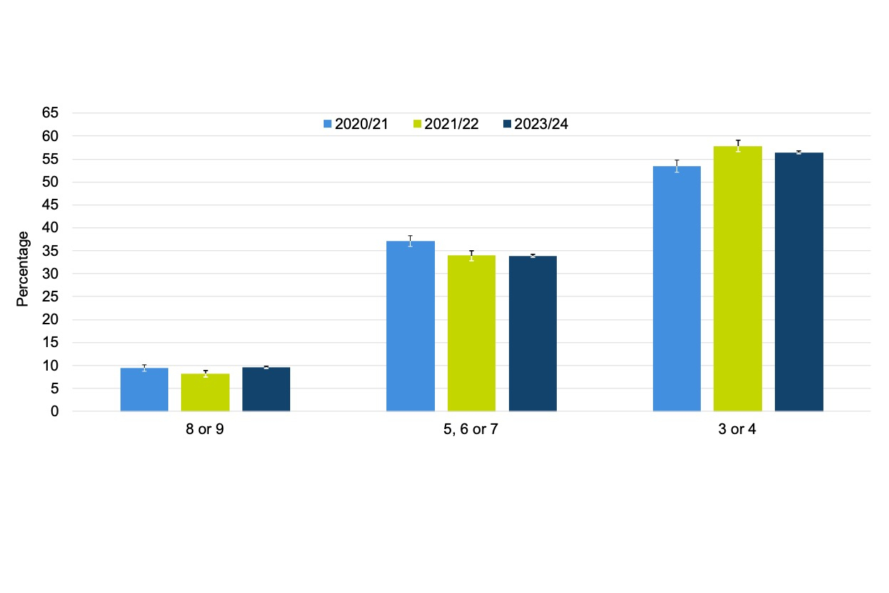 |  | CARE, EMPOWERMENT AND SUPPORT NEEDS OF OLDER PEOPLE (CRITICAL EVALUATION)  Maintaining Functional Ability  - Older People have access to healthcare services and regular health checks and support with medication management.  - Community rehabilitation and physiotherapy services  (NHS England, n.d.; British Geriatrics Society, 2019)  Promoting Independence  - Home adaptations (e.g. handrails, stair lifts)  - Community support and home care  (Sheasby, 2025; NHS, 2025)  Freedom and Choice  - Person- Centered care planning  - Respect for autonomy and decision- making  - Access to social activities  (Turner, 2025)  Pivotal Point  - Although services are available, their quality and accessibility differ by location.  - Resources for social care are under pressure due to rising demand. |  | Older people in the community 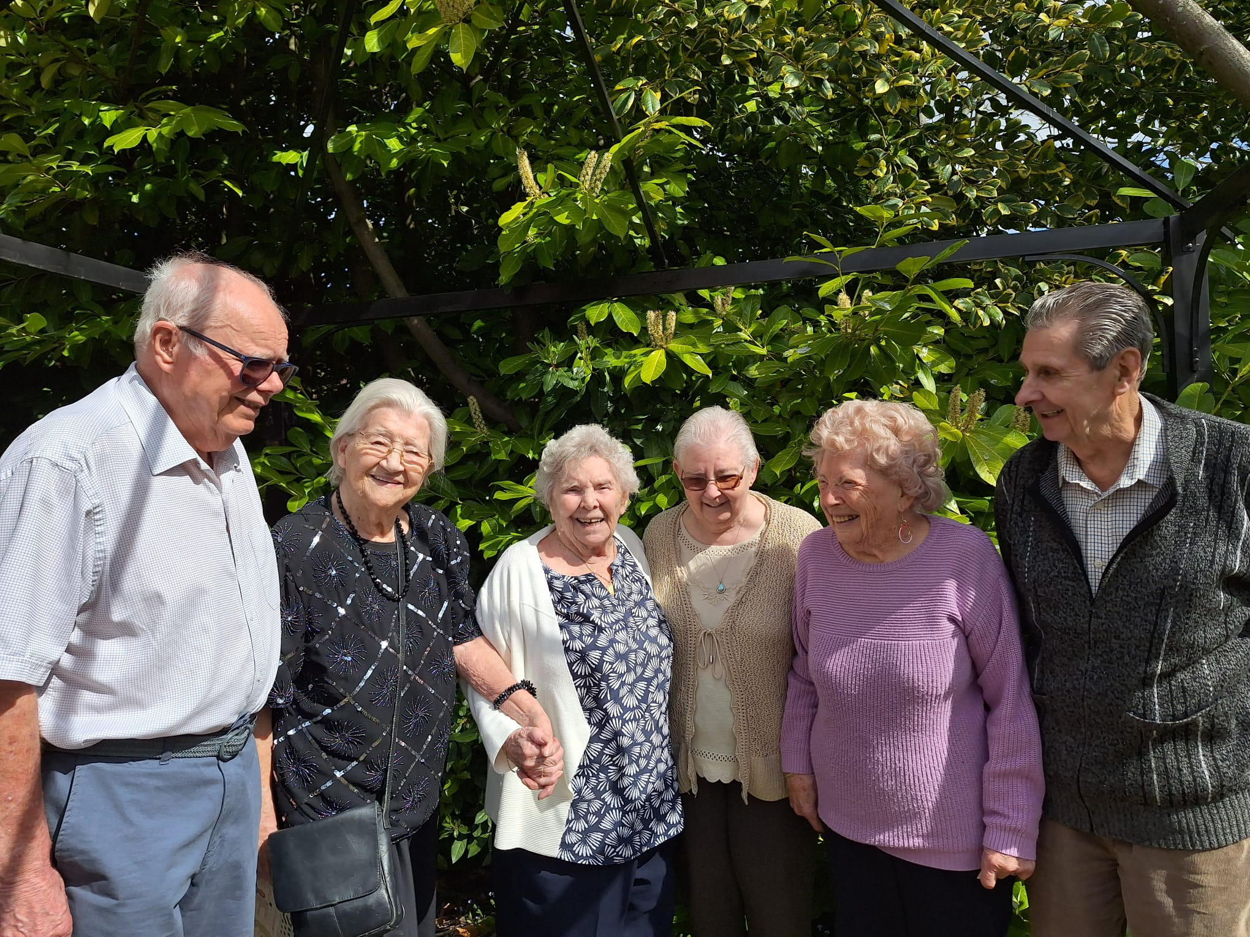
EMPOWERING THE OLDER PEOPLE  INTRODUCTION  Maintaining independence, respect, and control over decisions that impact their life is what it means to empower older people. It entails offering the chances, resources, and assistance required to maintain functional ability and social participation. Encouraging empowerment is crucial to ensuring that senior citizens can live independently, safely, and confidently in their own communities (National Institute for Health and Care Excellence, 2015).  Meaning of Older People-  Older People are normally defined as individuals aged 65 and above according to NHS England (n.d.)  - People aged 65+ make up around 19% of the population in the UK (Barton, Sturge and Harker, 2024)  - The percentage is expected to rise to 24% by 2043 according to Lewis, Cromarty and Barton (2021)  - Community -based care helps older people keep independence, dignity and their well-being (Elhag et al., 2025).  - Increase in life expectancy means greater demand for health and social care services (Uberoi, 2025) |  |  |  | Policy: Care Act 2014- This promotes independence, well- being and safeguarding. it also requires local authorities to assess and meet care needs (Care Quality Commission, 2022)  CHALLENGES FACED BY OLDER PEOPLE  - Chronic health conditions (e.g. dementia)  - Age discrimination and digital execution  - Social Isolation  - Lack of transportation  - Financial difficulties  (World Health Organization, 2025)  RECCOMENDATIONS FOR IMPROVING SERVICES  - Increase funding for community care services  - Expand preventative health programs for older adults  - Promote age- friendly communities and social inclusion initiatives  - Provide access to digital support and assistive technology  (Age UK, 2026; Office for Health Improvements and Disparities ,2022)  CONCLUSION  The ageing population is increasing rapidly in the UK. Older people require person- centered care that supports independence and well-being. Community -based services are important and needs stronger support and funding. Improving policies and services can empower older adults to live on their own for long.
EFFECTIVENESS OF APPROACHES AND INTERVENTIONS IN THE UK
Community – Based Care
- Helps older people to remain in familiar environments
- Reduces hospital admission and improves quality of life
(Elhag et al., 2025)
Preventative Health Approaches
- Early Intervention programs
- Health promotion (exercise, nutrition, social participation
(Local Government Association, 2017; British Geriatrics Society, 2019)
Current UK Provision
- Support from NHS
- Local authority social care support
- Charitable services such as Age UK
(NHS,2025; Age UK, n.d.)
RELEVANT THEORIES AND POLICES
- Activity Theory of Ageing – suggests that keeping social, mental and physical activity might help older people retain their well-being (Ungvarsky,2025).

- According to disengagement theory, a normal and unavoidable part of growing older is a gradual retreat from social responsibilities and activities. (Nickerson,2023)

References
Age UK (n.d.) Care and support. Available at: https://www.ageuk.org.uk/information-advice/care/ (Accessed: 10th March 2026).
Age UK (2026) Supporting older people’s health in 2026. Available at : https://www.ageuk.org.uk/discover/2026/january/supporting-older-peoples-health-in-2026/#:~:text=This%20year%2C%20the%2010%20Year,such%20as%20digital%20champion%20programmes. (Accessed: 9th March 2026)
Barton, C., Sturge, G. and Harker, R. (2024) The UK’s changing population. London: House of Commons Library. Available at : https://commonslibrary.parliament.uk/the-uks-changing-population/#:~:text=The%20UK's%20population%20is%20also,but%20higher%20than%20some%20countries. (Accessed: 3rd March 2026).
British Geriatrics Society (2019) Healthier for longer: how healthcare professionals can support older people. Available at : https://www.bgs.org.uk/resources/healthier-for-longer-how-healthcare-professionals-can-support-older-people#:~:text=The%20recently%20published%20Consensus%20Statement,3 (Accessed : 16th March 2026).
Care Quality Commission (2022) The Care Act and the ‘easements’ to it. Available at : https://www.cqc.org.uk/guidance-providers/adult-social-care/care-act-easements-it#:~:text=The%20Care%20Act%202014%20is,care%20and%20support%20is%20organised. (Accessed: 4th March 2026).
Department for Culture, Media & Sport (2024) Community Life Survey 2023/24: Loneliness and support networks. Available at : https://www.gov.uk/government/statistics/community-life-survey-202324-annual-publication/community-life-survey-202324-loneliness-and-support-networks--2 (Accessed : 25th February 2026).
Elhag, S., Niechcial, M.A., Potter, L. and Gow, A.J. (2025) Exploring the impact of community-based interventions on healthy older adults’ physical health, psychological wellbeing, and social connections: a systematic review. Ageing Research Reviews, 111, 102784. Available at : https://doi.org/10.1016/j.arr.2025.102784
Lewis, A., Cromarty, H. and Barton, C. (2021) Housing an ageing population: a reading list. London: House of Commons Library. Available at : https://commonslibrary.parliament.uk/research-briefings/cbp-9239/#:~:text=The%20older%20population%20in%20the,from%202%25%20to%204%25 . (Accessed :3rd March 2026).
Local Government Association (2017) Partnerships for Older People Projects: preventative care. Available at : https://www.local.gov.uk/case-studies/partnerships-older-people-projects-preventative-care#:~:text=The%20Partnerships%20for%20Older%20People,%2C%20adult%20social%20care%2C%20resource. (Accessed : 10th March 2026).
National Institute for Health and Care Excellence (NICE) (2015) Older people: independence and mental wellbeing (NG32). Available at : https://www.nice.org.uk/guidance/ng32/resources/older-people-independence-and-mental-wellbeing-pdf-1837389003973 (Accessed : 16th March 2026).
NHS England (n.d.) Improving care for older people. Available at : https://www.england.nhs.uk/ourwork/clinical-policy/older-people/improving-care-for-older-people/#:~:text=Generally%2C%20someone%20over%20the%20age,to%20require%20care%20and%20support. (Accessed : 3rd March 2026).
NHS (2025) Care and Support you can get for free. Available at : https://www.nhs.uk/social-care-and-support/care-services-equipment-and-care-homes/care-and-support-you-can-get-for-free/#:~:text=You%20may%20qualify%20for%20NHS,for%20NHS%20continuing%20healthcare%20funding. (Accessed : 10th March 2026)
Nickerson, C. (2023) Disengagement theory of aging. Available at: https://www.simplypsychology.org/disengagement-theory.html ( Accessed. : 4th March 2026).
Office for Health Improvement and Disparities (2022) Healthy ageing: applying All Our Health. Available at : https://www.gov.uk/government/publications/healthy-ageing/healthy-ageing-applying-all-our-health (Accessed : 9th March 2026).
Sheasby, L. (2025) Independence in Health and Social Care -What is it and why is it important? Available at : https://www.theaccessgroup.com/en-gb/health-social-care/access-technology-enabled-care/independence-in-health-and-social-care/#:~:text=Summarising%20the%20importance%20of%20promoting%20independence%20in,in%20your%20local%20authority%20contact%20us%20today. (Accessed : 6th March 2026).
Turner, N. (2025) “Person-centered care planning in Medicaid 1915(c) Home and Community Based Service (HCBS) waivers for older adults,” Innovation in aging, 9(Supplement_2). Available at: https://doi.org/10.1093/geroni/igaf122.3501.
Uberoi, E. (2025) The implications of population ageing for social policy. London: House of Commons Library. Available at : https://commonslibrary.parliament.uk/research-briefings/cbp-10338/#:~:text=pensions%2C%20and%20education.-,Health%20and%20social%20care,women%2C%20are%20also%20unpaid%20carers. (Accessed : 3rd March 2026).
Ungvarsky, J. (2025) Activity theory (aging). EBSCO Information Services Research Starters: Sociology. Available at : https://www.ebsco.com/research-starters/sociology/activity-theory-aging (Available : 3rd March 2026).
World Health Organization (2025) Mental health of older adults. Availlable at : https://www.who.int/news-room/fact-sheets/detail/mental-health-of-older-adults#:~:text=Social%20isolation%20and%20loneliness%2C%20which,focus%20on%20supporting%20healthy%20ageing. (Accessed : 3rd March 2026).

