Patrick Dalea

13/02/2022

Evidence-Based Policing and Decision Making

  - Luke Roach
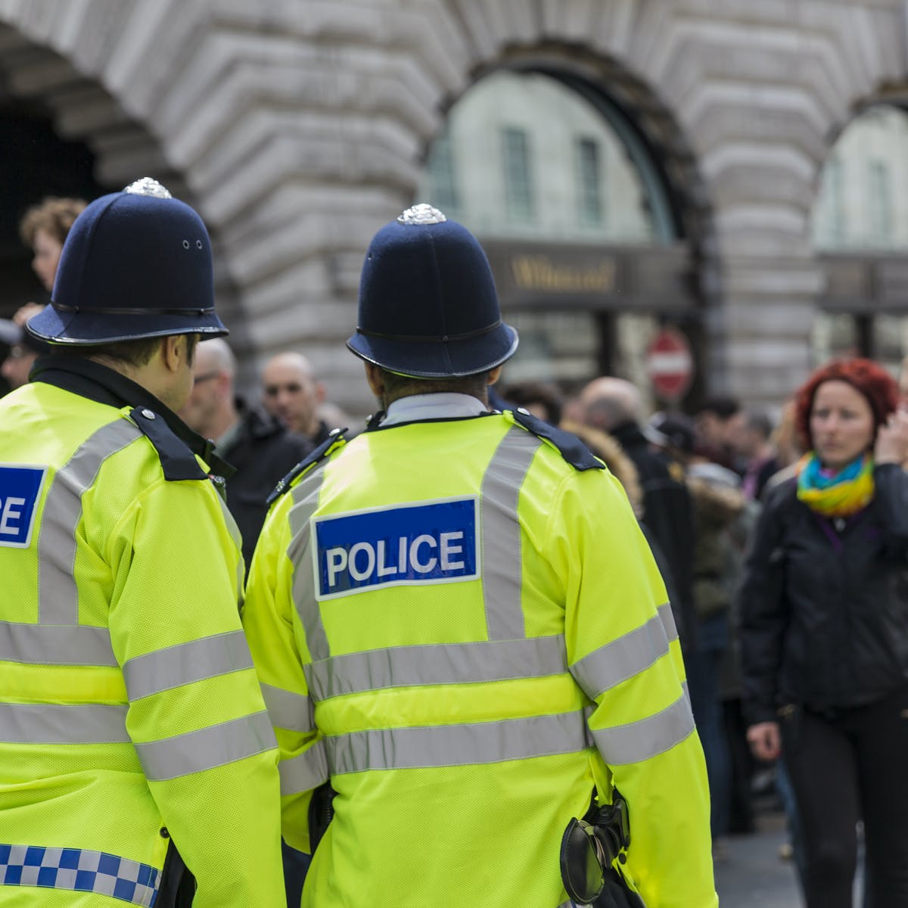

About HOTSPOT  In my opinion HOTSPOT is a very good strategy to use especially because it’s focusing its attention on an area that needs changing which can bring more awareness to the people living there and around. HOTSPOT strategy work very well especially on cases like spots where narcotics are being sold illegally, police keeps an eye on that area so they know how it’s happening and then they will analyse the are to find why that area, why is that area so vulnerable for this kind of actions, and then they will find out how to stop it, it can be because of the area doesn’t have enough lightning or it’s known as being cop free.  Things like those can cause a lot of damage to a spot or a neighbour but in this case, HOTSPOT can change this. HOTSPOT can actually be used by anyone searching online: www.police.uk and put in their postcode to see what cases happened around their area and if they need to be more careful at any of the streets nearby in case something bad usually happens there, which overall I think it’s a good idea to offer some statistic information to the community.  Overall, all these models turn out as being effective which is a good thing, but they come out as effective when those models are used well and in an appropriate way. Some people might say they are not effective that it’s just luck and there some people saying that those models are the meaning of the future policing, but it all depends on how well we understand when to use them. It is a good thing to know them and take those models in consideration and see if they fit in the situation, you are. In my opinion all these models are good and effective and easy to use but it depends on the officers as well, on how well trained they are and how implicated they will be in their cases. Along with all of this, the meanings of POP, SARA and HITSPOT can actually be taught in school from year 7 and so on for the kids to understand how the police officer work and why they shouldn’t do such things, or to avoid the kids growing up and not understanding why would the police do that and that and how do they come to an solution so quick and easy and why is it a good solution.  SARA  Scanning, Analysis, Response and Assessment…it’s one of the essential methods to systematically identify and analyse problems and to develop unique responses to problems that appear along and to assess the problem whether the response has been successful or not.  POP  Police Oriented Policing, it’s usually known as problem-solving policing and it’s almost similar to the SARA context, but it’s an approach to stop crime and disorder which includes a specific problem through a lot of analysis so they can understand the problem and how it develops. Understanding the problem helps a lot at tackling the problem knowing it’s development and how much it can grow and how fast.  HOTSPOT  Hotspot is a strategy that includes targeting resources and activities at the places where crime is happening more often. The strategy is based on the are of the crime that happens and includes the analysis of the area where the crime is happening as in: Where? Why? How?  - Models of  Evidence-Based Policing |  | 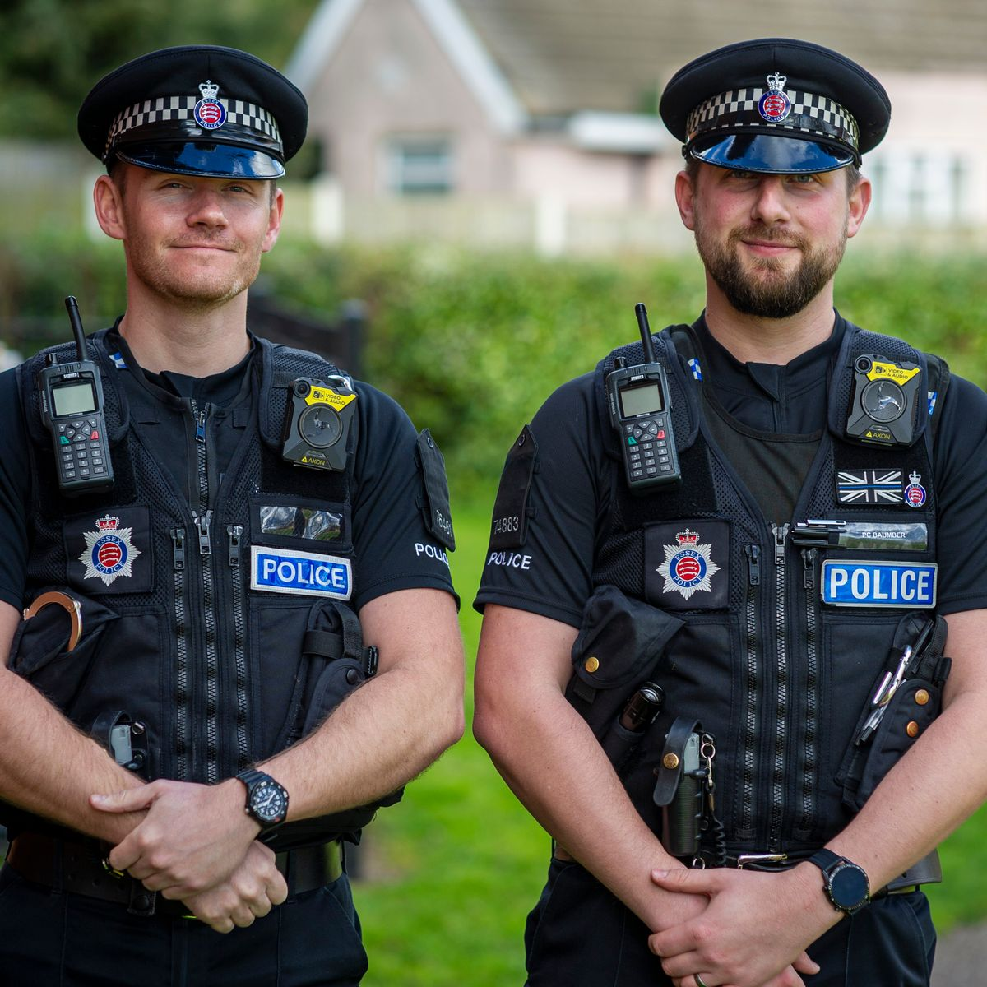  About POP  In my opinion POP is a very easy to use strategy and very essential nowadays. The evidence received by using POP shows that POP has reduced levels of general offending.  “The review also analysed the results using an approach which has been suggested as a more suitable effect size measure for place-based studies. This analysis suggested that POP led to a 33.8% reduction in crime and disorder” -https://whatworks.college.police.uk/toolkit/Pages/Intervention.aspx?InterventionID=47  About SARA  SARA is a very effective strategy to use and very easy to be practiced. In the day to day life you would not even think those kind of strategies exists.  In my opinion SARA is very effective and a strong key to be used in policing cases especially because it forces the officers to analyze the actions that happened which will give them more experience to go forward with, and I don’t see any weak points for the SARA technique.  Process of SARA done:  -Scanning: officers will look and identify possible problems, they can consult with residents who live in the area assigned to the officers  -Analysis: focus is pointed to finding the problems nature and the cause.  -Response: Officers use the data collected in the Analysis stage to address the problem.  Assessment: The whole work that has been done will be evaluated to see how effective it was.
To change the overall look of your document, choose new Theme elements on the Page Layout tab. To change the looks available in the Quick Style gallery, use the Change Current Quick Style Set command. Both the Themes gallery and the Quick Styles gallery provide reset commands so that you can always restore the look of your document to the original contained in your current template.
Page 2

Pros and Cons
Talking about POP, HOTSPOT and SARA could be easy and easy to understand as well but thinking that those strategies actually do something in our day-to-day life is actually interesting, the fact that some techniques are being put in the right place and used in the right way can impact a whole area/neighbourhood.

PROS:
SARA:
- Forces the officers to analyse and to think instead of just acting
-Give the officers more perspectives to look at from.
POP:
-Decentralisation, POP has the meaning at aiming at the front-line officers who have a bigger change into understanding the situation than a rank that isn’t always on the streets.
-Involves a better number of citizens, into talking to the police and open up to them to solve their different problems.
HOTSPOT:
-Brings benefits to neighbourly areas, as in police patrols will be patrolling an area more often if it’s known for bad things happening there
-Conceals Crime Spots into not spreading anymore.

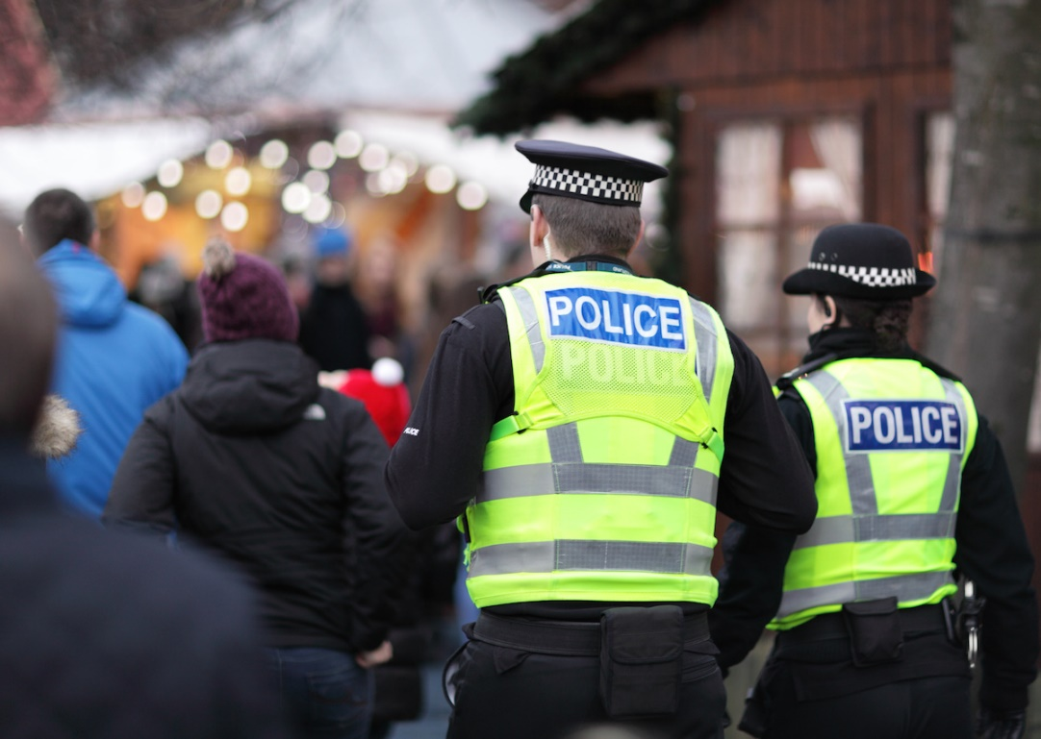
CONS:
SARA:
-It’s not a continuous path, after they see improvements they just stop focusing on the area or the street/building etc.
POP:
-Lack of Training, most of the time I have seen something pop in the media is about an officer that looks like doing a bad thing but actually he is doing the right things but there is a lack of training on handling the crowds around him.
HOTSPOT:
-Lack of commitment to the problem solving process, unfortunately not all officers will be happy to communicate to the community they patrol around, and it is a shame knowing that there’s officers out there not wanting to listen to their people.

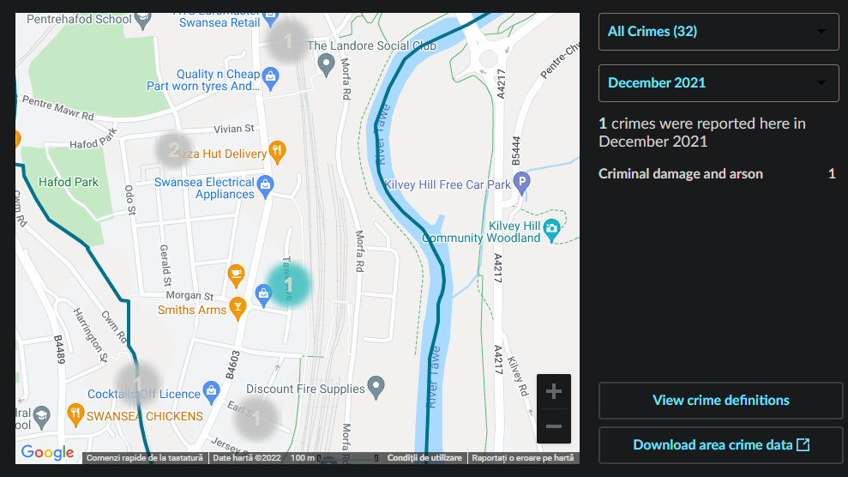
Example

According to https://www.police.uk/pu/your-area/south-wales-police/landore/?tab=CrimeMap in my area was Criminal Damage and Arson and it was flagged as a hotspot.
Why was it flagged as a hotspot?
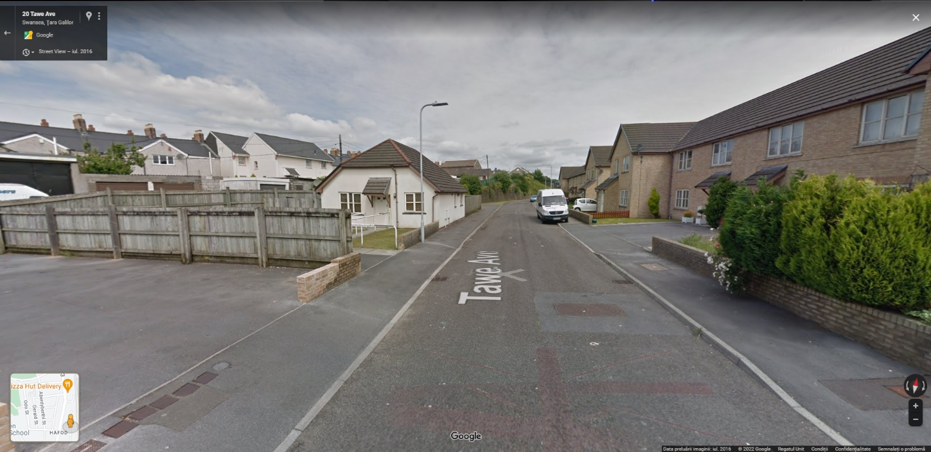
As you can see the area is very concealed and away from traffic or public, only a few residents, there is no shops, markets or an official building with security cameras or any building that would have a security guard. In this case officers for sure used the SARA strategy to understand why and how did this happened

They scanned the area to understand why did it happened here, and why it didn’t happened perhaps a couple of streets down. They analysed what happened and how it happened using of course what the residents heard in that area if anything they heard was out of context and things like this. They responded to the problem with increasing the patrol around the Hafod area overall as I have seen a lot of cars lately patrolling around the area. And in the end the assessed what they have done to this case and to the area to see if it was effective and since December nothing like Criminal Damage and Arson happened in the area again, so I will say that they made a good choice.

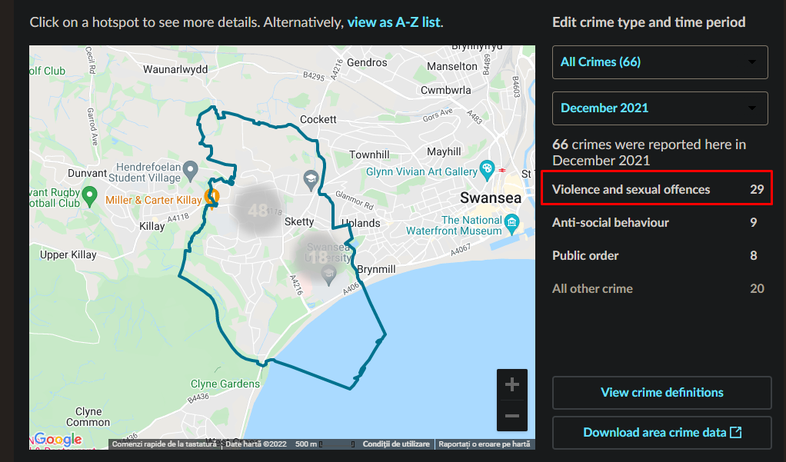

Example

As you can see the Sketty area it has a big exposure to Violence and Sexual Offences. The Sketty area is a student area basically as in it’s very close to the Swansea University and it has a lot of different neighbourhoods not far from the actual university. The student life is very crazy as most of us know already which means alcohol and drugs most of the time which lead to actions without thinking them. This area is so exposed to this kind of stuff because of the choices the Students are making, nothing the police can do than just increasing the patrols around the area but as you can see it is a big area and it will cost the department some good money to make that happen. The area has been marked as hotspot and it is a big number of criminal offences for December when most of the students are away from the University’s area.
As you can see down below the hotspot strategy didn’t work at all, the cases raised since December 2020 to December 2021. Beside the students in the Sketty area there only senile people and wealthy families in their 50s-60s or more.
I don’t think there is an effective way for stopping these kind of actions in this area because as I said before the life of a student when they just tasted the taste of freedom and living on their own makes them do very bad things like starting on drugs which will lead them to making bad actions like some of those that are reported on the hot spot above.
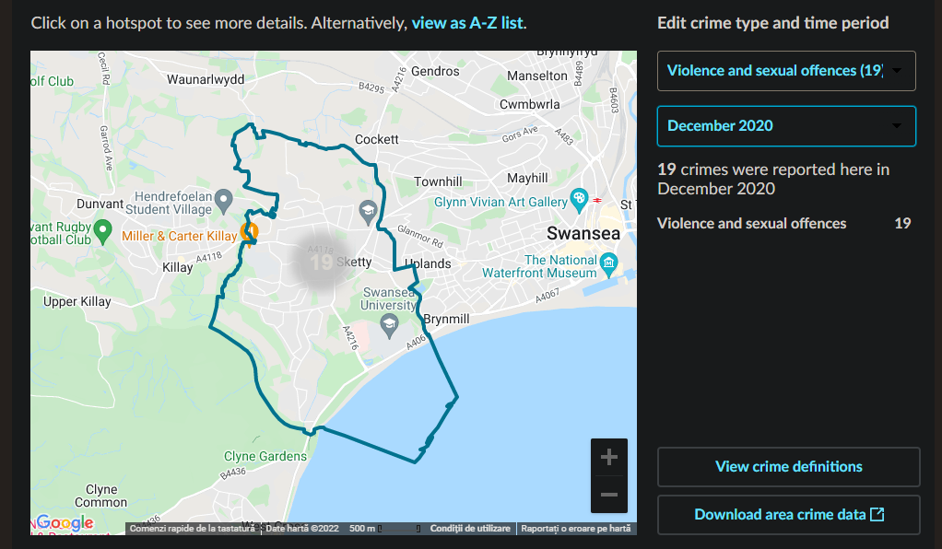

Overall

Overall all of these models turn out as being effective which is a good thing, but they come out as effective when those models are used well and in an appropriate way. Some people might say they are not effective that it’s just luck and there some people saying that those models are the meaning of the future policing but it all depends on how well we understand when to use them. It is a good thing to know them and take those models in consideration and see if they fit in the situation you are. In my opinion all of these models are good and effective and easy to use but it depends on the officers as well, on how well trained they are and how implicated they will be in their cases. There are different ways of making these kind of problems disappear besides these models like SARA, HOTSPOT etc. One thing I believe could help a lot is the department to send somebody to another country that will accept this and try to understand their ways of handling things maybe it’s not going to be perfect because every country and its residents are different but it is worth a shot to see different approaches to vital problems like Dealing Drugs, student areas being known as places where the most Sexual Offences happen. Trying to see the approaches from more perspective will help making the right choice in different scenarios by giving the officer the power of thinking and something for the officer to rely on.

“The act of policing is, in order to punish less often, to punish more severely.”
- Napoleon Bonaparte

References:
“The review also analysed the results using an approach which has been suggested as a more suitable effect size measure for place-based studies. This analysis suggested that POP led to a 33.8% reduction in crime and disorder” -https://whatworks.college.police.uk/toolkit/Pages/Intervention.aspx?InterventionID=47

Screenshots taken on Google Maps and www.police.uk

