Ysgol Y Gogarth, n.d, pg/td1)

‘Person Centred Tools support person centred thinking and skills. Person Centred Tools can be used in a variety of situations and help to plan, organise, understand and connect with others’ (No Author, 2015, pg/td4).
PCP Community Clubs
FREE* community events.
Run by the community, for the community.

Why? / Pam?
People Centred Place/Lle canolig i bawb
Gate Road/Heol y Gat
Gorslas,
SA14 7LW

Email- people.centred@place.co.uk
E-bost- Lle.canolig@pawb.co.uk

Phone/Galw- 07491 698617

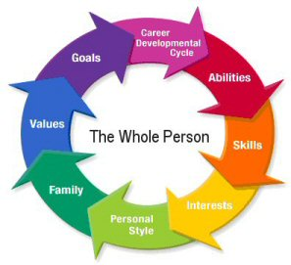
Contact/Cysylltu

MAE ‘CYNLLUNIO PERSON CANOLOG’ YN HELPU POBL DATBLYGU SGILIAU I GYRRAEDD EI GOLIAU A’i HUNAN BENDERFYNIAD.

Clwb Cymunedol CPG
Clybiau cymunedol. i’r gymuned, oddi ar y cymundod.
Am ddim*

‘Embracing the principles of independence, choice, inclusion, equality and empowerment as the foundations of service provision’ (Joseph Rowntree Foundation, 2006).

‘Wedi’i wreiddio o fewn egwyddorion hawliau, annibyniaeth, cynhwysiad a dewis. Gall bawb elwa o gael proffil un-dudalen, nid yn unig y dysgwr. Maent yn sicrhau fod pawb yn dod i ‘nabod yr unigolyn yn well a’u cefnogi’n dda’ (Cyngor Gwynedd, 2019).
*If you can afford to, a discretionary £2 Is payable towards the materials used if you chose to participate in the clubs. Food and beverage will occur a small additional charge.

* Os gallwch, bydd £2 yn daladwy os hoffwch ymuno gyda’r clybiau. Mae yna gost rad ychwanegol amcanu’r bwyd, a’r diodydd.

Yr holl berson -(No Author, 2017, edited)

(Ysgol Y Gogarth, n.d, pg/td1)
Come and meet people in your community!
Dewch i gwrdd â phobl yn eich cymuned
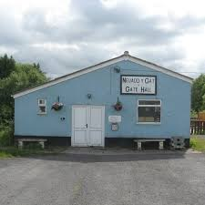
Protecting our communities/ Diogelu ein cymunedau

‘Protective factors or systems comprise a very simple recipe of caring relationships, high expectation messages, and opportunities for participation and contribution’. (Saleebey, 2006).
Cyfrifoldeb pawb ydi hi i sicrhau bod pobl yn ein cymuned yn cael siawns i ddatblygu, a mwynhau byw yn ein cymunedau.
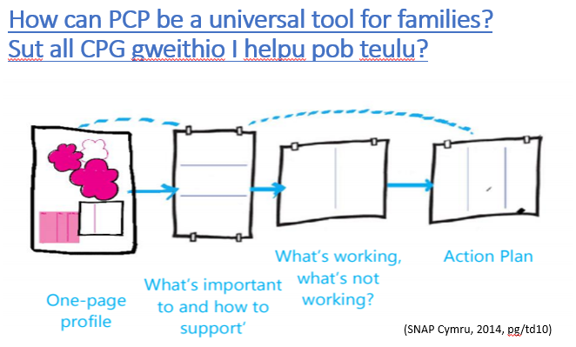


(Neuadd Y Gat Penygroes Gate hall, n.d)
Monthly PCP club Events/ Clybiau CPG ym misol (First week of every month/Wythnos gyntaf pob mis)
- PCP meeting/cyfarfod CPG (Thursday 16.30-18.00 Iau)
- Pizza night/Noswaith pitsa (Friday 16.30-18.00 Gwener)
- Gardening club, clwb garddio (Saturday 12.30-14.00 Sadwrn)
- Cooking club/Clwb coginio (Saturday 14.30-16.00 Sadwrn)
- Children’s play sessions/ Sesiwn chwarae plant (Saturday 16.30-18.00 Sadwrn)
- Teenage hang out sessions/Sesiwn chwarae i arddegwyr (Suday 16.00-18.00 Sul)
- Or if none of these catch your eye, we could help you to set up your own! /Neu greu un eich hunain!

What we offer/ Cyfleoedd ar gael

Leaflet References/ Cyfeirnodau -
Conger Gwynedd, (2019) Cynllunio sy’n canolbwyntio ar yr unigolyn mewn addysg https://www.gwynedd.llyw.cymru/cy/Trigolion/Dogfennau-trigolion/Ysgolion-a-dysgu---dogfennau/AAA/CCU---Pamffled-Cymraeg---2.pdf (Gwelwyd 1/4/2019)
Joseph Rowntree Foundation, (2006) Person centred planning in social care. Available via https://www.jrf.org.uk/sites/default/files/jrf/migrated/files/9781859354803.pdf (Accessed: 02/04/2019)
No author, (2015) SEND Guidance: Person centred planning toolkit. Available via file:///C:/Users/joeln/Downloads/Person_Centred_Planning_Toolkit%20(1).pdf (Accessed: 28/3/2019)
Saleebey, D., (2006). The strengths perspective in social work practice. Available via http://catalogue.pearsoned.ca/assets/hip/ca/hip_ca_pearsonhighered/samplechapter/0205408176.pdf (Accessed 2/4/2019)
Picture references/ Cyfeirnodu Lluniau –
Neuadd Y Gat Penygroes Gate Hall, (n.d) Available via https://www.facebook.com/gatehallpenygroes (Accessed 1/4/2019)
No Author, (2017) Person-Centered Planning. Available via http://sefb320.pbworks.com/w/page/8429383/Person%20Centered%20Planning (Accessed 12/3/2019)
SNAP Cymru, (2014) Person Centred Planning. Available via http://www.snapcymru.org/wp-content/uploads/2014/09/PCP-Booklet.pdf (Accessed 2/3/2019)
Ysgol Y Gogarth, (n.d) Person Centred Planning. Available via http://www.ysgolygogarth.co.uk/parents/person-centred-planning (Accessed 2/4/2019)

