The Professional Practitioner Portfolio

I confirm that I have not used any AI tools in the research and creation of this assignment. I confirm that I have not presented any AI generated materials as my own work. I confirm I have copies of my drafts, notes, and other resources I used, which I may be asked to provide in evidence.
Component 1

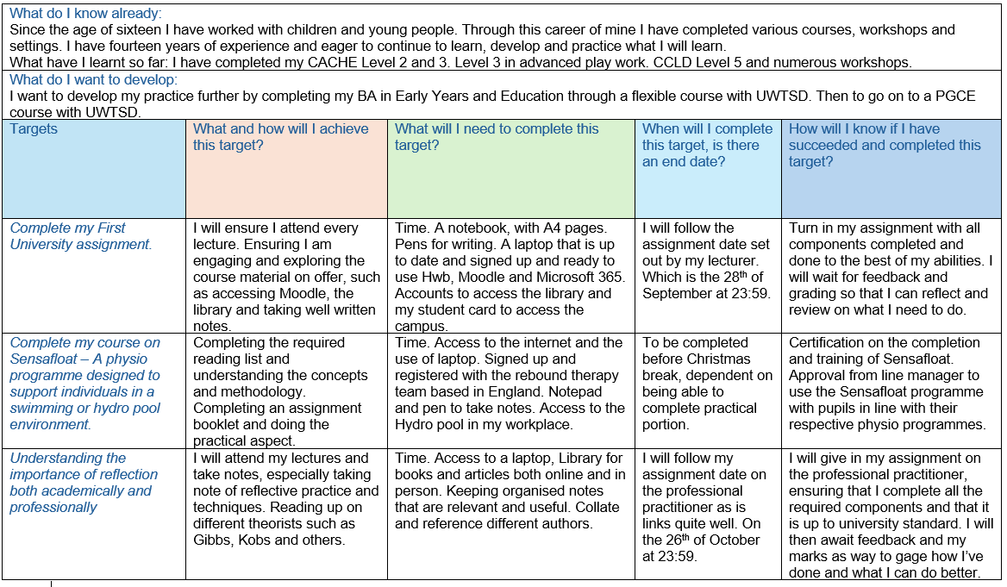

Component 2
What is reflection and reflective practise?  The idea of reflection has excited since ancient Greece and further back. Great philosophers of the tome such as Plato and Aristotle explored the ideas of reflection and critical thought. However, in today’s world reflection and reflective practice play a significant role in a whole spectrum of industries and sectors, but also in someone’s personal life. There are a great emphasis and importance for practitioners in early years and educational professionals to highlight and document their ability to reflect and to use reflection on their own practice. Brock (2015, p. 33) supports this.  According to Hallet (2012, p. 24) reflective practice is forever changing, adapting, and supporting professional and personal development of those in Early Years and Education. Though governments dictate and guide the methods of reflecting. At it is core it remains the same. It is the individual that guide their own learning and development. As practices change with the times and untapped resources come available. It enables a person to look in and on their own practice with understanding and confidence. | Why is reflective practise important to EY practise?  Craft and Paige-Smith (2011, p. 113) support and acknowledge the impact and importance that reflective practice plays in Early Years. Understanding this allows and individual to have the tools needed to act on their own reflection and therefore become better practitioners in an Early Years setting. It gives the practitioner the ability to understand and differentiate what and how. They emphasise the point the need to bring different elements of practice and theory. When to use them, as always not everything is straightforward.  Understanding different methods of reflective practice is valuable in an Early Years setting. Hallet (2012, p. 103) would go on to list a deluge of values that are core to a practitioner understanding in Early Years settings and in other sectors. An understanding of communication and dialogue is key when working with a wide range of individuals and professionals. Understanding the importance of research and being inquisitive, then having the understanding to act on information and to reflect upon it. As years go by, we all change as individuals. It is key to recognise the changes both personal and professionally. Being confident and keen to look over workplace culture and to bring into account. Be approachable and open to different ideas, theories, and changes. The world is forever changing, are many unique cultures and ideas. Finally, taking personal responsibility for your own opinions and be objective.
The theory of reflective practise:

There are countless theorists to consider, more importantly in a sector such as working with children and young people.

Lindon and Trodd (2016, p. 26) both navigate through Donald Schon’s ideas and theories on reflective practice and exploring the works of Chris Argyris. These two theorists had a fascination and a yearning to understand the myriads of contradictions within a multitude of sectors both public and private. They both looked for what they would consider inconsistencies in practices, for there are gaps that would be seen when comparing intended daily practices and actual daily practices. As Argyris and Schon note, individuals may have the best intentions and think of doing and showing good practice. But the realities at times is the opposite and those good practices are not shown.

Lindon and Trodd (2016, p. 27) continue to explain and explore the way a professional would explore and think during their working day. Individuals both professional and not, would hold a ‘manual’ in their heads that guide and dictate their way through world. This would help them with the thinking of their professional actions and the general planning of the day. How they use these mental ‘manuals, would shape their reflection on the in and on of their practice.
ERA Cycle  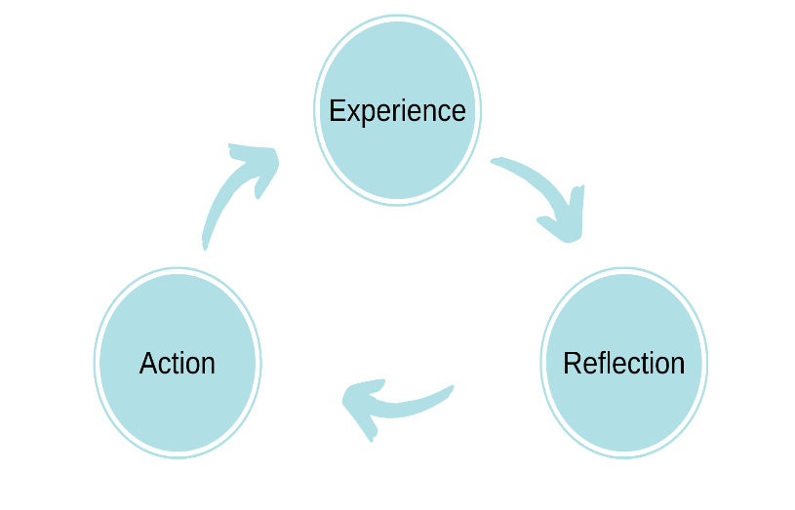  (Jasper, 2013) | Kolb’s Experiential Learning Cycle  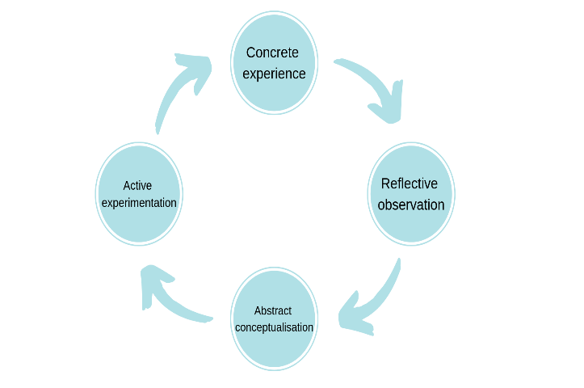  (Kolb, 1984)
Analysis of ERA and Kolb’s models – compare/contrast/pros/cons:

Looking at two different reflective cycles is crucial in understanding the best methods when looking to reflect on professional and personal practices.

The Experience, Reflection and Action Cycle (ERA) thought my Jasper, 2013) is simplistic and straightforward. Ideal for new practitioners, as you would look at the experience in the past and present tense, then you would go onto reflection, look at what happened, what worked, what did not and how we felt during that experience. Finaly action, what is the next steps, what can I do differently and how will I know if I succeeded. Benefits of EPA is the structure of the model is simple; it is ideal for new Early Years practitioners. The downsides are that it is to open ended, the model is too simple to use in complex situations. There is never a definite end. Practice is always being developed and refined.

Kolb’s (1984) own model is much more robust and in-depth when comparing to EPA. You would still start at the experience, but it should be something more depth and impact. It can be something new or an event that has happened more than once. next step is reflective observation, the key being to note anything and everything that has not been done before. Onwards we take what we have experienced and observed and put it all together to produce innovative approaches and ideas. Then using these latest ideas appropriately for what has happened or something entirely new. The benefits of this model it allows more thought to brought into new and current experiences and practices. The downside for those, is that it is less simplistic.

Conclusion

The ERA Cycle by Jasper (2013) feels more natural when looking at a persons own natural progression. The cycle is infinite and can be used daily. Ideal for practitioners where reflection is key for good practice. The cycle all links together which makes sense for the user. However, this has its own flaws as well. Ryder and Downs (2022) note their own concerns of the practitioners becoming a passive observer, rather than being someone who is more active and responsive.

Ryder and Downs (2022) would go on to support the notion that Kolb’s learning cycle is not well suited for the modern world, while other theorist and authors have tried to influence and change Kolb’s work, they argue that the model is far too simple and does not take in account the different mediums on hand through the use of technology. It fails to acknowledge the distinctive styles of working and how people are more individualistic. Ryder and Downs argue that the model needs flexibility at it is core messaging and function.

Reference List

A. Brock (ed.) (2015) The early years reflective practice handbook. London; New York: London; New York: Routeldge.
A. Craft & A. Paige-Smith (eds.) (2011) Developing reflective practice in the early years. 2nd ed. Maidenhead: Open University Press.
Hallet, E. (2012) The Reflective Early Years Practitioner. London, SAGE Publications.
Jasper, M. (2013). Beginning Reflective Practice. Andover: Cengage Learning
Kolb, D. (1984) Experiential Learning: Experience as the Source of Learning and Development. Upper Saddle River: Prentice Hall.
Lindon, J. & Trodd, L. (2016) Reflective Practice and Early Years Professionalism. Third edition. London, England: Hodder Education.
Ryder, M., and Downs, C. (2022) ‘Rethinking reflective practice: John Boyd’s OODA loop as an alternative to Kolb’, The international journal of management education, 20(3). Available at: https://doi.org/10.1016/j.ijme.2022.100703. (accessed on: 24/10/2025)
Thompson, C. (2021) Reflective practice for professional development: a guide for teachers. 1st ed. Abingdon, Oxon; New York: Abingdon, Oxon; New York: Routledge.

Component 3

Recognise and analyse the significance of different aspects of professional practise and why these are important in meeting the individual and inclusive needs of children.

Introduction – what is professional practise/ what is a professional?

Practitioners have existed since the dawn of human civilisation and in recorded history. Practitioners play an important cornerstone in our society; they hold a wide spectrum of roles. They are our professionals that have learned and experienced their respective roles.
Johnston et al (2018) goes on to say that that professional come in different levels and training requirements. This then reflects on the responsibilities that a professional needs to undertake to undertake. Johnston (2018) will point out and give societal examples of what is valued most by people when looking at different professionals in the early years and educational settings. Some people will value a schoolteacher more than an early year’s practitioners such as a nursery nurse or manager. This can be seen by the pay discrepancies and general perception by the public.
Various levels of professional guidelines, standards and practice are now clearly governed in the United Kingdom and Wales. The National Day Nurseries Association (NDNA) supports those who what to work in Early Years and education. They showcase the need what is expected for would be and current practitioners and how to conduct their themselves professionally.

What values are important for a professional practitioner and why are values important to professional practise?

Values Underpin who we are as individuals and how we navigate our lives and make decisions. Our values define us, especially as professional practitioner working with young people and children.
The British Association for Early Childhood Education (2011) promotes values and ethics to Early Years practitioners. They support and guide this in countless ways, their code of practice that they have developed to support practitioners in the Early years field. The need for the individual to have empathy and capacity to understand ethical dilemmas and to conduct themselves to the corresponding situation. To understand right and wrong, this is where critical thinking is needed to reflect on the ability to understand the morality of the moment and make choices based on that reflection.
It is of paramount importance for professionals to understand what the children in their care need to thrive and grow. The British Association for Early Childhood Education (2011) emphasise the need for practitioners to comprehend that children grow so fast and that they need to provide those key foundations to support children, be that socially, emotionally, intellectually and physically. Children have the right to learn in a safe and secure environment. To grow and understand the world around them, to build and grow confidence and to have the tools and strength to overcome any disadvantages and adversaries.

Why are communication and relationships important to professional practice and meeting the needs of children?

Communication, especially effective communication is key for any Professional practitioner, Moreso for those working in an Early Years setting. Communication is needed for the wellbeing of Children and young people.
City & Guilds (2023) have worked to support Early Years practitioners to develop their wide range of communication skills. A practitioner needs these key skills to work collaboratively with parents, guardians, colleagues, other professionals and most importantly the children and young people in their care. This allows ease of communication and the betterment for all.
City & Guilds (2023) further supports the importance of communication and understanding it’s many facets. This involves understanding people and accepting that everyone is different. Certain methods of communication will be better than others, so an eye for detail and picking up those communication cues. Having a mental script and ensuring you can answer those questions when dealing with other people, especially children. Give consideration on how as a practitioner you can present yourself too others. Making sure to make eye contact, answering and asking questions and given the speaker a chance to answer and being mindful of not interrupting.

Why is having an in-depth knowledge and understanding important to professional practice, including aspects of safeguarding?

Having the knowledge and understanding to navigate the importance of having and using the knowledge as a professional practitioner, the knowledge to dealing with safeguarding is so important to ensuring the safety and well-being of the children in our care.
Whitters (2022) emphasises the importance of understanding the standards that are in place to cover both education and care. These standards are in place with a baseline in mind when it comes to providing education and care for children. The standards fail to take in account that not all children come from ideal circumstances and background and may have associated trauma and developmental delays.
Having this knowledge will help practitioners to navigate safeguarding issues with efficiency and professionalism
According to the Wales Safeguarding Procedures (2025) there are principles that underpin safeguarding in Wales and professional practitioners in care and education to be aware, especially in positions of authority and leadership. Every professional and setting have a part to play in working together to ensure the safety of all children. Making sure that any information that is being share is in line with current information sharing when regarding the safeguarding of children. Having partnerships in place that productive working relationship can be facilitated.

Why are partnership and multi-agency working important to professional practice?

Partnership is a cornerstone of a practitioner’s skills set, being able to work effectively with many different individuals. From parents, guardians, therapists, health professionals and many more. Wilson (2025) goes on to proclaim the importance of nurturing key relationships with healthy engagements from parents and guardians. This is for the benefit of children, in supporting their learning and development both at home and at the setting. Various Acts of parliament such as the Education act (1944) noted the importance of the involvement of parents. Today there is a more cohesive agreement that the more involved the parent, the benefit it is to their child’s development and attainment.
Research has shown that parental and guardian involvement has a positive impact on the child, regardless of their circumstances and background. By putting that child first enables a direct dialogue and conversations with parental figures. These conversations can give us a picture to how a child lives and what background they come from. Give them a voice and respect them as their child’s first teacher and carer says the Department for Education (2024).

How does the observation and planning cycle inform professional practice and ensure practitioners are meeting the needs of children?
Hallet (2013, p. 62) supports the importance of Early Years practitioners needing a good grasp of observation when learning to become an early year’s practitioner and using this skill in their setting for the betterment of the children and their families.
Observation is a for practitioners to inform and reflect on their practice. They can use observations to grasp where the children are in their development. Looking at their physical, mental, emotional and social progress at the setting. Recording this information can give insight on any noticeable patterns, decisions, if anything needs to be raised with other professional o then reflect and improve for the betterment of the children. Finally, Hallet (2013) stresses the importance of observation being used as a tool and reveal key information on a child that has not been seen before, this information and inform practice and supporting the development of the individual.

How do the principles of the UNCRC inform professional practice and why is this important?

The UNCRC (1989) plays a key role in the legislation of the United Kingdom and In Wales. These acts have enshrined the principles of the UNCRC, Acts such as the Children’s Act (1989) and the Children’s Act (2004). The Conventions hold 54 individual articles that envelopes every facet of a child’s life. It covers from cultural, social, political and economic rights. These are universal rights and are applicable to every child and every child has a right to know these articles and the right therein.
These different conventions and legislations impact on a professional practitioner practice. It ensures that the child is always at the heart of the setting ant that decisions and planning keep the child at the forefront.

Conclusion – summary of points

Professional Practitioners need to take many different factors and influences into account. Practitioners need to ensure that they have the tools, understanding and the values to work in an Early Years setting. They’re often overlooked, when being compared to teachers or professionals in other sectors. But their role is paramount to giving our children the tools and knowledge to grow and thrive.

Developing a range of tools such as effective communication ensures an easy flow of information and the preparedness for the practitioners to observe and support the children in their care. It allows an easy line of communication and cooperation with other agencies and professionals.

Having the knowledge and know how of various legislation and guidelines, play a role in the function and set up of all settings around the world. When looking at settings in Wales we see the importance of learning through play and keeping the child at the heart of all. They are the future, and we must equip them well and to remember children are learning and are competent.

Wilson (2025) puts great import on the children’s outcome. Thought partnerships with parents and guardians are part the parcel in an Early Years setting. We can always see the immediate or obvious benefits of working relationships with parents and guardians. As it can’t always be quantifiable or tangible, as relationship is different complex with hundreds of factors. This when settings and practitioners and adapt and make use of tools and programmes in their area. Such as parenting groups or a parents and toddlers’ group to start that relationship earlier.

Reference list

City & Guilds. (2023). Principles and Values of Children’s Care, Play, Learning and Development (0-19 years of age). The importance of effective communication in children’s care, play, learning and development. moodle.uwtsd.ac.uk/pluginfile.php/721015/mod_resource/content/2/EFFECT~1.PDF (Accessed: 23/10/2025)

Department for Education (2024) Working in partnership with parents and carers. https://help-for-early-years-providers.education.gov.uk/support-for-practitioners/working-in-partnership-with-parents-and-carers (accessed: 24/10/2025)

Early Education, The British Association for Early Childhood Education. (2011). Code of Ethics. (Accessed: 22/10/2025)

Hallet, E. (2013) Reflecting Upon Professionalism in the Early Years. In: The reflective early years practitioner . Los Angeles :, SAGE.

Johnston, J., Nahmad-Williams, L., Oates, R., & Wood, V. (2018). Early Childhood Studies: Principles and Practice (2nd ed.). Routledge.

National Day Nurseries Association: https://ndna.org.uk/firstfiveyearscount/wales-early-years-workforce-careers/ (Accessed: 22/10/2025)
UNCRC (1989) What is the UNCRC? https://www.unicef.org.uk/what-we-do/un-convention-child-rights/ (Accessed: 24/10/2025).

Wales Safeguarding Procedure (2025). Section 1, Safeguarding principles. https://www.safeguarding.wales/en/chi-i/chi-i-c1/c1-p2/ (Accessed: 23/10/2025)

Whitters, H.G. (2020) Adverse childhood experiences, attachment, and the early years learning environment: research and inclusive practice . 1st ed. Abingdon, Oxon :, Routledge.

Wilson, T. (2025) Working with parents, carers and families in the early years : the essential guide . Second edition. London :, Routledge.

