Assignment 1: E-Portfolio

Task 1 – Mind map 3
Agency Website 3
Task 2 – Ideation 4
Task 3 – Project Poster and Chart 5
Project Planning 5
Project Management 7
Working link e-portfolio 8

Task 1 – Mind map
What is a mind map? A mind map is a graphical representation of ideas or topics, with the central theme at the centre and related ideas branching off from it. Mind maps are a useful tool for brainstorming, organising and storing information.
Mind maps can be drawn by hand or created using mind mapping software. They usually contain colours, pictures, and keywords that make it easier to remember and understand [1], [2], or [3].
The main benefits of mind mapping are:
— More effective brainstorming of ideas
— More efficient organising of information
— More effective learning and remembering of information
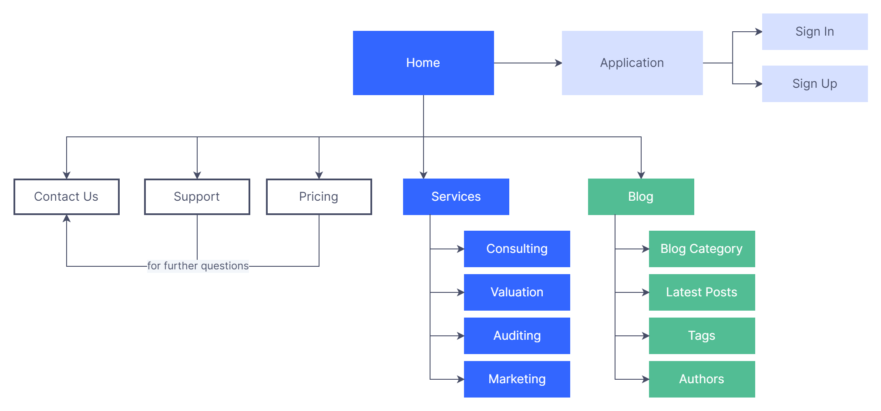
Figure 1: Website sitemap

Agency Website
The Agency is a website design and development agency based in Los Angeles, CA. We specialise in developing high quality, fully responsive websites that are easy to use and deliver results. We take a holistic approach to web design and development. This means that we consider the entire user experience, from the first visit to the website to conversion. Our goal is to create websites that not only look good, but also function perfectly and deliver the results our clients want.
We have a team of experienced designers and developers who are passionate about creating great websites. We work closely with our clients to understand their needs and goals, and then we create a bespoke website tailored to their specific requirements [7].

Task 2 – Ideation
The website design and development agency I propose would aim to provide a one-stop shop for all web design and development needs. The agency would offer various services including website design, development, hosting, and maintenance. The agency would also offer a range of additional services such as search engine optimisation, social media marketing and email marketing.
As someone who is passionate about computers, I am excited about the opportunity to start my website design and development agency. This allows me to develop new skills and knowledge in this area and help others to do the same.
I believe that the most effective way to learn a skill is to learn it yourself. Therefore, I would like to take this opportunity not only to improve my skills but also to share my knowledge with others. I will be offering my services to businesses and individuals who require help designing and developing their websites, and I hope to use my skills to create websites that are both visually appealing and user-friendly.
As well as developing my skills, I would also like to use this opportunity to learn more about the business side of website design and development. I want to better understand how to market and promote websites and how to manage a team of web developers. This knowledge will be invaluable as I continue to grow my business.
I look forward to using this opportunity to not only improve my skills and knowledge, but to help others do the same. I believe that by sharing my expertise, I can make a positive impact on the computer industry as a whole [4], [5], or [6].

Task 3 – Project Poster and Chart

Project Planning
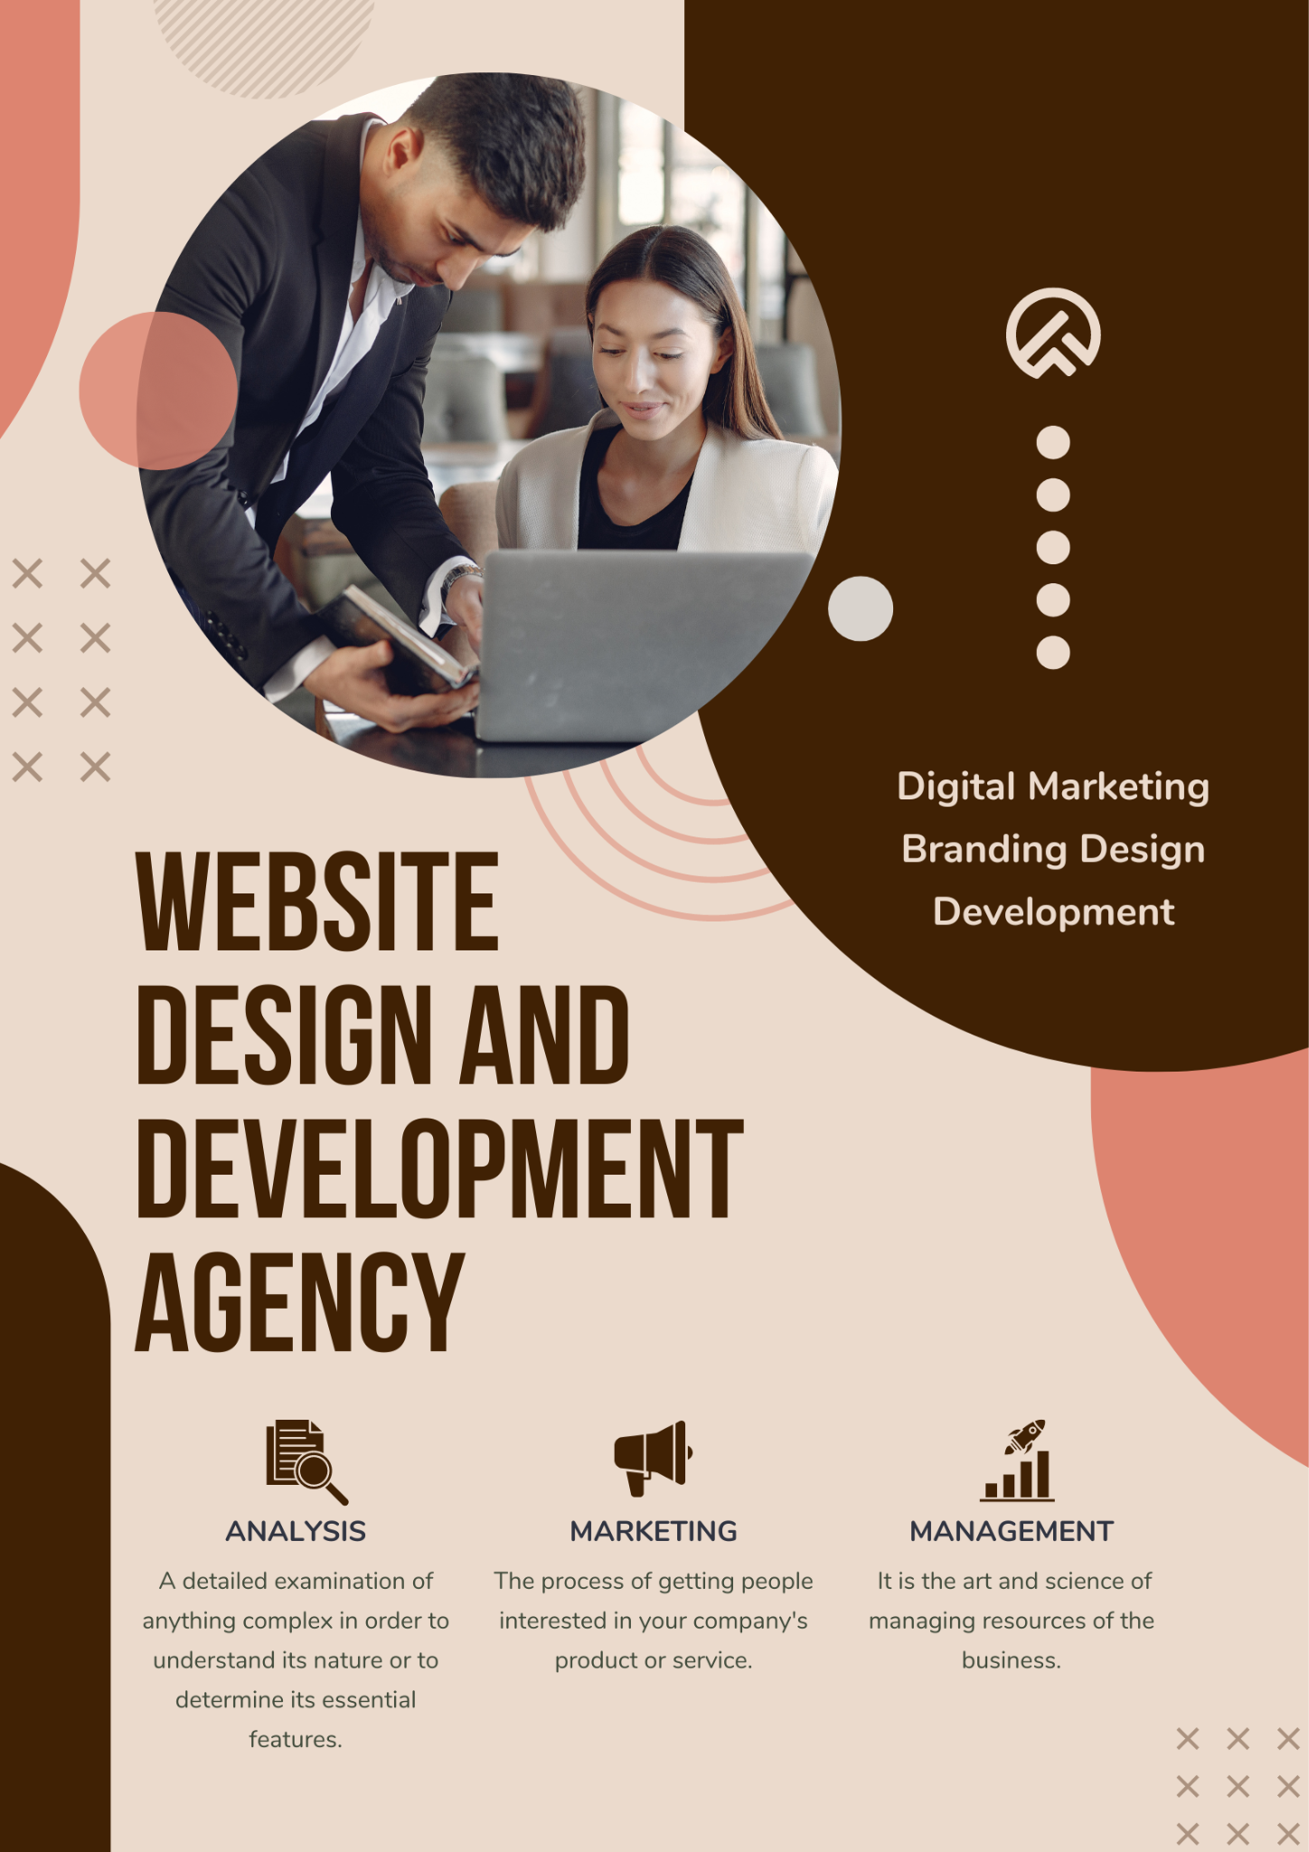
Figure 2: A3 digital poster
In a website design and development agency, technology and resource requirements vary depending on the size and scope of the projects. However, there are some key areas that all agencies should be aware of to ensure they are providing the best possible service to their clients. The first area to consider is the website platform. There are several website platforms, all of which have their advantages and disadvantages. It is important to choose a platform that meets the specific needs of the agency and their clients.
Once the website platform is selected, the next step is to determine the hosting requirements. Hosting can be provided by different providers, each with their own pricing structure and level of support. It is significant to decide a provider that offers the right mix of features and pricing for the agency's specific needs.
The next area to consider is the domain name. The domain name is the address of the website and is used to identify the website to visitors. It is significant to decide a domain name that is easy to remember and reflects the nature of the website.
The final area to consider is the design of the website. The website should be designed to be easy to navigate and provide the user with the information they are looking for. The website should also be visually appealing and reflect the agency's branding [8].

Project Management
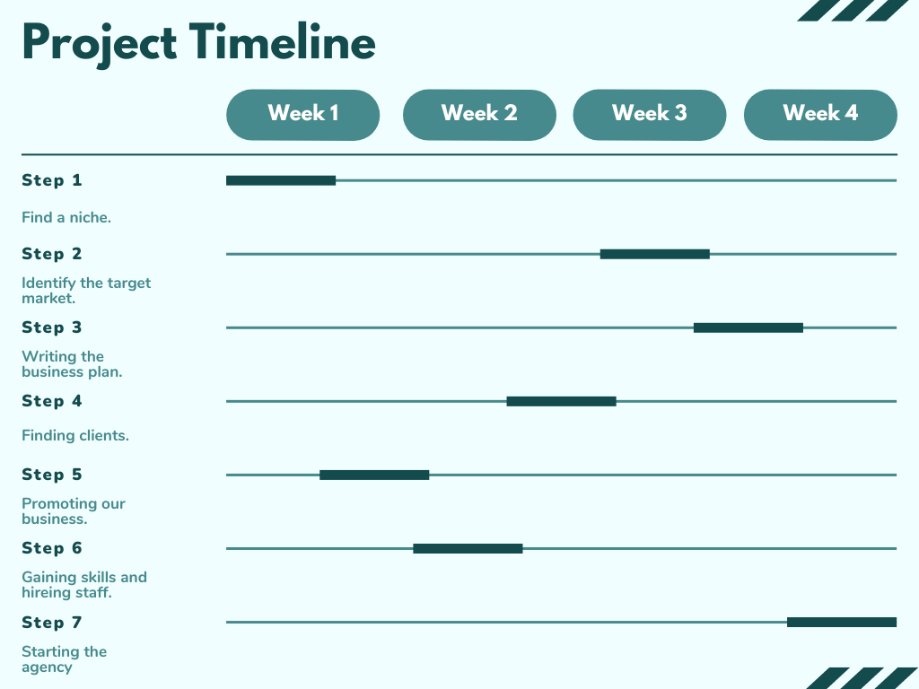
Figure 3: Project Timeline

Working link e-portfolio
https://sites.google.com/view/e-portfolio-ancaleonte/assessment-elements

References
[1] Duggan. (2015). The Seventh Sense : How Flashes of Insight Change Your Life. Columbia University Press, Doi: https://doi.org/10.7312/dugg16906. Available at: https://ezproxy.uwtsd.ac.uk/login?url=https://oxford.universitypressscholarship.com/view/10.1093/acprof:oso/9780199589838.001.0001/acprof-9780199589838
[2] J. S. Bamberger, Discovering the musical mind: a view of creativity as learning, First edition. Oxford: Oxford University Press, 2013. Available at: https://ezproxy.uwtsd.ac.uk/login?url=https://www.jstor.org/stable/10.7312/dugg16906
[3] A. Singh and A. Singla, “Constructing definition of smart cities from systems thinking view,” Kybernetes, vol. 50, no. 6, pp. 1919–1950, 2021, doi: 10.1108/K-05-2020-0276. Available at: https://www-proquest-com.ezproxy.uwtsd.ac.uk/docview/2547235532?pq-origsite=primo&accountid=130472
[4] B. A. Reinig, R. O. Briggs, and J. F. Nunamaker, ‘On the Measurement of Ideation Quality’, Journal of Management Information Systems, vol. 23, no. 4, pp. 143–161, May 2007, doi: 10.2753/MIS0742-1222230407. Available at: https://www.tandfonline.com/doi/pdf/10.2753/MIS0742-1222230407
[5] “ideation,” CITplus, vol. 23, no. 5, pp. 48–48, 2020, doi: 10.1002/citp.202070530. Available at: https://onlinelibrary.wiley.com/doi/abs/10.1002/citp.202070530
[6] T. Vilarinho, B. A. Farshchian, J. Floch, and O. G. Hansen, Participatory Ideation for Gamification: Bringing the User at the Heart of the Gamification Design Process. Springer Verlag, 2019. Available at: https://ntnuopen.ntnu.no/ntnu-xmlui/handle/11250/2600260
[7] Agency Website: https://digitalagencynetwork.com/inspiring-digital-agency-website-designs/
[8] A3 digital poster: https://www.adobe.com/express/create/poster/a3

