University of Wales Trinity Saint David Birmingham

Managing Enterprise in the 21st Century
4Style
Written Business Plan

Students Name and ID:
Joanna Dombek (2026062)
Paula Louise Canning (2026605)
Rahela Begum (1818336)
Marcia Leonie Reid (2007781)

Lecturer: Dr Olu Adegbite

Table of Contents
1. Business Overview
2. Product and Services
3. Market Audit
a. Competitors
b. SWOT Analysis
c. PESTLE Analysis
4. Target Market
5. Marketing Plan
6. Management Team
7. Financial Plan
a. Cashflow Forecast
b. Profit & Loss
8. References

- Business Overview

I am going to introduce you to our fantastic new product we are about to launch, which is a Cordless Hairdryer, throughout my 35 years of being in the hairdressing industry this is something that I have thought about may times, so there is not a better opportunity than now to put our thoughts into action, also to be able to make a dream come reality. As a partnership we are happy to call our Business 4STLYE, I am happy to explain the aim of our business, and the benefits also the potential it will have worldwide, from hair dressing salons to hairdressing training academy, freelance hairstylist and eventually retail, we as a business are confident that our product will be phenomenal to all professionals mentioned, using the cordless hairdryer it enables the stylist to work more freely and more adaptable this also has a huge impact on the Health & Safety within the workplace as so many accidents can be avoided within a salon or at home, occasionally clients tripping over hazardous wires, this will also reduce accidents within the workplace. As many months of researching, we found that was a huge gap in the market for this product, so we decided 4STYLE will fill that gap, this would be something so unique and ongoing not only within hair salons and hairdressing academy’s globally, eventually every household would own our very own cordless hairdryer product worldwide. After recently completing a survey on 100 hairstylists we asked, “would a cordless hairdryer benefit you?”, 98% agreed that it would benefit them, also commented how this would benefit them “this would make my work so much easier” and “no more fighting with any wires”. (2017)

2. Product & Services

Our company will be aiming to manufacture cordless hairdryers all over the world, we want to make our dreams become reality. We plan to reach out to partnerships and investors. Our headquarters will be based in Jewellery Quarter Birmingham. We chose Birmingham as it is accessible in all areas within the UK, and this is where we plan to launch our product. Our manufacturers are based in France after approaching and researching many different companies, France was far more economical and suited our business best, although Poland was cheaper, they just did not have the knowledge required that suited our means. Also, France is easy enough to travel to if any problems did occur it is only one hour flight or we have the channel tunnel, so was an excellent choice to choose France. We as a business are hoping to launch our product on September 22nd , we have already had a few hairdryers made up and are currently being inspected and used as a sample until September. Our mission as 4STYLE company is to improve the working day for our clientele by using a cordless hairdryer around the World our vision is to be one of the Worlds manufactures and suppliers for cordless hairdryers global, and to make all the hair stylists, hair salons and training hair academy’s all over the World to make their work more adaptable and comfortable in there day to day life. (2010).

3. Market Audit
- Competitor’s analysis
All businesses have competitors. We are a new business in the market and that is why it is particularly important for us to do good market research. Our two main competitors are Dyson and Babyliss.
 | 4Style | Dyson | BaByliss
Target Market | Hairdresser Salons  Training Academy | Retail | Retail
Product and services | Cordless salon hairdryer  Wireless cordless product  Lightweight  Long lasting reachable battery  ION technology  Ceramic non-stick  Light weight | Cordless hairdryer  Wireless cordless product  Short battery time | Cordless hairdryer  Wireless cordless product  Short battery time
Price | 250 Pounds | 349 Pounds | 335 Pounds
Distribution Channels | Direct – personal visit  Online using website  Online virtual presentation  Distribution – phone, email, website, social media | Online  Shop | Online  Shop

During the analysis of our competitors, we decided that we must determine the strength of other competitors also work and problems that appear at weakness. Both companies have been on the market for many years. They offer a product that has an extremely high price. However, the products that are present on the market do not have a good opinion. They are suitable for home use. During our analysis, we also noticed that hairdressers do not want to use our competitors' products due to the exceptionally low battery life. The hairdresser is the product that hairdressers use the most time during their work. It must give them convenience, so we decided to minimize the weight of the product to minimize the burden on hairdressers' hands. A cordless dryer gives more freedom of movement and provides more safety for the hairdresser and the client. Thanks to our welded battery, the maximum battery time is enough for 9 hours of using the product.

- SWOT Analysis

- STRENGTHS
- First in the market offer product with that long lasting battery
- ION technology
- Ceramic Non-stick Coached
- Light weight
- Decent price compared to our competitor’s
- Modern design
- WEAKNESS
- New company on the market
- Similar product on market
- OPPORTUNITIES
- Keeping up with technology
- Online presence
- Global expansion
- Developing market
- Meet customers need
- THREATS
- Market fluctuation in the UK
- Fluctuations in Foreign Exchange
- Economy
- Delay in product launch

- Pestel Analysis
Pestel analysis is it is a tool for analysing and monitoring factors that have an impact on the organization. (Union. Programme and Al, E. 2011)

Political – Trade restriction and Brexit
Economic – Inflation, Economic Growth, Inflation rates rise, vat rise, exchange rates. We decide to manufacture abroad to cut cost.
Sociological – Cultural aspect
Technological – Automation
Environmental – Registered with British Standard Institution, Health and Safety, Recycled material used for casing with rechargeable battery.
Legal – Health and Safety. Our product is carefully checked to not overheat. The product is equipped with ION technology and Non-stick ceramic coating. Thanks to this, the product does not damage the hair and provides better result., British Kitemarked in the UK, different regions and demographically the voltage must be adapted to suit in each country, Consumer safety always first.

4. Target Market
4Style’s target market is anyone working in the Hair and Beauty Industry. This product will benefit this group for the portability of the product and for getting rid of dangerous and trailing wires. We will be targeting Salons, Educational/Training establishments, and the General Public worldwide. We have decided to target the Salon Professionals as they are influential to the public. The public tend to buy what is being used in Salons, what they see Professionals use during teaching and popular advertised items. This product will be marketed to all age groups and genders so research will be important. This will give more of an idea of who our customer base is.
We compiled a research questionnaire with a few questions for the Salon Professionals to give feedback. Some useful information obtained:
-The majority thought it more important to have more power than speed when drying hair.
- 50% would be happy to lose power if the product is cordless.
- 50% would be happy to pay up to £200 for a cordless hairdryer.

(White, 2022)

5. Marketing and Sales Plan
Figuring out the target market will enable 4Style to develop and implement effective market plans, acquire new clients, and expand in new markets, resulting in increased sales revenue and market share of brands (Vaidya, 2022). Having used the 4P’s of Marketing, it has helped 4Style to define our marketing options in terms of Price, Product, Promotion and Place, so that what we are offering meets a specific customer need or demand (Mind Tools Content Team, 2019).
Price – The hairdryer will be priced at £250 and with a small, reduced cost for early purchase when released on sale. A discount will also be given on early purchase for Trade customers.
Product – Our aim is to bring something viable to the market that is convenient without trailing wires that has a long-lasting battery. This hairdryer is to be lightweight but still powerful and that is what is lacking in the market with competitors.
Promotion – We will do a big advertising campaign on all Social Media platforms as we have a website that can be linked for purchase also. We will take part in promoting the cordless hairdryer at Hair and Beauty Fairs worldwide. Billboards are a useful advertising technique too. It would be useful to give promotional leaflets to shops that sell hair styling tools.
Place - Customers will be able to buy this product online via the 4Style website and in various Hair & Beauty supply stores (as listed on the website). We will be looking to sell on Amazon, which is available worldwide and used by millions of consumers as well as TV and radio adverts.

6. Management Team
4STYLE management team consists of five members:
- Executive Director- Paula Canning, Paula fits perfectly within this role due to her experience in previously having run her own salon, with 25 years of hairdressing experience behind her. She will be responsible for recruiting and training staff members.
- Team Leader- Marcia Reid, Marcia, a professional barber with 10 years' experience in hand will be overseeing day to day operations and performance of staff. Setting daily target sales and administrative duties. She will also be responsible for Market Research within the company, making sure 4STYLE is offering quality products and keeping competitors at bay.
- Advertising- Joanna Dombek, Joanna will be running our campaign through social media and responsible for updating the 4STYLE website. Dealing with the public and resolving any issues should any arise.
- Financial Manager- Rahela Begum, Rahela will be overseeing the end-to-end finance operation. Monitoring cash flow monthly, determining profitability, managing expenses, and producing accurate end of year financial information reading to submit to HMRC (HM Revenue and Customs).
- Operational Services- All members will be responsible for invoicing and sending out orders as and when received, ensuring orders are checked for quality and invoiced accordingly. Logging sales, returns and exchanges within the system.
Our team is diverse through different life experiences, education, culture, personality, and backgrounds which make us unique, and each member brings something to the table. Bringing team members with diverse cultural backgrounds together, teams in business can benefit from cultural diversity and reach higher levels of performance (Fulton,2021).

7. Financial Plan
Having received a grant of £30K and each co-owner contributing £5k of their own money, 4STYLE has a healthy £50K start-up fund.
- The annual projection cashflow forecast is based on a 10-15% growth in sales each month. During the peak season (spring and summer) we should be hitting our target due to supply and demand in the market. As can be seen, negotiating fixed rent, and taking advantage of business offers with telecommunications keeps our overheads low. Every quarter we will have a meeting and review. Below reflects expenditure within the business for a 12-month period.

- 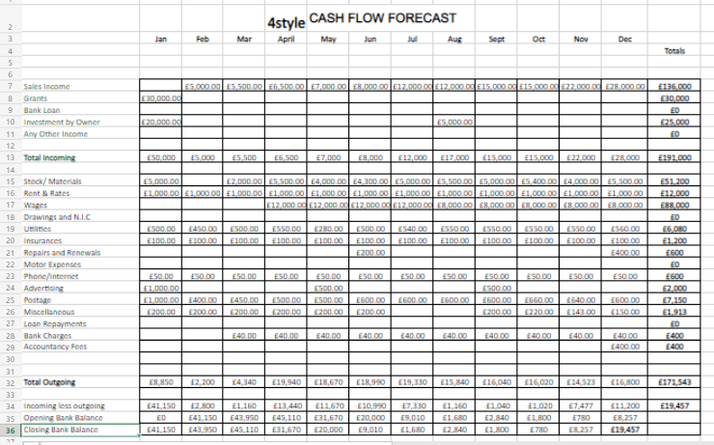

- At the end of the year, a financial statement showing Profit and Loss is produced. This summarizes revenue from sales and expenditure for the 12 months of business. At the end of the period dividends can be divided by owners or left in the business as opening balance for the upcoming year.

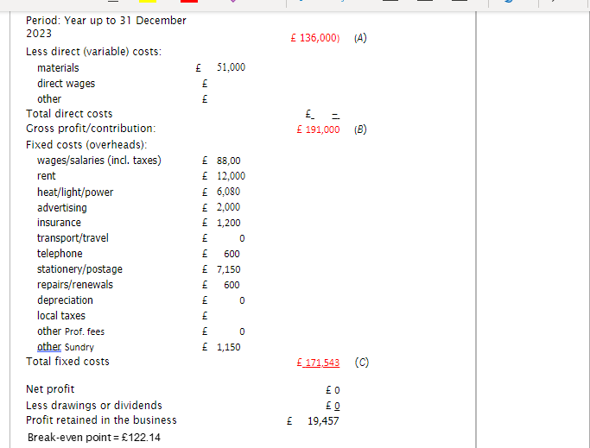

As a result of the dividends/profit, we will leave the balance in the company to continue into the next successful year and see what becomes then. (Haralayya,2021) reflects on profit and loss, Analysis discloses the prevailing relationship among sales, costs, and profit. There are fixed costs and variable costs involved in running a business.

8. References

Aleš Groznik, KrapežJ., Manfreda, A., Miha Škerlavaj, Zorc, S., Aleksandra Radulović, Božidar Krstajić, Ilieva, V., Marinova, M., Mladen Stanojević, Neagu, G., European Union. Programme and Al, E. (2011). ICT and energy: PESTLE & SWOT analysis Slovenia. S. L.: Forsee Partnership, Cop.
Chambers, I. (2003). Indian healthcare industry: a SWOT analysis. New Delhi: Published by Saket Projects on Behalf of Ficci.
Fulton, B.R., (2021). Bridging and bonding: Disentangling two mechanisms underlying the diversity–performance relationship. Nonprofit and Voluntary Sector Quarterly, 50(1), pp.54-76.
Haralayyaf, B., (2021). Financial Statement Analysis of Shri Ram City Union Finance. Iconic Research and Engineering Journals, 4(12), pp.183-196.
Ludwig Von Mises (1951). Profit and loss. South Holland, Ill.], [Consumers-Producers Economic Service.
Mind Tools Content Team, (2019). The Marketing Mix and the 4P's of Marketing. [Online]
Available at: www.mindtools.com
[Accessed 7 April 2022].
‌Vaidya, D., (2022). Target Markets. [Online]
Available at: www.wallstreetmojo.com
[Accessed 10 April 2022].
White, M. G., (2022). Defining your Target Market. [Online]
Available at: www.business.lovetoknow.com
[Accessed 10 April 2022].
‌
‌

