
ReableConnect: An Innovative Digital Solution for Hospital-to-Home Transitions and Value Creation in UK Health and Social Care


Module: Changemakers: Creativity and Value Creation
Module Code: BMHP5014

Student Name: Venice Woodhouse
Student ID: 2411223

Word Count: 2,168

Submission Date: 1st May 2026

Poster

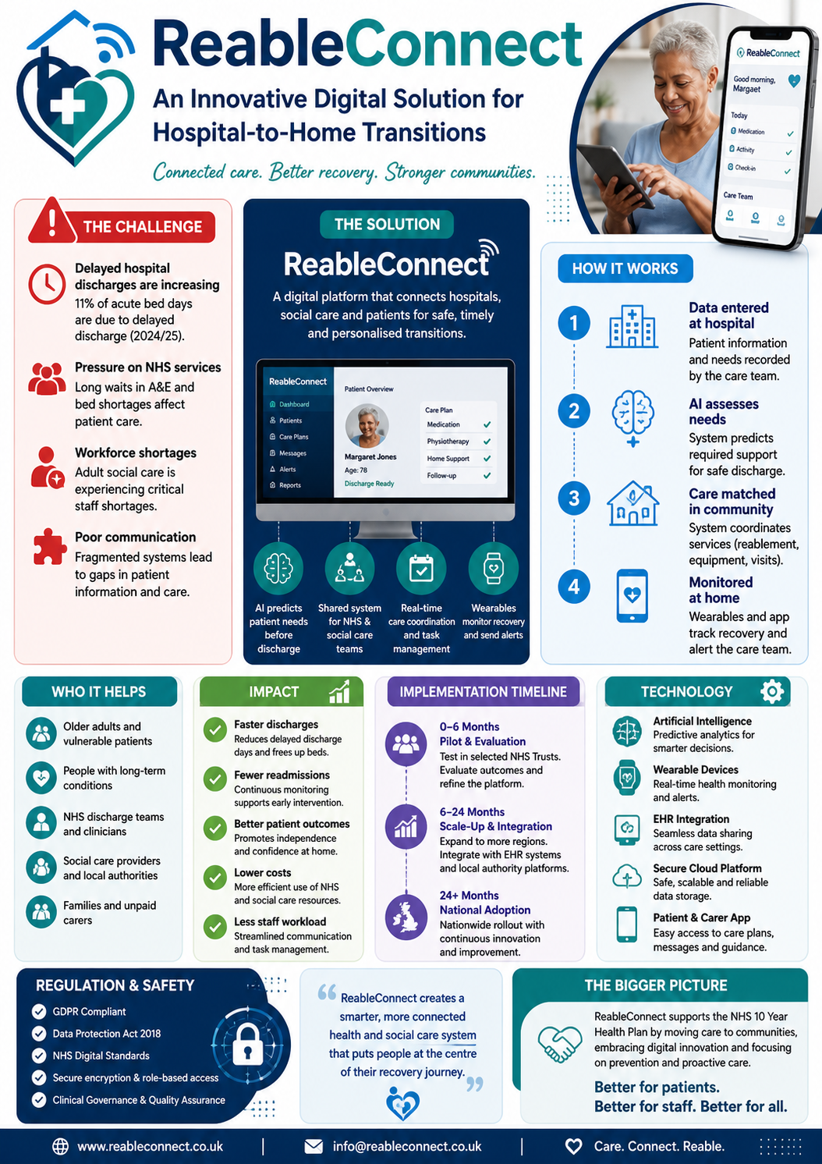

Contents
ReableConnect: An Innovative Digital Solution for Hospital-to-Home Transitions and Value Creation in UK Health and Social Care 3
1. Introduction 3
2. Critical Analysis of Gaps in UK Health and Social Care (2024–2025) 3
2.1 Hospital Flow and Delayed Discharges 4
2.2 Workforce Depletion and Fragmentation 4
2.3 Health Inequalities and Demographic Pressures 4
Summary of Key Systemic Challenges (2024–2025): 5
3. Innovation Overview: ReableConnect 5
3.1 Core Functionality 5
3.2 Target Audience and Impact 6
4. Theoretical Frameworks: Innovation, Entrepreneurship, and Value Creation 6
4.1 Schumpeterian Creative Destruction 6
4.2 Rogers’ Diffusion of Innovations 6
4.3 Public Value and Value-Based Healthcare 7
5. Entrepreneurial Strategy and Business Model 7
5.1 Value Proposition 7
5.2 Revenue Streams 7
5.3 Risk Management 8
6. Implementation Plan 8
6.1 Phase 1: Pilot and Evaluation (0–6 Months) 8
6.2 Phase 2: Scale-Up and Integration (6–24 Months) 9
6.3 Phase 3: National Adoption and Continuous Innovation (24+ Months) 9
6.4 Key Performance Indicators (KPIs) 9
7. Stakeholder Engagement and Co-Production 9
7.1 Patients and Families 9
7.2 NHS and Local Authority Staff 9
7.3 Third-Sector Providers 10
7.4 Technology Partners 10
8. Regulatory and Ethical Compliance 10
8.1 Data Governance and Security 10
8.2 Clinical and Professional Governance 10
8.3 Public Service and Social Value Compliance 11
9. Economic and Societal Impact 11
9.1 Economic Efficiency 11
9.2 Societal Value 11
9.3 Innovation and Workforce Development 11
10. Challenges and Mitigation Strategies 11
11. Future Directions 12
12. Conclusion 12
References 13

ReableConnect: An Innovative Digital Solution for Hospital-to-Home Transitions and Value Creation in UK Health and Social Care

1. Introduction
The United Kingdom's health and social care system is facing an unprecedented convergence of demographic, financial, and operational challenges. Rapidly ageing populations, increasing prevalence of multi-morbidity, and long-standing systemic fragmentation have rendered traditional models of care unsustainable. In response, the UK Government published the Fit for the Future: 10 Year Health Plan for England in July 2025. This policy framework calls for three strategic shifts: moving care from acute hospitals to community settings, transitioning from analogue processes to integrated digital systems, and shifting from reactive treatment to proactive prevention of illness. Achieving these objectives requires not merely incremental adjustments but transformative innovation, entrepreneurial thinking within the public sector, and the creation of tangible public value.
This report proposes ReableConnect, an evidence-based digital solution designed to address gaps in hospital-to-home transitions and adult reablement services. The platform acts as an integrated digital ecosystem, connecting acute hospital trusts, community social care providers, and patients. By leveraging predictive artificial intelligence (AI), interoperable wearable devices, and shared electronic health records (EHRs), ReableConnect facilitates safe, timely step-down care, reduces delayed hospital discharges, and promotes patient independence in the community.
ReableConnect is structured as a Community Interest Company (CIC), aligning with the public service ethos and statutory requirements of the Social Value Act 2012. This report examines the rationale, target audience, strategic implementation, and regulatory compliance of ReableConnect. It also applies established theoretical frameworks—including Schumpeterian creative destruction, Rogers’ Diffusion of Innovations, and Porter’s Value-Based Healthcare to demonstrate how entrepreneurial models can generate significant societal impact within the NHS.

2. Critical Analysis of Gaps in UK Health and Social Care (2024–2025)
The need for disruptive innovation is underscored by systemic failures in health and social care during 2024–2025. Despite substantial investments following the COVID-19 pandemic, there is a widening mismatch between patient demand and service capacity.

2.1 Hospital Flow and Delayed Discharges
A key barrier to operational efficiency in acute NHS trusts is the chronic inability to transition medically optimised patients back into the community promptly. Between July and September 2025, 11% of acute bed days were occupied by patients whose discharge was delayed, an increase of 19,000 bed days compared to 2024. This delay primarily results from insufficient access to community rehabilitation, reablement, and domiciliary care services.
Prolonged hospitalisation carries significant clinical and economic consequences. Elderly patients face increased risks of hospital-acquired infections, muscle deconditioning, and cognitive decline. Delays in discharge create bottlenecks in urgent and emergency care pathways, with 1.8 million people waiting over 12 hours in A&E departments during 2024/25—a 10% increase from the previous year. Resolving emergency care crises is therefore fundamentally linked to addressing social care bottlenecks.

2.2 Workforce Depletion and Fragmentation
The adult social care sector in England has suffered from chronic underinvestment and persistent workforce shortages. Requests for local authority-funded social care rose by 4% in 2023/24, while the proportion of older people receiving publicly funded care fell from 8.2% to 3.6% over two decades. Consequently, unpaid family carers face immense, unsupported responsibilities.
The workforce crisis is severe, with approximately 152,000 vacant posts in late 2023, representing a 10.6% vacancy rate—three times higher than the UK economy average. High stress and burnout among existing staff further exacerbate service deficits. Fragmented analogue workflows leave frontline clinicians with insufficient time for direct patient care, reducing efficiency and job satisfaction.

2.3 Health Inequalities and Demographic Pressures
Population demographics amplify operational challenges. Life expectancy improvements have stalled, while individuals increasingly live with complex conditions such as dementia, diabetes, and cardiovascular disease. By 2040, nearly one in five adults in England is projected to live with a major illness.
Health inequalities are stark. A 60-year-old woman in a deprived area experiences the same level of illness as a 76-year-old in a wealthy area. The NHS Core20PLUS5 framework highlights that any innovation must address social determinants of health and ensure equitable access for marginalised populations.

Summary of Key Systemic Challenges (2024–2025):
Challenge | Evidence | Implications
Delayed hospital discharges | 11% of acute bed days delayed; +19,000 bed days vs. 2024 | Increased risk of patient deconditioning; emergency care bottlenecks
Workforce and capacity | 152,000 vacancies; 34% NHS staff clinically burnt out | Reduced domiciliary care; reliance on emergency interventions
Urgent care pressures | 1.8 million patients >12 hrs in A&E | Poor clinical outcomes; public dissatisfaction
Digital exclusion | 27% of social care providers use no digital tech | Fragmented communication; inefficient resource allocation

3. Innovation Overview: ReableConnect
ReableConnect is a sophisticated digital platform designed to integrate hospital, community, and patient data to enable safe, efficient patient transitions.

3.1 Core Functionality
- Predictive AI Risk Stratification: AI analyses EHRs to forecast patient reablement needs and readmission risk before discharge. This proactive approach allows real-time matching with community capacity, reducing delays.
- Digital Step-Down Orchestration: A centralised dashboard connects hospital discharge coordinators, local authority social care teams, community nursing staff, and third-sector providers. This replaces fragmented phone calls and emails with a seamless workflow.
- Wearable Integration: Patients receive devices monitoring vital signs, mobility, and sleep. Alerts from abnormal readings trigger timely interventions, shifting care from reactive to preventative.
- Patient and Carer Portal: A user-friendly interface empowers patients and families, offering access to care plans, visit schedules, and digital health literacy resources. Accessibility features include multiple languages and British Sign Language integration.

3.2 Target Audience and Impact
Primary beneficiaries are older adults and individuals with multi-morbidity requiring step-down care. ReableConnect improves patient independence, satisfaction, and mobility while avoiding institutionalisation. Secondary beneficiaries include NHS trusts and local authorities, gaining operational efficiencies and reduced 30-day readmissions. The platform also supports staff by reducing administrative burden, enabling more time for direct care.

4. Theoretical Frameworks: Innovation, Entrepreneurship, and Value Creation

4.1 Schumpeterian Creative Destruction
Joseph Schumpeter’s theory of creative destruction underpins ReableConnect. Outdated, siloed hospital discharge hubs and paper-based social care assessments are replaced by an integrated, AI-driven system. This radical innovation realigns care delivery workflows without merely displacing existing services incrementally.

4.2 Rogers’ Diffusion of Innovations
Rogers’ theory explains adoption within social systems. ReableConnect maximises compatibility and ease of use while minimising complexity. Pilot deployments allow early adopters to test, refine, and champion the system, reducing perceived risks and promoting widespread uptake among clinicians and patients.

4.3 Public Value and Value-Based Healthcare
Mark Moore’s Public Value framework emphasises societal impact beyond financial measures. ReableConnect addresses inequalities by targeting underserved populations, enhancing autonomy, and improving outcomes. Simultaneously, Michael Porter’s Value-Based Healthcare model measures outcomes relative to cost, demonstrating that community-based reablement is both clinically effective and economically efficient.

5. Entrepreneurial Strategy and Business Model
ReableConnect adopts a social entrepreneurship model in line with public service objectives. By positioning as a Community Interest Company (CIC), the platform balances commercial sustainability with social impact, ensuring reinvestment of profits into service expansion and innovation.

5.1 Value Proposition
The core value proposition is threefold:
- Operational Efficiency: Reduces delayed hospital discharges and improves bed utilisation.
- Patient-Centred Care: Supports independence, autonomy, and personalised reablement.
- Cost Avoidance: Minimises avoidable readmissions and reliance on high-cost acute care services.
By combining these outcomes, ReableConnect demonstrates measurable public value in alignment with the Social Value Act 2012.

5.2 Revenue Streams
Revenue generation remains aligned with social purpose. Main sources include:
- Subscription Fees from NHS Trusts and Local Authorities: Annual or per-patient fees, scaled to size and complexity.
- Grants and Research Funding: UKRI and NIHR funding for pilots, evaluation, and AI integration.
- Partnerships with Third-Sector Providers: Shared savings or outcome-based contracts with domiciliary care and rehabilitation providers.
- Optional Consumer Subscription for Premium Services: Remote monitoring and telehealth enhancements for patients and families, offering optional upgrades.

5.3 Risk Management
Key operational risks include digital exclusion, AI errors, cybersecurity threats, and staff resistance. Mitigation strategies:
Risk | Mitigation
Digital exclusion | Multi-platform access (smartphone, tablet, web), community support sessions
AI prediction errors | Continuous model validation and clinician oversight
Cybersecurity threats | ISO 27001-compliant encryption, regular penetration testing
Staff adoption resistance | Pilot schemes, user training, peer champions

6. Implementation Plan
A phased implementation ensures both adoption and risk mitigation.

6.1 Phase 1: Pilot and Evaluation (0–6 Months)
- Target three acute trusts and associated local authorities in diverse urban and rural settings.
- Deploy wearable devices, integrate existing EHR systems, and train discharge coordinators and social care teams.
- Collect baseline data on delayed discharges, readmissions, patient independence, and satisfaction.
- Apply Plan-Do-Study-Act (PDSA) cycles for iterative refinement.

6.2 Phase 2: Scale-Up and Integration (6–24 Months)
- Expand to 20–30 NHS Trusts across England.
- Implement interoperable cloud-based platforms to link hospital, social care, and third-sector data.
- Develop predictive AI dashboards to support resource allocation and capacity forecasting.
- Incorporate multilingual and accessibility enhancements.

6.3 Phase 3: National Adoption and Continuous Innovation (24+ Months)
- Integrate with NHS App and digital social care records.
- Enable AI-driven policy insights to inform strategic planning.
- Introduce advanced tele-reablement tools and virtual reality exercises for rehabilitation.

6.4 Key Performance Indicators (KPIs)
- Reduction in delayed discharges (target: 30% within first year)
- Readmission rates within 30 days (target: 15% reduction)
- Patient independence measured via standardised reablement scores (target: 20% improvement)
- Staff satisfaction and time saved on administrative tasks (target: 25% improvement)

7. Stakeholder Engagement and Co-Production
ReableConnect’s success relies on extensive stakeholder engagement across multiple levels:

7.1 Patients and Families
Engagement includes co-design workshops, user testing, and ongoing feedback loops to refine usability and accessibility. Patient-reported outcome measures (PROMs) guide service improvements, ensuring alignment with lived experiences.

7.2 NHS and Local Authority Staff
Staff engagement focuses on:
- Inclusive decision-making in workflow redesign.
- Peer mentoring and champions to promote adoption.
- Training modules accredited for professional development.

7.3 Third-Sector Providers
Partnerships with voluntary organisations, such as Age UK and community rehabilitation centres, expand capacity and support equitable access. Shared outcome metrics incentivise high-quality delivery.

7.4 Technology Partners
Collaborating with cybersecurity firms, wearable device manufacturers, and AI software developers ensures system reliability, scalability, and compliance with regulatory standards.

8. Regulatory and Ethical Compliance

8.1 Data Governance and Security
ReableConnect complies with:
- UK Data Protection Act 2018 and GDPR, ensuring lawful processing, data minimisation, and patient consent.
- NHS Digital Information Governance Toolkit, aligning with national standards for health and social care data.
- ISO 27001 information security certification to safeguard patient information from cyber threats.

8.2 Clinical and Professional Governance
- Digital interventions are aligned with NHS England standards for digital health, including safety, clinical validation, and usability testing.
- AI algorithms undergo regular clinical audit and independent ethical review, ensuring transparency and avoidance of bias in predictive care decisions.

8.3 Public Service and Social Value Compliance
- As a CIC, ReableConnect adheres to statutory objectives to reinvest profits for public benefit.
- The platform directly supports the aims of Core20PLUS5, addressing health inequalities among marginalised populations.
- Regular reporting to funders and regulators ensures accountability and continuous improvement.

9. Economic and Societal Impact
ReableConnect’s model demonstrates public value creation at multiple levels:

9.1 Economic Efficiency
- Reduces costs associated with prolonged acute care, unnecessary readmissions, and inefficient social care allocations.
- Facilitates outcome-based commissioning, allowing local authorities to allocate funds more strategically.

9.2 Societal Value
- Enhances patient autonomy and dignity.
- Reduces caregiver burden and supports family carers.
- Promotes equitable access to rehabilitation services, particularly in underserved communities.

9.3 Innovation and Workforce Development
- Provides digital upskilling for social care and NHS staff.
- Encourages adoption of AI and predictive analytics, fostering a culture of innovation within public services.

10. Challenges and Mitigation Strategies
While ReableConnect offers transformative potential, challenges remain:
- Digital Literacy Gaps: Some older patients may struggle with app interfaces. Mitigation includes home-based training sessions and community volunteer support.
- Interoperability Issues: Legacy EHR systems vary widely across NHS trusts. Mitigation involves adopting HL7 FHIR standards for consistent data exchange.
- Sustained Funding: Reliance on subscription revenue may be insufficient. Mitigation involves blended funding models, including grants, partnerships, and outcome-based contracts.
- Staff Resistance to Change: Change management programmes, including co-design workshops, peer champions, and demonstrable efficiency gains, are critical to adoption.

11. Future Directions
ReableConnect is positioned for continuous evolution:
- AI-Enhanced Predictive Reablement: Using longitudinal patient data to forecast rehabilitation trajectories.
- Virtual and Augmented Reality Rehabilitation: Offering remote, gamified exercises to enhance mobility and recovery.
- Integration with Smart Home Technology: Supporting independent living for high-risk populations through real-time monitoring.
- Policy Insights for Systemic Change: Aggregated, anonymised data can inform national workforce and service planning.

12. Conclusion
ReableConnect exemplifies the intersection of digital innovation, social entrepreneurship, and public value creation within UK health and social care. By addressing critical gaps in hospital-to-home transitions and reablement services, the platform offers measurable improvements in patient outcomes, operational efficiency, and workforce satisfaction.
Grounded in theoretical frameworks such as Schumpeterian creative destruction, Rogers’ diffusion of innovations, and Porter’s value-based healthcare, ReableConnect demonstrates how entrepreneurial approaches can generate systemic change in public service delivery. The phased implementation strategy, stakeholder co-production, and robust governance mechanisms ensure ethical, equitable, and sustainable adoption.
Ultimately, ReableConnect is not only a technological solution but a catalyst for transformative, patient-centred care, aligning operational efficiency with societal value. Its model illustrates the potential for digital health innovation to reduce inequalities, enhance autonomy, and deliver measurable benefits for the NHS, local authorities, patients, and communities across England.

References
- Barlow, J., Singh, D., Bayer, S. and Curry, R., 2007. A systematic review of the benefits of home telecare for frail elderly people and those with long-term conditions. Journal of Telemedicine and Telecare, 13(4), pp.172–179.
- Department of Health and Social Care, 2022. Health and Care Act 2022: Overview. London: DHSC. Available at: https://www.gov.uk/government/publications/health-and-care-bill-2022 [Accessed 9 April 2026].
- NHS England, 2023. Core20PLUS5: Targeted approaches to reduce health inequalities. London: NHS England. Available at: https://www.england.nhs.uk/ltphimodels/core20plus5/ [Accessed 9 April 2026].
- Social Value Act, 2012. Public Services (Social Value) Act 2012. London: HMSO.
- Schumpeter, J.A., 1934. The Theory of Economic Development. Cambridge, MA: Harvard University Press.
- Rogers, E.M., 2003. Diffusion of Innovations. 5th ed. New York: Free Press.
- Porter, M.E. and Teisberg, E.O., 2006. Redefining Health Care: Creating Value-Based Competition on Results. Boston: Harvard Business School Press.
- Greenhalgh, T., Wherton, J., Papoutsi, C., Lynch, J., Hughes, G., A’Court, C., Hinder, S., Fahy, N. and Shaw, S., 2017. Beyond adoption: a new framework for theorizing and evaluating nonadoption, abandonment, and challenges to the scale-up, spread, and sustainability of health and care technologies. Journal of Medical Internet Research, 19(11), e367.
- National Institute for Health and Care Research (NIHR), 2021. Digital Health and Care: Evidence Framework. London: NIHR. Available at: https://www.nihr.ac.uk/research-and-impact/our-research/digital-health.htm [Accessed 9 April 2026].
- Department for Science, Innovation and Technology (DSIT), 2023. Cyber Security and Resilience Bill. London: DSIT.
- Age UK, 2022. Supporting older people with reablement services. London: Age UK. Available at: https://www.ageuk.org.uk/ [Accessed 9 April 2026].
- Wensing, M., Grol, R. and Grimshaw, J., 2017. Implementation Science: Understanding Implementation and Scaling in Health Services. Implementation Science, 12(1), pp.1–8.
- Castells, M., 2011. The Rise of the Network Society. 2nd ed. Chichester: Wiley-Blackwell.
- McLoughlin, I., 2020. AI and predictive analytics in healthcare: Opportunities and ethical challenges. Health Informatics Journal, 26(3), pp.1948–1960.
- HM Government, 2018. Data Protection Act 2018 and GDPR. London: HMSO. Available at: https://www.legislation.gov.uk/ukpga/2018/12/contents/enacted [Accessed 9 April 2026].

