Module name: Human Resource Management
Group Assignment - Leadership Development
Individual part - Trait theory

Module code: LCMB7000
Student name: Shabaaz Ali Syed
Student ID: 2128679

Table of Contents
Introduction 2
Trait theories 2
Brief about the topic 5
Conclusion 6
References 7

Introduction
The trait theory in leadership development proposes inherent talents and features which form a leader in any person. These features may comprise attitude or behaviour, physical appearance, and mental as well as emotional intelligence of an individual. Trait theories disregarded the conventions around traits of leadership being hereditary or developed. This theory usually introduces a personality model which assesses amicability, carefulness, sociability, sensitivity, and candidness. It provides thorough information and comprehension of the constituents of the leadership necessary to become a leader. It assists to evaluate a person for his/her ability to become a leader by setting a benchmark for assessment (Nawaz and Khan, 2016). The leader possesses an entire set of natural and successively attained individualities, though due to the deficiency of realistic investigations and studies which adequately considers environmental influences, there is a contradiction in determining these individualities of leadership. Further, they also do not offer any clarity on methods for analysing these individualities. This theory emphasizes the leader and certain styles of demonstrated traits which produce effective leaders (Uslu, 2019). For instance, Steve Jobs was a brilliant leader and is often considered a case study on leadership skills and his talent of zealously expressing his ideas which encouraged other people to accompany him in his endeavours. The trait theories have been utilized to cultivate many evaluation procedures to provide simplified comprehension of the variety of factors concerning an individual's conduct, social relations, and opinions regarding everything surrounding him/her (Ghasabeh et al., 2015).

Trait theories
Administrative leadership is a versatile arena and has been studied thoroughly by a range of scholars taking different approaches to define it. I have learnt that leadership happens in every domain and its study encompassed various facets including managerial, educational, psychological, sociological, and political. The definition of the concept of leadership varies a lot due to the abundance of diverse research conducted by scholars from different backgrounds, and hence no common explanation of leadership is formulated which can be accepted globally (Andriukaitiene et al., 2017). Some of the major theories as shown in the figure below:
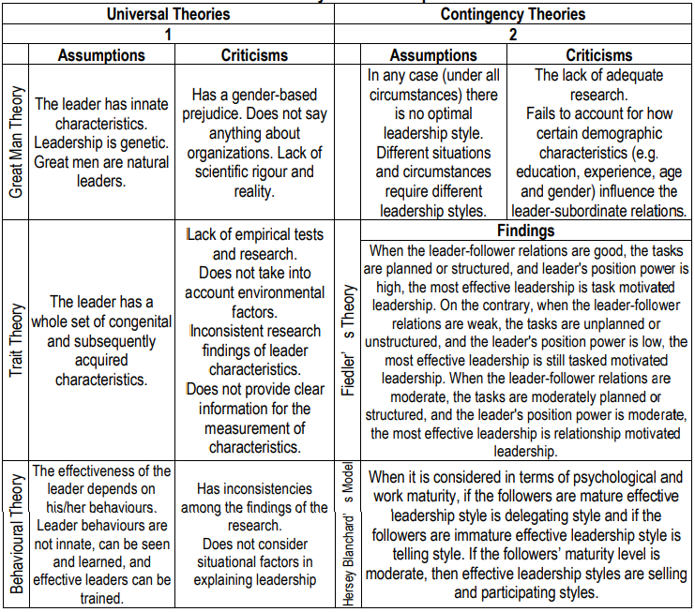
Figure-1. Leadership theories
(Source: Uslu, 2019)
In the initial 20th century, the leadership trait theory also referred to as the Great Man theory was the first logical effort to research the leadership concept. The idea of a great man proposes some exceptional individuals have the aptitude to reform and bring tangible transformation to the culture. The leadership trait theories started emerging throughout the 1920-30s. In 1949, the qualities of alertness, intelligence, responsibility, insight, persistence, initiative, sociability, and self-confidence were proposed as the exclusive effective leadership traits. Additionally, the prominence of circumstantial influences was acknowledged. Though, these effective leadership traits differ in every situation and erstwhile function collectively. The effectiveness of leadership cannot be projected based only on traits in a particular situation which I will apply in future also. Eventually, six effective leadership traits including honesty, motivation, self-confidence, integrity, knowledge and cognitive ability of the business were proposed. But later on, four crucial leadership traits of competency, honesty, foresight and being an inspiration were accepted. Although leadership trait theories highlighted the significance of leadership traits but never elucidated the presence of these traits being inherent in every individual or whether can they be acquired by adequate preparation or learning. Further research underlined the fact that trait theories overlooked the effects of circumstantial and environmental aspects on the efficacy of a leader in any condition (Asrar-ul-Haq and Anwar, 2018). In this way, I developed an understanding of the trait theory of leadership and thereby I have decided to instil traits like social and intellectual aspects to differentiate between me and other non-leaders.
Knowing the traits in people which are important for a leader has potential consequences in the choice of electing leaders. If there are more experienced female leaders then the traits of male speciality will be less recognized in the list of traits essential for leadership, while traits like cooperation, empathy and sensitivity remain constantly anticipated irrespective of other traits and experience in leadership. The occurrences of gradual change are necessary for contemporary leadership and supportive corporate culture to best utilize these changes (Nichols, 2016).
Human resource management or HRM deals with every facet of employing people and managing them in an organization. It comprises various activities of planning and managing humans as a resource including recruitment, workforce management and skill management along with corporate social responsibility, database management, organizational management and development. Other activities such as resourcing allocation, employee learning support, performance management and incentives, management-employee relations, employee service provisions and employee welfare (Armstrong and Taylor, 2020). It also has an international dimension which was been understood from designing presentation for my group work.
International Human Resource Management (IHRM) has conventionally studied Multi-National Enterprises (MNEs) with regards to their diverse human resources in the various countries they operate in. MNEs have to do the transaction not only with a range of domestic business practices but also with a series of issues in national policy to form a business strategy. IHRM ascertains efficient methods for MNEs to address the needs of the organisation to coherently and cost-effectively approach to manage its workforce in these countries. Moreover, it ensures receptiveness to the dissimilarities in expectations from functioning with diversity. Thus it focuses especially on the management of the international workforce which is one of my crucial learnings developed from the presentation (Brewster et al., 2016).

Brief about the topic
The topic mainly focuses on the trait theory in the context of a successful business leader capable of managing and organizing the businesses in the domestic as well as international marketplace to establish a reputed brand image. The traits of a leader still remain to be governed by traits of contemporary influential business leaders and the theory of leadership traits also stays fluid. Any organisation is as good as the people who work in it hence the significance of HRM and IHRM is more evident in formulating an effective strategy and ascertainment strategic objectives.
Conclusion
Overall I have learnt that the growth of a business leader cannot be determined by theory and has to be looked at as a comprehensive concept of human behaviour and development with regard to the sociocultural, ethnic, political, economic and other circumstantial influences an individual faces during his/her life experiences.

t

References
Andriukaitiene, R., Voronkova, V., Kyvliuk, O., Maksimenyuk, M. and Sakun, A. 2017. Theoretical insights into expression of leadership competencies in the process of management. Problems and Perspectives in Management 15(1-1), pp. 220-226.
Armstrong, M. and Taylor, S. 2020. Armstrong's handbook of human resource management practice. London: Kogan Page Publishers.
Asrar-ul-Haq, M. and Anwar, S. 2018. The many faces of leadership: Proposing research agenda through a review of literature. Future Business Journal 4(2), pp. 179-188.
Brewster, C., Houldsworth, E., Sparrow, P. and Vernon, G. 2016. International human resource management. London: Kogan Page Publishers.
Ghasabeh, M.S., Soosay, C. and Reaiche, C. 2015. The emerging role of transformational leadership. The Journal of Developing Areas 49(6), pp. 459-467.
Nawaz, Z.A.K.D.A. and Khan, I. 2016. Leadership theories and styles: A literature review. Leadership 16(1), pp. 1-7.
Nichols, A.L. 2016. What do people desire in their leaders? The effect of leadership experience on desired leadership traits. Leadership & Organization Development Journal 37(5), pp. 658-671.
Uslu, O. 2019. A general overview to leadership theories from a critical perspective. Marketing and Management of Innovations (1), pp. 161-172.

