Academic and Employability Skills

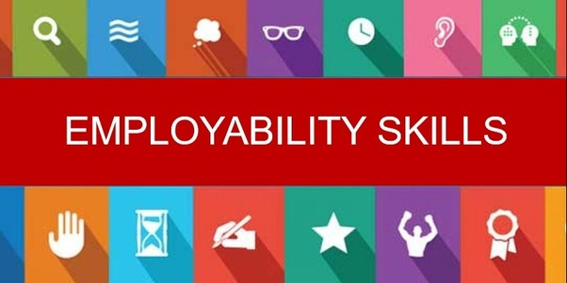

University of Wales Trinity Saint David
Name: Maureen Graham
1818267
Date: December 30,2019

Table of Content

Introduction………………………………………1
Methods ………………………………………….2
Discussions……………………………………….3
Academic Skills…………………………………..3
Employability Skills……………………………...4-5
Reflective writing………………………………...6
Time Management……………………….……….7
CV Writing……………………………………….8
Conclusion…………………………………….….9
References ………………………………………10
.

Introduction

My name is Maureen Graham register and attending UWTSD University upon coming to this university I had no knowledge or idea of using Moodle by coming to this university I now know how useful Moodle can be.
By using Moodle, it has been helpful in doing research also helps in writing cover letters and more. It also helps to make me aware and more advance in my studies and Moodle is very easy to use.
The purpose of this report is to provide useful data on how to write a expository essay, CV letter and reflective writing.

1
Methods

This report will focus mainly on writing a cover letter, CV writing and reflective writing. In carrying out this research references will be taken from published books, newspaper reports and journals. This will provide accurate data and aid in writing these letters and provide a better understanding in using the Moodle. Information was obtained by reading through all the available data and analysing to provide accurate data in this report. This report will focus mainly on academic writing and employability skills and the importance in the working environments. Information to assist with this report will be taken from textbooks, journals and web pages that will provide accurate information.

2
Discussion

This report will be based on Academic and employability skills and how it enhances and individual skills and contribute to the skill development. This report will provide detailed description on the Academic skills that will enable every student to have the knowledge to survive in a modern economic environment. Also, employability skills are what every student will use to in the working world and along with their career development.

Academic Writing
The purpose of this report is to take a closer look at Academic Writing and how it improves an individual skill in the working environments. Academic writing is clear, focussed, structured asked by evidence Academic writing help readers to better understand information provided. The type of Academic writing are:

- Expository Writing
- Persuasive Writing
- Narrative Writing

In this section a closer look will be taken at Expository writing. Expository writing is used to provide an explanation to reader and the steps and processes or actions to back a thesis and also used to convey factual information. The main reason or purpose of Expository writing is to provide information. The purpose of Expository writing is to analyse information and present and show case information.

In is section closer look will be taken at Persuasive writing. Persuasive writing can be define has “a piece of writing in which the writer uses words to convince the reader hat the writers opinion correct with regard to an issue” and this is according to (https://www.definitions.net// ). Persuasive writing is great skill for students to acquire has it give them the opportunity to write what they are passionate about and it’s a great way to express their views about certain topics and situations.

In this section a closer look will be taken at Narrative writing. This is a type of writing that tells a story. This consist mainly of five section which includes the plot, setting, character, conflict and theme which all build on a story, movie or even a joke. This is an essential skill to have has it aids in the working world to construct a cover letters and e-mails.
3
Employability Skills

A closer look will be taken at Employability skills and how it helps in the working environments. Employability can be defined as “ the transferable skills needed by an individual to make them employable” and this is according to ( https://www.exert.ac.uk). The types of Employability skills are

- Teamwork
- Self-management
- Adaptability
- Problem-solving

The value of Teamwork. Teamwork is the combing of skills and knowledge to achieve a common goal for an organisation. In any organisation teamwork plays a valuable part in the organisations growth and also assist in guiding employee's on how to work together in the best interest of the company. This will aid in helpings employees/individuals how to work together and give each person the opportunity to bring across their ideas and to aid in making the best decision has a group. Teamwork plays a vital part in the daily growth and development of the organisation. Teamwork is the combine action of a group of persons to bring ideas together to make efficient and effective decision. Teamwork is very important part in an organization or even study group for school, as this helps e h individual to bring different ideas and experiences together for a common purpose. This helps individuals to cooperate and bring their individual skills and experiences and to provide good feedback. Teamwork is very important in any organization has it helps employees and students to work together and exchange different ideas and experiences and create new ways of doing things.
Teamwork example listed below;

4
In this section a closer look will be taken at Self-management. Self-management is an attribute that an individual posse and helps individual to be more productive in the working environment. This is very vital in the working world and give each employee the opportunity to manage their time effectively and achieve a common goal. This also includes or help individual to be great at making decision and taken responsibility for their actions. This is an important skill that everyone should have in order to effectively manage their time and also to achieve goals and be productive and not just in the working world but also in their day to day lives. The importance of self-management is improving ones self and also setting goals and achieving them in a timely manner.

In this section a closer look will be taken at Adaptability. Adaptability is the ability to approach and change actions to suit a situation on or to make a decision. Adaptability is the ability to be flexible and adapt to the constant change in the working environment or society on a hold. This is a great skill for employees have that easily adapt to change in the working environments. Adaptability in the working environment helps employees to change in order to be successful and aid in achieving the organizations goal. In a working environment there is constant change and being able to adjust to these changes is very vital in an organization.

The term problem solving means the ability to solve issues n a timely and effective manner. This mainly includes being able to identify the problem, generating solutions and being able to select the best solutions and then implementing these solutions in a timely manner. In the working world one may face a number of problems some greater than others and a bit ore challenging. But once you have mastered the art of problem solving and being able to o this in an effective manner is very important. This skill also requires a person to work well under pressure and is not fazed when a new problem arises. Being able to solve problems is very important has I t makes an individual stand out for making a great decision. Also, this boost a person confidence in being able to solve a problem on their own. When solving a problem, it is best to not make it personal and also to break down the problem in parts which makes it easier to solve and always be open for suggestions and help.

5
Reflective Writing

Reflective Writing is an analytical writing in which the writer describes an event, memory or past experiences. This gives the student the opportunity had emotions and to give a positive or negative light to a specific story. Reflective writing gives students the opportunity to has their thought and emotions and helps to bring the story to life and to make a personal connection with the writer and reader. This type of writing helps to the writer to document experiences and opinion and a way of achieving clarity and a better understanding of what was learned. This is very important has helps the writer and the reader to connect through the story.

Time Management
Time managements is the ability to use one’s time in an effective and productive manner. This too is a very vital part in an organisation and helps individuals to manage their time wisely to reach a common goal. Is helps individuals to organise their time and complete task given on time. This is a skill that everyone should master has it will allow you to accomplish more in a shorter timeframe. This helps individuals to prioritise task given and to plan. Good time managements skills will include prioritising, delegation, strategic planning and problem solving. Once theses skills are mastered in will help with career growth and very skilled individual. In the 21st-century people are more focused on how to spend their time and what to spend their time doing. Therefore, once the art f time management is mastered it gives growth and makes the working environment more efficient and allows goals to be meant it a specified timeframe.

6
CV Writing
The term CV stands for Curriculum Vitae which is a detailed document which outlines ones academic and professional background. This is a document that can be submitted when applying for a job and is used to promote one’s self. This includes an individual professional and academic background along with one’s abilities and skills along with achievements and an individual has accomplished. CV Writing is very important when applying for jobs has it gives a brief background on the individuals. The image below shows an example of a Curriculum Vitae and how it should be done:
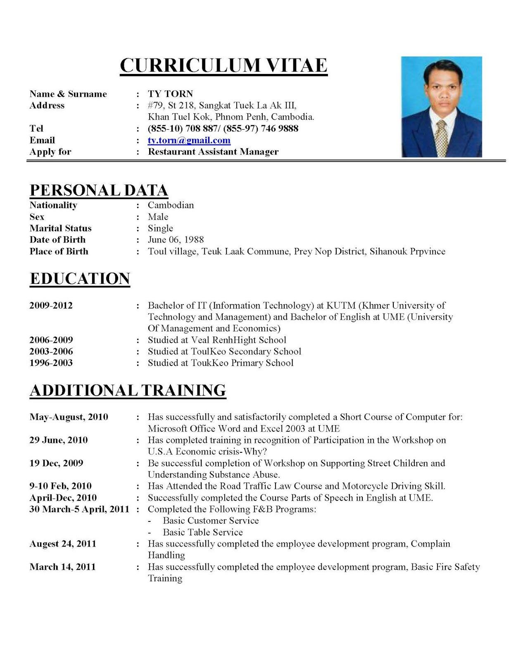
Eg 1. Curriculum Vitae
7

Conclusion

In conclusion these types of writing play a vital part in the working world and helps to get the task done in and effective manner. In academic writing you learn how to write CV writing and reflective writing along with how to do research. This helps and teaches you how to apply for jobs and be successful. In academic writing you learn how to develop a career of readiness and employability skills which helps to develop your career. Also having a degree or a masters is great and very important but can only go so far and do so much. However, having good employability skills along with great academic skills this will be of greater benefits to one’s self and to an organisation.

This report has focused on academic and employability skills and has provided the types long with their meaning. It has also showcased the importance of these skills in the working environment and in a person’s daily life. Through this report three academic writing styles were looked at that is very beneficial to a person. Also, four vital employability skills were discussed which will help one to stand out when seeking a job and also make the work load a lot easier. This helps a person to stand out when seeking employments in a sense where you have a great education background and also posse good employability skills which is great addition. Hence this report has shown the importance’s and the skills that one should have to make them more marketable and give them a step ahead when seeking employment and even lets them stand out.

9
References

- David W.G. Hind and Stuart Moss. Employability Skills 2nd Edition.
- Gillie Bolton (2001). Reflective Practice: Writing and Professional Development.

- James Innes (2009). The CV Book: You Definitive Guide to Writing the Perfect CV.

- John M. Swales. (2004) Academic Writing for Graduate Students. Essential Task and Skills.

- Jane Spiro, Kate Williams and Mary Woolliams (2012). Reflective Writing.

- Mercy V. Chaita. Developing Graduate Employability Skills. Your Pathway to Employment.

- Paul J Silvia (2007) A Practical Guide to Productive Academic Writing.

- Stephen Bailey. Academic Writing. A Handbook for International Students.

10

