

Module Code: ECAD5015

Assignment Title: Deepening Practice
ALN – Part 1 Journal
Student Name: Amelia Morgan
Student Number: 2304864
BA Primary Education (QTS)

AI Acknowledgement

I acknowledge the use of Chat GPT https://openai.com/index/chatgpt/ on 7th May 2025 to support my research. I used the prompt(s):
1. Please, can you find credible literature on visual timetables
2. Please can you find literature that states a limitation of communication lanyards.
I confirm that I have not presented any AI generated text as my own work.
I confirm that I have copies of my drafts, notes, and other resources I used before and after the use of AI tools which I may be asked to provide in evidence.

Targets from previous module | How I have worked on these? | An example can be seen on…
- Esnure that you make full use of the recommended reading list and focus on edcuational research sources. | - I have made a consious effort to use documents from lectures and make use of the reading list to support my research. | - Introduction.
- Please revise the correct protocols for Harvard referncing to improve precision and accuracy of citing the work of authors. | I have ensured that I have used the correct protocols when citing using Harvard referencing. | Throughout my assignment.

Create a journal to demonstrate deep practical and theoretical understanding of inclusive practice within a primary school classroom.
Introduction
The Welsh Government (2016) defines inclusive practice as a process where all students can access opportunities in ways relevant to their needs. How schools and practitioners respond to meeting the needs of all children and young people plays an important role in creating a supportive learning environment that encourages development, wellbeing and achievement of every individual. The implementation of inclusivity within schools requires an inclusive curriculum that is differentiated to meet the needs of all pupils. Additionally, measures need to be put in place to enhance practitioners’ awareness of inclusive learning. The Additional Learning Needs (ALN) reform (Welsh Government, 2018) aims to provide person-centred support for learners with ALN. It focuses on early identification and assessment, with each learner obtaining an Individual Development Plan (IDP) outlining their needs and support. The reform encourages better collaboration across education, health and social care services, ensuring continuity of support as learners transition between progression steps. It promotes inclusive practices, integrating learners with ALN into mainstream education when possible. It emphasises the importance of teachers and professionals to be offered training to better support diverse learners, ensuring a more coordinated, flexible and inclusive approach to education. The ALN reform (Welsh Government, 2018) directly links to the Additional learning Needs and Education Tribunal Wales Act (Welsh Government, 2018) as the act focuses on tailoring support to the individual needs, ensuring their voices and preferences are considered in decision-making processes. The ALN reform aligns with the curriculum for Wales (Welsh Government, 2024) and the Four purposes (Welsh Government, 2022) by promoting a personalised, inclusive approach to education. The reforms focus on early identification and tailored approaches that help learners achieve the four purposes of the curriculum, developing as confident and capable individuals. By providing individualised pathways through IDPs, learners can make progress in their learning following the progression steps. The emphasis on professional development ensures educators have the skills to encourage proficiency in all learners.
The United Nations Convention on the Rights of the Child (UNCRC) (United Nations, 1989) supports the ALN reform by ensuring that children with ALN receive the right to education, participation and protection. Article 28 of the UNCRC recognises the right to an education that promotes the Child’s development, aligning with the ALN reforms’ person-centred, inclusive approach. Article 23 highlights the rights of children with disabilities to receive personalised care and support, which is directly reflected in the reform’s emphasis on tailored IDPs and coordinated services, ensuring every learner’s right to thrive in an inclusive educational environment. Hehir (2016) emphasises the importance of inclusive education in encouraging equal opportunities for all children, including those with ALN. He believes that inclusive practice promotes participation, wellbeing and improves outcomes. However, a limitation identified with being inclusive is the lack of resources and training for teachers. Kefallinou (2020) and Hehir (2016) highlight that insufficient professional development and inadequate funding can hinder the effective implementation of inclusive practices, creating barriers to full participation for some pupils.

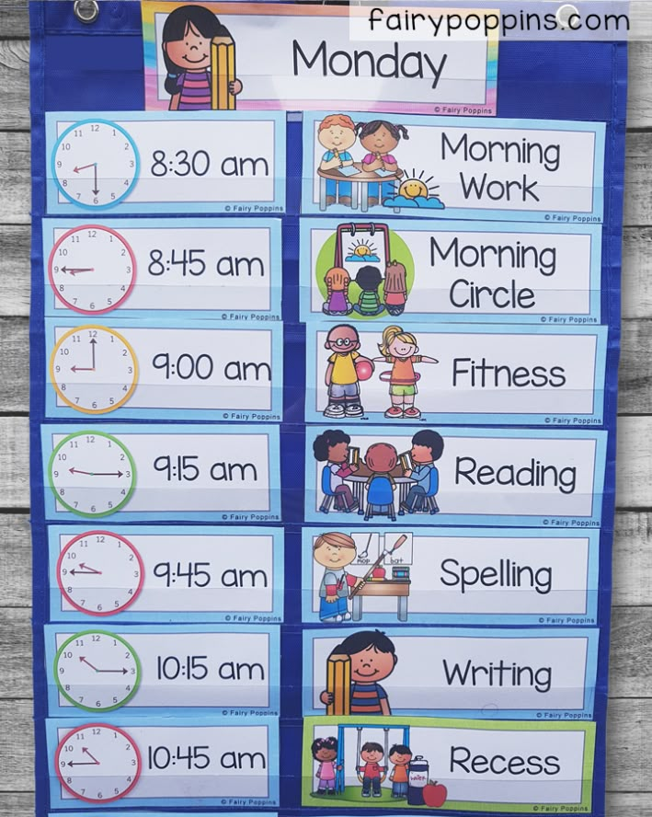
Strategy 1 - Visual timetable
A visual timetable is a tool used in many classrooms, displaying the daily schedule using images, symbols, pictures and/or written text. It helps students understand the structure of their day and promotes organisation. Visual timetables are particularly beneficial for students with ALN, as they provide a clear and inclusive way to anticipate upcoming activities (Cardillo, 2017). Rutherford et al (2020) reported that 73% of pupils used the visual timetables frequently and found that they support transitions, promoted independence and reduced reliance on teachers. It was shown that visual timetables are beneficial for all pupils, not just those with ALN.
(Poppins, 2025)

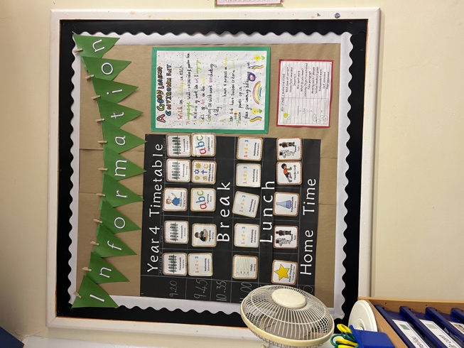
Whilst on my PTE, it was evident that visual timetables are used across the school and displayed in different formats. Some visual timetables show daily activities and some present weekly activities. Macdonald et al (2018) and Rutherford et al (2020) believe that daily timetables may be more effective in providing immediate, clear expectations for the day, specifically supporting pupils with ALN who may become overwhelmed from seeing a broader overview of activities. It was found that younger children and pupils with ALN benefit more from daily timetables as they reduce the cognitive load and potential anxiety associated with processing a longer timeframe. However, Macdonald et al (2018) suggest that a weekly timetable could be used to
(Author’s own, 2025)

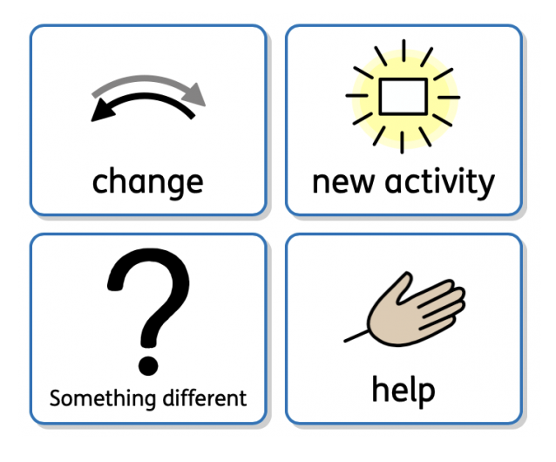
provide an overview for the students who need it. Doing this will create an inclusive classroom where all children are considered.
However, a limitation identified when implementing visual timetables is that they may lead to increased anxiety or behavioural issues when unexpected changes occur. McCann (2020) suggests that this can be particularly challenging for pupils with Autistic Spectrum Condition (ASC) or children who rely heavily on routine, this change may cause confusion or distress. To minimise this, Rutherford
(McCann, 2020)
(2020) suggests it could be beneficial to incorporate flexibility into the visual timetable. For instance, introducing a ‘change’ symbol, similar to the images above, can signal that alterations to the routine may occur, helping children anticipate and adapt to changes more comfortably.
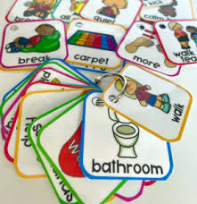
Strategy 2 – Communication lanyard
Communication lanyards are widely recognised as effective tools to Augmentative and Alternative Communication (AAC) (Speech and Language UK, 2025), particularly those with ASC or other communication challenges. They provide immediate access to visual symbols, aiding in the expression of needs, emotions and responses. Everyone communicates in different ways, and not talking doesn’t mean not communicating. Speech and Language UK (2025) recognises some forms of
(Autism little learners, 2025)
communication such as body movement and gestures, facial expressions, sounds and noises, signing and eye contact. The Welsh Government (2016) Inclusion and Pupil Support Document mentions communication aids as part of inclusive education strategies. It states that schools are encouraged to use appropriate communication aids to support pupils with diverse needs.
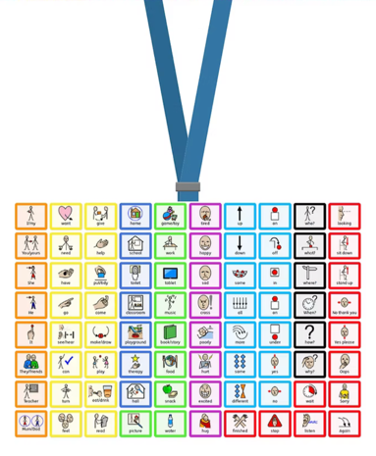
Whilst on PTE, I created a communication lanyard similar to this image to support a non-verbal child in the class. This form of communication supported the child and was accessible to all other children in the classroom. Estyn (2024) highlights how visual aids support early communication by offering consistent and accessible cues. This tool helps pupils understand routines, make choices and express their needs more independently. Using a communication lanyard, I was able to give the child simple instructions, and they were able to communicate their needs to me. In line with BERA (2024), I have anonymised the school and the children’s identities.
(Speech and Language Academy, 2025)
Although communication aids can be beneficial and support inclusive practice, a limitation identified was resources and staff training. The Welsh Government (2016) recognise that communication aids may need to be tailored to individuals' needs, which can be time consuming and resource intensive. Additionally, Murray et al (2019) suggest that communication aids are often abandoned, with reported rates of 30-50% due to poor fit with user needs and lack of training to utilise the aid. McCann (2020) states that often parents/carers and practitioners may ultimately give up because the child has ‘outgrown’ the aid. However, she believes that visual timetables grow with the child and should be adapted frequently to meet their needs. Schools may consider engaging with individuals alongside their families in customising their visual aid. This collaborative approach ensures that the chosen tools and symbols align with the users’ preferences and daily routines, reducing the likelihood of abandonment (Murray et al, 2019).
Conclusion
Inclusive practices, such as visual timetables and communication lanyards, are essential in aligning with the Curriculum for Wales (Welsh Government, 2024) and the Additional Learning Needs (ALN) reform (Welsh Government, 2018), promoting inclusion and accessibility for all learners. Estyn (2024) emphasises that inclusive education encourages participation and improves outcomes for students with ALN. Visual timetables have been shown to support transitions and promote independence among all pupils (Rutherford et al, 2020). Similarly, communication lanyards serve as effective Augmentative and Alternative Communication (AAC) tools, aiding expression for students with communication challenges.
However, challenges such as insufficient resources and staff training can hinder the effective implementation of these tools. Murray et al. (2019) highlight that inadequate professional development and poor fit with user needs can lead to the abandonment of communication aids. Reflecting on my Professional Teaching Experience (PTE), the application of these strategies highlighted their positive impact on student engagement and independence. Moving forward, my professional development (Welsh Government, 2024) will focus on enhancing inclusive pedagogies and staying informed on best practices to support all learners effectively.

Reference list:
Cardillo, N (2017) Visual aids supporting the learning of children in our classrooms. Available at: https://scholar.google.com/scholar?hl=en&as_sdt=0%2C5&q=visual+timetables&oq=visual+Tim (Accessed: 7th May 2025)
Estyn (2024) Developing early communication skills with predominantly preverbal pupils. Available at: https://estyn.gov.wales/improvement-resources/developing-early-communication-skills-with-predominantly-pre-verbal-pupils/ (Accessed: 7th May 2025)
Hehir, T. (2016) A summary of the evidence on inclusive education. Available at: https://files.eric.ed.gov/fulltext/ED596134.pdf (Accessed: 6th May 2025)
Kefallinou, A. (2020) Understanding the value of inclusive education and its implementation: A review of the literature. Available at: https://www.researchgate.net/profile/Simoni-Symeonidou/publication/344261482_Understanding_the_value_of_inclusive_education_and_its_implementation_A_review_of_the_literature/links/5ffe1848a6fdccdcb84d6d6f/Understanding-the-value-of-inclusive-education-and-its-implementation-A-review-of-the-literature.pdf (Accessed: 6th May 2025)
Macdonald, L. et al (2018) The use of visual schedules and work systems to increase the on-task behaviour of students on the autism spectrum in mainstream classrooms. Available at: https://research-repository.griffith.edu.au/bitstreams/e1a2dcaf-2567-4e6a-b625-2fed3c9d95d7/download (Accessed: 7th May 2025)
Murray, J (2020) The decision-making process in recommending electronic communication aids for children and young people who are non-speaking: the I-ASC mixed methods study. Available at: https://eprints.whiterose.ac.uk/id/eprint/145285/1/I-ASC%20SR2%20Paper%20-%20D%26R-AT%20pre-print%20version.pdf (Accessed: 7th May 2025)
Rutherford, M et al (2020) Pupils’ views on visual timetables and labels in mainstream primary classrooms. Available at: https://eresearch.qmu.ac.uk/bitstream/handle/20.500.12289/10672/10672.pdf?s (Accessed: 7th May 2025)
Speech and Language UK (2025) Children communicating in different ways. Available at: https://speechandlanguage.org.uk/help-for-families/resource-library-for-families/children-communicating-in-different-ways/ (Accessed: 7th May 2025)
United Nations (1989) The United Nations Convention on the Rights of the Child. Available at: https://www.unicef.org.uk/wp-content/uploads/2016/08/unicef-convention-rights-child-uncrc.pdf (Accessed: 6th May 2025)
Welsh Government (2016) Inclusion and pupil support. Available at: https://www.gov.wales/sites/default/files/publications/2018-05/guidance-inclusion-and-pupil-support_0.pdf (Accessed: 6th May 2025)
Welsh Government (2018) Additional learning needs (ALN) transformation programme. Available at: https://www.gov.wales/sites/default/files/publications/2018-09/additional-learning-needs-aln-transformation-programme-v2.pdf (Accessed: 6th May 2025)
Welsh Government (2022) Developing a vision for curriculum design. Available at: https://hwb.gov.wales/curriculum-for-wales/designing-your-curriculum/developing-a-vision-for-curriculum-design (Accessed: 6th May 2025)
Welsh Government (2024) Curriculum for Wales. Available at: https://hwb.gov.wales/curriculum-for-wales (Accessed: 6th May 2025)
Welsh Government (2024). Professional standards for teaching and leadership. Available at: https://hwb.gov.wales/api/storage/19bc948b-8a3f-41e0-944a-7bf2cadf7d18/professional-standards-for-teaching-and-leadership-interactive-pdf-for-pc.pdf (Accessed: 7th May 2025)
Images
Authors’ own (2025) Image collected on PTE2. University of Wales Trinity Saint David. Unpublished.
Autism Little Learners (2025) Visual Cue Card Lanyard set – For School. Available at: https://autismlittlelearners.com/product/visual-cue-cards-for-lanyard/ (Accessed: 7th May 2025)
McCann, L. (2020) The right way to use Visual Timetables. Available at: https://reachoutasc.com/the-right-way-to-use-visual-timetables/#:~:text=A%20visual%20timetable%20scaffolds%20those,opportunity%20to%20ask%20an%20adult. (Accessed: 7th May 2025)
Poppins, F (2025) Back to school – ideas for setting up your classroom. Available at: https://uk.pinterest.com/pin/13088655162419843/ (Accessed: 7th May 2025)
Speech and Language Academy (2025) A5 Lanyard Communication Board. Available at: https://www.speechandlanguageacademy.co.uk/product-page/lanyard-communication-aid (Accessed: 7th May 2025)

