

Euan Kelly

ACDB5015 - Design of Shaped Charges

  - University of Wales Trinity Saint David (UWTSD)
  - Ordnance Munitions and Explosives – Advanced Physics of OME

  - BEng
  - Academic Year: 2023 - 2028

  - Supervisor: Kelvin Donne

  - November 2025

Table of Contents
1 Abstract 2
2 Acknowledgments 2
1. Introduction 8
2. Literature Review 9
2.1. History & Development of Shaped Charges 9
2.2. Applications of Shaped Charges 9
2.3. Modelling approaches for Shaped Charges 10
2.4. Material Models for Shaped Charges 10
2.4.1. Johnson Cook (JC) & Elasticity 11
2.4.2. Jones Wilkins Lee (JWL) 12
2.5. Conclusion of Literature Review 12
3. Two-Dimensional Abaqus Simulations 13
3.1. Overview of 2D Modelling 13
3.2. 2D Sketch 13
3.3. 2D Meshing 16
3.3.1. 2D Case Mesh 17
3.3.2. 2D High Explosive Mesh 18
3.3.3. 2D Liner Mesh 19
3.4. Material properties and Model parameters 20
3.5. Design of Shaped Charge 23
3.5.1. Design 1 – TNT Explosive & Copper Liner 23
3.5.2. Design 2 – TNT Explosive & Tungsten Liner 24
3.5.3. Design 3 – Composition B Explosive & Copper Liner 24
3.5.4. Design 4 – Composition B Explosive & Tungsten Liner 24
3.6. Pressure Wave Progression (2D) 24
3.6.1. Pressure Wave Initial Contact with Liner (2D) 25
3.6.2. Pressure Wave Causing Liner to Collapse (2D) 27
3.7. Velocity Analysis 30
3.7.1. Velocity Plots at Liner Collapse 31
3.7.2. Velocity Plots at Tip of Fully Formed Jet 35
4. Three-Dimensional Abaqus Simulation 37
4.1. Rationale for Choosing Design 3 37
4.2. Transition Between 2D Design to 3D Design 37
4.3. Meshing 3D Shaped Charge 39
4.3.1. TET Meshing 39
4.3.2. Linear Meshing 39
4.3.3. 3D Case Mesh 40
4.3.4. 3D High Explosive Mesh 41
4.3.5. 3D Liner Mesh 44
4.4. Velocity Analysis (3D) 45
4.4.1. Velocity Plots at Liner Collapse 45
4.4.2. Velocity Plots at Tip of Fully Formed Jet 46
4.4.3. Velocity Plots at the Rear of a Fully Formed Jet 47
5. Smooth Particle Hydrodynamics (SPH) 48
6. Conclusion 52
6.1. Future Recommendations 52
7. References 52

Figure 1 - 2D Case Sketch 14
Figure 2 - 2D High Explosive Sketch 15
Figure 3 - 2D Liner Sketch 16
Figure 4 - 2D Case Mesh 17
Figure 5 - 2D High Explosive Mesh 18
Figure 6 - 2D Liner Mesh 19
Figure 7 - Design 1 Pressure Wave Initial Contact with Liner 25
Figure 8 - Design 2 Pressure Wave Initial Contact with Liner 26
Figure 9 - Design 3 Pressure Wave Initial Contact with Liner 26
Figure 10 - Design 4 Pressure Wave Initial Contact with Liner 27
Figure 11 - Design 1 Pressure Wave Causing Liner to Collapse 27
Figure 12 - Design 2 Pressure Wave Causing Liner to Collapse 28
Figure 13 - Design 3 Pressure Wave Causing Liner to Collapse 29
Figure 14 - Design 4 Pressure Wave Causing Liner to Collapse 30
Figure 15 - Design 1 Velocity Graph of Initial Liner Collapse 31
Figure 16 - Design 1 Nodes Selected for Velocity of Initial Liner Collapse 31
Figure 17 - Design 2 Velocity Graph of Initial Liner Collapse 32
Figure 18 - Design 2 Nodes Selected for Velocity of Initial Liner Collapse 32
Figure 19 - Design 3 Velocity Graph of Initial Liner Collapse 33
Figure 20 - Design 3 Nodes Selected for Velocity of Initial Liner Collapse 33
Figure 21 - Design 4 Velocity Graph of Initial Liner Collapse 34
Figure 22 - Design 4 Nodes Selected for Velocity of Initial Liner Collapse 34
Figure 23 - Design 1 Velocity Plots of Fully Formed Jet Tip 35
Figure 24 - Design 2 Velocity Plots of Fully Formed Jet Tip 35
Figure 25 - Design 3 Velocity Plots of Fully Formed Jet Tip 36
Figure 26 - Design 4 Velocity Plots of Fully Formed Jet Tip 36
Figure 27 - 3D Case Part 37
Figure 28 - 3D High Explosive Part 38
Figure 29 - 3D Liner Part 38
Figure 30 - Tetrahedral Element Meshing 39
Figure 31 - 3D Case Mesh 40
Figure 32 - 3D Explosive Mesh Global Seed 41
Figure 33 - 3D Explosive Mesh Local Seed – Single Bias 42
Figure 34 - 3D Explosive Mesh Local Seed - Double Bias 43
Figure 35 - 3D Liner Mesh Global Seed 44
Figure 36 - 3D Liner Mesh Local Seeds 44
Figure 37 - 3D Model Velocity Plots at Liner Collapse 45
Figure 38 - 3D Model Velocity Nodes at Liner Collapse 45
Figure 39 - 3D Model Velocity Plots of Fully Formed Jet Tip 46
Figure 40 - 3D Model Velocity Nodes of Fully Formed Jet Tip 46
Figure 41 - 3D Model Velocity Plots at Rear of Liner 47
Figure 42 - 3D Model Velocity Nodes at Rear of Liner 47
Figure 43 - SPH Step 198 48
Figure 44 - SPH Step 411 49
Figure 45 - SPH Step 1137 with all Parts 49
Figure 46 - Step 1137 Liner Only 49
Figure 47 - SPH Step 2274 Liner Only 50
Figure 48 - SPH Step 3412 Liner Only 50
Figure 49 - SPH Step 6002 Liner only 50
Figure 50 - SPH Velocity at Tip of Formed Liner 51
Figure 51 - SPH Velocity at Slug of Formed Liner 51

Equation 1 - Johnson-Cook Plasticity Model 9

Table 1 - Aluminium Case Elasticity Values 20
Table 2 - Aluminium Case JC Plasticity Values 21
Table 3 - Copper Liner Elasticity Values 21
Table 4 - Copper Liner JC Plasticity Values 22
Table 5 - Tungsten Liner Elasticity and JC Plasticity Values 22
Table 6 - JWL Parameters for Composition B 23
Table 7 - JWL Parameters for TNT 23

Introduction
Shaped charges are explosive devices designed to focus energy from detonating explosive products into a narrow, high-velocity jet that can penetrate reinforced material, mainly metals, by utilising a ductile angled liner moulded to the shape of the energetics and casing. Shaped charges have many uses in both military and industrial environments, such as High Explosive Anti-Tank (HEAT) rounds, demolition charges in both military and industrial cases, and to assist in well perforation in the oil and gas industry [1]. The narrow jet and confined explosion make shaped charges extremely useful for precise targeting, especially in demolition, as they allow users to control the explosion and therefore understand the collapse of the target, meaning they can create a safety zone for surrounding personnel.
Using Abaqus as a simulation software, it allows users to visually analyse the performance of energetics against liners and the formation of the liner in microseconds, which can influence design changes such as using a different liner material or energetics. Values such as stress, strain, and jet velocity can be obtained and studied, which would be harder to do in a real scenario due to the speed of the event. However, as shown in this report, the importance of meshing is critical in the process of obtaining reliable results.
The purpose of this report is to investigate visual and numerical data obtained through 5 shaped-charge simulations in both 2D and 3D models and how design alterations provide alternate outcomes. The models will consist of 4 2D models using varying energetics and liners to understand the stress-strain and velocities throughout the explosive train and formation of the jet. Finally, a 3D model was selected to provide a realistic representation of the geometry and liner phenomena displayed in a real-world test.

Literature Review

History & Development of Shaped Charges
The effect and ability of shaped charges was developed towards the end of the 19th century by a series of researchers, most notably by Charles Munroe. Munroe’s early designs consisted of sticks of dynamite surrounding a tin can with the bottom of the tin can open and facing downwards. He trialled this design against the top of a steel safe and was able to punch a hole through it due to the can acting as a fast velocity jet liner [2]. The action of a liner inverting due to the detonation wave pressure from the energetic onto a ductile metal and creating a jet liner is known as the Munroe effect and is named after Charles Munroe [3]
Following research from Munroe, the Allies and Germany rapidly investigated the use of shaped charges, especially in HEAT ammunition, during tank warfare in the Second World War, using a steel liner due to the better-performing material, copper, being required for other products such as brass ammunition cases [3].
Shaped charges can be observed in various charges in the modern era. In the early 2000’s the Taliban often utilised the RPG-7 to target allied forces in heavily armoured vehicles. The RPG-7 used ammunition with a tandem warhead, which means there is 2 warheads with an initial charge used to weaken armour and a secondary charge, in this case, in the format of a shaped charge to penetrate through the already weakened armour point. This is especially useful against Explosive Reactive Armour (ERA) as the initial charge will initiate the protective armour to allow the secondary charge to penetrate the vehicle without disruption from the protective systems [4].

Applications of Shaped Charges
Shaped charges serve purposes in both military and civil scenarios, though primarily in military use. They are most used to combat thick armour due to their ability to penetrate reinforced metals. Shaped charges are also used in breaching scenarios when entering a restricted area or in demolition scenarios, such as destroying bridges to prevent the enemy from advancing. They are appropriate for breaching and demolition due to their focused energy and controlled penetration, which allows for a precise cut into materials.
In a civil environment, the charges are often seen in building demolitions. Like military use, the ability to precisely destroy infrastructure allows engineers to predict the way a building will fall. This gives users more control during demolition events in comparison to using generic plastic explosive, which would not focus its energy in a precise direction and instead spread detonation waves uncontrollably, making the effects on buildings less predictable.

Modelling approaches for Shaped Charges
The ability to carry out modelling on systems such as Abaqus has the potential to produce improved designs while significantly reducing design time and associated costs due to the ability to alter simulations quickly and not produce physical products. Furthermore, additional advantages of modelling-based approaches include in-depth analytical abilities of velocities and stress-strain, represented through graphs with data selected precisely through using nodes. This allows users to identify patterns as well as limiting factors such as the liner angle impacting velocity and penetration values. Finally, modelling provides a platform to experiment with shape charge materials that may not be possible in real-world experiments due to issues with manufacturing or obtaining resources, because of raw material prices increasing [5].

Material Models for Shaped Charges
The models used in this report were designed using open-source information on shaped charges. All models have followed a common design that has undergone previous testing by Cheng Wang [6]. The cone angle, 60°, and cone liner, 2.4mm, are controlled variables in the simulations, as the results analysed revolve around velocities and stress strains due to alternate energetics and liner materials. Altering the liner angle would result in a change in velocity, as a more acute angle slows velocity with a larger penetration area, with a tighter angle creating a high velocity, more energy-focused jet. This design did not state the case materials used, so aluminium was selected as another controlled variable, as this is a common case material found in shaped charge designs [7].

Johnson Cook (JC) & Elasticity
Johnson-Cook (JC) is an essential set of values related to a ductile material. In the case of a shaped charge, it is relevant to the case and liner to utilise when modelling shaped charge simulations, as the numerical values will show how the material performs under high strains and deformation. JC values consist of a plasticity model, featuring values detailing the effects of strain, strain rate and the melting points of given materials [8]. It also includes a damage parameter, displayed in values D1-D5, which tracks the material's deformation through varying strain stages.
Simulations also require elastic property values for the same materials, in the case of a shaped charge simulation, Young's Modulus and Poisson's ratio. These values define how stiff a material is and how stress waves, or specifically in the case of shaped charges, detonation waves, will propagate through these materials. The elasticity characteristics refer to the strain applied to a material until it undergoes permanent deformation. Every material has a yield point, where, when passed, it will undergo permanent deformation and transition from the elastic region to the plastic region [9]. It is essential to get these values correct, as small inaccuracies can provide drastic changes in wave speeds and stress distributions through a shaped charge, causing simulation results to be inaccurate. If a user were to receive inaccurate results, and the shaped charge were to be manufactured and operated by a human, it could pose a large safety risk.

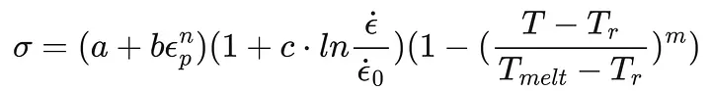
Equation 1 - Johnson Cook Plasticity Model
Equation 1 details the JC plasticity model, where ‘a’ resembles the initial yield stress and ‘b’ the hardening constant, both are measured in pressure units. ‘n’ describes the material's deformation and what type of behaviour will be described. When n=1, the material behaves as a perfect linear elastic material, and if n=0, it will display non-linear behaviour. If the ‘n’ value falls between 0-1, then it will behave in an elastoplastic manner, meaning it will deform elastically to begin with and then plastically once the yield strength is exceeded. C and M are constants that describe how the material will react to changes in strain rate and temperature alterations. The term Tr and Tmelt is the reference temperature and materials melting point, whilst T is the current temperature [10].

Jones Wilkins Lee (JWL)
The Jones-Wilkins-Lee (JWL) equation of state (EOS) is a thermodynamic law that represents the thermodynamic behaviour of detonation products [11]. Using the JWL EOS it allows the explosives within a shaped charge simulation to demonstrate extreme pressure levels immediately after detonation, to demonstrate an accurate shock load on surrounding materials, for example, a liner. By not using JWL, it runs the risk of not transferring the correct value of energy at detonation, and therefore, the shock loading onto the surrounding materials will cause them to deform inaccurately, degrading the performance and providing users with inaccurate velocity and penetration statistics.

Conclusion of Literature Review
This literature review has detailed the history of shaped charges and the evolution of their evolution, beginning with Charles Munroe's early testing and future development in military environments, as well as their involvement in the Civil sector. This development has seen advances in shaped charge design development, understanding of explosives characteristics, as well as the performance of ductile metals under high-strain scenarios. This development has aided the creation of charges designed for specific outcomes, whether that be armour penetration or breaching underground to access oil wells. The main goal of a shaped charge is its ability to focus explosive energy into a small target in a predictable manner.
This review also highlighted the importance of numerical modelling of shaped charges through software such as Abaqus. This allows designers to save time, money and reduce risk to humans through physical interaction by digitally simulating a shaped charge and being able to break down and analyse its performance in very precise increments. By doing this, simulators can explore how changes in geometry, liner materials and explosive characteristics affect the performance and correct design issues more efficiently than a human could physically.
Finally, the accuracy of shaped charge simulation heavily relies on sourcing and inputting the correct material and explosive characteristics. Using JC and JWL values is essential to demonstrate the extreme deformation that the casing and liver will undergo, as well as the JWL values to depict an accurate resemblance of detonation behaviour. This review pinpoints the importance of ensuring these values are precise to ensure results are accurate and prevent any risk if a simulated model is brought into the real world.

Two-Dimensional Abaqus Simulations

Overview of 2D Modelling
Modelling can be completed in both 2D and 3D, with both holding their pros and cons. Using 2D modelling puts less strain on computer components and, therefore, can be completed using less advanced technology. This is because run times are shorter and less detailed because of less complex designs [12]. When creating a 2D axisymmetric design, it requires the same steps as 3D, with requirements to complete meshing, boundary conditions and contact definitions, but at a lower detail with less in-depth meshing, making the main difference. As a result of this, the outcome of a 2D model will not accurately depict the results compared to a 3D model due to the limited complexity of the meshing and geometry. However, because of fewer elements and a simpler geometry, the simulations are often more stable, especially when simulating shaped charges demonstrating extreme pressures and large deformation. There is a total of four 2D models simulated in this report, all using different explosive fills and liners to understand how the different chemical and physical properties provide an alternate outcome.

2D Sketch
All simulations seen in this report have utilised the same sketch design to keep the comparison of results fair and relatable. The design is based on a common design seen in shaped charge design, with a cone angle of 60°. This design was chosen as existing data will allow for accurate comparison in results and provide the ability to identify issues with the simulation if the results are not comparable.

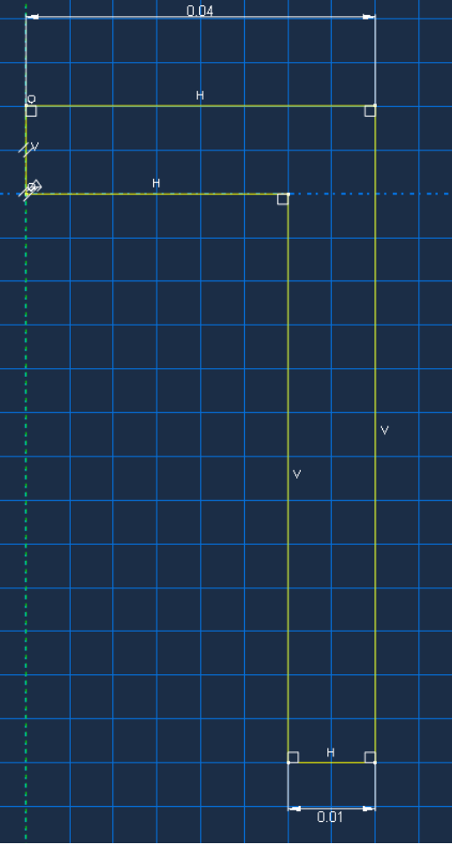
Figure 1 - 2D Case Sketch
As shown in Figure 1, the 2D case has a shoulder width of 0.01m, a lid width of 0.04m and a height of 0.06m. The design size of shaped charges is directly related to their operational requirement, and a shaped charge of this size would be common in a breach environment. During this sketch, a tool was used to label each dimension to confirm the design was as required and then saved to the system to load into each simulation, ensuring the design never changes.

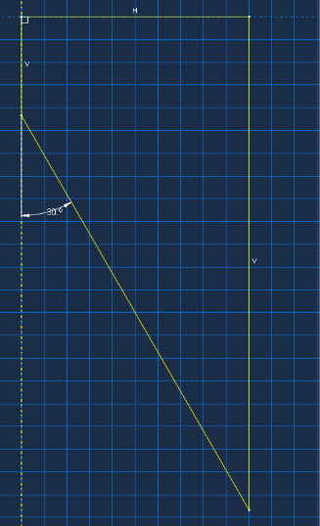
Figure 2 shows the 2D sketch of the High Explosive (HE). As the annotation shows, a 30° angle has been used on the inside of the HE. This is where the liner is connected to the HE to form the cone shape, and is 30° as the 2D design is split along the y-axis. The external lines of this sketch were taken directly from the case sketch in Figure 1, where the lines that did not intersect between the case and HE were then deleted. By completing the sketch like this, it ensures there won't be any voids between the surfaces when they are later connected.
Figure 2 - 2D High Explosive Sketch

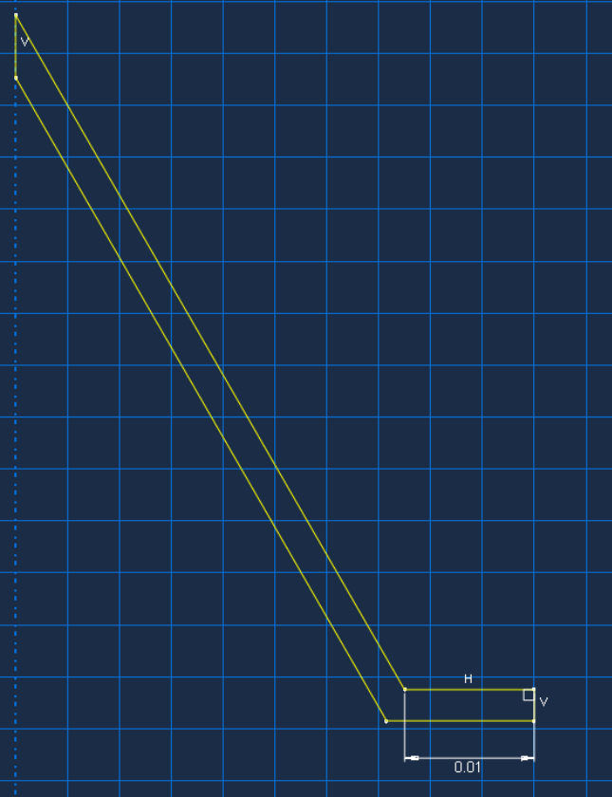
Figure 3 displays the sketch of the liner used in this design. Like the case and HE, the previous parts were added before the sketch to keep any sketch lines that intersected with the liner, preventing any voids from occurring. The top of the liner uses a 30° angle and is 2mm thick, although not detailed in Figure 3. Even the slightest inaccuracy in the sketch at connecting points would lead to poor contact between the parts, potentially preventing the simulation from running or hindering the propagation of detonation waves, which could cause the liner to collapse.
Figure 3 - 2D Liner Sketch

2D Meshing
Abaqus uses finite elements to demonstrate the different stages of simulation in numerical form. These elements are created by meshing the parts used in the design, which creates nodes to allow stress/strain and velocities to be recorded and analysed. The mesh can be altered to become coarser or finer using a tool to alter the values. The finer the mesh, the greater the ability to represent stress/strain, wave propagation and deformation of the materials [13]. This is very important when simulation detonations where incredibly high pressures are loaded onto materials to create the phenomenon of the liner inverting and into a plasma-like state. However, as previously stated, the finer a mesh is, the higher the load on the computer components, and if the standard of the computer is not adequate, it may crash the simulation or take an inefficient amount of time. Therefore, it is important to find a balance between a coarse mesh to ensure the simulation is time effective and that it is fine enough to gain precise results. When meshing designs with various parts, it is recommended to complete finer meshes around the key analysis areas, for example, in a shaped charge are around the connection of the HE to the liner and the entirety of the liner.

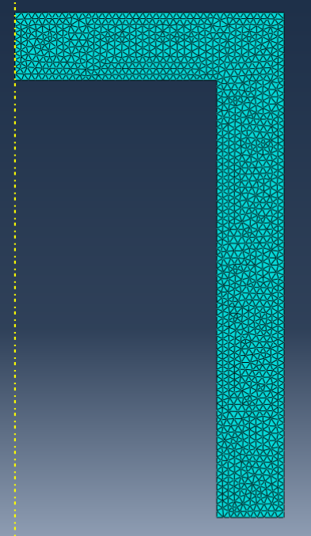
2D Case Mesh
Figure 4 - 2D Case Mesh
Figure 4 shows the mesh design of the case used in the 2D simulations. This is a medium-level mesh, as the priority to see the effects of the case is low in this simulation. However, it is still important to have a degree of fine meshing to ensure the detonation wave from the HE propagates efficiently and does not distort around the edges due to a coarse case mesh. The case was meshed using a global seed, meaning the mesh nodes are equal throughout the whole case and at a standard value.

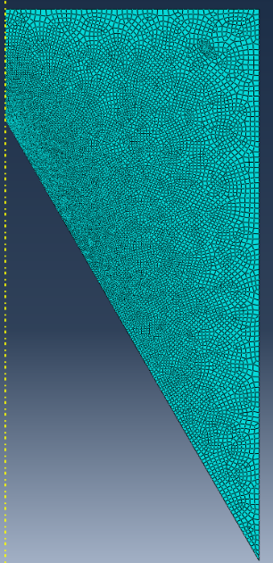
2D High Explosive Mesh
Figure 5 - 2D High Explosive Mesh
Figure 5 demonstrates the mesh design for the HE fills. In comparison to Figure 4, the mesh is considerably finer, especially as it moves towards where the HE connects to the liner. This was done by manually setting the seed for each edge of the part. The outside edges were connected to the case, matching the seed value of the case to prevent deformity during detonation. By using a finer mesh towards the liner, it will provide in-depth detail of the detonation wave propagation as it travels towards the liner and how the variation in JWL properties from the explosives displays different results at the same stages of the simulation.

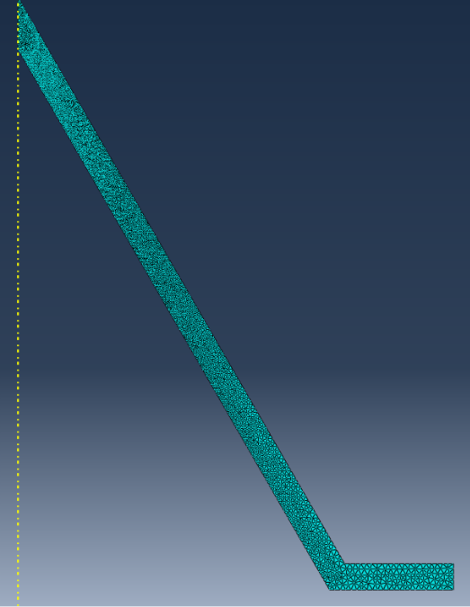
2D Liner Mesh
Figure 6 - 2D Liner Mesh
Figure 6 shows a very fine mesh for the liner. This is because this is the main area of focus for this simulation, and therefore, the most detailed results need to be monitored. Like the case and HE, the contact point between parts has matching seed values to ensure a smooth transition of effects between parts. The liner is especially finer at the tip, and this is where the liner tip will form once the detonation wave impacts and the liner inverts. The tip of the liner is where the velocity will be at its highest, and therefore, a finer mesh will allow for the most precise recording of values when plotting velocity graphs.

Material properties and Model parameters
The simulations discussed in this report utilise 2 different HE fills, TNT and Composition B, and 2 different liner materials, Copper and Titanium, with all simulations using an aluminium case.
The following tables exhibit the appropriate values entered to complete the relevant simulations for the materials.
There was no mention of case materials in the selected design, and therefore an aluminium case was selected due to its frequent use in shaped charge designs. Tables 1 and 2 display the Elastic and Plastic values for aluminium. [14].
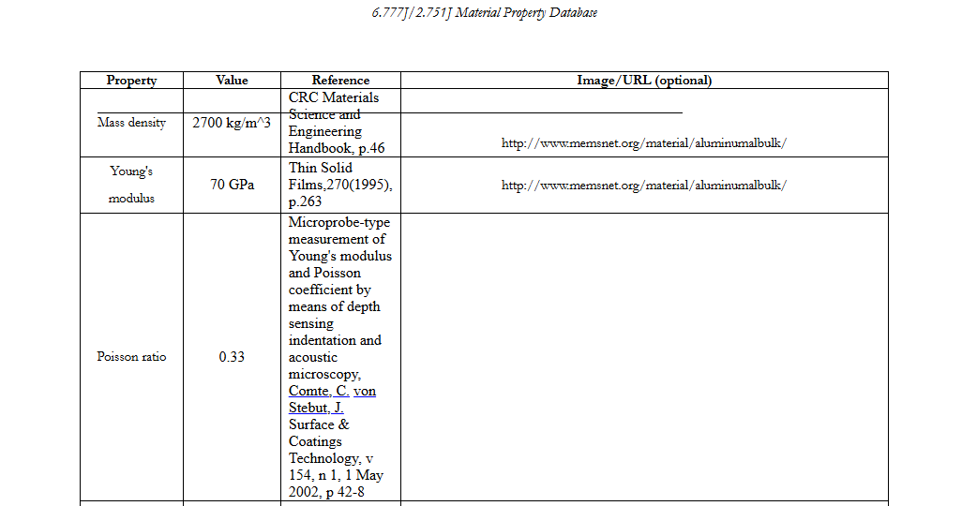
Table 1 - Aluminium Case Elasticity Values

Table 2 - Aluminium Case JC Plasticity Values
Material | A  (MPa) | B  (MPa) | n | m | C | $ρ$  (kgm⁻³) | E (GPa) | v | $$θ_{transition}$$ | $$θ_{melt}$$
Aluminium 6061-T6 | 324.1 | 113.8 | 0.42 | 1.34 | 0.002 | 2700 | 70 | 0.34 | 293K | 925K

Tables 3 and 4 relate to the Elastic [15] and Plastic [16] values for the copper liner. This copper is Oxygen Free High Conductivity (OFHC), making it extremely ductile. This, paired with its high density, allows for a great penetrator into reinforced armour [17].
Table 3 - Copper Liner Elasticity Values
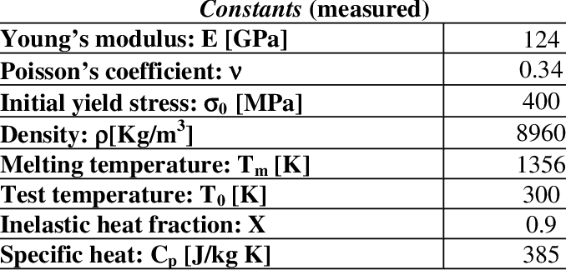

Table 4 - Copper Liner JC Plasticity Values
Material | A  (MPa) | B  (MPa) | n | m | C | $ρ$  (kgm⁻³) | E (GPa) | v | $$θ_{transition}$$ | $$θ_{melt}$$
Copper OFHC | 90 | 292 | 0.31 | 1 | 0.025 | 8960 | 124 | 0.3 | 293k | 1356K

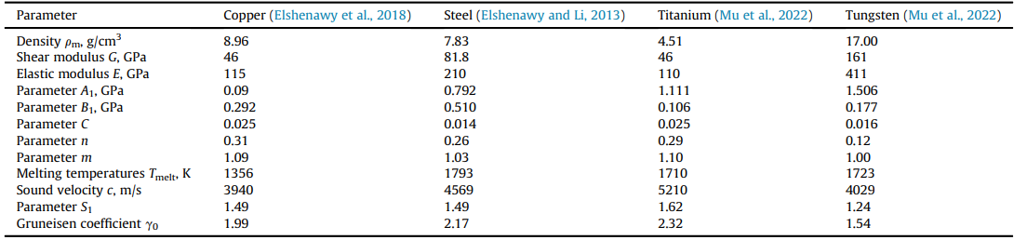
Table 5 displays the final liner material, Tungsten, elasticity and plasticity values [18]. Like copper, tungsten is a very common liner material used in shaped charges, this time due to its extreme density and high strength, making it a long-lasting penetrator when faced against a thick target [19].
Table 5 - Tungsten Liner Elasticity and JC Plasticity Values

Finally, Tables 6 and 7 provide the JWL values in relation to the 2 HE fills, TNT and Composition B. Composition B was selected as it is primarily a mix of 60% RDX and 40% TNT, meaning it will provide a much larger detonation energy than standard TNT due to the higher detonation velocity in RDX. The simulation will look to provide an understanding of how the alternate liners perform at higher velocities.

Table 6 - JWL Parameters for Composition B
Material | Density $ρ$  (kgm⁻³)) | Detonation Wave Speed | A | B | Omega | R1 | R2 | Detonation Energy Density (Jkg⁻¹) | Pre-det Bulk Modulus (GPa)
Comp B | 1666 | 8221 | 524 | 7.67 | 0.34 | 4.20 | 1.10 | 4784000 | 10
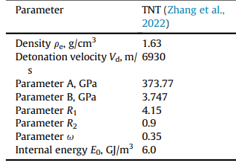
Table 7 - JWL Parameters for TNT

Design of Shaped Charge

Design 1 – TNT Explosive & Copper Liner
Design 1 is comprised of a TNT Explosive Fill with a Copper liner at 30°. Existing simulations using this HE filling with a 2mm Copper liner have yielded jet velocities of approximately 6000m/s [18].

Design 2 – TNT Explosive & Tungsten Liner
Design 2 utilises a TNT explosive with a Tungsten Liner. The choice to use a tungsten liner will allow a direct comparison of how the liner properties influence the jet, with the TNT acting as a controlled variable. This means the detonation velocity will remain the same, and therefore the plasticity and elasticity of the liner will be analysed. The expected jet velocity of this Design is approximately 4000 m/s as seen in existing data [18].

Design 3 – Composition B Explosive & Copper Liner
Design 3 uses an alternate HE filling but the same liner material as Design 1. The liner acting as a controlled variable will allow results to show how detonation velocity impacts the liner when comparing Design 1 and 3. The expected jet velocity in this Design is 6800 m/s [18].

Design 4 – Composition B Explosive & Tungsten Liner
Design 4 uses Composition B, the same as Design 3, and a Tungsten Liner, the same as Design 2. By performing simulations on these 4 designs using the same dimensions, the report will look to detail how JC and JWL values can provide different jet formations and velocities. This is important to understand as the velocity of the jet often determines how well it will penetrate its target. The expected tip velocity to see in this simulation is 5000m/s [18].

Pressure Wave Progression (2D)
The pressure wave, also known as the detonation wave, refers to the movement of a shock wave creating pressure through a medium, in this case, the explosive, once it has been initiated. As this wave propagates, it transitions the explosive material into a high-pressure product, which then, in the case of a shape charge, deforms the liner once it exceeds the yield strength of that material. Abaqus can display this wave through the pressure feature when reviewing results.

Pressure Wave Initial Contact with Liner (2D)
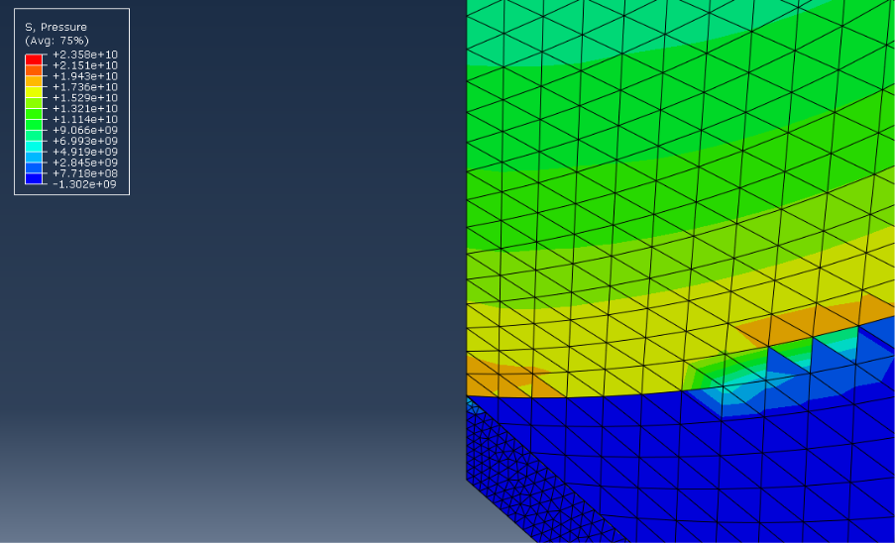

Figure 7 - Design 1 Pressure Wave Initial Contact with Liner
Figure 7 shows the initial detonation wave propagating through the HE fills in Design 1 and contacting the liner. The table within Figure 7 depicts pressure values scaled using different colours. As expected, the pressure is highest at the front of the wave in the orange colour, with the contents behind in green. This is because the material ahead has not chemically reacted and, therefore, is being compressed and undergoing incredibly high stress. The front of this wave is called the Von Neumann spike [20].
As expected, Figure 8 is identical to Figure 7 due to the simulations using the same TNT HE fills. Therefore, the pressure waves are similar at the same step time due to the same design and meshing.
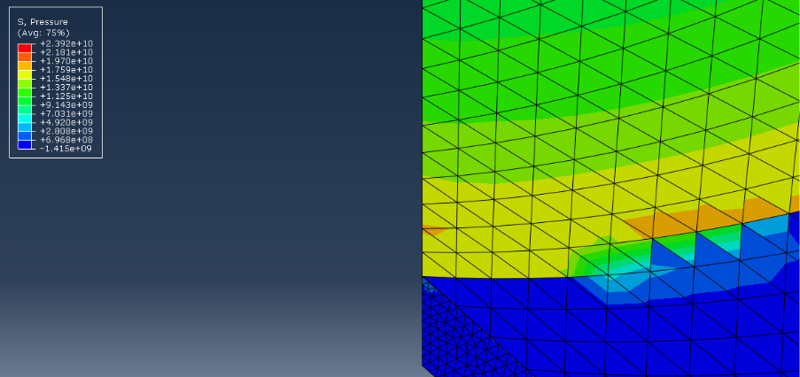
Figure 8 - Design 2 Pressure Wave Initial Contact with Liner
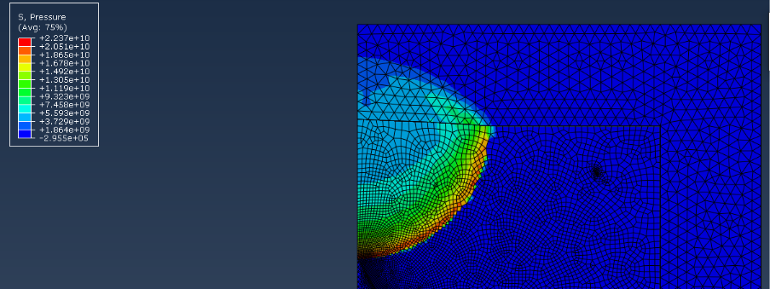
Figure 9 - Design 3 Pressure Wave Initial Contact with Liner
Figure 10 - Design 4 Pressure Wave Initial Contact with Liner
Alternatively, Figures 9 and 10 display a different pressure wave. This is due to the change in HE fills to composition B, which possesses a higher detonation velocity value. The increased wave size and pressure confirm that the JWL values were entered correctly and that the simulations are accurate.

Pressure Wave Causing Liner to Collapse (2D)
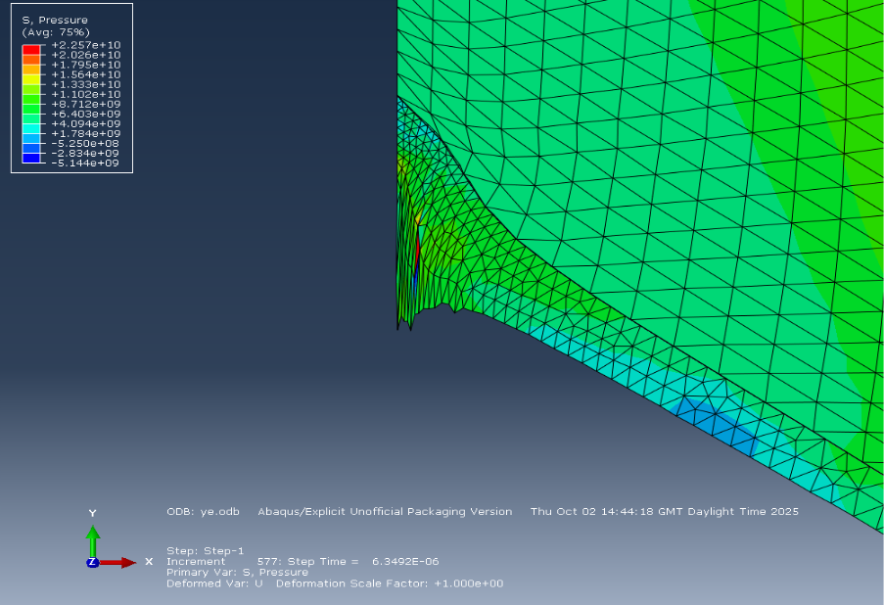
Figure 11 - Design 1 Pressure Wave Causing Liner to Collapse
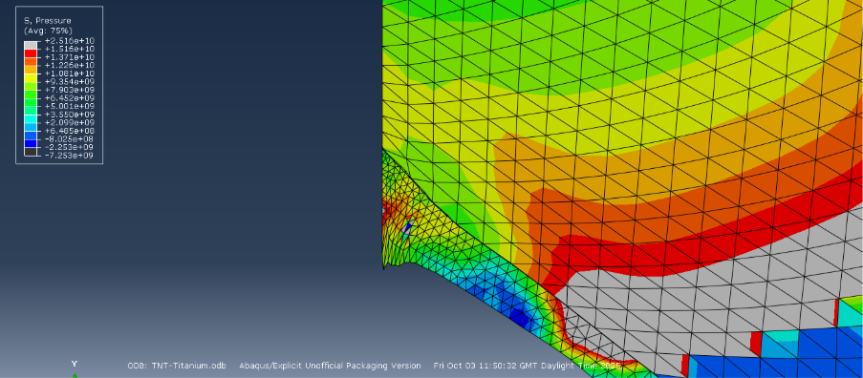
Figure 12 - Design 2 Pressure Wave Causing Liner to Collapse
Figures 11 and 12 depict the liner beginning to collapse as the pressure wave makes further contact with the liner. Figure 11 includes the copper liner with a lower density than the tungsten liner in Figure 12. This suits what is visible in these figures, as the copper has deformed considerably more at the same stage as the tungsten when exposed to the same velocities. The colour key identifies that the tungsten can withstand higher pressure before deforming and matches the research completed in chapter 3.4, where it indicates tungsten has a higher yield stress.
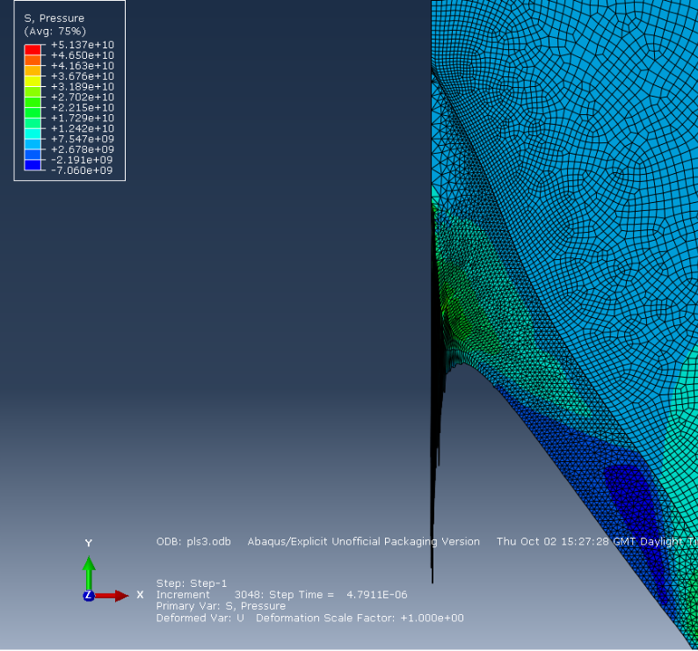
Figure 13 - Design 3 Pressure Wave Causing Liner to Collapse
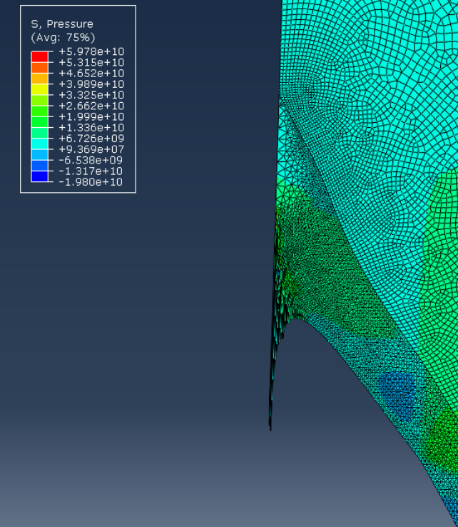
Figure 14 - Design 4 Pressure Wave Causing Liner to Collapse
Figures 13 and 14, using Composition B, have enabled the liner to become significantly more formed at this stage in comparison to the liners under the influence of TNT. Additionally, like the liners in the TNT tests, the copper liner has become significantly more pointed and into a thinner jet compared to the tungsten. As stated, this is due to it being more ductile and having a lower yield stress, meaning it becomes permanently deformed at lower stress levels. Figures 13 and 14 display a low-pressure zone within the liner with pressures around it higher; this could be due to a poor mesh when using higher velocity materials such as the composition B, but due to its location will have no effect on results regarding the tip and rear of the jet.

Velocity Analysis
Understanding the velocity of a shaped charge's jet is critical to understanding performance values. Shaped charges are highly beneficial when facing ERA, and by increasing the velocity of the jet tip, there is a greater chance that it will penetrate the target effectively, as the speed of the jet overpowers the reaction of ERA [21].

Velocity Plots at Liner Collapse
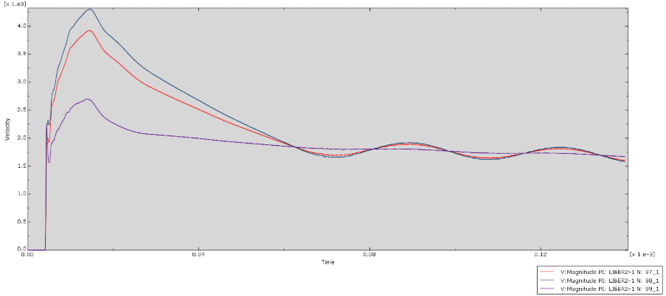
Figure 15 - Design 1 Velocity Graph of Initial Liner Collapse
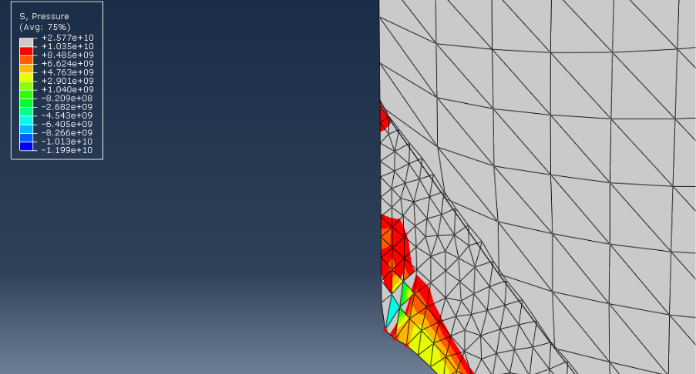
Figure 16 - Design 1 Nodes Selected for Velocity of Initial Liner Collapse
Figures 15 and 16 show the initial liner collapse velocities and the nodes selected for Design 1. These nodes are selected at the top of the liner, which in turn will become the tip of the liner. The values recorded in Figure 14 are around the expected velocity (3500-4500m/s) as the tip of the liner will undergo increased pressure as it further forms and therefore increase the velocity along with this.
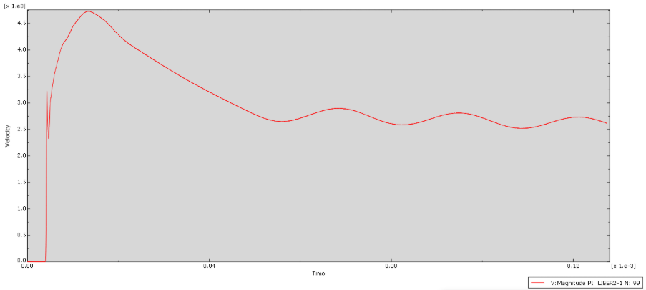
Figure 17 - Design 2 Velocity Graph of Initial Liner Collapse
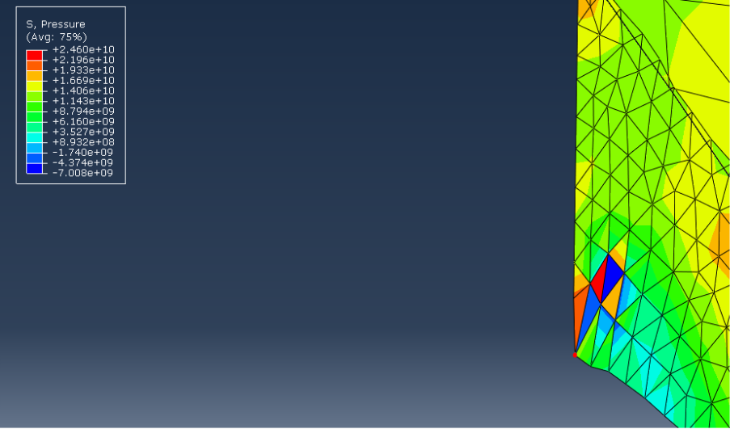
Figure 18 - Design 2 Nodes Selected for Velocity of Initial Liner Collapse
Figures 17 and 18 show the same procedure followed as 15 and 16, with fewer nodes selected. The values displayed in the Figure are, however, this time concurrent with existing data of shaped charges with matching materials and liner thickness at approximately 4700m/s [18].
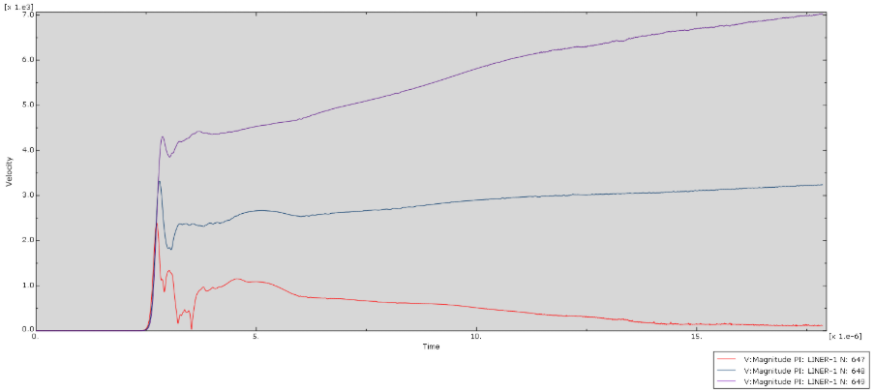
Figure 19 - Design 3 Velocity Graph of Initial Liner Collapse
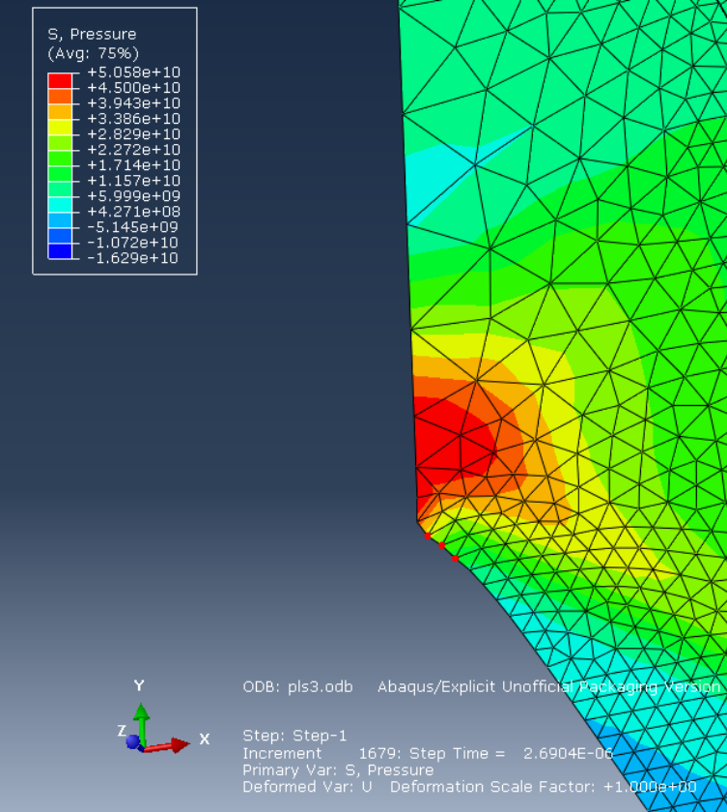
Figure 20 - Design 3 Nodes Selected for Velocity of Initial Liner Collapse
Figures 19 and 20 show design 3 velocities at liner collapse. These values are slightly lower than expected. However, this is likely due to a fault in the Abaqus software, not allow the nodes to be placed directly at the top of the liner, and therefore, it does not reflect the true jet tip velocities but rather slightly behind the tip. It does, however, support the fact that Composition B, with its higher detonation velocity, will create a faster jet than TNT when using copper.
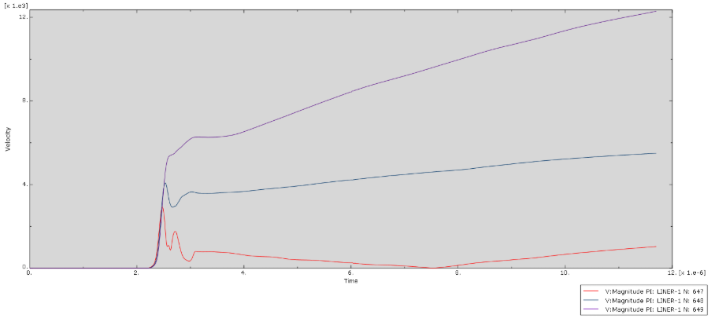
Figure 21 - Design 4 Velocity Graph of Initial Liner Collapse
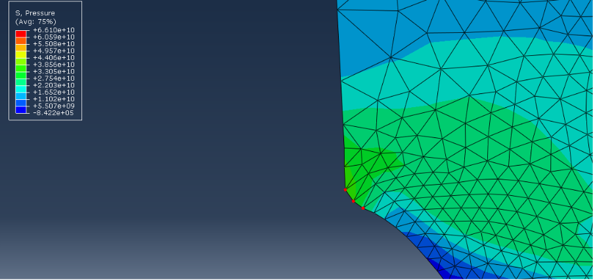
Figure 22 - Design 4 Nodes Selected for Velocity of Initial Liner Collapse
Figures 21 and 24 indicate varying initial liner collapse velocities ranging between 3000m/s to 6000m/s. Design 4 materials would be expected to display velocities of 5000m/s, which 1 node is close to [18]. Although the nodes are as close as they can be, the varying velocities could be due to a poor mesh, and by refining the mesh, the nodes would be able to be grouped tightly, which could provide a truer reflection of the velocities.

Velocity Plots at Tip of Fully Formed Jet
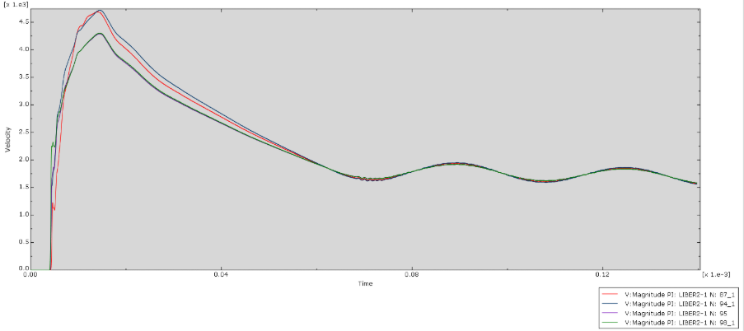
Figure 23 - Design 1 Velocity Plots of Fully Formed Jet Tip
Figure 23 shows similar velocities to those seen in Figure 15, where the velocity of the tip is approximately 1000m/s slower than existing data supports using TNT and copper with a 2mm thick liner [18].
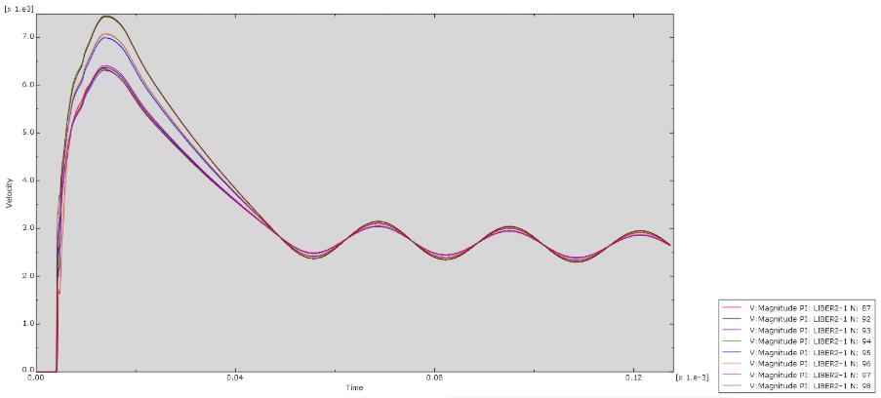
Figure 24 - Design 2 Velocity Plots of Fully Formed Jet Tip
Figure 24 provides a drastic change in velocities from that seen in Figure 17, with Design 2 at the liner beginning to collapse. Figure 24 shows velocities of the jet peaking at 7500m/s, which is extremely high for this combination of materials. It is not identifiable where this peak has come from, as the simulations were all run using the same liner sizes, and as Figure 18 shows, the original nodes were also taken from what would become the tip of the jet.
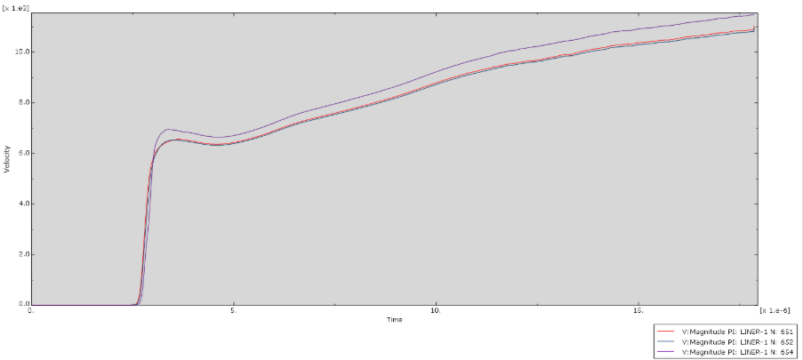
Figure 25 - Design 3 Velocity Plots of Fully Formed Jet Tip
Figure 25 shows accurate velocities compared to existing literature when the jet has fully formed at approximately 6750m/s [18]. This could be likely due to the ability to group nodes closer at the tip of the jet once it had fully formed. The velocity here further supports that when copper is paired with composition B, it will produce a superior velocity to that of TNT and copper.
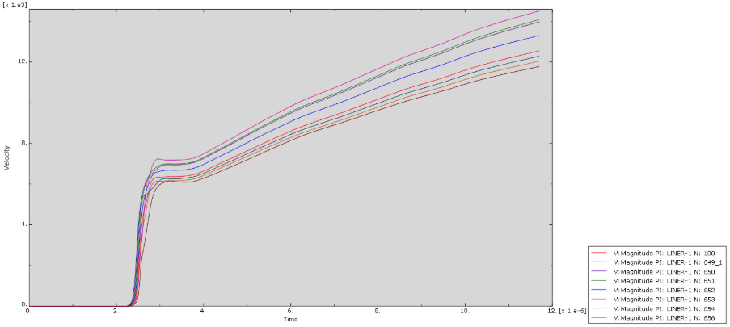
Figure 26 - Design 4 Velocity Plots of Fully Formed Jet Tip
Figure 26 also shows a spike in the velocity of the fully formed tungsten jet, similar to what was observed in Figure 24, design 2. This indicates that there may be an issue with a value inputted for the JC plasticity or elasticity for tungsten, as the velocity is considerably higher than existing literature supports, even when paired with alternative explosives.

Three-Dimensional Abaqus Simulation

Rationale for Choosing Design 3
After reviewing the velocity graphs, Design 3, Composition B and Copper provided the most accurate velocity results, which provided confidence with this design. Additionally, due to the higher velocities obtainable, the copper liner is the most common liner featured in shaped charges [22].

Transition Between 2D Design to 3D Design
To create a 3D design, the original parts must be regenerated. This allows them to gain the characteristics and behave on the XYZ planes rather than just the XY planes. By doing this, the simulation will give truer results to how the shaped charge would perform, as well as help identify any design errors. The newly regenerated shapes can be seen in Figures 27, 28 and 29.
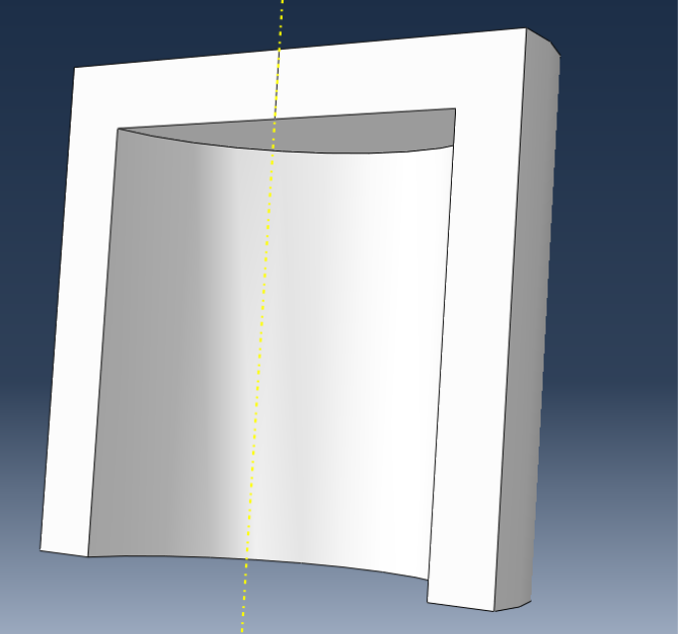
Figure 27 - 3D Case Part
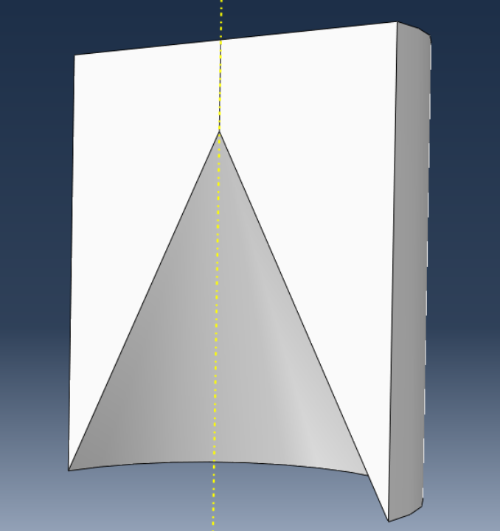
Figure 28 - 3D High Explosive Part
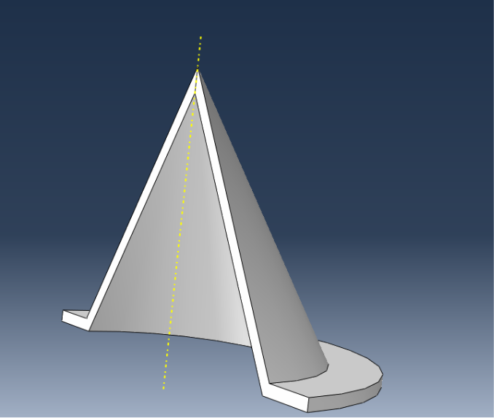
Figure 29 - 3D Liner Part

Meshing 3D Shaped Charge
Due to the variation in properties and interaction boundaries in 3D compared to 2D, the meshing requires further attention to detail to ensure the simulation runs smoothly and the physical effects can be captured clearly.

TET Meshing
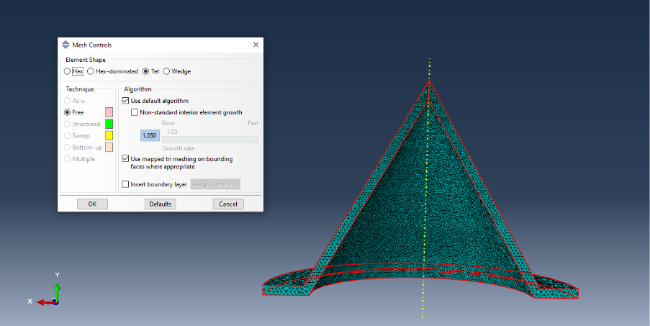
Figure 30 - Tetrahedral Element Meshing
Figure 30 shows the implementation of tetrahedral meshing. 3D simulation requires this, as the elements will automatically conform to the curved edges and can fill 3D volumes whilst reducing the likelihood of distortion in this area, critical in modelling with explosives, where key events happened under immense pressure and can lead to distortion [23]. This will allow the simulation to replicate the chemical and physical reaction experienced throughout clearly and allow for better analysis.

Linear Meshing
In addition to tetrahedral meshing, explicit linear meshing is also required to perform 3D simulations. This is due to the large deformations that the parts will undergo throughout the trial. Using linear elements, it offers improved numerical robustness and stability under extreme load and deformation, vital in explicit simulations. As well as this, the linear elements a more efficient than the quadratic elements, allowing smaller time increments and results to be provided more efficiently, whilst retaining reliable results [24].

3D Case Mesh
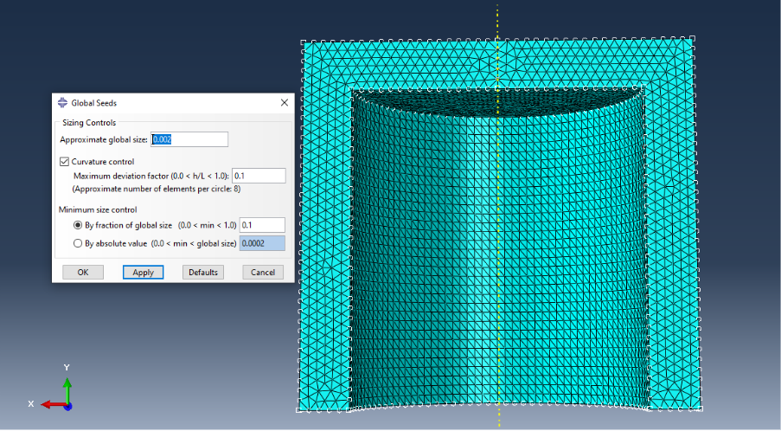
Figure 31 - 3D Case Mesh
The coarsest part of this mesh simulation is the case. Although still fine to an extent to ensure the HE does not instantly distort, the case does not require a highly detailed mesh, as the focus of the research is the effects of the HE on the liner.

3D High Explosive Mesh
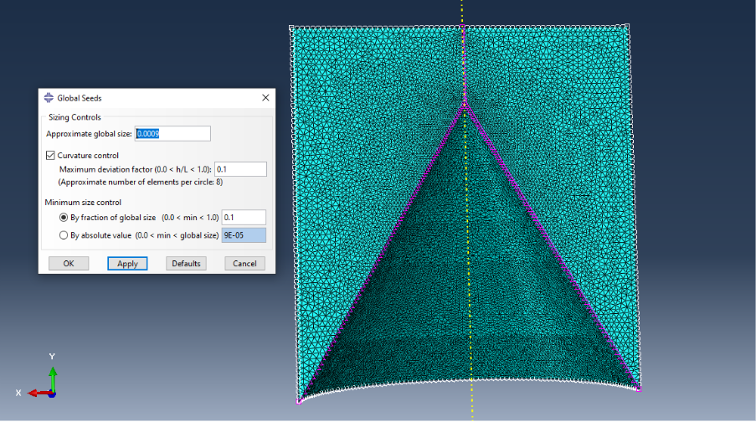
Figure 32 - 3D Explosive Mesh Global Seed
A global seed of 0.0009 was used on the intersecting area of the HE and the liner. This is a fine mesh size and will allow a smooth transition of the detonation wave from the HE into the liner to ensure the physical effects of the HE are retained, and no performance is lost when transitioning between parts. This will help to ensure reliable results are achieved. The seeding around the edges of the HE are like that of the case global seed and becomes finer as it moves towards the liner to ensure great detail can be monitored as the simulation progresses.
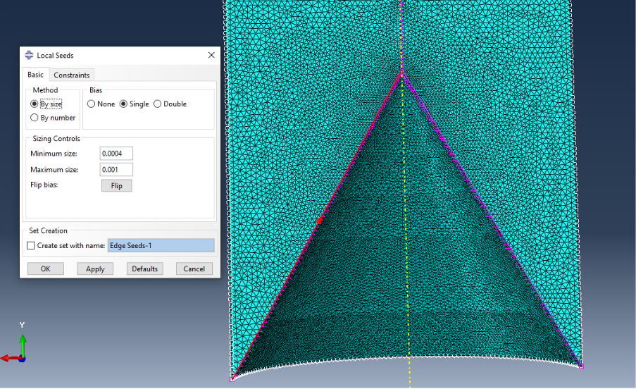
Figure 33 - 3D Explosive Mesh Local Seed – Single Bias
Abaqus provides the ability to create a single bias, which means the mesh size can gradually become finer along an edge with a minimum and maximum size option. In the case of the HE contacts with the liner, the focus is on the tip of the jet, and therefore, the single bias has been directed to the top of the cone to ensure this area receives the most numerical robustness and stability.
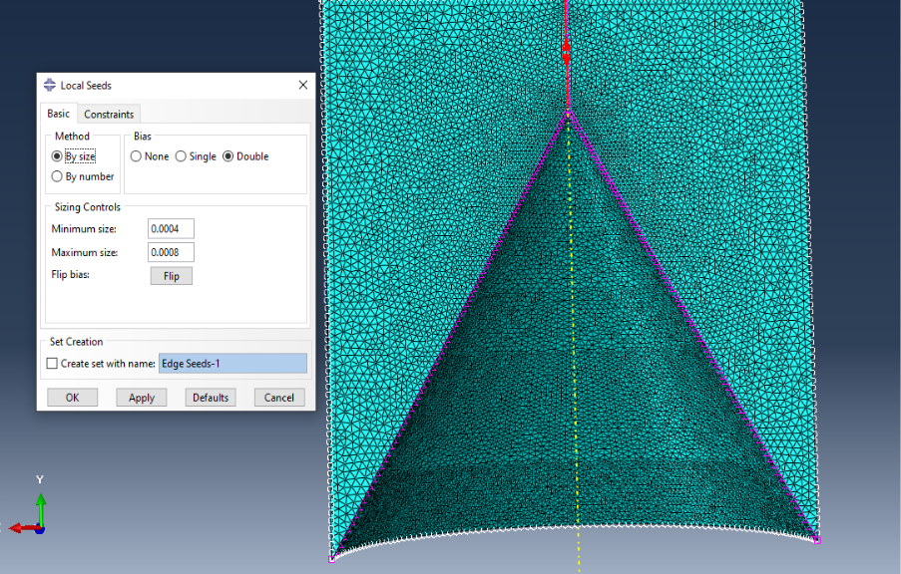
Figure 34 - 3D Explosive Mesh Local Seed - Double Bias
A double bias can also be used to define a specific line within a part. In this case, a double bias was selected along the y-axis line, identifiable in Figure 34 with the red line. A double bias was selected here, as the detonation point was selected on x=0 at the top of the HE. As a result of this, the detonation wave will propagate initially from here, meaning this section will undergo major deformation, and by using a finer mesh, it will allow the effects to propagate effectively without distorting.

3D Liner Mesh
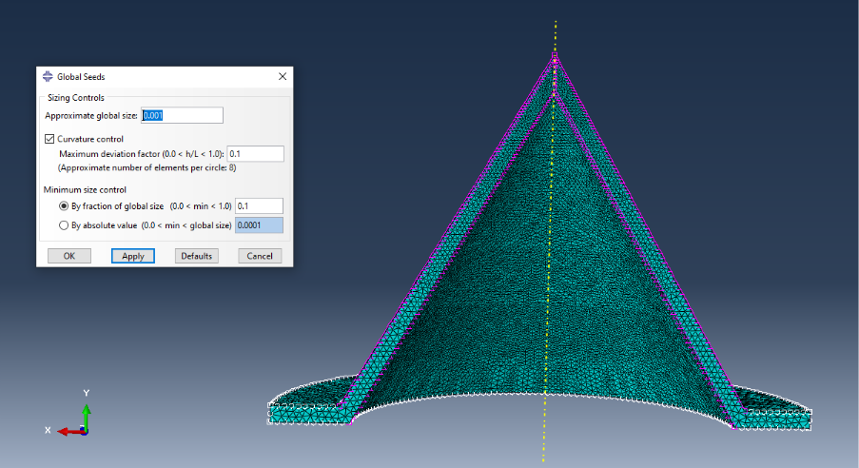
Figure 35 - 3D Liner Mesh Global Seed
The liner is the focus of this report and therefore requires the finest mesh that will efficiently run on this simulation. After trial and error, a global seed of 0.001 was chosen. This matches the coarsest parts of the HE mesh, towards the bottom of the liner, where the tail of the jet will form.
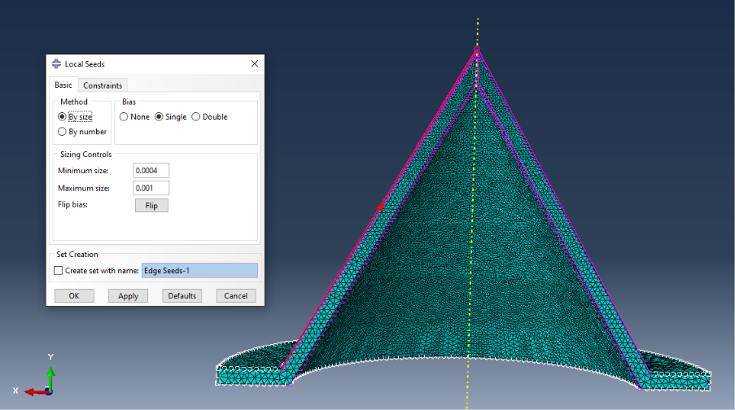
Figure 36 - 3D Liner Mesh Local Seeds
To ensure the best particulars of this event can be captured, an extremely fine single bias was used to have a mesh size as fine as 0.0004 at the tip of the jet. This is to allow the best representation of true velocity to be demonstrated.

Velocity Analysis (3D)

Velocity Plots at Liner Collapse
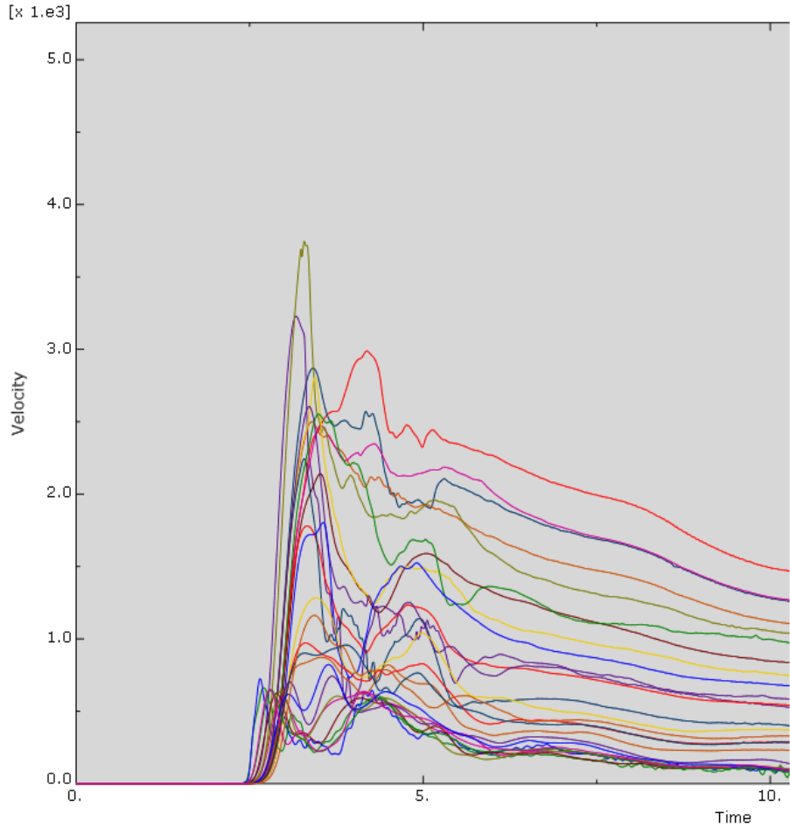
Figure 37 - 3D Model Velocity Plots at Liner Collapse
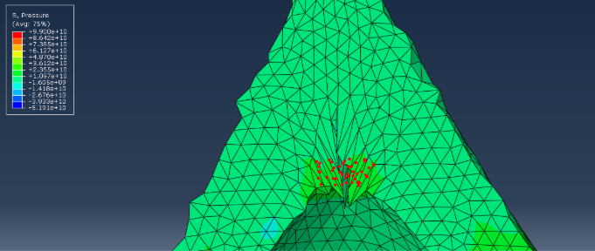
Figure 38 - 3D Model Velocity Nodes at Liner Collapse
Figures 37 and 38, respectively, show the velocities captured at initial liner collapse. Figure 37 supports existing literature that the velocity plot at the initial collapse should be approximately 2000-3000m/s, as the jet has not fully formed and therefore will be subject to higher pressure with further collapse, increasing the velocity of the jet [25].

Velocity Plots at Tip of Fully Formed Jet
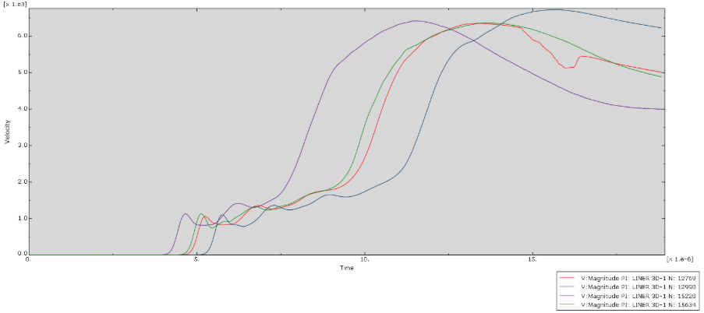
Figure 39 - 3D Model Velocity Plots of Fully Formed Jet Tip
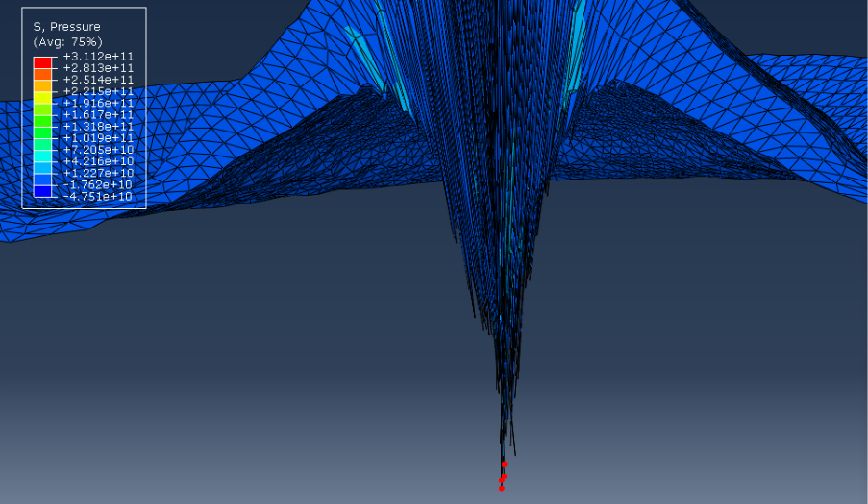
Figure 40 - 3D Model Velocity Nodes of Fully Formed Jet Tip
Figures 39 and 40 indicate the velocities at the tip of the jet once fully formed. Figure 39 indicates that the jet peaks at 6500-7000m/s before declining. This is the expected velocity of a Composition B and 2mm copper-lined shaped charge, as seen in the 2D Design 3 and in existing literature [18] [25].

Velocity Plots at the Rear of a Fully Formed Jet
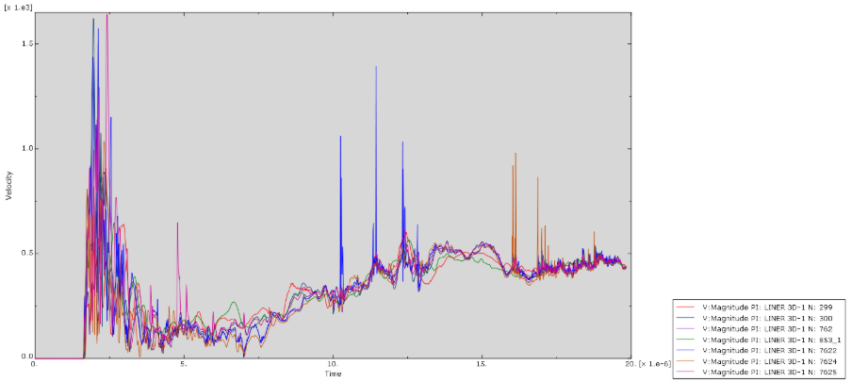
Figure 41 - 3D Model Velocity Plots at Rear of Liner
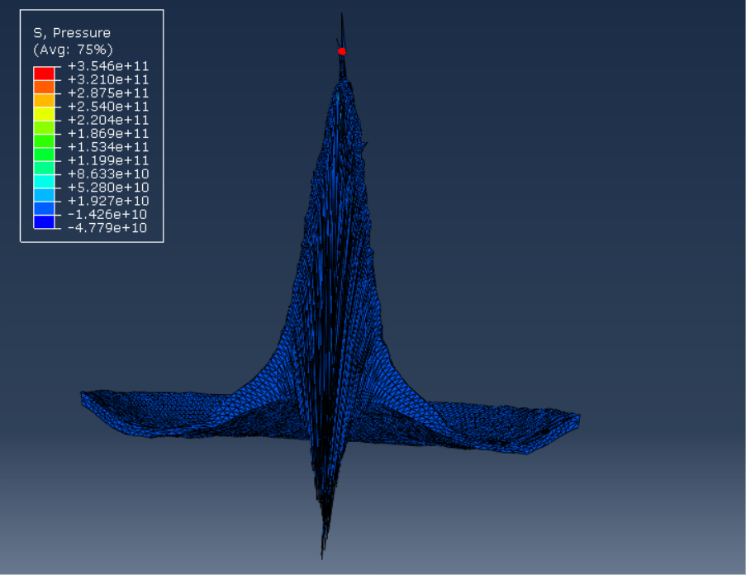
Figure 42 - 3D Model Velocity Nodes at Rear of Liner
Figures 41 and 42 are velocity plots taken at the rear of the shaped jet. This segment is known as the slug, and a much denser part of the jet made up of parts of the liner that have not fully formed and therefore a velocity gradient exists between the tip and slug of the liner, as supported by Fig. 8 in [26]. The exact velocity of a shaped charge slug is also dependent on the type of liner and dimension, as well as the explosive used, but typically reaches velocities of 1000-3000m/s at its peak [27]. This is a good agreement with the velocities recorded in this 3D model.

Smooth Particle Hydrodynamics (SPH)
SPH is a key modelling tool when dealing with models that will undergo severe plastic deformation. Using SPH prevents element distortion and failure due to the removal of meshing in the model. The SPH allows a targeted area, in this case, the Liner, to flow freely without the risk of distortion. This enables a realistic material flow, like a shaped charge would, as they act hydrodynamically when under high loads [28]. Due to this, SPH can reliably demonstrate the Munroe effect than Lagrangian elements can, but at the cost of intense computer load and time.
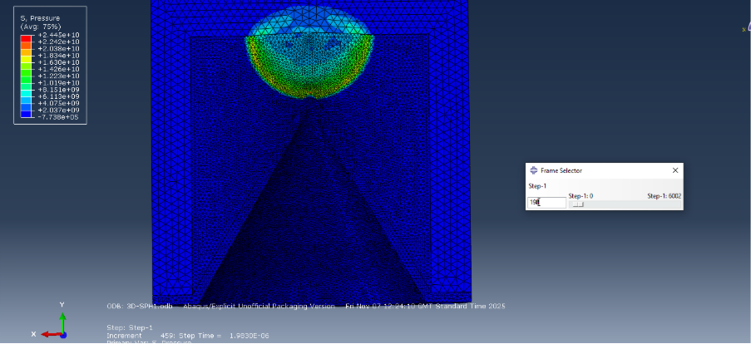
Figure 43 - SPH Step 198

Figure 43 shows the initiation of SPH at step 198. This time frame was selected because this is the beginning of the load onto the liner, and therefore, no effects would be present prior.
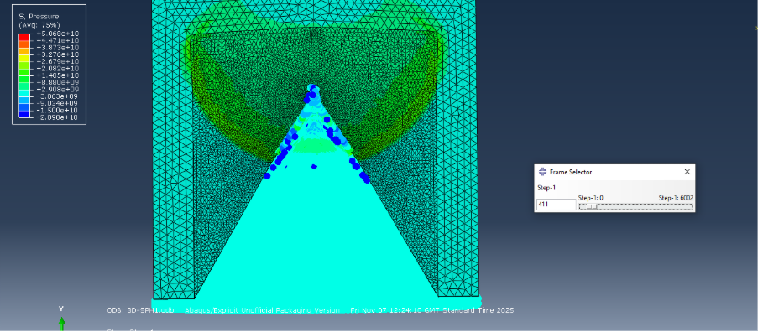
Figure 44 - SPH Step 411
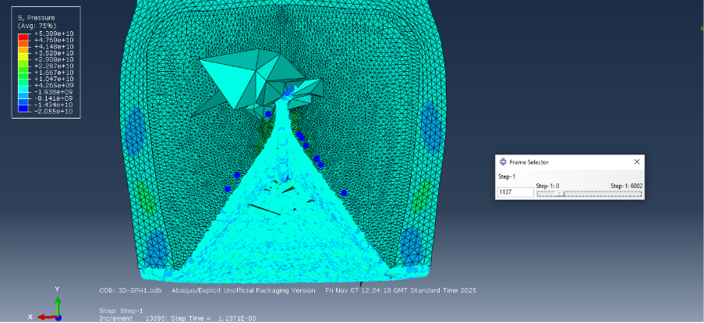
Figure 45 - SPH Step 1137 with all Parts
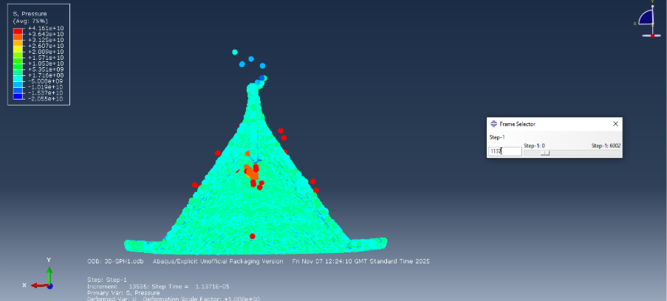
Figure 46 - Step 1137 Liner Only
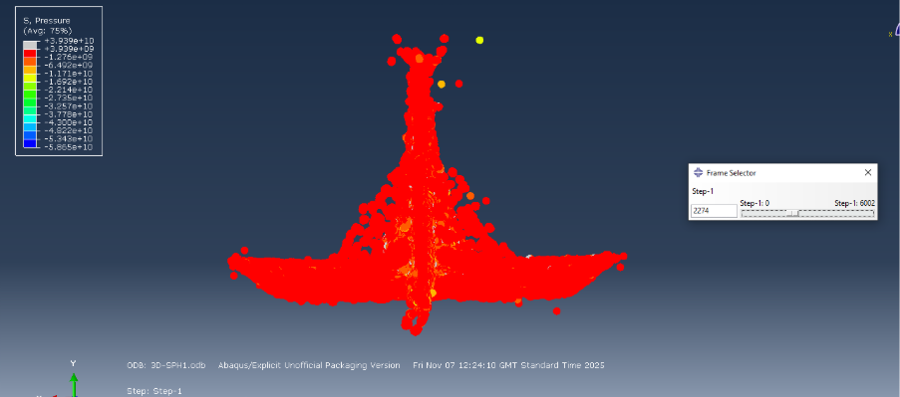
Figure 47 - SPH Step 2274 Liner Only
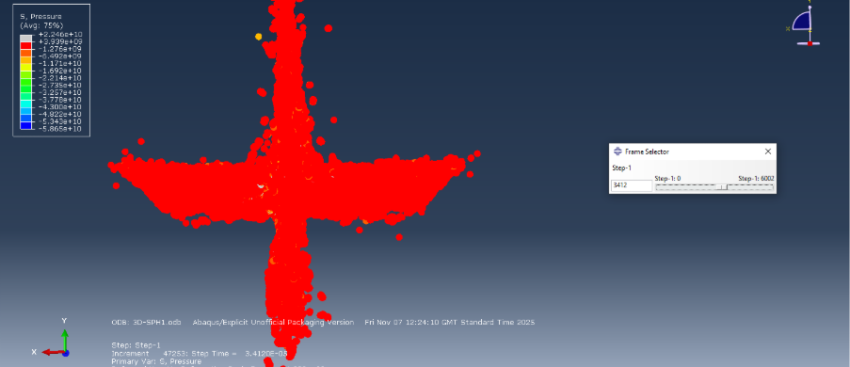
Figure 48 - SPH Step 3412 Liner Only
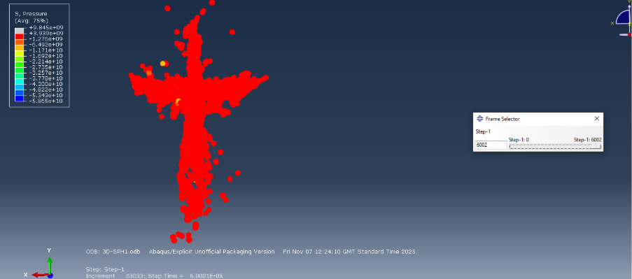
Figure 49 - SPH Step 6002 Liner only
Figure 44-49 shows the full SPH process of liner collapse all the way through the final step at 6002. These figures demonstrate a clear increase in pressure on the liner, as the colour change demonstrates. It also shows the liner forming more thoroughly than seen in the previous 3D model, demonstrating the benefits of SPH modelling. There were, however, rogue particles at the tip and slug of the jet, indicating a slight issue with the elements selected for SPH, but this does not affect the results.
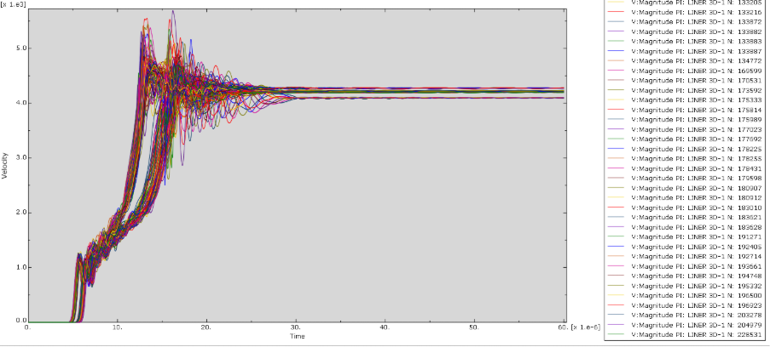
Figure 50 - SPH Velocity at Tip of Formed Liner
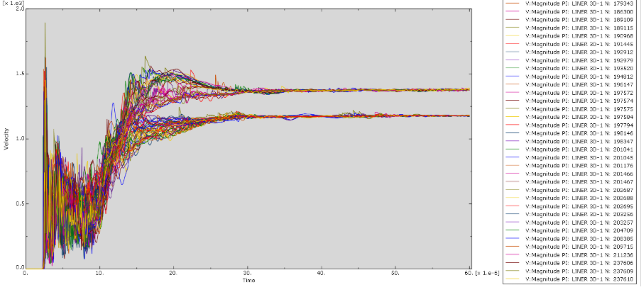
Figure 51 - SPH Velocity at Slug of Formed Liner
Figures 50 and 51 show the velocities captured at step 6002 at each end of the Liner. These values reflect what was seen in Figures 39 and 41, indicating that no errors occurred with the SPH run and that the velocities match existing research [25] [27].

Conclusion
In conclusion, although all simulations produced a shaped charge, they did not all match the existing literature with the expected velocities. All copper that was trialled in this report did conform with the expected velocities at both the tip, 6750m/s, and the slug,1000-3000m/s [18]. However, this was not the case for the Tungsten trials, where velocities peaked exceptionally high outside the expected 5000-6000m/s range, depending on the explosive used [18].
The 3D model and use of SPH reciprocated the velocities shown in the 2D modelling, but with a clearer image and longer simulation. This helped understand the meshing issues and identify errors to improve the trials. The use of SPH enabled a clearer understanding of the fluid process a liner undergoes when subject to detonation loading.

Future Recommendations
In future testing, it is recommended that further research into errors with tungsten velocities be conducted further and whether there was an issue with the JC values entered. Due to time restrictions and limited access to software, this was not feasible in this report. Additionally, testing other explosives, such as pure HMX, due to its considerably higher detonation velocity [29], is recommended along with SPH to see if the jet will fully form into a streamlined shape with the implementation of a target to understand the penetration values of this jet.

References

[1] | S. B. R. B. P. O. Franz Chouly, Advances in Applied Mechanics, 2025.
[2] | W. Walters, “A brief History Of Shaped Charges,” Army Research Laboratory, 2009.
[3] | M. Cazalet, “The most misunderstood weapon in the world: Mythbusting HEAT warheads and their countermeasures,” 24 June 2024. [Online]. Available: https://euro-sd.com/2024/06/articles/38841/the-most-misunderstood-weapon-in-the-world-mythbusting-heat-warheads-and-their-countermeasures/. [Accessed 19 December 2025].
[4] | C. D. Y. H. Z. W. J. C. Jianping Yin, Shock and Vibration, 2021.
[5] | E. L. Baker, “MODELING AND OPTIMIZATION OF SHAPED CHARGE LINER,” U.S. ARMY ARMAMENT RESEARCH, DEVELOPMENT AND, New Jersey, 1993.
[6] | C. Wang, “Numerical Simulation on Jet Formation of Shaped Charge,” 2015.
[7] | Drilling Manual, “Shaped Charges For Oil Well Perforating,” 20 12 2023. [Online]. Available: https://www.drillingmanual.com/shaped-charges-oil-well-perforating. [Accessed 19 12 2025].
[8] | Abaqus, “ABAQUS Analysis User's Manual - 18.2.7 Johnson-Cook plasticity,” [Online]. Available: https://classes.engineering.wustl.edu/2009/spring/mase5513/abaqus/docs/v6.6/books/usb/default.htm?startat=pt05ch18s02abm21.html. [Accessed 27 December 2025].
[9] | Intstron, “Modulus of Elasticity,” [Online]. Available: https://www.instron.com/en/resources/glossary/modulus-of-elasticity/. [Accessed 27 December 2025].
[10] | WELSIM | Quantify the Uncertain, “Johnson-Cook Model and Its Curve Fitting,” Medium, 29 July 2023. [Online]. Available: https://getwelsim.medium.com/johnson-cook-model-and-its-curve-fitting-e2bce9c9094c. [Accessed 27 December 2025].
[11] | Itasca, “Jones-Wilkins-Lee Equation of State,” [Online]. Available: https://docs.itascasoftware.com/itasca950/common/models/jwl/doc/modeljwl.html. [Accessed 27 December 2025].
[12] | M. H. W. A. Faical Baghdadi, “A Numerical Comparison of 2D and 3D CFD Modelling for Contraction and Expansion Geometries with an Emphasis on Solid Particles Erosion,” 2024.
[13] | M. Veidth, “The Best Guide to Abaqus Mesh and Meshing Techniques: Abaqus Bottom-up Mesh, Abaqus Adaptive Mesh, Orphan mesh to Geometry,” 20 June 2024. [Online]. Available: https://caeassistant.com/blog/abaqus-mesh-a-guide-to-meshing/. [Accessed 28 December 2025].
[14] | L. E. Schwer, “LUMINUM PLATE PERFORATION: A COMPARATIVE CASE STUDY USING LAGRANGE with EROSION, MULTI-MATERIAL ALE, and SMOOTH PARTICLE HYDRODYNAMICS,” 2009.
[15] | S. Ahzi, “Modelling and Simulation of Thin Sheet Blanking Using Damage and Rupture Criteria,” 2005.
[16] | G. R. J. &. W. H. Cook, “A CONSTITUTIVE MODEL AND DATA FOR METALS SUBJECTED TO LARGE STRAINS, HIGH STRAIN RATES AND HIGH TEMPERATURES”.
[17] | X.-w. Hou, Journal of Materials Research and Technology, 2025.
[18] | K. Jiang, “Petroleum Science - Theoretical calculation and analysis of the velocity of shaped charge,” 2024.
[19] | C. W. Wenlong Xu, “The jet formation and penetration capability of hypervelocity shaped charges,” 2019.
[20] | R. L. Jameson and A. L. Hawkins, “Detonation Pressure Measurements in TNT and Octol.,” 1970.
[21] | W. E. R. G. Randall L. Simpson, “Propellants, Exlosives, Pyrotechnics,” vol. 19, no. 1, pp. 15-18, 1994.
[22] | J. Hall, “Shaped Charges: Harnessing Precision in Explosive Technology,” 20 January 2025. [Online]. Available: https://www.explosives.net/shaped-charges-explosive-technology/. [Accessed 2 January 2026].
[23] | P. Mehmert, Quality Analysis of Additively Manufactured Metals, Elsevier, 2023.
[24] | Abaqus, Abaqus Analysis Users Guide, 2016.
[25] | S. Zaki, “Effect of liner material and explosive,” Sage, 2019.
[26] | D. A. Jones, “A REVIEW OF ONE DIMENSIONAL SHAPED CHARGE THEORY PART 1 - JET FORMATION,” Department Of Defence, Melbourne, 1984.
[27] | J. J. Milinazzo, “Energy Transfer of a Shaped Charge,” Sandia National Laboratories, 2016.
[28] | J. J. Monaghan, “Smoothed Particle Hydrodynamics,” Victoria, 1992.
[29] | K. Elsharkawy, “Experimental Studies on Improved Plastic Bonded Explosives Materials (PBXs) for Controlled Fragmentation Warheads,” Beijing, 2016.

