18/12/2025
Suneth Fernando
[company name]
IWD
Assignment 2 : Website design and development
StudentID: 2439677
Name: Gabriel Jimenez Kak
Table of Contents
Introduction to your case study which you choose 2
User Requirements 2
Website Design 2
Home page Wireframe (screenshot from Visio) 2
Website Implementation 3
Home page (screenshots) 3
Validating my website 4
Self-evaluation of my website 4
Usefulness (usability and utility): 4
Search Engine Optimisation (SEO): 4
Accessibility: 4
Reference list 5

Introduction to your case study which you choose
For this assignment, I have chosen to design and develop a website for a fictitious business named "The Green Leaf." This business operates in the e-commerce sector, specifically focusing on the retail of indoor house plants and plant care accessories.
The primary function of this business is B2C (Business-to-Consumer) retail. The website serves as a digital storefront where customers can browse a catalog of plants, learn about their specific care requirements, and initiate contact with the business for support or orders. The intended target audience includes:
- Homeowners and renters: People looking to decorate their living spaces with greenery.
- Office workers: Individuals seeking low-maintenance plants for workspaces.
- Plant novices: Beginners who require guidance and "hard-to-kill" plant options.
The website aims to solve a specific user problem: the hesitation to buy plants due to a lack of knowledge about plant care. Therefore, the site combines e-commerce functionality with educational resources.

User Requirements
To ensure the website meets the needs of the target audience, I established a list of user requirements before development. These are divided into functional requirements (what the site does) and non-functional requirements (how the site performs).
Functional Requirements
The user expects the website to perform the following actions:
- Navigation: The user must be able to easily navigate between the Home, About, Products, Care, and Contact pages using a consistent menu.
- Product Information: The user needs to see clear images of the plants, along with prices, names, and specific benefits (e.g., "Air Purifying").
- Educational Content: The user requires access to a dedicated "Care Tips" section to learn about watering, lighting, and humidity.
- Contact Mechanism: The user must have a way to input their name, email, and message into a form to contact the business.
- Visual Engagement: The user expects a visual representation of the brand through a logo and high-quality imagery.
Content Requirements per Page

Website Design

Home page Wireframe (screenshot from Visio)

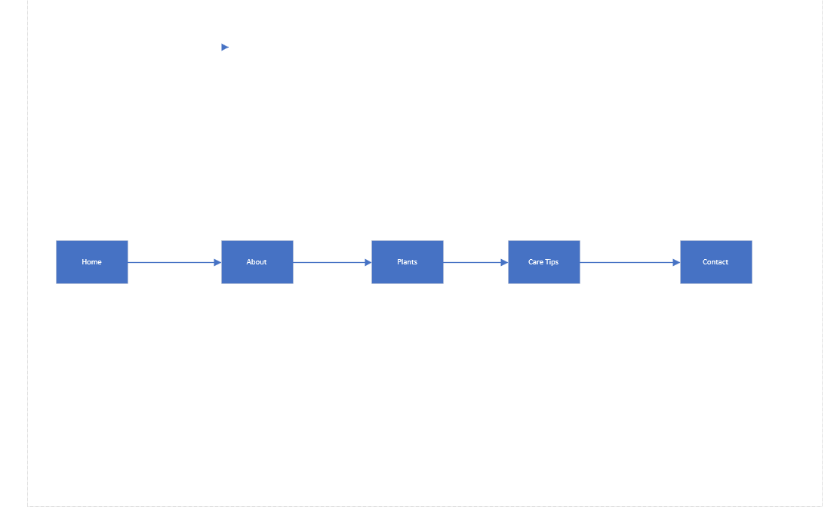

Website Implementation

Home page (screenshots)

To develop "The Green Leaf" website, I used Visual Studio Code (VS Code) as my text editor. VS Code is an industry-standard editor that provides syntax highlighting, auto-completion (IntelliSense), and live server capabilities, which made the development process efficient.
I utilised the following scripting languages:
- HTML5 (HyperText Markup Language): Used for the semantic structure of the page (using tags like <header>, <nav>, <main>, <article>, <footer>).
- CSS3 (Cascading Style Sheets): Used for the presentation layer. I utilized CSS Flexbox for the navigation menu alignment and CSS Grid for the responsive product gallery and care tip cards. This ensures the site works on both desktop and mobile devices.
Screenshots of Implementation
Home Page
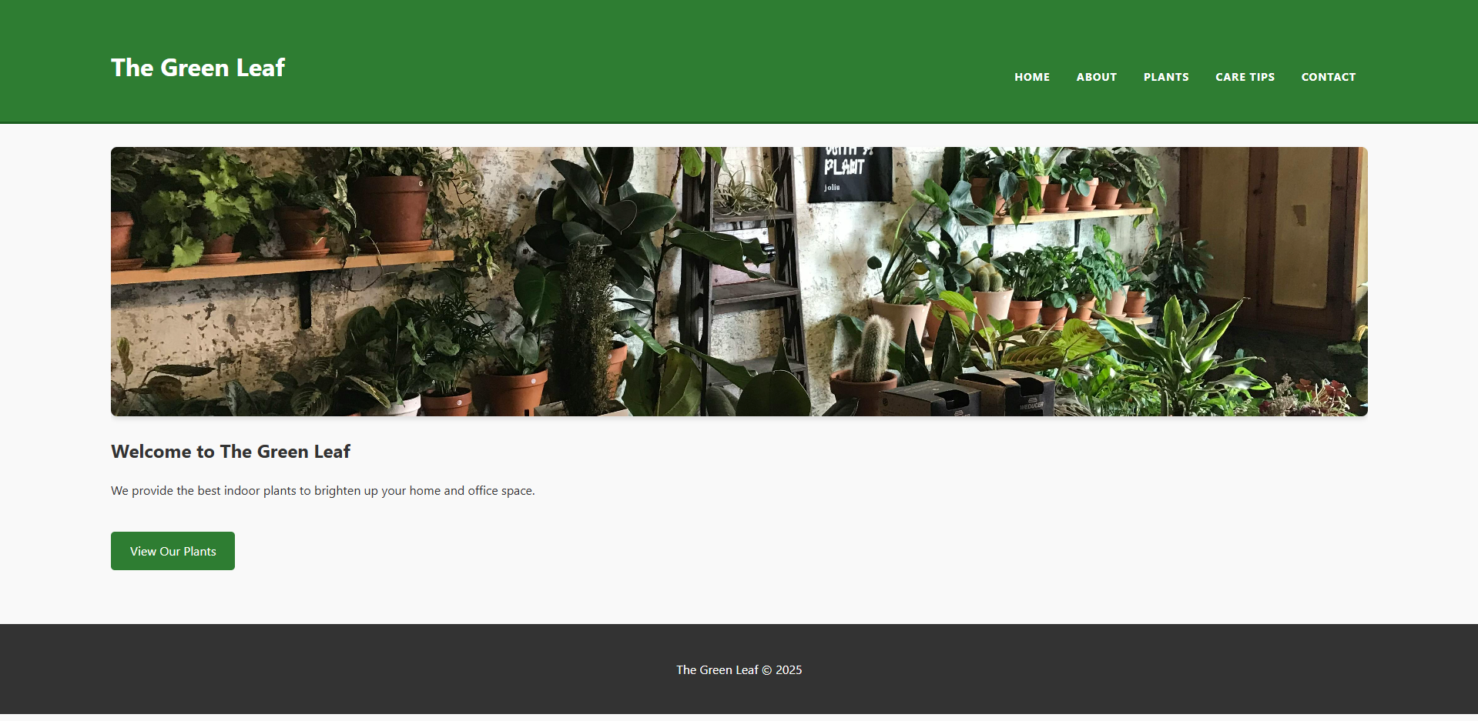
Annotation: The home page features a responsive navigation bar with the logo on the left. The hero image serves as the main visual hook, followed by a clear "View Our Plants" call-to-action button.
Products Page
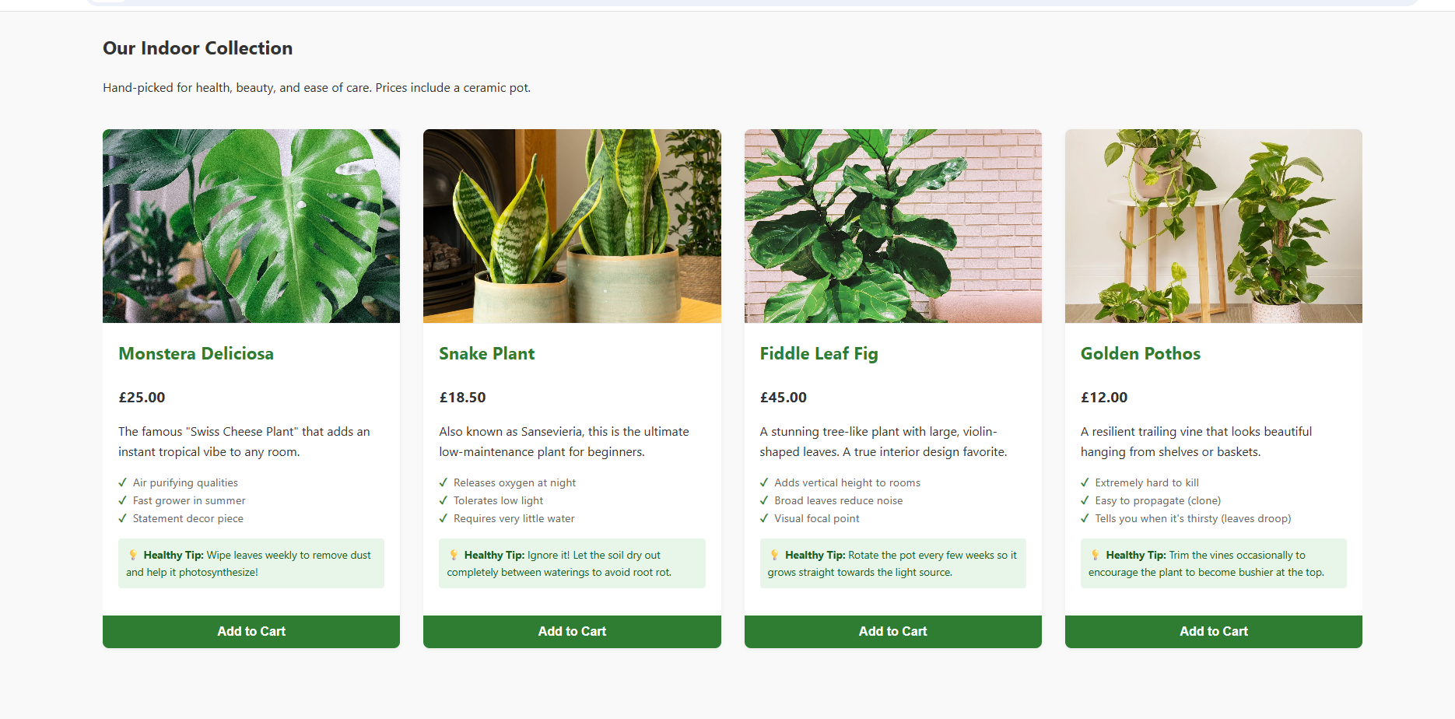
Annotation: This page utilizes CSS Grid. The product cards include a hover effect (lifting the card up) to provide user feedback. The layout adjusts from 4 columns on desktop to 1 column on mobile.
Care Tips Page
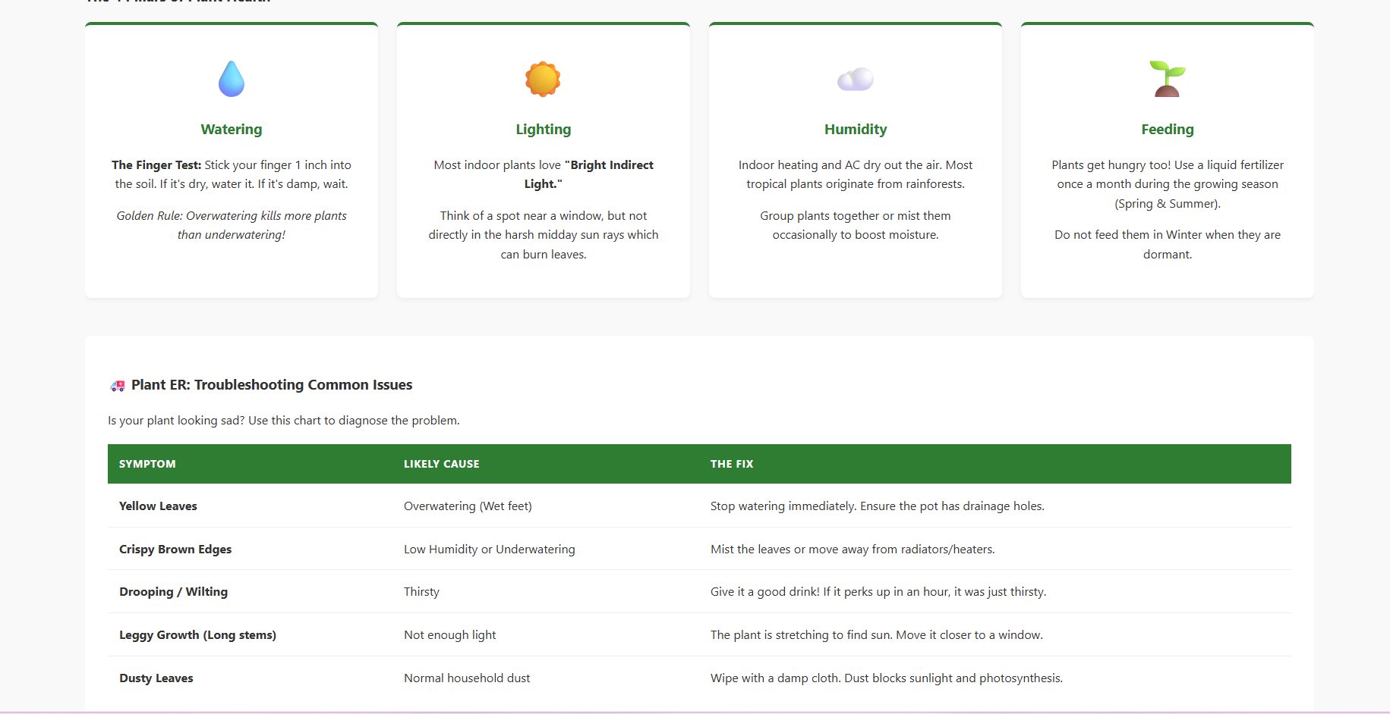
Annotation: This page features a data table styled with CSS for readability. The "4 Pillars of Care" are displayed using a grid layout with emoji icons acting as visual anchors.

Other pages (screenshots)

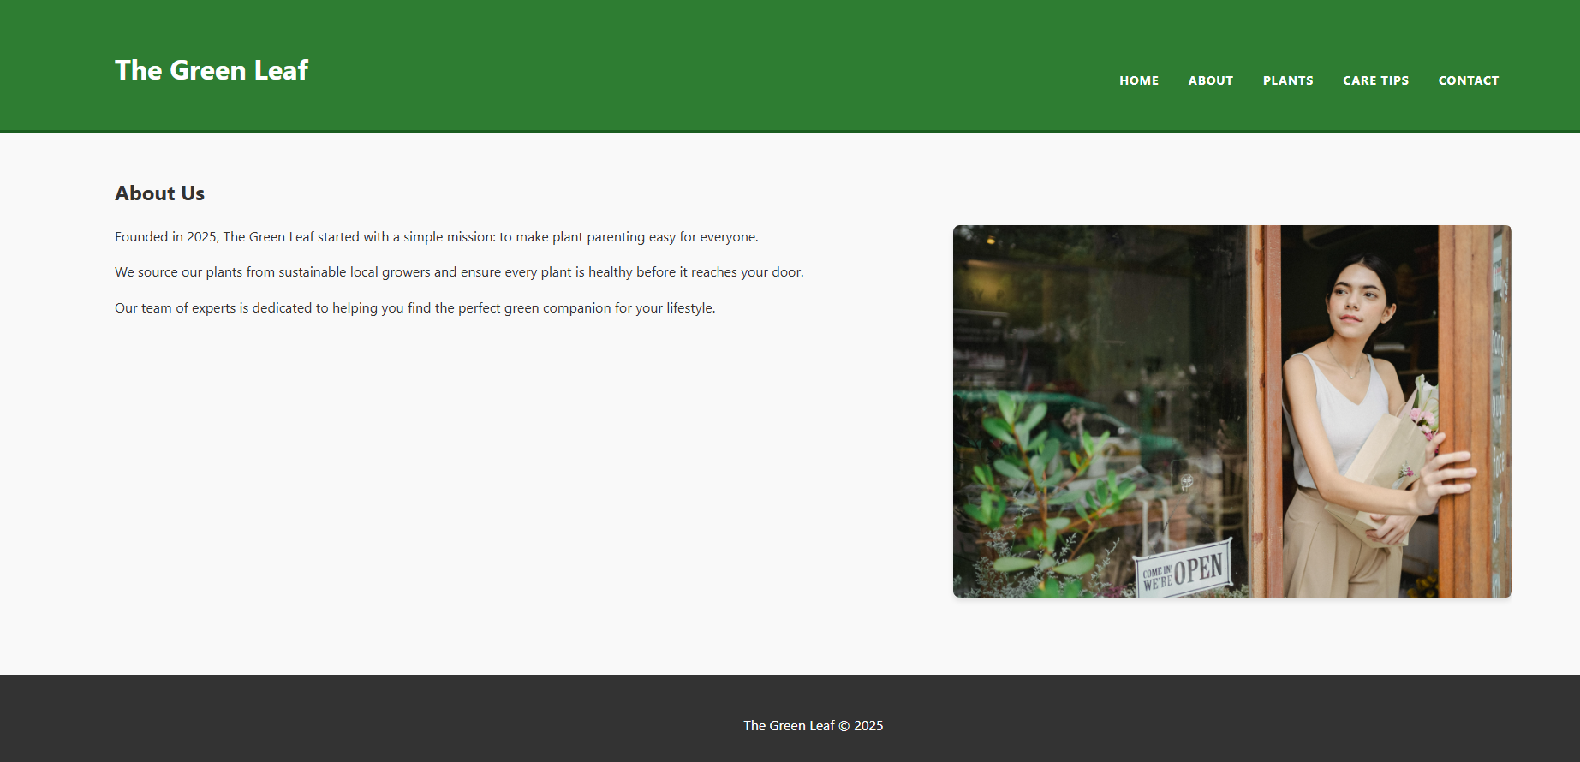

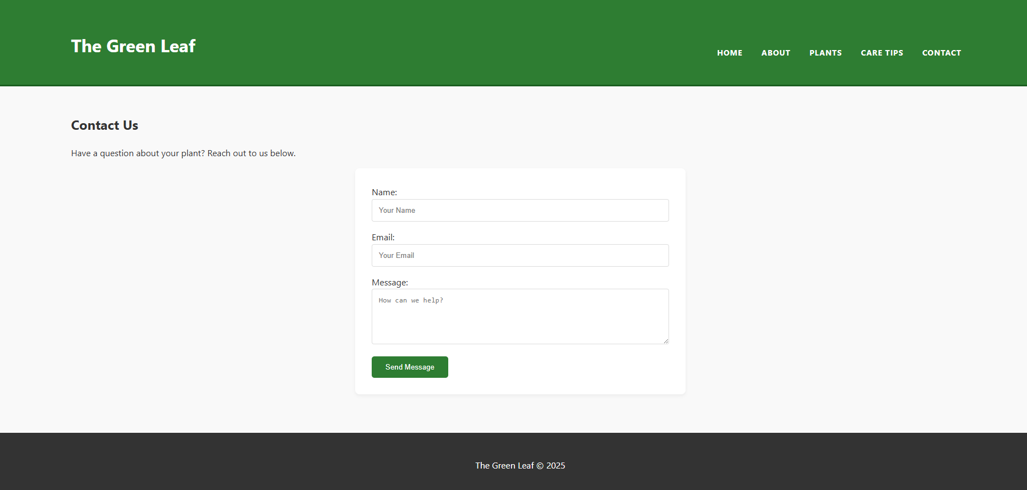

Validating my website
Please use the links provided in assignment brief to validate ONE HTML PAGE AND ONE CSS PAGE
Please find the links below
HTML VALIDATION LINK : https://validator.w3.org/
CSS VALIDATION LINK : https://jigsaw.w3.org/css-validator/
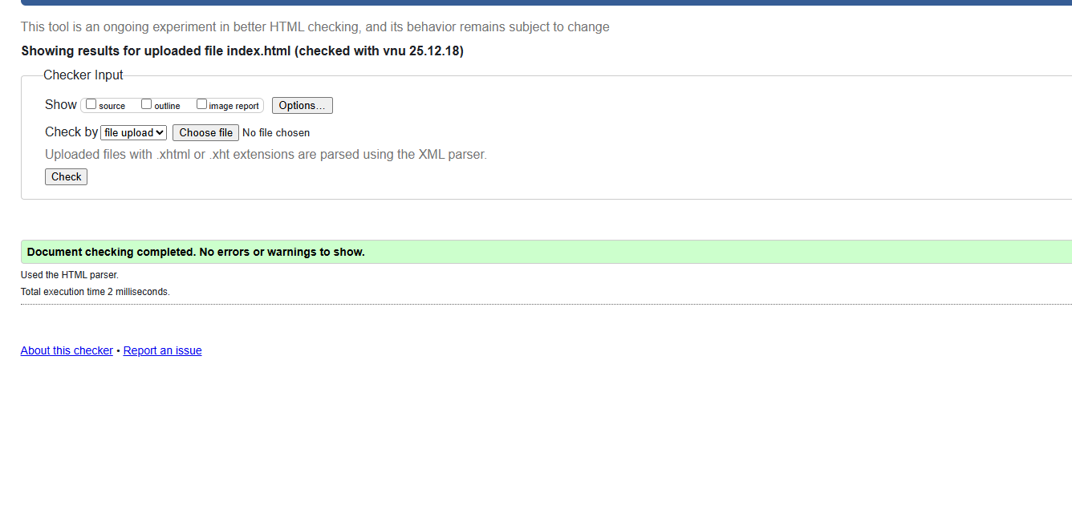
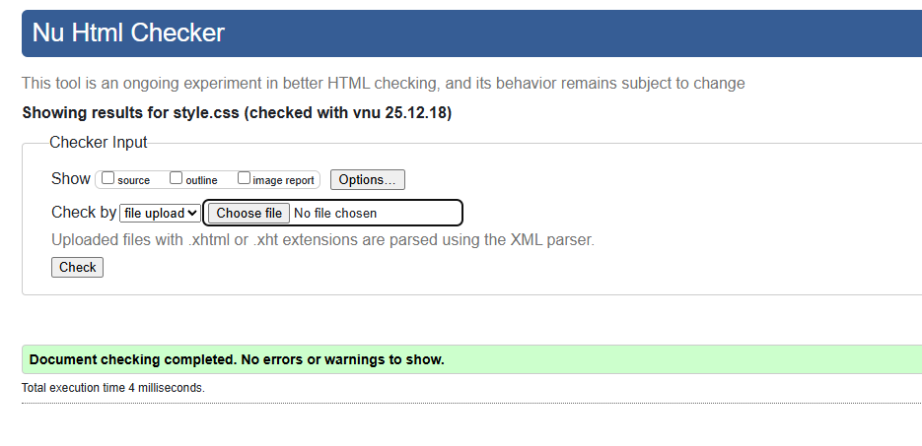
There is no errors

Self-evaluation of my website

Usefulness (usability and utility):
Research:
Website usability is defined by Nielsen (2012) as a quality attribute that assesses how easy user interfaces are to use. The word "usability" also refers to methods for improving ease-of-use during the design process. According to Nielsen, usability consists of five quality components: learnability, efficiency, memorability, errors, and satisfaction. A study by Palmer (2002) found that website usability, specifically navigation and layout, significantly impacts a user's intent to purchase and their trust in the retailer. The study highlighted that users must be able to find information quickly (low download delay) and navigate logically.
Evaluation of "The Green Leaf":
- Utility (Functionality): The website fulfills its core utility by providing product information and care instructions. The forms function correctly, and links navigate to the correct destinations.
- Usability (Ease of Use):
  - Learnability: The navigation bar uses standard conventions (Home, About, Contact), making it easy for new users to learn the site immediately.
  - Efficiency: The "Products" page allows users to see price and benefits at a glance without clicking through multiple pages, reducing the "interaction cost."
- Content: The language used is simple and jargon-free (e.g., "The Finger Test" for watering), which caters to the target audience of beginners.
Recommendations:
To improve, I would implement a "Search" bar in the header to allow users to find specific plants instantly. Additionally, adding a "Filter" option on the product page (e.g., Filter by "Low Light" or "Pet Friendly") would significantly enhance efficiency as the product catalog grows.

b. Search Engine Optimisation (SEO)
Research:
SEO is the process of affecting the online visibility of a website in a web search engine's unpaid results. Zhang and Cabage (2017) discuss that SEO involves both technical architecture and content relevance. Search engines use "crawlers" or "spiders" to index content. A key study by Yalçın and Köse (2010) emphasized that on-page factors—such as keywords in titles, headers, and meta tags—are critical for ranking. They found that proper semantic HTML structure helps search engines understand the hierarchy of content.
Evaluation of "The Green Leaf":
I have applied several on-page SEO techniques to the website:
- Title Tags: Each page has a unique <title> tag (e.g., The Green Leaf | Care Guide). This is the primary signal to Google about the page's content.
- Semantic Headings: I used a logical hierarchy of <h1> for the main title and <h2> for section headers. This helps spiders understand the page structure.
- Alt Attributes: All images, including the product images (e.g., alt="Snake Plant"), have descriptive text. This allows search engines to "see" the images and index them for image search.
- Meta Viewport: The inclusion of <meta name="viewport" content="width=device-width, initial-scale=1.0"> ensures the site is mobile-friendly, which is now a ranking factor for Google (Mobile-First Indexing).
c. Accessibility
Research:
Web accessibility means that websites, tools, and technologies are designed and developed so that people with disabilities can use them. The guiding standard is the WCAG 2.1 (Web Content Accessibility Guidelines).
The guidelines are organized around four principles, known by the acronym POUR:
- Perceivable: Information and user interface components must be presentable to users in ways they can perceive (e.g., text alternatives for non-text content).
- Operable: User interface components and navigation must be operable (e.g., keyboard functionality).
- Understandable: Information and the operation of user interface must be understandable.
- Robust: Content must be robust enough that it can be interpreted reliably by a wide variety of user agents, including assistive technologies.
Evaluation of "The Green Leaf":
I evaluated the site using the WAVE (Web Accessibility Evaluation Tool) browser extension.
- Perceivable: I ensured high contrast between the text and background. The dark grey text (#333) on the white background provides a contrast ratio that exceeds the AA standard. I also added alt tags to all images for screen reader users.
- Operable: The website is fully navigable using only a keyboard. The simple vertical scroll and distinct button styles make it easy to focus on elements.
- Understandable: The form labels in contact.html are explicitly linked to their inputs (e.g., "Name", "Email"), preventing confusion during data entry.
- Robust: The code is valid HTML5, meaning it will likely be interpreted correctly by future browsers and specialized assistive tools.
d. Comparative Analysis
I compared "The Green Leaf" against two live competitors: Patch Plants (a modern specialized plant seller) and B&Q (a general hardware store that sells plants).
Area | Patch Plants (Specialist) | B&Q (Generalist) | Analysis & Comparison
Usability | Excellent. Uses a clean, card-based grid very similar to my design. Navigation is category-based. | Moderate. The menu is cluttered because they sell thousands of non-plant items. Harder to find specific plants. | My website follows the Patch Plants model (clean, focused), which offers a better User Experience (UX) for plant buyers than the cluttered B&Q approach.
Accessibility | Good. Clear fonts and high contrast. Uses ARIA labels for screen readers. | Fair. Some dynamic pop-ups and complex menus may trap keyboard-only users. | My site is simpler than both, which inherently makes it more accessible, though Patch Plants has more advanced accessibility features like text resizing.
SEO | High. They have a blog and extensive care guides which capture keywords. | High. They rely on their massive brand authority and domain rating. | My site uses the same on-page technical SEO as Patch, but lacks the domain authority and volume of content they possess.
Mobile | Very responsive. Images stack perfectly. | Functional, but load times are slower due to heavy scripts. | My website loads faster than B&Q because it does not rely on heavy JavaScript frameworks, ensuring better mobile performance.
Conclusion:
While B&Q has more stock, Patch Plants is the better website in terms of usability and design. My website, "The Green Leaf," successfully mimics the successful UX patterns of Patch Plants (clean white space, green accents, clear grid) rather than the complex directory style of B&Q.

Reference list

[1] J. Nielsen, "Usability 101: Introduction to Usability," Nielsen Norman Group, Jan. 03, 2012. [Online]. Available: https://www.nngroup.com/articles/usability-101-introduction-to-usability/
[2] J. W. Palmer, "Web site usability, design, and performance metrics," Information Systems Research, vol. 13, no. 2, pp. 151-167, 2002.
[3] S. Zhang and N. Cabage, "Search Engine Optimization: Comparison of Link Building and Social Sharing," in Journal of Computer Information Systems, vol. 57, no. 2, pp. 148-159, 2017.
[4] N. Yalçın and U. Köse, "What is search engine optimization: SEO?," Procedia-Social and Behavioral Sciences, vol. 9, pp. 487-497, 2010.
[5] W3C, "Web Content Accessibility Guidelines (WCAG) 2.1," World Wide Web Consortium, Jun. 2018. [Online]. Available: https://www.w3.org/TR/WCAG21/
[6] ISO, "ISO 9241-11:2018 Ergonomics of human-system interaction — Part 11: Usability: Definitions and concepts," International Organization for Standardization, 2018.

