DWDM Tutorial 16 – Classification Analysis Report
Glass Data Set – Classification with Weka

1. Introduction
This report presents a classification analysis performed on the Glass Data Set using Weka. The dataset is based on forensic chemical analysis and is used to determine the origin of different types of glass found at crime scenes. The goal of the analysis is to identify the most accurate classification tool, or combination of tools, for identifying glass type, and to evaluate whether distinguishing between float and non-float glass is easier than distinguishing between all glass sub-types.

2. Dataset Description
- Relation: Glass
- Instances: 214
- Attributes: 10 (9 numeric predictors + 1 nominal class attribute)
- Predictor attributes: RI (refractive index), Na, Mg, Al, Si, K, Ca, Ba, Fe (chemical composition, all numeric)
- Class attribute (Type): build wind float, build wind non-float, vehic wind float, vehic wind non-float, containers, tableware, headlamps
Note: no instances of the class 'vehicle window non-float' are present in the dataset, so this class could not be evaluated by any classifier (its metrics appear as undefined, shown as '?', in the Weka output).

3. Methodology
All classifiers were evaluated using 10-fold stratified cross-validation, Weka's default test option, which is appropriate given the relatively small size of the dataset (214 instances). Four classification algorithms were compared, spanning different learning paradigms:
- J48 – a decision tree (divide-and-conquer) classifier
- JRip – a rule-based classifier (propositional rule learner, RIPPER)
- Random Forest – an ensemble of decision trees
- Naive Bayes – a probabilistic classifier based on Bayes' theorem with an attribute-independence assumption

4. Results

4.1 Overall Performance Comparison
Classifier | Correctly Classified (%) | Kappa | Weighted F-Measure
J48 | 66.82% | 0.5500 | 0.668
JRip | 68.69% | 0.5691 | 0.676
Random Forest | 79.91% | 0.7229 | 0.793
Naive Bayes | 48.60% | 0.3168 | 0.453

Random Forest achieved the highest accuracy (79.91%) and the highest Kappa statistic (0.7229), indicating substantial agreement beyond chance. Naive Bayes performed markedly worse than the other three algorithms, with an accuracy of only 48.60%.

4.2 Per-Class Analysis
Examining the confusion matrices for each classifier reveals a consistent pattern across algorithms: the two classes 'build wind float' and 'build wind non-float' are frequently confused with one another. This is expected, as both are building window glass and differ only in the manufacturing/finishing process, so their chemical compositions are very similar.
The class 'vehic wind float' was the most difficult to classify correctly for every algorithm (Recall of 0.353 for J48, 0.118 for JRip, 0.353 for Random Forest, 0.235 for Naive Bayes). This is very likely due to the small number of instances of this class in the dataset (only 17), rather than to a limitation of any particular algorithm. Notably, Random Forest — despite its strong overall performance — did not improve the Recall on this class relative to J48, which supports the hypothesis that the issue is data scarcity rather than algorithm choice.
By contrast, the 'headlamps' class was consistently well classified by all algorithms (Recall between 0.793 and 0.846), as was 'containers' for the tree/rule/ensemble-based methods.
Naive Bayes performed particularly poorly on 'build wind non-float', with a Recall of only 0.171: 48 of its 76 instances were misclassified as 'build wind float'. This is consistent with Naive Bayes' core assumption that predictor attributes are conditionally independent given the class — an assumption that does not hold for this dataset, since the chemical oxide percentages (Na, Mg, Al, Si, K, Ca, etc.) are compositionally correlated (an increase in one oxide's proportion tends to be offset by a decrease in others).

4.3 Confusion Matrices
Classes: a = build wind float, b = build wind non-float, c = vehic wind float, d = vehic wind non-float, e = containers, f = tableware, g = headlamps.
J48:
 | a | b | c | d | e | f | g
a | 50 | 15 | 3 | 0 | 0 | 1 | 1
b | 16 | 47 | 6 | 0 | 2 | 3 | 2
c | 5 | 5 | 6 | 0 | 0 | 1 | 0
d | 0 | 0 | 0 | 0 | 0 | 0 | 0
e | 0 | 2 | 0 | 0 | 10 | 0 | 1
f | 1 | 1 | 0 | 0 | 0 | 7 | 0
g | 3 | 2 | 0 | 0 | 0 | 1 | 23
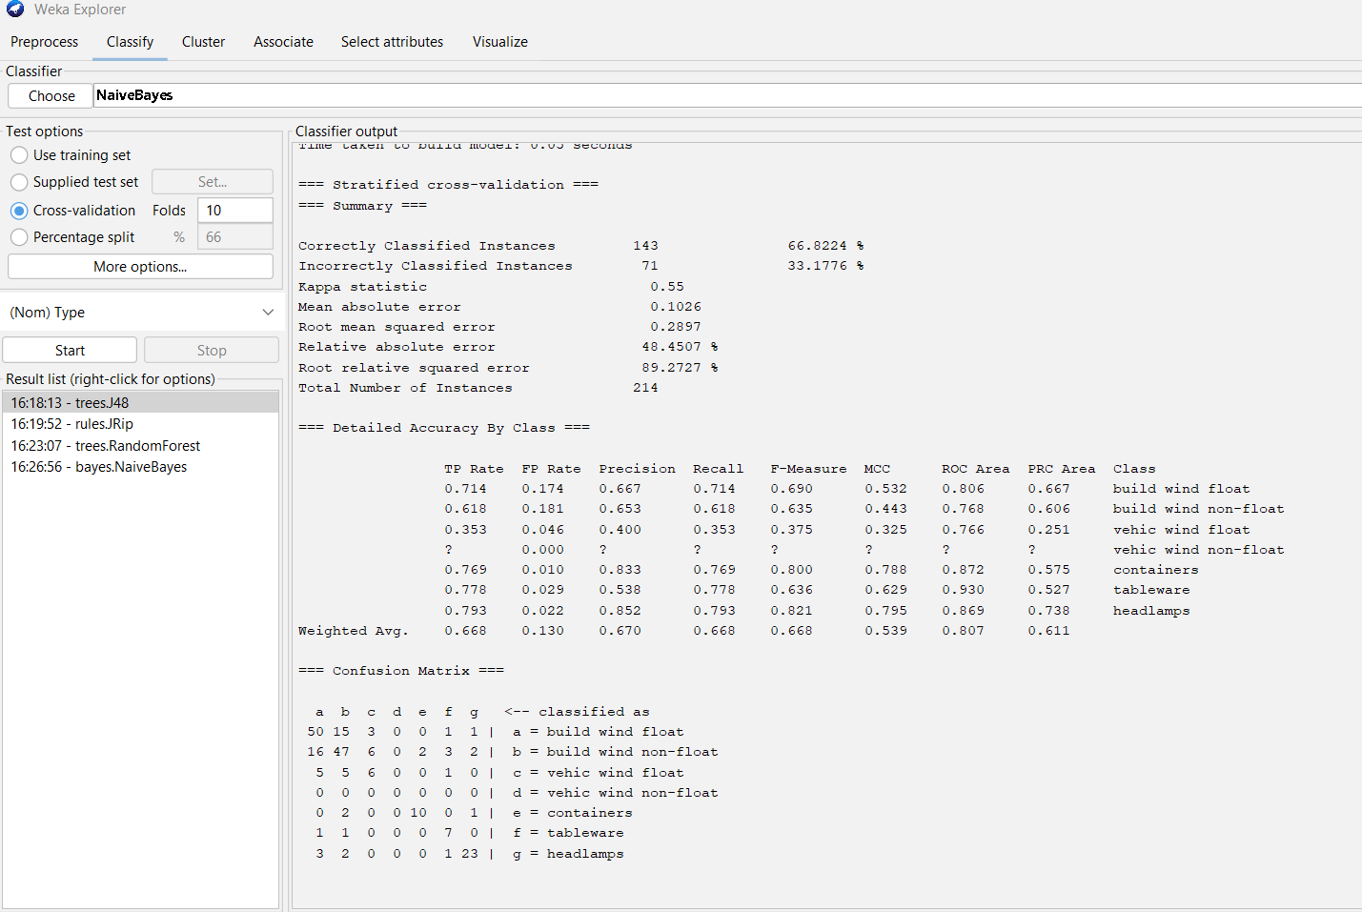
Figure 1. Weka output for J48 (10-fold cross-validation).
JRip:
 | a | b | c | d | e | f | g
a | 47 | 18 | 2 | 0 | 0 | 1 | 2
b | 10 | 58 | 3 | 0 | 3 | 1 | 1
c | 8 | 6 | 2 | 0 | 0 | 1 | 0
d | 0 | 0 | 0 | 0 | 0 | 0 | 0
e | 0 | 2 | 0 | 0 | 10 | 0 | 1
f | 0 | 1 | 0 | 0 | 1 | 7 | 0
g | 0 | 4 | 1 | 0 | 1 | 0 | 23
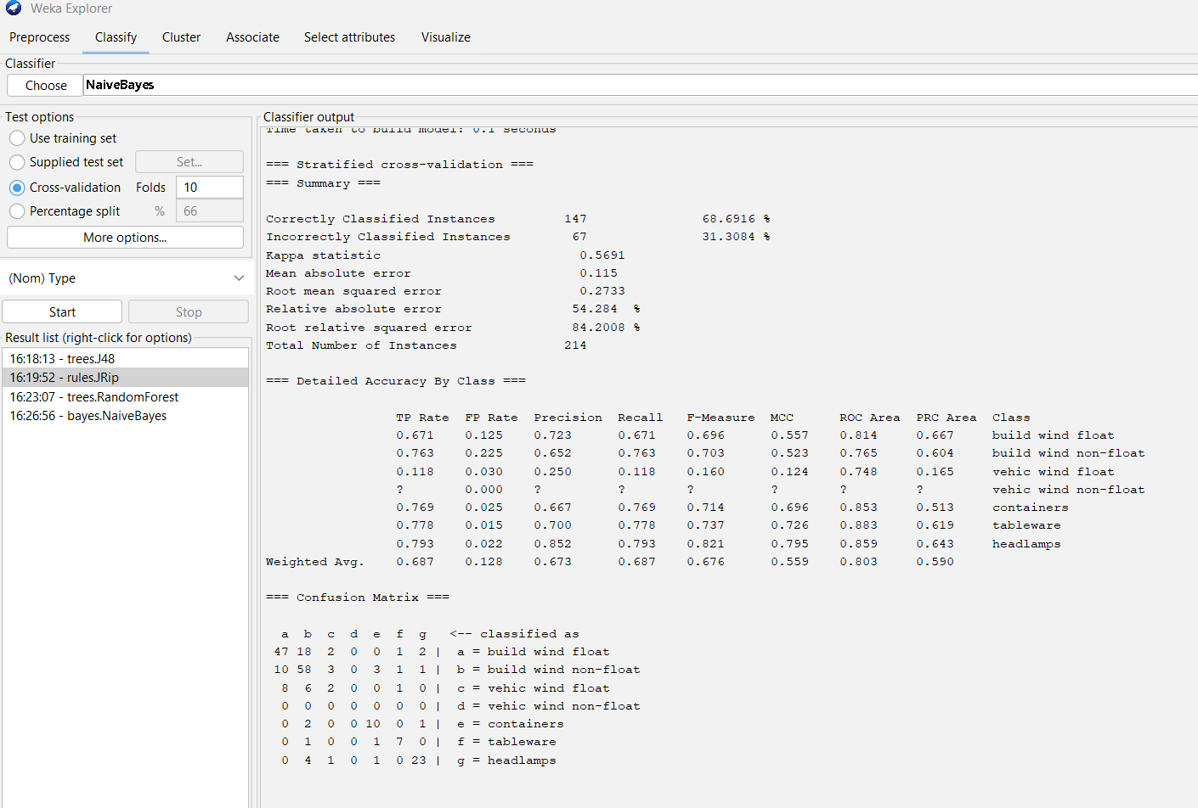
Figure 2. Weka output for JRip (10-fold cross-validation).
Random Forest:
 | a | b | c | d | e | f | g
a | 61 | 7 | 2 | 0 | 0 | 0 | 0
b | 8 | 62 | 2 | 0 | 2 | 1 | 1
c | 8 | 3 | 6 | 0 | 0 | 0 | 0
d | 0 | 0 | 0 | 0 | 0 | 0 | 0
e | 0 | 1 | 0 | 0 | 11 | 0 | 1
f | 0 | 1 | 0 | 0 | 0 | 7 | 1
g | 1 | 4 | 0 | 0 | 0 | 0 | 24
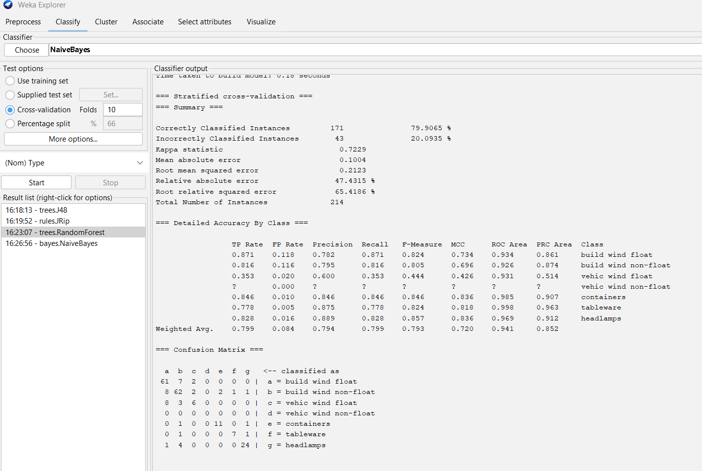
Figure 3. Weka output for Random Forest (10-fold cross-validation).
Naive Bayes:
 | a | b | c | d | e | f | g
a | 51 | 5 | 11 | 0 | 0 | 2 | 1
b | 48 | 13 | 6 | 0 | 5 | 3 | 1
c | 12 | 0 | 4 | 0 | 0 | 1 | 0
d | 0 | 0 | 0 | 0 | 0 | 0 | 0
e | 0 | 8 | 0 | 0 | 4 | 0 | 1
f | 0 | 0 | 0 | 0 | 0 | 8 | 1
g | 1 | 1 | 0 | 0 | 3 | 0 | 24
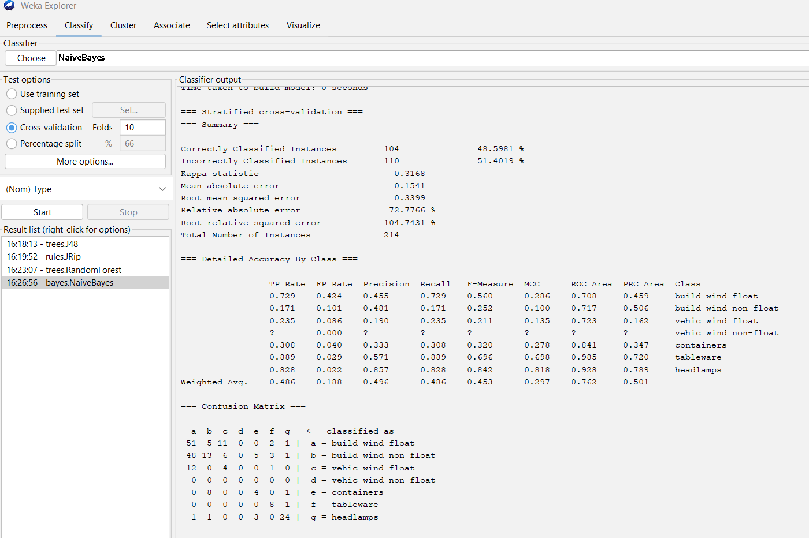
Figure 4. Weka output for Naive Bayes (10-fold cross-validation).

5. Float vs. Non-Float Glass
The tutorial also asks whether it is easier to distinguish between float and non-float glass than between all individual glass types. This requires merging the seven original classes into two groups (float: 'build wind float' and 'vehic wind float'; non-float: 'build wind non-float', 'vehic wind non-float', 'containers', 'tableware', 'headlamps') using Weka's class-editing or attribute-merging tools, and re-running the classifiers on the binary class.
This step has not yet been carried out at the time of writing. Based on the per-class results above, a clear improvement in accuracy would be expected for the binary task: the main source of error across all four algorithms was confusion between chemically similar sub-types within the same float/non-float category (e.g., 'build wind float' vs 'build wind non-float', and the various non-float classes vs one another), rather than confusion across the float/non-float boundary itself. Collapsing these fine-grained distinctions should therefore remove most of the misclassifications observed, and is expected to yield a noticeably higher accuracy than the 6-class problem.

6. Attribute Relevance
Inspection of the J48 decision tree shows that not all nine chemical attributes contribute equally to classification; attributes appearing near the root of the tree (e.g., Al, Ba, RI) are the most discriminative, while others contribute only to deeper, more specific splits. As suggested by the tutorial hints, removing weakly contributing attributes (via the Preprocess tab, then re-running the classifier and comparing accuracy) can be used to test whether a simpler model retains comparable accuracy — this simplification was not required to identify the best-performing algorithm overall, since Random Forest already achieved a substantially higher accuracy using the full attribute set.

7. Conclusions
- Random Forest was the most effective classifier tested, achieving 79.91% accuracy and a Kappa of 0.72, substantially outperforming J48, JRip, and especially Naive Bayes.
- The rule-based (JRip) and tree-based (J48) classifiers performed similarly to one another, with JRip slightly ahead.
- Naive Bayes was the weakest performer, likely due to the correlated nature of the chemical composition attributes violating its conditional independence assumption.
- Across all algorithms, the main source of classification error was confusion between chemically similar glass sub-types within the same broader category (e.g., building window float vs. non-float), rather than confusion between fundamentally different types of glass.
- The 'vehicle window float' class was consistently the hardest to classify for every algorithm, most likely due to its very small number of instances (17) in the dataset rather than any algorithmic limitation.
- Collapsing the classification task into float vs. non-float glass is expected to be considerably easier than distinguishing all seven original sub-types, since most observed errors occurred within the float/non-float groups rather than across them (pending confirmation by running this test in Weka).

