Coursework Title; - Operating system
Module Name: Architecture & OS
Module Code: ACCA 4022
Student Name: Afshan Abbas
Student ID: 2515417
Lecturer Name: Md Shantanu Islam

Submission date: 26/03/2026

Contents
Introduction 4
Key functions of general Operating Systems 4
Task Management: 4
Application/Program Management: 4
File/Directory Management: 5
Device Management: 5
Security Management: 6
Use of Windows OS CLI commands 7
Example 1: 7
Example 2: 7
Example 3: 8
Example 4: 8
Example 5: 8
Example 6: 9
Example 7: 9
Example 8: 10
Example 9: 10
Example 10: 11
Use of Linux OS CLI commands 11
Example 1: 11
Example 2: 12
Example 3: 12
Example 4: 13
Example 5: 13
Example 6: 14
Example 7: 14
Example 8: 15
Example 9: 15
Example 10: 16
Use of Windows OS scripts 16
Example 1: 16
Example 2: 17
Use of Linux OS scripts 18
Example 1: 18
Example 2: 19
Conclusion 20
References 20
Appendices 21

Introduction

An operating system (OS) is the primary interface between users and hardware. It manages resources, coordinates program execution, simplifies software use, and supports multiple execution modes.
The CLI allows users to launch applications directly and automate tasks by running scripts. Both Linux and Windows operating systems support graphical user interfaces (GUIs).

Key functions of general Operating Systems
An Operating System (OS) is essential software that manages computer hardware and provides a user interface (1), aiming to simplify use and maximize resource efficiency. An Operating System (OS) is an essential component of system software responsible for overseeing computer hardware and software resources (2), as well as delivering standardized services to application programs. It functions as a bridge between users and hardware, facilitating efficient and reliable application execution (3). Process Management focuses on controlling and coordinating the execution of processes-programs that are currently running (4).
The operating system ensures that each process receives appropriate CPU time, manages their interactions, and allocates necessary resources such as memory and I/O devices (5). It also prevents race and deadlocks conditions by regulating how process access shared resources (6). Memory Management is responsible for assigning and reclaiming memory for processes (7). The operating system ensures that each process has the memory it requires while protecting the memory space of other processes (8).

Task Management
Task management involves systematically planning, organizing, and executing tasks to accomplish defined objectives (9), employing a range of tools and strategies to optimize productivity (10). Task management involves tracking and handling tasks throughout a project to boost decision-making, communication, efficiency, and effectiveness.
Task Manager is a built-in Windows tool that lets users view running processes, apps, services, and hardware usage in real time (11). If an issue occurs, you can quickly end or restart a process to resolve it (12).

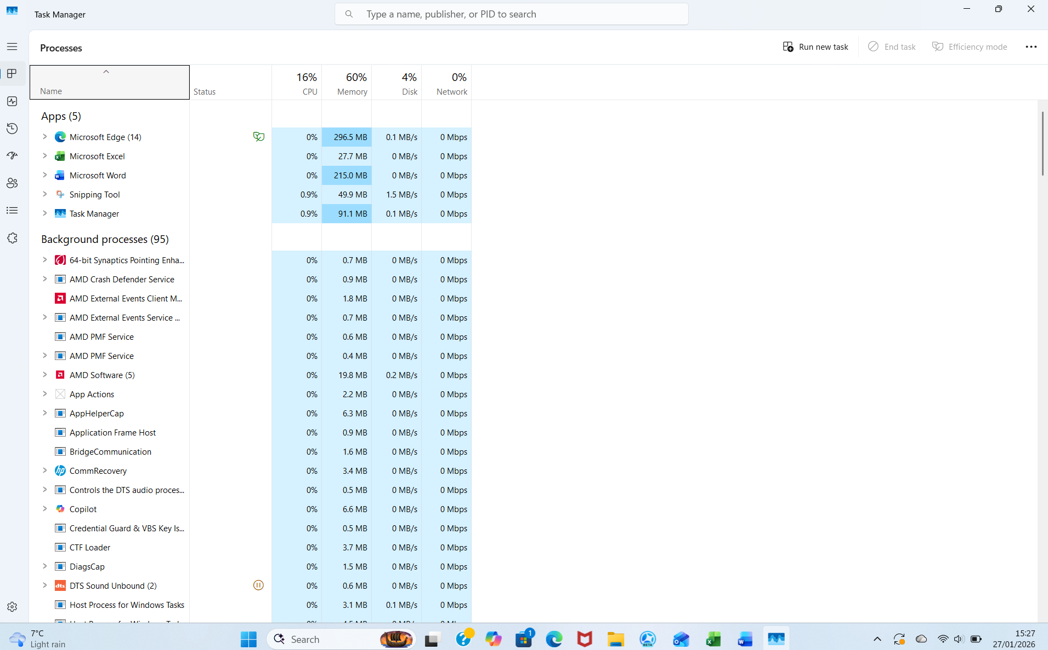

Figure 1: Description Task management

Application/Program Management:

Application program management in Windows employs a range of techniques and tools to deploy, configure, maintain, and secure applications across Windows devices (13). Windows Application Management enables IT administrators to enhance application performance, ensure compliance with company policies, and protect confidential information. As workplaces increasingly embrace BYOD (Bring Your Own Device) and remote work, UEM solutions are reshaping the approach to managing applications in a wide range of settings (14).
Effectively managing applications on employee-owned devices (BYOD) is essential in today’s workplaces (15). Windows Application Management for BYOD makes sure employees can use only the apps they need for their jobs and keeps company data safe (16). This approach allows you to deploy, set up, and track business apps on personal Windows devices without sacrificing user privacy (17).

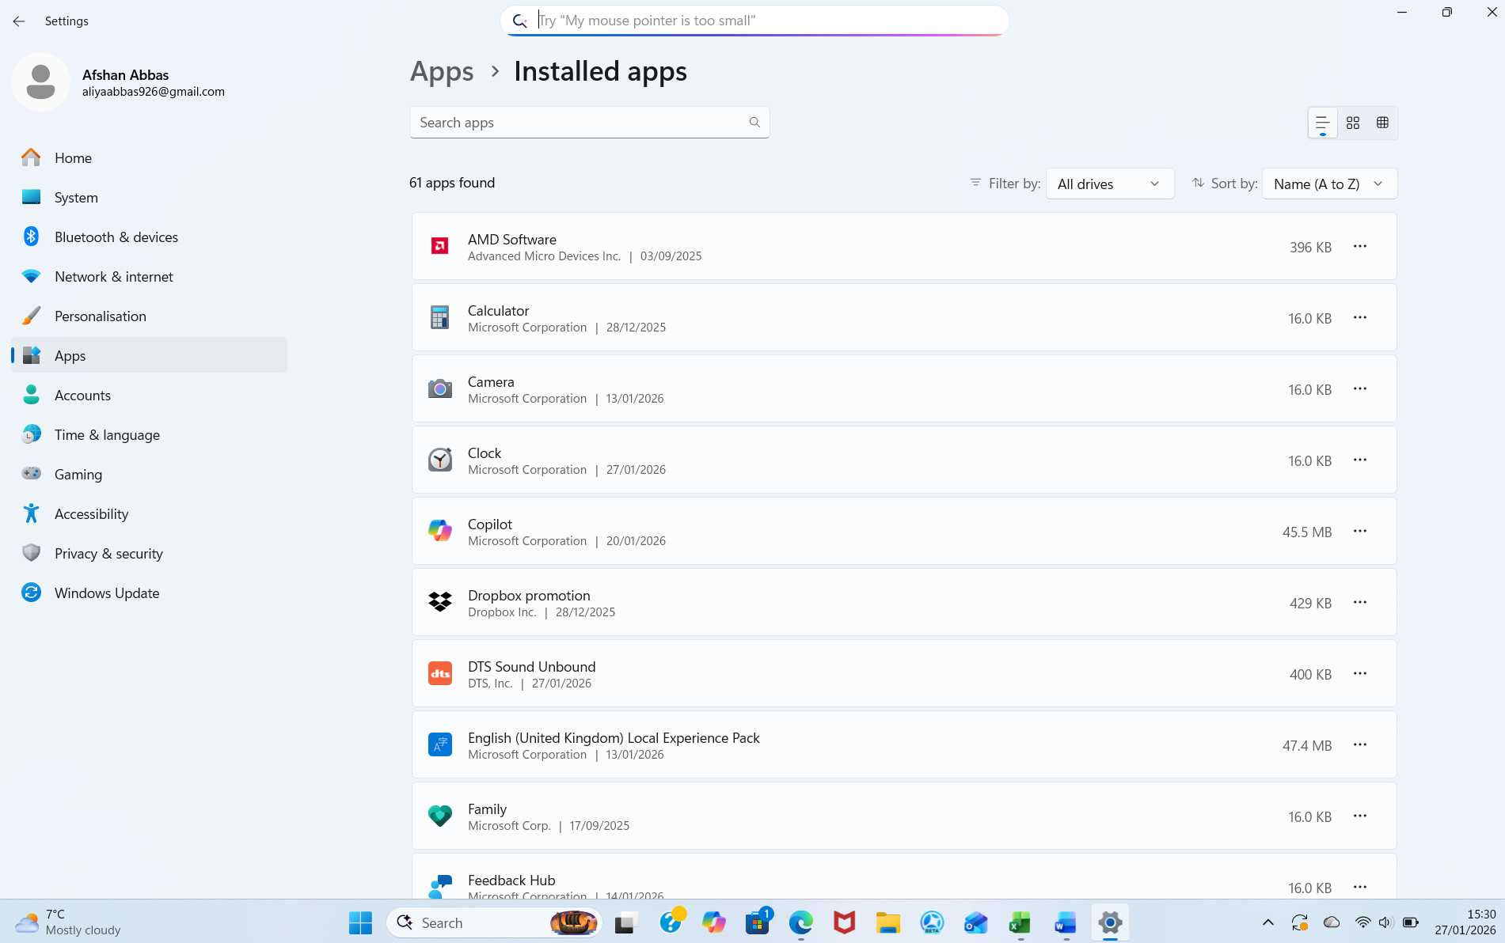
Figure 2: Windows Application management Interface.

File/Directory Management:

Managing files and directories involves efficiently storing and retrieving them on a computer, which helps maintain organisation and protect data integrity (18). Managing files and directories well ensures data stays safe, improves efficiency, and allows users to locate information easily. (19). Keeping everything organized reduces wasted time and lessens the chances of losing or damaging data (20).
File systems play an essential role in operating systems by offering an organized method to store, arrange, and oversee data on devices like hard drives, SSDs, and USB drives. (21). A file is a collection of data such as numbers, characters, graphs, or images (22).Each file must have a unique name and a proper extension for easy reference and storage (23).

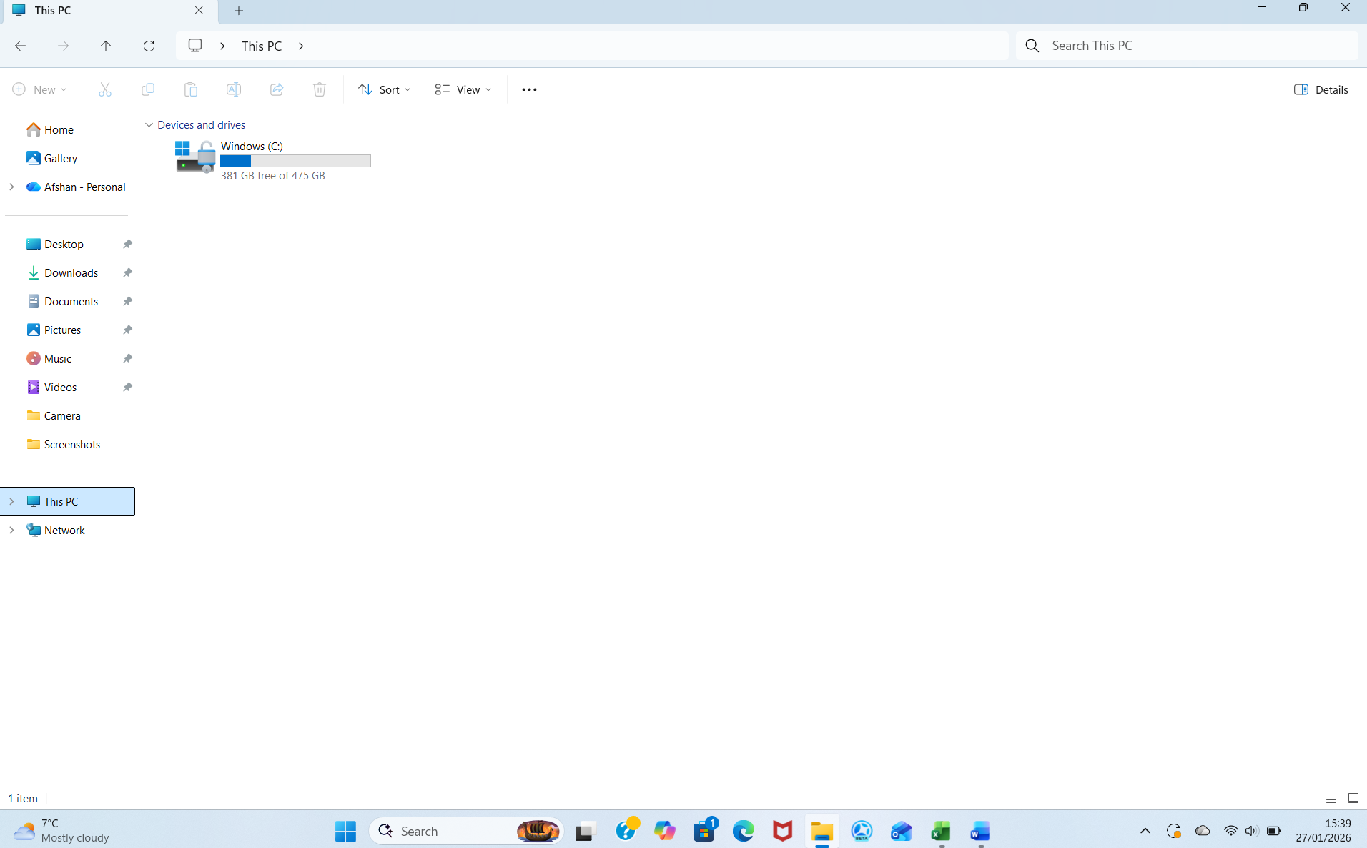
Figure 3: Description Windows File explorer showing file directories.

Device Management
Device management allows businesses to oversee and maintain all types of devices, such as virtual machines, computers, smartphones, and IoT gadgets (24). It is an essential part of any security plan, enabling administrators to keep devices current,and following company rules (25). The main aim is to safeguard the organization's network and information from unauthorized access (26). With remote and hybrid workforces, a strong device management strategy is essential to safeguard resources and data on all devices (27).

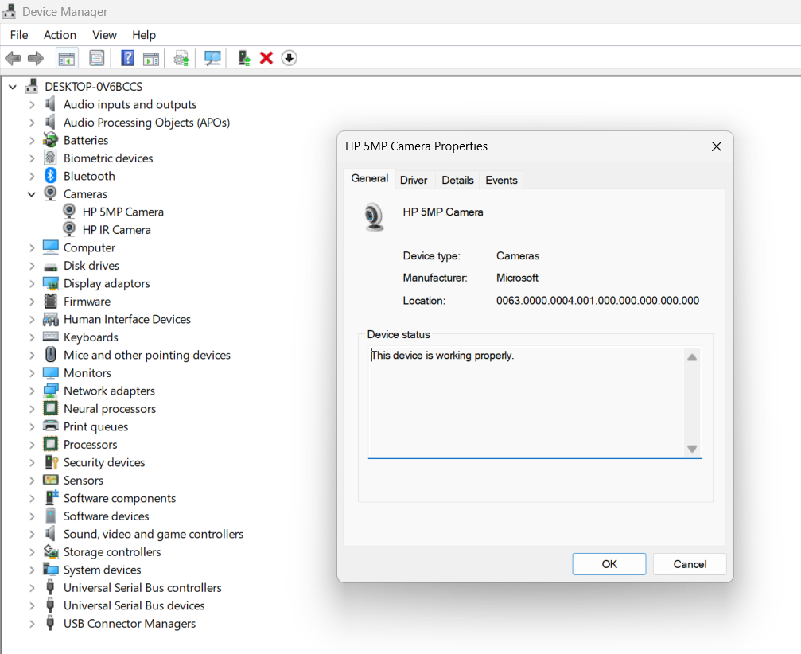

Figure 4: Description Windows device manager displaying hardware devices.

Security Management

Windows security management includes various tools and settings meant to protect your data and devices from possible risks (28). Windows and chip-to-cloud security verify network device security. With tools like Entra ID and Intune, you can enforce policies and simplify IT management (29). Windows 11 combines hardware and software to secure data from your PC to the cloud (30). This protection keeps organizations safe regardless of work location. Windows 365 Cloud PCs, available on any device, offer scalable Windows security through Microsoft's cloud services (31).

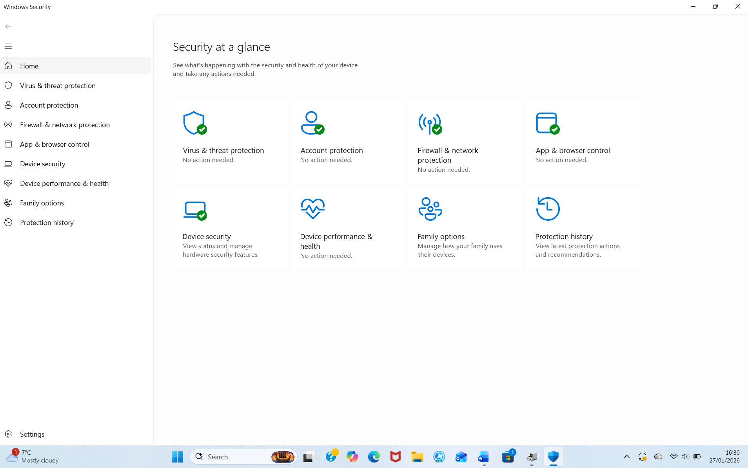
Figure 5: Description Windows security setting Interface.

Use of Windows OS CLI commands

The command line interface (CLI) offers users a robust way to control their operating system by entering commands in text form (32). Windows operating system CLI commands and functions are integral to effective system administration, network troubleshooting, file management (33). They enable users to automate processes, execute instructions, and directly interact with the operating system (34).
Windows OSL CLI functions allow users to work with the operating system using command line instructions (35). These tools can automate processes, handle tasks and change settings that aren't possible through the graphical interface—such as copying files, backing up information, or setting up the system (36). Although the CLI offers extensive capabilities, it requires caution, because certain commands may have lasting effects on the system (37).

Example 1:
Dir(directory). 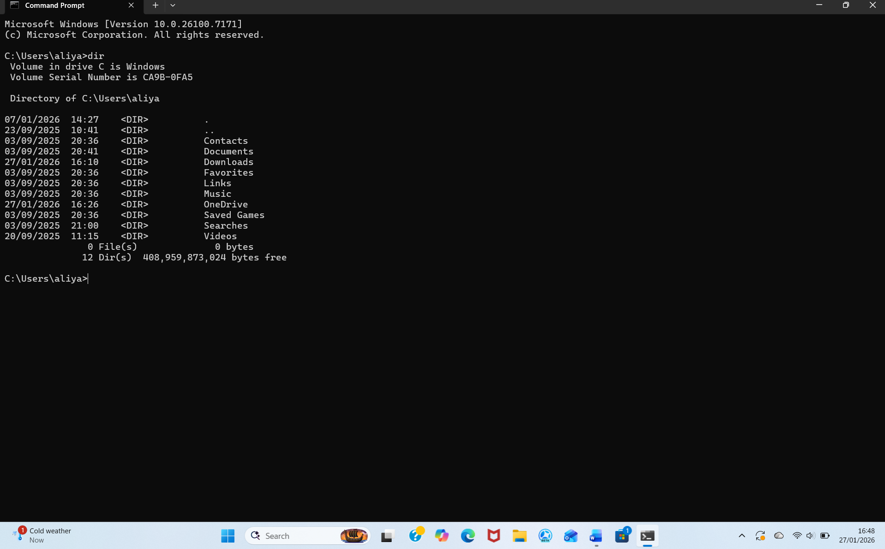

Example 2:
The command here is cd (change directory).
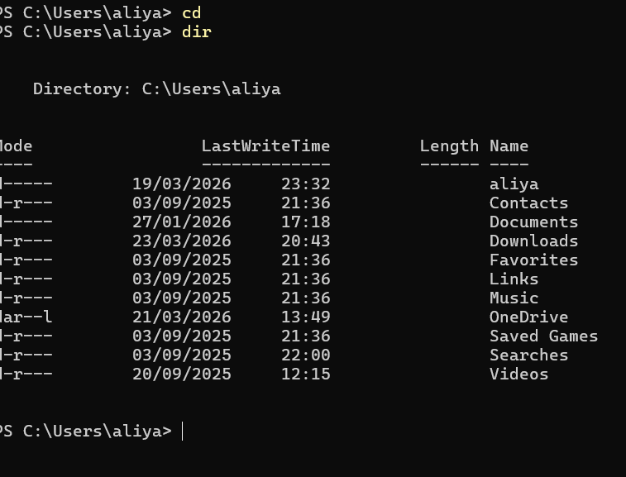

Figure 7: Description Output Cd command

Example 3: mkdir creates new directory
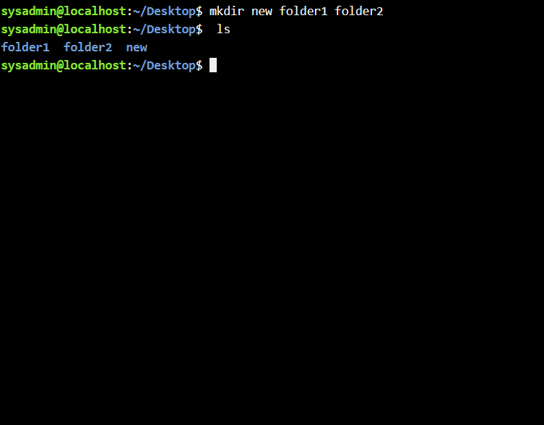

Figure 8 -output of mkdir command

Example 4;-rmdir directory

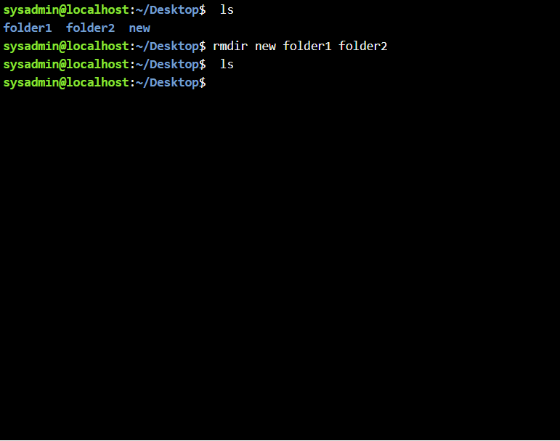
Figure 9 ;-output of rmdir command

Example 5;-echo (displays text messages in the command prompt). The echo command prints messages to the prompt exactly as entered, making it helpful for displaying information or debugging scripts.

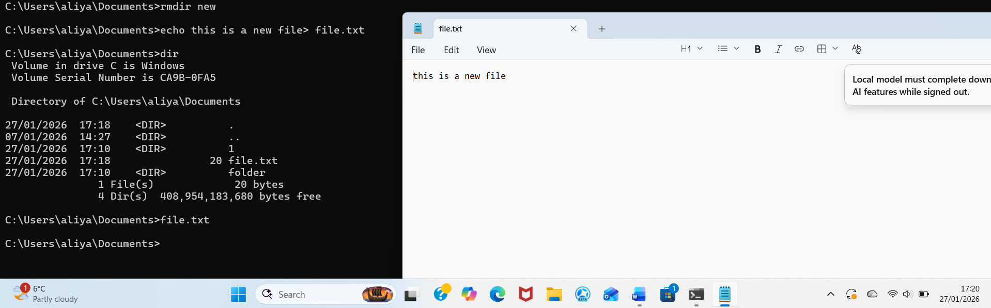
Figure 10: Description Output of echo command

Figure 11: output of tasklist command

Example 6 : tasklist (shows all currently running processes).
The tasklist command lets users view every active process running on the system, displaying details such as memory usage, process name, and ID. This helps users track programs and assess overall system performance.

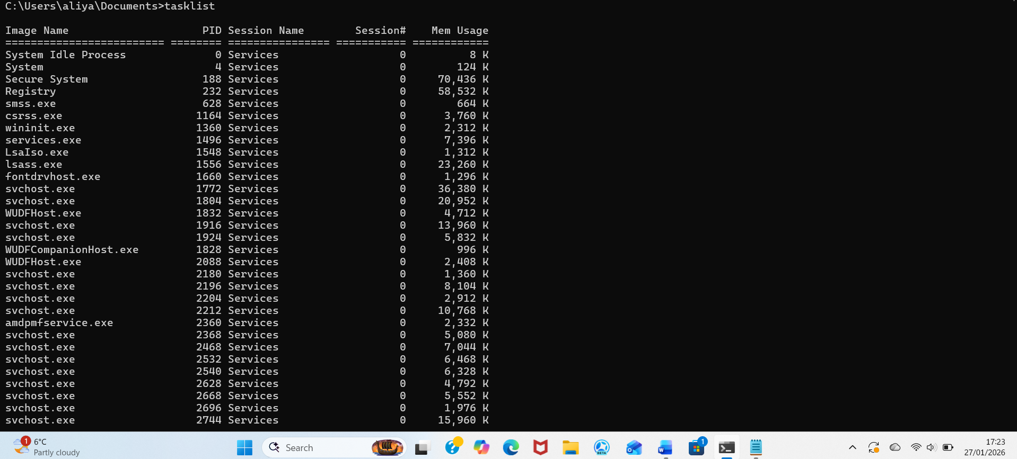

Figure11;-output of tasklist command
Example 7;-Systeminfo (displayed detailed information about the computer system).
The systeminfo command shows OS version, processor type, installed RAM, and boot time, giving users a quick overview of system specs.
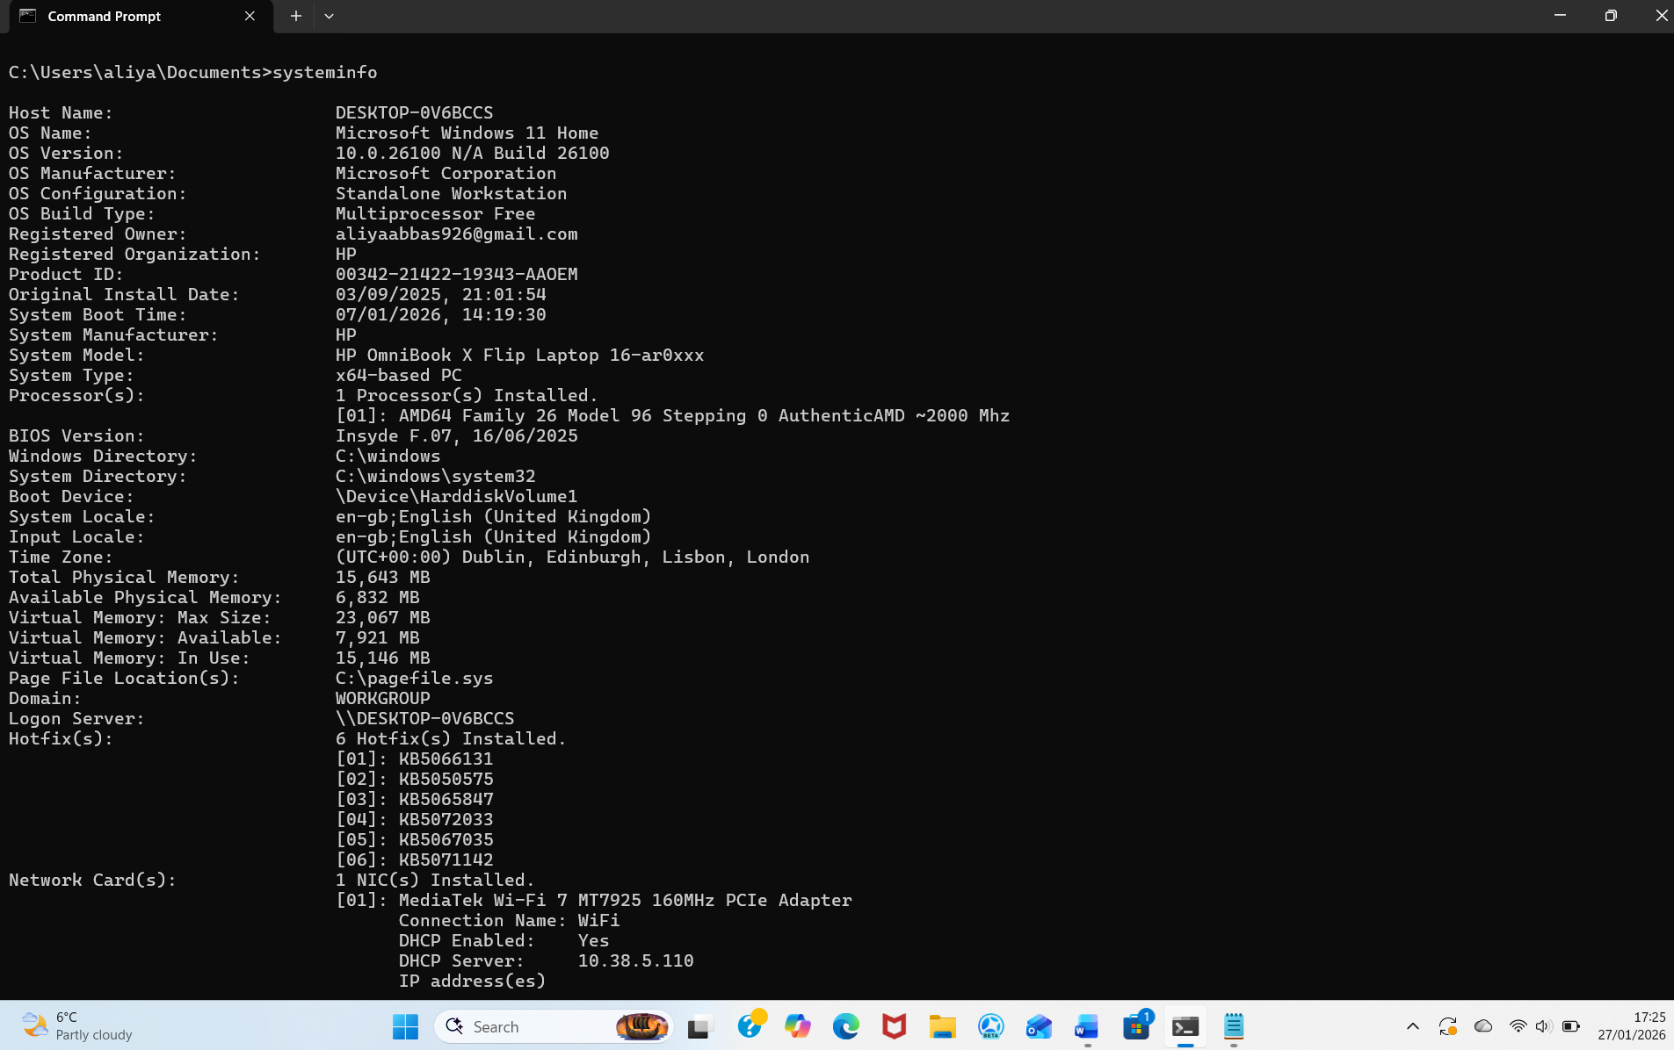
Figure 12: output of system info command.

Example 8:
Ipconfig(displays network configuration information).
The ipconfig command shows network configuration details, including the IP address, subnet mask, and default gateway. This information assists users in diagnosing issues related to network connectivity. 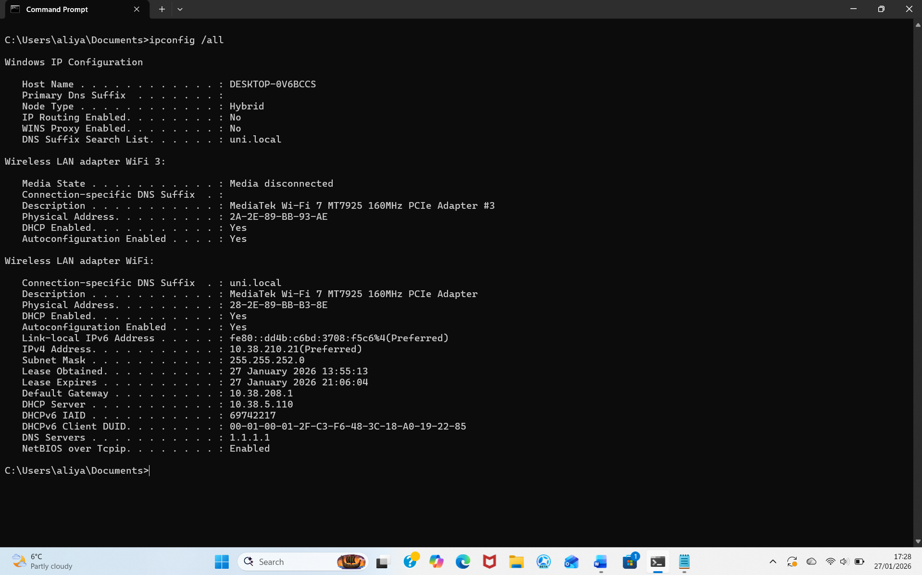
Figure 13: output of ifconfig command.

Example 9:
ping (tests connectivity between network devices).
The ping command checks if a computer can connect to another device on a network. Its output includes response times and packet statistics, which confirm whether the connection works properly.
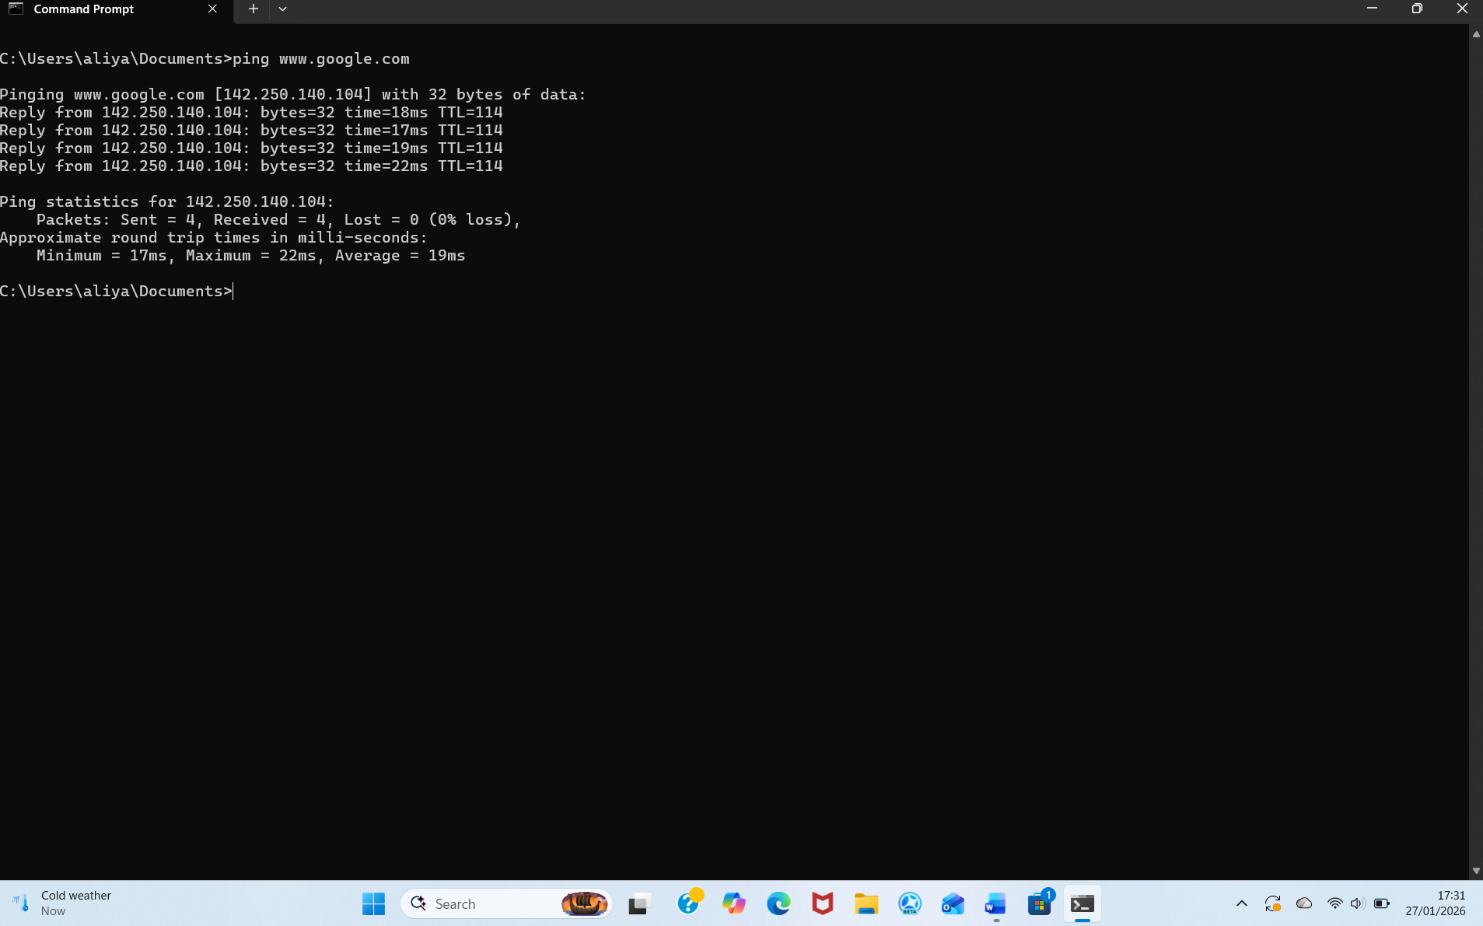
Figure 14: Description output of ping command.

Example 10: tracert
Example 10; -The tracert command reveals the path that network packets follow to reach their destination. It displays each router along the route, helping users identify where delays or connectivity issues might occur.
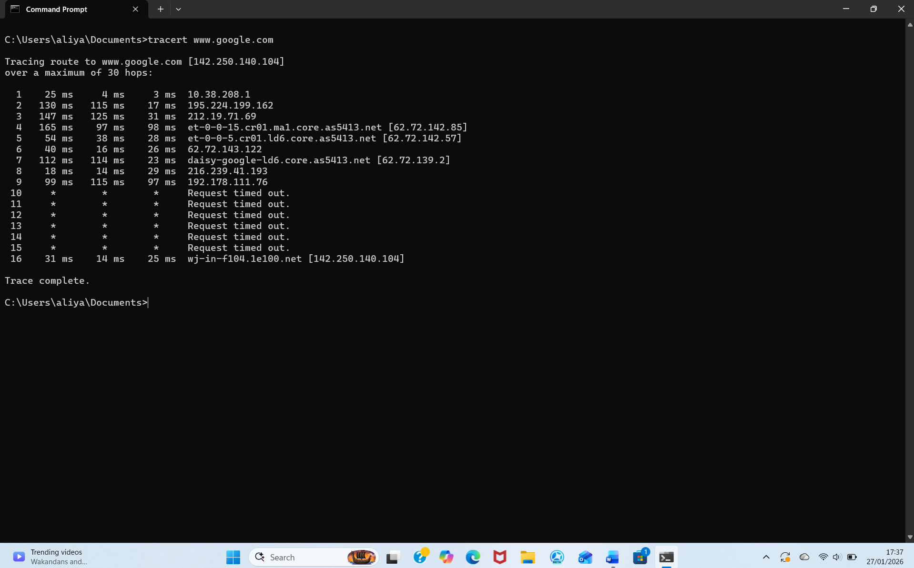

Figure 15: Description output of tracert command.

Use of Linux OS CLI commands
Linux operating systems provide a powerful command-line interface (CLI) that allows users to interact with the system by typing commands rather than relying on a graphical interface (38).This interface is accessed through a programme known as the Terminal, which offers full control over the system operations and supports operations and supports automation through scripting (39). Using (CLI) commands, users can navigate the file system, processes and configure system behaviour, and perform tasks with precision and speed (40).

Example 1:
su –(switch to another user’s account).
The su command lets a user switch account, typically to root. It asks for a password and updates the prompt to reflect the new user.
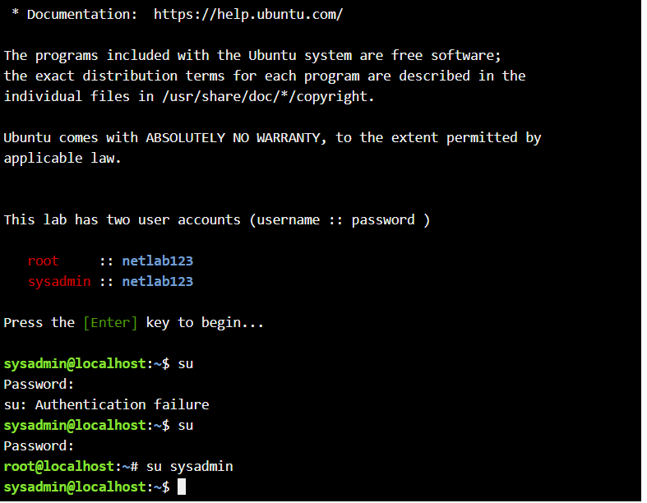
Figure 16: Description output of su command.

Example 2:
Pwd (display the current work directory).
The pwd command displays the full path of the current directory.
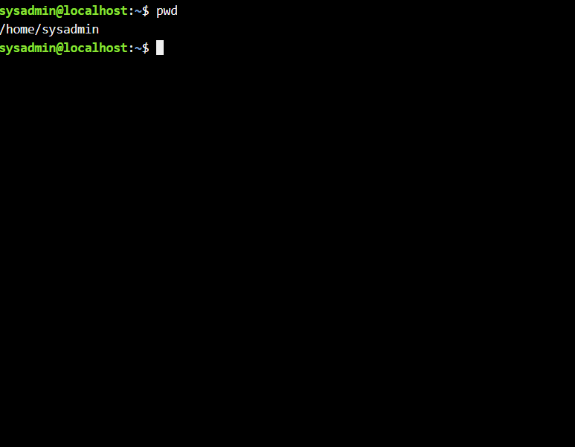
Figure 17: Description output of pwd command.

Example 3:
The `cd` command updates the current directory in Linux, with the shell prompt reflecting your new location.

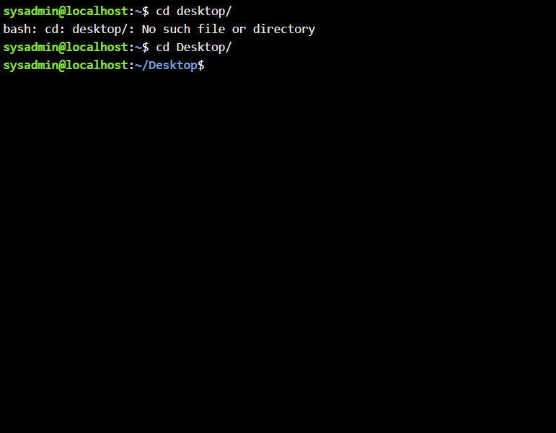: figure18;-output of th ecd command

Figure

Example 4: mkdir (create a new directory)
The mkdir command is used to make a new directory. Typically, it doesn't display any output, but you can see the newly created folder when you list directories with the ls command.

Figure 19: Description( output of mkdir command)

Example 5;- Ls (list files and directories)
figure 20: - (output of ls command) The `ls` command shows the files and directories in the current folder. Its output displays file names, and with extra options, it can also include permissions, file sizes, and modification dates. 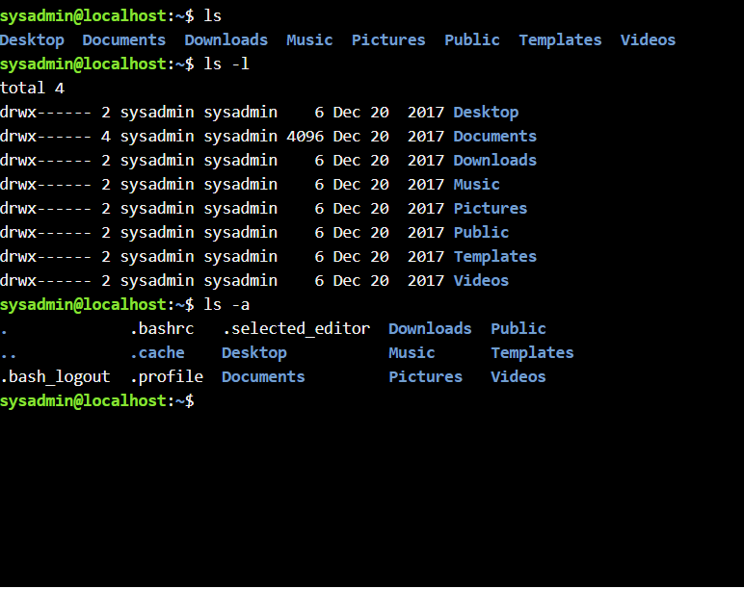
:

Figure 21: Description output command mkdir

Example 6:
Here the command is rmdir (remove and empty directory). The rmdir command deletes an empty directory, and if successful, it no longer appears in the list when you run ls.
r.

Figure 21: Description (output of rmdir command)

Example 7:
The touch command is used to create a new empty file or update the timestamp of an existing file. Typically, it produces no visible output, but the newly created or updated file can be seen when you list files using the ls command.
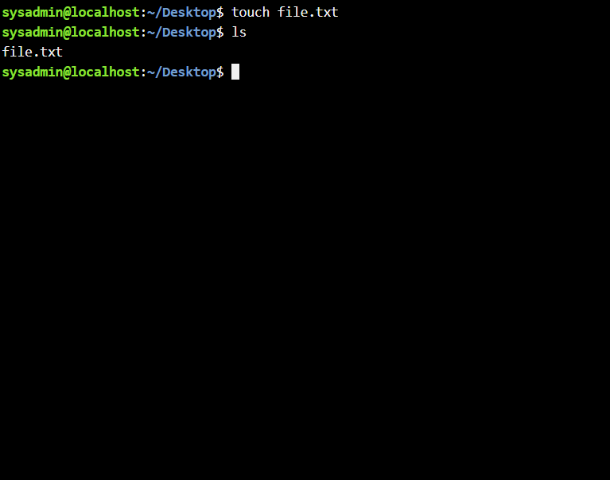
Figure 22: Description (output of touch command)

Example 8:
echo and cat .(write and display file content).
The echo command writes text to a file, and cat displays its contents in the terminal.
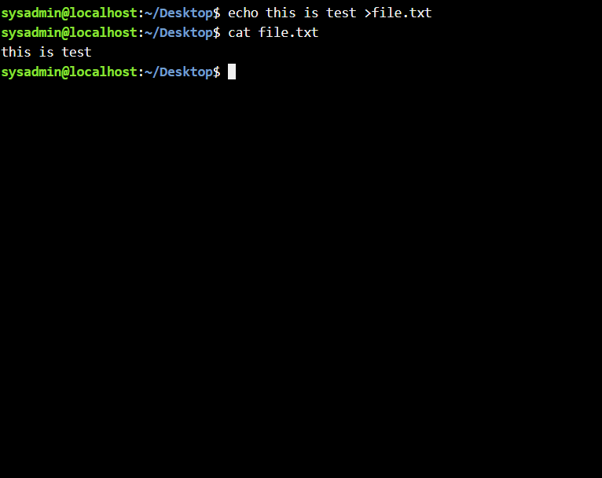ts)

Figure 23: Description (outoput of echo and cat command).

Example 9;- ifconfig (display network interface configuration). ifconfig shows network interface settings, including IP addresses, interfaces, and status for troubleshooting.
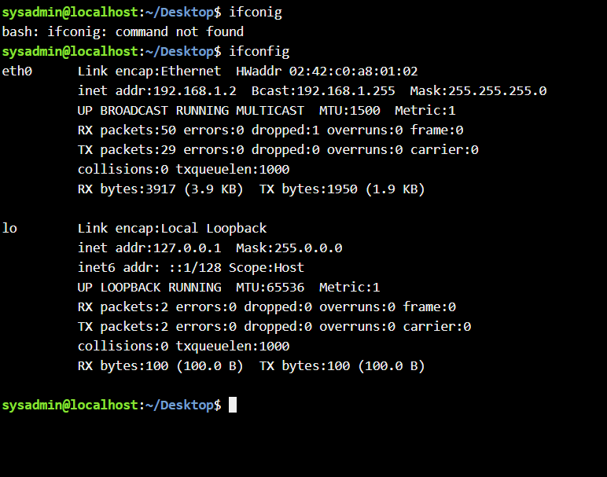
Figure 24: Description (output of ifconfig command

Example 10:
whoami displays the username of the current user. It prints the active account name in the terminal. 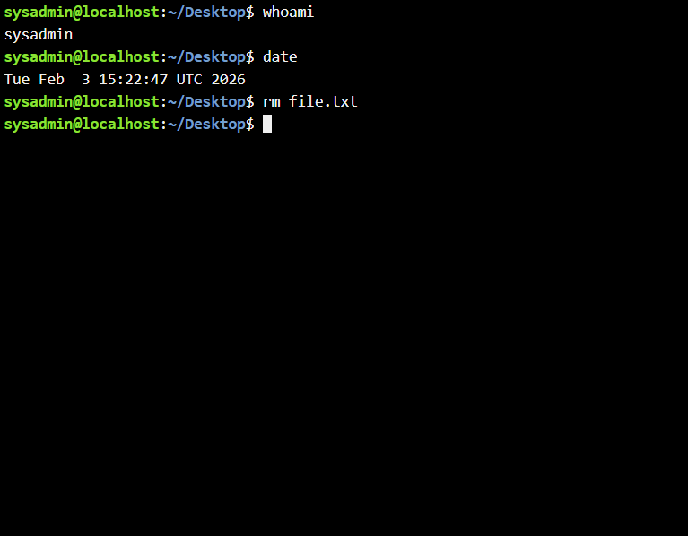

Figure 25: Description (output of whoami command).

Use of Windows OS scripts

Batch scripting automates repetitive tasks through command sequences in .bat files, run by cmd.exe in Windows (41). It efficiently handles file operations and simple configuration updates on servers and local machines (42).
Sequentially executing commands means running multiple batch file instructions one after another (43). Automating file creation and removal within a directory. Gathering outputs and recording results in a file enables efficient system health assessments (44). Diagnostic commands involve linking together multiple commands to gather and evaluate information about a system (45). Deployment scenarios—Helping with basic tasks like software update rollouts (46).

Example 1:

This is the OS script -cd Desktop/ Example 1;- add two numbers
This batch script demonstrates a simple calculation using user input in Windows. After disabling command echo with @echo off, it prompts for two numbers, stores them as num1 and num2, adds them with set/a sum=num1+num2, and displays the result. The pause command keeps the window open for review.
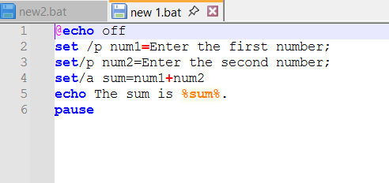
Figure 26: File Description( input of script).

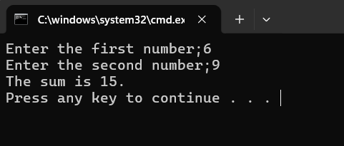
Figure 27: File Description (output of figure26)

Example 2: Voting Age script –
The batch script checks whether a user is old enough to vote based on age they enter. The script begins with @echo off, to keep the output clean by hiding the command lines. The command set/p age =prompts the user to type in their age and stores the value in the variable called age. Thes script then uses an if statement to compare the age entered age with the voting requirements. The condition if %age% geq 18 checks whether the age is greater than or equal to 18. if it is, the script displays the message “You are eligible to vote”. if the age is below than 18, the else section runs and shows “You are not eligible to vote yet”.in the example shown, entering 11 results in the message that the user cannot vote, while entering 56 confirms eligibility.
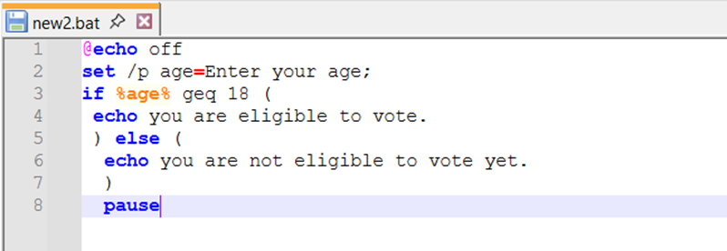
Figure 28: input of script
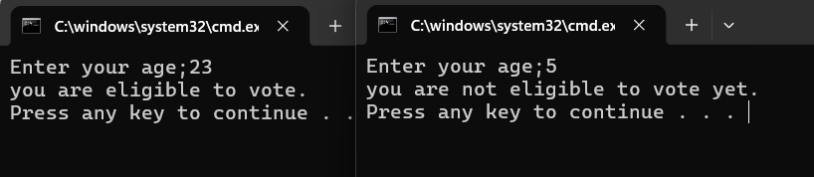
Figure 29: output of figure 29.

LINUX OS SCRIPTS AND APPLICATIONS
Linux operating systems use bash scripting to automate command line tasks (38). Bash scripts are files that contain various commands executed by the Linux shell (39). They allow users to perform repetitive tasks efficiently, such as processing files, executing commands or carrying out calculations (40). Batch scripting is commonly used in system administration and automation (41).

Example 1: Bash script to add 2 numbers.
This bash script adds two numbers entered by the user. It begins by using the echo command, which prints the message “Enter the first number” on the screen. The command read num1 then waits for the user to input a value and store sit in the variable num1. The script repeats the same process for the second number by displaying “enter the second number” and readnum2.to store the input in the variable. Once both numbers have been entered, the script performs the calculation using total=$((num1+num2)). This line adds the two values and stores the result in the variable total. Finally, the echo command displays the result in the terminal with the message the sum is $total.
For example, the user enters 67 and 69, the script correctly calculates and displays the result as 136. This example demonstrates how Bash script can accept user input, perform calculations and display results.

Figure 30: Input of script

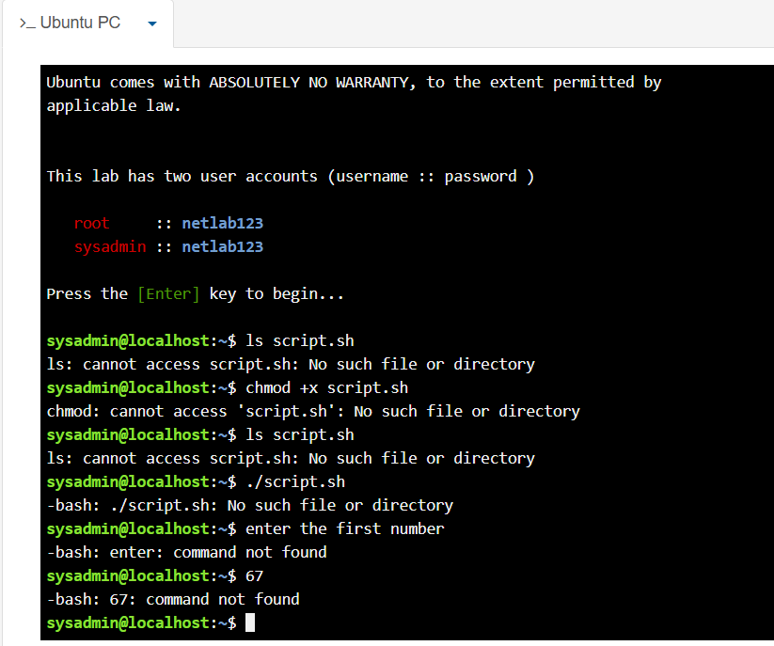

Figure 31: Description output of script figure 30

Example 2: loop -This bash script demonstrates how a loop can be used to automatically repeat commands automatically in Linux. It uses for a loop written as for ((i=;1i<=10; i++)). This loop begins with the value of i set to 1, increases the value by 1on each interaction and stops when it reaches 10.

Inside the loop the command echo “$i” outputs the current value of the variable i. The keywords do and done define the start and end of the loop block.

When the script is executed using ./loop.sh, the loop runs ten times and prints the numbers 1-10 in the terminal. Each number appears on a new line, as shown in the output. in the screenshot shows each number on a separate line.

This example highlights how loops in bash scripting can automate repetitive tasks, allowing commands to be executed multiple times without manually repeating code.

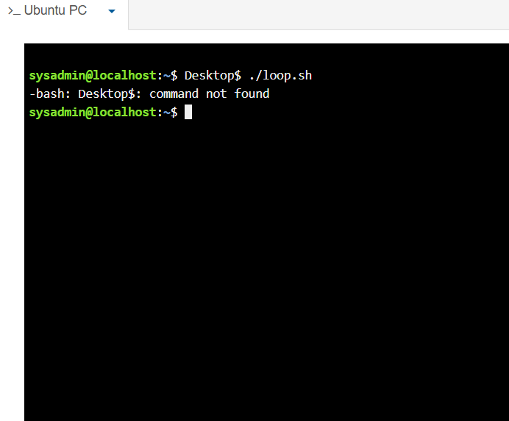

Figure 32;- Input of script
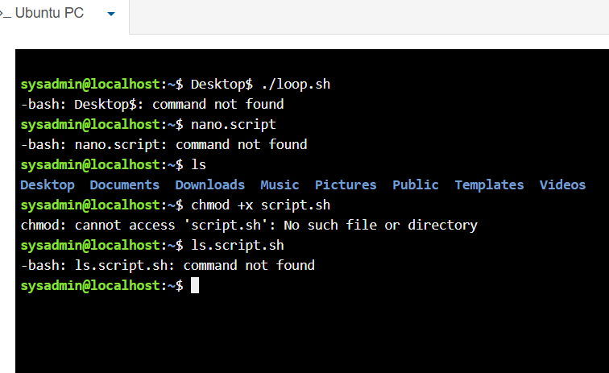
Figure 33: output of figure32

Conclusion
This is a detailed summary of Operating Systems their key functions, windows OS CLI commands, Linux OS CLI commands, use of Windows OS scripts, Linux OS scripts and Applications, BASH scripts.



Figure 34: Certificate of completion

References; -
- W. Stallings, Computer Organization and Architecture, EBook [Global Edition]. Harlow: Pearson Education, Limited, 2021.

- K. C. Laudon and J. P. Laudon, Management information systems : managing the digital firm. Harlow, England: Pearson Education Limited, [] Â, 2020.

(3) D. A. Tevault, The Ultimate Linux Shell Scripting Guide. Packt Publishing Ltd, 2024.

- Dr. Lalit Gupta and Dr. Kumud Rai, Gene Technology, Immunology and Computational Biology (English Edition). Thakur Publication Private Limited, 2023.

