

DISSERTATION- PROPOSAL

Name: AditkumarArvindsingh Rajput
Student ID: 2327679
Course: MBA in International Business
Module: Dissertation (LCMB7035_LON)
Lecturer Name: Tushara Balendran

Contents
INTRODUCTION 3
RATIONALE OF THE STUDY 3
AIM OF THE RESEARCH 3
RESEARCH OBJECTIVES 3
RESEARCH QUESTIONS 4
LITERATURE REVIEW 4
1. DIGITAL MARKETING 4
2. CONSUMER BUYING BEHAVIOUR 5
RESEARCH OBJECTIVES 5
The Race Framework (Digital Marketing) 6
ADVANTAGES OF RACE FRAMEWORK 7
DIS-ADVANTAGES OF RACE FRAMEWORK 7
2. McKinsey’s Consumer Decision Journey Framework 8
ADVANTAGES AND DISADVANTAGES 8
Research Methodology 9
RESEARCH ONION MODEL 10
TYPE OF DATA 11
1. QUANTITATIVE DATA 11
2. QUALITATIVE DATA 11
3. MONO-METHOD 12
SAMPLING TYPE AND ANALYSIS 12
DATA COLLECTION METHOD 13
ANALYSIS OF DATA 13
RESEARCH ETHICS 13
RESOURCES AND PLANNING 14
REFERENCE LIST 15

Research Title: The Influence of Digital Marketing Strategies on Consumer Buying Behavior: “A Comprehensive Analysis of Marks and Spencer’s Retail in the UK”.

Criteria: 1

INTRODUCTION
In the current tech era, the way businesses try to engage with their consumers has been completely revolutionized by digital marketing. The improvement in digital marketing has provided immense opportunities for the business in order to focus more on personalized advertisements, and also they can target the specified segment by using data-driven strategies. In the retail industry, a lot has changed, as has been seen towards e-commerce platforms, and this change has completely transformed consumer buying behavior. The advancements in e-commerce platforms because of digital marketing are reshaping how customers light at the time of purchasing products.

RATIONALE OF THE STUDY
The United Kingdom is one of the largest base consumer markets in the retail sector, and Marks and Spencer’s (M&S) is the leading fashion brand in the country, using digital marketing as a strength element of its main strategy to remain ahead in the fashion industry. This research aims to explore and understand the influence of Marks and Spencer’s digital marketing strategies on consumer buying behavior. However, after analysis of consumer buying behavior and digital marketing, this study will provide useful recommendations for maximizing M&S’s digital marketing strategies, which will help them connect with more consumers and stay competitive in the retail sector. Furthermore, to examine the effectiveness of the strategies also needs an in-depth study on different stages of the buying process in decision making.

AIM OF THE RESEARCH
The main of this research is “To examine how digital marketing strategies used by Marks and Spencer influence consumer buying behavior in the UK.”

RESEARCH OBJECTIVES
There are various research objectives that will be carried out throughout the research.
- To analyze what kind of digital marketing strategies are employed by Marks and Spencer in the UK.
- To investigate the opportunities and challenges for Marks and Spencer implementing digital marketing in the retail sector.
- To evaluate how different digital marketing strategies influence consumer buying behavior.

RESEARCH QUESTIONS
There are some specific research questions that help to understand the aim of the research and also provide the right direction in order to present this research project more accurately.
- What are the current digital marketing strategies Marks and Spencer’s is adopted in the retail industry?
- What are the main challenges and opportunities that are available for Marks and Spencer’s in the retail industry after employing digital market strategies?
- What is the influence of digital marketing on consumer buying behavior?

LITERATURE REVIEW

1. DIGITAL MARKETING
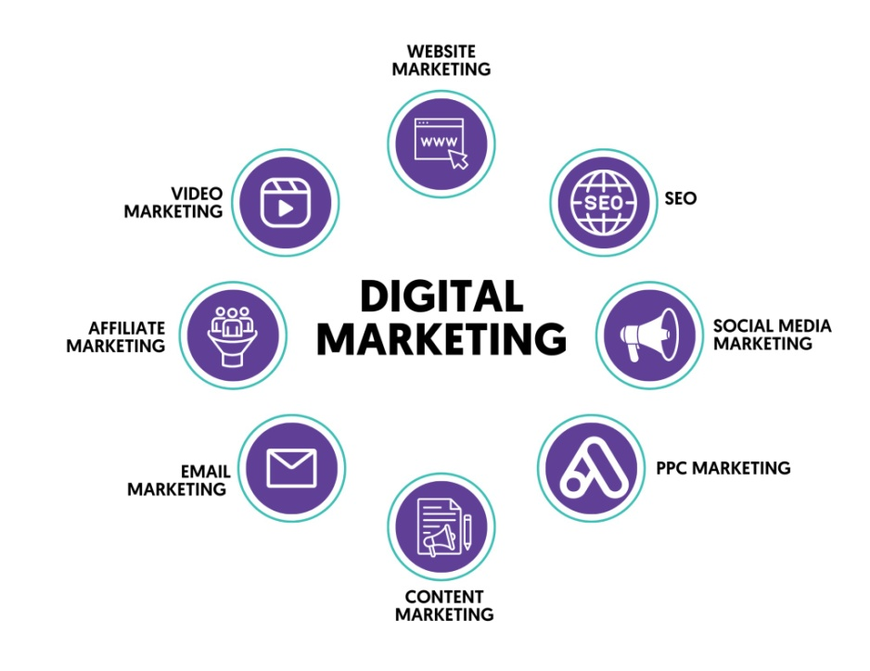
Image Source: https://www.reliablesoft.net/learn-digital-marketing/
There are so many well-known definitions of digital marketing carried out by various authors, but the definition from (Desai (2019) says that all marketing campaigns that utilize electronic devices or the Internet are involved in digital marketing. However, every company is engaging with their current and potential clients via some well-known digital platforms such as websites, social media, email, and search engines. Digital marketing is a digital strategy where businesses spend most of their time with clients, and this is also known as “online marketing,” “internet marketing,” and “web marketing’. On the other hand(Chaffey 2016) indicates that digital marketing is similar as E-marketing. It is a fundamental term which includes the use of technologies to make online channels to help various marketing activities to improve clients’ needs and help businesses to better their relationship with consumer’s.

2. CONSUMER BUYING BEHAVIOUR

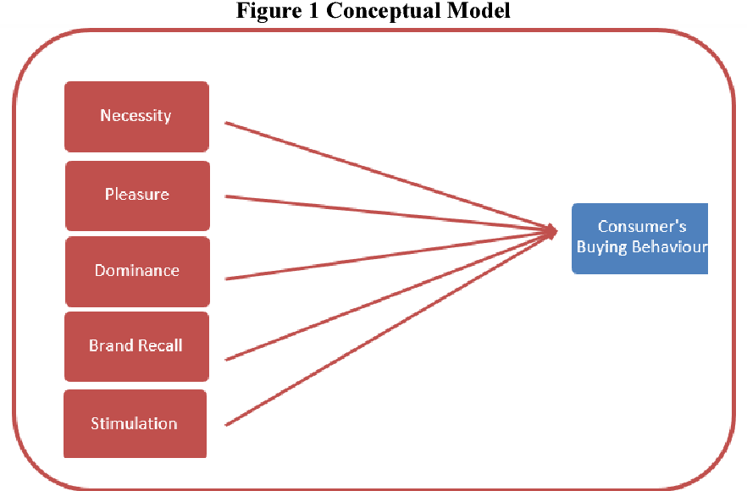
Image Source: https://jethrojeff.com/
There are some well recognized authors and writers described some unique and various definition about consumer buying behaviour and depicts that consumer buying behaviour plays a vital role in the field of marketing. According to (Kotler and Keller (2011), consumer buying behaviour is an integral element of marketing, and it is necessary to study how people, groups, and organizations think at the time of purchasing goods or services to fulfill their needs and wants, and that’s why they define it as an integral element. Meanwhile, (Solomon et al. (1995) defined consumer buying behaviour as a procedure by which independents and a group of people decide to acquire or use goods and services to satisfy their desires and needs, known as consumer buying behaviour (Dudovskiy 2013).

RESEARCH OBJECTIVES
In the dynamic world of technology, digital marketing has given immense support to businesses, whether they are small businesses or big organizations. The companies utilize digital tools such as social media, e-commerce platforms, and other digital platforms to influence consumer buying behaviour. The research objectives will clarify some paramount factors, such as what kind of digital marketing Marks and Spencer is employing in order to attract consumer buying approaches and how they can stay in the competitive business environment.
1. The current digital marketing strategies employ by the Marks and Spencer’s in the fashion industry.
Marks and Spencer’s is well known in the UK for its quality of fashionable clothes and has almost 1000 stores across the UK. The company deeply believes that investing in digital platforms will create a huge difference in its marketing approach and strategies. Marks and Spencer’s vision is to provide a seamless shopping experience to its customers by starting omni-channel retail stores. One of the best and most valuable marketing strategies for M&S is the introduction of its digital shopping app, which has led to around a 33% sales increase in the peak season, and in that, the online sales are giving them more revenue through their app. They also have started click-and-collect services, which will give consumers seamless shopping experience (Team TBH 2024).
2. To investigate the opportunities and challenges for Marks and Spencer implementing digital marketing in the retail sector.
Marks and Spencer’s are a well-established retailer in the UK with a strong brand presence, and there are a lot of opportunities and challenges present for them that could grow and expand the business. The opportunities, such as international expansion, especially in the emerging economic country, to attract more consumers who prefer fashionable clothes. Another one is the investment in e-commerce growth, as they can meet consumer buying needs with ease. Further, M&S can also give attention to sustainability to differentiate the brand from others. On the other hand, there are various challenges for them, like intense competition from their rivals in the retail industry and the change in economic uncertainty, which might affect the overall profit. Lastly, it is seen that the brand is currently struggling to fulfil the demands of consumers even though they started a few initiatives as they failed to recover the profit margin of decreasing sales (The Strategy Story 2023).
3. The influence of different digital marketing on consumer buying behvaiour.
(Institute of Data 2024) indicates that consumer purchasing behavior is a process where an independent person or group of people decides to purchase a product or service. It is important for businesses to understand what kind of digital marketing campaign will influence consumer decision-making power at the time of purchasing the products. There are various elements, such as psychological, social, and economic, which majorly encourage consumer purchasing power. However, the enhancement of digital marketing has completely changed consumer shopping patterns, and the various data-driven digital channels help businesses to identify consumer buying patterns. Thus, digital marketing has become an inverted part of consumer buying behavior and helps them to shop seamlessly.

The Race Framework (Digital Marketing)
The RACE framework was introduced by Dr. Dave Chaffey in 2010. The aim behind to bring this model was mainly for marketing and this model provide simple and effective digital marketing or omni-channel marketing strategies and helps companies to develop better communication plans by utilizing this model in order to attract consumers attentions to increase online and offline sales. The below diagram will indicate the structure of the model and the major goals of its elements, such as Plan, Reach, Act, Convert, and Engage (Chaffey 2023). However, this framework is divided into four stages that provide immense support to brands to connect with their consumers via online marketing activities.
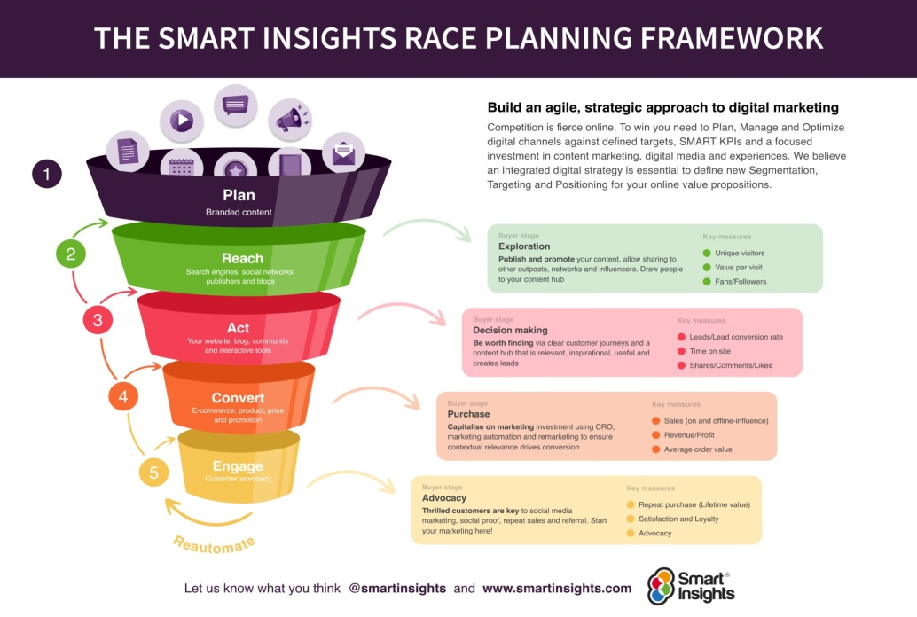
Image Source: https://www.smartinsights.com/digital-marketing-strategy/race-a-practical-framework-to-improve-your-digital-marketing/

ADVANTAGES OF RACE FRAMEWORK
1. The first element of the race model mainly gives attention to raising the brand recognition via different online and offline platforms. It also includes various online platforms such as landing pages, social media pages, and micro sites (Cuofano 2022).
2. This framework also gives well-structured strategies for digital marketing planning. However, big or small businesses can also adopt marketing strategies for excellent results aligning with companies’ specific goals (Cuofano 2022).
3. Another benefit of this model is to capture the large amount of audience to increase brand recognition across the wide audience, and this will increase the user exchange online for purchasing, while this will generate leads for businesses (Cuofano 2022).
4. The theory also depicts that with the help of race model companies can generate more revenue, and this will lead to faster consumer loyalty and also increase the number of existing consumers (Cuofano 2022).

DIS-ADVANTAGES OF RACE FRAMEWORK
1. The first and main drawback of this model is that it required more investment and resources to execute the marketing plans (Mostofi 2024).
2. Another challenging step is to collect the accurate and correct data and for that huge amount of human capital and resources while implementing the data-driven strategies. On the other hand, it is not convenient for every business to get access to a wider audience (Mostofi 2024).
3. To reach wide audience companies might face intense competition from its rivals in the industry and in result this could affect conversion rates as not all users or consumers will agree to convert and share their data (Cuofano 2022).

2. McKinsey’s Consumer Decision Journey Framework
In his research (Kashiv 2024), he depicts the consumer decision journey model, which was introduced by McKinsey in 2009. The ideal concept behind this model was to reflect the continuous changing in consumer buying behaviour aligned with technology advancement. It was a conventional traditional marketing funnel idea that reflects the consumer decision-making process while purchasing the products or services. However, this model was divided into four stages, such as consideration, evaluation, purchase, and post-purchase experience. Later, with the increase in digital platforms and channels, few changes have been seen in the CDJ framework, which also influences consumers online, and they also included the elements like ‘Explore and Engage” to attract people online through social media relationships. McKinsey also started focusing on consumer behaviour and personalised marketing by including data analytics in the CDJ, which gives them in-depth information about the consumer buying process.

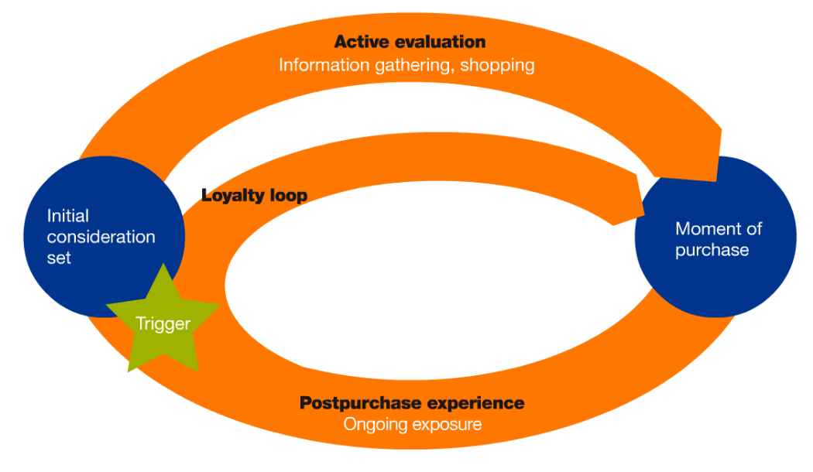
Image source: https://blog.bmtmicro.com/consumer-decision-journey/

ADVANTAGES AND DISADVANATGES
ADVANTAGES
1. Reflects Nonlinear Consumer Behaviour: McKinsey CDJ model gives more attention on the nonlinear nature consumer and modern thinking of consumer decision process. The model replicates that while purchasing products, consumers engage with various brands, and sometimes, they revisit the brand that attracts them more in their decision journey, and because of this model, it allows companies to plan according to consumers’ needs and wants (Kashiv 2024).
2. Post-Product Experience: This is the most vital component and benefit of this model, as they value more about the customer post-product experience. This model considers the consumer’s whole purchasing journey by involving the after sale so that businesses can maintain a good and long-term relationship with consumers and track consumers loyalty towards the brand (Kashiv 2024).
3. Adaptable for various industries: Another benefit of McKinsey’s CDJ model is its flexible framework, and this can be utilised in any industry, market, and target segment. However, because of this adaptable nature of the framework, this model is an essential tool for businesses to identify different consumers’ needs and perspectives (Kashiv 2024).
DISADVANATGES
1. McKinsey’s CDJ model faces some challenges, like this tool does not give much attention to creating effective advertising for initial brand awareness, while rather this focuses more on an initial consideration. It is necessary for brands to make touch point strategies to create hype about their products to attract the consumers (Edison 2019).
2. Another limitation of this model is overspending the efforts on post purchase experience by neglecting the various brand experiences and just focusing on existence brand purchase action (Edison 2019).
3. The consumer decision journey covers various aspects such as awareness, assessment, and purchasing actions, but it also limits the emotional factor of the consumer at the time of decision-making. Emotional behaviour is one of the key elements for customers while purchasing the products and this factor is not explained much on this model (Kashiv 2024).
Overall, McKinsey’s consumer decision journey model provides valuable information about the wide range of consumer behaviour while making decisions, and it is paramount to understand the benefits and limits of this model so that businesses can utilise this model effectively while connecting with consumer segments.

CRITERIA: 2

Research Methodology
(Sreekumar 2023) says that a research methodology indicates the methods and process widely used to find and examine data associated with a specific research study topic. Researchers use this method or process to track their study so that they can select the chosen research tools to achieve their objective research goals. It consists of all the important elements of research, for example, data collection, analysis techniques, the research design, and the selected general framework in which the study goals can be carried out. All these factors will provide you with information about what research methodology is and why it is crucial to select proper and suitable techniques.

RESEARCH ONION MODEL
Definition: The Research Onion model was introduced by Saunders in 2007. This model illustrates various decisions that will help to make appropriate research methodology. The external onion model describes a range of options that advance from high-level, which consists of philosophical, tactical, and practical in nature. This theory also helps to showcase the general progress for the methodology chapter. On the other hand, this model is not quite perfect, even though it’s a valuable tool for thinking comprehensively about methodology. There are various elements in the research onion model, such as philosophies, approaches, strategies, choices, time horizons, and techniques and procedures (Phair & Warren 2021).
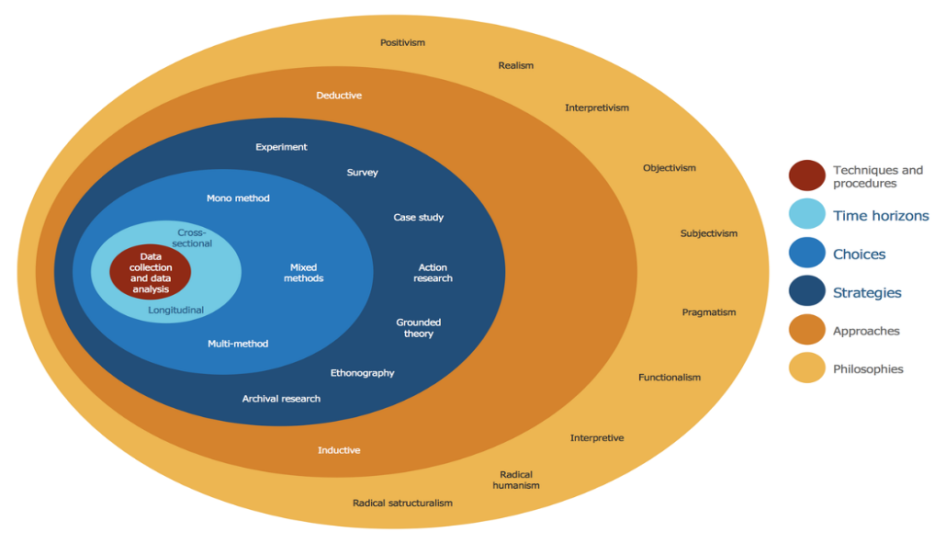
Image source: https://www.linkedin.com/pulse/exploring-depths-research-design-revealing-layers-onion-borg-ellul/
1. Research Philosophies- Positivism
The first element of the onion model is research philosophy. This is the first and important element, which is the foundation for any study. Positivist research maintains an opinion that knowledge is not restricted to the topic of analysis. The researcher does not illuminate; they rather observe; in other words, the investigation must be carried out objectively and cannot include personal opinions. Positivism claims that all meaning is accordant throughout the subject and that there is just a single reality. According to positivism, empirical research, which depends on measurement and observation, is the only way to get knowledge. However, it is declared in a various way that all knowledge belongs to posteriori knowledge instead of human reasoning. For the positivist, knowledge is either true, incorrect, or meaningless(Phair & Warren 2021).
2. Research Approach: Deductive
The deductive approach formulates the research procedure to test the prediction or theories founded on an existing theory (Silverman, 2013). The positivist approach makes it possible for the development of ideas and the statistical examination of projected results to a specified amount of probability and can be considered as being particularly suitable to the deductive approach (Snieder & Larner 2009). It is described as a shift from general to specific; the knowledge obtained within the research process is evaluated against the general theory and knowledge base once it has been developed (Kothari 2004). However, the expectation generated by previous research would be formulated somewhat through testing hypotheses; a deductive method can also be compatible with qualitative research methods. According to Saunders et al. (2007), by developing an awareness of observation through surveys, the deductive method allows you to compare different people’s opinions using empirical evidence. The process can be replicated depending on the data gathered to support or dispute the questions(Thesismind 2019).

TYPE OF DATA
Definition: Any information that has been acquired, observed, or generated with the intent to bolster initial study findings is counted as research data. It’s crucial to put together research data that is suitable for processing, interpretation, and communication. There are so many variables in data available, such as digital and physical data (Ko 2024).

1.QUANTITATIVE DATA
In quantitative analysis, the data is expressed in numerical format so that it can be counted or measured. The data is derived from experiments, surveys, market reports, matrices, and some other resources. Quantitative data is more objective and conclusive in nature; it indicates the results as well as expressed in numbers. The gathering of data depends on how much the quantity is. For example, age, height, weight, temperature, and income. The quantitative data are counted as fixed and universal (GeeksforGeeks 2021).

2. QUALITATIVE DATA
Qualitative data are the ones obtained utilizing categorical variables. The nature of qualitative data is more conceptual and informative. This evaluates the information based on the data type, collection, or category. However, the data collection relies on what type of quality is provided. The qualitative data has been separated into multiple categories based on elements. The information collected through these kinds of studies or analyses can be applied to perceptions, theorization, and the formulation of creative theories. Texts, documents, audio and video recordings, transcripts, and other resources are taken to collect these data (GeeksforGeeks 2021).

3. MONO-METHODQUANTITATIVE
In this research, the focus will be on mono-method quantitative which completely relies on the quantitative data for investigation.The Mono method is the practice of performing research that uses just a single approach or plan. It demonstrates the fact that toanalyze the data, researchers depend on a particular approach, such as quantitative or qualitative(Statswork 2023).

SAMPLING TYPE AND ANALYSIS
1.SAMPLING
According to Hassan (2024b), in research, sampling is a crucial process that allows researchers to reach conclusions about larger groups by examining more manageable, smaller elements. To be able to gather accurate, representative data without interviewing the entire population, sampling strategies are essential. To help you identify the most effective strategy for your research area, this article covers various kinds of sampling methods and crucial strategies.
2. SAMPLE SIZE
In this research, the aim is to include 50 participants, consisting of employees from Marks and Spencer and students from the University of Wales Trinity Saint David, London campus. To provide more accurate representation from both points of view, students as well as staff members from the retail sector.
3. SAMPLE TYPE
In her article (Bisht 2023), the intentional selection of an individual or a selected group of people from a wider population with the aim of extracting statistical findings and projecting the characteristics of the entire sample is referred to as sample type. There are various kinds of sampling methods available that provide accurate data based on people's age, gender, income, education, and geographic location. However, the selected group of people will be of both genders, and the age will be from 20 to 45. The focus will be more on the people who live in London for a more accurate survey, and the selected students will be studying at the University of Wales Saint Trinity David, pursuing an MBA international business course Level 6 to 7.
4. SAMPLING METHOD
In this study, the attention will be on two sampling methods, such as probability sampling and cluster sampling. According to Bisht (2023), each element in the population has an equal chance of being selected for the final sample regardless of this sampling method. This is also referred to as random sampling, and it illustrates how samples are generated at random and with non-zero probability. While, on the other hand, the population is divided into clusters through this sampling method, and a random sample of the clusters is then added to the final sample.

DATA COLLECTION METHOD
In this research, we are going to use the Google form for creating the online questionnaire that is going to involve in this research. In terms of questions, there will be around ten closed-ended questions for participants, and for that, they will have 8 to 10 minutes to answer the questions.

ANALYSIS OF DATA
To analyze the data, Microsoft Excel will be utilized for evaluating the collected survey data using a quantitative mono-method approach. To identify patterns in consumer behavior, the data will be arranged, cleaned, and analyzed using a descriptive statistical approach. The trends will be represented using graphs, charts, or tables, which will depict how well M&S’s digital marketing strategies affect working on consumer decision-making.

RESEARCH ETHICS
Research ethics comprises norms for activity along with discussions about how to differentiate between good and unacceptable conduct in research. A lot of individuals believe that specific regulations, like respect for life, are universal since them applicable to all cultures (Leonardo D. de Castro 2015). In order to relate with this study, it will be ensured that the primary collected data will be confidential throughout the research and the data will be maintained and safeguarded.

RESOURCES AND PLANNING
A Gantt chart is a tool that manages and shows your planning for the research or project and helps with scheduling and overseeing projects of every sort. It is particularly valuable for visualizing projects. Researchers and project managers utilize a Gantt chart, which serves as a graphical representation of tasks performed against the time, for measuring progress (APM 2021).

TASK | WEEK TIMELINE
 | 1 | 2 | 3 | 4 | 5 | 6 | 7 | 8 | 9 | 10 | 11 | 12 | 13 | 14 | 15 | 16
1. Introduction
2. Literature Review
3. Research
Methodology
4. Survey Questions and interviews
5. Collecting data
6. Analysis of data
7. Discussion of data
8. Conclusion and Recommendation

Figure source: Personal Gantt chart (Designed by myself )

REFERENCE LIST
APM 2021, What Is a Gantt chart? | APM, Apm.org.uk, Association for Project Management, viewed 13 February 2025, <https://www.apm.org.uk/resources/find-a-resource/gantt-chart/>.
Bisht, R 2023, What Are Sampling Methods? Techniques, Types, and Examples | Researcher Life, Researcher.life, viewed 2 February 2025, <https://researcher.life/blog/article/what-are-sampling-methods-techniques-types-and-examples/>.
Chaffey, D 2016, Definitions of Emarketing vs Internet vs Digital marketing, Smart Insights, viewed 16 January 2025, <https://www.smartinsights.com/digital-marketing-strategy/online-marketing-mix/definitions-of-emarketing-vs-internet-vs-digital-marketing/>.
― 2023, RACE Marketing Model, Dr Dave Chaffey: Digital Insights, viewed 22 January 2025, <https://www.davechaffey.com/digital-marketing-glossary/race-marketing-planning-model/>.
Cuofano, G 2022, What is the RACE model?, FourWeekMBA, viewed 22 January 2025, <https://fourweekmba.com/race-model/>.
Desai, V 2019, Digital Marketing: a Review, ResearchGate, www.researchgate.net, viewed 16 January 2025, <https://www.researchgate.net/publication/333709419_Digital_Marketing_A_Review>.
Dudovskiy, J 2013, Consumer Buyer Behaviour Definition - Research Methodology, Business Research Methodology, viewed 16 January 2025, <https://research-methodology.net/consumer-buyer-behaviour-definition/>.
Edison, B 2019, Evaluating the Mckinsey Model for The Consumer Journey, www.linkedin.com, viewed 27 January 2025, <https://www.linkedin.com/pulse/evaluating-mckinsey-model-consumer-journey-barry-edison/>.
GeeksforGeeks 2021, Difference between Qualitative and Quantitative Data, GeeksforGeeks, viewed 1 February 2025, <https://www.geeksforgeeks.org/difference-between-qualitative-and-quantitative-data/>.
Hassan, M 2024a, Mixed Methods Research - Types & Analysis, Research Method, viewed 1 February 2025, <https://researchmethod.net/mixed-methods-research/>.
― 2024b, Sampling Methods - Types, Examples, Research Method, viewed 2 February 2025, <https://researchmethod.net/sampling-methods/>.
Institute of Data 2024, The Power In Being Proficient In Consumer Behavior and Digital Marketing | Institute of Data, The Power In Being Proficient In Consumer Behavior and Digital Marketing, viewed 17 January 2025, <https://www.institutedata.com/us/blog/consumer-behavior-and-digital-marketing/>.
Kashiv, M 2024, ‘“Deciphering Consumer Behavior: A Comparative Analysis of Kotler’s and McKinsey’s Models with Insights from Customer Analysis”’, International Journal of Creative Research Thoughts, vol. 12, no. 2320-2822, pp. 2320–2882, viewed 27 January 2025, <https://www.ijcrt.org/download.php?file=IJCRT24A4197.pdf>.
Ko, J 2024, Guides: Research Data Management: What is data?, guides.library.unisa.edu.au, viewed 1 February 2025, <https://guides.library.unisa.edu.au/ResearchDataManagement/WhatIsData>.
Leonardo D. de Castro 2015, Research Ethics - an overview | ScienceDirect Topics, www.sciencedirect.com, viewed 13 February 2025, <https://www.sciencedirect.com/topics/social-sciences/research-ethics>.
Mostofi, A 2024, What is the Race model in digital marketing?, itroz, Ashkan Mostofi, viewed 22 January 2025, <https://www.itroz.com/en/blog/what-is-the-race-model-in-digital-marketing/>.
Phair, D & Warren, K 2021, Saunders’ Research Onion: Explained Simply, Grad Coach, viewed 29 January 2025, <https://gradcoach.com/saunders-research-onion/>.
Sreekumar, D 2023, What is research methodology? Definition, types, and examples | paperpal, Paperpal, viewed 29 January 2025, <https://paperpal.com/blog/academic-writing-guides/what-is-research-methodology>.
Statswork 2023, Qualitative research – statswork, www.statswork.com, viewed 13 February 2025, <https://www.statswork.com/insights/sample-work/research-methodology/qualitative-research/>.
Team TBH 2024, Exploring Marketing Strategies of Marks & Spencer (M&S), The Brand Hopper, viewed 17 January 2025, <https://thebrandhopper.com/2024/08/10/exploring-marketing-strategies-of-marks-spencer-ms/#google_vignette>.
The Strategy Story 2023, Marks and Spencer (M&S) SWOT Analysis - the Strategy Story, The Strategy Story, viewed 17 January 2025, <https://thestrategystory.com/blog/marks-and-spencer-ms-swot-analysis/#google_vignette>.
Thesismind 2019, Analysis of Saunders Research Onion, Thesismind, viewed 29 January 2025, <https://thesismind.com/analysis-of-saunders-research-onion/>.

