University of Wales Trinity Saint David

School of Engineering



Passive RC Filter Network Analysis

Electrical & Electronic Principles

(ACDB4002)

Rachel Williams

2208603

April 2023

Abstract
Detailed in this report is an analysis of two circuits containing passive filters to determine the attenuation of the filters. Theoretical predictions were calculated and displayed in bode magnitude plots. The experimental results were acquired by slowly increasing the frequency of the input signal using a function generator. To measure the output voltage for the low pass filter, an oscilloscope was placed across the capacitor. This oscilloscope was placed across the resistor for the output voltage of the high pass filter. The output voltage was noted for each selected value of frequency.
The output voltage measured was slightly smaller than the predicated value, for both the high-pass and low-pass filter circuits. This variance led to an investigation of what could cause the measured output voltage to be smaller than predicted. The possible causes considered include; the tolerance of the resistor, accuracy of equipment, and energy losses.
In order to further investigate the possibility of the tolerance of the resistor causing discrepancies in the results, the output voltage was recalculated to find maximum and minimum values within the +/-5% tolerance of the resistor.
The recalculated values of the output voltage were larger than the measured output voltage; this indicated that a secondary factor of the 3 listed was impacting the calculations or the circuits alongside the tolerance of the resistor.

Contents

1 Abstract 2
2 Contents 3
3 Introduction 5
3.1 Broad Aim 5
3.1.1 Objectives 5
4 Literature review 6
4.1 Low pass filters 6
Figure 1- Low Pass Filter Circuit (Mark Whiteley, 2002) 6
4.2 High pass filters 6
Figure 2 - High Pass Filter Circuit (Gupta, 2018) 6
4.3 Bode plots 7
Equation 1- Equation for attenuation (Ellingson, 2019) 7
5 Methodology 8
5.1 Circuit descriptions 8
5.2 Calculations 8
6 Results 10
6.1 Low pass filter 10
Figure 3-Practical output voltage of the low pass filter 10
Figure 4-Predicted output voltage of the low pass filter 10
Figure 5-Practical attenuation of the low pass filter 11
Figure 6-Predicted attenuation of the low pass filter 11
Figure 7- Series 1-Predicted output voltage (+5% resistance to resistor), Series 2- Predicted output voltage (-5% resistance to resistor, Series 3-Practical output voltage measured 12
6.2 High pass filter 13
Figure 8-Practical output voltage of the high pass filter 13
Figure 9-Predicted output voltage of the high pass filter 13
Figure 10-Series 1-Predicted output voltage (+5% resistance to resistor), Series 2- Predicted output voltage (-5% resistance to resistor, Series 3-Practical output voltage measured 14
Figure 11-Practical attenuation of the high pass filter 14
Figure 12-Predicted attenuation of the high pass filter 15
7 Discussion 16
8 Conclusions 18
9 References 19
10 Appendices 19
10.1 Appendix 1 19
Table 1- Theoretical Results Low Pass Filter 19
Table 2-Theoretical Results High Pass Filter 20
Table 3-Practical Results Low Pass Filter 21
Table 4-Practical Results High Pass Filter 22
10.2 Appendix 2 23
Table 5-Incorperation of the 5% tolerance of the resistor the output voltage values (Low pass filter) 23
Table 6-Incorperation of the 5% tolerance of the resistor the output voltage values (High pass filter) 24

Introduction
High pass and low pass filters are passive components used to filter AC signals of unwanted frequencies above or below a certain threshold. The range of frequencies transmitted by passive filters is referred to as the passband, the band of frequencies blocked by the passive filters is referred to as the stopband. A passive filters cut-off frequency is displayed by where the passband and stopband meet.
Low pass filters operate by blocking frequencies above its cut-off frequency, and transmitting signals lower than its cut-off frequency. High pass filters operate as the opposite, transmitting signals higher than its cut-off frequency, and blocking frequencies below its cut-off frequency (Huelsman, 2003). One common use for low pass filters include anti-aliasing before an analogue-to-digital conversion (Thompson, 2014).
Low pass filters and high pass filters are noted as useful tools in sound design via subtractive synthesis (Mantione, 2018). In this application the filters are used to adjust the sound of a signal as they eliminate signals above or below their cut-off frequency, resulting in a different sound.

Broad Aim
Included in this report are the results of applying voltage at varying frequencies across a circuit containing a high pass filter and a circuit containing a low pass filter. Also analysed was how the experimental results compare to the theoretical values calculated, and any possible causes for inconsistencies between the two.

Objectives
- Introduce the concepts and principles of passive filters
- Predict in which way the filters will react to the varying frequency using theoretical knowledge
- Create circuits for the output voltage of the filters to be analysed
- Note methodology for practical work
- Calculate the attenuation
- Calculate the cut-off frequencies of the high and low pass filters
- Compare the practical results to the theoretical ideas and predictions

Literature review
To give a brief overview of the topics included in this report, noted in this document is research conducted on the topic of passive filters.

Low pass filters
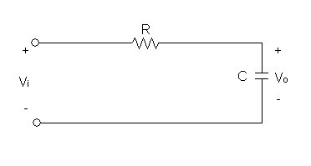
Figure 1- Low Pass Filter Circuit (Mark Whiteley, 2002)
As displayed in figure 1, a low pass filter consists of a circuit where a capacitor is preceded by a resistor (Mark Whiteley, 2002). The output voltage is the voltage across the capacitor. Low pass filters can filter high frequency signals due to the capacitor in the circuit posing high reactance to low frequencies, meaning the voltage across the capacitor will be at its maximum at the lowest frequencies. As the frequency of the signal increases the capacitive reactance falls until the frequency reaches the filters cut-off frequency, once this value of frequency has been surpassed, the voltage across the capacitor will rise to be equal to the input voltage. At high frequencies the low capacitive reactance leads to a low voltage across the capacitor and an increased voltage across the resistor. (Boston University, 2019)

High pass filters
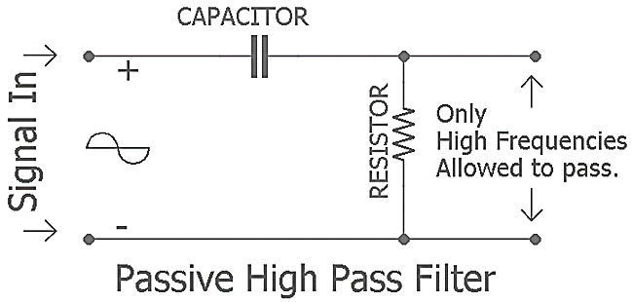
Figure 2 – High Pass Filter Circuit (Gupta, 2018)
As shown in figure 2, a high pass filter consists of a circuit where a capacitor is proceeded by a resistor. For a high pass filter the voltage across the resistor is equal to the output voltage. Gupta explains in an article that a high pass filter operates as the exact opposite of a low pass filter in that it eliminates all signals with frequencies below its cut-off frequency. (Gupta, 2018) This is due to the resistance of the resistor being proportional to the frequency of the signal. This will effectively reduce the resistance to be close to zero at very low frequencies, meaning almost no voltage across the output. As the frequency increases the resistance of the resistor will increase causing the voltage across the output to increase.

Bode plots
The output voltage can be plotted against the frequency of the input signal, the name of this graph is the bode magnitude plot
Equation 1- Equation for attenuation (Ellingson, 2019)
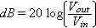

An important point displayed upon the bode plots is the display of the cut-off frequency. This point is equal to the frequency when the $\frac{input voltage}{output voltage}=0.707$, or -3dB when converted to decibels (Chuan-Zheng Lee, 2017). This will be a point of comparison for the practical results to the predicted results.

Methodology

Circuit descriptions
In order to compare the calculated values of the attenuation to the theoretical values, it was necessary to measure the change of the output voltage as the frequency was adjusted.
To calculate the attenuation values of the circuits, a peak-to-peak input voltage of 10V was applied across the high and low pass filter circuits, the frequency of the input voltage was then set at various values ranging from 100Hz to 300kHz and the output voltage of the circuit was noted. The same input voltage was used in calculating the theoretical attenuation. The low pass filter circuit consisted of a 10kΩ resistor followed by a 560pF capacitor. The high pass filter circuit consisted of a 15nF capacitor followed by a 10kΩ resistor.

Calculations
As seen in equation 1 the attenuation relies upon the input and output voltage. First the total impedance of the circuit was calculated, in order to calculate the output voltage for the differing values of frequency was calculated for the two circuits. First the capacitive reactance was calculated, which is given by;
$$X_{C}=\frac{1}{ωC}$$
(D.I.Crecraft, 1993)
Where $ω=2πf$
As capacitive reactance is 90˚ out of phase with the resistance, the Pythagorean theorem can be implemented so that;
$$Z=\sqrt{(R^{2}+X_{C}^{ 2})}$$
Where Z=Total impedance of the circuit.
The output voltage for the low pass filter is given by;
$$V_{out}=V_{in}\frac{X_{C}}{Z}$$
The output voltage for the high pass filter is given by;
$$V_{out}=V_{in}\frac{R}{Z}$$

From the output voltage the attenuation was calculated using the equation;
$$Attenuation=20\log_{10}{\frac{V_{out}}{V_{in}}}$$
(D.I.Crecraft, 1993)

Results
Included in this section is graphic representations of the predicted and practical results for the high and low pass filters, for the data in table format see appendix 1.

Low pass filter
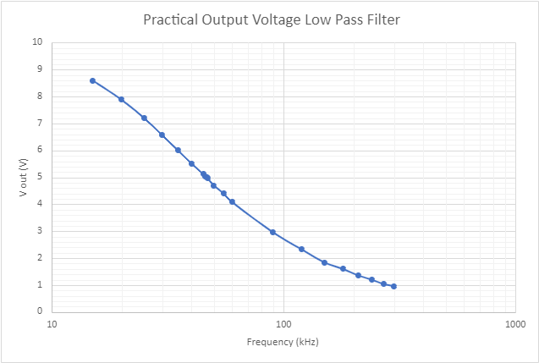
Figure 3-Practical output voltage of the low pass filter
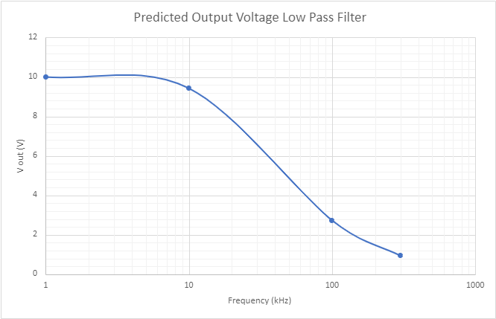

Figure 4-Predicted output voltage of the low pass filter
Displayed in figures 4 and 5 are the voltage values for varying frequencies across the low pass filter circuit. In figure 5 there is a rise in the predicted output voltage between 2kHz and 7 kHz, this is an error with the software used to create these graphs, the output voltage would not increase beyond 10V. However, overall the values for the predicted output voltage (figure 5) and the practical output voltage (figure 4) beyond 10kHz are similar.
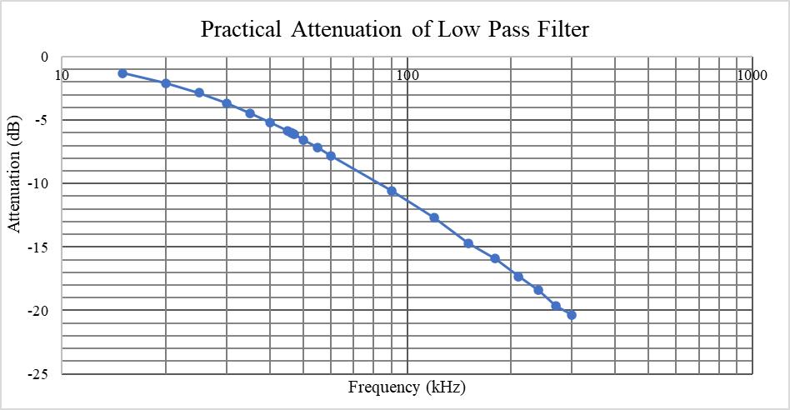
Figure 5-Practical attenuation of the low pass filter
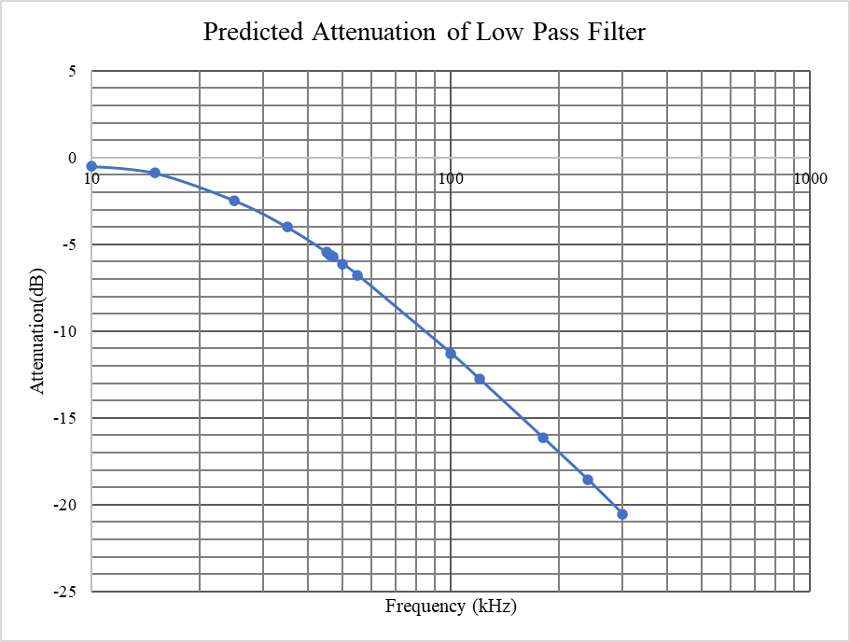

Figure 6-Predicted attenuation of the low pass filter
Displayed in figure 6 and 7 are the predicted and practical values of attenuation for the low pass filter circuit. From figure 6 and 7 the cut-off frequency was determined by finding the value of the frequency where the attenuation was equal to -3dB, as noted earlier in this report (4.3 Bode Plots). The predicted value for the cut off frequency for the low pass filter was roughly 28kHz. The practical cut off frequency for the low pass filter was roughly 27kHz.

Figure 7- Series 1-Predicted output voltage (+5% resistance to resistor), Series 2- Predicted output voltage (-5% resistance to resistor, Series 3-Practical output voltage measured
Displayed in figure 11 is the predicted output voltage (+5% and -5% resistance to the resistor) and the practical output voltage measured. From figure 11 it can be determined that at higher frequencies the tolerance of the resistor could be the reason for the variance of the predicted values from the practical results. However, figure 11 also displays that the tolerance of the resistor does not account for the discrepancies in the results under 30kHz, as the practical output voltage falls below the minimum calculated voltage.

High pass filter
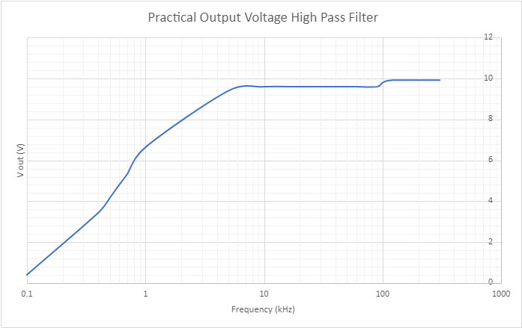
Figure 8-Practical output voltage of the high pass filter

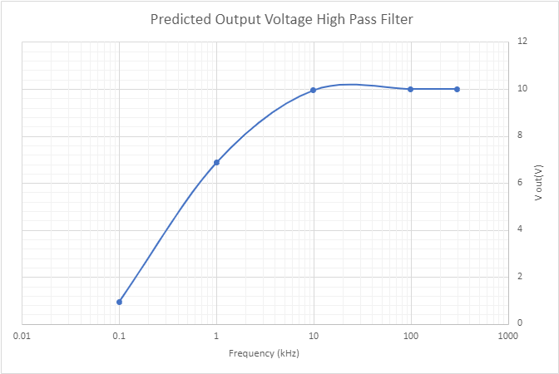
Figure 9-Predicted output voltage of the high pass filter
Displayed in figures 8 and 9 are the voltage values for varying frequencies across the high pass filter circuit. Similar to figure 5, the value of the predicted voltage in figure 9 also rises above 10V, which would not be possible, due to the law of conservation of energy. Seen in figure 8 is another software issue, as the voltage should rise in the shape of an exponential curve.

Figure 10-Series 1-Predicted output voltage (+5% resistance to resistor), Series 2- Predicted output voltage (-5% resistance to resistor, Series 3-Practical output voltage measured
Seen in figure 10 between 0.1 kHz and 0.4kHz is that the predicted output voltage is outside of the maximum and minimum output voltages determined by the tolerance of the resistor. This displays that the tolerance of the resistor is not the only factor affecting the differing results.

Figure 11-Practical attenuation of the high pass filter

Figure 12-Predicted attenuation of the high pass filter
Similar to figures 6 and 7, the cut off frequency for the high pass filter will be determined from figures 10 and 11.
The predicted and the practical values determined for this frequency from figures 10 and 11 was roughly 1 kHz.

Discussion
Comparing figure 5,6,7 and 8 slight differences can be seen in the practical results and the predicted values. The highest output voltage achieved by the low pass filter was 8.6V. The highest voltage achieved in the predicted results was 10V.
A factor to consider when comparing the predictions to the practical results is the accuracy of the equipment. For example, in the predictions the tolerances of the resistor were not considered. The +/-5% tolerance of the resistor was applied to the predicted results. For frequencies below 120kHz, a 5% increase of the resistance of the resistor brought the predicted values closer to the values of the practical results. However as displayed in figure 7, below 30kHz the predicted output voltage after accounting for the 5% tolerance of the resistor was larger than the output voltage measured. This indicated that there are multiple factors affecting the results at once, for example the prediction calculations assumed ideal conditions, such as no internal resistance of the wires and no energy losses. These factors show the inaccuracy of the predicted results. The scale of the impact of disregarding the internal resistance of the wires had on the results would be determined by the material the wires are composed of, and could be calculated and accounted for if the experiment were to be conducted again. Once the frequency surpassed 120kHz, the original predicted values, where the tolerance had been disregarded, became closer in value to the practical results. See appendix 2 for values.
As displayed in figure 10, the practical results did not lie within the maximum and minimum values of the predicted voltage for the high pass filter. This indicates that the tolerance of the resistor is not the only factor causing the discrepancy between the predicted values and the practical results.
Heat loss is another factor that could be contributing to the difference in the results, this is caused by energy escaping the circuit in the form of heat, and would cause the output voltage to be smaller than anticipated.
A final factor that could interfere with the results is the presence of parasitic induction within the resistor. The presence of induction would decrease the overall reactance of the circuit, as the presence of capacitive reactance and inductive reactance would cause electrical resonance. This would cause an increase in the practical voltage in comparison to the predications, however my results show my predicted values are higher than my practical results, therefore unlikely this factor is having a significant impact on the circuit. Another argument for the unlikelihood of the effect of parasitic inductance being a contributor to the difference it is negligible at the frequencies used in conducting this experiment.
The cut-off frequencies for the low pass filter determined from figures 6 and 7 were similar, however there was a slight difference displayed. The cut off frequencies for the high pass filter determined in figures 10 and 11 were in complete agreement. The difference of the low pass filter cut-off frequencies could be due to human error causing an incorrect reading of the output voltage. A reason for this suggestion as a cause is due to the alignment of the high pass filter cut off-frequencies, this eliminates faulty equipment or miscalculations as causes.

Conclusions
To conclude, this investigation determined the cut off frequencies of a high pass filter and a low pass filter through practically acquired data. This data was compared to theoretically determined values, in order to review the accuracy of the theoretical method of calculating the cut-off frequency for passive filters, the practical results were compared to the theoretical predictions.
It was determined that a low pass filter, consisting of a 10kΩ resistor and a 560pF capacitor with an input voltage of 10V, the cut-off frequency is between 27 and 28kHz. Also determined was that a high pass filter, consisting of a 10kΩ resistor, a 15 nF capacitor and an input voltage of 10V, has a cut-off frequency of 1kHz.
There were 4 factors in total that were considered to have possibly caused the variance between the practical results and the predicted values. One of these factors included the disregard of the tolerance of the resistor within the predicted values. To attempt to confirm if this factor could be the main contributor to the variance, the tolerance of the resistor was applied to the calculations and the predicted values adjusted. The new predicted values were then compared again to the practical results to discover if they were now in agreement. See appendix 2 for the original predicted output voltage, the maximum and minimum output voltages based on the tolerance of the resistor. For ease of comparison the practical values for the output voltages were also included.
By reviewing the values determined and how they compare to the predicted values, the theoretical methods used to calculate the attenuation and cut off frequencies of the passive filters were accurate to an extent, however there are many factors that may affect the accuracy of the values. Examples of this are the losses noted in section 7. Effective methods to improve upon the accuracy of the results would be to attempt to insulate the wires more efficiently, and to account for the internal resistance of the wires within the calculations for the predicted values. Due to the software issues encountered with excel in the creation of the bode magnitude plots during this investigation, it is recommended that the data is input and graphs formulated via MATLAB. Plotting the bode plots in MATLAB would allow for abscissa lines to be added, and exact values for the cut-off frequencies be determined.

References
Boston University. (2019, September 20). High-pass filter. Retrieved from http://physics.bu.edu: http://physics.bu.edu/~duffy/semester2/d21_filters.html#:~:text=The%20capacitive%20reactance%20of%20the,frequencies%20the%20opposite%20is%20true.
Chuan-Zheng Lee, S. U. ( 2017, August 4). Filters and Bode magnitude plots. Palo Alto, California, U.S.
D.I.Crecraft, D. a. (1993). Electronics. London: Chapman and Hall.
Ellingson, S. W. (2019). Electromagnetics Vol. 2. Blacksburg: Virginia Tech Publishing.
Gupta, S. (2018, February 21). Passive High Pass Filter. Retrieved from Circuit Digest: https://circuitdigest.com/electronic-circuits/passive-high-pass-filter
Huelsman, L. P. (2003). Analog Electrical Filters. In R. A. Meyers, Encyclopedia of Physical Science and Technology (Third Edition) (pp. 519-530). Los Angeles: Ramtech Limited.
Mantione, P. (2018, October 26). The Fundementals of Subtractive Synthesis. Retrieved from theproaudiofiles.com: https://theproaudiofiles.com/the-fundamentals-of-subtractive-synthesis/
Mark Whiteley, U. o. (2002, May). Low Pass Filters. Guildford, United Kingdom.
Thompson, M. T. (2014). Intuitive Analog Circuit Design (Second Edition). Worcester, USA : Thompson Consulting, Inc.

Appendices

Appendix 1
Table 1- Theoretical Results Low Pass Filter
Frequency (Hz) | Capacitive reactance (Ω) | Impedance (Ω) | Output voltage (V) | Attenuation (dB)
10 | $$28.42{×10}^{6}$$ | $$28.42{×10}^{6}$$ | 10 | 0
100 | $$2.842{×10}^{6}$$ | $$2.842{×10}^{6}$$ | 10 | 0
1000 | $$284{×10}^{3}$$ | $$284{×10}^{3}$$ | 10 | 0
10000 | $$28.42{×10}^{3}$$ | $$30.13{×10}^{3}$$ | 9.43 | -0.51
100000 | $$2.842{×10}^{3}$$ | $$10.4{×10}^{3}$$ | 2.73 | -11.28
1000000 | $$284.21$$ | $$10{×10}^{3}$$ | 0.284 | -30.93

Table 2-Theoretical Results High Pass Filter
Frequency (Hz) | Capacitive reactance (Ω) | Impedance (Ω) | Output voltage (V) | Attenuation (dB)
10 | $$1.06{×10}^{6}$$ | $$1.06{×10}^{6}$$ | 0.094 | -40.54
100 | $$106.1{×10}^{3}$$ | $$106.57{×10}^{3}$$ | 0.94 | -20.54
1000 | $$10.6{×10}^{3}$$ | $$14.57{×10}^{3}$$ | 6.86 | -3.27
10000 | $$1.06{×10}^{3}$$ | $$10.056{×10}^{3}$$ | 9.944 | -0.049
100000 | $$106.1$$ | $$10{×10}^{3}$$ | 10 | 0
1000000 | 10.61 | $$10{×10}^{3}$$ | 10 | 0

Table 3-Practical Results Low Pass Filter
Frequency (kHz) | Output voltage (V) | Attenuation (dB)
15 | 8.6 | -1.310030975
20 | 7.88 | -2.06947565
25 | 7.2 | -2.853350071
30 | 6.56 | -3.661923212
35 | 6 | -4.436974992
40 | 5.52 | -5.161218445
45 | 5.12 | -5.81460078
46 | 5.04 | -5.951389271
46.5 | 5 | -6.020599913
47 | 4.96 | -6.09036647
50 | 4.7 | -6.558042841
55 | 4.4 | -7.13094647
60 | 4.08 | -7.786796738
90 | 2.96 | -10.57416578
120 | 2.32 | -12.6902403
150 | 1.84 | -14.70364354
180 | 1.6 | -15.91760035
210 | 1.36 | -17.32922183
240 | 1.2 | -18.41637508
270 | 1.04 | -19.65933321
300 | 0.96 | -20.35457534

Table 4-Practical Results High Pass Filter
Frequency (kHz) | Output voltage (V) | Attenuation  (dB)
0.1 | 0.4 | -27.95880017
0.4 | 3.44 | -9.268831149
0.5 | 4.16 | -7.618133387
0.6 | 4.8 | -6.375175252
0.7 | 5.32 | -5.481767354
1 | 6.64 | -3.556638413
5 | 9.4 | -0.537442928
10 | 9.6 | -0.354575339
20 | 9.6 | -0.354575339
30 | 9.6 | -0.354575339
40 | 9.6 | -0.354575339
50 | 9.6 | -0.354575339
60 | 9.6 | -0.354575339
90 | 9.6 | -0.354575339
100 | 9.8 | -0.175478486
110 | 9.9 | -0.087296108
120 | 9.92 | -0.069766557
150 | 9.92 | -0.069766557
180 | 9.92 | -0.069766557
210 | 9.92 | -0.069766557
240 | 9.92 | -0.069766557
270 | 9.92 | -0.069766557
300 | 9.92 | -0.069766557
150 | 9.92 | -0.069766557
180 | 9.92 | -0.069766557
210 | 9.92 | -0.069766557
240 | 9.92 | -0.069766557
270 | 9.92 | -0.069766557
300 | 9.92 | -0.069766557

Appendix 2
Table 5-Incorperation of the 5% tolerance of the resistor the output voltage values (Low pass filter)
Frequency (kHz) | Predicted output voltage of low pass filter (V) | Predicted output voltage after accounting +5% tolerance of the resistor (V) | Predicted output voltage after accounting -5% tolerance of the resistor (V) | Practical output voltage (V)
35 | 6.30 | 6.11  . | 6.50 | 6.00
45 | 5.34 | 5.15 | 5.54 | 5.12
46 | 5.26 | 5.07 | 5.45 | 5.04
46.5 | 5.22 | 5.03 | 5.41 | 5.00
47 | 5.17 | 4.99 | 5.37 | 4.96
50 | 4.94 | 4.76 | 5.13 | 4.70
55 | 4.59 | 4.42 | 4.78 | 4.40
120 | 2.30 | 2.20 | 2.42 | 2.32
180 | 1.56 | 1.49 | 1.64 | 1.60
240 | 1.18 | 1.12 | 1.24 | 1.20

Table 6-Incorperation of the 5% tolerance of the resistor the output voltage values (High pass filter)
Frequency (kHz) | Predicted output voltage of high pass filter (V) | Predicted output voltage after accounting +5% tolerance of the resistor (V) | Predicted output voltage after accounting -5% tolerance of the resistor (V) | Practical output voltage (V)
0.1 | 0.94 | 0.98 | 0.89 | 0.4
0.4 | 3.53 | 3.68 | 3.37 | 3.44
0.5 | 4.26 | 4.43 | 4.09 | 4.16
0.6 | 4.92 | 5.12 | 4.73 | 4.8
0.7 | 5.51 | 5.69 | 5.31 | 5.32
1 | 6.86 | 7.03 | 6.67 | 6.64
5 | 9.78 | 9.80 | 9.76 | 9.4
10 | 9.94 | 9.95 | 9.94 | 9.6
50 | 10 | 10 | 10 | 9.6
120 | 10 | 10 | 10 | 9.92

