

COMPONENT 2
COURSEWORK: INDIVIDUAL REPORT
Name: Stefanita-Cosmin Calarasu
ID: 2328896

Module code: LCBB5014
Module Title: Data Handling and Business Intelligence
Table of Contents
Introduction 3
Data Cleaning and Preparation 3
Descriptive Statistics and Summary 4
Trend Analysis and Visualisation 7
Statistical Analysis 9
Insights and Recommendations 12
References 14

Introduction
The report is constructed to analyse the dataset Letterboxd Movie that includes reviews of consumer behaviour. The dataset reflects the film’s popularity of the business in the current market. It includes information on the genre, runtime, average rating, likes, watch hours, languages and fan count. This study develops an analytical understanding of audience behaviour and the factors that influence a movie's popularity and rating. The use of the DIKW or Data Information Knowledge Wisdom hierarchy, the raw information is transformed properly to generate actions that improve the business performance (Cato, McGrow and Rossetti, 2020). The report is going to determine a trend that is observed between various numerical variables, including the rating and consumer likes, from the perspective of the genre or language. The analysis will utilise the Microsoft Excel and SPSS software to develop descriptive, diagrammatic, and inferential statistical analyses to review the performance.
The current report aims to develop a structured report by utilising the statistical software and showcase various essential techniques like data cleaning, manipulation and generation of descriptive understanding before undertaking the inferential statistics. The outcome towards enhance decision-making for the film industry.

Data Cleaning and Preparation
The first phase of the data management process is to determine the presence of missing information in the data set. This is observed by utilising the Excel function of identification of the blanks, and as stated below, there are no blank cells within the data set, indicating no missing information.

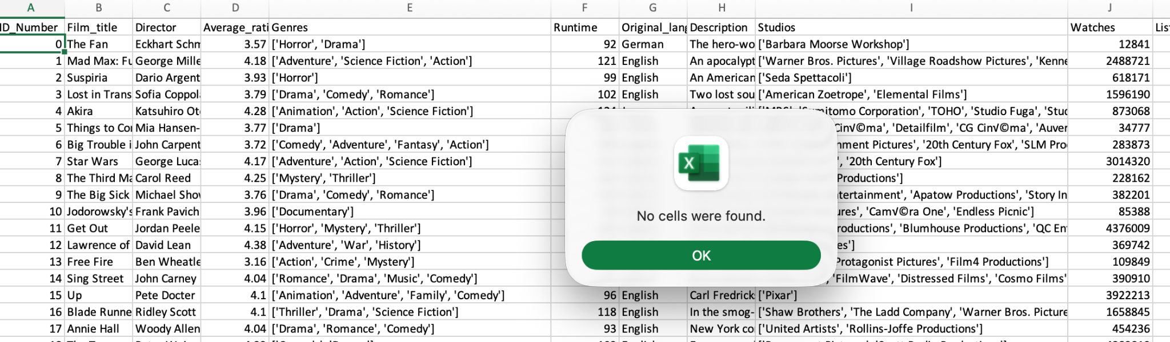
Figure 1: Identification of the missing observation
(Source: Imported from Excel)
The following issue is to determine the presence of duplicate entries within the dataset.
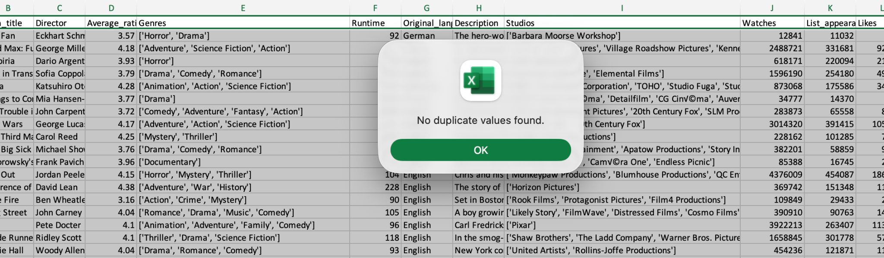
Figure 2: Determining the duplicate values
(Source: Imported from Excel)
The dataset reveals that there are no duplicate entries. The idea is to improve the quality of data on which critical business-related decisions are made and enhance the value of the business in the long run (Bernardo et al., 2024; Fu, Nicholson and Easton, 2024). Further, the application of the TRIM function helps in standardising all the textual information that is available in the dataset. It removed any unnecessary spaces between the names that can cause a mismatch between the variables. The outliers were observed for the case of the total number of watches, and the process of trimming is one of the legitimate choices, but it is under-justified, and it can remove valid information as well (Cooksey, 2020). The lowest quartile is observed as 2979.75, which means that the movies that have a number of watches below 2979.75 would not be considered for the analysis. It removed around 2500 data points, which did not receive high watch hours, and their rating would not showcase consumer perception properly.

Descriptive Statistics and Summary
The descriptive understanding of the average rating, runtime, watches and fans is obtained below.
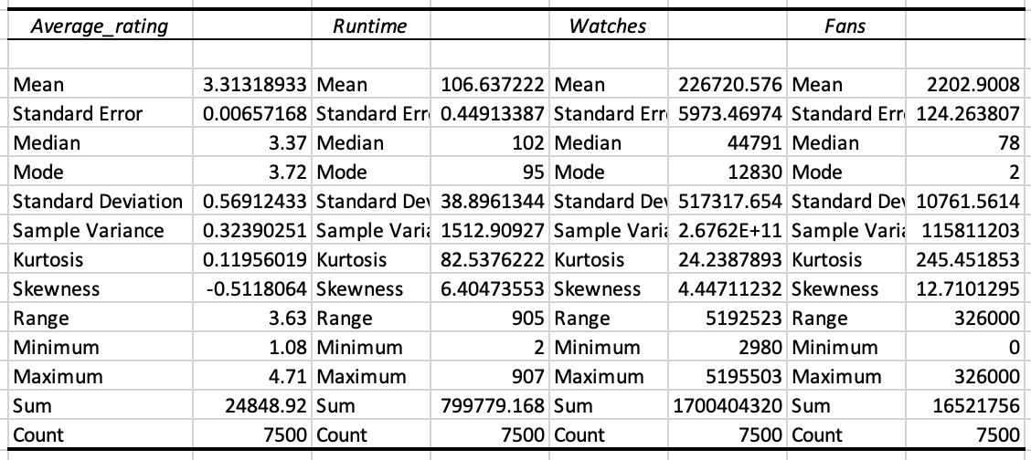
Figure 3: Descriptive Statistics
(Source: Imported from Excel)
The client data set included 7500 observations, and through this result, the average rating is observed, which is 3.31 with a deviation of 0.56. The deviation remains minimal, reflecting the consistency in the data set. The average runtime is 106 minutes with a deviation of 38 minutes, which indicates that most of the movies are between 90 and 150 minutes. The overall watch is 226720.576, but it also has a high deviation level of 517317.654. The average number of fans is identified as 2202, but it also has a high standard deviation of 10761. Through the descriptive understanding, it can be said that the watch time and the fans may not provide a statistically reliable outcome, as the observations are highly dispersed within the data set (Yan, 2022). Hence, this would make it difficult to identify any potential pattern in the data.
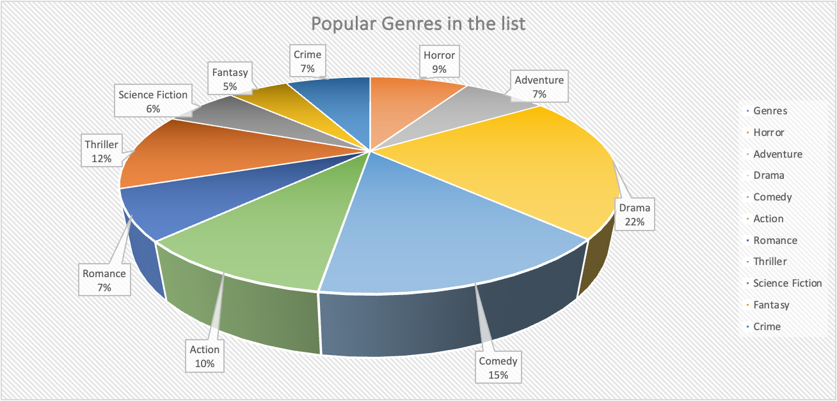
Figure 4: Popular language movies
(Source: Imported from Excel)
The popular language choices that are identified from the status it is the drama, which includes 22% of the movies, followed by comedy with 15% and thriller with 12%. The other popular genres are action, romance, science fiction, crime, fantasy, horror and adventure.
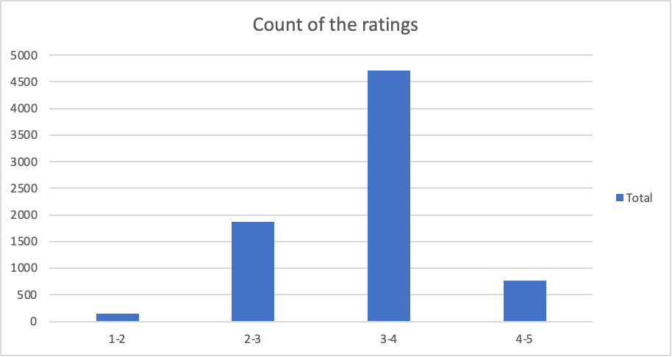
Figure 5: Ratings count rate
(Source: Imported from Excel)
The result indicates that the ratings between 3 and 4 are the most common ones, reflecting the popularity of the movie. The selected 7500 movies have above 4500 ratings between 3 and 4, while around 2000 of the movies have ratings between 2 and 3. There are only close to 700 movies that has rating between 4 and 5, reflecting the fact that the majority of the movies are deemed to be average by consumers.
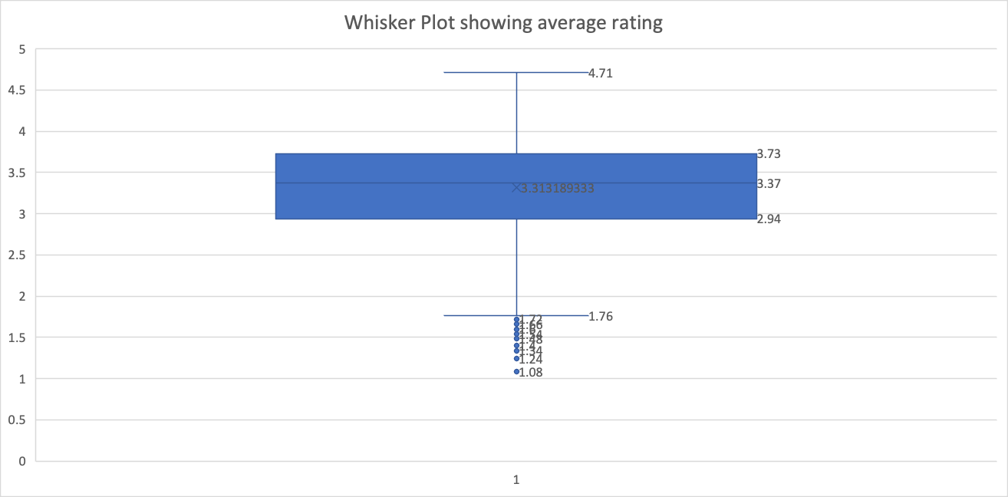
Figure 6: Whisker Plot showing the average rating of the consumers
(Source: Imported from Excel)
The result reflects the fact that most of the ratings lie between 2.94 and 3.73. These are the popular rating choices that are provided by the consumers, and the range of information remains between 1.76 and 4.71. Even though there are a few outliers that are observed below 1.76, they can be considered in the analysis, as they are only below the lower quartile by a negligible margin. This reflects on the understanding obtained from the whisker plot.

Trend Analysis and Visualisation
The following trend analysis reflects the growth of average rating taking place by genre of the movies. At first, the average rating by genre is examined through the line graph as follows.
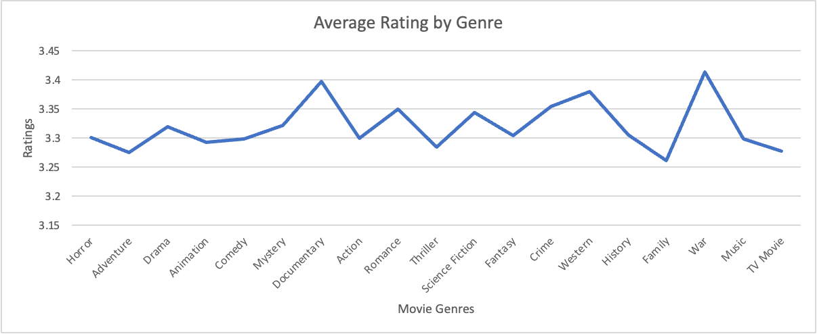
Figure 7: Average Rating By Genre
(Source: Imported from Excel)
The results indicate that movies based on the genre of war have an average rating of over 3.4, while the movies that are documentaries also have an average rating of 3.4. The Other popular choices are romance, science fiction and western movies. The least popular choices are the TV movies, adventure, family and animation movies. However, it is essential to note that not all movie genres experience a similar amount of watch hours. Hence, a movie with short watch time might experience a higher rating compared to another popular movie, as the number of movies is low, creating a statistical issue (Ramos, Calvão and Anteneodo, 2015). In order to avoid the issue, the following diagrammatic trend reflects the watch time hours by the movie genres to reflect on the popularity of the movies among consumers.
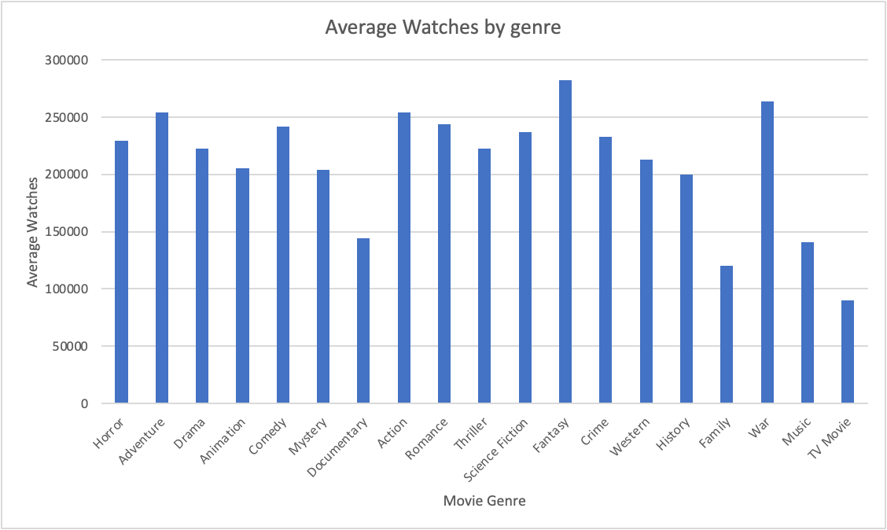
Figure 8: Average Watches by Genre
(Source: Imported from Excel)
The bar diagram highlights that the popular rating, as observed in the case of war, also has high viewership. This means that the genre war is popular among consumers and is largely seen. On the other hand, the documentaries are one of the least-watched movies, but despite their lower watch rate, the quality of the production tends to be highly effective in attracting consumers' viewership. It is observed that the most viewed is seen in the case of fantasy, and it holds an average rating of 3.3, indicating that the fantasy movies are moderately popular. Similarly, adventure movies also hold high watchability, but their average rating is close to 3.25, indicating that the adventure movies are not well perceived by consumers. The TV movies have a low view rate and low rating as well, along with family movies, indicating that these genres are not very popular among consumers. Overall, the popular genre with high ratings is found to be war-related movies and fantasy that have been successful in attracting consumers.
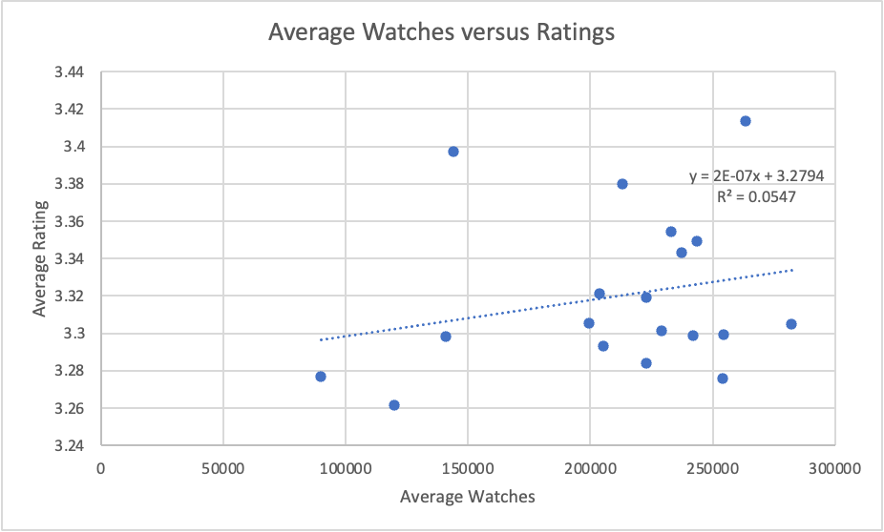
Figure 9: Relationship between average watches and average rating
(Source: Imported from Excel)
The trend analysis reflects a moderately positive relationship that exists between average watches and average ratings across various genres of movies. The result indicates that an increase in the watch time by one unit would result in an increase in the rating by 5%. Hence, it can be established that average watch time can generate positive ratings among various movie genres.

Statistical Analysis
The first part of the analysis is to review the existence of a relationship between the average rating of the English and Non-English Films. The following hypothesis will be tested through the t-statistical analysis, as reflected below.
H1: The statistically significant difference exists between the average rating and between English and Non-English Films.
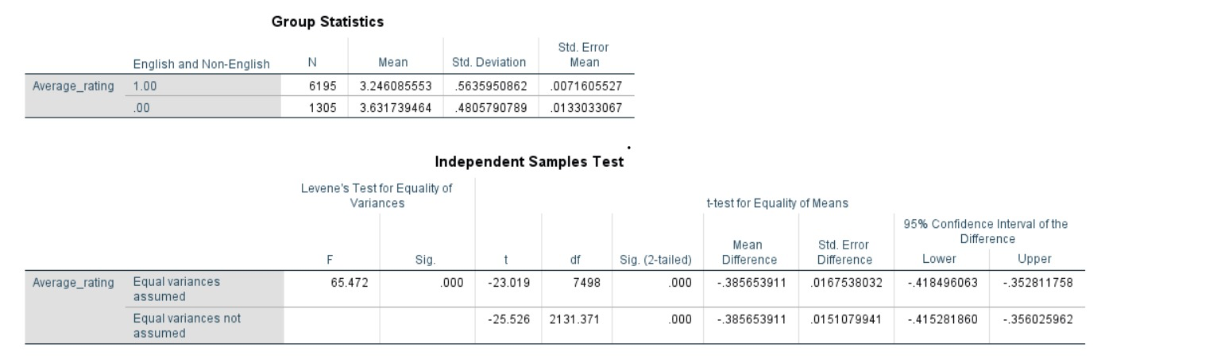
Figure 10: Independent Sample t-test
(Source: Imported from SPSS Analysis)
The test reflects the presence of equality of variance, which is highlighted through the F value, which is 65.472, and it indicates the possible violation of homogeneity of variance at the 5% level of significance. This means that the equality of variance does not exist between the two groups. The t-statistic value is -23.019, and the p-value < 0.001, indicating that the average rating between the two groups, that is, the English movies and the non-English movies, is significant, and the alternative hypothesis is accepted in this situation. The analysis highlights that language remains an important factor that shapes the audience's perception towards the content, and it influences the engagement level of the consumers.
The second part of the analysis is to review the relationship between the runtime and the consumer engagement procedure. The impact of rising runtime on engagement is understood through the correlation analysis.
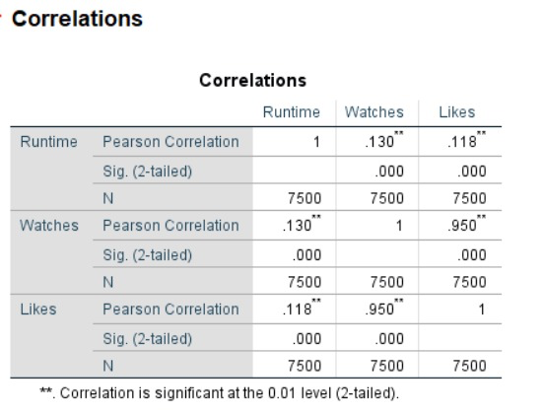
Figure 11: Correlation Analysis
(Source: Imported from SPSS analysis)
The Pearson correlation analysis is conducted in this situation, and it reflects the positive relationship that exists between runtime, watches, and likes. Both watches and likes are found to be holding a weak positive relationship with values of 0.13 and 0.118. As stated by Voronin (2025), implementing Karpik’s Theory of singularities, the social influences like expert rating, family or friend recommendations have a greater impact on movie-watching decisions.
The regression analysis also tests the following hypothesis.
H1: Language description length influences the average rating of the movies.
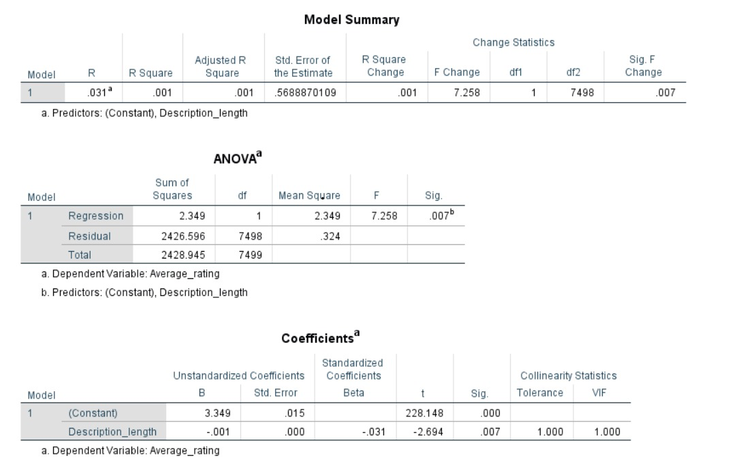
Figure 12: Regression Analysis Result
(Source: Imported from SPSS analysis)
The p-value is 0.007, which is less than 0.05, indicating the significant relationship existence between description length and the average rating. Now, the R-square value is 0.001, indicating that as the description length increases by 1 unit, the average rating increases by 0.1%, which is extremely low. The results add value to the observation from Zhao, Zhu and Pan (2026), who stated emotion and social value are important indicators of behavioural intention, which comes with reading movie descriptions and reviews from experts.
The final analysis reflects on the influence of the original language on consumer engagement level.
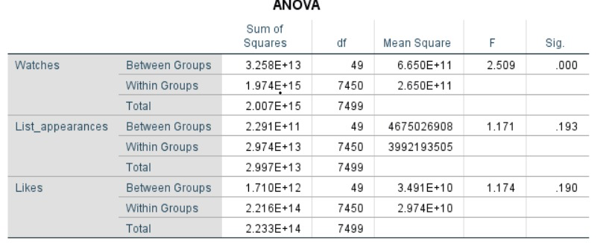
Figure 13: Impact of original language on consumer engagement level
(Source: Imported from SPSS result)
The result indicates that only the watch time between the different language groups is getting impacted, with the p-value found to be less than 0.001. As observed by Laoli et al. (2025), English language movies are well perceived by people to learn the language well, depicting their influence over high watch time.

Insights and Recommendations
The statistical analysis reflected the importance of business, intelligence, insights, and reviewing the performance. It reflected on understanding the audience behaviour, as the independent sample test reflects the fact that the average rating is influenced by the language of the movies. However, as the number of English movies is significantly higher compared to other languages, the result can be considered highly biased (Cooksey, 2020). Therefore, if the market is segmented equally, the consumer preferences can be understood better, along with the understanding of their social status (Syrjälä et al., 2025). Through the statistical analysis, it is also observed that runtime holds a negligible positive relationship with the engagement of the consumers, while the description length can have a negligible positive impact on the watch hours. This occurs primarily because the description of an increase increases the engagement rate of the consumers, making them watch and reflect on the description.
The understanding from the current result indicates that the business should focus more on a language-based targeting process to attract specific consumers that creates a virtual language landscape, which improves the cognition of the movie scene (Zeng et al., 2023). The engagement of consumers for different movie languages can be improved by incorporating subtitles, and it can make other language movies highly popular among mass audiences (Wu, Jiang and Chen, 2025). Overall, the statistical analysis is highly effective and influences the business in defining the target market efficiently in the future.

References
Cato, K.D., McGrow, K. and Rossetti, S.C. (2020) ‘Transforming clinical data into wisdom: Artificial intelligence implications for nurse leaders’, Nursing management, 51(11), pp.24-30.
Cooksey, R.W. (2020) ‘Descriptive statistics for summarising data’, In Illustrating statistical procedures: Finding meaning in quantitative data (pp. 61-139). Singapore: Springer Singapore.
Bernardo, B.M.V., São Mamede, H., Barroso, J.M.P. and Dos Santos, V.M.P.D. (2024) ‘Data governance & quality management—Innovation and breakthroughs across different fields’, Journal of Innovation & Knowledge, 9(4), p.100598.
Laoli, A., Bago, E., Lase, D.A., Vita, H. and Gulo, S. (2025) ‘Influence of watching English movies on English language speaking skills’, International Journal of Multilingual Education and Applied Linguistics, 2(1), pp.30-38.
Ramos, M., Calvão, A.M. and Anteneodo, C. (2015) ‘Statistical patterns in movie rating behavior’, Plos one, 10(8), p.e0136083.
Fu, Q., Nicholson, G.L. and Easton, J.M. (2024) ‘Understanding data quality in a data-driven industry context: Insights from the fundamentals’, Journal of Industrial Information Integration, 42, p.100729.
Syrjälä, H., Ruiz, C.D., Leipämaa-Leskinen, H. and Luomala, H.T. (2025) ‘From consumers to consumption: The socio-technical assemblage of the persona in market segmentation’, Journal of Business Research, 194, p.115387.
Voronin, Y. (2025) ‘Detailing social influence in predicting cinema attendance: a vignette approach’, Poetics, 113, p.102041.
Wu, T., Jiang, N. and Chen, M. (2025) ‘The role of cognitive factors in consumers' perceived value and subscription intention of video streaming platforms’, Acta Psychologica, 254, p.104758.
Yan, J., Möhrlen, C., Göçmen, T., Kelly, M., Wessel, A. and Giebel, G. (2022) ‘Uncovering wind power forecasting uncertainty sources and their propagation through the whole modelling chain’, Renewable and Sustainable Energy Reviews, 165, p.112519.
Zeng, Y., Xu, Z., Chen, L. and Huang, Y. (2023) ‘Exploring the mechanism of empathy on lens language and linguistic landscape on movie-induced tourism: The moderating effect of cultural differences’, Frontiers in Psychology, 14, p.1109328.
Zhao, N., Zhu, X. and Pan, X. (2026) ‘Examining the Relationship Between Perceived Value and Movie Consumption Behavioral Intention: The Mediating Role of Satisfaction’, Behavioral Sciences, 16(4), p.556.

