ECEY4001
2408623
3040 WORDS
HUMAN DEVELOPMENT
Introduction: This poster will show the human development in life and how we live safely on this planet.

1. Developing an infographic to explore Maslow’s model in depth
(1000) words)
What is purpose of Maslow’s Hierarchy?
Maslow’s hierarchy can be useful to people on personal level. By identifying basic needs, a personal can determine exactly what he or she is missing in his or her life, whether is it friends, knowledge, or other needs. Also, it provides us whit valuable information about the basic human needs and motivation that drive learner behaviour. This in turn can help us improve our learning strategy.
Basic needs:
In this theory of motivation, Maslow proposed a hierarchy of refers to the idea that the basic need must be satisfied before moving on to the next need.
These needs include: 1. Psychological needs,
{food, water, warmth, rest}
2. security and safety
3.love and truth
The need for of love and belonging: Here the individual want to practice to love and participate in being part of the group, i.e. belonging, with others outside the country, and he feels distressed when friends are absent from him and the presence of this need is manifested when individuals cooperate with his community. On the contrary, rebellion and cultural disobedience are the result of not satisfying this need.
What does mean feeling self-esteem? Here the individual wants to achieve his personal value and magnify the role he plays in society, of his felling of distinction and the respect of his community. Satisfying, this makes the individual feel strong, self-confident, competent and valuable among the group. Conversely, he may feel inferior, helpless, and weak. This feeling is linked to the individual’s success in his daily work
What are the things that are important and necessary for human survival?
Water: human need moisturising to support body functions and prevent dehydration.
food: human need and livelihoods; to maintain biological function.
Shelter: human need protection and safe living environment. In addition, need sleep and recreation to maintain physical health and cognitive function. Moreover, the human also need air to breathe and sustain life.
How do we organise your relationships between family and friends?
The first aspect to note is that organising our social relations is one of most prominent axes of life we live. There are more precious than the bonds we build with family and friends, they understand our security, our joy, and our refuse in time of joy and sadness. After that, the most important question remains “How do we make these relationships a permanent source of happiness and piety? And how do we practice the art of social communication with ingenuity and wisdom, achieving a perfect balance in our social relationships between family and friends?” In this article you will find methods that will help you organise your social relationships between family and friends. For example, you can: set specific time each day dinner with family without any other concerns and determine specific of the weekend to spend with friends. In addition, determine a day of the week to spend with the family. Also, it is a well- known fact that it is a person’s right to feel confident in himself because self-confident always motivates and encourages a person to achieve positive things. Available at: https://search.app/bRfvANxwxBwVdtot6

What is the powerful quote about security?

Safety and security do not just happen; they are the result of collective consensus and public investment. We owe our children the most vulnerable citizen in our society, a life free of violence and fear.” “Precaution is better than cure. Social Needs: Maslow’s Hierarchy: Let us begin by considering, when you have problem in your life, who do you go to and who do you talk to? And how do you usually deal with your problems? It is necessary to have a favourite person to look up to in these circumstances to motivate and support you in a useful way so that you avoid anxiety, stress, and depression and so that you feel that you always have people who love you and are with in all your circumstances. We all like to feel accepted by others and we should all support each other. In addition, when we make sure to develop and build honest and amazing relationships such as friends and family, we are able to be deal with difficult situations. Available at: study.com https:// search. app/davrfLXa5P2LR28W8
What is the concept of achieving community safety? We mean that every citizen feels accepted within the community, respected and socially just, and part of this community believes, and libra realizes the multiple principles and values of security, including social solidarity, Compassion between people, Providing opportunities, Respect and appreciation, Brotherhood among members of one community, Mutual trust. Then, we must revive the social values that have been studied around the world, and restore to man his soul, much of overwhelming material fires, and spread spiritual, societal and psychological security everywhere and broadcast it is messages in soul with good manners and kindness it is in word and dee so that our people can be reassured that we love for them what we love for ourselves that we love for them as they care for themselves. Psychological safety: for example, a person has psychological needs that must be fulfilled otherwise he will live whit an anxious heart and scattered thought. There are fears that feeling of psychological security, such as fear of poverty, fear of loneliness, fear of the future, and all of these are enemies of peace and reassurance.
The responsibility for achieving psychological security falls first on the family when the individual feels safe and secure within it as result of family cohesion. The lullaby of a child in his mother’s arms gives him the security, and his caressing of the world, the father’s voice in the house is the security, and his caressing of his child is reassurance and tenderness.
enteral to this analysis is a good and sincere friends is a safety valve in our world life and an oasis of comfort from worries and sorrows. A neighbour who checks on you every now and then removes fear and anxiety from your heart. A police officer who watches over the safety of his nation, the comfort of his country, and the security of creation from evil is one of the makes of security. A loyal arm force is stationed on the borders to protect the country from being assassinated by ungrateful, envious people. Available at: https://doi.org/10.1155/2016/8058093

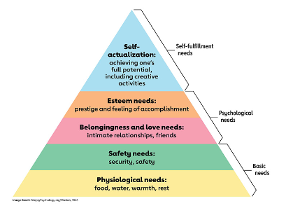
Available at: https://sl.bing.net/bWFYIZJty1s

2. Explore in depth the concept to of holist child development with links to Maslow’s model (1000) words.

Prenatal development and birth:
What is natural birth? A normal pregnancy in a woman lasts nine months. When the full nine month are over, the baby is born. In fact, it is a long period for a woman to be pregnant, but in fact, from our point of view, compared to other major things, such as the great apes, nine months is a short period. We must distinguish between humans and major things, such as growth, gestation period, and brin size at birth. Gorilla, and chimpanzees are fully developed at the age of eleven, but at the age of twenty in humans. As a result, newborn humans are not fully mature, but their brain size does not exceed a quarter of the size of adults at birth. Also, the brain size of human infant does not reach half the size of adult brain until after a fully year.
Suggestion on child development: Som of us object to these ideas, but everyone has an opinion about raising children and they are convinced of it. In addition, even if you did not study psychology, you have ideas about raising children, it is not necessary to be educated. Let us see these ideas: 1. Anim behaviour is instinctive, but human behaviour is acquired, this is the difference. 2. She smiled, but she is a new child. I feel that she knows me. 3. If you have a child, do not give him anyone to take care of him yourself. 4.The important and interesting point is not to harm the child at all, here the child learns and distinguishes right from wrong.

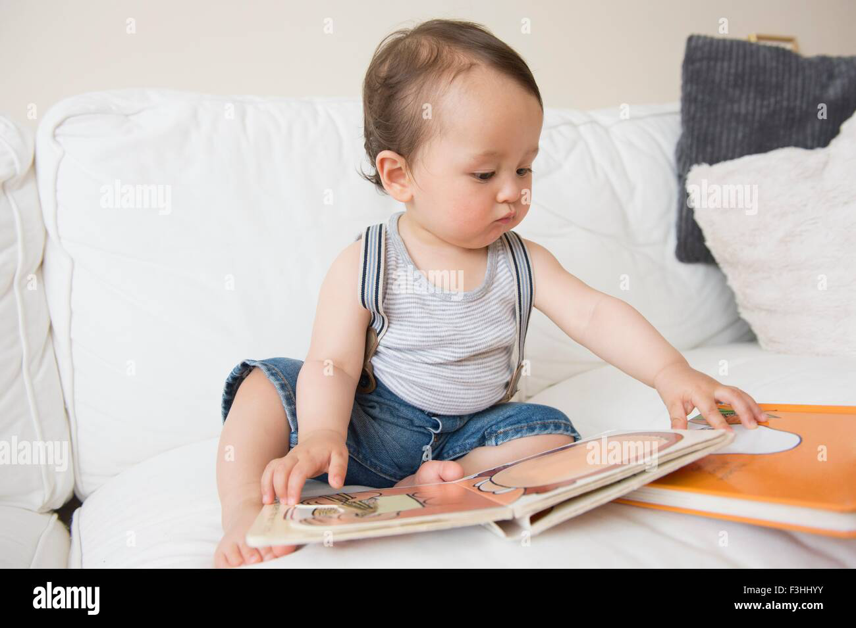
{Source: By Alamy, 2017}

Children’s developing mind:
How to deal with and know children’s perceptions? It is difficult to work with young children because they are not able to tell us what they are thinking and what they want, but we must understand what they know from their behaviour. Children’s memory has a certain limit, and then researchers invented techniques to assess their mental abilities. If you want to know how a child perceives, for example: We show the child two different pictures at the same time. Here you must know how long the child looked at each picture. If the child looked at the picture with equal time, this means that he cannot distinguish between them. However, if he looks and focuses on one picture one more than the others, this means he “prefers” one of them. Firstly, Here the child can distinguish between the two pictures. Secondly, because one of these two picture is the most stimulating and most beautiful to look at.

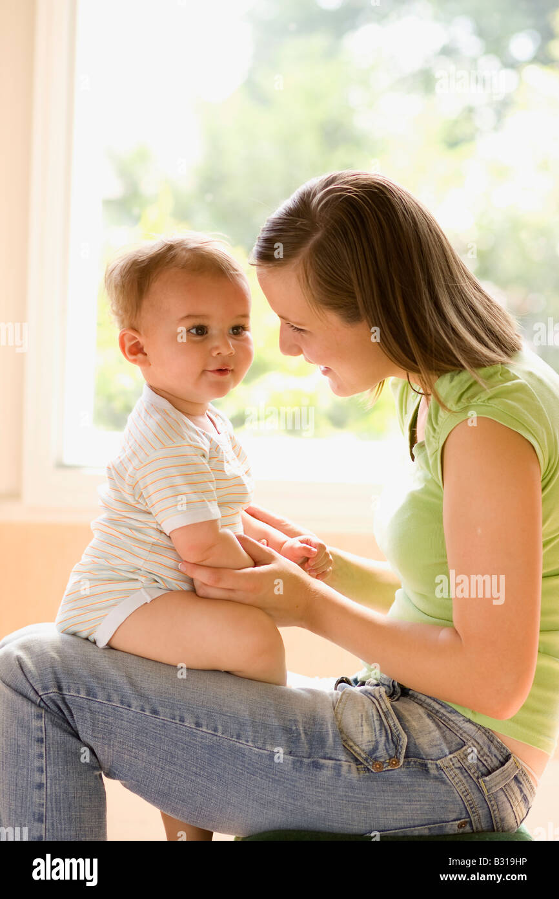
(Source: By Chris Rout, 2018.)

First words and sentences:
How do the babies pronounce their first sentences and words? People usually ignore the first words that a child says because they are never understand and in addition they are not in the dictionary! However, these are words that a child always says, so it means that the child repeated them a lot, so it means something or there is a certain situation. Let us explain to you if a ten-month-old child says” Ma” when he sees his mother’s face, this means that he points to her every time in this word. Therefore, these first words are called making people and things in the child’s environment. Also “WA” may mean in the child’s eyes “I want water “. However, the child does not have ability to pronounce words easily. He is only able to pronounce one words from re time to time, then there is a difference in the context and gesturers. We can understand the meaning more clearly. Gestures play a role in the development, stimulation and reinforcement of pronunciation of words and the mother’s language in children in a short time. Gestures are non- verbal communication, either through the hands or physical action.

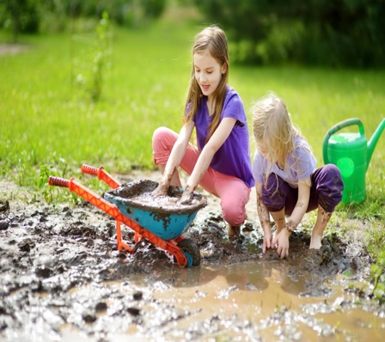
(Source: By Cosby Stone,2019.)

Early years development: In fact, children do not spend much time outside in the fresh air. Some children do not have a garden in their parents’ houses, although even if there is a large space, it is not suitable for children between the ages of two and three year, even if the garden change, it may not be suitable for children. In addition, the beauty of gardens is wonderful and relaxing for the soul and picturesque by nature. It may also be something else or a purpose for adults, and it is not a large space for children to run in. There are many places paved with pebbles that are overly exciting and many in gardens that are specially made and attractive for young children to play in. In addition, they have opportunities to dig, touch and bury things to develop their mental and brain skills and to explore. Children are naturally curious and have the skill of exploring. Gardens have become a fun place for children to develop their skills and release their energy. They have become considered another room in the house.
Strong social skills are essential for building healthy relationships with peers and adults.
- Teach Respect and Cooperation: Encourage sharing, taking turns, and working together with others. Role-playing or group activities help teach teamwork.
- Conflict Resolution Skills: Help children understand how to resolve conflicts calmly and respectfully. Teach them how to negotiate, apologize, and forgive.
- Model Positive Relationships: Children learn by example, so demonstrate kindness, effective communication, and problem-solving in your own interactions.
- Expose to Diversity: Encourage interactions with a wide range of people and cultural experiences to help children understand and appreciate differences.

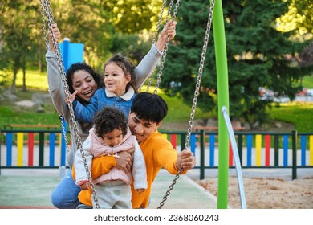

(Source: By Cristina Villar Martin, 2023.)

Outdoor provision and physical development
Let us learn how to provide fresh air and physical development for children. There are many benefits to playing in fresh and clean air that has a beneficial effect on their health and overall growth, for example, improving body functions such as the heart and lungs. Therefore, they must be provided with the necessary things to develop different parts of their bodies. Large outdoor space must be carefully and carefully organized and served with games such as climbing and ropes, especially water games because they are overly exciting for children, in addition to swings and kinetic games to strengthen the body. In the past years, the focus was on placing equipment in schools and nurseries that are suitable for children in the style of garden equipment, but fixed. As a result, this is to motivate children and parents who are looking for education institutions. This type of equipment plays a significant role in developing physical skills and competition among children, and then children can have opportunities and time to play.

3. Offer three examples from early years practice to highlight Maslow’s significant understanding child development. (1000 words).
Foundation of early year childhood: What makes of a child happy? The child is happy when he feels the complete well- being provide to him by his parents and practitioners, especially the mother, because the child comfort and well- being are first provided by the mother. Here the child feels safe because he is closely linked to her relationships with his mother. What confirms this is one of the foundations of healthy, that relationships are stable. Therefore, anything that disrupts healthy relationships is expected to have negative effects on the child’s development. Moreover, primary caregivers must build secure attachment relationships between them and their children so that children grow in a healthy and sound manner. Successful family relationships make children a healthy and successful generation for the environment.
Healthy eating nutrition, food and eating habits: What is the role of practitioners? Let’s get to know the children’s nutritional program that practitioners and key officials should follow. Many specialist doctors said this would affect on eating habits throughout their lives in the future, so the early years environment is a vital way to encourage healthy eating as it provides the best healthy eating habits that can be provided. Then take this into consideration. (Guidelines: Encourage childcare practitioners to use age- appropriate guides lists for children. Storage: The childcare program should provide free healthy and nutritious meals with drinks to nurseries and school during school hours.)

‘Measuring’ personal, social and emotional development: When a young child to play and interact whit other children, he may lean on walls because from his point of view it is safe so that he does not fall. There may be special friendships and play action, and patterns will begin to emerge. This is the time when the child’s independence becomes more apparent. Here the child is tested by his behaviour in addition to developing confidence and self- esteem at different rates. Also, as a three-year -old child, he considers himself and has high confidence to talk to adults and understanding that others have different feelings than his feelings. In fact, ADHD is a frequent, high-quality interaction between adults and child, but practitioners need to be sensitive to the children need to take a social break to get away from excessive encouragement and activity beyond the normal limit. Children also need a quiet, separate room so that they can stay asleep for enough hours of sleep that is sufficient for the body.

How to create a safe and stable environment for children? It is often said that always important and necessary to think about building a safe environment for children in society, also adult is an important part of society and have great importance and consideration. The role of the official here is to prepare a group of different activities to develop children’s skills and encourage children to reach resources on their own so that they feel independent, in addition to counting the appropriate number of adults and children in the group. You must know that the child not able to control the sound in the classroom. Focus on whether the children have ample space to move and around. Is it clean fun?
Children require proper nutrition, adequate sleep, and regular physical activity to grow and develop at a healthy rate. If these basic physical needs aren't met, children may experience stunted growth, developmental delays, or health problems that can affect their learning and social interactions. Ensuring children have access to healthy food, clean water, and a safe place to sleep is crucial for their physical well-being and overall development.

Conclusion: Maslow is important to early year practice because of Maslow’s Hierarchy of needs is critical to early years practice because it provide a framework for understanding how children’s emotional, social, and physiological needs must be met before they can fully engage in learning. According to Maslow, basic needs such as safety, food and emotional security must be satisfied before a child can focus on higher – level needs like belonging, esteem, and self-actualization. By recognizing and addressing these needs, practitioner can create supportive environments where children can thrive emotional and intellectually, ultimately promoting holistic development.

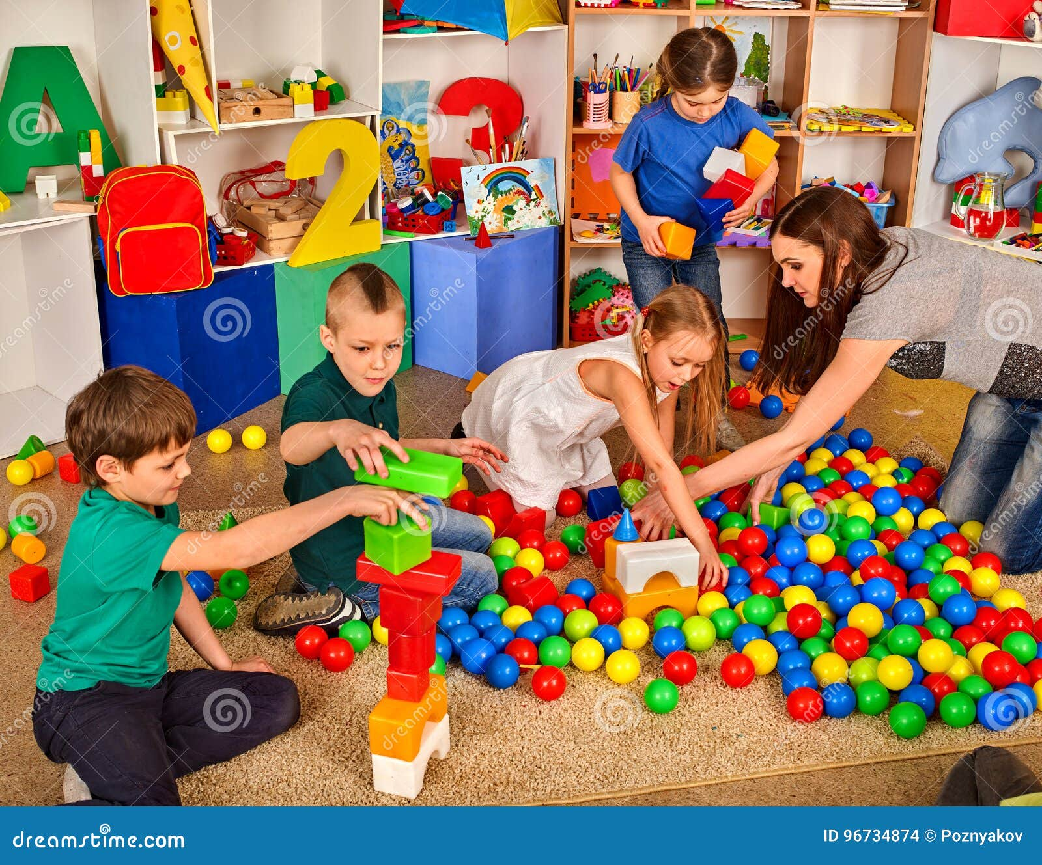
(Source: By Poznyakov, 2008 children playing in kids cubes in door. Lesson in primer school.)

Robinson, M. (2008) Child development from birth to eight. (1st edition.). YHT Ltd, London.

Johnston, J. (2018). Early childhood studies: principles and practice (2nd edition.). Routledge, Taylor & Francis Group.

Smith, P. K., Cowie, H., & Blades, M. (2015). Understanding children’s development (Sixth edition.). John Wiley & Sons Ltd.

Mukherji, P., & Dryden, L. (Eds.). (2014). Foundations of early childhood : principles and practice (1st ed.). SAGE.

Rodie, K. (2018). The holistic care and development of children from birth to three : an essential guide for students and practitioners. Routledge.

Weinberg, D. R. (2011). Montessori, Maslow, and Self-Actualization. In Montessori life (Vol. 23, Number 4, pp. 16-). American Montessori Society.

(Source: By Poznyakov, 2008 children playing in kids cubes in door. Lesson in primer school.)
(Source: By Cristina Villar Martin, 2023.)
(Source: By Cosby Stone,2019.)
(Source: By Chris Rout, 2018.)

{Source: By Alamy, 2017}

