Coaching and Mentoring Skills for the Workplace
BMSW6105_CARD

Coaching and Mentoring Within an Organisational Context

SARWAT ZAREEN ASFI
1905650

University Of Wales Trinity Saint David

Executive Summary

This report is requested by the UWTSD (University of Wales Trinity Saint David). The aim of this report is to identify the critical evaluation between coaching and mentoring.
The first part of the report provides the brief academic definition of coaching and mentoring, followed by the differences and the similarities between coaching and mentoring, the tangible and intangible benefits of coaching and mentoring towards the employee and employer will also be explained.
The second part of the report will critically assess the role of a line manager as a Coach / Mentor in the organisation. The coaching relationship in the workplace and some of the ways where the line manager is involved in the organisation as a coach or mentor. The GROW model will be explained that how coaching and mentoring can have advantage or disadvantage for the organisation.
Furthermore, the third part of the report will define the term of resilience and how building resilience through coaching and mentoring in the organisation affects the workforce. Kurt Lewin Model will be used to define the three stages of Unfreezing, Change and Refreezing.
The fourth section of this report will be evaluating own performance which was conducted in the peer coaching exercise. Self-reflection will be presented by using Gibbs Reflective Model to determine what went well and what can be done differently in the future. SWOT analysis and PDP (Personal development plan with be conducted for better understanding of self-reflection.
Finally, the last part will be focused on drawing the conclusion based on the discussion in the main finding of the report.
All research will be conducted by using academic and reliable online resources including UWTSD Library, Articles, Journals, and Books.

Table of Contents
Introduction 4
Coaching 4
Mentoring 4
Difference Between Coaching and Mentoring: 5
Similarities Between Coaching and Mentoring: 5
Tangible and Intangible Benefits of Coaching and Mentoring 6
The Line Manager as a Coach/Mentor: 6
Coaching Relationship in Workplace: 7
GROW Model for Coaching and Mentoring 8
The Role of Coaching and Mentoring in Building Resilience 9
Organisational Change in Covid 19 Pandemic 9
Kurt Lewin’s Change Model 9
Self-Reflection on peer coaching exercise and a personal development plan 10
SWOT Analysis 11
Personal Development Plan 12
Conclusion 12
References 13

Introduction
Mentoring and coaching both exist for similar purposes. The core purpose of both these professions is to help others develop, grow and reach their whole potential through effective and motivating techniques. Both techniques provide people with the opportunity within an organisation to be responsible for personal as well as career development. These two methods are always linked together in discussions of employee development within an organisation. The firms take the techniques as an ‘either or’ decision. However, both these methods contain a wide range of differences which make them different from each and other regardless of the core similarities.

Coaching
According to the International Coach Federation, “Coaching is the process of partnering with clients in a thought-provoking and creative process that inspires them to maximise their personal and professional potential. (Garvey, et al. 2010).
According to Cox (2014), the main objective of coaching is to improve the skills and knowledge capability of an individual. It requires feedback, together with other methods such as inspiration, effective problem solving and constantly matching leadership style to prepare each coachee in achieving a specific task. Coaching is focused on helping people to help themselves through interacting with them significantly and guiding them through a two-way conversation.
Career coaches can provide employees with assistance regarding how to improve themselves and their mindsets to become efficient in their professional lives. It helps the employees identify their shortcomings as well as strengths and provides them with an accurate set of skills and tools to handle future situations and challenges in a more effective manner (Bachkirova, et al. 2011). In contrast with mentoring, career coaching is usually more tailored and structured to specific outcomes as opposed to general individual’s development.

Mentoring
Mentoring is commonly defining a relationship between less experienced mentee, and an experience individual recognised as a mentor. Mentoring is traditionally a face-to-face long-term relationship between mentor and a mentee for their professional, academic or personal development (Donaldson, et al. 2000). The mentor is responsible for providing support and giving feedback to the individual when achieving their goals (Gray, 2018).
Clutterbuck and Megginson, (1999) suggest that mentoring is helping other individual and making a considerable change to their skill, knowledge and mindset. The main aim of the mentor is to help them think outside the box regardless of their job, or their personal circumstances so they can develop an understanding of themselves, of their capabilities and acknowledge of those skills and utilise them accordingly.
A mentor in an organisational context is someone who supports, advises and guides employees to make them more confident and efficient individuals. Mentors take time to understand employees and the challenges they face on a deeper level. Based on their understanding, they advise and guide employees accordingly to their goals (Bachkirova, et al. 2015). The process of mentoring is based on building self-confidence, developing leadership and communication skills, and gaining insight into new perspectives. Therefore, the process of mentoring leads to an inspired and motivated staff within an organisation.

Difference Between Coaching and Mentoring:
As discussed by Hawkins (2013), the difference between Coaching and Mentoring may vary by some key elements which can be found below:
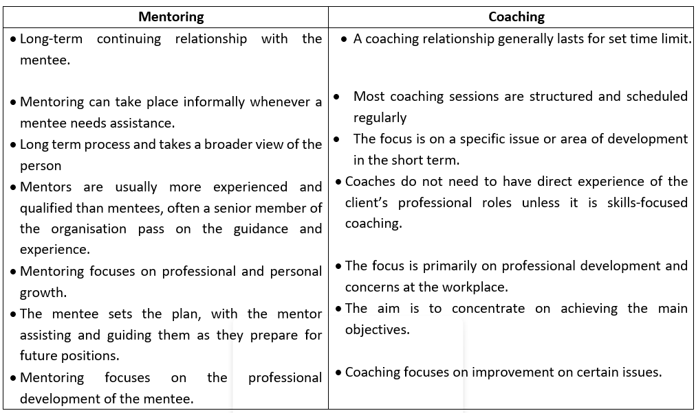

Similarities Between Coaching and Mentoring:
In both techniques, there is a profound relationship based on trust between both the parties and a desire to develop by the employees. The processes include the development of self-awareness amongst the employees and providing exposure to a new mindset (Lovely, 2004). The main objective is to help unlock the true potential of the individuals based on their understanding of them. In addition, the processes are centred on the sharing of knowledge and development of a substantial skill set to become a highly qualified professional (Crawley, 2020)
It is important to be clear on the purpose of coaching and mentoring so that the effectiveness of coaching or mentoring can be assessed in relation to its purpose, rather than by some generic calculation of ‘Return on Investment’ (McCarthy, 2014a).

Tangible and Intangible Benefits of Coaching and Mentoring
Hawkins & Smith (2014) described Coaching and Mentoring significantly promotes high work performance and new approaches in workplace. This also suggests that any type of coaching, for example, developmental or transformational could deliver intangible as well as tangible benefits. This increases the knowledge of our understanding of those intangible results which evaluates the coaching effectiveness. There are several advantages of using coaching in practice and these can be classified as tangible and intangible benefits for the organisation.
The table below shows the tangible and intangible benefits of coaching:
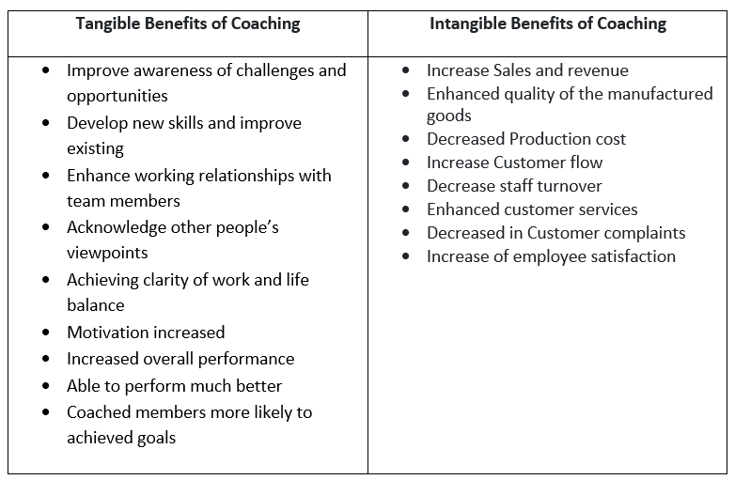

The Line Manager as a Coach/Mentor:
A line manager is referred to as a person who has direct responsibility for several employees in the company. The line managers provide a vital chain of command for the team members and the organisation. The line managers help in the provision of “informal coaching and mentoring” for the members of the team along with any formal schemes in which they are involved. For instance, a line manager calls a meeting during break time. During the meeting, the team aim to discuss recent issues to resolve them. Thus, the line managers play an essential role in the development, support and retention of talented employees (Parsloe, and Leedham, 2016).
Many studies have been completed evaluating the impact of line managers on corporate performance. Most of these studies have concluded that the relationship of line managers in employee development is vital (Hakro, and Mathew, 2020a). In some cases, the substantial amount of positive relationship between the staff is produced by the extra attention of the line manager towards the employee.
Cox (2014), describe the line managers are significant in any organisation for employee’s monitoring and development, regardless the financial conditions and any other organisational circumstances. The Manager’s coaching and mentoring style enable the organisation to improve communication, increase production, clarity of goals and objectives and increase employees work progress. However, the line managers must deal with different commitments and challenging situation.

Coaching Relationship in Workplace:
Norman (2019) explained the relationship of coaching in workplace is to work ‘with each other’ rather than ‘on each other’. Leader will need to bring their full potential into the collaboration to work cohesively with their employees while coaching. In the Organisation the coaching is a two-way confidential process where the coach build trust with the coachee so they can share their thoughts and experiences and engaging in coaching without hesitation.
Many observers stated that it depends on the line manager’s coaching style if they give enough time and consideration more than a basic level to the coachee’s to help them solve problem (Ferrar, 2006).
According to Cox (2014), the role of a line manager is extremely challenging in a coaching role. In the companies such as Kellogg Europe have senior managers with higher level of coaching skills which makes them a great role model to the other line managers to encourage good coaching practise in the organisation. Moreover, the expert line managers transfer the coaching skills and knowledge internally in the organisation which helps develop the coaching rapport within the organisation and achieving task-specific behavioural changes.
Below are some of the ways in which line managers are involved in coaching and development (Megginson, and Clutterbuck, 2010):
- Training and demonstrating new staff regarding the corporate system and the company’s policies.
- Line managers are accountable for the facilitation of the team and rotation through other departments and roles.
- Along with the formal schemes in which they are involved, line managers provide informal "coaching and mentoring" for team members.
- Team members' skill sets are expanded, which keeps them engaged and improves team communication and resilience.
- In various organisations, the line managers play an active role in the recommendation of the team members for the promotion and creation of accurate programs for development for them.
- The experienced line managers organise formal training for the employee and the courses or training are run by professional accreditation organisations.

GROW Model for Coaching and Mentoring
The GROW model was developed by Sir John Whitmore and his colleague Alan Fine and Graham Alexander in 1980s. The framework of this model is to use in meetings, conversations and everyday leadership to unlock potential and possibilities (Passmore, 2006).
The manager is responsible for supervising the options for the training and development for the employees and to determine the accurate solution. The desire must be established by the manager and the employees towards the attainment of new knowledge and skillset through training and development(McCarthy, 2014b).
According to (Lea, 2020) GROW model is widely used in coaching and mentoring for goal setting and problem solving. It provides a methodical framework of four main stages for coaching and mentoring sessions. It is simple, practical, and easier to understand, comparatively to the other coaching models {Citation}
The GROW Model contain of four stages as following:
- Goal Setting: The first stage in coaching session a clear, measurable goal must be set. The goal should be inspirational, and positive and can be short term or long-term goal. In this initial stage the Coach identify Coachee’s goals for them to focus and challenge themselves to achieve it.

- Reality: Second stage is to examine the present reality of the coachee’s current situation, by using different techniques and method so the coach have better idea and understanding of the issue. The Coach might ask the coachee at this stage to assess their own obstacle before offering any solution or feedback. All attention should be on coachee and the coach must identify the positive possibility in the situation. The attention should be on the assumption made my coachee so the coach can help finding the outlook on the future goals.
- Option: By this stage the reality and obstacle have been discussed and coach and coachee should examine the options how to prevent the issues which causing preventing progress. During this stage wide range of options should bring forward and carefully investigate suggestion from coachee. At the end of this stage the coach and coachee should establish some choices to overcome the obstacle and there is less uncertainty around important decisions making.
- Will: At the final stage of the GROW model the coachee decide to move forward for achieving the final goal. With the guidance of the coach the plan is drawn and discussed by the coachee and any obstacle that may be encountered during the process have been identified and the solution are considered. However, the coach must motivate and ensure the coachee always work towards achieving their goals.
Finally, the GROW model is one of the coaching and mentoring models which can be include into leadership and managerial systems in organisations. If the leaders and managers are equipped with coaching tools like GROW, they can use it in the workplace to motivate the workforce and substantially improve the workplace culture.

The Role of Coaching and Mentoring in Building Resilience
Resilient individuals can cope better in unexpected situations, particularly while the workload is immeasurable and stressful levels are high in the working environment. The signs related to low resilience are easily spotted. These consist of the inability to make decisions, minor illnesses that are physical and frequent, feeling overwhelmed, lack of self-confidence, short temper and lower amount of tolerance (Hakro, and Mathew, 2020b).
The mentors and coaches could facilitate in two common ways:
- Helping the mentee or the coachee to deal with the situations in workplace.
- Creation of the overall resilience for the employees.
In both situations, the key focus is to reduce stress levels, by helping and supporting the staff members who are feeling work life is getting out of their control (Bachkirova, et al. 2015). The simplest way is to generate a list of actions to take, which can be followed step by step to reduce stress and anxiety in the workplace. This will help change the strategy towards a working approach and the change can be implemented accordingly.
Coaching and mentoring have different points of developing resilience. Coaches and Mentor need a specific type of resilience too: coaches may see certain number of clients per day and have the resilience to keep their focus up for the rest of the day. Coaches encourage building up resilience before an event, during and afterwards if needed by the coachee. With Coach’s skills and knowledge, they may be able to help building resilience and provide safety which often required for coachee’s to explore the boundaries of their approach and performance (Rees, 2019).

Organisational Change in Covid 19 Pandemic
The COVID-19 pandemic resulting global financial and human disturbance, basically it has changed our way of life, the way we work and the education system, and so on. Having the accelerated crisis and unexpected transformation in the business world, we have seen the revolution, corporation, and amalgamation of businesses pull together to help each to enable business operation as well as to boost the country’s economy. The pandemic has modified work restrictions, and everyone has acknowledged the immense changes and adapted them accordingly (Peters, 2020).

Kurt Lewin’s Change Model
In an organisation the change can be an unavoidable experience, and successful change can only be managed by experiences managers and leaders (Hartzell, 2021).
Hussain et al., (2018) identified that change model was developed by Kurt Lewin which involved three stages: Unfreezing, Changing and Refreezing. This model signifies the simplicity of understanding the process of change and creativity of the perception that change is needed and moving towards new level of normality.
Unfreezing
The unfreezing stage needs to implement initially before making any change in the organisation. Coaching can help people resist change, the aim of unfreezing is to establish an awareness and create a level of trust and acceptability. Communication through coaching or mentoring is the most important part of this phase so the employees can become informed of the reason for the change and how it will be beneficial for each of them as well as the organisation. The shared information will motivate the employees and the acceptance of the change will be easily adaptable.
Changing
Lewin referred the change step as a transitioning or moving stage. Professional coaching can help this change to becomes reality, where most people struggle with new change. Change should be plan and executed methodically, as there will be change in employee’s behaviour, practices and their way of thinking. Coaching can help to reminded employees throughout this process the reason and benefit of this change so it can be fully accepted and implemented.
Refreezing
The final stage of this model called refreezing, which is symbolise as reinforcing, stabilising and solidifying the change. The changes affected the organisational procedures, objectives, goals and business structure and accepted as a new norm. This step considered very important to ensure that employee do not go back to old ways, and employee make all effort to guarantee the change is still valid and implemented in the organisation culture. Acknowledgment and positive rewards to an individual can strengthen the reinforced of the change and affect positively in workplace culture.
Grant et al, (2009) recommended that the role of coaching and mentoring can be applied as a focused approach method. Coaching which is conducted by a professional body improve goal achievement, enhanced resilience, workplace welfare and reduce depression and stress level. Methodical approach suggests the candidates found coaching and mentoring helped to boost their self-confidence, self-awareness, develop management skills and helped with organisational change. It can be concluded that short-term coaching can be effective and executive coaching can be beneficial as it helps individuals deal with insecurity and challenge comes with organisational change.
Self-Reflection on peer coaching exercise and a personal development plan
Gibbs (1988) the self-reflection provides an overview that allows the consumers to assess the six stages of the task description, feeling, evaluation, analysis, conclusion, and action plan. This self-reflection is conducted by using Gibbs’ Reflective model (MindTools Team, 2019).
I performed a virtual coaching session with a fellow peer where I had an assessor, and another fellow peer was present to watch me. This was my first formal coaching session and I have used a relatively simple “Instant Pay Off Model” by Landsberg (2015).
I have good IT skills, but I was a little nervous as we were behind the screen and were not sure how this session would go. I was anxious as I never had a chance to know this peer personally or speak to him one-to-one prior to the session.
When I started the session, I felt comfortable and confident. The question and answers on the topic went well. I have managed to build a good connection with the coachee throughout the session and I responded very well towards the coachee’s struggles and solutions.
This coaching session helped me recognise my personal strength, weaknesses, opportunities, and threat for future coaching activities, with the help of SWOT analysis I was able to draw my personal development plan as follows:

SWOT Analysis
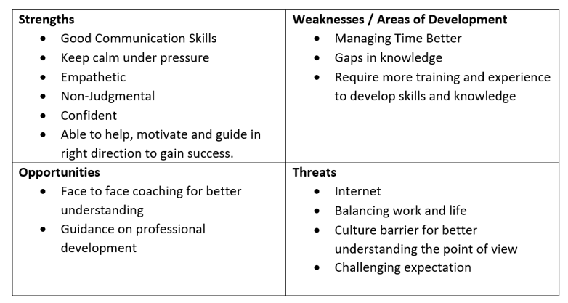

Personal Development Plan
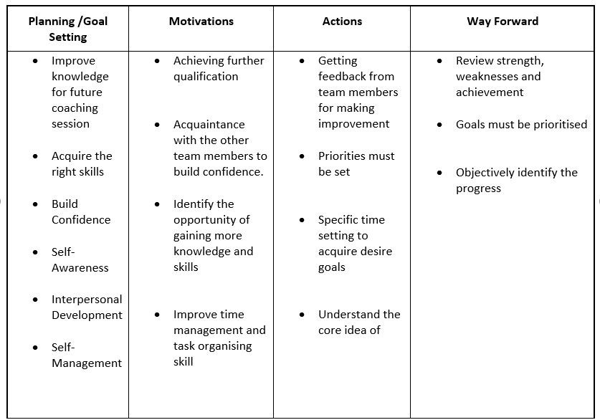
In my opinion the Instant Pay Off Model was suitable for peer coaching session as it was a short and quick and it helped the individual to know their goals, desired outcome, build their skills, and after jointly brainstorming remove the obstacles and help them to solves the problem. I reflect this experience extremely beneficial because it helped me to face my personal obstacles as a coach and understand the areas needs improvement. It also helped me to determine how to tackle the situation differently in the future where I felt nervous or anxious.

Conclusion
In conclusion, this report has effectively presented that coaches and mentors required diverse set of skills, knowledge and experience to make them expert in the focused area. The coaching and mentoring field continues to develop new prospective which can bring change into the organisations. Productive coaching and mentoring required the commitment and pointing the coachee and mentee to the right direction and make them feel comfortable while simultaneously inspiring them to achieve their full capacity. It is important to be specifically encourage employees to achieve the business goals and objectives.

References
Bachkirova, T., Arthur, L. and Reading, E. (2015). Evaluating a coaching and mentoring program: Challenges and solutions. International coaching psychology review, 10(2), pp.175-189.
Bachkirova, T., Jackson, P. and Clutterbuck, D. (2011). Coaching And Mentoring Supervision: Theory and Practice: The complete guide to best practice. McGraw-Hill Education (UK).
Clutterbuck, D. and Megginson, D. (1999). Mentoring executives and directors. Oxford: Butterworth-Heinemann, p.17.
Clutterbuck, D. (2004). Techniques for coaching and mentoring. Routledge.
Clutterbuck, D. (2008). What's happening in coaching and mentoring? And what is the difference between them? Development and Learning in Organizations: An International Journal.
Cox, E. (2014) The complete handbook of coaching. London: SAGE PUBLICATIONS.
Crawley, L. CIPD. (2020) Learning and Skills at Work 2020. London: Chartered Institute of Personnel and Development.
Donaldson, S. I., Ensher, E. A., & Grant-Vallone, E. J. (2000). Longitudinal examination of mentoring relationships on organizational commitment and citizenship behavior. Journal of Career Development, 26, 233-249.
Garvey, B., Garvey, R. and Stokes, P. (2021). Coaching and mentoring: Theory and practice. Sage.
Garvey, R., Strokes, P. and Megginson, D. (2010). Coaching and mentoring: Theory and practice.
Gibbs, G. (1988). Learning by doing. [London]: FEU.
Grant, A., Curtayne, L. and Burton, G. (2009) Executive Coaching Enhances Goal Attainment, Resilience and Workplace Well-Being: a randomised controlled study. The Journal of Positive Psychology, 4(5), pp.396-407.
Gray, D.E., Garvey, B. and Lane, D.A. (2016). A critical introduction to coaching and mentoring: Debates, dialogues and discourses. Sage.
Gray, J.A. (2018). Leadership Coaching and Mentoring: A Research-Based Model for Stronger Partnerships. International Journal of Education Policy and Leadership, 13(12), p 12.
Hakro, A.N. and Mathew, P. (2020). Coaching and mentoring in higher education institutions: a case study in Oman. International Journal of Mentoring and Coaching in Education.
Hartzell, S. (2021) Lewin’s 3-Stage Model of Change: Unfreezing, Changing & Refreezing - Video & Lesson Transcript. Available at https://study.com/academy/lesson/lewins-3-stage-model-of-change-unfreezing-changing-refreezing.html (Accessed 20 December 2021).
Hawkins, P. (2013) Coaching, mentoring and organizational consultancy.2nd ed. Maidenhead: Open University Press
Hawkins, P. and Smith, N., (2014) ‘Transformational Coaching’. In: Cox, E., Bachkirova, T. and Clutterbuck, D., (eds), The Complete Handbook of Coaching. London: 2nd edition: Sage. pp228-243.
Hussain, S. T., Lei, S., Akram, T., Haider, M. J., Hussain, S. H. and Ali, M. (2018) ‘Kurt Lewin’s change model: A critical review of the role of leadership and employee involvement in organizational change’, Journal of Innovation & Knowledge, (3) 3, pp. 123–127. DOI: 10.1016/j.jik.2016.07.002 (Accessed 18 December 2021).
Landsberg, M. (2015) The Tao of Coaching Boost Your Effectiveness at Work by Developing Those Around You. London: Profile Books.
Lea, S. (2020) GROW Model. Available at https://www.businessballs.com/coaching-and-mentoring/grow-model/ (Accessed 20 December 2021).
Lovely, S. (2004) Staffing the principalship: Finding, coaching, and mentoring school leaders. ASCD.
McCarthy, G. (2014) Coaching and Mentoring for Business, SAGE.
Megginson, D. and Clutterbuck, D. (2010). Further techniques for coaching and mentoring. Routledge.
MindTools Team (2019) Gibbs’ Reflective Cycle: Helping People Learn from Experience. Available at: http://www.mindtools.com/pages/article/reflective-cycle.htm (Accessed 07 December 2021).
Norman, C. (2019) How to make a coaching relationship work. Available at https://www.peoplemanagement.co.uk/voices/comment/how-to-make-a-coaching-relationship-work (Accessed 17 December 2021).
Parsloe, E. and Leedham, M. (2016) Coaching and mentoring: Practical techniques for developing learning and performance. Kogan Page Publishers.
Passmore, J. (2006) Excellence in Coaching: The Industry Guide, Kogan Page Publishers.
Peters, R. (2020) What lessons can COVID-19 teach us about organisational change? | CIPD. Available at https://peopleprofession.cipd.org/insights/articles/lessons-covid-19-organisational-change (Accessed 20 December 2021).
Rees, J. (2019) The Resilience Toolkit: Powerful ways to thrive in blue-light services, SRA Books.

