Assignment 1: E-Portfolio
Module Name: Learning in the Digital era
Rachid Aboulachouaq (2237654)
2023
Contents
E- Portfolio 2
Task 1 – Essential Skills 3
Task 2 – Academic Poster 4
Task 3 – Reference Manager 5
Task 4 – E-portfolio 6

E- Portfolio
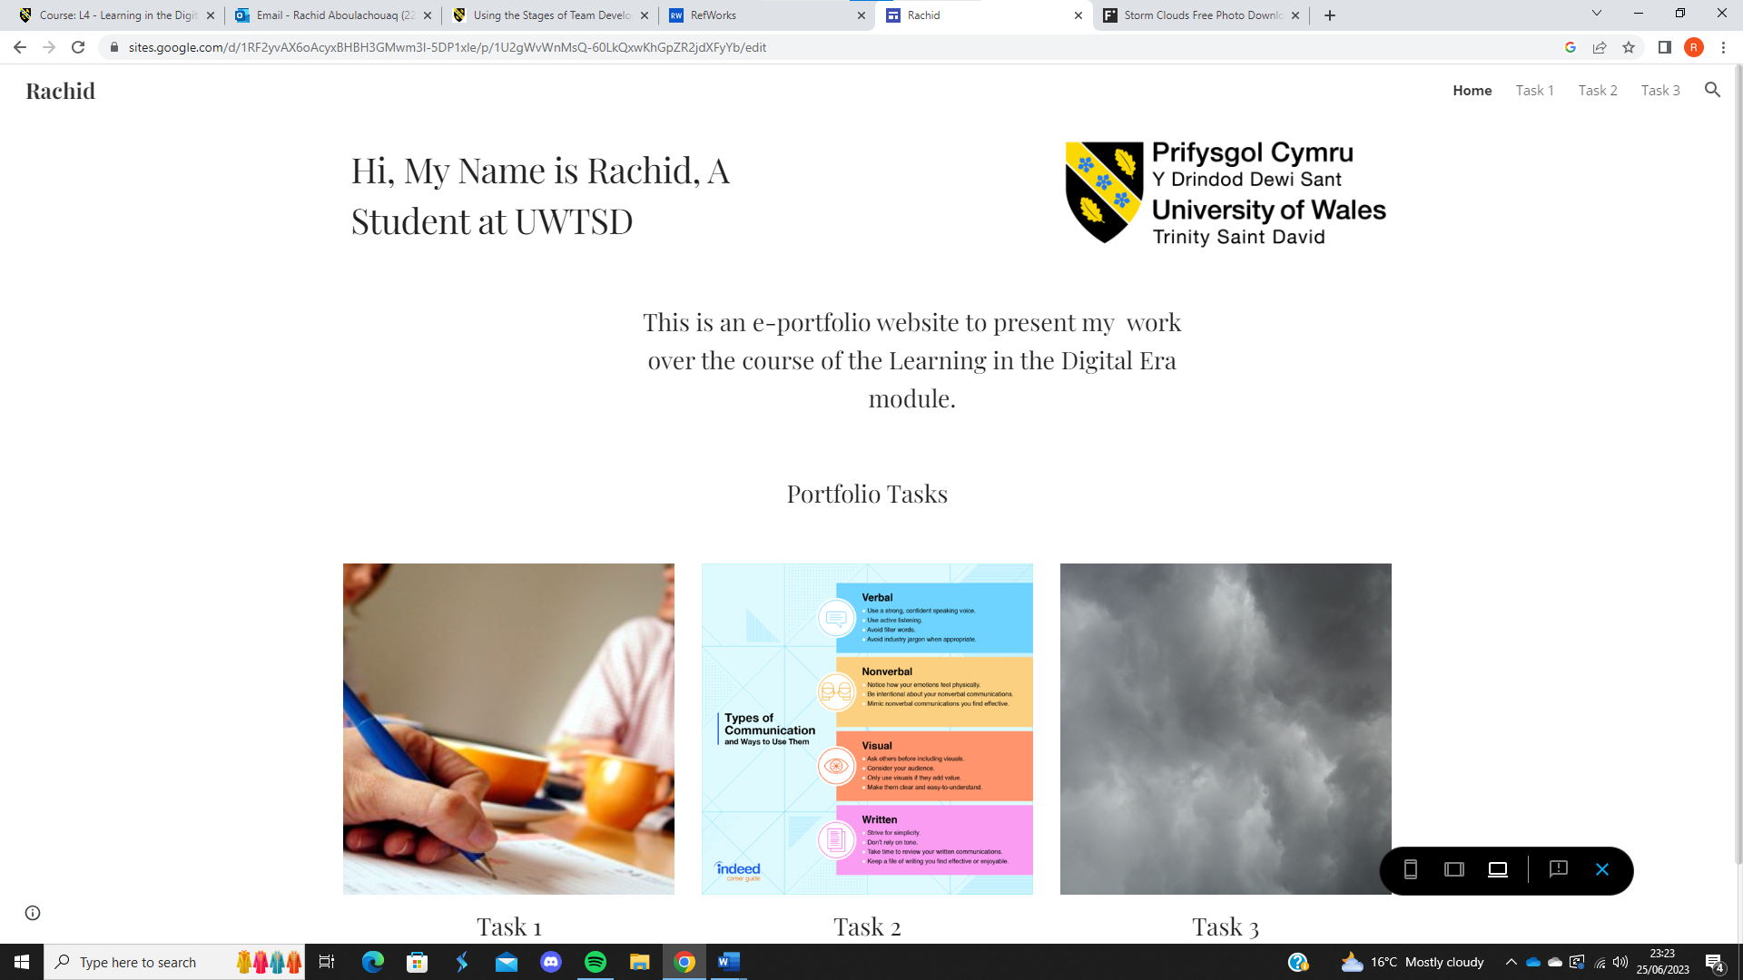
https://sites.google.com/view/lde-portfolio-2237654/home

Task 1 – Essential Skills
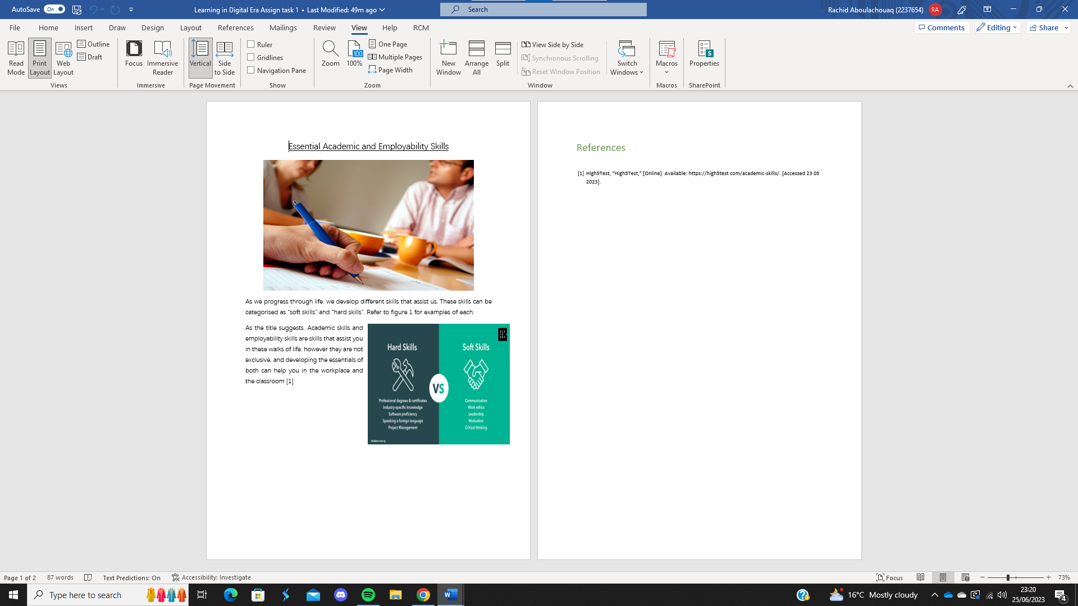

Task 2 – Academic Poster
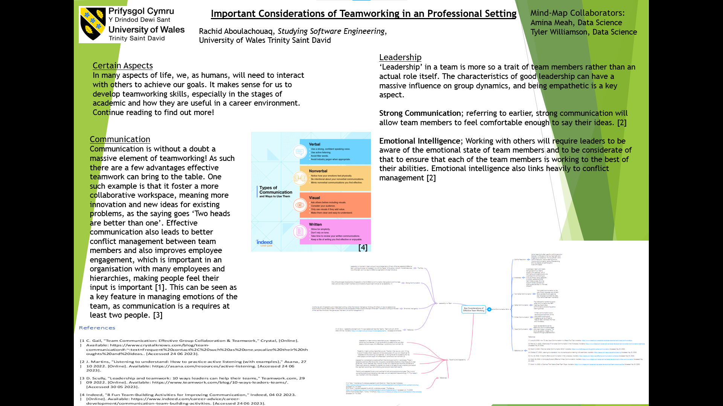
View Poster Here

Task 3 – Reference Manager
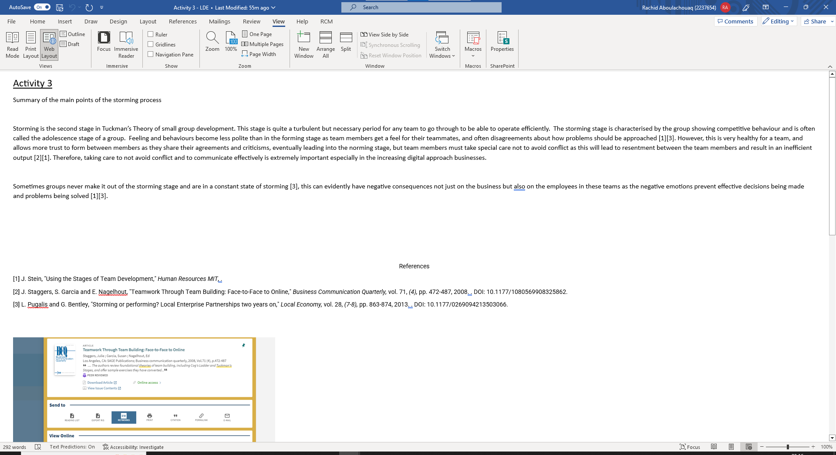
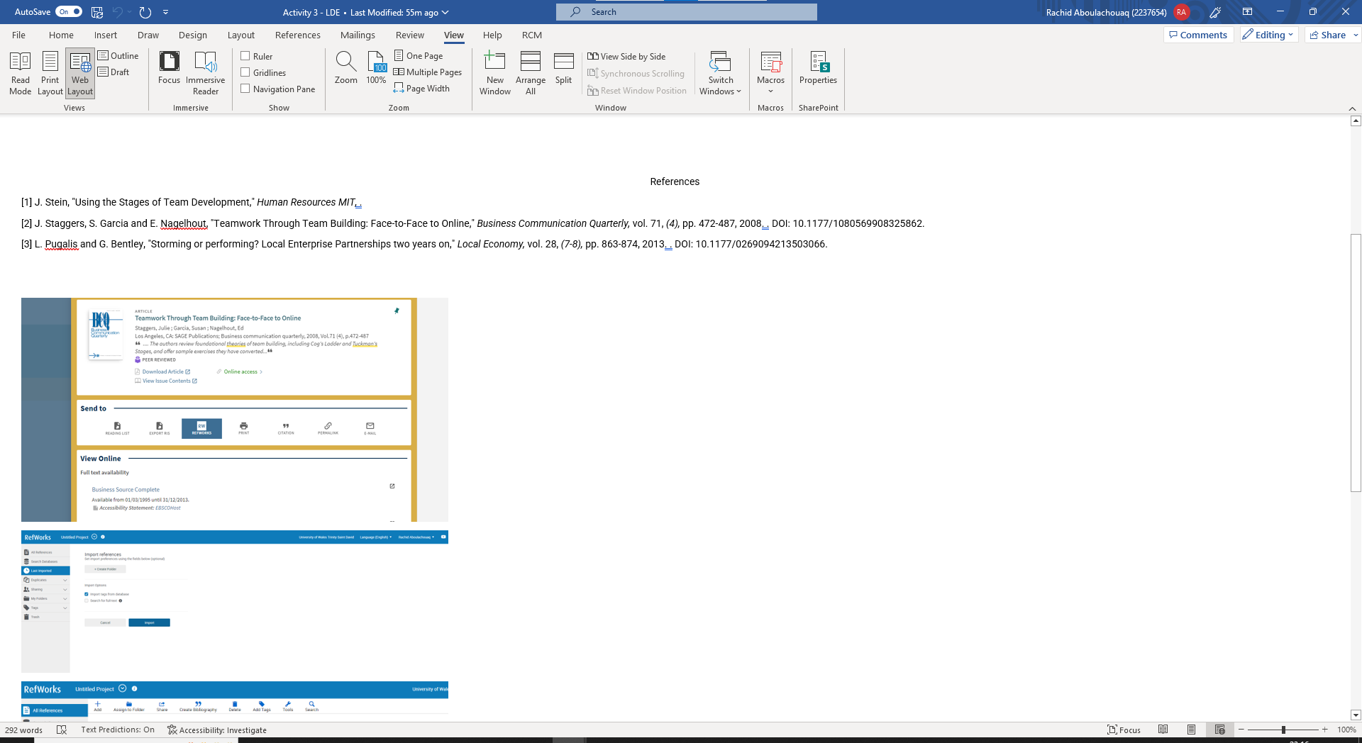
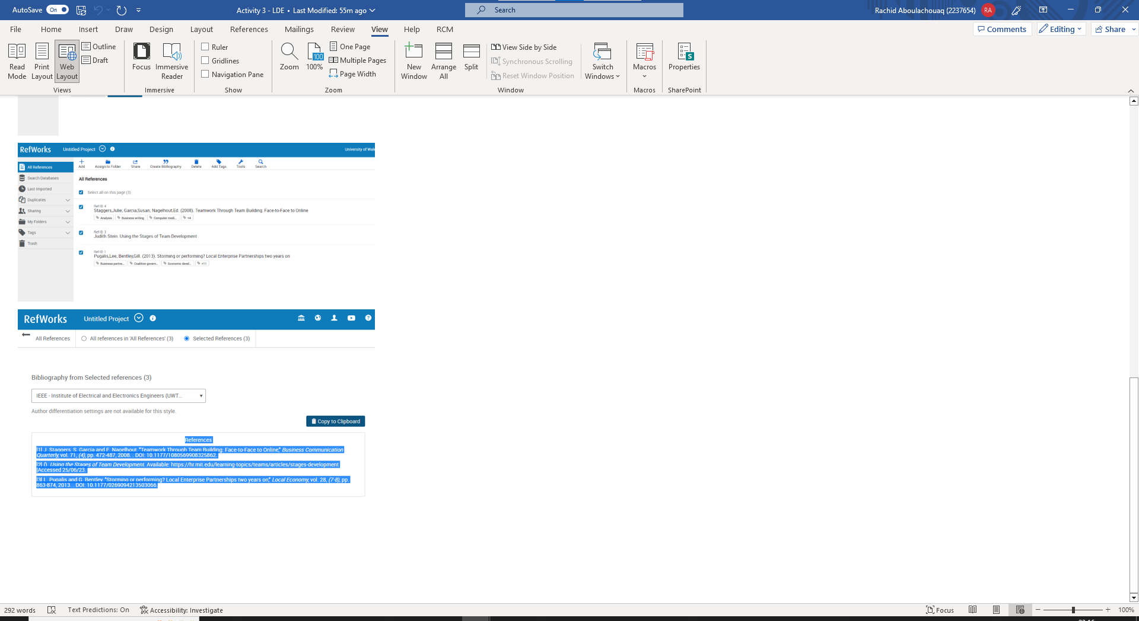

Task 4 – E-portfolio


