Awe and wonder: science, mathematics, and the outdoors

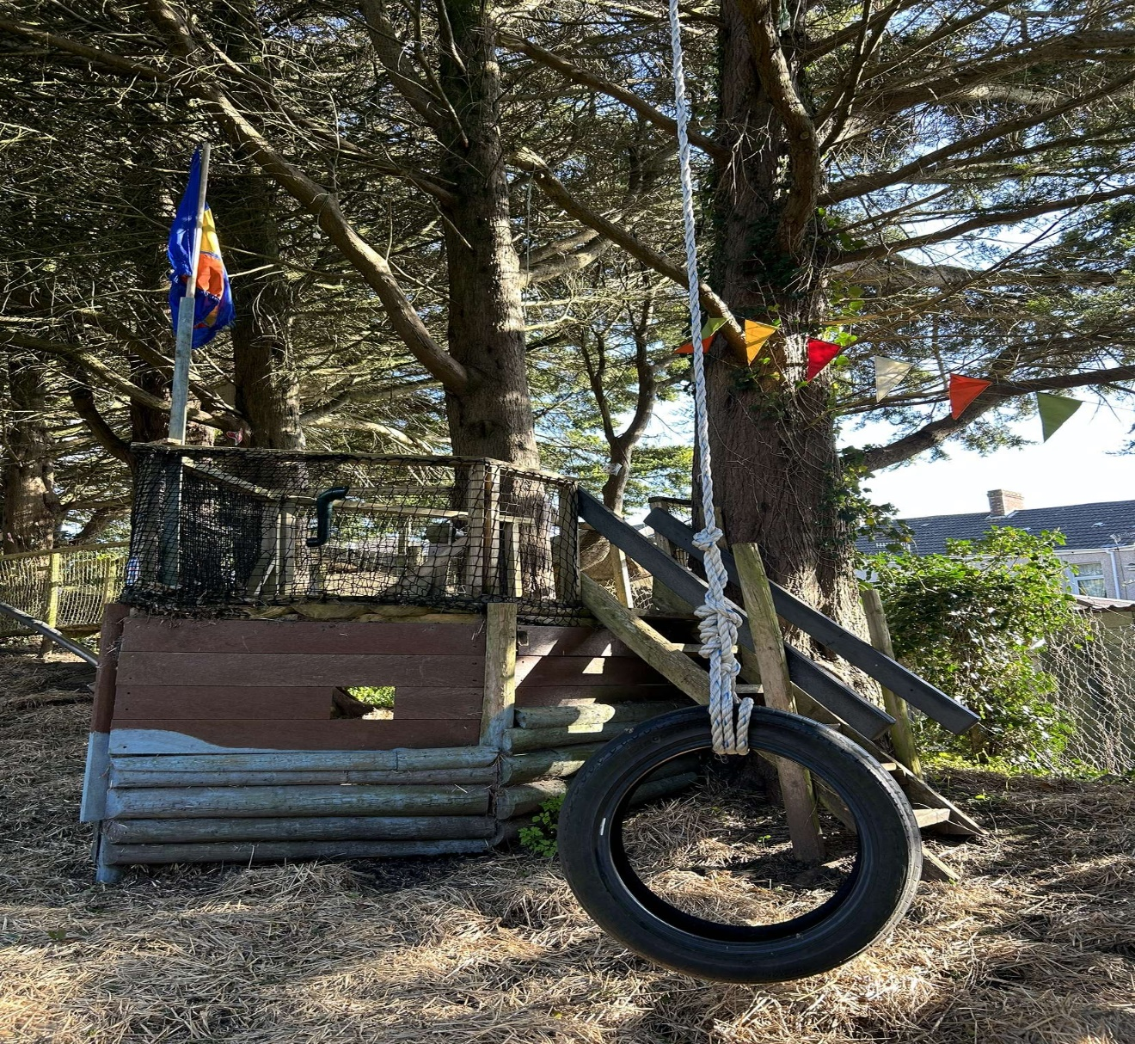

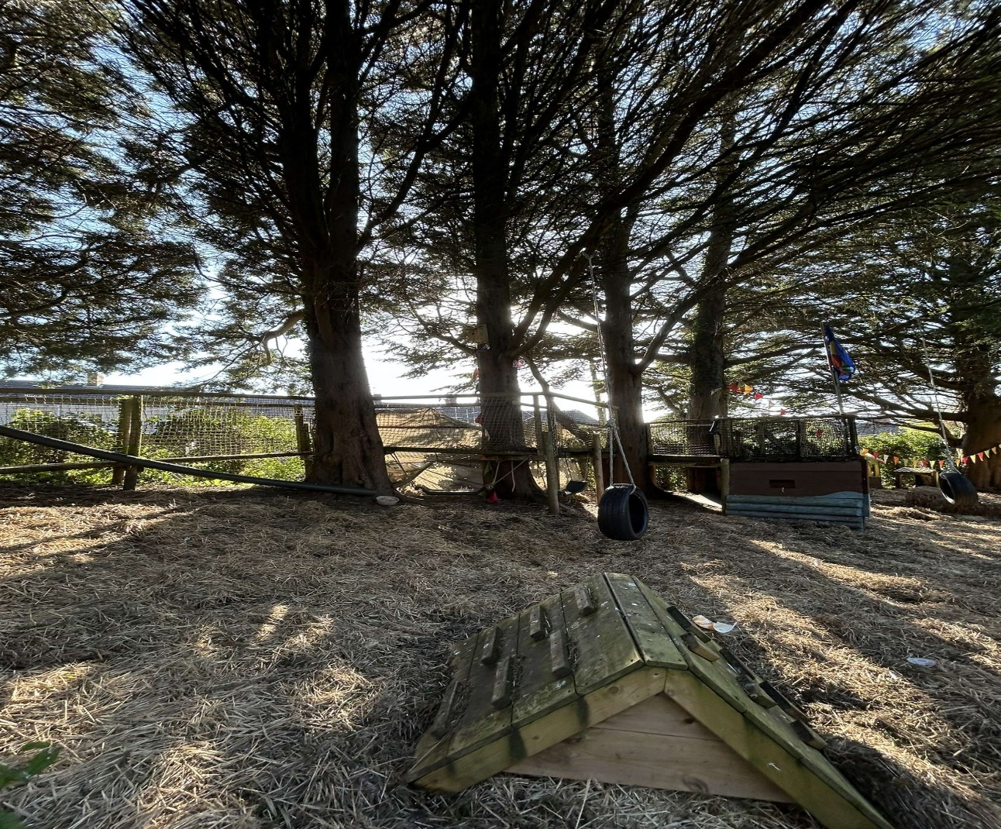
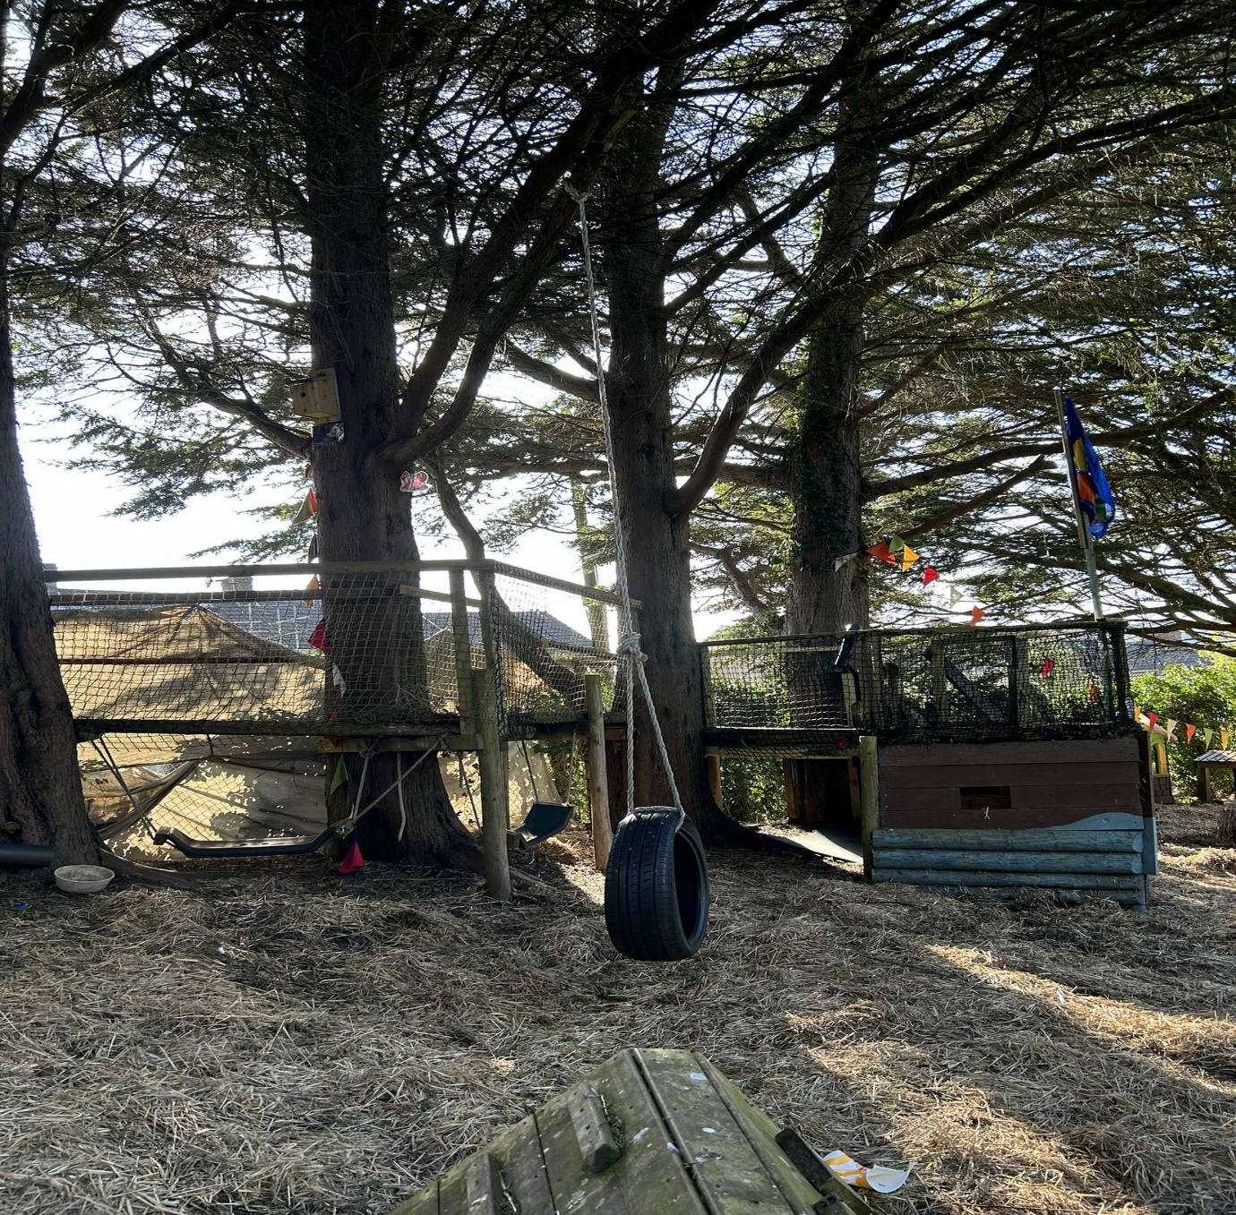

Learning Journal
9AM – As children came into school, we went straight outside to play as the weather was dry. Today they were playing on the pirate ship in the nursery that is made from wood, ropes and hay on the floor.
9:15 AM – The children separated into their groups, and they made up their own games. One group had decided to play hide and seek. By playing hide and seek outside they were including mathematics into their game by having to count when other group members were going to hide. As I watched the children playing, I could have a clearer understanding of the children’s abilities in mathematics as it allowed me to see how far the children could count.
9:30 AM – It was Ellie’s turn to count but she was very nervous. Ellie had come up to me quietly and asked “Miss, can you help me count past fourteen please?”. Ellie began counting when all the other children went to hide on and around the pirate ship. We got to number fourteen, and Ellie opened her eyes and looked at me while I then continued to count with her quietly and she said them out loud. We reached 30 together and then Ellie shouted, “Ready or not, here I come”.
10 AM – After the children had been playing hide and seek for 45 minutes, it was Callum’s turn to count and after he’d finished counting, off he went running but tripped and fell over a branch that was on the floor. After ensuring Callum was okay, we then went on to have a lesson on how the branch had ended up on the floor and the way that gravity helps it. The children were learning how if it was not for gravity, the branch would not have fallen on the floor and would have stayed in the air. Gravity is what drags the branch to the floor after it snaps off of a tree.
10:30 AM – Following on from the lesson about gravity with the branch, we decided to keep discussing the topic gravity. We moved to play with the tyre swing where Rosie asked, “Why does the tyre swing backwards and forwards?”. As a class then, we were discussing all together why the children thought the swing moved the way it does and there is where we discussed gravity. I explained to the children that when we pull the swing backwards and up in the air, it is because of gravity, when you let it go, it starts swinging back and forth.
11 AM – The children decided they were hungry and that it was snack time. As the weather was nice today, we ate our snack outside down on the pirate ship as a picnic. As we were sat there, eating our picnic, the children were looking at all the leaves that they could see on the floor. They were asking many questions about why they are all different colours and different shapes and sizes. After they’d finished their snack, I set them a task of collecting as many different leaves as they could in 25 minutes and then we were going to come back together and discuss them all.

11:45 AM – We got back together as a group and placed all of the leaves onto a blanket and inspected them all. The children put the leaves into matching group and counted the groups to see how many we had. They managed to find 15 different leaves. This sparked the conversation of the leaf’s life cycle and what changes it goes through and why it happens. I brought out the iPad and found a diagram of the colour stages a leaf would go through during its’ life cycle. The children then looked through their leaves and matched the photo by lining their own leaves up I the same order as the photo shows.

12 PM – While discussing a leaf’s life cycle, one child found a caterpillar on their leaf but was unsure what animal it was. We had a group discussion on what animal they thought it was. Luke shouted, “It is a caterpillar”. Through this, the children began running around to see if they could find anymore but they could not. We got one of our bug pots with a magnifying lid so the children could take it in turns to have a closer look at the caterpillar. Luke turns to Rosie, and they have a conversation.
Luke – “Where does a Caterpillar come from?”
Rosie – “An egg”
Luke – “I have never seen a caterpillar egg before”
Rosie then turned to me and proceeded to ask me to show them all a photo of a caterpillar egg. After all the children had seen the photo, we began to talk about the caterpillar’s life stages. The children were all amazed that it begins with an egg and then transforms all the way into a butterfly.

12:30 PM – The children all went inside to have their lunch.
1PM – After eating and clearing the mess of lunch, the children wanted to go back outside to play on the pirate ship. As the afternoon went on, the children were enjoying running around in the sun and playing their own games. As the pirate ship is built on a slope, we started speaking about the uneven surfaces. The children were all rolling down the hill and then having to run back to the top. They wanted me to count how long it took them to reach the bottom and make it all the way back up to the top again. They took it in turns to see how fast they all were and then they were comparing their times.
2:30 PM - The children were all still playing and rolling around outside talking about their times of rolling down the hill when Ellie asked, “Why doesn’t my block roll down the hill?”
Ellie was playing with her blocks that were all different shapes and sizes and she was trying to roll them down the hill. When it came to her triangle block, Ellie discovered that it would not roll down the same as her circular block. I began explaining that there are more chances of objects rolling down the hill if they are circular and they travel at a faster pace if they are heavier. We were rolling stones and balls down the hill to see which one would travel faster. The children discovered that the football travelled the fastest down the hill as it was heavier than everything else. It was explained to the children that it is due to gravity pulling them, the balls travel down the slope so fast.
3PM – The last activity the children did before they were going home was to collect a few rocks and see if they could notice all the different textures and weights of them. They collected a few into a bucket and came together to compare them. They put all the big rocks in a pile together and all the small rocks together. They were picking them up one by one and comparing them to each other with how heavy or light they were. As they were picking them up, they were looking out for the different patterns and textures on the rock faces seeing if they were smooth or lumpy. The children were looking if the rocks had lines on them or if they were plain. The were noticing if they were different colours or if they matched. `

Section 3
Experience exploring outdoor space in photograph | How will young people BENEFIT from this activity? | Hazards and associated risks | Who is at risk? | PRECAUTIONS in place to reduce the risk of injury | Overall risk after precautions  RATING: L/M/H
Tyre swing | The tyre swing allows the children to develop better balance as well as good coordination. From being on the tyre swing it also benefits their motor skills and form stronger muscles. | The children could fall off but also other children could be getting in the way of the swing. The rope could have weakened and then it might not be strong enough and could snap. | The children | Only one child allowed on the swing at the time  Allow space around the swing to ensure other children do not get knocked over  When a child is on the swing, make sure they are holding on tight enough | Medium
Stairs of the pirate ship | It can help develop a child’s balancing skills as well as their coordination and spatial awareness. Climbing the stairs is also a good way of building muscles for children in their legs. | Falling up or down the stairs, handrail might not be safe and secure, one stair could be broken, objects on the stairs in the way, steps could be uneven, weather could have affected the stairs making them slippery. | The children | Do a safety check first before allowing the children to have access to the stairs and ensure that they are dry and not slippery.  Checking that the handrail is secure and in one piece.  Ensure that everything is removed from the stairs and that there are no trip hazards in the children’s way. Make sure that a member of staff is watching the stairs at all times ensure that there is only one child on the stairs at all times to avoid them falling over each other. | Medium
Wooden climbing frame | The benefits from the climbing frame would be improving muscle strength, hand-eye coordination as well as improving their focus. It helps the child develop confidence in themselves and benefits their decision-making skills. | The children could easily fall off and hurt themselves. Items of clothing could also get stuck on the climbing frame leaving the child hurt. The surfaces could also be slippery from wet weather making it unsafe. | The children | Check the climbing frame first before allowing the children to use to, making sure that it is dry and not slippery to avoid slips and falls. Ensure that there are no obstacles in the way of the children or anything they could get their clothes stuck on leading them to fall. Ensure that the climbing frame secured well and that there is no risk of it falling apart so that the children do not fall off. | Low
The pirate ship | The benefits of the pirate ship include helping a child’s imagination as well as their creativity. It also enables them to work on their problem-solving skills as well as their balance. | The surfaces could be slippery leading to a fall or a slip. The netting on the side could have broken leaving a gap for the children to fall through. It is high in the trees and the branches could have snapped or could be old and broken. | The children | Must ensure that an adult has been around to check the floor and that it is not slippery. Make sure the netting has been checked before the children are allowed to go on and that if there are any holes, they get fixed immediately. Check the trees for any broken branches and remove them from the children’s way to avoid injuries. | Medium
Hay/mud play | This supports children’s balance and coordination. Mud and hay playing also benefits the children’s problem-solving skills. Young children can also benefit from playing with mud and hay as it is a way of engaging with their senses while building the immune system. | There could be animal waste in the mud/hay. The mud could be wet from rain causing the children to slip and injure themselves. Little bugs that bite or sting could be living in the hay or the mud. | The children | Do a safety check on the area first before allowing the children there to check if there is any animal waste in the area. If there is, dispose of it appropriately and ensure the environment is then clean. Check that the mud is not too slippery for the children to play in before they go on it. Make sure the children are protected by bug spray just in case. | Low
Tree climbing | Tree climbing helps the child focus and develop a better concentration. It engages with a child’s hand-eye coordination skills and allows them to challenge themselves and push their boundaries. It is a good way to exercise as well as helping to develop their balance and spatial awareness. | A child could easily fall off the tree, causing injury such as broken bones. Branches could be unsafe. The tree could be slippery. | The children | Ensure that a member of staff is near the tree at all times to guide the children or to catch them if they slip. If the tree is too slippery, do not allow the children to climb them. Only allow the child to climb to their own abilities and guide them when coming back down in order to prevent falling and injury. Make sure the branches are safe and not on the verge of breaking. | High

Section 4
According to Community Playthings (2018) engaging in the outdoors in early childhood allows the children to develop great mathematical skills as there are a variety of aspects of the outdoors that benefits the children. While children are playing outside, they are constantly learning and developing many skills. Being outside, children are engaging with nature and therefore they are exploring everything that they find which includes, leaves, stones and rocks, trees, and bugs. Through doing this, Community Playthings (2018) suggests children are developing their mathematical thinking skills such as counting and discovering the different shapes. Likewise, Development and Research in Early Mathematics Education (2021) highlight that early outdoor experiences are a positive influence on children’s mathematical skills. Children enjoy partaking in collecting items through exploring the outdoors. Development and Research in Early Mathematics Education (2021) implies that through collecting items outside, children can focus on their mathematical skills doing this as they can count all the objects they find, they can discuss the different shapes that they have found and also go into more depth by exploring the difference in weight between the objects.
Furthermore, NAEYC (2023) indicates that outdoor play benefits children’s mathematical skills as natural resources have their own way of incorporating mathematics into a child’s everyday life. It is suggested that even a tree stump can have mathematical and scientific benefits. For example, children can use a tree stump to learn about balancing and height. They can work on their balancing skills as they stand on top of the tree stump helping their coordination through balancing on one leg and then changing over to the other leg. Children can also use skills such as measuring height and distance with a tree stump. NAEYC (2023) propose that children could compare different tree stumps and compare their heights but also measure distance through seeing how far off the stump the children can jump. This is working on their mathematic skills as well as their problem-solving skills. Similarly, University of Minnesota (2021) highlights that early mathematics in the outdoors supports children’s development in many ways. For example, a child’s problem-solving skills are greatly benefited from outdoor play. While being outside, children are dealing with a variety of objects such as plants, rocks, hills, and water. Each oft these objects have both mathematical and scientific aspects to them. When it comes to plants, science is involved as the children can learn about the life cycle behind the plants. Mathematics is involved within playing and engaging with the plants as children are able to count them, organise them according to size as well as shapes. According to the University of Minnesota (2021) hills are a good example of incorporating science to outdoor play within early years as well as it is a way of teaching children about gravity and how it works. For example, by rolling a ball down a hill, it is showing the children that different shape objects travel differently from the gravity pulling them down. They can focus on how the shapes, how different shapes travel at different paces and also if they roll down or not.
Moreover, Clare Devlin Early Education Consultancy (2020) indicates that mathematical theories are significant to everyday life in early years. It is highlighted that an outdoor environment is crucial to the mathematical development of children. By being outside, they have ample opportunities to learn through exploration. Counting is an important role that comes into play when wanting to develop mathematical skills in early years. Clare Devlin Early Education Consultancy (2020) implies that children learn the difference between 2D and 3D shapes from playing outdoors as well as learning and understanding the difference between weights, lengths, and heights. Similarly, Teach Early Years (no date) suggests that outdoor play has many ways of benefits a child’s counting skills. An example given by Teach Early years (no date) is counting bricks in the building’s wall. By doing this, children are exploring how high they can count as well as progressing and learning the higher numbers that come after they have reached their capabilities. Clare Devlin Early Education Consultancy (no date) provide ideas of how adults in early years settings can help offer scientific aspects into outdoor play for children. One example given is to plant seeds with the children. This enables them opportunity to ask questions and develop a deeper understand of life cycles of different plants or vegetables and the process behind it. It also offers them the opportunity to be independent through taking care of the plants themselves by watering them and ensuring they are keeping them alive.
According to Froebel Trust (2023) Froebel identified outdoor play for children as holistic. It was a form of allowing children to have the freedom and allow them to develop through creative and imaginative play. It was noted that Froebel had a passion for nature and therefore was not against children learning and developing through the outdoors. It is emphasized by Froebel Trust (2023) that Froebel thought that outdoor play was beneficial to not only children’s mental, physical and emotional health but also very educational for them. Froebel identified that the outdoors has its’ own way of teaching children about a variety of life’s aspects. For example, it is suggesting that children learn better about different lights and sounds when they are outdoors as there are more aspects to explore. It is also suggested by Froebel Trust (2023) that children develop a better understanding of gravity and the science behind it from being outside and seeing examples of how gravity works better. Additionally, Learning Resources (2022) indicates that outdoor play is essential as a part of a child’s growth and development in many different ways. By being outdoors, it is implied that a child is developing better intellectually as they are having unaware science lessons through playing. While being outdoors, whether it is on a school playground, in a garden at home or at a park, science is all around. Learning Resources (2023) gives an example of a climbing frame. While the children are enjoying climbing and playing on the climbing frame, they are discovering and learning about gravity. Nonetheless, playing in the outdoors in early years allows children to develop their five senses which are taste, smell, touch, see and hear.
PACEY (2021) propose that outdoor play is an important role in developing mathematical and literally skills in early years. There are many different ways of incorporating mathematical aspects to children’s time outside. By using stones or sticks and some paint to create mark makings children are developing their creative skills as well as their mathematical skills. They create their own pictures using the stones or sticks and then proceed to count the number of sticks they have used, or number of different paint colours they have used. Moreover, PACEY (2021) highlight that adults could include number sequencing games during the children’s time outside. An example provided by Pacey (2021) is playing number snake with the children. While this focuses on numbers and learning to count, it also encourages them to focus on their balancing skills, coordination, jumping skills and changing directions. There are a variety of easy games that adults and early years practitioners could include in outdoor playtime which engages and focuses on mathematical skills for the children that could lead to improvement on their knowledge. By engaging in a simple game of hopscotch or skipping with hoops, the children are learning to count and developing and upgrading their skills to become better at number counting.
Lastly, Welsh Government (2020) indicates that the curriculum for Wales shows that within early years play is crucial for the mathematical development of the children. It offers the children the opportunity to develop new skills in problem-solving involving numbers, explore their creativity. Day Nurseries (2024) similarly suggest that it is vital for children to learn basic early mathematics such as counting as it enables them to further develop their problem-solving skills. It is suggested to do tasks such as adding and taking away objects, therefore the children will have to count and work out how many they have left. Day Nurseries (2024) highlight that the curriculum for Wales implies that children should be outdoors, learning how to recognize different shapes and begin to be able to name them. By doing this, it helps develop their problem-solving skills which is a very important skills that is needed in everyday life. Day Nurseries (2024) also emphasise that incorporating science in the outdoor environment is just as important as incorporating mathematics. By being outdoors, adults and practitioners have the opportunity to carry out experiments with the children in which are age appropriate for them, to understand the basics of science. An example provided by Day Nurseries (2024) is to use a variety of materials that you can find outside and test them against gravity, teaching the children about the difference and what could happen to the heavier and lighter ones or if something moves whether you push or pull it.

Reference list
Clare Devlin Early Education Consultancy. (2020) Providing the Curriculum Outdoors – Mathematics. Available at: https://www.claredevlin.org/blog-page/2020-06-04/providing-the-curriculum-outdoors-mathematics (Accessed: April 24th 2024).
Community Playthings. (2018) Maths in the great outdoors. Available at: https://www.communityplaythings.co.uk/learning-library/articles/maths-in-the-great-outdoors#:~:text=Children%20naturally%20use%20mathematical%20thinking,from%20indoors%20using%20nature's%20bounty (Accessed: April 24th 2024).
Day Nurseries. (2024) Curriculum for Wales: Early Years. Available at: https://www.daynurseries.co.uk/advice/curriculum-for-wales-early-years (Accessed: April 27th 2024).
Development and Research in Early Mathematics Education. (2021) Taking Math Outdoors: A Natural Learning Environment. Available at: https://dreme.stanford.edu/news/taking-math-outdoors-a-natural-learning-environment/ (Accessed: April 24th 2024).
Froebel Trust. (2023) Schemas, outdoor play and Froebel. Available at: https://www.froebel.org.uk/news/schemas-outdoor-play-and-froebel (Accessed: April 25th 2024).
Learning Resources. (2022) Why is Outdoor Play Important for Children’s Development? Available at: https://www.learningresources.co.uk/blog/why-is-outdoor-play-important-for-childrens-development/ (Accessed: April 25th 2024).
NAEYC. (2023) Eight Ways to Encourage Math Learning During Risky Outdoor Play. Available at: https://www.naeyc.org/resources/blog/eight-ways-encourage-math-learning-during-risky-outdoor-play (Accessed: April 24th 2024).
PACEY. (2021) Using outdoor provision to support learning in the Early Years Foundation Stage. Available at: https://www.pacey.org.uk/news-and-views/pacey-blog/2021/june-2021/blog-using-outdoor-provision-to-support-learning/ (Accessed: April 26th 2024).
Teach Early Years. (No date) Early Years Science Activities for the Great Outdoors. Available at: https://www.teachearlyyears.com/learning-and-development/view/taking-science-outdoors#:~:text=There%20is%20a%20huge%20amount,of%20different%20types%20of%20leaves%2C (Accessed: April 25th 2024).
University of Minnesota. (2021) Taking Math Outdoors: A Natural Learning Environment. Available at: https://news.cehd.umn.edu/taking-math-outdoors-a-natural-learning-environment/ (Accessed: April 24th 2024).
Welsh Government. (2020) Mathematics and Numeracy. Available at: https://hwb.gov.wales/curriculum-for-wales/mathematics-and-numeracy (Accessed: April 26th 2024).

