Games Architecture and Mechanics
Assignment 2
Jake Russell
1602835

Table of Contents
Task 1 3
Task 2 3
Task 3 6
Appendix 10
Display.h 10
GameObject.h 10
Mesh.h 11
Objloader.h 12
Transform.h 13
Display.cpp 14
GameObject.cpp 16
Mesh.cpp 17
Objloader.cpp 18
Source.cpp 20
Transform.cpp 20

Task 1

For task 1, in order to update at a fixed rate and have it render at a potentially variable rate, first the render() method and update method() were separated by placing the update() method in a contained while loop which loops at a fixed rate. This was done with the following code:
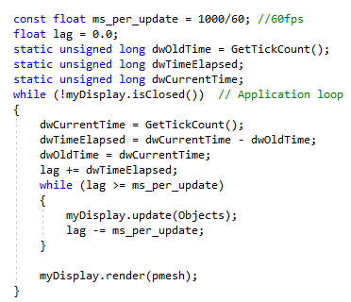
Figure 1: Code for fixed rate timing
In order for the loop to run at 60 fps, a variable called ms_per_update was made, and it was set the value of 1000/60 which is 16.666 recurring being the millisecond delay between updates when it is updating at 60 fps. This calculation being how many milliseconds in a second (1000) divided by the desired fps, being in this case 60. The lag variable is made as a way to track how far behind the loop is compared to real time, the inner while loop with the update() method then loops until the main loops clock has caught up.

Task 2

For task 2 to integrate the obj loader into the prototype an object of class obj and a new constructor called Mesh(const char *f) were made within the mesh class. A function was also made to convert the polygons from the obj file into a vertex list called objPoly2Vertex:
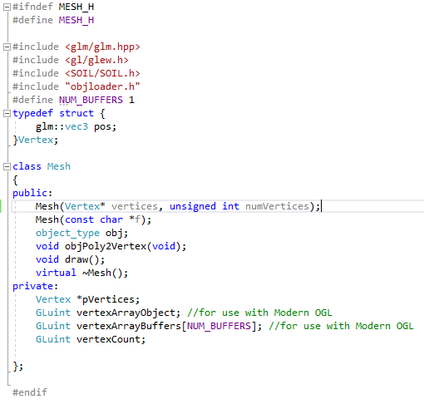
Figure 2: task 2 mesh.h
In the mesh.cpp class, the object is called from the object loader through obj.objloader(f), and it is then converted by calling objPoly2Vertex:
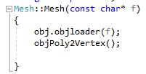
Figure 3: task 2 mesh.cpp
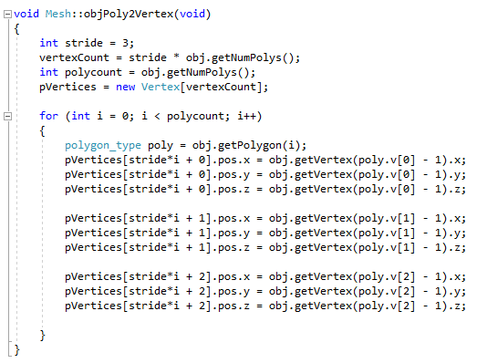
Figure 4: mesh.cpp convert function
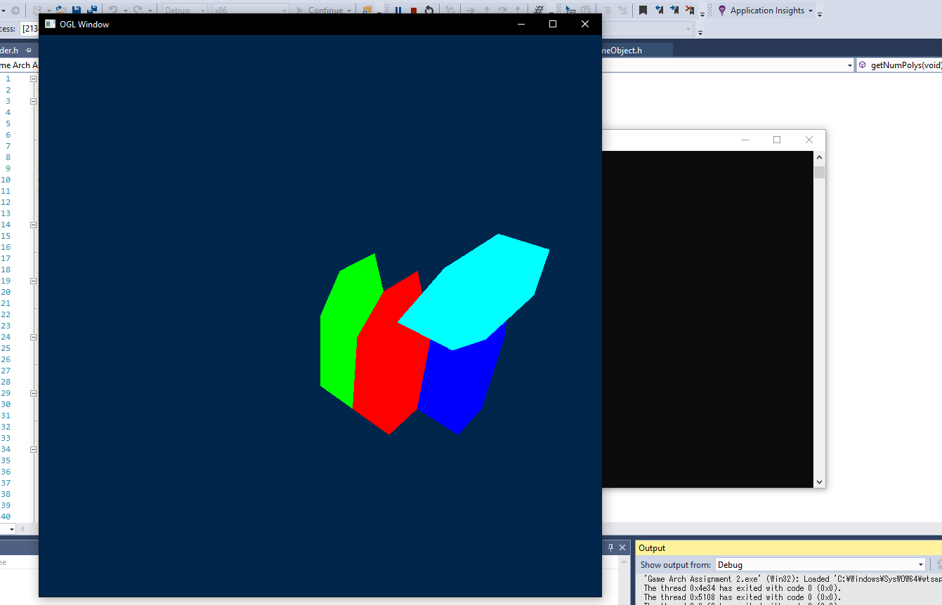
Figure 5:Task 2 House.obj

Task 3
For task 3 a class called GameObject was made as the container class. A vector was then made called Objects which takes in objects of type GameObject with the initial amount set as 3. Within the GameObject class, an empty function was made named GOupdate to called later. Next in the display class, the display classes update function was adjusted to be to take in the vector “Objects”. A new function was inside display.cpp named ObjectUpdate which outputs to the user that objects have been updated. This function is then made to be called within the display classes update function. Lastly in the source.cpp, the gameloop was made to send the vector “Objects” when calling myDisplay.update.
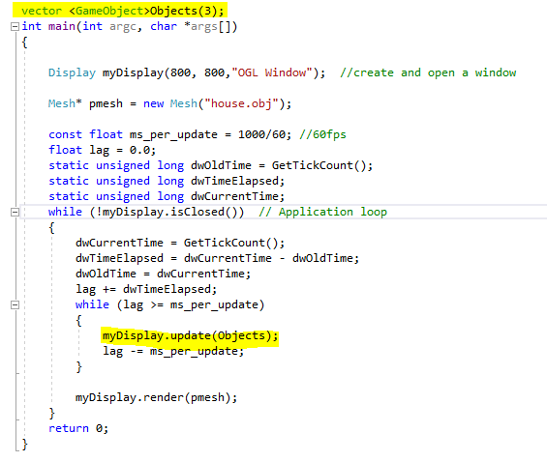
Figure 6:task 3 source.cpp
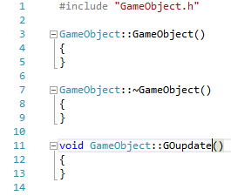
Figure 7:task 3 GameObject.cpp
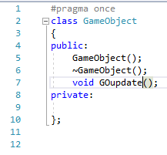
Figure 8:task 3 GameObject.h

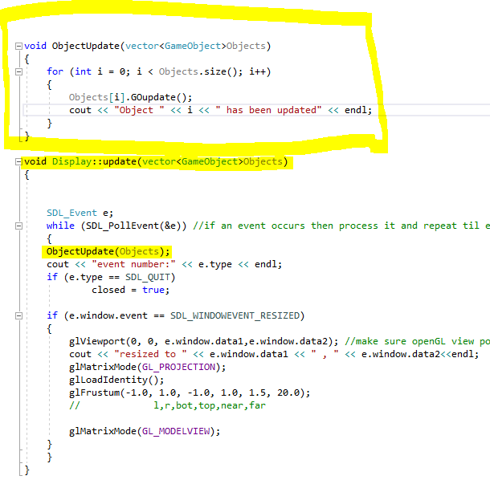
Figure 9: task 3 Display.cpp
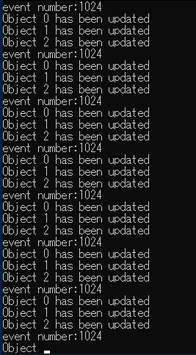
Figure 10: task 3 test

Appendix

Display.h
#ifndef DISPLAY_H
#define DISPLAY_H
#include <sdl2/SDL.h>
#include <GL/glew.h>
#include <string>
#include "mesh.h"
#include <vector>
#include "GameObject.h"
//uses SDL2 to create a window to display our OGL stuff
using namespace std;
class Display
{
public:
Display(int width, int height, std::string title);
virtual ~Display();
void swapBuffers();
bool isClosed();
void update(vector <GameObject>Objects);
void clear(void);
void render(Mesh *pMesh);
private:
bool closed;
SDL_Window* window; //pointer to window
SDL_GLContext glContext; //context for drawing OGL to SDL window
};

#endif //DISPLAY_H

GameObject.h
#pragma once
class GameObject
{
public:
GameObject();
~GameObject();
void GOupdate();
private:

};

Mesh.h
#ifndef MESH_H
#define MESH_H

#include <glm/glm.hpp>
#include <gl/glew.h>
#include <SOIL/SOIL.h>
#include "objloader.h"
#define NUM_BUFFERS 1
typedef struct {
glm::vec3 pos;
}Vertex;

class Mesh
{
public:
Mesh(Vertex* vertices, unsigned int numVertices);
Mesh(const char *f);
object_type obj;
void objPoly2Vertex(void);
void draw();
virtual ~Mesh();
private:
Vertex *pVertices;
GLuint vertexArrayObject; //for use with Modern OGL
GLuint vertexArrayBuffers[NUM_BUFFERS]; //for use with Modern OGL
GLuint vertexCount;

};

#endif

Objloader.h
#ifndef OBJLOAD
#define OBJLOAD
/*****************************************************************************************
*Loads obj file - limited to vertices, faces, normals, texture maps
*loads to object structure as defined in .h file
******************************************************************************************/

#define MAX_VERTICES 8000 // Max number of vertices (for each object)
#define MAX_POLYGONS 8000 // Max number of polygons (for each object)
#define MAX_NORMALS 8000 // Max number of polygons (for each object)

// Our vertex type
typedef struct {
float x, y, z;
}vertex_type;

// Our normal type
typedef struct {
float i, j, k;
}normcoord_type;

// The polygon (triangle), 3 numbers that aim 3 vertices
typedef struct {
int v[3], t[3], n[3];
}polygon_type;

// The mapcoord type, 2 texture coordinates for each vertex
typedef struct {
float u, v;
}mapcoord_type;

// The object type
class object_type {
public:
int id_texture;
object_type() {}
~object_type() {}
int objloader(const char *p_filename);
int objdatadisplay();
int getNumPolys(void) {return polygons_qty;}
polygon_type getPolygon(int i) { return polygon[i]; }
vertex_type getVertex(int i) { return vertex[i]; }

private:
char name[20];
int vertices_qty;
int polygons_qty;
int mapcoord_qty;
int normcoord_qty;

vertex_type vertex[MAX_VERTICES];
mapcoord_type mapcoord[MAX_VERTICES];
normcoord_type normcoord[MAX_NORMALS];
polygon_type polygon[MAX_POLYGONS];

};

#endif

/*************************************************************/

Transform.h
#ifndef TRANSFORM_H
#define TRANSFORM_H
#include <glm/glm.hpp>
#include <GL/glew.h>
#include <string>

//Holds a mesh's transform
class Transform
{
public:
Transform();
Transform(glm::mat4x4* m);
virtual ~Transform();

void UpdateMV(glm::mat4x4* m);

private:
glm::mat4x4 mv;
};

#endif

Display.cpp
#include "display.h"
//#include<GL/GLU.h>

#include <GL/glew.h>
#include <string>
#include <iostream>
#include <vector>
#include "GameObject.h"
using namespace std;

Display::Display(int width,int height, std::string title)
{
SDL_Init(SDL_INIT_EVERYTHING);//uses SDL2 to create

//std::cout << "hello world" << std::endl;

SDL_GL_SetAttribute(SDL_GL_RED_SIZE, 8);
SDL_GL_SetAttribute(SDL_GL_GREEN_SIZE, 8);
SDL_GL_SetAttribute(SDL_GL_BLUE_SIZE, 8);
SDL_GL_SetAttribute(SDL_GL_ALPHA_SIZE, 8);
SDL_GL_SetAttribute(SDL_GL_BUFFER_SIZE, 32); //THESE SIZES ARE AT LEAST THESE VALUES.
SDL_GL_SetAttribute(SDL_GL_DOUBLEBUFFER, 1); //1 turns double buffering on in SDL.

window = SDL_CreateWindow(title.c_str(), 100,100/* SDL_WINDOWPOS_CENTERED, SDL_WINDOWPOS_CENTERED*/, width, height, SDL_WINDOW_OPENGL | SDL_WINDOW_RESIZABLE );

glContext = SDL_GL_CreateContext(window); //create the context
SDL_GL_SetSwapInterval(0);
GLenum status = glewInit(); //glew searches to find every single OGL function supported.
if (status != GLEW_OK)
{
cerr << "Glew failed to initialize" << endl;
}

closed = false;
glShadeModel(GL_FLAT); //uses GL_SMOOTH or GL_FLAT

//set viewport to screen size and initialize projection matrix. Leave with matrixmode = Modelview
glViewport(0, 0, width, height); //make sure openGL view port is scaled to size of new window (if you want!) - why didn't I use freeglut?
glMatrixMode(GL_PROJECTION);
glLoadIdentity();
glFrustum(-1.0, 1.0, -1.0, 1.0, 1.5, 20.0);
// l,r,bot,top,near,far
glMatrixMode(GL_MODELVIEW);

}

Display::~Display()
{
SDL_GL_DeleteContext(glContext);

SDL_DestroyWindow(window);
SDL_Quit();
//std::cout << "bye bye" << std::endl;
}

void ObjectUpdate(vector<GameObject>Objects)
{
for (int i = 0; i < Objects.size(); i++)
{
Objects[i].GOupdate();
cout << "Object " << i << " has been updated" << endl;
}
}

void Display::update(vector<GameObject>Objects)
{

SDL_Event e;
while (SDL_PollEvent(&e)) //if an event occurs then process it and repeat til event queue is empty - catches SDL_QUIT if it is in the queue
{
ObjectUpdate(Objects);
cout << "event number:" << e.type << endl;
if (e.type == SDL_QUIT)
closed = true;

if (e.window.event == SDL_WINDOWEVENT_RESIZED)
{
glViewport(0, 0, e.window.data1,e.window.data2); //make sure openGL view port is scaled to size of new window (if you want!) - why didn't I use freeglut?
cout << "resized to " << e.window.data1 << " , " << e.window.data2<<endl;
glMatrixMode(GL_PROJECTION);
glLoadIdentity();
glFrustum(-1.0, 1.0, -1.0, 1.0, 1.5, 20.0);
// l,r,bot,top,near,far

glMatrixMode(GL_MODELVIEW);
}
}
}

void Display::swapBuffers(void)
{
SDL_GL_SwapWindow(window);
}
void Display::render(Mesh* pMesh)
{

clear();// makes the point that the frame buffer is usually cleared before redrawing
glLoadIdentity();
//glTranslatef(-5, -2, -10);//
gluLookAt(5.0, 5.0, 5.0, 0.0, 0.0, 0.0, 0.0, 1.0, 0.0);
// 5,5,5 - place camera ; 0,0,0 - aim lens towards 0,0,0;
// 0,1,0 - the up vector defines an unique orientation
glColor3f(0.0, 1.0, 0.0);
pMesh->draw();
glTranslatef(1.0, 0.0, 0.0);
glColor3f(1.0, 0.0, 0.0);
pMesh->draw();
glTranslatef(2.0, 0.0, -1.0);
glRotatef(90.0, 0.0, 1.0, 0.0);
glColor3f(0.0, 0.0, 1.0);
pMesh->draw();//mesh.draw(); // draw the model (s)
//glScalef(0.5f, 0.5f, 0.5f);
glRotatef(90, 0, 0, 1);
glTranslatef(0.5, 0, 0);
glColor3f(0.0, 1.0, 1.0);
pMesh->draw();
swapBuffers();
}
bool Display::isClosed()
{
return closed;
}

void Display::clear(void)
{
glClearColor(0.0f, 0.15f, 0.3f, 1.0f);
glClear(GL_COLOR_BUFFER_BIT);
}

GameObject.cpp
#include "GameObject.h"

GameObject::GameObject()
{
}

GameObject::~GameObject()
{
}

void GameObject::GOupdate()
{
}

Mesh.cpp
#include "mesh.h"
#include <iostream>
#include <fstream>
#include <string>

using namespace std;
Mesh::Mesh(const char* f)
{
obj.objloader(f);
objPoly2Vertex();

}
Mesh::Mesh(Vertex* vertices, unsigned int numvertices)
{
vertexCount = numvertices;
pVertices = vertices;
}

Mesh::~Mesh()
{

}

void Mesh::draw()
{

for (int i = 0; i < vertexCount; i+=3)
{
glBegin(GL_TRIANGLES);

glVertex3f(pVertices[i].pos.x, pVertices[i].pos.y, pVertices[i].pos.z);

glVertex3f(pVertices[i+1].pos.x, pVertices[i+1].pos.y, pVertices[i+1].pos.z);

glVertex3f(pVertices[i+2].pos.x, pVertices[i+2].pos.y, pVertices[i+2].pos.z);

glEnd();
}
}

void Mesh::objPoly2Vertex(void)
{
int stride = 3;
vertexCount = stride * obj.getNumPolys();
int polycount = obj.getNumPolys();
pVertices = new Vertex[vertexCount];

for (int i = 0; i < polycount; i++)
{
polygon_type poly = obj.getPolygon(i);
pVertices[stride*i + 0].pos.x = obj.getVertex(poly.v[0] - 1).x;
pVertices[stride*i + 0].pos.y = obj.getVertex(poly.v[0] - 1).y;
pVertices[stride*i + 0].pos.z = obj.getVertex(poly.v[0] - 1).z;

pVertices[stride*i + 1].pos.x = obj.getVertex(poly.v[1] - 1).x;
pVertices[stride*i + 1].pos.y = obj.getVertex(poly.v[1] - 1).y;
pVertices[stride*i + 1].pos.z = obj.getVertex(poly.v[1] - 1).z;

pVertices[stride*i + 2].pos.x = obj.getVertex(poly.v[2] - 1).x;
pVertices[stride*i + 2].pos.y = obj.getVertex(poly.v[2] - 1).y;
pVertices[stride*i + 2].pos.z = obj.getVertex(poly.v[2] - 1).z;

}
}

Objloader.cpp
#include <iostream>
#include <fstream>
#include "objloader.h"

using namespace std;
int object_type::objloader(const char * f)
{
FILE *l_file; //File pointer

int ipolygon = 0, imap = 0, ivertex = 0, inormal = 0;
char l_char; //Char variable
char myString[256];
// int vertex;
unsigned short l_face_flags; //Flag that stores some face information

if (( l_file=fopen(f, "rt")) == NULL) return 0; //Open the file

while (!feof(l_file)) //Loop to scan the whole file
{

fscanf_s(l_file, "%c", &l_char);
if (l_char == '\n')//read char if'/n' -skip to next and read
fscanf_s(l_file, "%c", &l_char);
switch (l_char) //parse
{
default: fgets(myString, 256, l_file);
break;
case 'v': //a vertex or a normal or a text co-ord
fscanf_s(l_file, "%c", &l_char);
switch (l_char)
{
case ' ': //a vertex -expect and so read 3 floats next
fscanf_s(l_file, "%f %f %f", &vertex[ivertex].x, &vertex[ivertex].y, &vertex[ivertex].z);

ivertex++;
break;
case 'n': //a normal -expect and so read 3 floats next
fscanf_s(l_file, "%f %f %f", &normcoord[inormal].i, &normcoord[inormal].j, &normcoord[inormal].k);
inormal++;
break;
case 't': //a texture map coord-expect and so read 2 floats next
fscanf_s(l_file, "%f %f", &mapcoord[imap].u, &mapcoord[imap].v);
imap++;
break;
} //end switch
break;
case 'f': //a face read next assume format is -> f 1/1/1 2/2/2 3/3/3
for (int i = 0; i < 3; i++) //for each vertex of polygon (triangle)
{
fscanf_s(l_file, "%c", &l_char); //read space char - ignore this
fscanf_s(l_file, "%d", &polygon[ipolygon].v[i]); //read vertex.
fscanf_s(l_file, "%c", &l_char); //read space char - ignore this
fscanf_s(l_file, "%d", &polygon[ipolygon].t[i]); //read text coord.
fscanf_s(l_file, "%c", &l_char); //read space char - ignore this
fscanf_s(l_file, "%d", &polygon[ipolygon].n[i]); //read normal.

}
ipolygon++;
break;

} //end switch
}
fclose(l_file); // Closes the file stream
vertices_qty = ivertex;
polygons_qty = ipolygon;
mapcoord_qty = imap;
normcoord_qty = inormal;
return 0;

}

Source.cpp
#include "mesh.h"
#include "display.h"
//
#include "glut.h"
#include <Windows.h>
#include <iostream>
#include <vector>
#include "GameObject.h"

using namespace std;

vector <GameObject>Objects(3);
int main(int argc, char *args[])
{

Display myDisplay(800, 800,"OGL Window"); //create and open a window

Mesh* pmesh = new Mesh("house.obj");

const float ms_per_update = 1000/60; //60fps
float lag = 0.0;
static unsigned long dwOldTime = GetTickCount();
static unsigned long dwTimeElapsed;
static unsigned long dwCurrentTime;
while (!myDisplay.isClosed()) // Application loop
{
dwCurrentTime = GetTickCount();
dwTimeElapsed = dwCurrentTime - dwOldTime;
dwOldTime = dwCurrentTime;
lag += dwTimeElapsed;
while (lag >= ms_per_update)
{
myDisplay.update(Objects);
lag -= ms_per_update;
}

myDisplay.render(pmesh);
}
return 0;
}

Transform.cpp
#include "transform.h"
Transform::Transform()
{

}
Transform::Transform(glm::mat4x4* m)
{

}
Transform:: ~Transform()
{

}

void UpdateMV(glm::mat4x4* m)
{

}

