REPORT:

A Critical Evaluation of the Impact ‘Quality’ Processes has on Customer Relationship Management.

Author: Shelina Begum (1704954)

Host: Marketing Week

Report Publication: 29th March 2019

Executive Summary

This report contains a detailed evaluation of the impact ‘quality’ procedures has on Customer Relationship Management (CRM). The report includes definitions and descriptions of ethics, sustainability and quality, alongside with theories and frameworks. Furthermore, the report contain two organisations that has been utilised, one from the retail sector, Lush UK which was founded in 1995 in Dorset and the other is from the service sector, Barclays Bank which is a British multinational bank and financial services business, headquartered in London. The policies and procedures of both companies has been discussed based on their ethical and sustainable.

Subsequently, both companies have been compared to identify the gaps based on their ethics and sustainability to discover what the companies are required to enhance their quality of their customer base and the organisation. Thus, the report contains the conclusion, and recommendation for the Barclays Bank as they require enhancement from the discussion of the ethics, sustainability and the gaps identified.
Contents

Executive Summary 2
1.0 Terms of Reference 5
2.0 Procedure 6
2.1 Books, Website and Journals 6
3.0 Findings 7
3.1 Ethics 7
3.2. Sustainability 7
3.3 Quality 8
3.4 Impact on CRM Systems 8
3.4.1 Ethics 8
3.4.2 Sustainability 9
3.4.3 Quality 10
3.5 Organisations CRM Systems 11
3.5.1 Lush 11
3.5.2 Barclays Bank 14
3.6 Organisations CRM Systems Gaps based on Ethics and Sustainability 16
4.0 Conclusion 18
5.0 Recommendations 19
5.1 Setting the proper ethical policy 19
5.2 Training the staff 19
5.4 Communicating the policy 19
5.5 Introducing proper communicational policies for the development of client relations 19
6.0 Appendices 21
Appendix A – Decision-Making Model 21
Figure. 1: PLUS ethical decision-making model 21
Figure. 2: The Character-Based Decision-Making Model 21
The Character-Based Decision-Making Model 21
Appendix B - Deming’s 14-Point Philosophy 22
Appendix C – Gavin’s 8 Dimension of Quality 25
Appendix D - Lush Ethical Buying Policy 26
Appendix E – Lush Environmental Policy 28
Appendix F – Lush People Policy 30
Appendix G – Employee Ratings 31
Figure. 5: Lush Employee Rating 31
Figure. 6: Barclays Employee Rating 31
Appendix H – Barclays Purpose and Values 31
Appendix I – Loyalty Matrix Based on Attitude and Behaviour 33
Loyalty Matrix of Lush 33
Loyalty Matrix of Barclays Bank 33
7.0 Acknowledgements 34
8.0 References 35
9.0 Bibliography 38

1.0 Terms of Reference

The report has been requested by the Chief Executive Officer of the Marketing Week on 6th March 2019. The purpose of the report is to investigate the customer experience of organisations based on the ethical and sustainability policies and its potential impact on the quality of the customer relationship. The report was compiled by Shelina Begum and submitted on 29th March 2019.

2.0 Procedure

The procedures utilised to prepare the report contains sources of information:

2.1 Books, Website and Journals

The researcher has investigated about ethics, sustainability and quality by viewing books in the library, by researching online websites and journals for further evidence.

3.0 Findings

3.1 Ethics

There are two key branches of ethics which are descriptive ethics and normative ethics. The term descriptive ethics refers to a group of moral principles that consist of describing, protecting and suggesting ideas of that are viewed as right or wrong behaviour (Les Montja, 2016). The normative ethics is involved with the research of morals such as disciplines and actions which are treated to be ultimately correct or incorrect, combined with the regulation that conducts those actions associated with (Mullins and Christy, 2016). However, business ethics are considered as research of organisation circumstances, exercises and choices where concerns of good and bad focussed (Crane and Matten, 2016).

3.2. Sustainability

The term sustainability regards to the entire earth, the truthfulness and wellbeing of its environment, and the future prosperity of humankind. It could be considered as a form of constancy categorised by several numbers that stays invariable. The situation that stays invariable is defined by a certain caring of dynamic stability in the connection of a population and the conveying size of its nature (Ben-Eli, 2018). It was stated by Muller (2014) that the Center for Sustainable Enterprise believes the core element in some way defines sustainability as “a way of doing business that creates profit while avoiding harm to people and the planet”. This description abstracts sustainability in terms of the decrease of undesirable external effects and disregards the nature of optimistic effects.

Corporate sustainable is described as addressing the requirements of an organisation's present immediate and unintended stakeholders without negotiating its capacity to address the issues of future stakeholders. Hence, corporate sustainability management is termed as a business approach which is invented to outline the environmental, social and economic impacts of an organisation so that, firstly, consequences in the sustainable improvement of the organisation and, secondly, gives a critical commitment toward the sustainable advancement of the economy and society (Josh and Li, 2016).

3.3 Quality

Quality alludes to how great something is contrasted with other comparable things. In other terms, its level of excellence. When applied to define individuals, it alludes to a characteristic or quality that they have. In manufacturing organisations particularly, quality is defined as a measure of excellence which alludes to a condition of being without defect. In manufacturing and engineering organisation, the term quality has a practical understanding as the advantage or non-inadequacy of something. It likewise alludes to an item as “fit for purpose” while in the meantime fulfilling customer desires (MBN, 2019).

3.4 Impact on CRM Systems

Customer relationship management (CRM) policies allow organisations to maintain their customer databases, providing teams a precise prediction of their sales and marketing attempts (Mansoor, 2017).

3.4.1 Ethics

Ethics is part of (CRM) systems as ethics in customer relations enhances the quality of service and promotes optimistic relations. Several leading organisations have a booklet titled the code of conduct and ethics that new staffs are obliged to sign (Newman, 2014). However, demographic changes lead to an increasing number of employees and customers insisting that organisations take action in a social sensible manner. It generally relates to how employees are handled therefore managers are gradually expected to judge and take action in agreement with ethical values (French, Rayner, Rees and Rumbles, 2015).

Ethics issues that challenge organisations incorporate however are not restricted to discrimination, social obligation and trustee issues. Ethics being part of the CRM systems forms a positive corporate culture by creating policies and procedures which promotes ethical activities, increases customers confidence as customers lose trust very fast with a few unpleasant online reviews. The organisations needs to maintain customer loyalty through ethical procedures that begin with reasonable and trustworthy advertising techniques and persist throughout the whole sales progression. It decreases financial danger, the organisation that does not create policies on ethical values are at risk. It additionally reduces possible lawsuits, it allows the organisation to sustain policies and procedures tackling different kinds of harassment and discrimination (Leonard, 2019). It was stated by Crane and Matten (2016) that business ethics and laws are different as both are two interconnecting issues.

However, managers must develop an ethical standard for staffs in the organisation which they are required to follow. This allows the discussion to progress toward utilising a model to resolve when a person is in breach of ethics. There are five foundations of ethical standards which are the utilitarian (all about balance), rights (the rights approach), fairness (being treated equally), common good (protecting the well-being of those around them) and virtue (the universal virtue such as honesty, compassion, courage, tolerance etc.). There are several models utilised for ethical decision-making, hence the ‘PLUS Ethical Decision-Making Model’ (see Appendix B, figure. 1 for the model) is one of the largely utilised and broadly mentioned ethical framework, this framework could be applied for the process decision-making. Thus, there is another framework the ‘Character-Based Decision-Making Model’ (see Appendix B, figure. 2 for the model) which was developed by the Josephson Institute of Ethics which has three most important elements managers can utilise to make an ethical judgement. Generally, an ethical decision-making model is a structure that managers utilise to generate the values and rules to the organisation and ensuring they are obeyed (Status, 2017).

3.4.2 Sustainability

Sustainability is part of CRM systems as stakeholders are demanding “strong economic performance in addition to organisations being socially and environmentally sustainable” and the organisations have identified the significance of sustainability. Several organisations throughout various areas have been able to instantly and obliquely develop value as an outcome of participating in sustainability associated performances (Acquaye, 2017).

Sustainability allows the organisations to enhance their value and stay customer-oriented, it enables to recognise, obtain and retain customers who are willing to pay extra for environmentally and socially friendly items. Many individuals such as females, married and the individual who have one or more children living at home are ready to pay extra for eco-friendly items. They position great significance on safety and friendly relationships with others, and they regularly care about ecological issues while purchasing any items (Muller, 2014).

The Triple Bottom Line
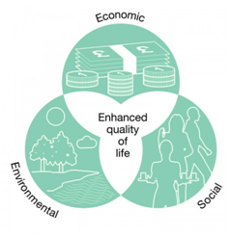
(Chamberlain, 2019)

The Triple Bottom Line is one of the sustainability management systems. It is one of the main systems which are utilised by organisations to measure their profits they are achieving through their corporate sustainability resources. Social bottom line measures the organisation’s profits in human resources and the organisation’s status within the local community. Environmental bottom line controls by handling and informing the organisation’s consumption, waste and emissions. The economic bottom line allows the organisation to evaluate how much of an impact the organisation has on its economic nature (Chamberlain, 2019).

3.4.3 Quality

In organisations, quality is frequently believed to begin and finish with the customer, and each aim heading to and from the customer should target for high standard service and communication. Dr. W. Edwards Deming’s transformation 14-Point Philosophy theory is popular for improving quality as he believed by enhancing quality, organisations will reduce costs and will raise production and market share. When Japanese companies Toyota, Fuji and Sony employed the Deming’s methods they achieved huge success. Deming’s 14-Point Philosophy (see Appendix A for the 14 points) are applied by many organisations, departments and teams, it allows the organisations to be aware of the significance to build a customer relationship, it decreases difference and promotes continuous transformation and enhancement in organisations (Mindtools, 2019).
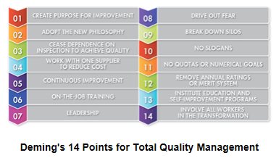
(ASQ, 2019)

“Deming’s 14 Points on Quality Management” is a fundamental theory on executing total quality management (TQM) which is a group of management methods to facilitate organisations increment their quality and production (ASQ, 2019). Therefore, quality is extremely crucial to be part of the CRM systems. Furthermore, there is another framework for quality which is David Gavin’s 8 Dimensions of Quality, it enables the organisation to discover what quality means to the customers. The eight dimensions of quality are performance, features, reliability, conformance, durability, serviceability, aesthetics and perceived quality (see Appendix C for explanation) (IFM, 2016).

3.5 Organisations CRM Systems

3.5.1 Lush

Lush is a retail organisation which opened in 1995 in Poole, Dorset. The organisation manufactures and distributes fresh handmade cosmetics such as soaps, creams, shampoos, lotions, moisturiser, shower gels, scrubs, masks and other beauty products for hair, face and body by utilising vegetarian and vegan ingredients. Lush delivers its products via the store, online, telephone and through partnerships by local authority proprietors internationally (Craft, 2019). The lush organisation is an ethical company, although they like to be known as a normal organisation than an ethical company. They suggest all organisations should be ethical and have fair trade (Lush, 2019).

Lush to have these policies in place which are ethical buying policy, environmental policy, people policy, animal testing policy, handmade policy, product policy, freshness policy, bulk buying policy, tax policy, anti-bribery and corruption policy, air travel and carbon policy, and
anti-slavery and human trafficking policy. Moreover, those policies and procedures enable the Lush managers to judge and act in concurrence with ethical principles. For instance, Lush’s ethical buying policy states that when they buy their products, they ethically think about the workers' rights, environment, animal protection and transport. They select their ingredients cautiously, so it is harmless and extremely attractive ingredients. Thus, their products are bought directly from their suppliers such as farmers, processors and growers worldwide, thus they know where it is coming from, how it is produced, who has grown it and have better knowledge of the raw. They have their team travelling worldwide to visit their supplier and purchase raw materials by one-to-one communication which enables them to raise good, trustworthy, long-term valuable relationships with the suppliers (Lush, 2019).

Furthermore, Lush’s environmental policy (see Appendix D) stated that they believe in recycling and utilising minimum packaging as possible. They have recycled eighty-nine percent overall of their packaging. Hence, it signifies that every tonne of their resources purchased, nine hundred kilograms originated from recycled sources. Lush packages the gifts with reprocessed paper and safeguarded utilising Eco flow, that is created from potato starch and is 100% recyclable. Additionally, they have regularly utilised innovation solutions to create an optimistic influence on earth, for example by creating their solid shampoo bar, by doing this they saved around six million plastic bottles worldwide. Lush buy their raw materials wisely as they favor to utilise ingredients that are constructed in an ecological way and keep away from ingredients which are not, for instance, Lush aims not to utilise palm oil for their soap base which is being replaced by more planet-friendly oils. Thus, Lush’s environmental policy (see Appendix E for the policy) states that they are operating to decrease the quantity of energy utilised to manufacture, transport and the way they sell their products to customers. Lush (2019) stated that they saved 450,000 litres amount of water a year from the sales of their shampoo bars worldwide. Thus, Lush specified they will endure monitoring how they utilise water in their factory and decrease the use of water.

Lush has a people policy (see Appendix F for the policy) which mentions that their employees are paid minimum twenty pence extra over statutory minimum pay and no employees are hired on a zero-hour contract, they recognised having contracted hours will save their employees from the economic crisis (Lush, 2019).

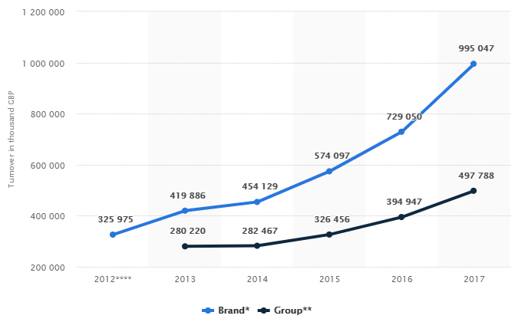
Turnover of Lush Cosmetics Limited worldwide from 2012 to 2017 (in 1,000 GBP)
Figure 3: Source (Statista, 2019)

This statistic shows the “turnover of Lush Cosmetics Limited worldwide from 2012 to 2017”. It shows the turnover for both the brand and group that has steadily grown over the six-year period, with revenue reaching 995 million British pounds for the brand in 2017 (Statista, 2019).

The various surveys and the researches that are derived from the reviews of the clientele of Lush suggest that the client base of the organisation has been growing with time. The majority of the client base is observed to be satisfied with the quality of products and the services that are provided by the company and have been looking forward to a long-term association with the company as well. Additionally, Gilliland (2019) mentioned Lush is generally known for their highly increasing and ground-breaking brands, particularly for their customer knowledge.

According to Best Companies (2019), seventy-three percent of Lush employees accepted the company operates on robust values, fifty-three percent did not support it as their employment interferes with their concerns and eighty-three percent accepted that the company genuinely worries about the environment (see Appendix G figure.5 for employee rating).

3.5.2 Barclays Bank

Barclays Plc is a British multinational investment bank and financial services business, headquartered in London. Apart from investment banking, Barclays is structured into four main organisations which are personal banking, corporate banking, wealth management, and investment management (Barclays (a), 2019). Barclays strategy is focussed on developing long-term, deep relationships with their customer which is accomplished via their colleagues, authorised by technology, consigning ideal and customised, and being impassioned about the customers. Barclays stated their values are “respects, integrity, service, excellence and stewardship” (see Appendix H for Barclays purpose, values and behaviours in more detail) which allows Barclays to go about as a focal point of gravity, directing them to act in the correct way and considering them responsible. Barclays aim is to “creating opportunities to rise,” to do this Barclays will keep on meeting up to take changes that will support customers, colleagues, clients, shareholders and society to rise (Barclays, 2018).

Barclays has policies and statements of intention in place to make sure reliable control on a variety of concerns, which are the code of conduct – The Barclays Way; Environment statements of energy and climate change, deforestation and palm oil, world heritage sites and Ramsar wetlands, environmental risk in lending; governance and financial crime statements of anti-money laundering and counterterrorist, bribery and corruption, data protection, donations, resilience, sanctions, supply chain and tax.

To maintain the trust of their stakeholders, they have the code of conduct which establishes a clear standard of ways that all employees should follow, it guides what should be accomplished. For example, Barclays demand employees ought to perform high, add values to customers and meet their regulatory agreements. For instance, Barclays expect colleagues to act with integrity, act with due skill, care and diligence, be open and co-operative with regulators treat customers, and observe proper standards of market conduct (Barclays, 2018).

Barclays has environmental policies, for example, energy and climate change where they focusing on “financing growth of renewable energy source and proactively supporting the development of businesses aiming to solve” which they follow the “Paris climate agreement;” taking a responsible and sustainable approach to the necessary financing sources of energy that are more carbon intensive or those wither environmental impact,” for example for “products and services to facilitate the transition,” they will advise customers on dealings and approaches to relocate their company and uphold effectiveness; and “reducing the carbon footprint of their own operations and supply chain throughout the world” (Barclays (b), (2019).

In 2017 Barclays customers got trapped as the bank was trying to remove danger as a result of money laundering laws, which was affected (Tims, 2017). Thus, according to IvyExec (2019) reviews (see Appendix G figure.6 for employee rating) specified that Barclays organisational culture has a shortage of trust, workers are scared to talk up. Thus, there is “lack of fairness and transparency” into job tasks, advancements and reward progressions.

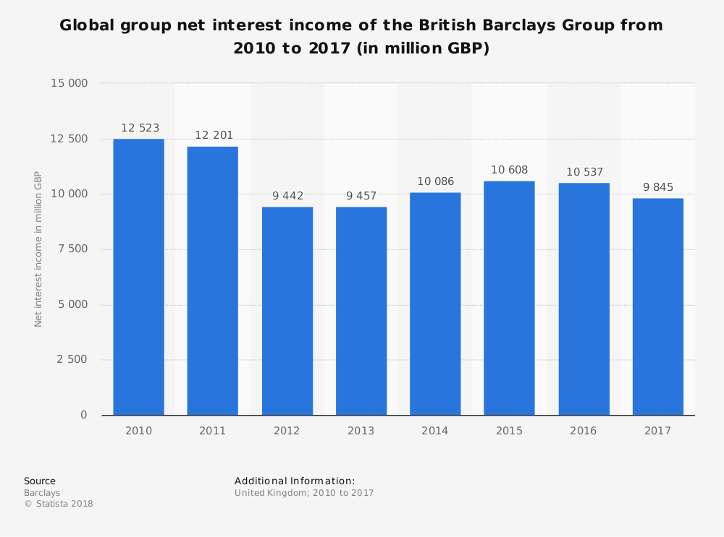
Figure. 4: Source: (Statista, 2018)

The various surveys and the researches that are derived from the reviews of the clientele of Barclays Bank suggest that the client base of the organisation has been reducing with time. Particularly, the figure.4 shows the income has been decreasing. The majority of the client base is observed to be dissatisfied with the quality of products and the services that are provided by the company and have not been looking forward to a long-term association with the company as well.

3.6 Organisations CRM Systems Gaps based on Ethics and Sustainability

The companies in the discussion, Lush and Barclays Bank is observed to have been demonstrating the several issues in the matters that are related to the ethics and the sustainability within the organisation. The retail company in the discussion, Lush UK, is known to be demonstrating the various ethical policies that are necessary for the development of the overall operations of the company in the given market. The lush UK is observed to maintain ethical practices and policies. This, in turn, helps in motivating the employees of the organisation to deliver their best towards the development of the organisation. The service institution, on the other hand, is known to have not been implementing the ethical practices thereby leading to the demotivation of the employees of the organisation. The discussion further states the fact that the service institution has been facing high employee retention due to the lack of proper motivation.

Moreover, Lush UK is further observed to be maintaining a proper sustainable approach towards the development of the overall performance of the company. The major issues that are addressed by the company are observed to be in favour of the environmental issues that are presented in the UK markets. The company is observed to have been including the practices that are relevant in the matters related to the sustainability within the given organisation. The financial organisation in the discussion is observed not to implement the proper environmental policies that are related to the operations of the company in the given markets. The major issues that are presented within the organisational operations do not discuss the facts that are related to the environmental development of the area wherein the concerned company has been operating.

The major issues that are faced by the organisations in terms of the ethical factors are evident within the business organisations. The multitude of organisations that has been featuring in the international market tends to put forth the various ethical decisions in the operations of the companies (Kumar and Reinartz, 2018). The majority of the organisations tend to have a greater impact on the environment of the area wherein the company has been featuring. The sustainability issues that have been put forth by the concerned organisations tend to have a huge impact on the matters that are related to the quality of the products and the services that are provided by the given company.

The ethical issues that are majorly faced by the business organisations can be eradicated through the implementation of the various ethical theories like the utilitarian approach as it is required for meeting the situation. The major ethical issues that are related to the organizational performance within the international markets tend to deal with the issues that have been presented due to the development in the maintenance of the proper relations with the client as well as treat the employees in a proper manner (Nguyen and Rowley 2015).
The companies in the discussion are known to have thrown light on the issues that are related to the sustainability issues and policies that are maintained within the organisation. The discussion fails to shed light on the development of the sustainability that is maintained within the organization as well as the policies that should be implemented in order to deal with the maintenance of the sustainability within the organisation. This might be achieved through the implementation of the proper alignment of the individuals with economical situations within the country.

4.0 Conclusion

In the discussion of the two organisations, it conclude the companies that have been operative in the given markets should implement the measures that are required for the development of the company in terms of the ethical activities and the sustainability measures that are necessary for the overall improvement of the organisation. The multitude of organisations that has been featuring in the international market should put forth the various ethical decisions in the operations of the companies. The sustainability issues that have been put forth by the concerned organisations tend to have a huge impact on the matters that are related to the quality of the products and the services that are provided by the given company. The sustainability measures that are implemented by the organisation should take special care in regards to their effect on the majority of the companies that are functioning in the given international markets. The discussion does not analyse extensively the matters that are related to the policies and the procedures that would help the organisations to deal with the betterment of the environmental surroundings of the organisation.

5.0 Recommendations

The major recommendations for the companies discussed are as follows:

5.1 Setting the proper ethical policy

Barclays Bank should be advised to deal with the issues that are presented in the matters that are related to the ethics within the organisation. The major ethical issues that are related to the organizational performance within the international markets tend to deal with the issues that have been presented due to the development in the maintenance of the proper relations with the client as well as treat the employees in a proper manner.

5.2 Training the staff

The staff of the organisation should be trained in order to deal with the issues that are related to the development of the organisation in the discussion. This training would help the employees of Barclays Bank to maintain the code of conduct within the given organisation as well as help in the overall development of the organisation.

5.3 Setting up a sustainable policy

Barclays Bank should be advised to implement a sustainability policy within the organisation in order to develop the issues that are related to the environmental stability within the organisation. The majority of the organisations tend to deal with several processes that help them to discuss the maintenance of the sustainability within the given organisation.

5.4 Communicating the policy

The policy of sustainability within Barclays Bank should be communicated in a proper manner to the employees. This helps in the reduction of the issues that are presented by the environmentalists of the world at large and the concerned market in specific.

5.5 Introducing proper communicational policies for the development of client relations

The Barclays is advised to implement the proper communicational policies in order to communicate with the employees. This would help in the maintenance of the proper client base within the organisation. The majority of the organisation tend to deal with the development of the organisation in terms of the communicational procedures within the organisation.

6.0 Appendices

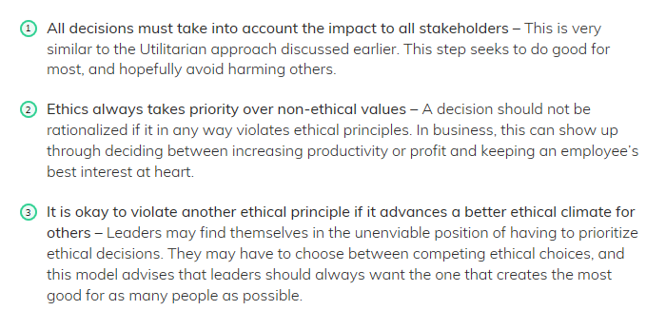
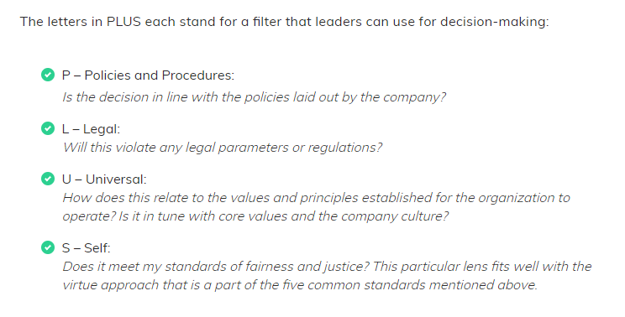
Appendix A – Decision-Making Model

Figure. 1: PLUS ethical decision-making model
Source: (Status, 2019)

Figure. 2: The Character-Based Decision-Making Model
Source: (Status, 2019)

The Character-Based Decision-Making Model
PLUS Ethical Decision-Making Model

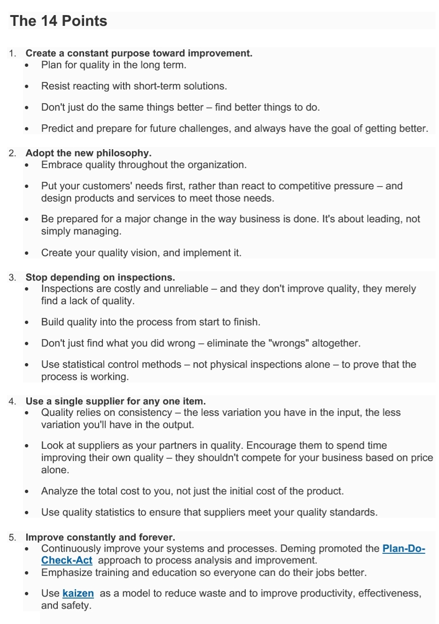
Appendix B - Deming’s 14-Point Philosophy

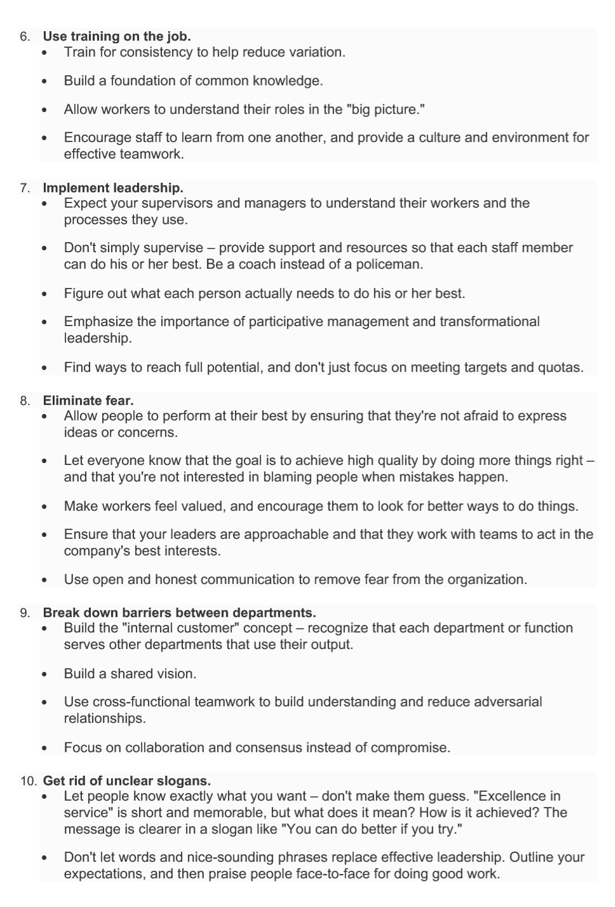
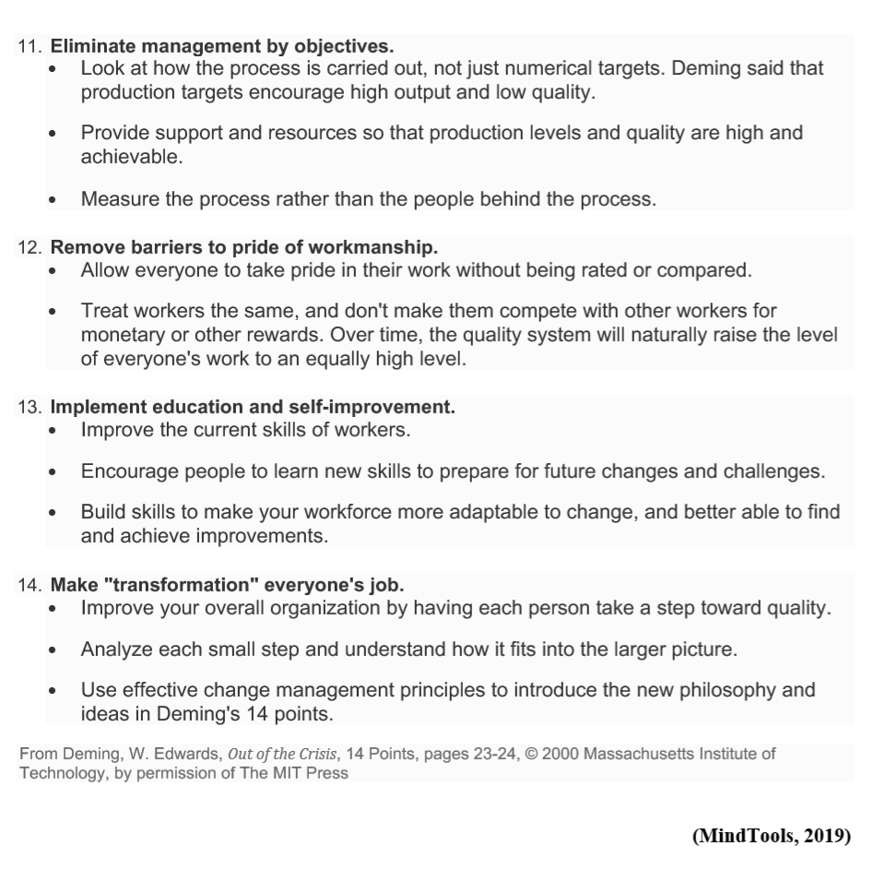

Appendix C – Gavin’s 8 Dimension of Quality
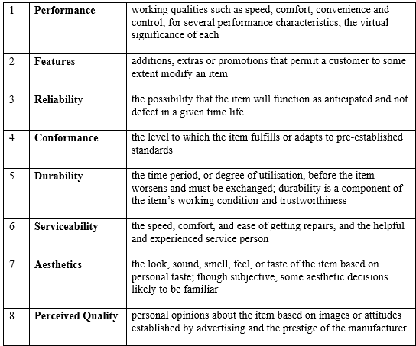

Appendix D - Lush Ethical Buying Policy
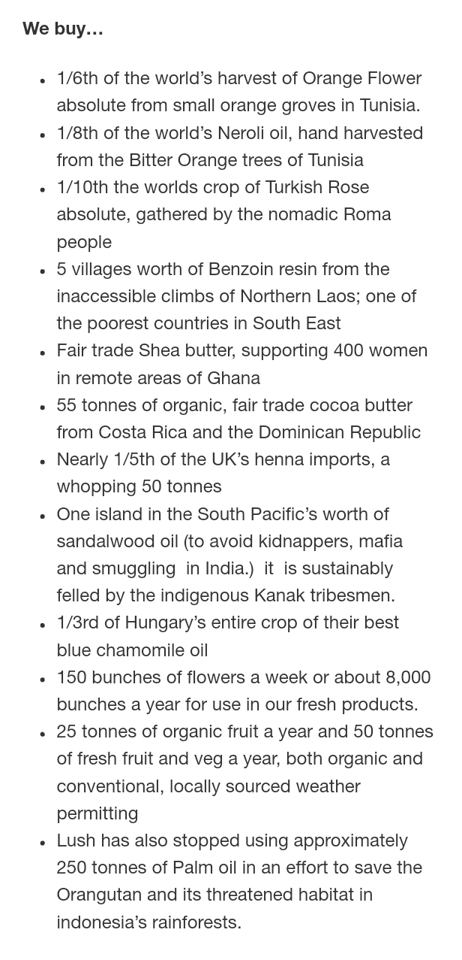
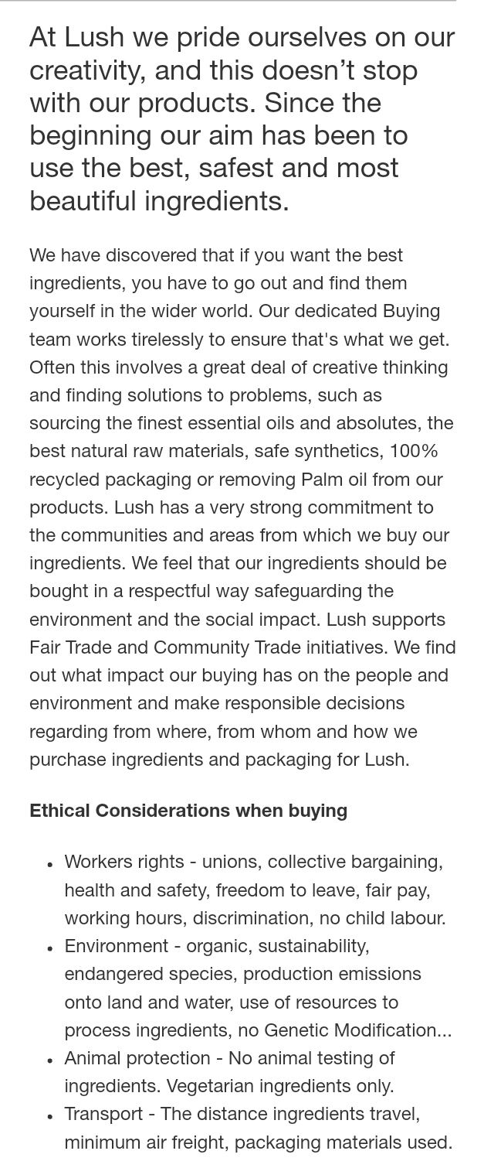
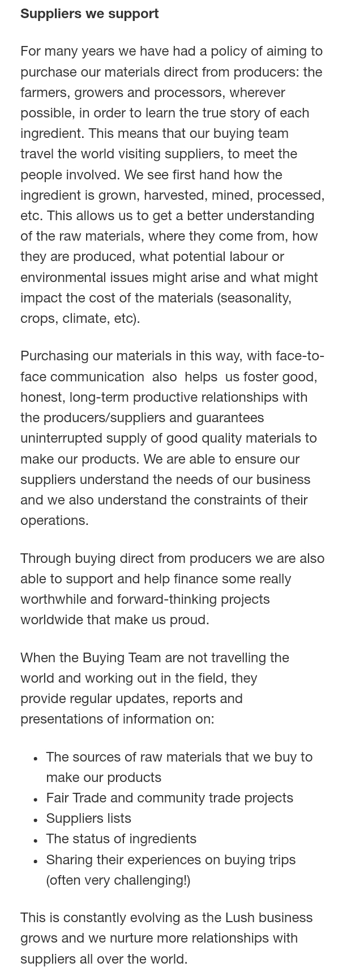

Appendix E – Lush Environmental Policy
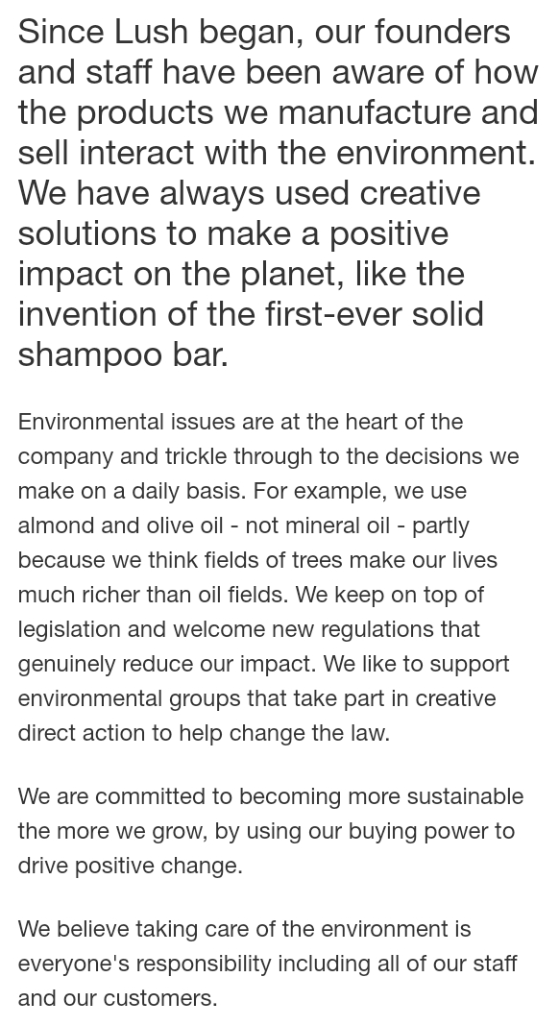
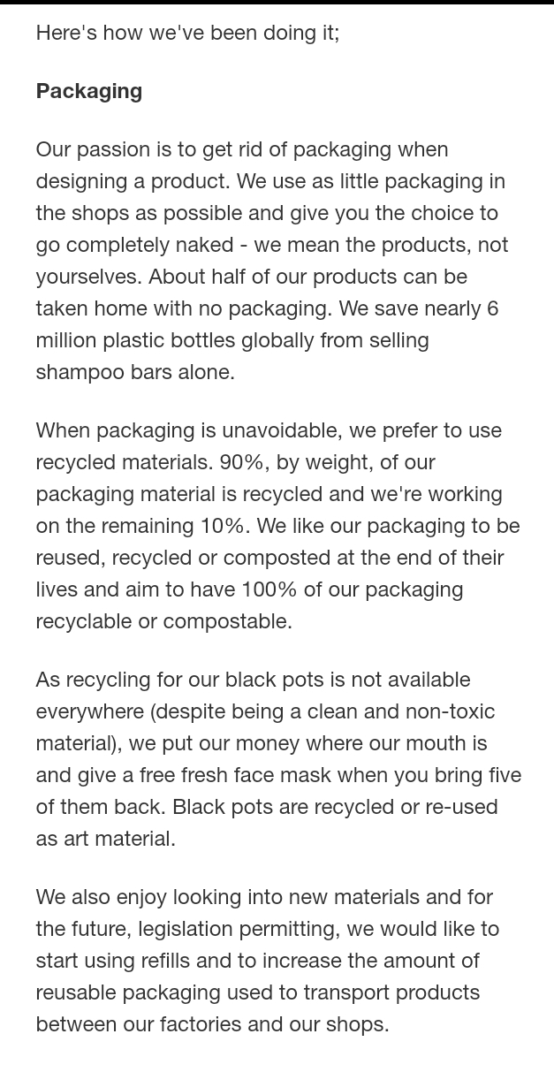
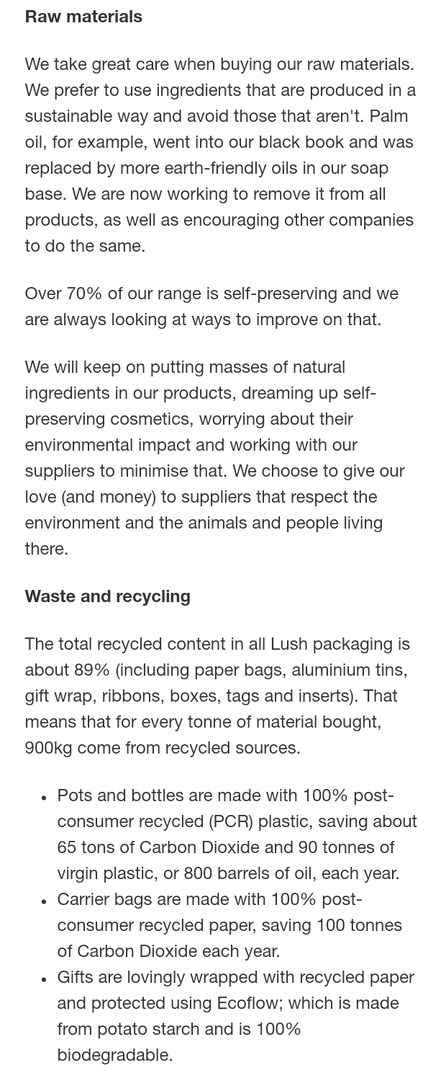
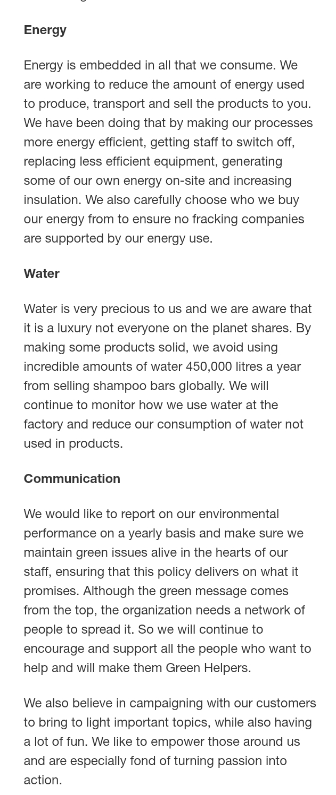

Appendix F – Lush People Policy
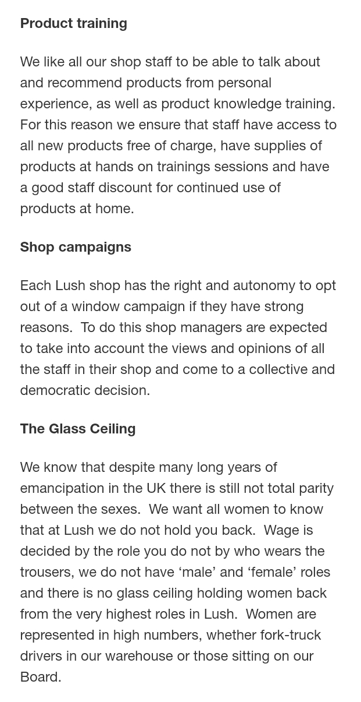
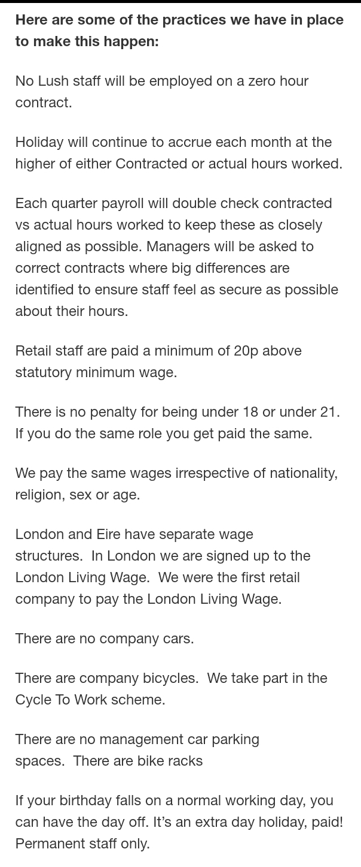
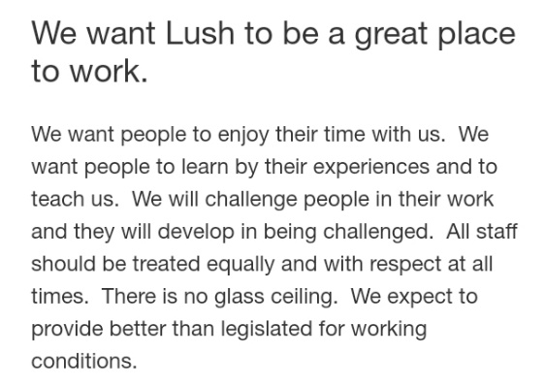

Appendix G – Employee Ratings

Figure. 5: Lush Employee Rating
Source: (Craft, 2018)
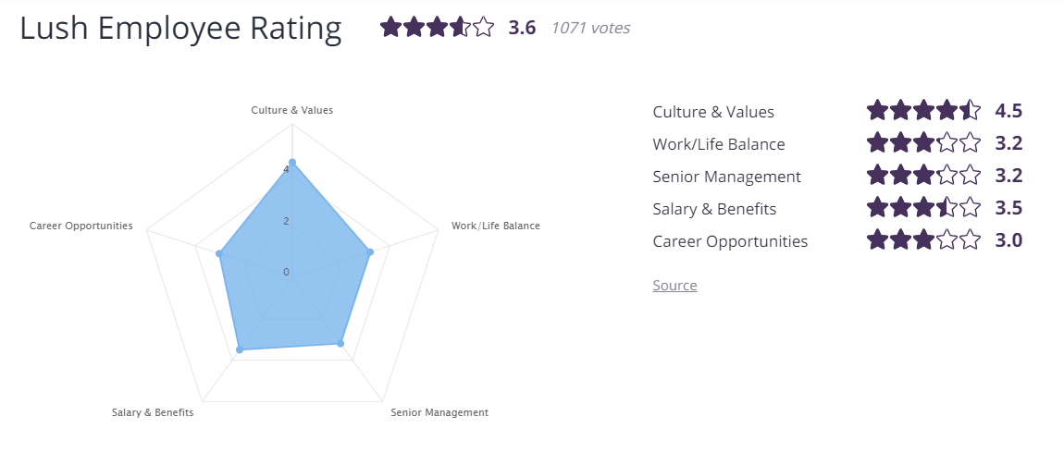

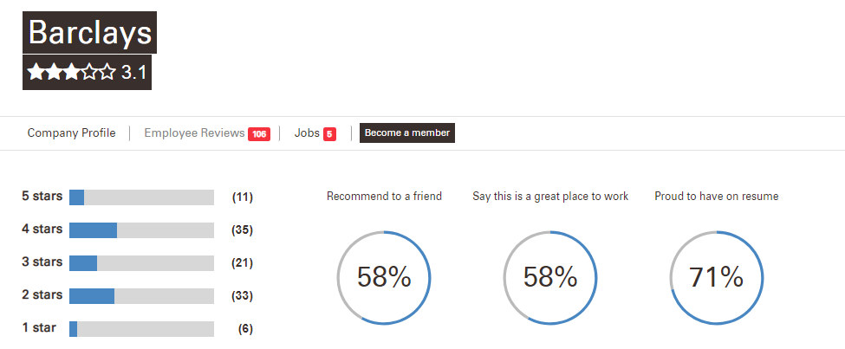
Appendix H – Barclays Purpose and Values

Figure. 6: Barclays Employee Rating
Source: (IvyExec, 2019)

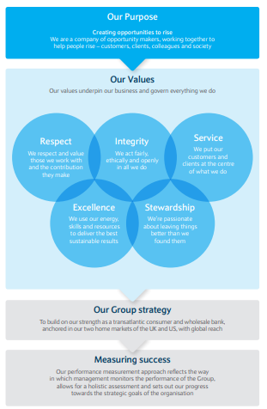

Appendix I – Loyalty Matrix Based on Attitude and Behaviour

Loyalty Matrix of Lush

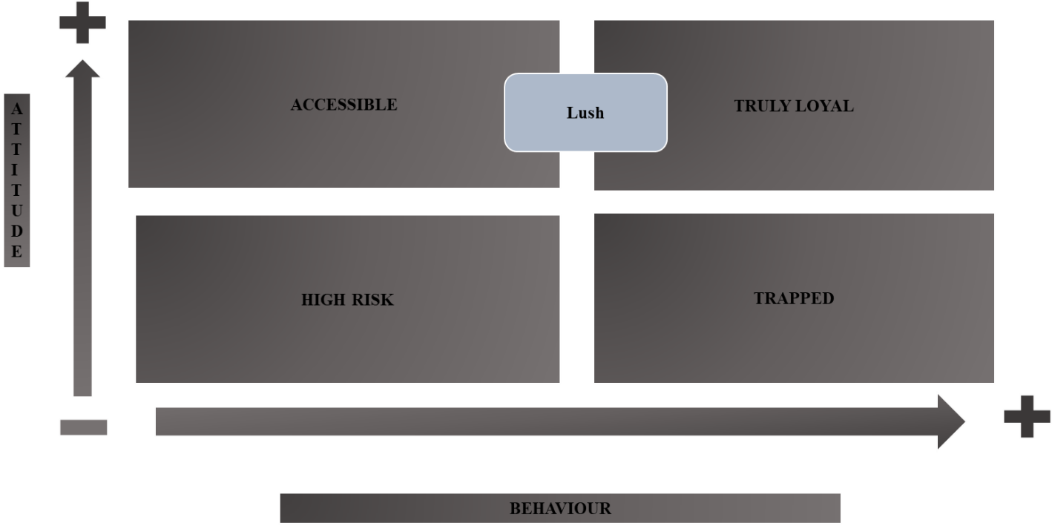

Loyalty Matrix of Barclays Bank

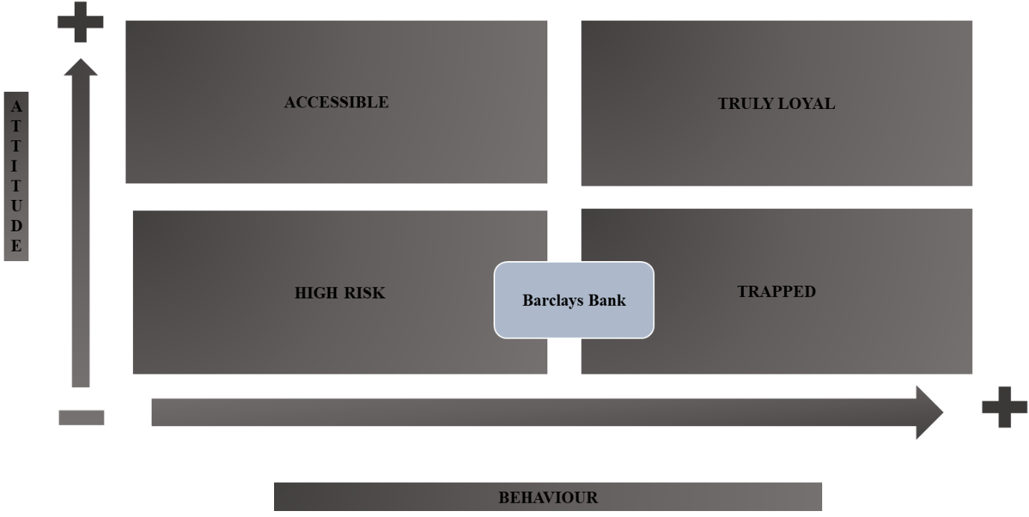

7.0 Acknowledgements

The researcher would like to acknowledge Maria Heffernan for the support and advice throughout the report.

8.0 References

Acquaye, Dr. A. (2017). Why Sustainability is Important in Business. [online]. Available at: https://blogs.kent.ac.uk/kent-business-matters/2017/05/22/why-sustainability-is-important-in-business/ (Accessed: 18th March 2019).

ASQ (2019). W. Edwards Deming’s 14 Points for Total Quality Management. [online]. Available at: https://asq.org/quality-resources/total-quality-management/deming-points (Accessed: 18th March 2019).

Barclays, (2018). The Barclays Way, how we do business. [PDF]. Available at: https://home.barclays/content/dam/home-barclays/documents/citizenship/the-way-we-do-business/The-Barclays-Way-Campaign-2018-Online.pdf

Barclays (a). (2019). Barclays - a quick history. [online]. Available at: https://www.archive.barclays.com/items/show/5419 (Accessed: 24th March 2019).

Barclays (b). (2019). Barclays Energy and Climate Change Statement. [online]. Available at: https://home.barclays/statements/barclays-energy-and-climate-change-statement/ (Accessed: 26th March 2019).

Barclays (c), (2019). Citizenship and Sustainability. [online]. Available at: https://home.barclays/citizenship/ (Accessed: 25th March 2019).

Ben-Eli, M. (2018). Sustainability: definition and five core principles, a systems perspective. Sustainability Science, 13(5), pp.1337–1343.

Best Companies (2019). Company profile: Lush. [online]. Available at: https://www.b.co.uk/company-profile/?lush-fresh-handmade-cosmetics-47653 (Accessed: 26th March 2019).

Chamberlain, A. (2019). Sustainability Management System: The Triple Bottom Line. [online]. Available at: https://www.era-environmental.com/blog/sustainability-management-triple-bottom-line (Accessed: 19th March 2019).

Craft, (2019). Lush. [online]. Available at: https://craft.co/lush (Accessed: 20th March 2019).

Crane, A. and Matten, D. (2016). Business Ethics: Managing Corporate Citizenship and Sustainability in the Age of Globalization. 4th edn. Oxford: Oxford University Press.

French, R., Rayner, C., Rees, G. and Rumbles, S. (2015). Organizational Behaviour. 3rd edn. Chichester: Wiley.

IFM (2016). Quality Framework. [online]. Available at: https://www.ifm.eng.cam.ac.uk/research/dstools/quality-framework/ (Accessed: 18th March 2019).

IvyExec, (2019). Barclays, company profile. [online]. Available at: https://www.ivyexec.com/company-profile/barclays-careers/employee-reviews (Accessed: 28th March 2019).
Kumar, V. and Reinartz, W. (2018). Strategic CRM Today. In Customer Relationship Management (pp. 3-16). Springer, Berlin, Heidelberg.

Joshi, S. and Li, Y. (2016). What Is Corporate Sustainability and How Do Firms Practice It? A Management Accounting Research Perspective. Journal of Management Accounting Research: Summer 2016, Vol. 28, No. 2, pp. 1-11.

Leonard, K. (2019). The Importance of Ethics in Organizations. [online]. Available at: https://smallbusiness.chron.com/importance-ethics-organizations-20925.html (Accessed: 18th March 2019).

Les Montja, M. (2016). DEFINITION of 'ethics' deconstructed. Accountancy SA, pp. 52-53.

Lush (2019). Our policies. This is what we stand for. Available at: https://uk.lush.com/tag/our-policies (Accessed: 20th March 2019).

Mansoor, H. (2017). 7 Reasons Why CRM And Sales Are Correlated To Sustainable Business Growth. [online]. Available at: http://customerthink.com/7-reasons-why-crm-and-sales-are-correlated-to-sustainable-business-growth/ (Accessed: 15th March 2019).

MBN. (2019). What Is Quality? Definition And Examples. [online]. Available at: https://marketbusinessnews.com/financial-glossary/quality/ (Accessed: 9th March 2019).

Muller, A. (2014). Sustainability and customer relationship management: current state of research and future research opportunities. Management Review Quarterly, 64(4), pp. 201-224.

Mullins, L.J. and Christy, G. (2016). Management & Organisational Behaviour. 11th edn. Harlow: Pearson.

Newman, E. (2014). Importance of Ethics in Customers Dealings. [online]. Available at: http://corp.yonyx.com/customer-service/importance-of-ethics-in-customer-dealings/ (Accessed:12th March 2019).
Nguyen, B. and Rowley, C. (2015). Introduction to ethical and social marketing in Asia: Incorporating fairness management. In Ethical and Social Marketing in Asia (pp. 1-32). Chandos Publishing.

Statista, (2019). Turnover of Lush Cosmetics Limited worldwide from 2012 to 2017 (in 1,000 GBP) [online]. Available at: https://www.statista.com/statistics/892361/turnover-lush-cosmetics-limited-worldwide/ (Accessed: 28th March 2019).

Status (2017). Ethical Decision Making Models and 6 Steps of Ethical Decision Making Process. [online]. Available at: https://status.net/articles/ethical-decision-making-process-model-framework/ (Accessed: 20th March 2019).

Tims, A. (2017). ‘Barclays took my £440,000 and put me through hell’- Guardian. Available at: https://www.theguardian.com/money/2017/jan/22/barclays-took-my-440000-customers-caught-up-banks-de-risking-money-laundering-laws (Accessed: 27th March 2019).

9.0 Bibliography

Birdsall, S. (2014). Measuring student teachers’ understandings and self-awareness of sustainability, Environmental Education Research, 20:6, pp. 814-835.

Brunk, K.H. (2012). Un/ethical Company and Brand Perceptions: Conceptualising and Operationalising Consumer Meanings. Journal of Business Ethics, 111(4), pp. 551-565.

Buchanan, D.A. & Huczynski, A.A. (2017). Organizational Behaviour. 9th edn. Harlow: Pearson.

Chandrupatla, T.R. (2009). Quality and Reliability in Engineering. Rowan University: New Jersey.

Corvellec, H. (2016). ‘Sustainability objects as performative definitions of sustainability: The case of food-waste-based biogas and biofertilizers’, Journal of Material Culture, 21(3), pp. 383–401.

Heath, J. (2014). 'A Market Failures Approach to Business Ethics.' Morality, Competition, and the Firm: The Market Failures Approach to Business Ethics. New York, Oxford Scholarship.

Jarrett, M. (2016). What is culture? Smart Business Akron/Canton, 25(12), pp.12-13.

Lummis, G.W., Morris, J.E., Lock, G. & Odgaard. J. (2017). The influence of ecological citizenship and political solidarity on Western Australian student teachers’ perceptions of sustainability issues. International Research in Geographical and Environmental Education, 26:2, pp. 135-149.

McKinley M. (2012). Ethics in Marketing and Communications. London: Palgrave Macmillan.

Mobus, G. (2017) ‘A Framework for Understanding and Achieving Sustainability of Complex Systems’, Systems Research & Behavioral Science, 34(5), pp. 544–552.

Moore, J.E., Mascarenhas, A., Bain, J. and Straus, S.E. (2017). Developing a comprehensive definition of sustainability. Implementation Science, 12.

Sims, R.R. (2017). A Contemporary Look at Business Ethics. Contemporary human resources management: issues, challenges, and opportunities. Charlotte: IAP.

