

Task 1 – Reading Task Template
Upload your photo of your A3 in-class notes here:
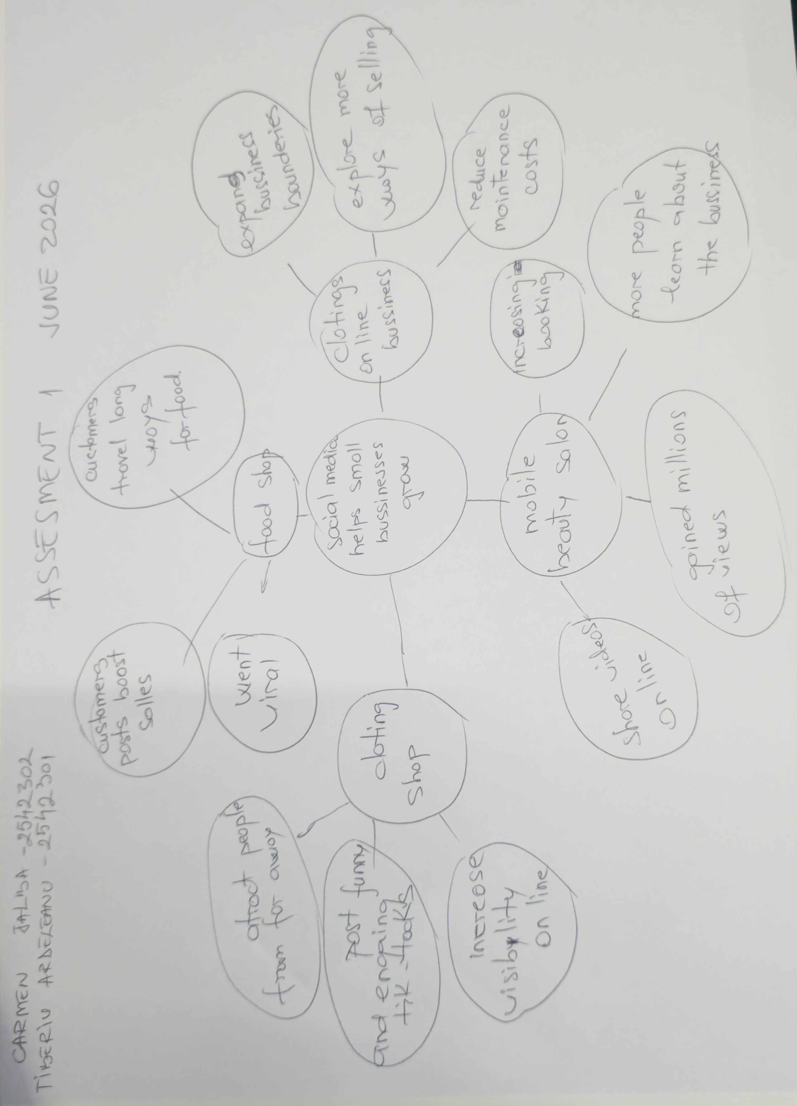

1. Answer these questions using the sentence starters below
a. What is the main idea of the text?
The main idea is social media helps small businesses grow
b. What are two key points?
One key point is social media attracts more customers.
Another key point is that good content helps businesses grow.
c. What part of the text did you find most important? Why?
The most important part is how social media helps businesses to get more customers. This is important because shows how successful the business can be by sharing conten online.
d. Was anything unclear or difficult to understand?
Not really, the article was pretty easy to understand because it shows real examples of businesses and explain clear how social media helps them grow.
e. How did your group help you understand the text better?
My group helped me by show me their perspective about the text and make me see the different perspectives around the text and the idea of it!
3. One sentence reflection
Question: What did you find challenging about this task?
The hardest part was to get the main idea of the text and making sure that I understood the context properly.

