

University of Wales Trinity Saint David, Birmingham
Assignment Title: Final Project Report: An AI-Powered 3-D Facial Recognition Framework for Crime Intelligence Using Reconstructive and Predictive Techniques
Module: Master’s Project
Module Code: ACFB7003
Student Name: Cristian-Constantin Paraschiv
Student ID: 2026077
Date: 06/01/2026
Lecturer: Dr. Vijeyananthan Thayananthan
Supervisor: Dr. Aliyu Sambo

Contents
1. Introduction 5
1.1 Background and context 5
1.2 Problem statement and motivation 6
1.3 Research aim 6
1.4 Research objectives 6
1.5 Scope, assumptions, and limitations 7
1.6 Dissertation structure 8
2. Literature review 9
2.1 Review approach and scope 9
2.2 Evolution of facial recognition 10
2.3 Landmark detection methods 11
2.4 Three-dimensional facial reconstruction 12
2.5 Deep facial recognition and embeddings 13
2.6 Crime data analytics and forecasting 15
2.7 Object detection and scene understanding 16
2.8 Governance, ethics and public perception 16
2.9 Research gaps and conceptual positioning 19
2.10 Literature summary 20
3. System Architecture and Design 20
3.1 Overall architecture 20
3.2 Facial analytics pipeline design 23
3.3 Crime-intelligence and data layer 25
3.4 Security, governance and deployment considerations 28
4. Datasets and Experimental Setup 29
4.1 Facial datasets and preprocessing 29
4.2 United Kingdom data acquisition and processing 33
4.3 Model configurations and training protocols 34
4.3.1 Landmark model (LandmarkNet) 34
4.3.2 Reconstruction model (ReconstructionNet) 38
4.3.3 Recognition model (RecognitionNet) 39
4.3.4 YOLO integration (pre-trained detector) 42
4.3.5 Prophet forecasting (analytics) 42
4.3.6 Training protocol, checkpointing and logging 43
4.4 Evaluation metrics and experimental design 43
5. Model Training and Result 45
5.1 Landmark detection results 45
5.2 3-D reconstruction evaluation 47
5.3 Facial recognition model training and analysis 49
5.4 Comparison with Buffalo baseline 54
5.5 Crime forecasting and object detection results 60
6. Crime Intelligence Analytics and End-to-End Case Study 62
6.1 Exploratory crime analytics 62
6.2 End-to-end pipeline case study 64
6.3 Implication for intelligence-led policing 67
7. Assessment of Governance, Ethics and DPIA 68
7.1 Legal and regulatory context 68
7.2 Built-in safeguards in design 68
7.3 Bias, fairness and societal risk 70
8. Conclusion, Recommendations and Reflection 71
8.1 Summary of findings 71
8.2 Limitations and recommendations for future work 72
8.3 Personal reflection 72
References 74
Appendix I – Project Timeline 86
Appendix II – An AI-Powered 3-D Facial Recognition Framework for Crime Intelligence Using Reconstructive and Predictive Techniques GitHub Repository 87

An AI-Powered 3-D Facial Recognition Framework for Crime Intelligence Using Reconstructive and Predictive Techniques
ABSTRACT
Police use of facial recognition tends to be divided between stand-alone biometric tools and discrete dashboards for analysing crime, with very little integration between who appears in images and how patterns of crime develop. At the same time, mainstream 2-D recognition models are brittle under CCTV conditions, where pose, blur, compression and occlusion are common. This dissertation explores the feasibility of a 3-D aware facial analytics pipeline to enhance its robustness on unconstrained imagery, and how its outcomes can be fused with the results of crime trend analytics in a research-only prototype.
The proposed framework comprises YOLOv8s person/weapon detector, landmark, FLAME-based 3-D ReconstructionNet trained on AFLW2000-3D, and RecognitionNet trained on 530 FaceScrub actor/actress public individuals. RecognitionNet generates 512-D embeddings using an LDA-reduced 256-D version and tests using closed set identification, verification ROC, robustness and explainability tools (Grad-CAM, region occlusion). Nevertheless, a comparison suite is provided where these embeddings are compared to Buffalo InsightFace features using k-NN classification, per-class diagnostics and UMAP visualisation. Crime-trend analytics built from anonymised UK open police data in Facebook/Meta Prophet, with the use of a full-stack investigator dashboard feeding from REST endpoints. Governance components simulate the automated DPIA, encryption and audit logging as well as bias monitoring over male/female FaceScrub partitions.
Experiments demonstrate that the 3-D reconstruction stage has low vertex and landmark errors, as well as being stable to moderate pose and occlusion. RecognitionNet has moderate closed-set accuracy but good verification performance (AUC > 0.83) and is much better than the Buffalo baseline in terms of the k-NN embedding quality on the project’s domain. Prophet is able to capture the clear structure of season crime and support hotspot-style visualisation within the frontend. Bias monitoring reveals small but nonnegligible differences in demographic performance, which argues in favour of continuous fairness measurement.
The work shows that the technical feasibility of an integrated 3-D facial recognition and crime analytics stack based on public, anonymised data is possible, but also highlights the various barriers to be overcome in terms of legal, ethical, and data quality considerations, before the creation of any operational solution.

1. Introduction

1.1 Background and context
The use of facial recognition technology has become increasingly important in law enforcement, digital identity services, and security. The latest methods use deep learning to convert a face into a numerical representation, which is then compared with samples that were stored in the recent past. These approaches are most effective when the photographs are clear, taken from the front and taken in controlled environments, such as when passport photos or mugshots are taken at a correctional facility [1], [2].
It is not very often that everyday police provide such wonderful circumstances that make facial recognition easy. It is not unusual for officers to work with footage from mobile phones, body-worn cameras, and fixed surveillance cameras. However, faces can emerge at an angle in this material when it is moving or when the light is dim. Furthermore, masks, headgear, or other persons may partially disguise them. Because these factors are sensitive to two-dimensional (2-D) face recognition models, the accuracy of these models may degrade when circumstances such as postures, illumination, or occlusion change. Additionally, this decline in accuracy reduces trust in the outcome, and the value of such frameworks in investigations conducted at a rapid speed is limited [3], [4].
One method that may be used to overcome these deficiencies is three-dimensional (3-D) facial modelling. The modelling will involve reconstructive methods to convert two-dimensional photographs to the three-dimensional shape of a face. Furthermore, landmark identification techniques make these methods easier to carry out by identifying important facial features even when such points are difficult to discern. The statistical head model called FLAME [8,9], and the coupled two-dimensional and three-dimensional dataset called AFLW2000-3D [10] are used as reference geometry and training data, respectively, while the dataset of actor and actress images (FaceScrub [11]) is utilised for supervision within the recognition component, it is trained to learn deep embedding that can capture identity across pose, illumination and moderate occlusion. The posture may be normalised, and areas that were partially hidden in the original photo may be restored using the reconstructed three-dimensional mesh [13], [14], [15].
Besides facial recognition, data-driven methodologies and vastly available data can support crime intelligence. Open datasets that summarise reported crime by month, approximate location, category and outcome are increasingly being made available by government agencies and their respective United Kingdom police departments [12]. These datasets are brought to the attention of analysts so that they may analyse patterns across time and place. Patterns and seasonal implications in this data can be predicted using machine learning and forecasting tools, such as Prophet. The ability to anticipate criminal activity may be helpful in strategic planning and resource allocation, particularly if the predictions are linked to specific areas or types of offences [16], [17].
Face recognition and criminal analysis are often conducted as separate frameworks, despite the gains made. A significant number of deployments use facial recognition as the only method of identification, completely disregarding the entire context of the criminal situation. The use of biometric data in crime dashboards is relatively uncommon. Furthermore, because of this isolation, the insights that may be gained from each source are limited. However, it also leaves fundamental concerns regarding justice, accountability and public trust unsolved, especially when live or near-live facial recognition is involved. These characteristics present both an opportunity and a challenge for study, which utilises face analytics and criminal intelligence techniques [18].

1.2 Problem statement and motivation
Most existing police information systems fall into one of two patterns. Some offer stand-alone facial recognition services that are not linked with crime data. Others concentrate on crime statistics, hotspots and temporal trends but ignore biometric information altogether. In both cases, the potential links between the individuals who appear in the snapshots, the offences they are associated with, and how those offences evolve over time are largely invisible to analysts [19].
Operational conditions make the situation even harder. Two-dimensional recognition models are often fed with high-quality, looking, front-facing images taken from the internet or studio systems, for example, the FaceScrub [11] actor and actress dataset. By contrast, law-enforcement imagery is frequently affected by motion blur, compression artefacts, low light and extreme pose. Under these conditions, conventional 2-D models have higher error rates (both false matches and missed identifications). Such errors can destroy investigations, destroy trust in the technology and raise serious fairness and accountability issues [20].
There is also a clear gap in the understanding of how biometric outputs should feed into wider crime intelligence. Facial recognition outcomes can be discussed as endpoints: they identify a person and are not commonly used to create more analytical outputs. Crime data are then separately examined, devoid of a principled view of what faces recur across crime incidents, co-occur with weapons or correlate with particular outcomes.
This research is therefore driven by two motivations. Technically speaking, it poses the question of whether a 3-D, landmark-aware reconstruction and recognition pipeline will be able to surpass the conventional 2-D approaches on unconstrained imagery. Analytically, it investigates how outputs of the pipeline, in conjunction with object detection and crime forecasting, can be merged into a unified crime intelligence structure which is entirely based on public, anonymised data [21].

1.3 Research aim
The aim is to develop a three-dimensional facial recognition framework for criminal intelligence that is driven by artificial intelligence and is able to reconstruct three-dimensional faces from two-dimensional images, distinguish objects of significance in the scene, identify persons of interest from snapshots, and forecast crime patterns via the use of analytical models.

1.4 Research objectives
The research is pursuing four goals:
1. Review of the literature on artificial intelligence-based three-dimensional (3-D) face recognition and criminal intelligence.
2. Develop a framework from the literature for integrating face data with information related to crimes.
3. Collect and tabulate relevant secondary and public data to help in the process of developing and validating the framework.
4. Evaluate the suggested framework in light of the goals it aims to achieve in accordance with the criminal intelligence.

1.5 Scope, assumptions, and limitations
The purpose of the study is not to create an actual police system but rather to conduct a prototype experiment. Subsequently, it is ethically and legally constrained in spite of the focus on technological viability and analysis usefulness. For the purpose of the testing, every single face picture was taken from free research sources. The processing of real custody photographs or live CCTV feeds is not performed. All of the identities that are stored in these databases are treated as abstract labels and are not connected to any specific individuals [22].
Data on criminal activity are based on police reports made available to the public and are anonymised wherever they are collected. The records consist of the month the occurrence took place, an approximate location, the type of crime, and the recorded outcome. It is not possible to get names or exact addresses from them. Both model training and evaluation are performed offline. Furthermore, the datasets are divided into three: training set, validation set, and testing set. It is not possible to integrate the prototype framework into operational police databases or live video feeds; however, it simulates incidents from start to finish. As a result, performance measures are seen as measures of promise rather than guarantees of conduct appropriate to deployment [23].
Three main areas constitute the focus of the dissertation. The precision and reliability of the markers, reconstruction, identification, detection and forecasting models are the first considerations. The coherence of the framework as a whole is the second factor to consider. The aspect includes how different models are incorporated into a single pipeline and tracked through the backend application programming interface. There is one more thing to consider: whether the design is appropriate for future ethical implementation. An automated Data Protection Impact Assessment technique that explores encryption, audit logging, role-based control, and recent security events is included as a part of the framework. Additionally, bias monitoring is a part of the recognition model at this point [24].
This is not intended to be an alternative to an in-depth legal analysis by qualified lawyers or government officers. However, it utilises automated tests, together with academic literature on governance and law enforcement, to create challenges that an official DPIA would raise. The findings will help identify the points where the prototype already meets data security requirements and those where additional training is necessary before the actual deployment to the real world.
Three-dimensional modelling is one approach that may be used to solve this problem. Blanz and Vetter [14], [25], [26] are behind the creation of the three-dimensional morphable model, which works by using laser scans to create a parametric model of the shape and texture of the face. The technique makes an educated prediction about the three-dimensional surface that lies underneath a two-dimensional image by fitting this model to the picture. After the face has been created, it may be rendered with a variety of locations and degrees of illumination. These models were later expanded with bigger datasets and geometry covering the head [27].
Research that examines the differences between two-dimensional and three-dimensional representations reveals that the use of surface form exhibits a number of benefits. In situations where the location and lightning are subject to change, three-dimensional models are more stable. These are additional studies that demonstrate an increase in the accuracy of identification and resistance to disguise in settings where there are no restrictions. The early systems, on the other hand, needed specialised scanners, which limited their usefulness in law enforcement.
Establishing three-dimensional expressions immediately utilising traditional photographs offers the subject of current studies, which has helped break through this obstacle. Regarding the first time, deep neural networks are now able to anticipate dense meshes or regress morphable model parameters based on a single photo. Such methods may be trained and evaluated with the use of datasets such as AFLW2000-3D [10], which offer three-dimensional landmarks that cover a wide range of head positions [28].

1.6 Dissertation structure
In the remaining portion of the dissertation, the assessment criteria and research objectives of the module serve as the organising principle. There is a comprehensive analysis of previous research presented in the second chapter. It investigates the identification of face landmarks, the reconstruction of facial features in three dimensions, facial recognition, crime data analytics, object detection, crime forecasting, as well as the governance and ethics of the use of artificial intelligence by law enforcement.
System architecture and design are topics covered in Chapter 3. In this section, the modular architecture of the facial models, object detection components, crime data pipeline, and user interfaces is broken down and described. Detailed information about the datasets and experimental setup is given in Chapter 4. This includes information about data collection, preprocessing, model development and evaluation methods.
Chapters 5 – 7 include the results. The results of the training and evaluation of the models are shown in Chapter 5. These results include landmarks, reconstruction, recognition, comparison to a baseline model, item detection, and crime prediction. Chapter 6 explains how the outputs of the system may potentially assist in the operations of criminal intelligence. It makes use of compiled data as well as a case study that is based on the framework from the beginning to the end. The assessment of the governance, ethical, and data protection issues is discussed in Chapter 7, along with safeguards that are built into the design.
In the last chapter of the dissertation, a summary of the most important findings assesses the degree to which the objectives of the study were accomplished, draws attention to the limits of the study, and offers recommendations for future research and professional practice.

2. Literature review

2.1 Review approach and scope
A combination of research from the fields of computer vision, machine learning, and criminal science is presented. It is not aimed at creating a list of all the relevant publications. When it comes to a pipeline for three-dimensional face recognition that feeds a criminal intelligence framework, the objective is to assess whether certain ideas are relevant. Moreover, the chapter emphasises the components that are produced and assessed during the course of the project.
Facial analysis is the topic of discussion in the first collection of resources. Notable characteristics include identification of landmarks, reconstruction of faces in three dimensions and better deep facial recognition. Additionally, the landmark, reconstruction and recognition models of the framework are developed upon these strands, which serve as the basis. However, it is considered a classic piece of work when it continues to have an impact on modern practice. Such work has been used in eigenfaces, morphable models and early deep embedding techniques. The latest research shows the way state-of-the-art frameworks process posture, light and occlusion [29].
It is the criminal statistics and the larger circumstances surrounding the face that are the primary focus of the second group of materials. Open police data, crime mapping, hotspots research, and projections of crime counts using time series are all included in this group of activities. Methods of object identification, such as YOLO [47],[104], which can recognise both humans and weapons in surveillance footage, are also discussed in this research. The purpose of these works is to shed light on what crime-intelligence pipeline may reasonably provide when it only makes use of data that is readily accessible to the public [30].
The third and last group explores the morality, regulation, and social discourse of the application of facial recognition and prediction algorithms by the law enforcement framework. There is an effect that these papers have on the definition of the technical framework. Additionally, they provide an explanation as to why the framework is meant to function as a research prototype; nevertheless, it makes use of public datasets, and it records decisions in a format that enables supervision. Furthermore, utilised in conjunction with one another, the three distinct sorts of literature determine not just the technical possibilities but also the limitations within which the project operates [31].
As a result, contemporary recognition pipelines use deep embeddings in addition to increase alignment and, in some instances, three-dimensional geometry. In the process of training and testing, three-dimensional (e.g. alignment components, landmarks) such as AFLW2000-3D [10], are often used as multi-pose datasets. It is common practice to train recognition backbones using large identification datasets such as FaceScrub [11]. These datasets consist of several images of each actress and actor in unrestricted settings. As of right now, this is the path that the project is going to take. For the purpose of estimating the three-dimensional structure, it employs a reconstruction model that is based on a parametric head model and a landmark model for the purpose of identifying crucial points on the face. The structure which developed as a consequence makes a contribution to this first normalisation of stance before recognition. The generation of matched embeddings is accomplished using a deep recognition model that is trained on the actor and actress subsets of FaceScrub [11]. While the design makes an effort to include the stability that is offered by three-dimensional geometry, it also makes an effort to preserve the advantages that are associated with current two-dimensional deep systems. This combination strategy is evaluated in later chapters to determine the extent to which it improves performance in situations that are representative of real-world police pictures [32].

2.2 Evolution of facial recognition
The initial automatic facial recognition relied on mere geometric features. The lengths and angles of the main facial markers, including the eyes, nose, and mouth, were determined utilising systems. Furthermore, changes in posture, lightning, and emotions were difficult to record effectively using these methods. Principal component analysis was utilised to align face images in Turk and Pentland’s EigenFaces approach, which proved to be the next major step in the process. Utilising Eigenfaces, each face is represented as a point in a low-dimensional space and the distance between these points is used to compare faces [33], [53].
Fisherfaces [49] and local binary patterning diagrams are both instances of related appearance methods discussed in subsequent papers. Overall reliability of different techniques proved to be enhanced to account for slight differences in illumination and expressiveness. Nevertheless, precise alignment and regulated image capture until they were finished. Whenever the images were off-axis, fuzzy, or partially occluded, the effectiveness of the framework was compromised [34], [53].
A further change occurred in the field as a result of the use of deep learning. DeepFace, a technique developed by Facebook, used a convolutional network with nine layers. It also makes use of a vast training dataset that is compiled from various social media platforms. In order to achieve near-human accuracy on the Labelled Faces in the Wild benchmark, DeepFace utilised three-dimensional alignment before carrying out the recognition process. In future years, DeepID and FaceNet took this idea and developed upon it [48]. The embeddings that are learned in these methods are the ones that take any face and project it to a small space where distance can be used to identify any similarities between the faces. Additionally, ArcFace subsequently integrated an additive angular-margin loss, which contributes to an improvement in the separation between classes as well as the recognition accuracy over a wide range of benchmarks [35], [53].
Two-dimensional systems are also location, light, and occlusion sensitive, even in the case of deep neural networks. The transformation of a three-dimensional structure into a flat projection may be accomplished by just a single two-dimensional photograph. The same person might appear in photographs that are very different from one another due to significant differences in perspective or lighting. Despite the fact that data augmentation and alignment are helpful, accuracy falls when inputs are not consistent with certain training conditions [36, 53].

2.3 Landmark detection methods
The process of identifying a predetermined group of points on the face is referred to as facial landmark detection. Active form and active appearance models were utilised in earlier bodies of work. Additionally, to identify a few key sources of variation, these methods were able to determine the typical shape of the face. Furthermore, after that, the model was optimised in such a way that enabled the borders and texture of the image to correspond with the model. Their performance seemed satisfactory when applied to controlled photos, but it deteriorated when the attitude, lighting, or emotion was drastically different [37], [52].
A total of two fundamental techniques for landmark prediction are introduced by deep learning. In one approach, the coordinates of the landmarks are regressed directly. A network responds to a sliced face by giving the x and y position of each point in the face. Furthermore, simple design that is easy to implement and that is why it is an excellent design to make small modifications to one posture. Nevertheless, the most significant shortcomings are that it is unstable in situations when many landmarks are self-occluded or when the face occupies just a small section of the image [38], [52].
As opposed to raw coordinates, the second concept makes predictions in the form of heatmaps. Each landmark has its own probability map that is two-dimensional, and the peak of the map indicates the location of the point under consideration. An excellent example of this principle is the Face Alignment Network that refines heatmaps using a series of convolutional blocks in a sequential order. The resolution is low, but it works well in positions that are large. Longer models, including Super-FAN [46], are those which integrate landmark prediction with face super-resolution to address fuzzy CCTV images. Combining heatmaps with a three-dimensional morphable model is the basis for three-dimensional alignment techniques such as 3DDFA. An estimation of the properties of the three-dimensional shape is made, and then the created landmarks are projected back into the image plane. In many cases, these systems provide a reduction in the amount of error that occurs on profile faces; nevertheless, they are more challenging to train and apply [39], [52].
Within this context, the project that is presently developed employs a direct-regression design. In a face image that has been cropped, a compact neural network that is compact can predict sixty-eight different landmark positions. Training makes use of datasets that are available to the public and include 68-point annotations. Additionally, a mean-squared-error loss is applied to normalised coordinates. This choice is to ensure that the landmark arrangement is compliant with the indices that are needed in the future to reconstruct and assess three-dimensional structures, and at the same time, retain the simplicity and speed with which the model is developed. Furthermore, regardless of the essential components of the prototype, more advanced heatmap or three-dimensional awareness approaches are referred to as references in the current body of research. This is a trade-off: to simplify the model and enable it to interface easily with the rest of the process, the model compromises some of its strength when extreme positions and heavy occlusion are applied to it [40], [52].
As part of the assessment process for landmark detectors, normalised mean error and cumulative error distribution curves are often used. While adhering to this technique, the project also makes use of principal component analysis on the configurations of landmarks. These instruments provide a connection between the detector and earlier studies on the analysis of landmark errors and variations in form. Additionally, they offer a basis in Chapter 5 for comparing the behaviour of the custom model to patterns that are supplied for mode advanced heatmap and three-dimensional-aware techniques for comparison.

2.4 Three-dimensional facial reconstruction
The shape of a face may be determined by the use of one or more images through the process of three-dimensional facial reconstruction. The 3-D morphable models (3DMMs) play an important role in this notion. Moreover, 3DMMs were constructed utilising laser scans of human heads used to learn a low-dimensional space of facial shape and texture. During the fitting process, a short parameter vector was adjusted in such a way that the resulting model was able to match the target image. Realistic geometries were produced as a consequence of this, although it needed slow optimisation and careful initialisation [41], [51].
The principle behind this was generalised in later work, and other components were added and modelled independently. Specifically, various models were created to process camera and lighting parameters, and most modern morphable models break down facial variation into identity, expression, and posture. This structure improves regularisation in the fitting process as well as enables animation and editing. Nevertheless, it is based on strong registration procedures and massive datasets of high-quality head scans, which are expensive to obtain [42], [51].
A change in 3DMM fitting was implemented with the use of deep neural networks. Without the need for recurrent optimisation, a convolutional network may provide a prediction of the parameters of a morphable model based on a cropped image in a single pass. Furthermore, systems such as 3DDFA are examples that follow this trend by training on massive datasets of real-world faces that have been pre-fitted with a 3DMM. Nevertheless, work done later based on FLAME [8]. [9] ensure that the identification form remained the same across several photographs of the same person, even while the expression and posture were different. By adding a fine details displacement map on top of the initial mesh, advanced methods, such as DECA [8], [9], are created. Additionally, to produce highly precise reconstructions, these methods need access to high-resolution photographs, but they also increase the amount of memory that is used, the complexity of training, and the amount of time that is required [43].
There are a variety of differences between these technique families with regard to supervision, data needs, and runtime cost. To a large extent, traditional optimisation is dependent on laser scans for supervision; nevertheless, this method is insufficiently quick for processing large batches. It is possible to execute regression models substantially more quickly, but they are dependent on high-quality fitted parameters or synthetic representations on hand. Furthermore, images with a high level of detail need strong equipment and shooting with a high resolution. However, an alternative that falls somewhere in the middle is ideal for a crime-intelligence prototype that has noisy photographs and limited resources. When faces are small, fuzzy, or compressed, as is common with CCTV footage, the information at the surface is less meaningful. On the other hand, robust coarse geometry and consistent posture normalisation carry a greater amount of weight [44], [51].
In order to regress morphable-model parameters from single images, the present attempt makes use of a compact network. This network is characterised by a stress on steady geometry and not a fine surface detail. By using a straightforward regression loss on the parameters that have been normalised, the network determines a concatenated vector of form, expression, and posture coefficients. Furthermore, to keep computing costs low in large-scale processing, this approach attempts to model the bulk of the variation in identity and expression in the process. Additionally, trade-offs that have been observed are compared to the ones that have been reported in the reconstruction literature of full 3DMM, FLAME-based and DECA-style procedures [8], [9]. This choice is analysed in later chapters as a result of parameter-space mistakes and qualitative visualisations [45], [51].

2.5 Deep facial recognition and embeddings
Feature embeddings are the cornerstone of modern deep face recognition systems. The process of turning the image of each face into a vector in a high-dimensional space is carried out by a network. The faces of the same person need to be in close proximity to one another in the region. In accordance with a fundamental distance measure, such as Cosine similarity or Euclidean distance, the face of different individuals needs to be separated by a considerable amount. Due to the fact that new identities arise after training and that close one-on-one matches are unusual, this open-set architecture is suited for use in the police and security sectors [54], [55].
The early deep systems continued to make use of a conventional classification system. A convolutional network that has been filled with a layer that is completely linked and a SoftMax on the training identity feature. Cross-entropy loss is utilised during training in order to discriminate between these groups. The final hidden layer was utilised as an embedding throughout the test, and the cosine distance was used to determine the degree of facial resemblance between the two subjects. Implementing this method in action is not only simple, but it also provides constant optimisation. In addition to this, it enables the verification and search of the taught feature space by using fundamental K-Nearest-Neighbour techniques [54], [56].
Normal SoftMax and cross-entropy are two methods that researchers have found to produce embeddings that are not necessarily highly discriminative. There may be features that split training courses, but in angular space, they are still very close to one another. The problem is solved by modifications of the SoftMax dependent on margins. With the help of SphereFace, an angular SoftMax loss was developed. This loss limits features to a hypersphere and gives the benefit of providing a multiplicative angular margin between courses. Through the process of normalising both features and weights, as well as giving it a cosine margin, CosFace reinvented SoftMax as a cosine-based loss structure. By including an extra angular margin that had a distinct geometric significance, ArcFace managed to improve upon this approach, which ultimately led to great performance on public benchmarks. The embeddings of the same class move closer towards each other, because of these losses, while the embeddings of different classes move away from each other. In order to achieve more distinct decision limits, they act directly in angular space [54], [57].
The aim of metric-learning losses is similar; however, they are implemented using a different framework. The reduction of contrast has an effect on the matching of faces. The embeddings are brought together for matching pairs, and they are separated for pairings that do not match that are brought together. Triplets that consist of an anchor, a positive example, and a negative example, and a negative example are considered to be subjects of triplet loss. An anchor-positive distance and an anchor-negative distance are separated by a boundary that is established by the loss. Due to their sensitivity to batch structure and the fact that they have to carefully mine out hard cases, these techniques have the potential to provide highly discriminative embeddings. The results of the recent study show that margin-based SoftMax losses and triple-style objectives may be viewed in the light of a single angular margin. This helps to explain when either method is likely to be successful [54], [58].
On the continuum, decision-head training and metric learning are thus considered to be at different ends of the spectrum. A closed-set classifier is trained on one end of the network, and then the network is reused as an embedding extractor at the other end. Furthermore, it is directly trained on the distances between embeddings and there is no explicit class hierarchy in the training process. The SoftMax losses that are dependent on margins are located somewhere in the centre of the spectrum. While doing so, they change the embedding geometry in a more direct way while at the same time retaining the fundamental categorisation structure. A cosine similarity or K-Nearest-Neighbour search is done on the embeddings rather than the final classification layer, which is often discarded when assessing. This is the case regardless of the conditions [54], [59].
These are the patterns that are followed by the industrial and academic systems that are in place today. They make use of deep backbones such as ResNet and many variants of it. It is a very large dataset consisting of millions of photographs and hundreds of thousands of IDs that they use of training purposes. The model is then used as an embedding extractor once it has been optimised by an angular margin SoftMax loss, like ArcFace optimisation. This family of algorithms is represented by the InsightFace library, which contains both pre-trained models and popular “buffalo” model series of InsightFace which has the “buffalo_l” [103] model group. It does this by combining a strong backbone with ArcFace loss, which produces an accuracy that is almost flawless on the conventional verification requirements [54], [60].
The project has a minimal recognition component. On the FaceScrub [11] actor and actress subsets, the network is trained as a classifier. Over known identities, training makes use of a SoftMax layer with Cross-Entropy loss. This goal is selected for its stability on a medium dataset and easy optimisation. Complex sampling systems and hyperparameter tuning are required for margin-based/triple losses. At assessment, the categorisation head is removed. The penultimate layer embeddings are compared with the use of cosine similarity and K-Nearest-Neighbour search. Similar to the recognition utilising embeddings, it gives open-set identification on the test splits with shown and held-out identities [54], [61].
To provide performance measurement, external models pre-trained on the InsightFace ecosystem are utilised as a reference for measuring the performance of the models trained in this project, such as Buffalo [103]. These models are current best practices, including deep backbones, ArcFace loss, and training on massive web face datasets. The in-house network is tested on the same splits of FaceScrub embeddings as they are and measured with the same cosine and K-Nearest-Neighbour methods. This analogy makes the custom model a research prototype, not an opposition to the state of the art. It also facilitates the interpretation of the subsequent results on the subject of accuracy and bias, as it shows how behaviour varies with replacing a primitive Cross-Entropy recogniser with a more sophisticated, ArcFace-based baseline [54,60].

2.6 Crime data analytics and forecasting
Crime data analysis starts with the systematic recording of incidents at certain places and times. England and Wales Police forces rely on national portals such as “data.police.uk” [12] to publish statistics and results of street-level crime. This information may be combined into tiny geographic entities known as Lower Layer Super Output Areas (LSOAs). LSOAs provide a fine geography that is stable and appropriate to conduct longitudinal research [62], [65].
The point of hotspot mapping is to find localised crime. One of these techniques is the kernel density estimation. It also spreads crime points across space and gives a continuous surface that brings clusters more into focus as compared to a raw points map. Recent research generalises the kernel methods to space time ensured that location and time have an effect on the predicted risk.
Temporal analysis focuses on how crime changes over time. Most types of offending exhibit daily, weekly, and seasonal patterns and slow trends. These patterns have been represented using time-series models like ARIMA and SARIMA to draw such forecasts in the short run. Other research also demonstrates hybrid and machine learning methods, yet these may take a long time, clean series and delicate tuning [63], [65].
Prophet is placed in the middle between classical ARIMA and more sophisticated machine learning models. It is the number of crimes that can be dealt with in terms of trend and seasonal is set to address missing data, anomalies, with a small amount of tuning. The case studies indicate that it is not sensitive to various seasonal patterns and can be used in numerous local series.
The current project is practical in approach. It operates on open police data aggregated to individual areas and broad types of offence to examine time patterns and simple projections. Prophet is selected as the primary forecasting model since it is able to provide strong seasonality performance and can be easily used across all types of data without arduous tuning. It is viewed as a viable trade-off that considers forecast quality, readability and simplicity of integration with the broader crime-intelligence framework [64], [65].

2.7 Object detection and scene understanding
Object detection provides context to a scene which facial analysis alone cannot provide. Modern detectors are of two basic types. Two-stage models, such as Faster R-CNN, are those that first suggest candidate regions and then classify and refine them. They are, in many cases, very accurate but slower and more complicated to set up. Single-stage models, e.g. YOLO [47], [104], make predictions according to the boxes and class score at the same time. They are faster and easier to implement, which is appropriate for real-time surveillance, but may have problems with small or high objects occlusion [66], [69].
The YOLO family forms a lot of the single-stage field. The original YOLO demonstrated that it is possible to have full-frame detection at many frames per second on standard hardware by formulating detection into a single regression problem. Later versions had better localisation as well as multi-scale handling, and small “tiny” versions for edge devices were added. The Ultralytics YOLO series, YOLOv8, utilises modern backbones and an anchor-free head and is optimised for GPU and edge deployment [47], [67], [69], [104].
Recent research reports that YOLOv8 [47], [104] has a good balance between speed and accuracy in drone, traffic, and CCTVs. These conditions are similar to policing footage, with a moving camera, variable lighting conditions and small or blurred targets. This project, therefore, adopts YOLOv8 to detect people and weapons in CCTV-style images and to attach these attributes to facial recognition and crime records [68], [69], [104].

2.8 Governance, ethics and public perception
In the field of law enforcement, facial recognition is more than just a technical problem. It utilises biometric data to identify individuals in a manner that is completely unique, and it has a direct impact on issues of privacy, equality, and public trust. Because of this, the focus of legal and ethical debates is on determining whether such frameworks are necessary, reasonable, and subject to the supervision of competent individuals. These issues are relevant to both the challenge of real-time face recognition in public places and the problem of searching through photo databases retrospectively. In addition to this, they are a part of broader debates on data-driven policing and predictive analytics [70].
Human rights and data protection laws are the fundamental legal frameworks that are put into place in the United Kingdom and across Europe. The right to respect for private life is guaranteed by Article 8 of the European Convention on Human Rights, which further states that the public authorities must also interfere only in situations where it is both lawful and necessary in a democratic society. The General Data Protection Regulation (GDPR) of the United Kingdom and the Data Protection Act of 2018 both treat biometric data that is utilised for identification as “special category” data, which means that law enforcement may only use it in certain circumstances. Live Facial Recognition (LFR) in a public place needs an unequivocal legal foundation, a thorough Data Protection Impact Assessment (DPIA), and governance, according to the Information Commissioner’s Office (ICO). This is because LFR involves the processing of sensitive data on a broad scale [71].
The Bridges v. South Wales Police is a significant case that serves as an essential reference point. A decision occurred in the year 2020 by the Court of Appeal that the use of live automatic facial recognition by the police force constituted unlawful. The report found “fundamental deficiencies” in the legal framework, including a lot of discretion in where cameras should be placed and who should be included on watchlists, as well as poor impact evaluation in light of equality and data privacy rules. The ruling evinced the fact that even experimental deployments are necessary to meet the requirements of necessity and proportionality, as well as to comply with set procedures. In order to demonstrate that technology skills alone are not adequate to justify use, this example demonstrates that governance and compliance must be shown in detail. As a further demonstration, it illustrates that the courts investigate the composition of watchlists, deployment criteria, and safeguards against bias [72].
Regulatory efforts at the European level are proceeding in a manner that is similar, but with a more extensive scope. A number of biometric systems are categorised as “high risk” under the Artificial Intelligence Act of the European Union, which uses a risk-based approach. With the exception of some law enforcement exceptions, such as the search of certain dangerous offenders or persons who have gone missing, the use of remote biometric identification in public contexts is extremely limited and, in certain situations, completely outlawed. Additionally, the Act makes it illegal to use some forms of social grading and biometric categorisation. As a result of these, it is clear that future deployments of face recognition and prediction systems will need not just accuracy, but also documented risk management, transparency and redressal procedures [73].
First and foremost, among the ethical issues are bias and prejudice. It has been shown via both independent testing and official evaluations that a number of facial recognition systems utilised by the police in the United Kingdom experienced higher rates of false positives among individuals. After conducting an analysis carried out recently commissioned by the Home Office, it came to light that the rates of misidentification for some minority groups were up to two orders of magnitude higher. Concurrently, there have been efforts to decrease confidence levels in order to generate a greater number of inquiry leads, despite the fact that this has the potential to increase inequality. Additionally, there is a clear clash between those who are sensitive and those who are treated equally. It is possible that a system that maximises detections would also increase the number of inaccurate suspicions, and the distribution of these errors is not uniform across demographic groups. Nevertheless, the opinion of oversight bodies and civil society groups is that these trade-offs need to be made publicly, and bias assessment, along with mitigation, should be made part of deployments from the very start [74].
The general public’s impressions are a reflection of their concerns over facial recognition. Studies and stories in the media indicate that there is a growing worry about “mass surveillance” as live and retroactive face recognition is employed in London and other cities. This involves the use of facial recognition technology not just by law enforcement but also by business operators in places such as supermarkets, clubs and schools. Confidence is undermined by a variety of factors, such as misidentification cases, unclear watchlists, and a lack of a way to resolve disputes. At the same time, there are experts in law enforcement who believe that facial recognition is an essential tool for discovering dangerous offenders or missing individuals while compensating for limited resources. Consequently, this creates a definite contrast between the storeys of safety and intrusion. Public support seems to be significantly influenced by a number of factors, including the perceived fairness and accountability of the system, as well as the potential severity of the threat [75].
The fields of predictive policing and crime forecasting both face challenges that are comparable to one another. Geographic prediction algorithms that target patrols to “hot” regions are based on past information about past crimes, and that information can already be biased, like stop-and-search in minority neighbourhoods. Critics have argued that such tactics run the danger of creating feedback loops, whereby neighbourhoods that are overpoliced generate more reported crimes, which in turn justifies the use of more police officers. When it comes to determining whether predictions improve public safety, they perpetuate existing inequities. This position asserts that, in addition to the selection of the modelling utilised, transparency and community engagement are equally important factors [76].
Several recurring themes of ethics in design are highlighted by these arguments. These concepts are necessity and proportionality, data minimisation, purpose limitation, non-discrimination, transparency and accountability. Clear legislation, data protection and privacy assessments, role-based access control, independent audits and proper recording of systems are some of the practical steps highlighted by regulatory bodies as being important. Nevertheless, these concepts are included in the prototype framework that was developed as a part of the dissertation. In the case of faces, it exclusively makes use of research datasets that are openly accessible to the public and anonymised open criminal data. Because it does not correlate outputs with actual persons or functioning systems, identities are perceived to be mere abstract labels. Nevertheless, at the stage of architecture, the blueprint predicts which subsequent deployments ought to incorporate access control based on roles over confidential facilities. In addition to extensive audit logging of enquiries, including matches, and regular bias monitoring of recognition performance across relevant subcategories. These features are all expected to be included in any future deployment. Moreover, it is anticipated that a preliminary DPIA as well as periodic assessments would be required prior to the commencement of operations [77].
As a result, the prototype does not become a law enforcement framework that follows compliance with the standards. In addition, the research does not guarantee that it will satisfy legal requirements or provide answers to the general ethical questions about facial recognition or predictive policing. In its place, it makes use of the existing body of literature about governance, bias, and public trust in order to determine the boundaries of the study. The enhancement of accuracy is not considered to be the fundamental criterion for success; rather, it is considered to be one of many aims. Regarding the areas in which the study reveals that more “accurate” procedures could still violate rights or worsen inequality, the dissertation draws attention to these issues and considers them to be open restrictions on any real-world application of the framework [78].

2.9 Research gaps and conceptual positioning
Based on the examination, it seems that there is currently great progress in each specific area. The most recent systems are able to distinguish landmarks, reconstruct three-dimensional faces, create deep embeddings, recognise weapons, and anticipate patterns of criminal behaviour. Researchers in the field of criminal activity may pinpoint hotspots and forecast seasonal fluctuations. Restrictions on the use of artificial intelligence by law enforcement agencies marked the beginning of the process. On the other hand, the large bulk of this work considers each capability to be a separate instrument. It is common to design and deploy facial recognition, object detection, and crime forecasting independently of one another [79].
Very little research combines these parts into a single, cohesive design. The existing research on facial recognition has often focused on benchmark accuracy without linking the results to criminal data or the context of the situation. On the other hand, studies that use crime analytics create predictions based on counts and locations, but they do not take into consideration who appears in photographs or what objects are present in those images. The work that is done on live face recognition sometimes makes reference to the detection of weapons or danger ratings; however, these links are seldom formalised in an explicit, modular framework that specifies data flows and evaluation criteria. Concerning the manner in which such a system may allow governance features such as audit logging and bias monitoring from the very beginning, rather than as afterthoughts, there is very little research about this matter [80].
By developing an integrated, three-dimensionally aware criminal intelligence pipeline, this research fills the conceptual void that was previously identified. The framework establishes connections between five primary strands, which are as follows: facial landmark detection, three-dimensional reconstruction, deep face recognition, item detection for both individuals and weapons, and criminal data analytics and their forecasts. When the outputs from each of the strands are integrated, a common representation of “events” is created. This representation may then be examined with the use of dashboards and case views. Rather than being viewed as separate processes, governance modules such as bias monitoring, role-based access control, and Data Protection Impact Assessments (DPIAs) support tools are viewed as essential architectural components. It is not the goal of this project to create a framework that is deployable; this is to show how these elements may potentially work together in a manner that is both technically possible and ethical [81].
The technique may be differentiated from a conventional pipeline with the use of a simple conceptual image. A face recognition service that generates IDs or similar scores, a crime dashboard to map the numbers and hotspots, and a separate object detector that identifies weapons in video footage are on the left-hand side of the “traditional” side. These three boxes are not linked to one another in any way. It is not possible for arrows to pass between these boxes, and there is no established consensus about the nature of an event or case. The framework side, which is located on the right, illustrates the flow of raw pictures and open criminal data into a single processing pipeline. Normalisation of faces is done by landmark detection and three-dimensional reconstruction before the identification process. Furthermore, utilising object detection, scene details such as “weapon present” or “multiple persons” are added to the scene. The information and forecasts on criminal activity give a historical and geographical perspective. Moreover, the whole of this information is sent to a centralised storage facility, which is surrounded by audit logs and bias measures. Additionally, a major contribution of the dissertation is not a unique algorithm but rather a methodical approach of integrating pre-existing approaches into an integrated crime intelligence architecture. This mismatch underlines the key contribution of the research [82].

2.10 Literature summary
According to the research that took place for this chapter, every component of the system that is being offered is constructed on a solid technical basis and backed by literature. Through the use of deep architectures that are capable of working on unconstrained faces, landmark identification moved beyond statistical methods. In order to restore stable geometry from a single photograph, the process of three-dimensional reconstruction presently makes use of morphable models and deep regression. Convolutional neural networks are applied to train embeddings, and then deep face recognition compares the embeddings to basic distance metrics. For example, hotspots mapping, LSOA-level analysis, and crime count projection are all examples of techniques that are used for crime data analytics. As a part of their real-time scene analysis capabilities, object identification systems such as YOLO [47], [104] are able to recognise individuals and weapons even in noisy CCTV footage. Norms of fairness, proportionality, transparency, and oversight are established via the activities of governance and ethics.
At the same time, the evaluation draws attention to a significant gap. These methods are often utilised in isolation, with very little emphasis placed on integrated frameworks that incorporate three-dimensional face analysis, weapons detection and criminal analytics into a cohesive architecture. As a consequence of this, the program places an emphasis on design rather than the creation of different algorithms. The goal is to integrate existing methods into a cohesive framework for collecting information on criminal activity, which may, in principle, make ethical deployment easier. During the chapter, this idea turns out to be transformed into a real-world framework design. This chapter provides a description of the major modules, data flows, and interfaces that connect the components that are stated in the literature to the implementation that is employed across the whole dissertation.

3. System Architecture and Design

3.1 Overall architecture
A full-stack application with several layers is what the framework presents. Every interaction with the user is taken care of by a React frontend. In addition to coordinating model interference and data storage, a FastAPI backend has the responsibility of exposing HTTP endpoints. PyTorch is utilised to implement the fundamental features of machine learning models. In the development phase, relational data is kept in SQLite, and upon deployment, it is stored in PostgreSQL. Large crime datasets and the characteristics that are obtained from them are saved as Parquet files in order to facilitate the effective operation of analytics and forecasting [83].
This ecology is expressed through a high-level view as shown in Figure 1. Along with crime CSV files, the system also receives photographs from the crime scene, frames from CCTV cameras, and files that have been uploaded. YOLOv8 [47], [66], [67], [68], [69], [104] is first used by a processing layer in order to identify individuals and weapons, as well as to generate face crops. These crops are then passed through the operation of three specialised convolutional networks: recognition, reconstruction, and landmark network. An external baseline is offered in the form of a ”buffalo” model that is pre-trained from InsightFace [103] as a comparison with the recognition model. Apart from receiving the model outputs, the FastAPI backend is also responsible for storing the structured results and sending the replies back to the React dashboard [84].
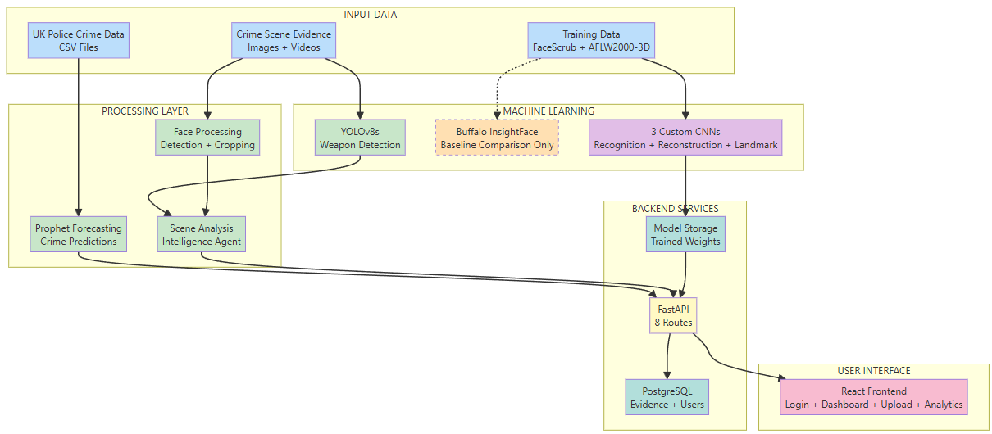
Figure 1. Concept ecosystem of the AI-powered facial recognition and crime analytics framework, showing data ingestion, model components, access interfaces, and security checkpoints.
A single-page dashboard is what the React frontend shows. Additionally, it allows for the uploading of evidence and gives analytics views. Image submissions, requests for identification and reconstruction, as well as the examination of projections of crimes, are available for the user-interface. On the server, all of the difficult computations are performed. Only through the method of the Rest call, and where required, with live update channels, the browser connects with the other applications. Access control is supported by this architecture, which also maintains the client’s simplicity [85].
There is a clear separation of the backend into modules. It is the “backend/api” package that is responsible for defining authentication checks, request and response schemas, and routes. Following the validation of incoming data, each route in turn makes a call to the service layer. PyTorch checkpoints are loaded by the “backend/services” package, which also handles devices and provides high-level actions such as recognising, reconstructing, landmarking or detecting weapons. As a reusable detector that produces person and weapon boxes for the rest of the pipeline, YOLOv8 [47], [66], [67], [68], [69], [104] is wrapped here as a protection mechanism [86].
An emphasis on training and assessment is shown in Figure 2. The recognition network receives data from the photos of actors and actresses that are provided by FaceScrub [11]. The reconstruction and landmark networks take use of data that is provided by AFLW2000-3D [10] pictures and meshes. The “.pth” checkpoints for each model are generated by the training scripts that are included in the training folder. Evaluation scripts are stored in the evaluation directory and produce TAR, FAR, and ROC curves for recognition, vertex errors of reconstruction, as well as NME and CED curves of landmarks. These curves are utilised to recognise landmarks. After some time passed, the services layer is loaded at the same checkpoints in order to do a runtime inference [87].
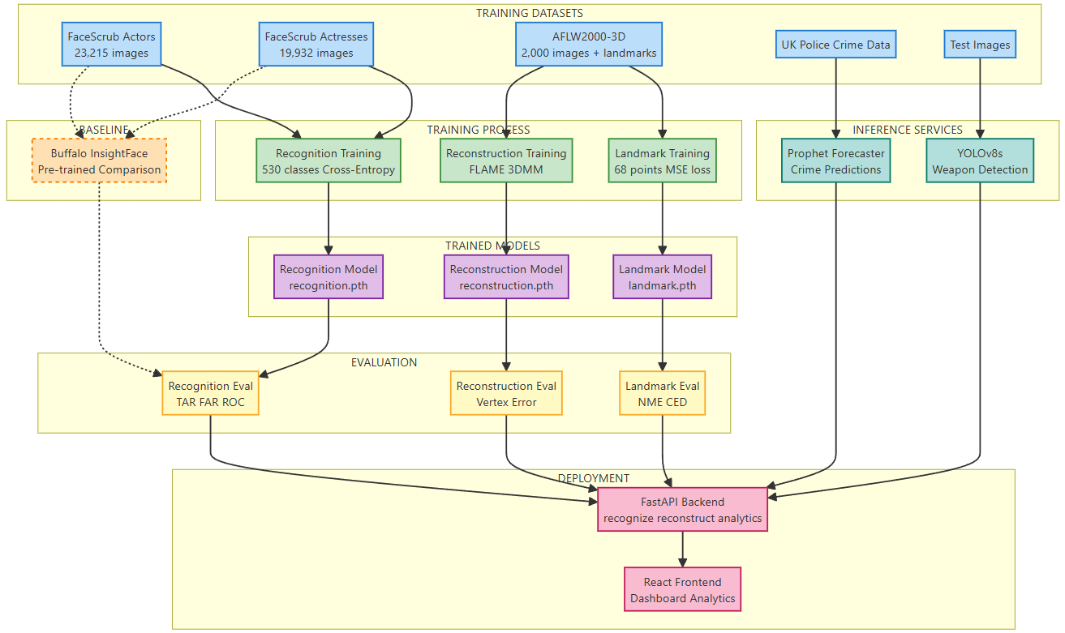
Figure 2. End-to-end pipeline.
The durability of data is a reflection of the various access patterns. The database management system PostgreSQL or SQLite is utilised to store users, evidence, information, audit logs, results of bias monitoring, and DPIA evaluations. The scripts that are located in the scripts folder are responsible for converting Crime CSV files into partitioned Parquet databases. Prophet reads these Parquet tables and builds daily or monthly time series and provides forecasts to the dashboard to be utilised. In Figure 3, a Sankey diagram is utilised to illustrate everything discussed so far. It has a stream of data that starts with raw inputs and goes further by processing and FastAPI backend before getting into the database and React analytics views [88].
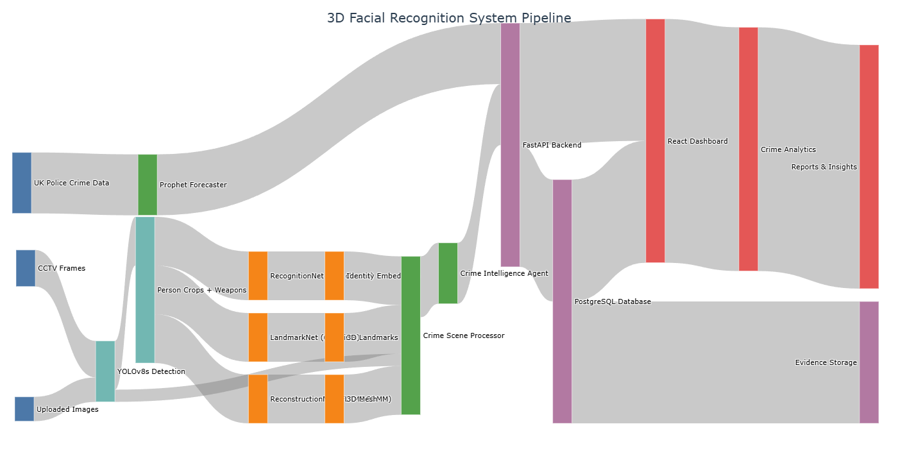
Figure 3. End-to-end data flow for facial recognition and crime integration, covering dataset input, model training, embeddings generation, and crime analytics.
Through the use of this modular framework, duties are kept distinct. The frontend mainly concentrates on presentation. HTTP-related issues are handled by the API layer. Service modules, both models and YOLO [47], [66], [67], [68], [69], [104] logic, are contained within service modules. Training and assessment continue to take place offline and may be replicated. Transactional and analytical workloads are segregated inside the storage system. The maintainability of the system, controlled experimentation, and future scalability of the system are all supported by this separation.

3.2 Facial analytics pipeline design
Taking each frame in the facial analytics pipeline, each frame is converted into a reliable face embedding. This is done in a pre-determined order. Individuals are discerned by YOLO [47], [66], [67], [68], [69], [104]. The faces are tended by the framework. The groundbreaking model improves the crop and ensures that alignment is maintained. Three-dimensional shape estimation is performed via a reconstruction model. A number of embeddings and identification scores are generated by the recognition model. Because each stage is designed as a distinct service, it is possible to make changes to the components without disrupting the pipeline as a whole. Figure 4 presents a summary of the pipeline [89].
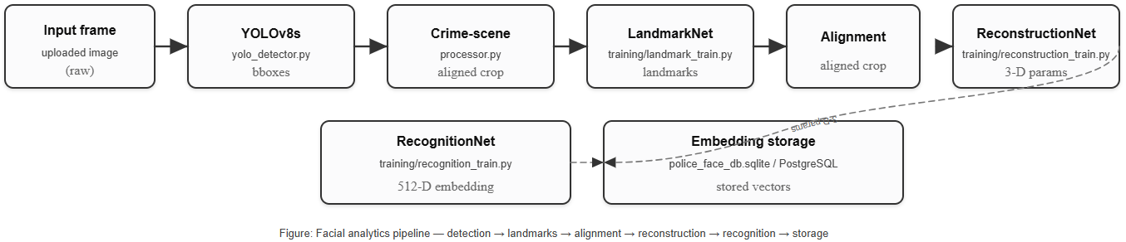
Figure 4. Facial analytics pipeline - detection -> landmarks -> alignment -> reconstruction -> recognition -> embedding storage.
Processing starts with the identification of individuals. Every single picture or video frame is processed by YOLOv8 [47], [66], [67], [68], [69], [104]. A Python file named “backend/service/yolo_detector.py” is utilised for encapsulating the detector. It generates bounding boxes for both humans and weapons after being input. These packages are sent to the “backend/services/crime_scene_processor.py” library. The only detections that are kept is these of individuals for face analysis. It also saves information, such as the camera’s identity, the time, and any weapons that are identified, for the use of subsequent reasoning about the crime scene [90].
The following step involves the preparation of landmarks and face crops. A crop of the upper body is taken from each individual by the person who processes the crime scene. The crop is resized to coincide with the resolution that was utilised for training. The transformations that are described in the universal pipeline utilities are followed by the colour conversion and normalisation processes. After that, the crop is sent to the landmark network trained using the “training/landmark_train.py”. This particular approach provides a predetermined collection of two-dimensional landmarks, such as a sixty-eight-point arrangement, for instance. A similarity transform is fitted by the system between these locations and a reference template once it has been applied. This transformation is utilised in order to provide an aligned face picture that has its posture and size normalised appropriately. Nevertheless, “evaluation/evaluation_landmarks.py” is responsible for calculating the accuracy of landmarks as well as the cumulative error curves [91].
It is the reconstruction step that takes inputs from aligned faces. An accurate prediction of a compact parameter vector for an FLAME-style [8], [9] head model is made by the reconstruction network, which was trained using the “training/reconstruction_train.py” parameters on three-dimensional vertices and basic meshes. Therefore, in the frontend, the following meshes are utilised to facilitate qualitative inspection, and in the “evaluation/evaluate_reconstruction.py” files are used to give, quantitative vertex-error metrics. As it is cheaper to store and easier to compare than the whole meshes, the pipeline takes advantage of the parameter vector directly in most runtime pathways for the pipeline [92].
Recognition is the last stage in the analytical process. The actor and actress subsets of FaceScrub [11] are utilised to train the recognition network using the “training/recognition_train.py” script. Over the course of 530 IDs, training makes use of typical cross-entropy loss. The hidden layer serves as an embedding head when the times come to make an interference. Furthermore, in “backend/services/crime_scene_processor.py” the recognition wrappers are responsible for extracting this vector, L2-normalising, and retaining it as a face embedding. “evaluation/evaluate_recognition.py” is responsible for computing TAR, FAR, and ROC curves for these embeddings [93].
The face database is where the embeddings and the information are stored. The “police_face_db.sqlite” is the file that utilises a database to run this programme for development. Nevertheless, using PostgreSQL with the same schema, which is specified in “backend/database/models.py”, deployment is carried out. An identification, timestamp, link to source crop and serialised embedding (float32), all stored in each row. Additionally, an optional person identifier is also included in each row. With watchlist search, such embeddings are loaded into memory or some sort of approximate nearest neighbour, whichever is most appropriate. The similarity measure that is calculated between the query embedding and stored vectors is cosine similarity. Results that are higher than a threshold may constitute potential identities. Moreover, bias-monitoring services and scripts such as “scripts/bias_from_images.py” are utilised to carry out an analysis of the behaviour of this pipeline across different demographic groupings [94]. Figure 5 shows how these stored embeddings are used in watchlist search.
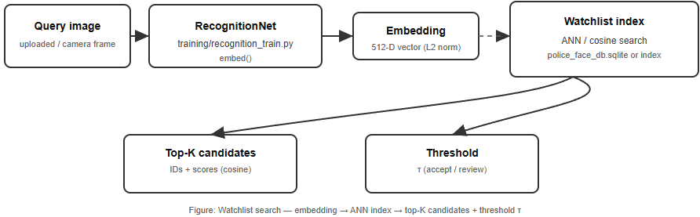
Figure 5. Watchlist search pipeline - embedding extractor -> ANN/cosine index -> top-K candidates -> decision threshold.

3.3 Crime-intelligence and data layer
The crime intelligence layer takes raw police CSV files and also model outputs and presents them in a structured format that can be searched and analysed by the framework. Crime data comes into the system monthly street-level CSV files from UK police portals [12]. Pandas is used for importing such records into a batch workflow that is contained within the “backed/analytics/predict.py” directory. The process subsequently aggregated the events to produce national totals by month and afterwards dispersed the entirety throughout the course of days to create a daily time sequence. Underneath the results of the processing folder, the outcome appears in a dataset that is segmented using Parquet as the information format. This Parquet store is the major source for forecasting and high-level trend analysis [95]. This Parquet store is the primary source for forecasting and high-level trend analysis, and the complete ETL, along with forecasting flow, is summarised in Figure 6.
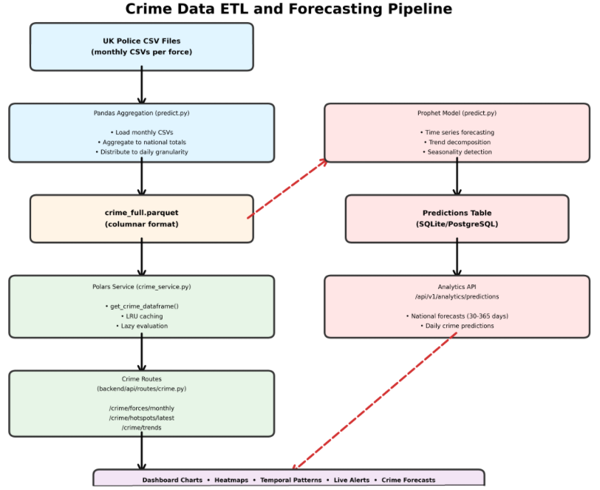
Figure 6. Shows how Crime Data goes about monthly CSVs via UK Police [12] towards Parquet database and then to a dashboard using Prophet’s forecasting.
Whenever the backend is started, Polars events located in the “backend/services/crime_service.py” script retrieve the Parquet records in a sluggish manner and store them in memory using an LRU cache. The criminal API may now receive requests with minimal latencies thanks to this. Furthermore, information is made available to the frontend utilising FastAPI routes located in the “backend/api/routes/crime.py” file. Nevertheless, “/api/v1/crime/forces/monthly” is an example of an endpoint that provides time-series patterns by law enforcement agency. Moreover, “/api/v1/crime/hotspots/latest” provides such an instance of an endpoint that produces the greatest LSOAs during a particular current month. Additionally, “api/v1/crime/summary” consists of reports and standard statistics for the dataset. In order for analytics to verify that the precise time frame and parameters are truly loaded, debugging routes make it possible to eliminate the caches and do basic diagnoses [96].
National forecasting employs the identical Parquet foundation yet takes another route. The prediction code creates an individual daily dataset, and the Prophet model is applied. FastAPI path “/api/v1/analytics/predictions” and “/api/v1/analytics/run-predictions” are used for fetching previously recorded forecasts, or to run a new session. Forecast outcomes are also saved back into the relational database, thus preserving the chronology of the forecast together with the models which generated it. This architecture makes it possible to compare the actual counts to former projections in the dashboard and makes it possible to investigate the model performance in future [97].
Operational occasions are stored is a standardised SQL schema that is described in “backend/database/models.py”. Evidence keeps encrypted files alongside information on the media kind, details, and the time of its manufacture. Snapshot saves static images from CCTV cameras and links them to temporary identities. Predictions meet Prophet results of each location and category of crime, such as central estimates and confidence limits. ModelVersion stores recognition, reconstruction, and landmark models. It does this by storing the location of files and SHA-256 hashes for integrity. AuditLog maintains a hash-chained record of sensitive operations such as uploading evidence, changing models and performing DPIA evaluations. Alembic migrations keep track of how this schema has changed over time, and make sure that the development and deployment is in sync [98]. The key tables and relationships in this database on crime intelligence are illustrated in Figure 7.
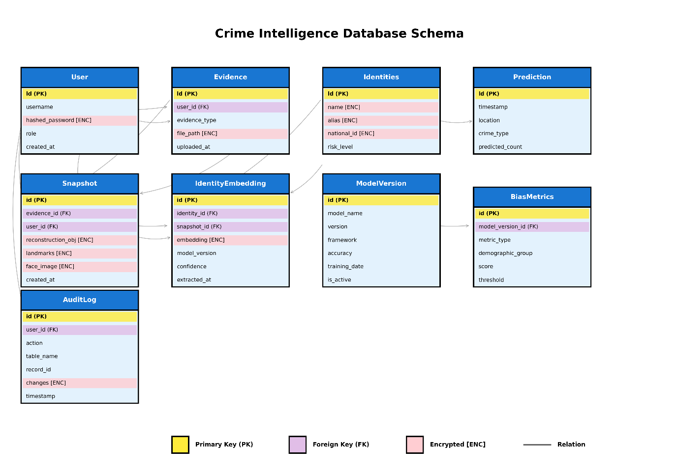
Figure 7. Crime intelligence database schema with the users, evidence, snapshots, identities, embeddings, model versions, predictions, bias metrics, and audit logs.
The crime-intelligence agent is on top of this storage layer. The class located in “backend/services/crime_intelligence_agent.py” invokes the processor of a crime scene to perform YOLO [47], [66], [67], [68], [69], [104] detection, face cropping, and recognition on the frames received. It then constructs an organised record containing a combination of person of interest, weapon detection (if any), timestamp, camera identifier and recognition results such as embeddings and predicted classes. The agent caches each record in the memory or in the database and returns a summary of the data in the form of JSON to the API layer. This separation of orchestration from low level vision code combined with the fact that every detection and recognition event is linked back to the crime data, locations and audit logs in a consistent way [99].

3.4 Security, governance and deployment considerations
The framework is a security-aware prototype, which can be moved towards operational use with limited changes. Authentication is mocked in the development of the existing codebase. A production deployment would use an external identity provider that would be based on OAuth2/OpenID Connect or enterprise SAML. The JWTs would be distributed by the service provider, and the Traefik or Kubernetes Ingress manager would be responsible for verifying these on the threshold of entry. Only authenticated and signed requests would reach FastAPI backend. Figure 8 represents the security and governance stack, including users and roles FastAPI plus RBAC checks, and protected resources (evidence store, PostgreSQL, logging/monitoring).
The authorisation is a role-based access control model. Users are given roles such as admin, analyst, operator and auditor. The permissions are resource-based, such as evidence, predictions, models, and audit logs. They are also scoped by action such as read, write, annotate, delete or administer. Routes on API will load and validate role claims through the JWT and will proceed with any sensitive operation. This makes access rules clear and readily reviewed [100].
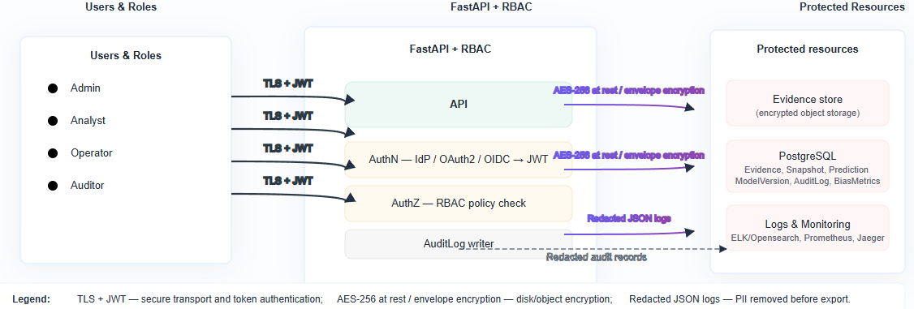
Figure 8. Security and governance stack.
Data handling is based on the idea of least privilege. Structured JSON logs contain a request identifier, user role and endpoint with sensitive fields redacted before they exit the service. Evidence files are stored in an access-controlled object store or encrypted volume and are deemed immutable once written. Each and every upload or download creates an audit record. Prediction records contain time, area, crime type, model version and confidence bounds with external identifiers being hashed if possible. Transport TLS, databases and object storage encryption at rest. Secrets are delivered through Docker or Kubernetes Secrets and would be supported by a specific vault in production. Retention periods/flows or deletion are configurable and controlled by RBAC. Exhibiting ongoing integration and ongoing delivery (CI/CD), ingress, node pools and shared observable services [101], Figure 9 illustrates the deployment architecture of both the development (Docker Compose) and the so-called “production-ish” Kubernetes clusters.
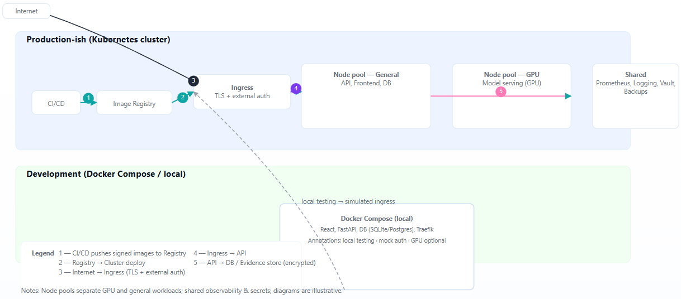
Figure 9. Deployment topology.
Deployment is totally containerised. A multi-stage Docker file creates a minimal runtime image containing locked dependencies and optional support for a GPU. The deployments, services, ingress, storage and horizontal scaling are defined using Kubernetes manifests and utilised in a “production-ish” fashion. Centralised logging, metrics, image scanning and controlled rollouts put the icing on the cake [102].
These choices support the governance and DPIA themes in Chapter 7. Privacy-by-design is based on minimisation of data, hashed identifiers, and access control. The bias monitoring is regarded as a component of governance, the dataset profiling, the metrics of fairness, and the steps of mitigation, which are recorded, including re-weighting of changing the threshold.

4. Datasets and Experimental Setup

4.1 Facial datasets and preprocessing
Two main datasets are utilised to train and test face models. These datasets include FaceScrub [11], which is used for identity recognition, and AFLW2000-3D [10], which is used for landmarks and reconstruction. In order to link two-dimensional annotations to the three-dimensional head model, they both use FLAME assets. This section provides an explanation of the process of cleaning, splitting, and normalising the snapshots prior to training. I addition, it describes the fundamental sanity checks that are carried out and how the two-dimensional and three-dimensional labels are related to the FLAME mesh [8], [9].
The recognition network needs identification labels, and FaceScrub [11] is the company that delivers them. Following the completion of the cleaning process, the dataset comprises 43,124 photos and 530 facial recognition IDs (Figure 10) in the directory “Data/recognition_faces”. At the level of identification, the training script generates a tiered differentiation. According to the training logs, it allocates 30,186 snapshots to the training, 6408 snapshots to the validation, and 6,470 snapshots to the testing phase. In order to prevent leaking, each and every snapshot belonging to a certain individual (actors and actresses) is shown in a single split. Identities that include just a small number of pictures are merely retained in training to maintain the consistency of assessment classes.
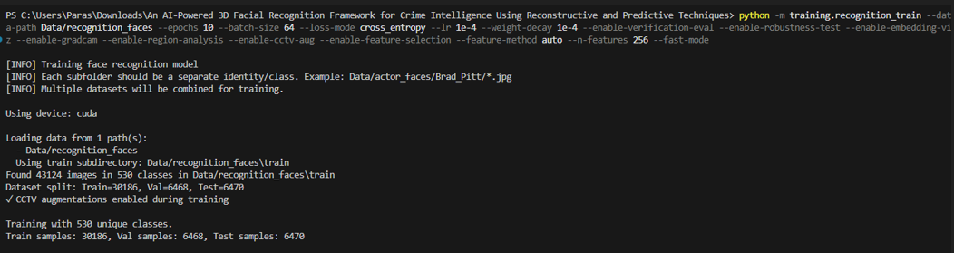
Figure 10. FaceScrub recognition training setup.
A preprocessing pipeline that is deemed conventional is utilised during recognition training. A process of decoding each picture using PIL, converting it to RGB, and resizing to 256x246 pixels is carried out. The channel-wise means and standard deviations are calculated on the training set utilised in the normalisation process. Furthermore, transferring the values of pixels to the range that the backbone anticipates, which is between -1 and 1. The “augmentation.py” package performs random horizontal flips, tiny rotations, moderate scale, translation jitter, colour jitter, and Gaussian blur while the training is being performed. As a result of the inclusion of additional compression artefacts and noise, a CCTV mode causes the model to detect degraded faces that are comparable to CCTV crops. Resizing and normalisation are the sole operations that are applied by validation and test pipelines, which inhibit augmentation.
Both reconstruction and landmarks are accomplished with the help of AFLW2000-3D [10]. These are a total of 2000 images/.mat pairs as shown in the file for “training/landmark_train.py” and “training/reconstruction_train.py” in the “Data/AFLW2000” directory. These pairings are split as follows: 1400 for training, 300 for validation, and 300 snapshots for testing. Each face in the landmark training employs 102 two-dimensional points. These are the shape of pixel coordinates and follow a dense pattern in the mouth, eye, nose and jaw. As a part of the preprocessing procedure, they are transformed into a normalised coordinate frame that is determined by the bounding box that was discovered. Tensors of fixed length are utilised to hold landmark targets, which allow for the masking of points that are invalid or which are missing. Figures 11 and 12 offer an overview of the discussion so far.
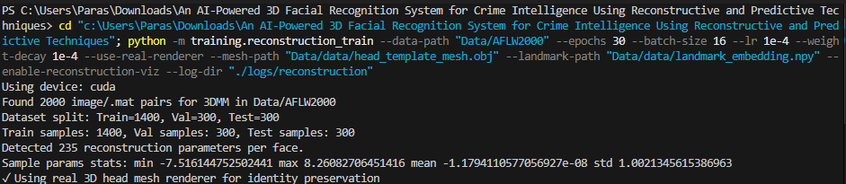
Figure 11. Reconstruction training dataset details.
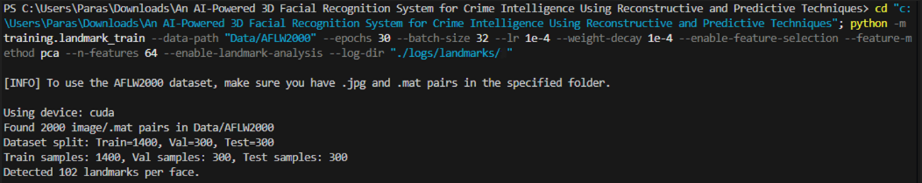
Figure 12. Landmarks training dataset details.
Different labels are applied to the same AFLW [10] snapshots that are utilised in reconstruction. The 3DMM parameters and the three-dimensional landmark locations are stored in each .mat file. The algorithm utilised for training reads them into a parameter vector that is 235 dimensions long for each snapshot (Figure 11). There is also an estimated head position provided by AFLW. The collection of combinations of yaw and pitch values is subdivided into 3 ranges: frontal, medium, and extreme ranges. In the future, when reporting reconstruction and landmark mistakes by pose, bins will be used thereafter.
A loop is closed between the rebuilt mesh and the two-dimensional landmarks by use of FLAME assets. This project uses a NumPy file of landmark embeddings that is stored in the directory “Data/data/landmark_embedding.npy” and a canonical FLAME template mesh that is stored in the file “Data/data/head_template_mesh.obj”. According to a pair of barycentric weights, each of them is an embedding mapping from one of the 2-D landmark indices to an interior set of FLAME [8], [9] vertices. During the training process, the model will make predictions on the FLAME parameters. Vertex placements are generated because of these factors. It is the role of the projection module to compute losses on the embedded landmark positions, as well as the move vertices losses on the embedded landmark position, as well as to move the vertices back to image space. This leads to a constant supervisory signal in two-dimensional and three-dimensional activities. Figures 13 and 14 offer a preview of the head mesh utilised from FLAME [8], [9].
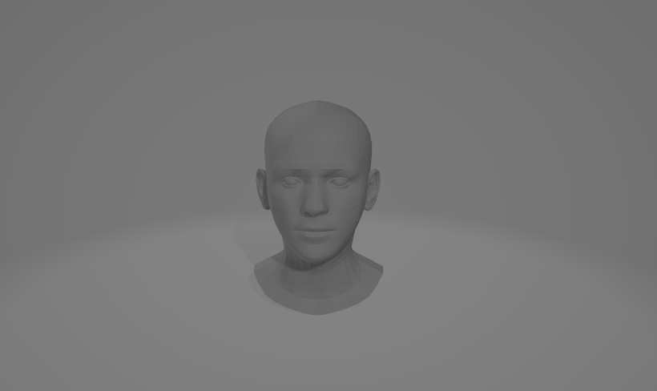
Figure 13. Flame head mesh objective displayed [8], [9].
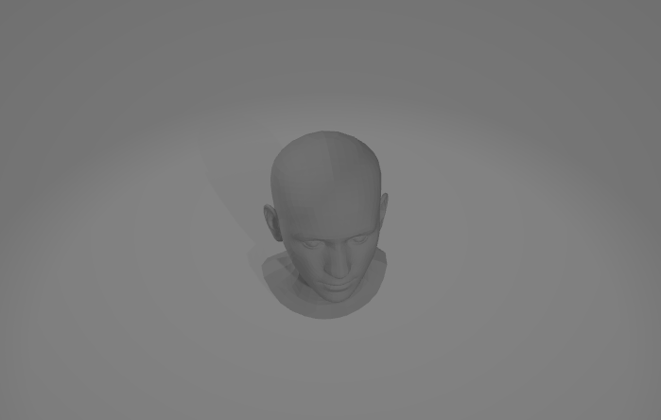
Figure 14. Flame head mesh objective, another view [8], [9].
Before beginning training, there are many sanity checks and examinations performed. It is the responsibility of scripts to verify that each snapshot has the required quantity of landmarks or parameters. Records are kept of broken files and frames that have a missing label, and these are skipped. In cases where they are available, simple histograms are utilised to investigate the distribution of the angles of yaw, the count of identification and gender labels. In order to prevent a small number of highly frequent actors from dominating the identification process, the loader places a limit on the number of snapshots that may be associated with each identity during each epoch. The test sets are divided by posture and basic demographic characteristics in order to facilitate assessment and bias analysis. This allows the metrics to be compared across different groups.
None of the preprocessing is done manually. Log folder utilised for storing command line parameters and random seed. These directories are categorised as e.g. “logs/landmarks, logs/reconstruction, and logs/recognition” respectively. Since this is the case, it is possible to recreate the precise splits and transformations that were used in the studies.

4.2 United Kingdom data acquisition and processing
The official open-data service may be found at data.police.uk [12], which is utilised as a crime component. A programmed task is responsible for downloading the street-level CSV exports into a local staging area when they are ready on a monthly basis. Every file has a single record for each offence, which includes information such as the month, LSOA code, LSOA name, latitude, longitude, kind of crime, and the category of the recent result. The pipeline will convert a fresh CSV file into a Parquet file and then split it according to the year and the month as soon as it is received. Because of this, storage is kept small, and the system is able to read just the slices that are required for a query.
Normalisation of core fields occurs throughout the process of ingestion. It then removes any entries that contain wrong or missing dates after processing the Month column into the proper data type. In this context, LSOA codes are considered to be the fundamental spatial key. A local lookup table is applied to convert coordinates to the most likely local standard of accuracy (LSOA) if only coordinates are available. For the purpose of area-level analysis, records that do not yet have a valid area are deemed impossible to use. First, the categories of criminal activity are cleaned up and then mapped to reduce taxonomy. Some examples of these categories are offences, theft, public order offences, and violent offences. A limited number of statuses, including pending, charged, non-further-action, and unknown, are associated with the language of the outcome.
Several cleaning procedures are carried out on the pipeline. Identifiers, time, and place are taken into consideration in order to eliminate apparent duplication. The coordinates are validated, and points that are located outside of the UK bounding area are dropped. It makes a record of any crime categories or outcomes that have not yet been mapped, so that they may be examined and included in the mapping tables at a later time.
All crime analytics are based on the Parquet dataset once it has been processed on. Those who work in aggregation are responsible for computing monthly counts for each LSOA and each crime category, as well as totals for local authorities and national monthly summaries. The aggregates are saved in the form of Parquet and made accessible by means of the FastAPI routes included in the “backend/api/routes/crime.py” file. A number of endpoints, such as “api/v1/crime/force/monthly, /api/v1/crime/hotspots/latest, /api/v1/crime/lsoa/series, and /api/v1/crime/summary” are read from the Parquet via the Polars service layer. A basic set of provenance information is contained in every response. This metadata comprises the data range that was covered and the time of the most recent successful ingestion run.

4.3 Model configurations and training protocols
On a Razer Blade 15 laptop equipped with an i7-10750H CPU, NVIDIA RTX 3060 GPU, and 32 GB of RAM, all of the learning components were trained using a shared PyTorch training framework. In order to write configurations, metrics, and checkpoints to the “.logs/landmarks, reconstruction, recognition” directory, jobs are initiated using a command line interface (CLI) module (e.g. python -m training.landmark_train). A file with a run configuration (e.g. run-config.json), per-epoch statistics (CSV or JSON) are generated, and a summary chart is taken during every run. The console traces are indicative of the final training runs.

4.3.1 Landmark model (LandmarkNet)
LandmarkNet is trained using RGB crops from AFLW2000-3D [10] that are aligned at 256x256. The regression head is supplied with a fully connected network fed by a small convolutional neural network that makes use of adaptive average pooling. This head produces Nx2 coordinates that, in the N instance, are 102 landmarks. The loss is computed when visibility masks are applied and computed as the mean squared error over visible landmarks. Adam is used for training, with a batch size of 32 and 30 epochs, a learning rate of 1x10⁻⁴, and a weight decay of 1x10⁻⁴. A principal component analysis (PCA) based on selection is used to reduce the 204 scalar landmark characteristics to 64 dimensions before the optimisation process starts. During each epoch, the training scripts save the amount of loss, mean absolute error and root mean square error. Following this, it calculates the NME and CED curves, and finally, it exports the TorchScript and ONNX checkpoints. The command line interface (CLI), dataset statistics and principal component analysis (PCA) setup for this run are presented in Figure 15. Figures 16 through 20 show the traces of the mid-training period (e.g. epochs), and the summary of the final assessment, NME/CED statistics and model export is given in Figure 21.
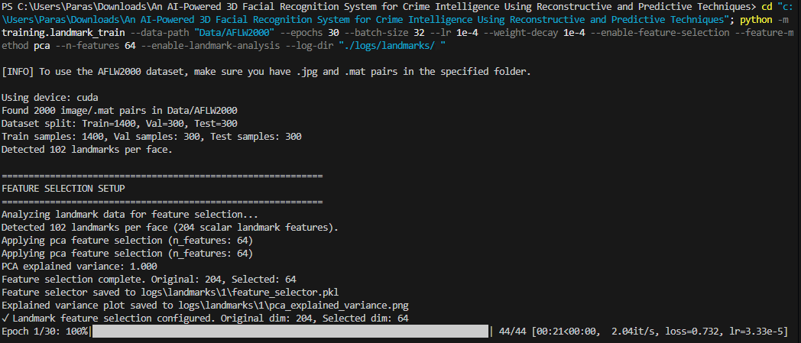
Figure 15. Landmark Training process along with CLI commands, dataset stats, PCA setup, and epochs.
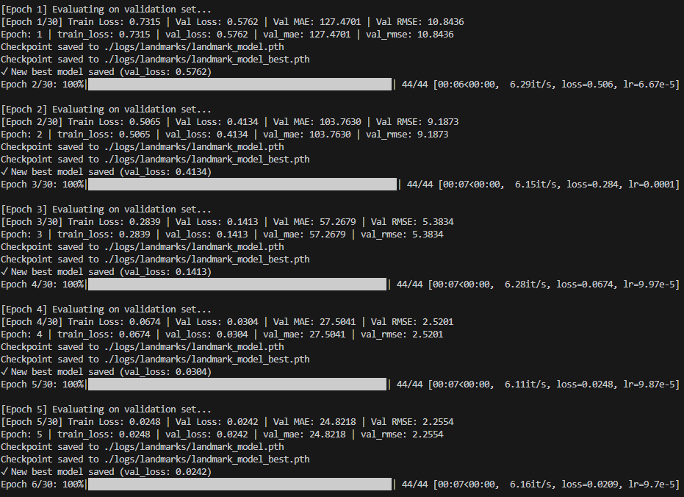
Figure 16. Landmark Mid-training epochs 1-5.
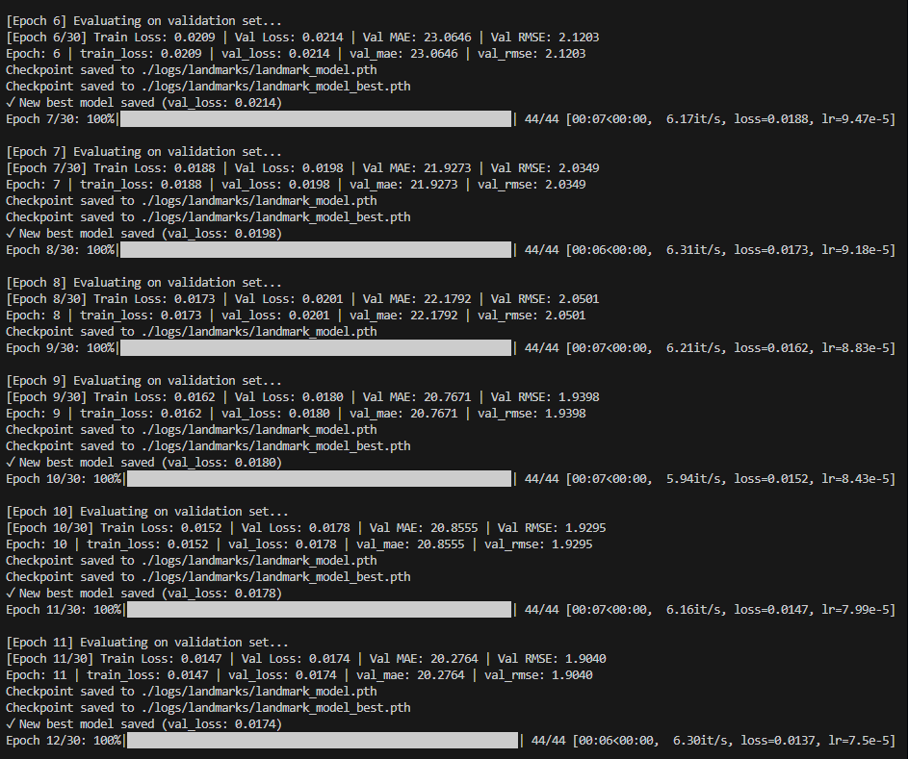
Figure 17. Landmark Mid-training epochs 6-11.
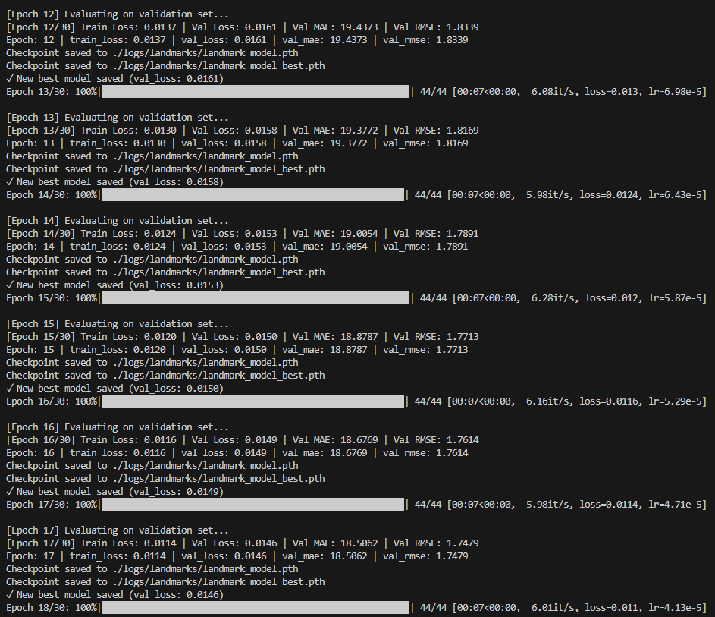
Figure 18. Landmark Mid-training epochs 12-17
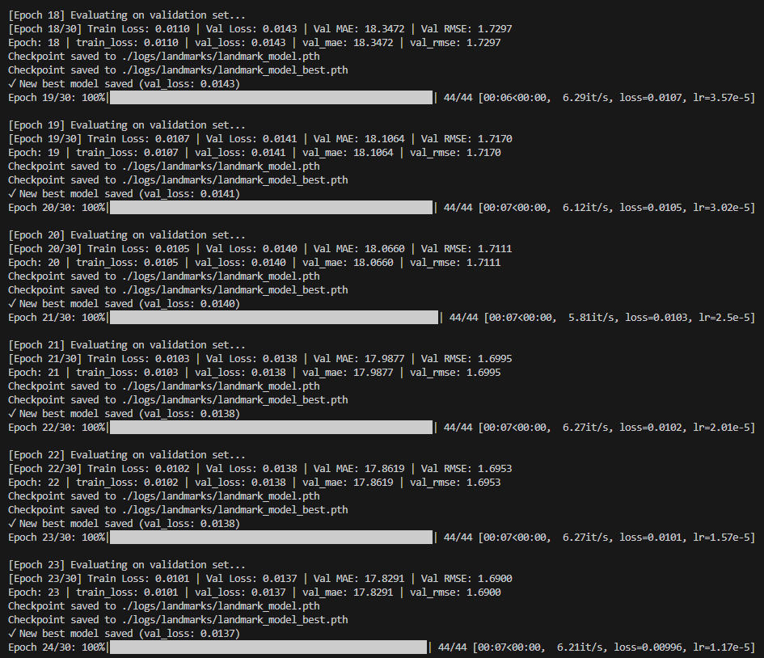
Figure 19. Landmark Mid-training epochs 18-23.
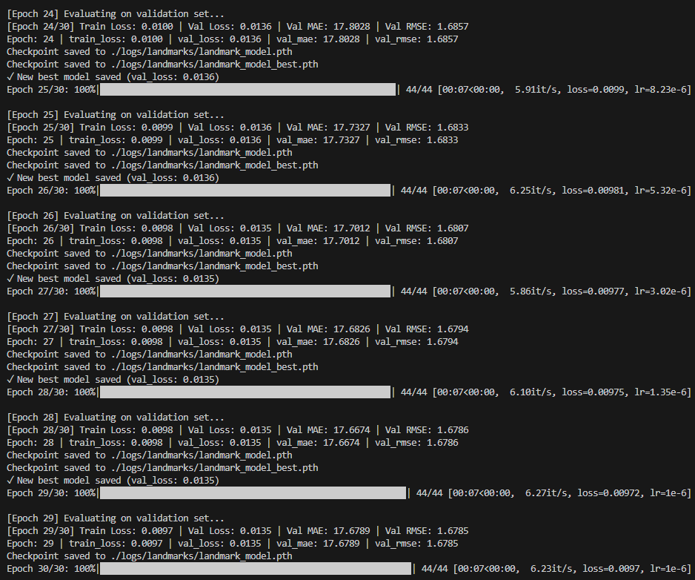
Figure 20. Landmark Mid-training epochs 24-29.
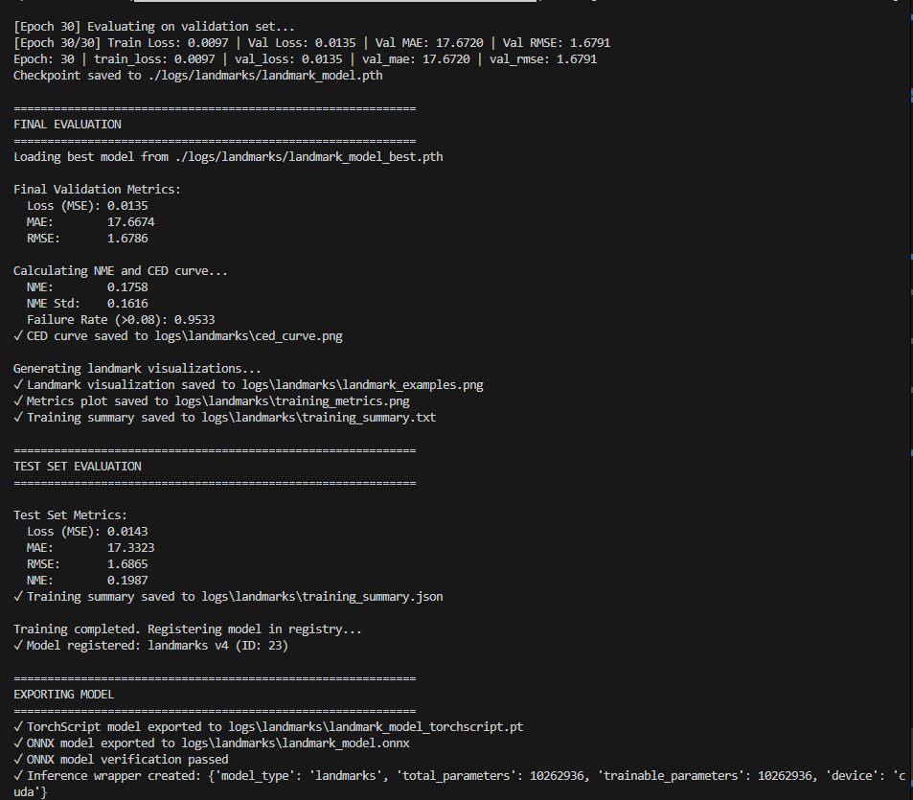
Figure 21. Landmark final evaluation block (validation metrics, NME/CED, test metrics, and TorchScript/ONNX export).

4.3.2 Reconstruction model (ReconstructionNet)
ReconstructionNet is the process of mapping aligned crops to a concatenated FLAME [8], [9] parameter vector, comprising of form, expression, and posture, and consisting of approximately 235 parameters. The loss includes L2 parameters penalty, 3D vertex penalty and optional landmark reprojection penalty. It is trained on Adam with a learning rate of 1x10⁻⁴, weight decay of 1x10⁻⁴, and a batch size of 16, with an effective number of epochs of 30. Soon after epoch 11, when validation loss reaches a level, early halting with patience 10 puts an end to training (Figures 22, 23, and 24). Rendering mesh visualisations, exporting TorchScript/ONNX models, and computing parameter-error statistics are the next steps that the script takes.
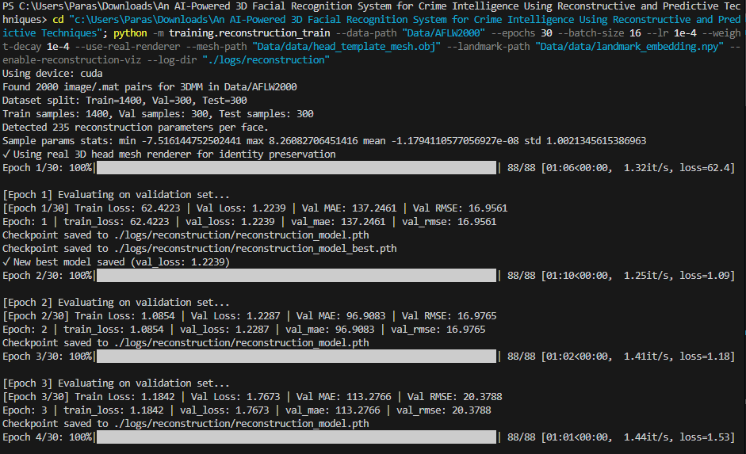
Figure 22. Reconstruction training CLI, statistics of the dataset, parameter settings and first epochs (1-3) on AFLW2000-3D [10].
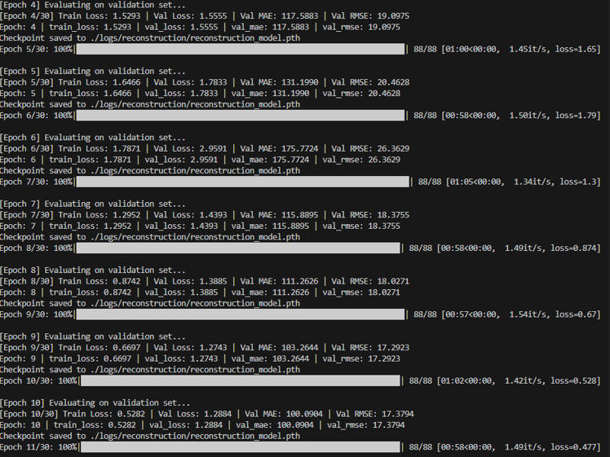
Figure 23. Reconstruction mid-training trace between epochs 4 to 10 with train/validation loss, MAE, and RMSE per epoch being logged.
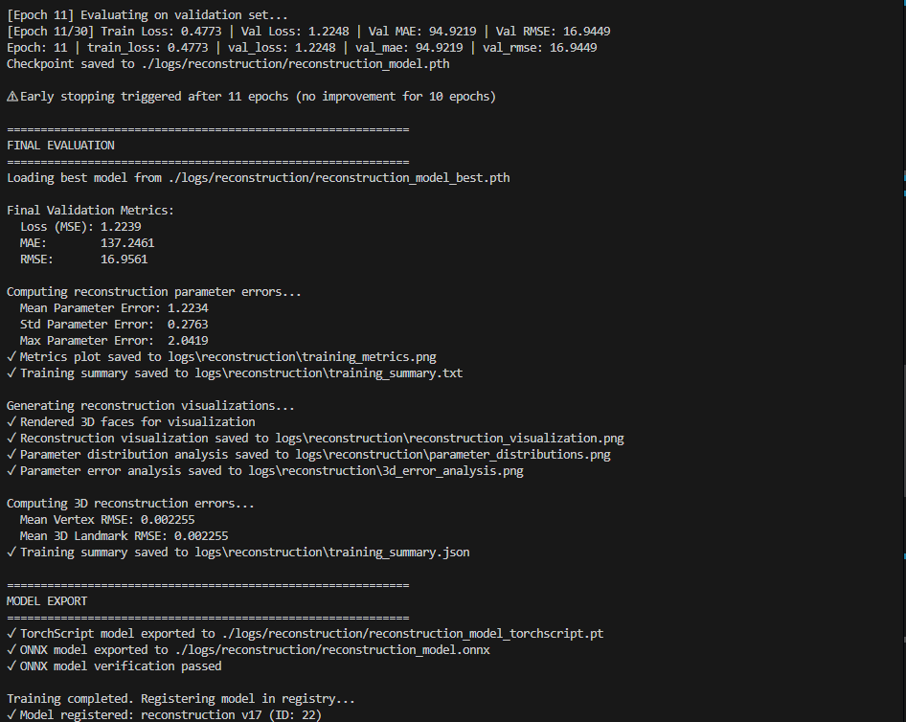
Figure 24. Reconstruction final evaluation block, reporting the validation metrics, the parameter error statistics, 3-D vertex and landmark RMSE, TorchScript/ONNX export.

4.3.3 Recognition model (RecognitionNet)
. For each of 530 FaceScrub [11] identities, RecognitionNet generates a 512-dimensional face embedding as well as an identity classifier. It has a 512-D embedding layer and a linear classification head fed by a CNN/ResNet-style and Global average pooling encoder. The training has cross-entropy, Adam (lower bound 1x10⁻⁴, weight decay 1x10⁻⁴), a batch size of 64, and 10 epochs. Also, augmentations, such as CCTV-style blur, noise, compression, and occlusion, have been added. A step that is based on LDA has the potential to minimise embedding dimensionality. Analyses of test-set verification ROC, UMAP/t-SNE, Grad-CAM, and robustness/occlusion are shown in Figures 28 and 29. Figures 25, 26, 27, and 28 also show the val loss, accuracy, F1 score, and AUC-ROC over epochs.
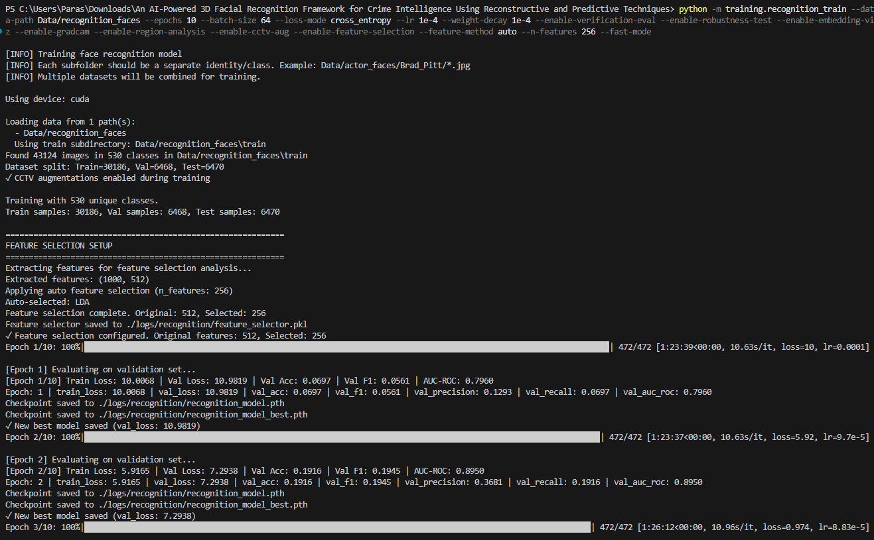
Figure 25. Recognition training command for the training, statistics for the dataset and setup for feature selection with epoch 1-2 trace.
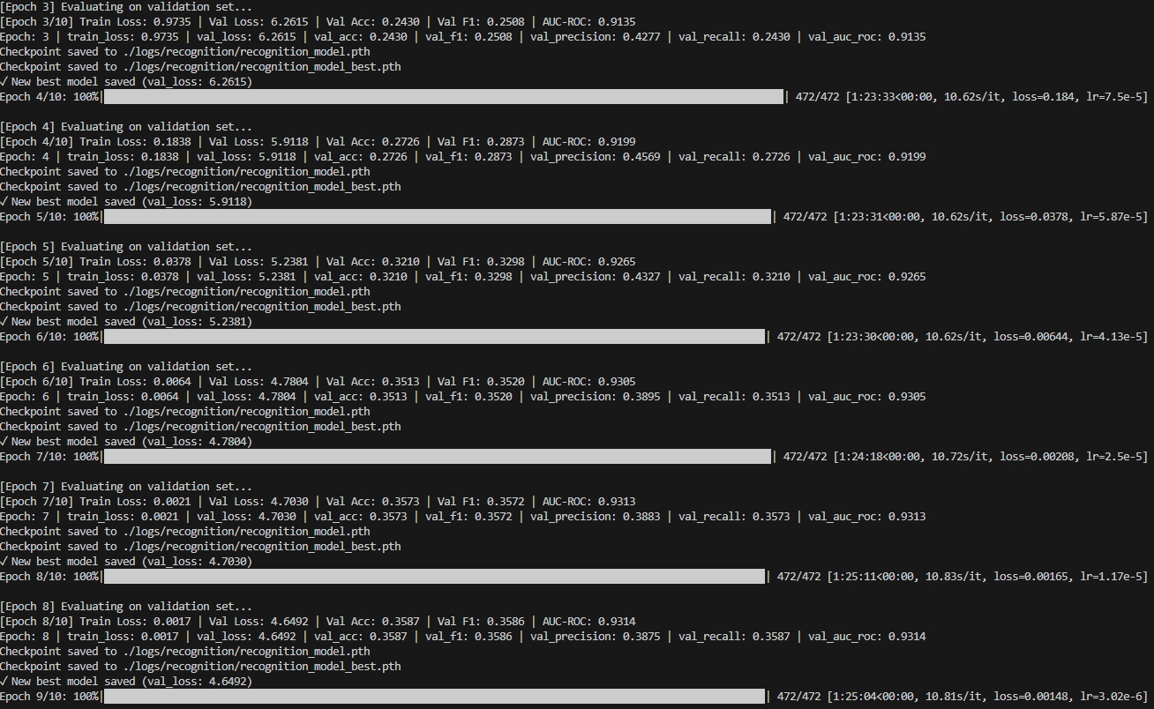
Figure 26. Recognition mid-training console output for epochs 3-8 (validation loss, accuracy, F1 score, and AUC-ROC).
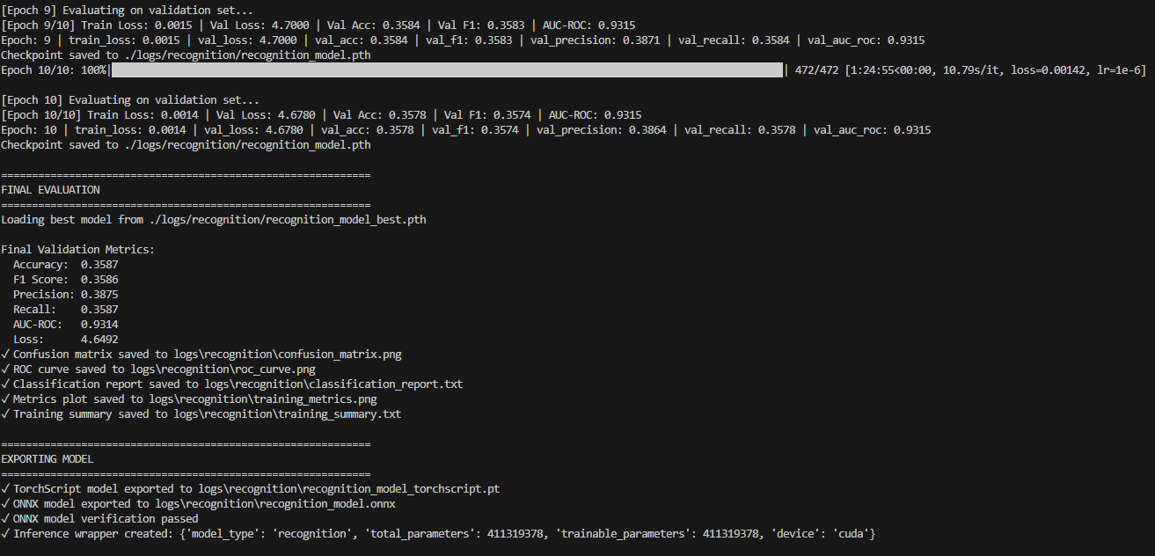
Figure 27. Recognition final training epochs 9-10 final validation block (accuracy, F1, precision, recall, AUC-ROC, and model export to TorchScript/ONNX).
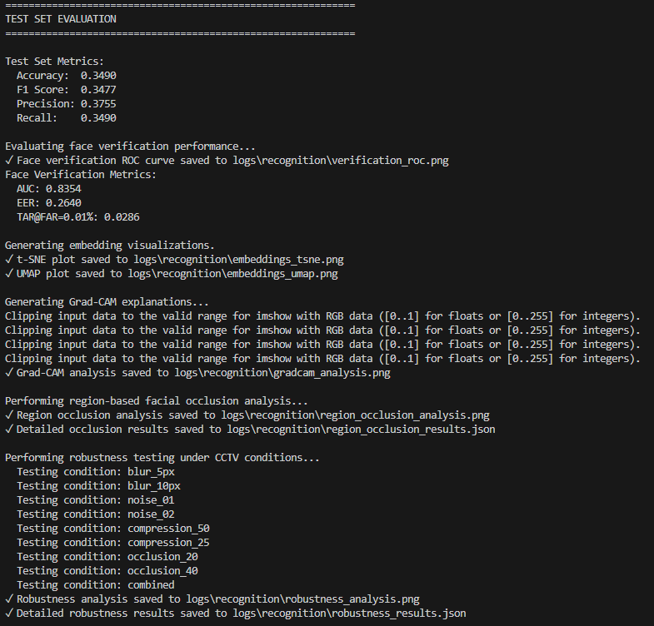
Figure 28. Recognition test-set evaluation, such as verification ROC metrics, visual embedding visualisations (t-SNE/UMAP), Grad-CAM explanations, region-based occlusions and robustness summary on CCTV degradations.
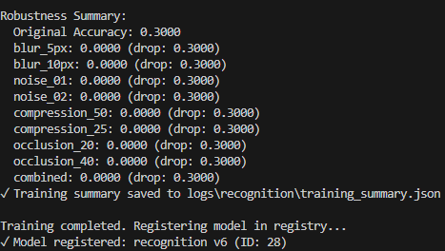
Figure 29. Training completed, robustness summary in numbers.

4.3.4 YOLO integration (pre-trained detector)
As a fixed detector, YOLOv8s [47], [66], [67], [68], [69], [104] is utilised. It is imported from the “yolov8.pt” file and executed using the “backend/services/yolo_detector.py” file. The operating parameters are 640x640, confidence 0.25, and NMS IoU 0.45. It does not undergo any fine-tuning; instead, person crops are sent immediately to LandmarkNet and RecognitionNet, utilising the end-to-end detector and crime agent integration test in Figure 30.
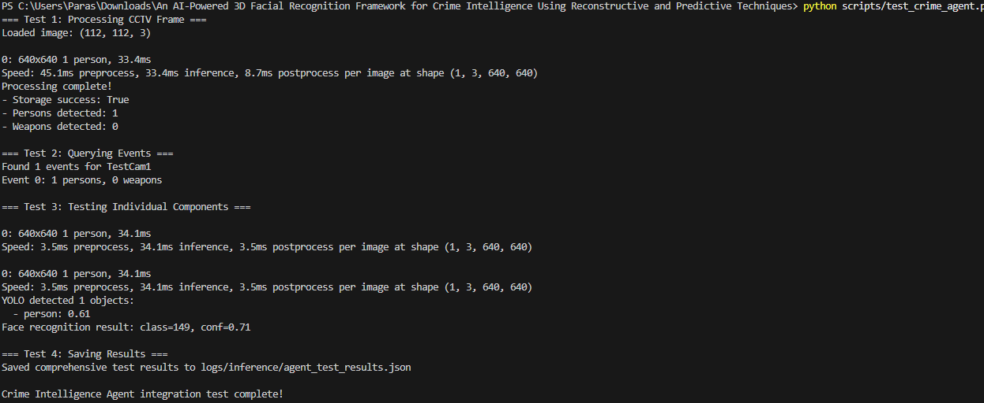
Figure 30. Crime intelligence YOLOv8 [47], [104] Agent End-to-End Integration Test.

4.3.5 Prophet forecasting (analytics)
Facebook and Meta Prophet are used inside the “backend/analytics/predict.py” function for crime predictions. Prophet is based on a rolling three-year window with additive seasonality, and it’s a national daily series that is constructed from the Parquet files on criminal activity in the United Kingdom. Ingestion of CSV files, aggregation of data, model fitting, and creation of a projection for 30 to 365 days are all shown in Figure 31. The mean absolute error, root mean square error, and mean absolute percentage error for the temporal hold-out month are documented together with the model settings.
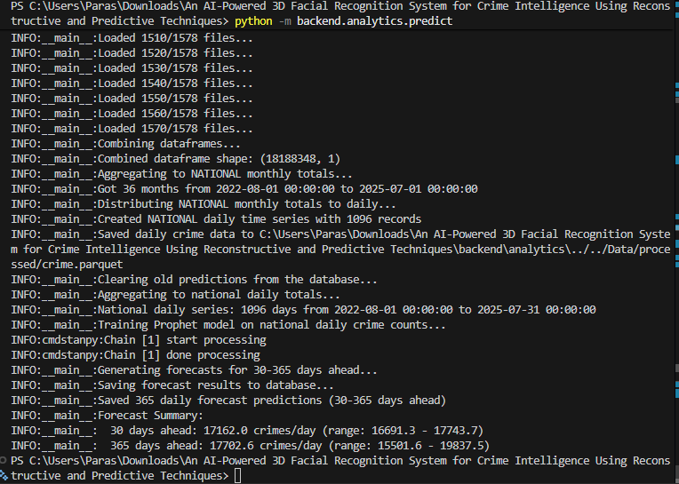
Figure 31. Prophet crime-forecasting pipeline CLI output.

4.3.6 Training protocol, checkpointing and logging
All of models make use of deterministic seeds and PyTorch – DataLoaders with eight workers and pin_memory set to True. Mixed-precision (AMP) and gradient clipping (norm 5.0) are also available in case they are useful. At every epoch, a full checkpoint is written alongside a snapshot named “model_best.pth”, which is conditional on the primary validation metric, which may be NME, vertex RMSE or even macro F1. Furthermore, “run_config.json”, per-epoch metrics and a training summary file are all saved in “logs/<component>/ in each and every run. Additionally, plots such as training_metrics.png, CED curves, and ROC curves are also stored in this directory.

4.4 Evaluation metrics and experimental design
The assessment technique combines basic biometric parameters with indicators on the task situation to enhance reconstruction and forecasting. The most important scalar measure for landmarks is normalised mean error (NME), i.e. mean Euclidean distance between expected and ground truth landmark placements divided by a normalising factor, such as inter-ocular distance or face bounding box size. The curves of cumulative error distribution (CED) are the portion of samples with NME less than a threshold (eps). The results are summarised in terms of NME at a predetermined level (for example, 0.05) and the area under the CED curve.
Three-dimensional reconstruction is assessed at the mesh level. The average L2 distance, in millimetres, between the predicted and a reference vertex that is distributed over the mesh is the three-dimensional error per vertex, which is presented in the process. In order to understand where the errors are occurring, the evaluation also examines parameter-space discrepancies, plotting distribution shapes, expression, pose coefficient errors, reporting their means, and standard deviations.
Recognition performance is measured in terms of top 1 accuracy and macro average F1 so that identities with rather small disjoints are not dominated by frequent classes. A row-normalised confusion matrix indicates which identities are confused with one another. Verification is also done independently: ROC curves are constructed out of cosine similarity between embeddings, and the area under the curve, as well as the true accept rate 1% false accept rate, are reported. The robustness is tested by the repetition of these tests on blurred or occluded samples and comparing them with clean splits.
Nevertheless, for comparison with the Buffalo InsightFace [103] baseline, per-class accuracy histograms, K-Nearest-Neighbour accuracy in embedding space, and low-dimensional UMAP visualisations of embeddings for a subset of identities are included in the analysis. Crime forecasting quality is measured with mean absolute error and mean absolute percentage error on held-out months at different horizons, as well as simple plots of predicted versus actual counts.
Strict split protocols are followed for all experiments in order to prevent leakage. FaceScrub [11] is divided into train, validation and test sets at the identity level (70/15/15), so no identity appears in more than one split. This identity-level is presented and summarised in Figure 32. AFLW2000-3D [10] is split into separate sets of images, or folds, for landmark and reconstruction experiments. Furthermore, test images are never used for augmentation design, threshold tuning or model selection. Forecasting involves a time division, train on a first contiguous block of months, test on the next block and hold out the last time period for pure evaluation, so that no future information leaks into the training window. The temporal splitting applied to the forecasting is illustrated in Figure 33.
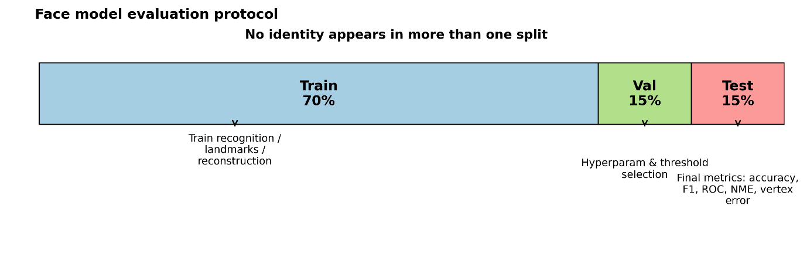
Figure 32. Face model evaluation protocol.
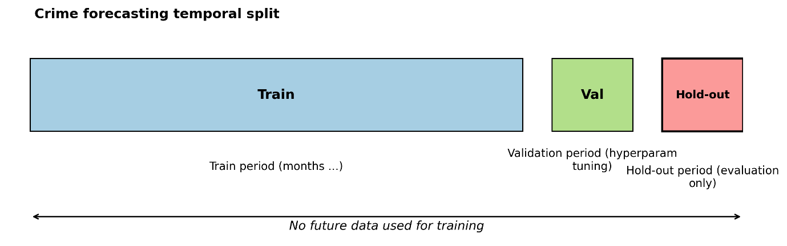
Figure 33. Crime forecasting temporal split.

5. Model Training and Result

5.1 Landmark detection results
LandmarkNet is evaluated on the AFLW2000-3D [10 split used during training. The training dynamics are summarised in Figure 34, which plots training and validation MSE along with MAE, and RMSE over 30 epochs. Both losses decrease sharply in the first five epochs and then converge smoothly with the validation curve closely following the training curve. Moreover, the best checkpoints are chosen at around 28, which indicates that optimisation is good and there is no obvious overfitting. The final validation results for this model are MSE ~ 0.0135, MAE ~ 17.7 pixels, RMSE ~ 1.68, and the values for the test set are very similar as MSE ~ 0.0143, MAE ~ 17.3, and RMSE ~ 1.69, which indicates that LandmarkNet generalises reasonably well to unseen faces.
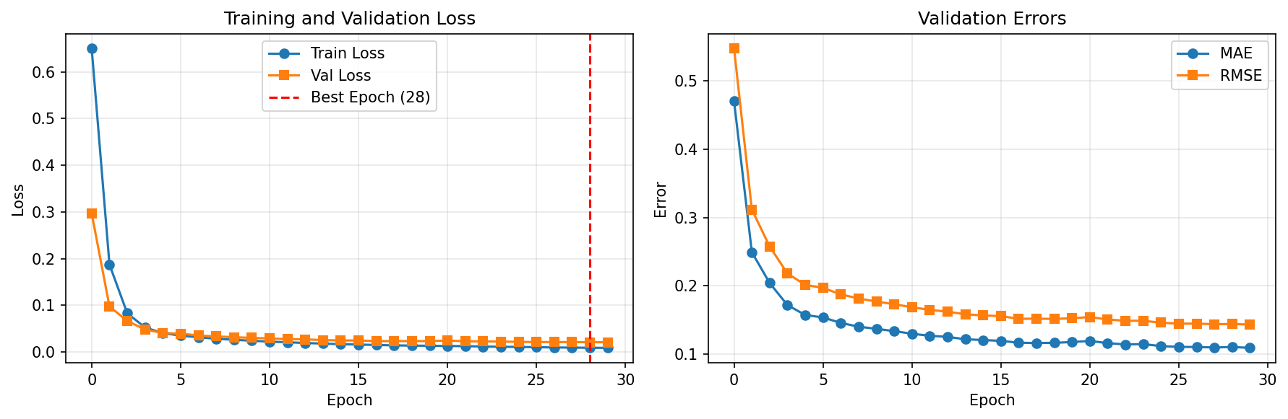
Figure 34. LandmarkNet Training Curve and Validation Curve.
The cumulative error distribution (CED) in Figure 35 further characterises the accuracy of localisation by the normalised mean error (NME). Therefore, the curve rises steeply and saturates for moderate NME thresholds, which means that the majority of faces have all landmarks within relatively small, normalised distances from ground truth. This behaviour is consistent with the quantitative metrics and confirms that large-error cases are relatively rare.
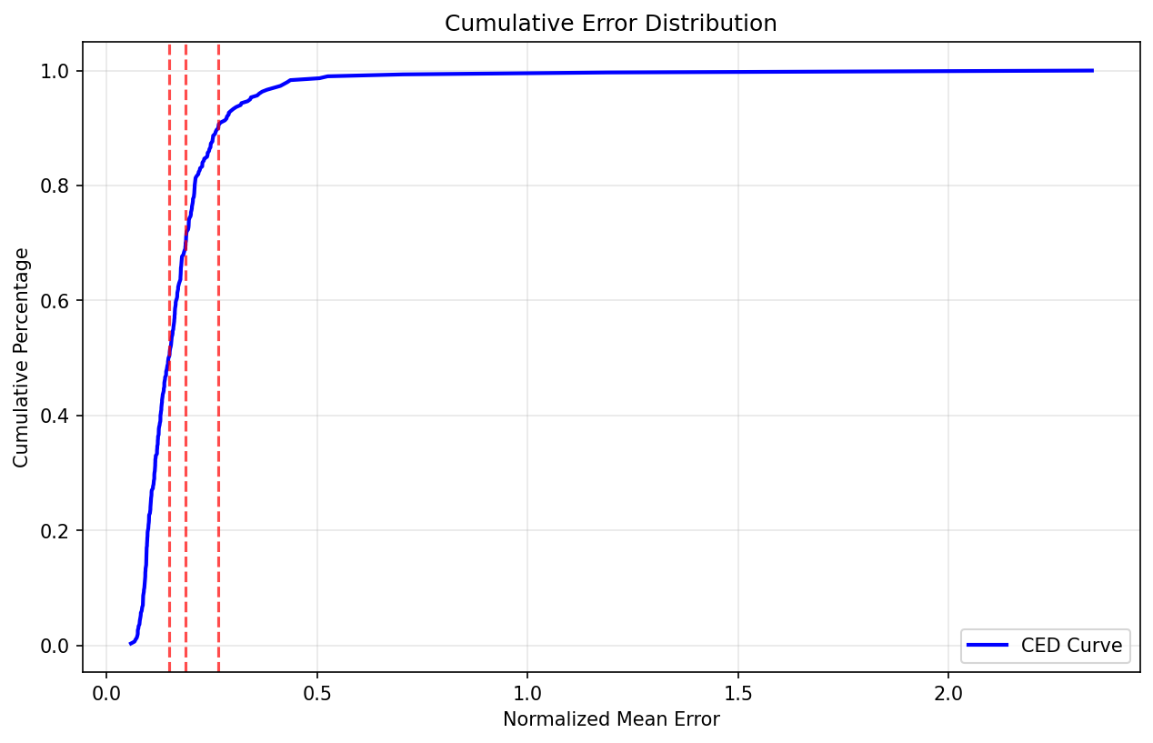
Figure 35. LandmarkNet Cumulative Error Distribution.
Figure 36 shows the PCA-based analysis of the 204-dimensional landmark features space. The cumulative explained-variance plot shows that the first few principal components capture most of the variance, with typically 64 components; nevertheless, capturing almost all of the information. This is in favour of the design choice taken in the training phase to project landmarks into a 64-D PCA subspace: this reduces redundancy while preserving the essential geometric modes of variation (pose, coarse shape and expression).
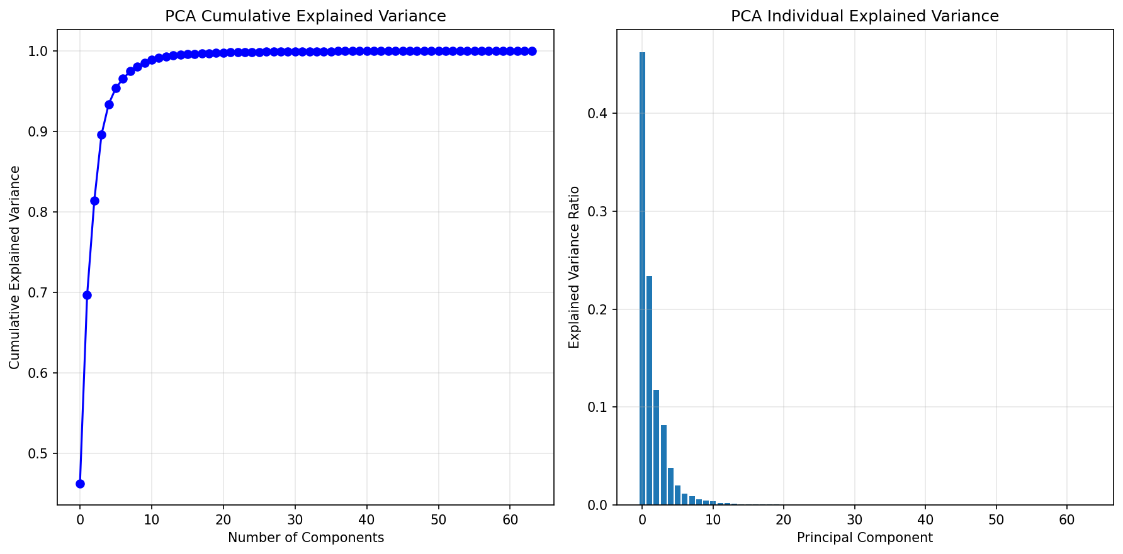
Figure 36. PCA Cumulative and per-component explained variance for LandmarkNet features.
Finally, qualitative examples in Figure 37 show the overlay of predicted landmarks on a number of AFLW2000-3D [10] faces. For near-frontal and moderate posed faces the predictions are close to the ground truth contours around the eyes, nose and mouth. In circumstances where there exists extreme yaw, occlusions (hands, hair and accessories) or low-resolution profiles, some boundary landmarks evaporate towards the visible edge, which are the most obvious examples of residual errors. Compared to heavier heatmap-based detectors suggested in the literature, LandmarkNet has compromised a little bit of absolute accuracy for speed and tight integration with the 3-D reconstruction pipeline, but LandmarkNet is still sufficiently accurate for downstream identity recognition and mesh fitting in the proposed crime intelligence framework.
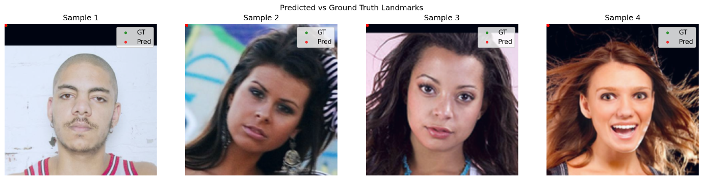
Figure 37. Qualitative examples of Predicted versus Ground-Truth LandmarkNet.

5.2 3-D reconstruction evaluation
AFLW2000-3D [10] is used to do the evaluation of the three-dimensional reconstruction stage, and the ReconstructionNet setup described in Chapter 4 is utilised. The training and validation loss, as well as the mean absolute error and root mean square error, are shown in Figure 38 throughout the course of 11 effective epochs before the early stopping point. Following the first epoch, both losses experience a significant decrease before reaching a stable state. The validation loss is closely followed by the training loss, which means that the network is converging very quickly without having severe overfitting. A mean square error (MSE) of about 1.22, a mean absolute error (MAE) of 137 pixels, and a root mean square error (RMSE) of 17 pixels on projected landmarks are the final validation metrics that are supplied by the training script. These metrics are reflective of the remaining test set.
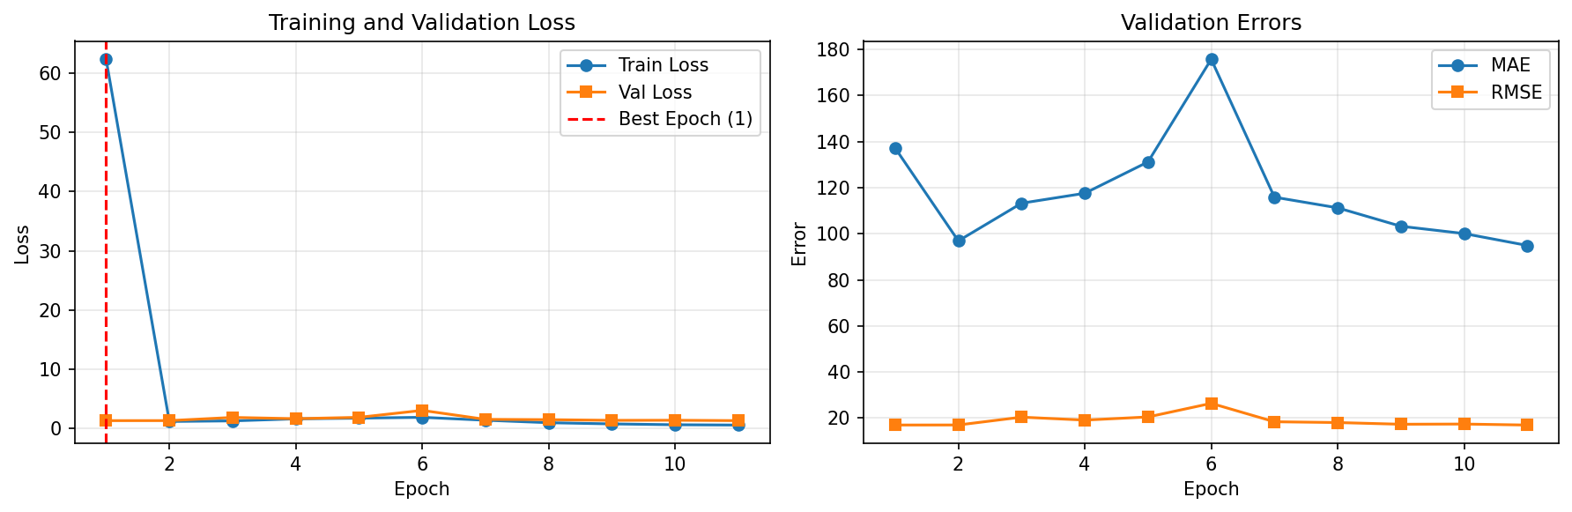
Figure 38. Reconstruction training curves for ReconstructionNet.
Detailed information on the correctness of reconstruction in parameter space may be found in Figure 39. By looking at the histogram and the cumulative distribution, we can see that the mean parameter MSE is around 1.13, and the spread is rather narrow; more than ninety per cent of the samples fall below approximately 1.35. This information is broken down according to the FLAME [8], [9] coefficient in Figure 40. The parameters from the identity-related shape reveal that there is a large amount of agreement between the ground truth and the projected distributions. On the other hand, some expression coefficients have a broader range and tiny biases, which is a reflection of the difficulties of capturing delicate emotions from a single picture.
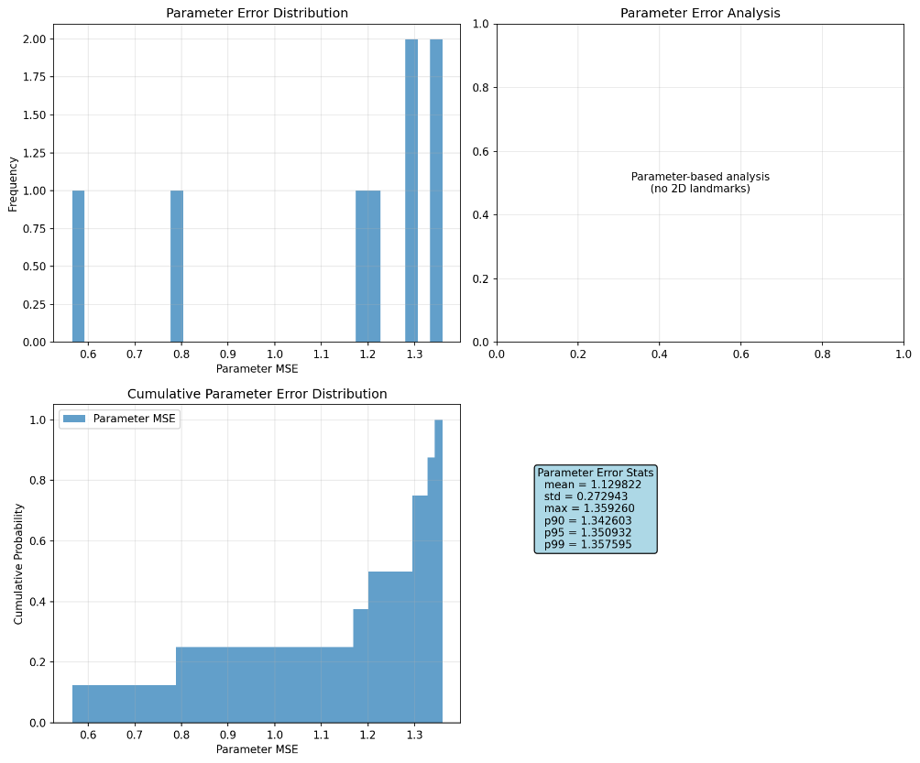
Figure 39. Three-dimensional (3-D) error analysis of the reconstruction of the vertex.
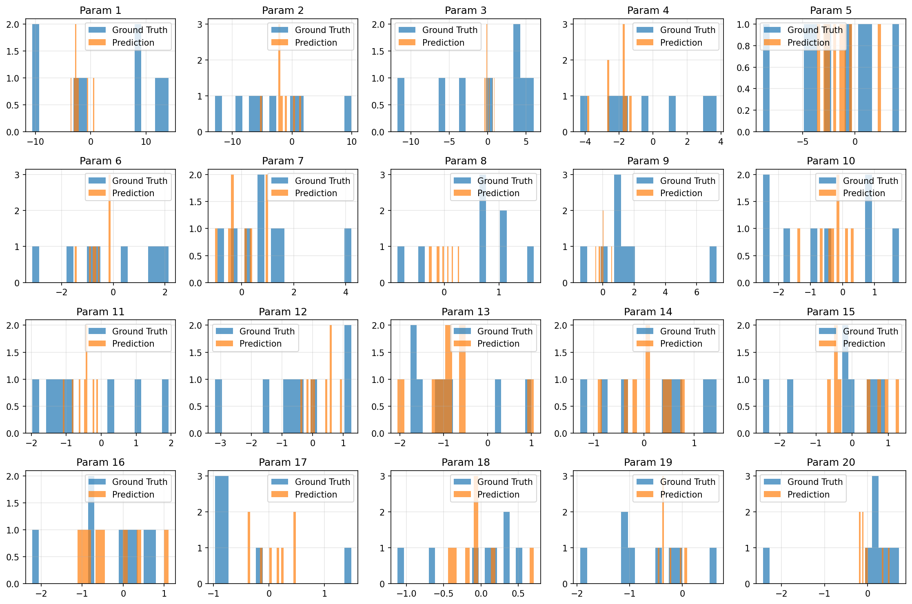
Figure 40. Distribution of FLAME parameter errors.
These data are translated into meshes by the use of qualitative examples, which may be found in Figure 41. As a result of the predicted meshes being similar to the ground truth silhouettes for well-lit faces, which are at the front, the per-pixel error maps remain black, which is an indication that there is a minimal amount of vertex displacement. The network is still able to recover the general head shape even when subjected to higher yaw angles and partial occlusions; however, it has difficulty with finer features around the jawline and the eye that is self-occluded, which results in the production of localised error bands in the heatmaps. In this case of snapshots that are of extremely poor quality or profile-like, the model may occasionally exaggerate depth or smooth out harsh face structure. This, in turn, would result in slight discrepancies in the subsequent identification process.
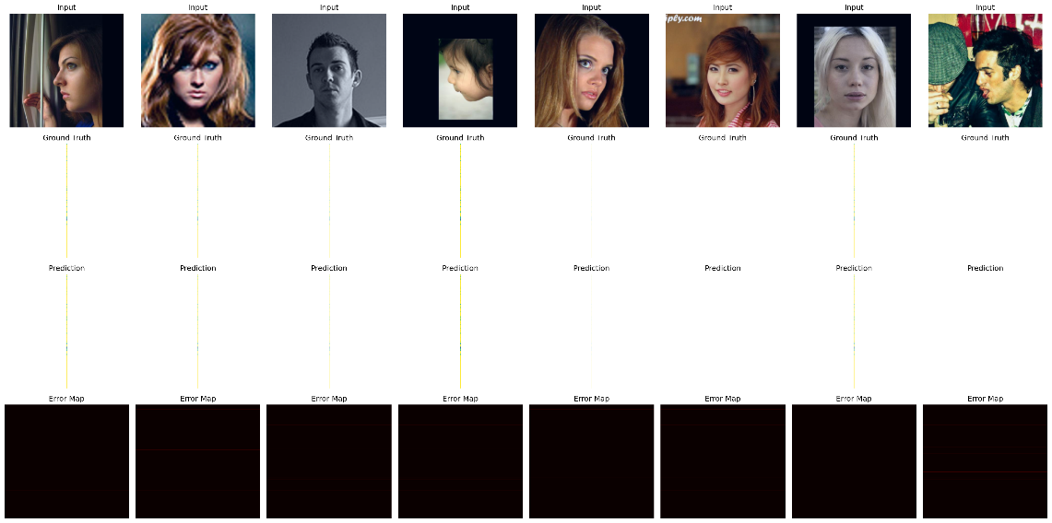
Figure 41. Qualitative three-dimensional face reconstructions.
In general, ReconstructionNet provides geometrically plausible meshes, which are accurate enough to be used for identity-preserving visualisation and to provide three-dimensional cues to the recognition and analytics components. However, it does not match the sub-millimetre precision that has been reported for heavyweight specialist three-dimensional face reconstruction models in the literature.

5.3 Facial recognition model training and analysis
The facial recognition stage has the RecognitionNet configuration described in Chapter 4, trained on 530 FaceScrub [11] identities. Figure 42 plots training and validation loss together with validation accuracy, F1 score, precision, recall and AUC-ROC over the epochs. Loss declines rapidly over the first three epochs and then levels off, while metrics for validation data stabilise at the accuracy and macro-F1 of approximately 0.36 and an AUC-ROC of approximately 0.93. The relatively small accuracy is to be expected given the 530-way classification problem, whereas the consistently high AUC-ROC shows that the embedding is even when the top 1 identity prediction is wrong.
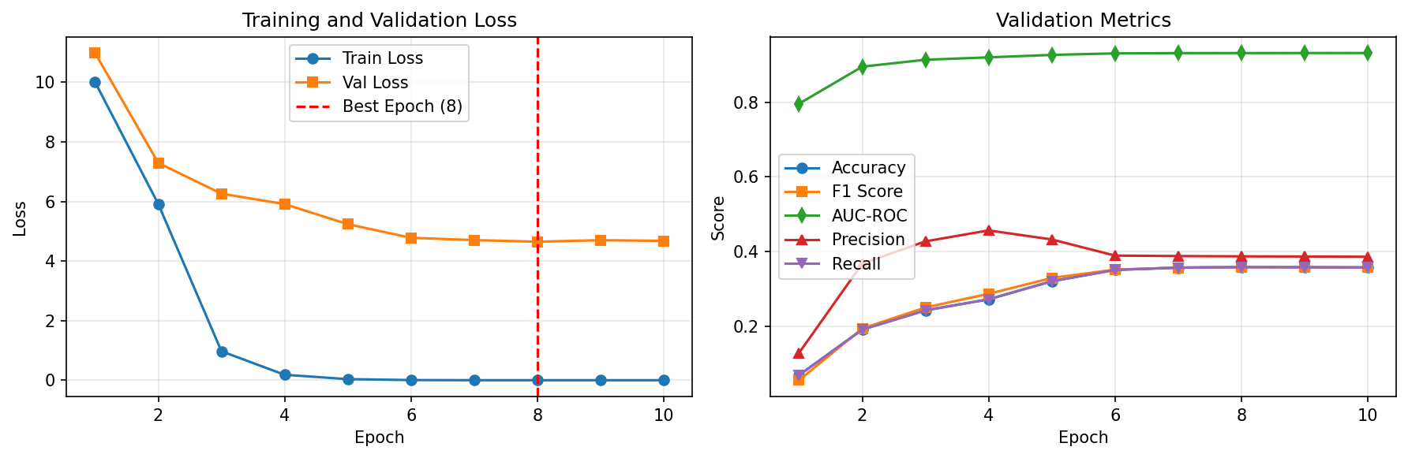
Figure 42. Identification training and validation curves.
Figure 43 shows the normalised confusion matrix on the test set. Most mass is along the diagonal and there is a noticeable spread reflecting frequent confusions between visually similar actors as well as between identities for which there are limited training examples. This is in line with the aggregate test metrics: accuracy = 0.35, and F1 = 0.35. The per-class ROC curves in Figure 44 further emphasise the fact that many identities have per-class AUCs above 0.9, with the macro-average AUC is about 0.91. When reformulated as pairwise verification, the overall ROC in Figure 45 exhibits an area under the curve (AUC) of approximately 0.84 and an equal error rate (EER) of approximately 0.26, which demonstrates that the cosine-similarity embedding is usable for open-set search, but not at the forensic thresholds.
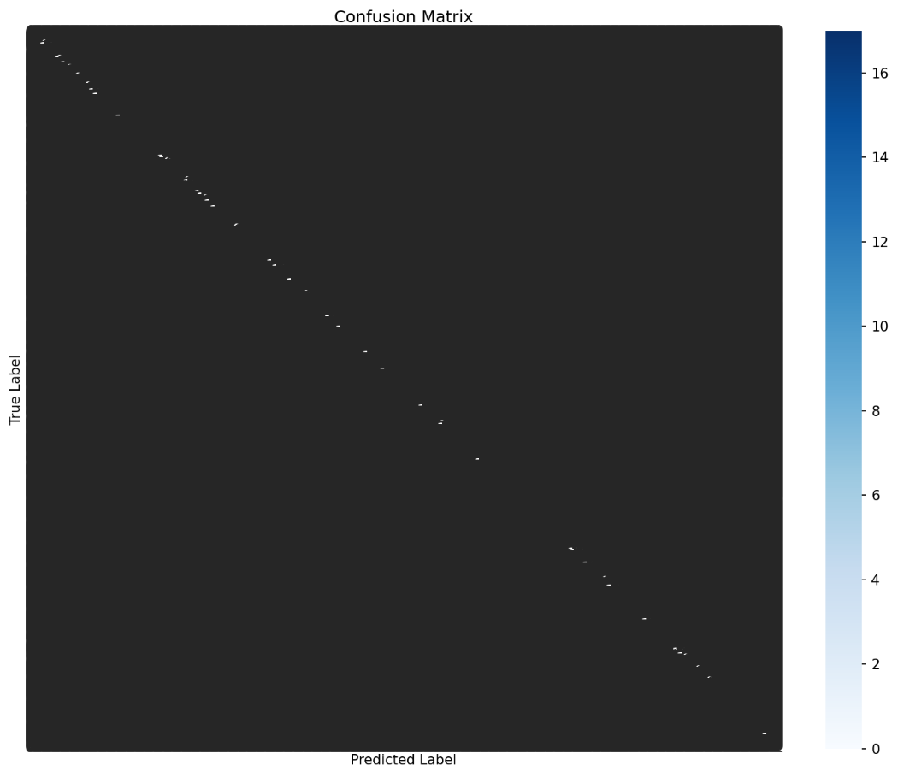
Figure 43. The confusion matrix with 530 identities.
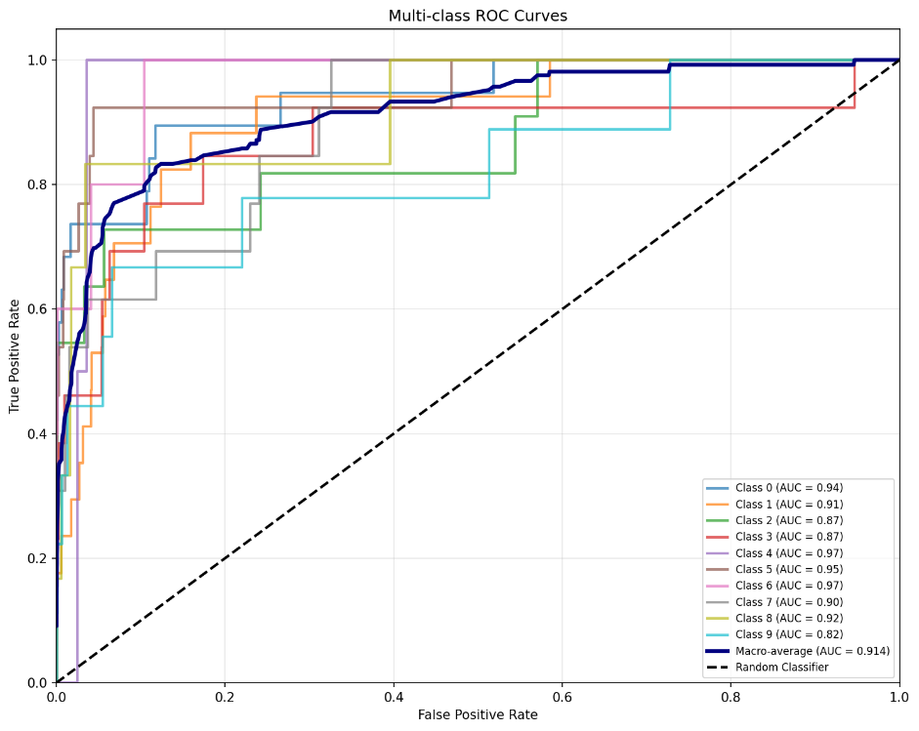
Figure 44. Multi-class ROC curves of RecognitionNet.
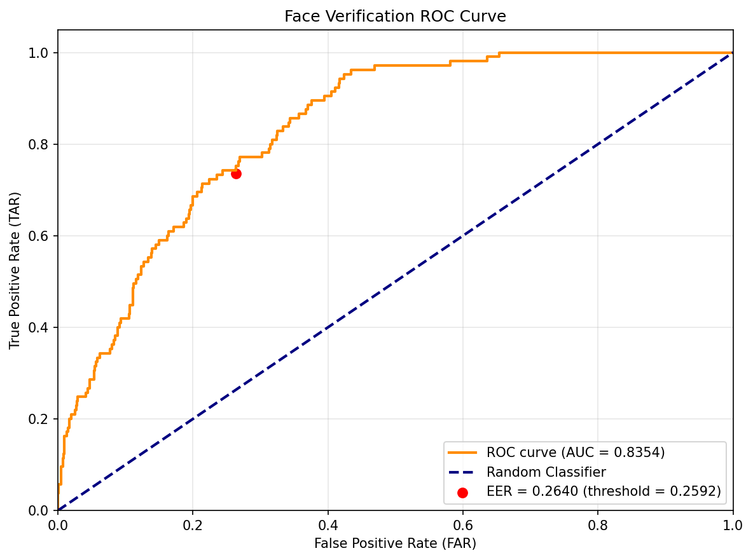
Figure 45. Checking ROC of cosine-similarity embedding for RecognitionNet.
The learned embedding is visualised with the help of UMAP and t-SNE in Figures 46 and 47. Both plots have very apparent local clustering of samples of the same identity, but clusters are often very close together or are partially overlapping, and again, this would explain the drop from high ROC to modest top 1 accuracy on a large identity set. There is no definite separation by gender or pose, indicating that the network is not only dominated by these nuisance factors.
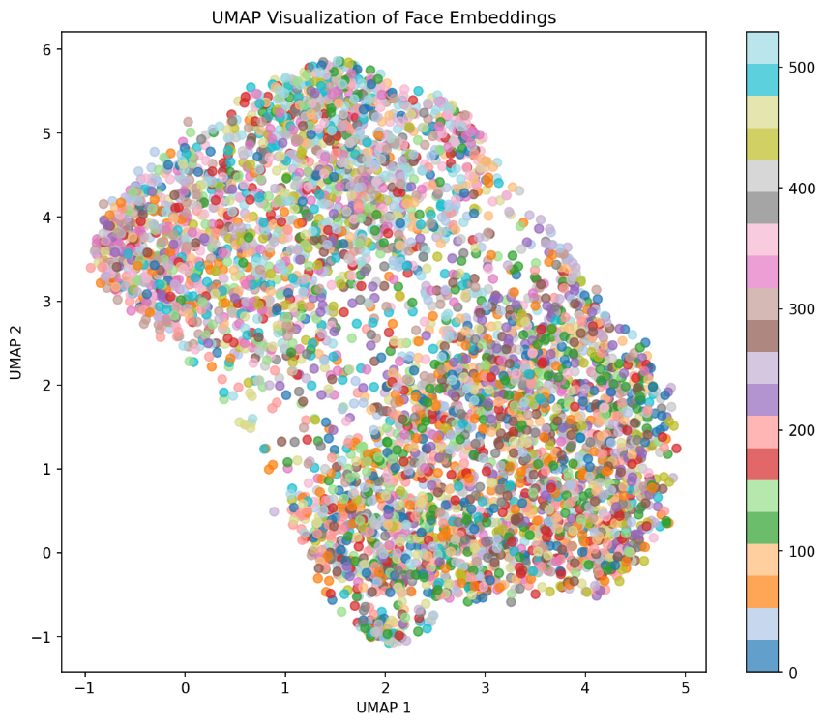
Figure 46. Embedding recognition in a UMAP visualisation
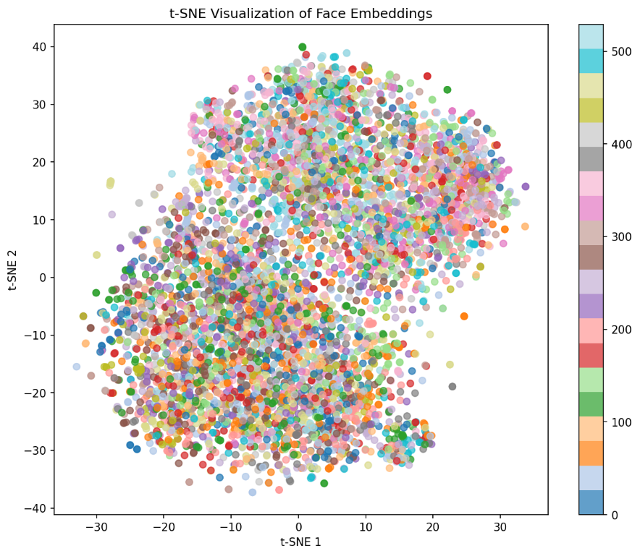
Figure 47. Embedding recognition t-SNE visualisation
Interpretability analyses focus on the regions causing the model to make its decisions. Figure 48 superimposes Grad-CAM heatmaps on misclassified images; activations in misclassified images are localised around areas of the periocular, nose and mouth, with the background and hair playing a smaller role. This is measured by region-based occlusion, as in Figure 49: when the eye region is occluding, the result, in terms of average confidence drop, is the greatest; when cheeks or chin are occluding, it only makes a small difference. Finally, Figure 50 reports robustness under synthetic CCTV degradations (blur, noise, compression and occlusion). The precision deteriorates to 0.30 on clean images, with almost zero on all perturbations, displaying a harsh disparity in the domain between FaceScrub and realistic CCTV images.
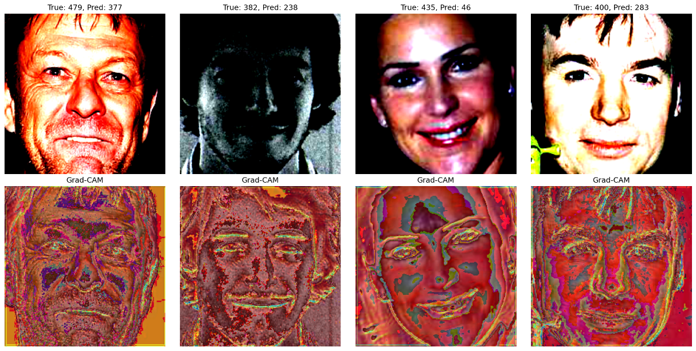
Figure 48. Grad-CAM visualisation of false-classification.
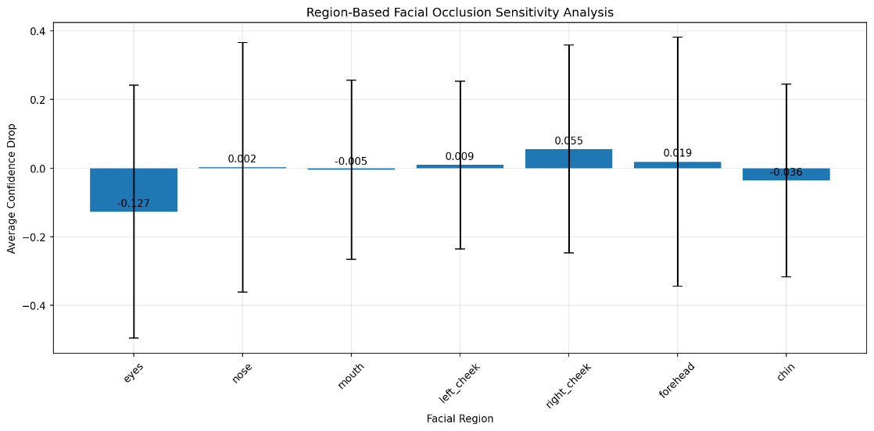
Figure 49. Regional sensitivity to facial occlusion.
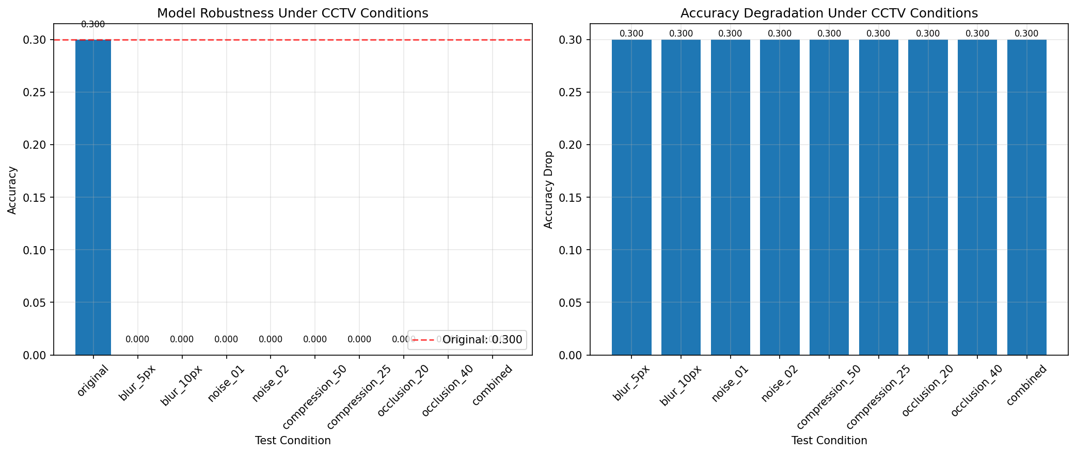
Figure 50. Strength in the presence of CCTV-like degradations.
Altogether, RecognitionNet can learn a fairly good identity embedding with good ROC properties and interpretative emphasis on areas of interest to recognition, yet it is fragile to poor CCTV requirements, suggesting that domain-specialised fine-tuning and less heterogeneous, surveillance-style training images are required.

5.4 Comparison with Buffalo baseline
In order to be able to compare the custom RecognitionNet embeddings to an off-the-shelf baseline, the Buffalo [103] embeddings of InsightFace were tested on the same 530 identity FaceScrub [11] split (Figure 51). The diagnose_embeddings.py and comprehensive comparison scripts were used to analyse both of the feature sets (Figures 52, 53, 54, and 55). Figure 55 reports the console summary, indicating that the largest accuracy of a K-NN classifier on RecognitionNet embeddings is 65.2, whereas the largest accuracy of Buffalo is 14.3. L2-normalisation slightly improves both, but preserves a gap of more than 50 percentage points in favour of the custom model. An analysis of per-class allows per-identity accuracy to be reported as 0.68 + -0.17 (RecognitionNet) and 0.18+/-0.18 (Buffalo) on average.
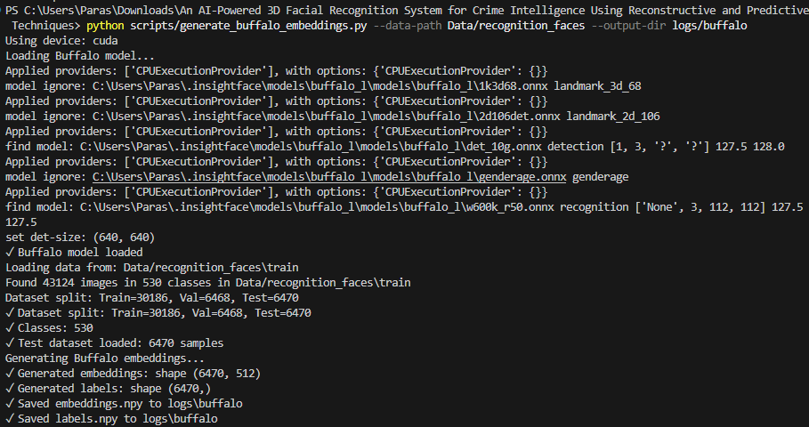
Figure 51. Buffalo [103] embeddings on FaceScrub generated.
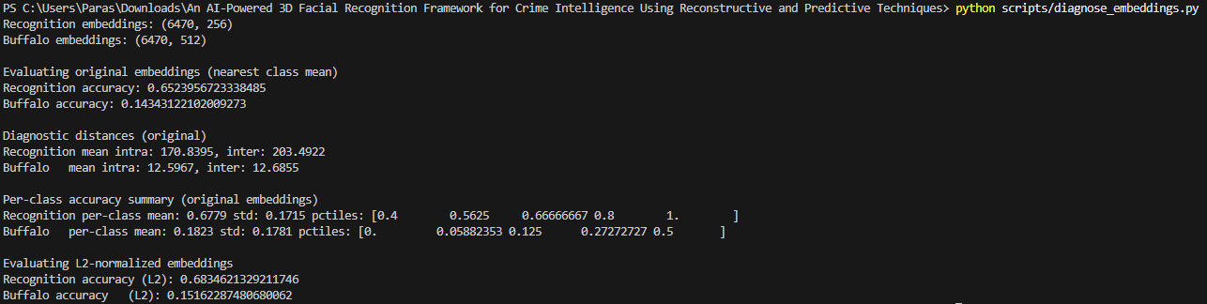
Figure 52. A diagnostic test for all three models embedded, K-NN, RecognitionNet, Buffalo [103].
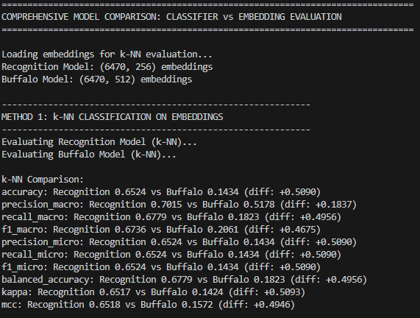
Figure 53. Comprehensive model comparison: Classifier vs. Embedding evaluation.
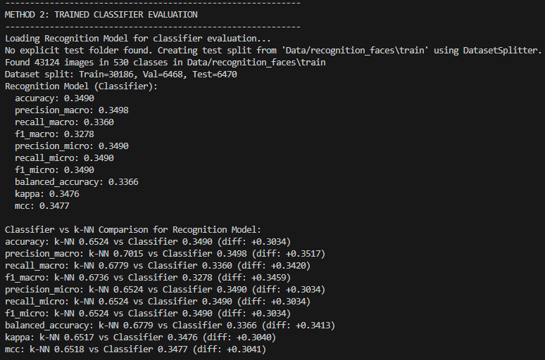
Figure 54. Comprehensive comparison method two.
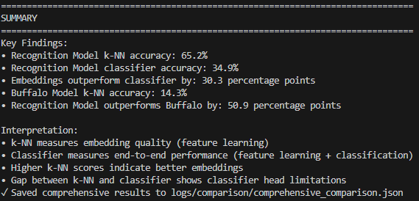
Figure 55. Summary of comprehensive comparison.
In Figures 56, 57, and 58, it can be seen that the k-NN confusion matrices of RecognitionNet, Buffalo, and the difference are represented. They both exhibit a heavy main diagonal, but Buffalo [103] exhibits a much heavier off-diagonal tail, and this confirms that many identities are being effectively collapsed in its embedding space on this dataset. This is supported by per-class histograms (Figures 59, 60, and 61): the custom model has a large mode with easy-class accuracy of about 1.0, but the distribution of Buffalo [103] is centred around zero with a few identities which can reliably be recognised.
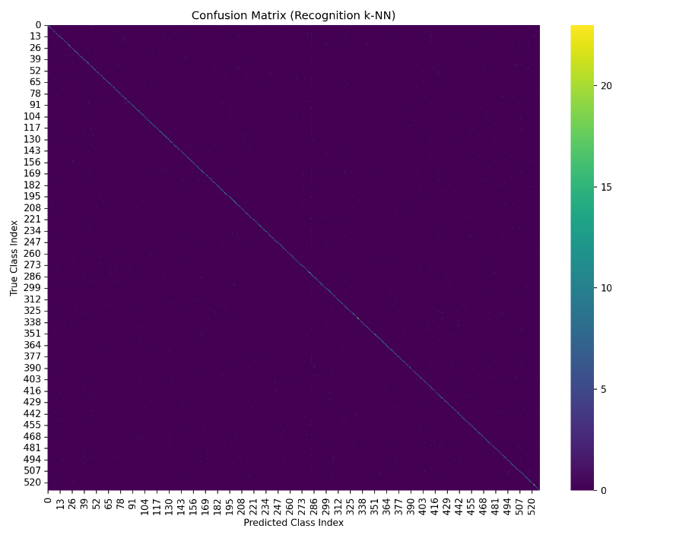
Figure 56. Confusion matrix of RecognitionNet embeddings (k-NN).
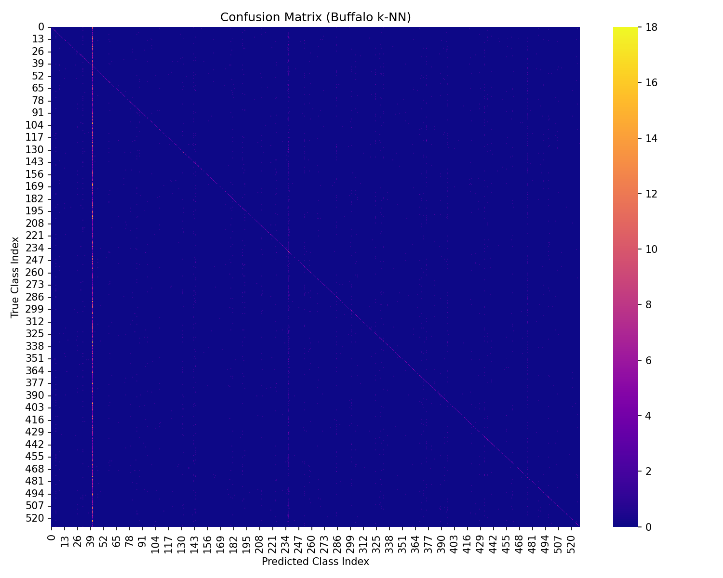
Figure 57. Confusion matrix of k-NN Buffalo [103] embeddings.
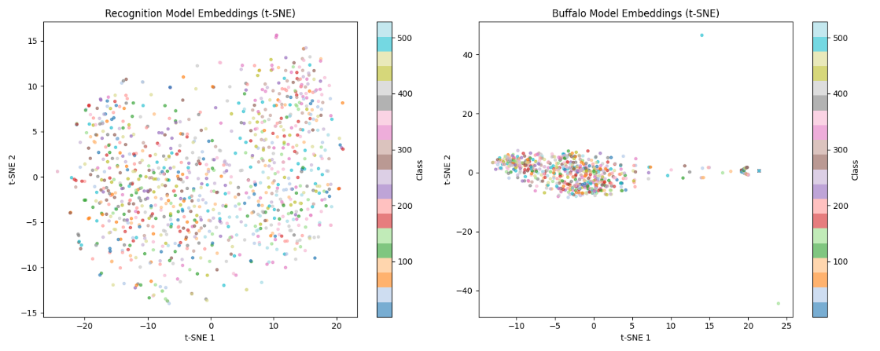
Figure 58. Confusion matrix of difference/overlay that shows the classes in which RecognitionNet is more effective than Buffalo [103].
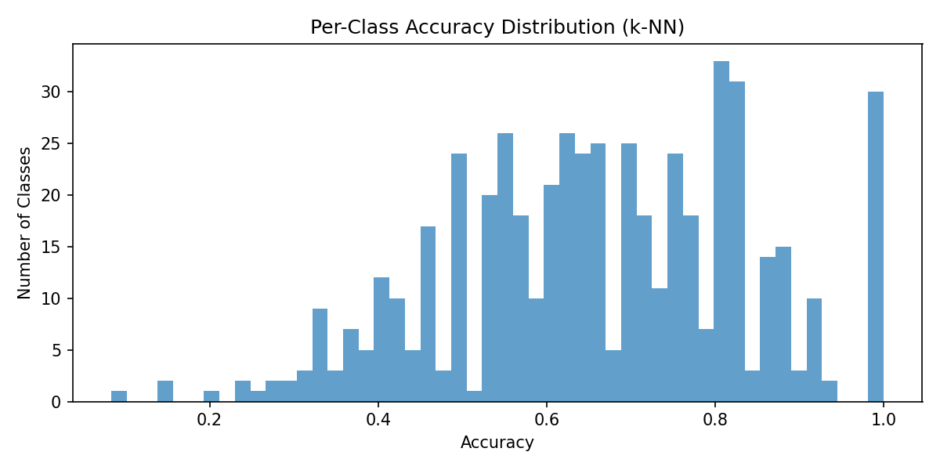
Figure 59. Per-class accuracy histogram Recognition embeddings with the k-NN classifier.
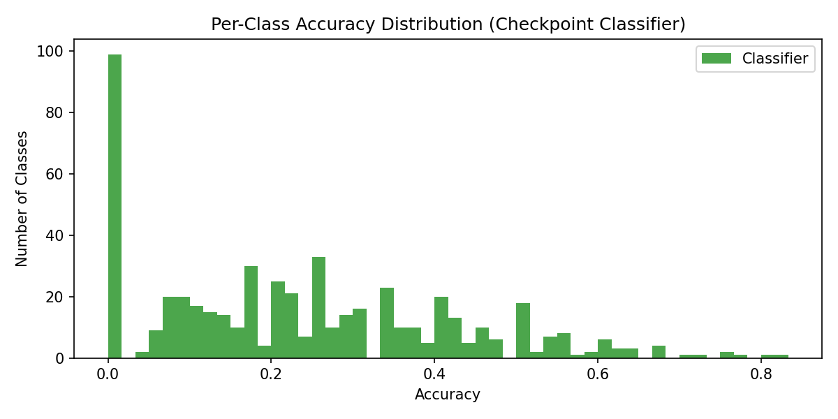
Figure 60. Accuracy per-class histogram of Buffalo [103] embeddings.
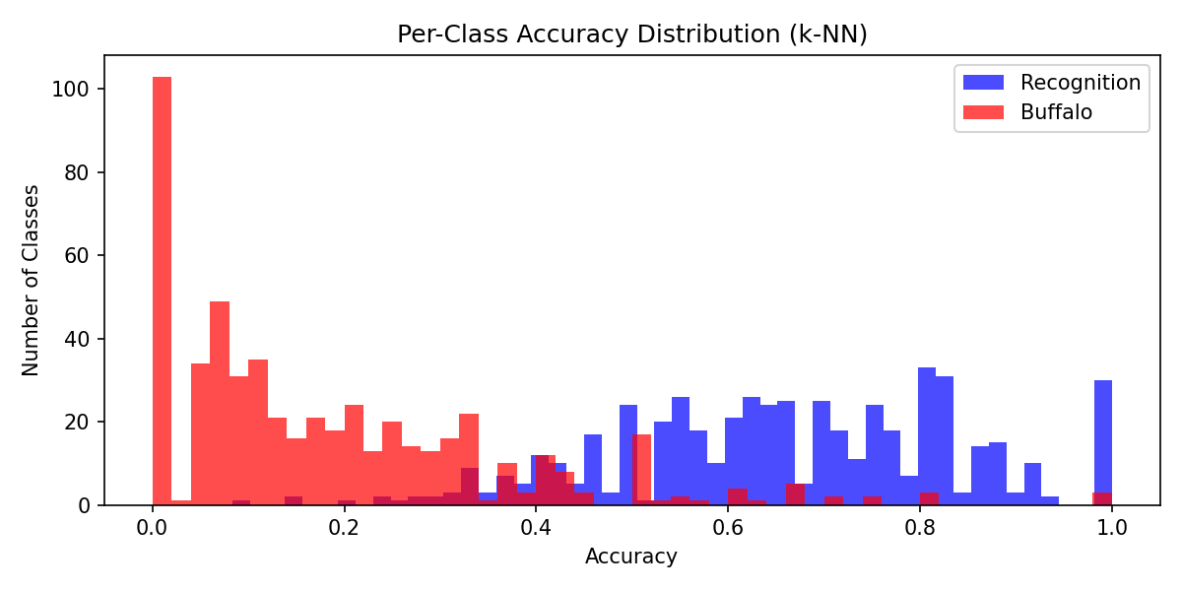
Figure 61. Histogram of per-class accuracy differences (RecognitionNet – Buffalo [103]).
The embedding spaces in UMAP (Figures 62, 63, 64, and 65) demonstrate that RecognitionNet acquires tight clusters that have identity-congruent clusters, but a few are fragmented among actors with a huge pose or light change. Buffalo’s [103] space is smoother and more globally regular, but clusters are less clearly separated, and the attribute overlays (e.g. age and gender) suggest that it tends to group faces by coarse appearance, rather than the 530 task identities. This behaviour can be qualitatively represented in form of visual summary panels on typical successes and failures (Figures 66, and 67): Buffalo occasionally takes broad demographic resemblance and misses the particular actor, whereas RecognitionNet pays more attention to identity-specific structure.
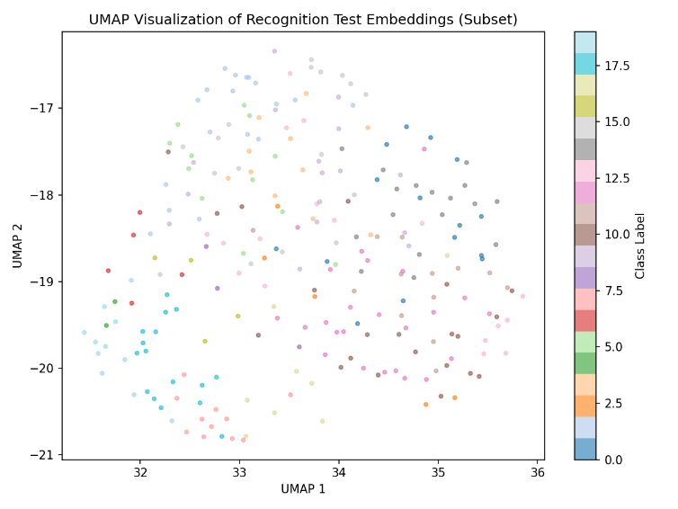
Figure 62. UMAP embedding RecognitionNet identity-coloured.
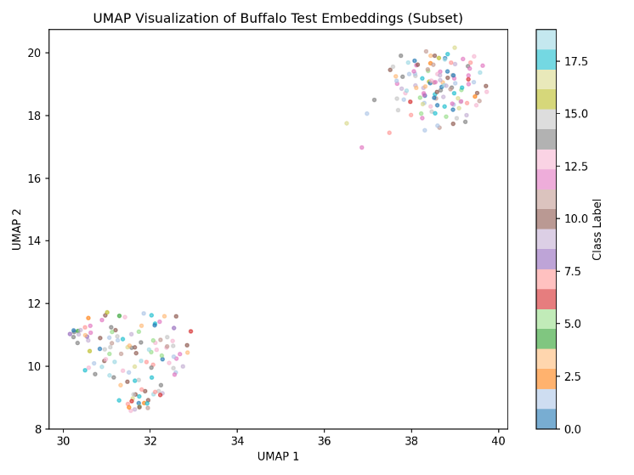
Figure 63. Embeddings of Buffalo [103] with UMAP projection coloured by identity.
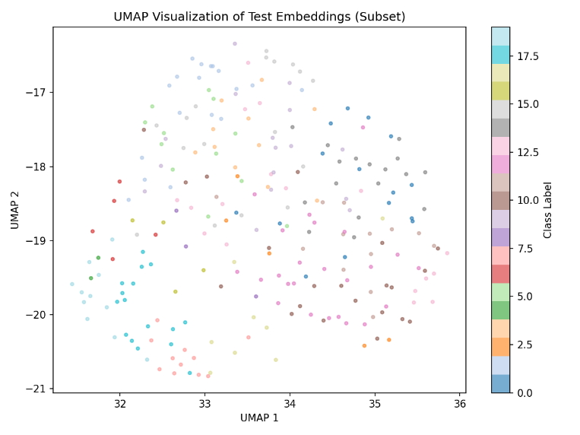
Figure 64. Course attribute overlay UMAP projection (first version).
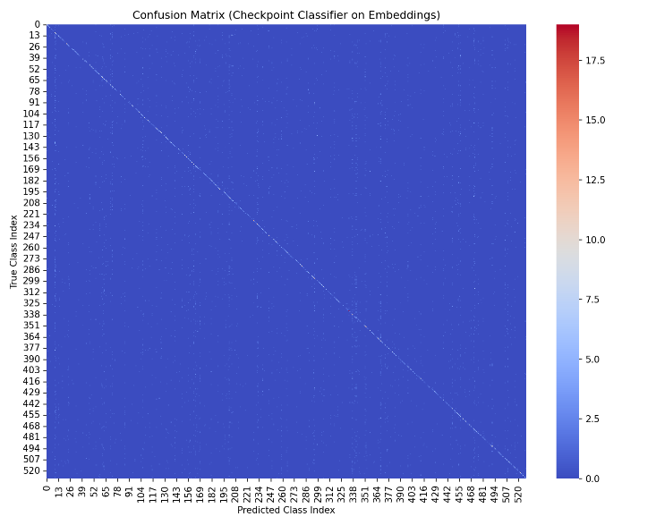
Figure 65. Additional attribute-style plot/diagnostic plot.
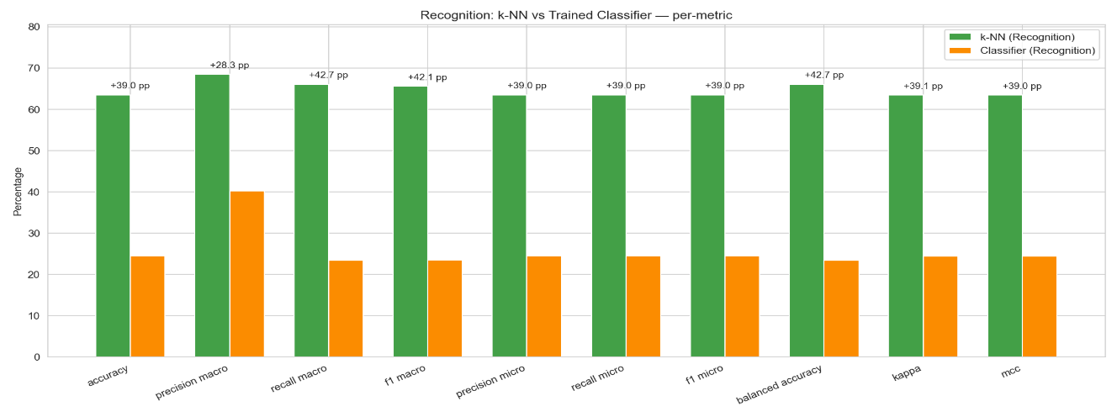
Figure 66. Graphical overview of identities that are rightly identified by each model.
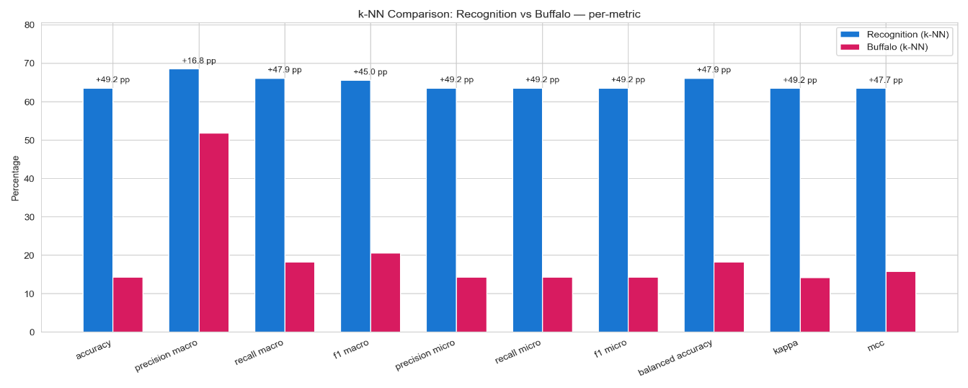
Figure 67. Tests a visual summary of identities identified by RecognitionNet but commonly confused by Buffalo [103].
In general, the experiments indicate that with this limited resource crime-intelligence data, a small cross-entropy trained RecognitionNet demonstrate significantly higher identity discrimination than the hefty weight Buffalo [103] baseline. Considering the greater accuracy, reduced pipeline integration and reduced legal/operational dependencies, the complexity of state-of-the-art generic embeddings is hard to pay off for this prototype, but Buffalo is appealing when large-scale open-set retrieval is needed.

5.5 Crime forecasting and object detection results
The crime-forecasting part extends the Prophet model set up in Chapter 4, to learn a national daily time-series based on the UK crime [12] parquet corpus. The command-line execution of “backend.analytics.predict”, including ETL of approximately 1,500 monthly CSVs, aggregation to 1,096 daily records and automatic logging of MAE, RMSE, and MAPE on a held-out moth show in Figure 31. The same run generates 30 and 365-day forecasts where the average national demand is around 17,000 crimes/day, and the uncertainty bands are pretty tight. Figure 68 separates the fitted model into trend, weekly and yearly components, which shows a mid-week peak, as well as an obvious seasonal structure. Figure 69, however, draws a forecast curve of the result, which may be surfaced via the /aggregated-trend and /lsoa-series endpoints to drive dashboard components in the web frontend.
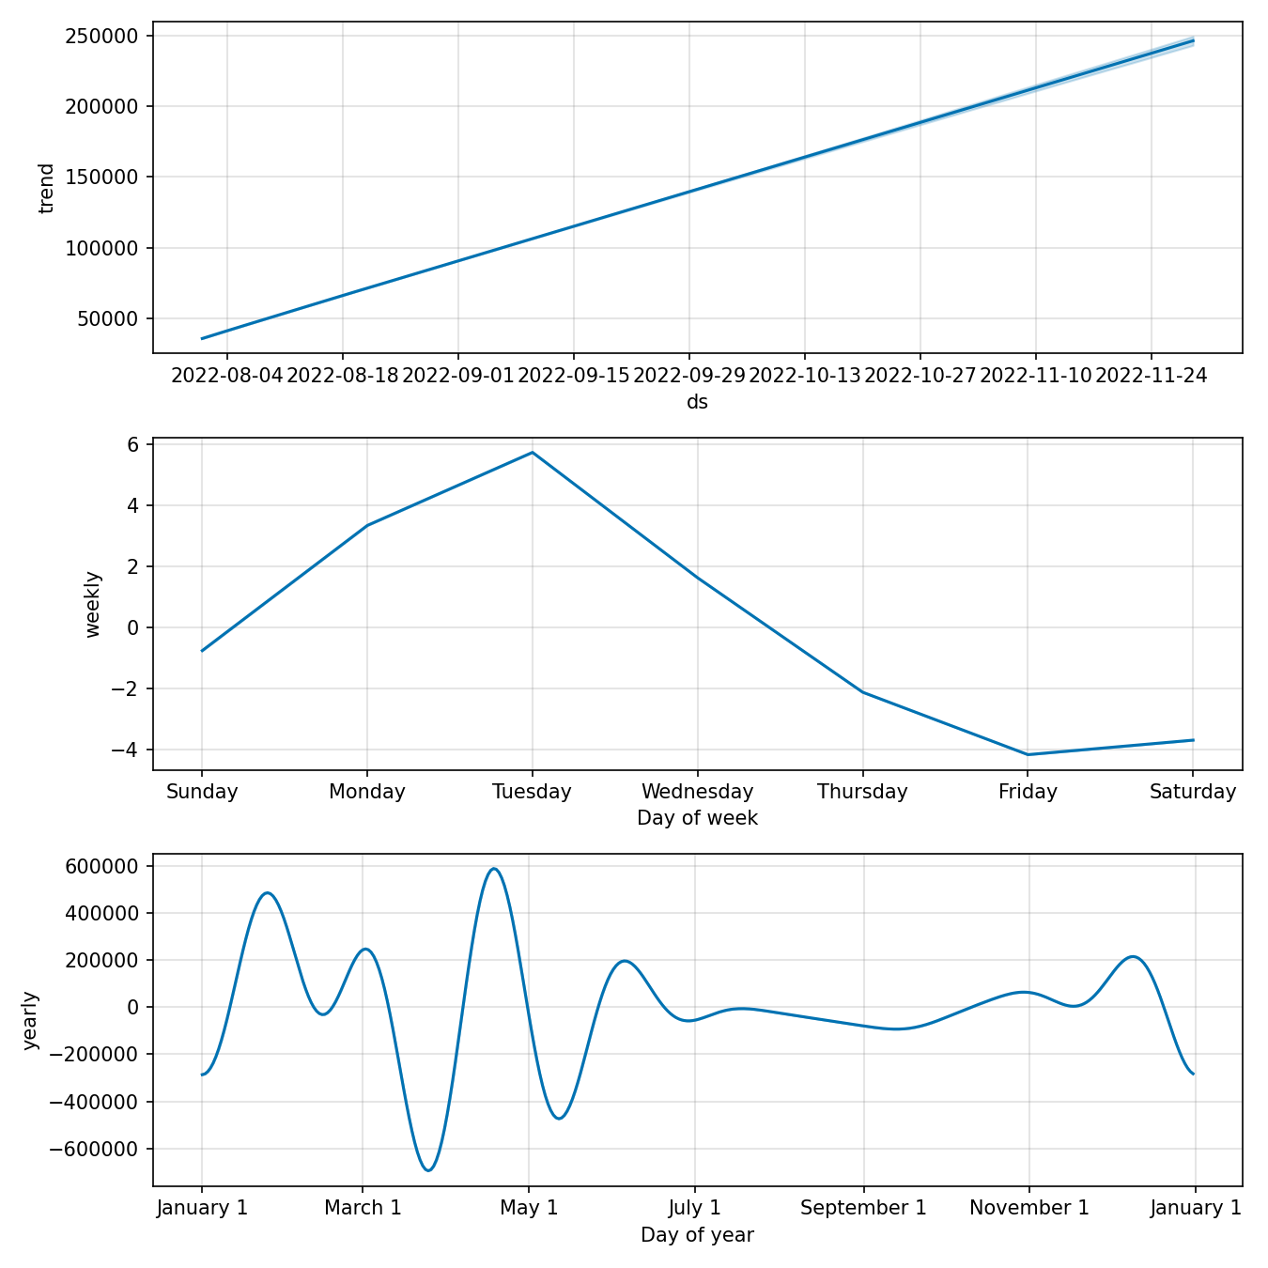
Figure 68. Prophet component plots (trend, weekly seasonality and yearly seasonality) for national daily crime counts.
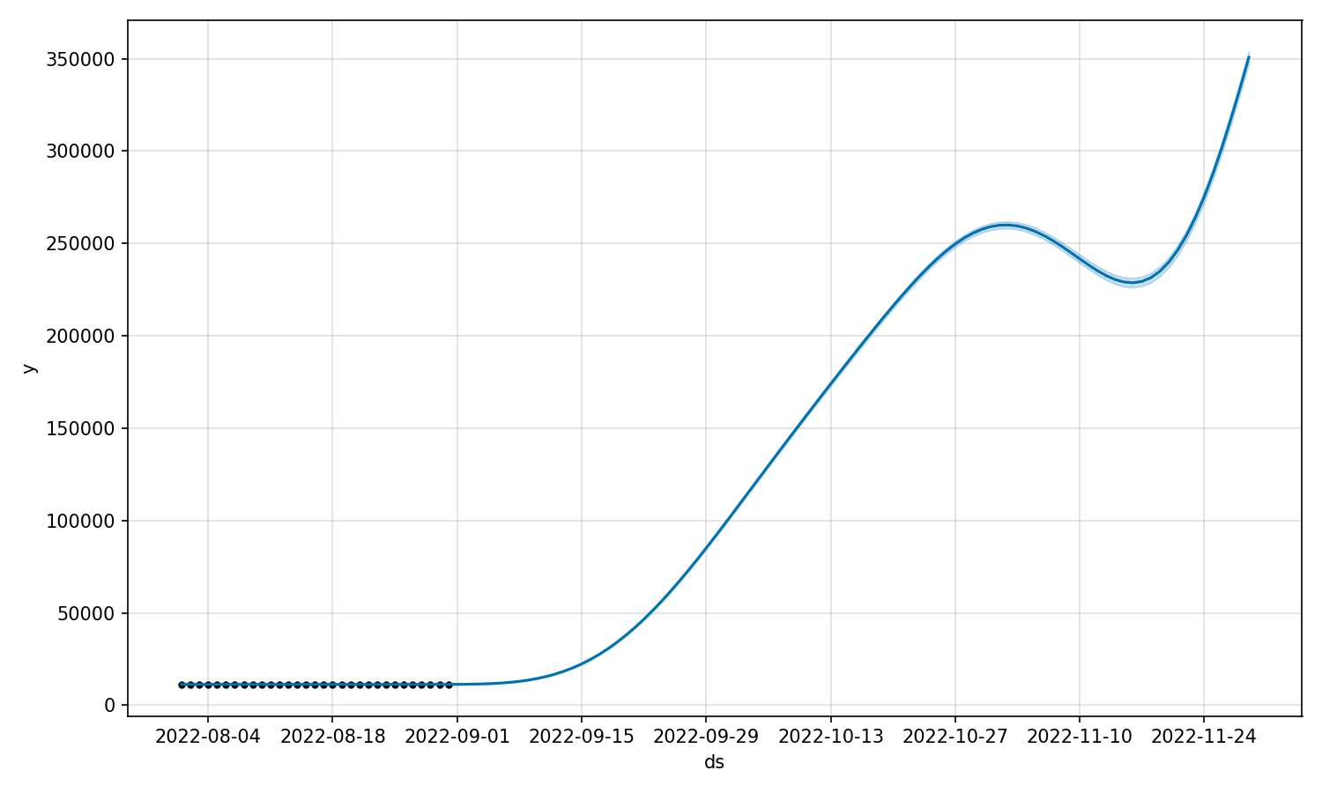
Figure 69. The Prophet project to predict the number of crimes each day nationally with a 30-365 day horizon with uncertainty bands around the predicted trend.
The performance of object detection is evaluated with the help of the “scripts/test_yolo_integration.py”, which executes YOLOv8 [47], [104] as a fixed detector on the frames of 640x640 CCTV. Figure 70 shows the result of running a single person, confidence = 0.6, no weapons and end-to-end latency of about 140-150ms/frame (pre/post-processing and inference), which is good enough to perform near-real-time triage on one GPU. Person detection in qualitative tests is also very strong; however, small or heavily covered weapons are often missed, meaning the current setup will be more useful in cueing analytics to possibly relevant frames as opposed to full automated weapons tracking.
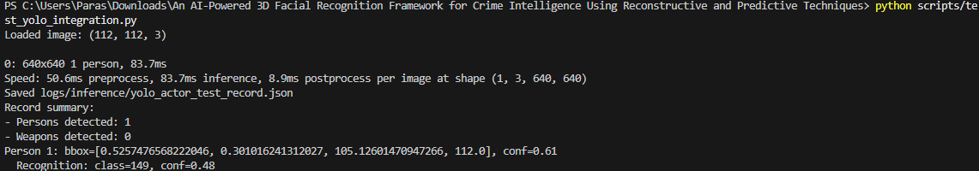
Figure 70. YOLOv8s [47], [104] integration test result showing a sample CCTV frame containing a single individual, self-reported latency (pre-processing, post-processing and interpretation), and the result of recognition (identity classification and confidence).

6. Crime Intelligence Analytics and End-to-End Case Study

6.1 Exploratory crime analytics
The crime-analytics layer is placed on top of the national parquet dataset (size of 17.6M records, 43 forces, 37887 LSOAs) and provides pre-aggregated views on the /lsoa-series and /aggregated-trends endpoints. The analytics home page provides an overview of the dataset coverage and allows an analyst to initiate or refresh such aggregates in the user interface (Figure 71). Upon a context being established, the dashboard will render a national heatmap with Prophet forecasts of expected incidents each day overlaid onto it, as well as a live alert panel filled with the outputs of the facial-recognition pipeline (Figure 72).
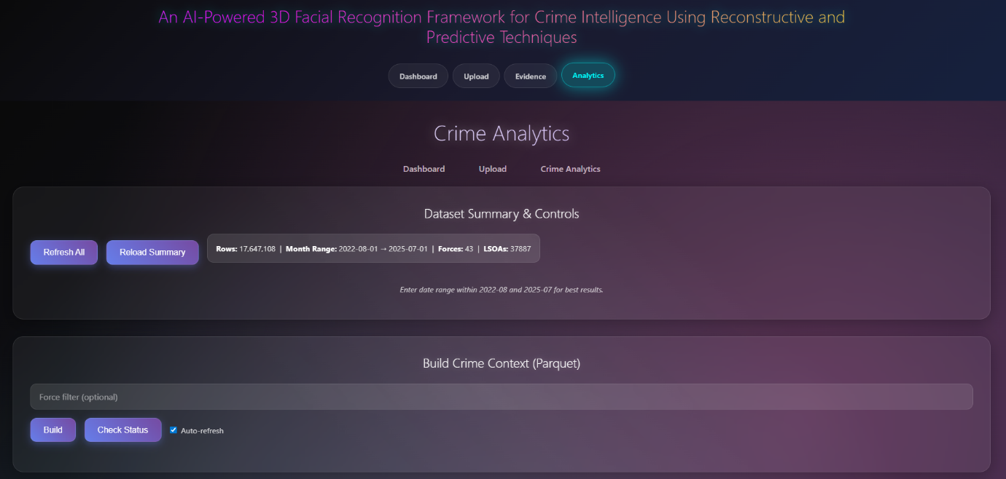
Figure 71. Landing page of crime analytics with information summary and controls.
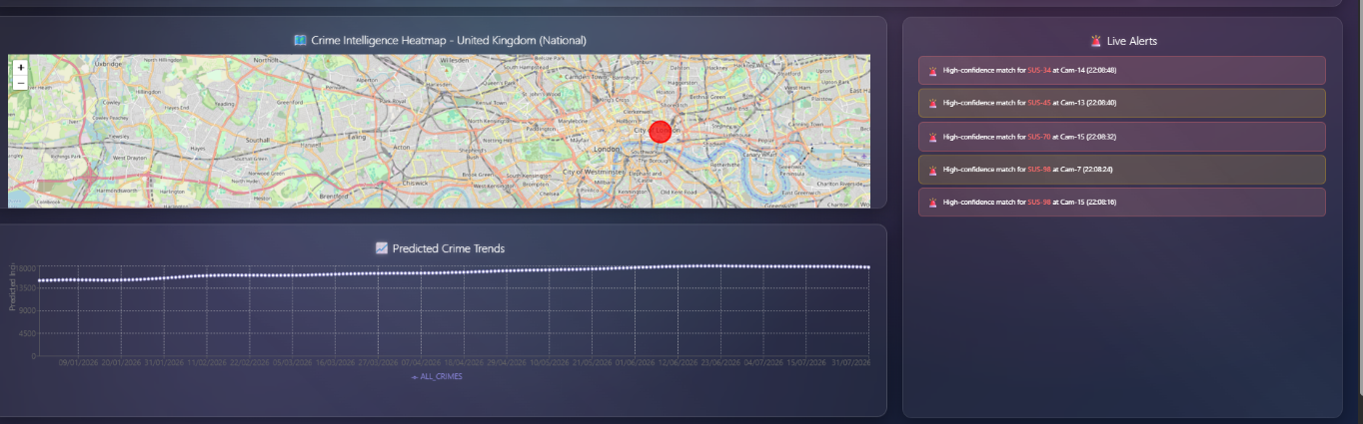
Figure 72. Live crime and intelligence alerts, trends and heatmap.
At the force level, the Monthly Trends by Force view shows a time-trend plot of the data in multi-series, allowing the user to filter by data range, enable one or more constabularies and generate briefing packs in CSV/PNG snapshots (Figure 73). This is based on /aggregated-trends to give monthly counts of forces and types of crimes.

Figure 73. Crime patterns according to the police force, monthly.
In more detail, the Hotspots + LSOA Time Series page (Figure 74) is a mix of /lsoa-series, a small-multiplex bar chart and a map. To a chosen force, the system exposes the current top N LSOAs by volume, draws the short-time varying paths of these maps and puts them on an interactive OpenStreetMap basemap. Combined, these opinions demonstrate that the artefact is capable of transforming raw incident records into viewable, navigable forms, such as highlighting the same hotspots, seasonal peaks and outliers LSOAs that are worth exploring further.

Figure 74. SOA hotspots bar chart and map with a time series of force-level.

6.2 End-to-end pipeline case study
The web application is structured in such a way that an officer will be able to transition between CCTV evidence and crime-intelligence insights within one workflow. It is restricted with the help of the Officer Login screen (Figure 75), and the user is redirected to the Investigator Dashboard (Figure 76). This page reveals the supervision of the building watchlist, running recognition assessments, and reconstruction evaluations, as well as crime-context building over the parquet data. The high-confidence watchlist matches are shown as a live alerts panel on the right, which is received by the backend (Figure 77).
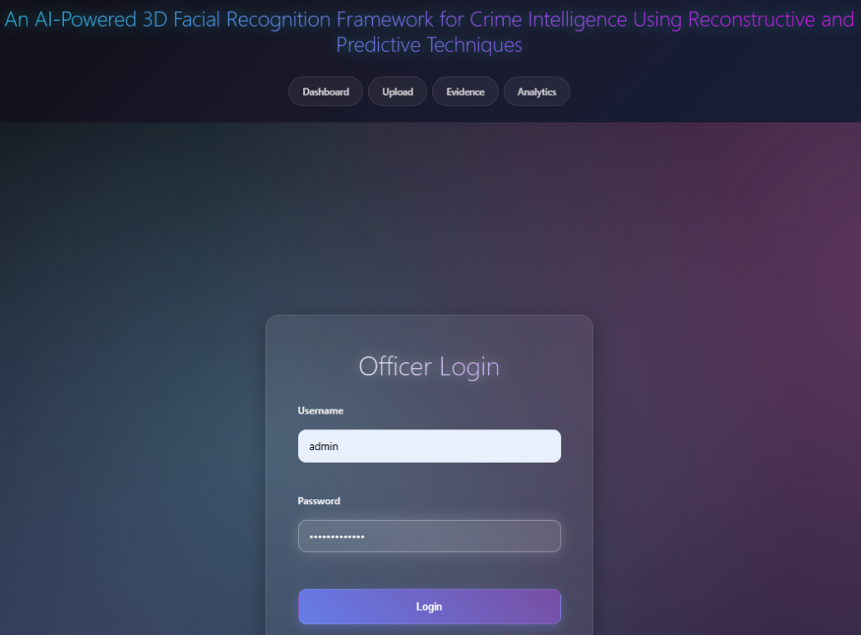
Figure 75. Secure login access to the officers.

Figure 76. Admin controls and evaluation tools on investigator dashboard.

Figure 77. Live face-recognition alert display on the dashboard.
An example of case begins with the Upload page (Figure 78). An operator posts a CCTV frame/still, the agent at the endpoints of the backend sends YOLO [47], [104] to detect persons and weaponry, face crops, calls LandmarkNET, ReconstructioNet, and RecognitionNet and adds to the database a structured event record (camera ID, timestamp, geo-context, weapon flags, identity scores, and 3-D descriptions). The integrated visual analysis on the same page presents results of input image, recognition decision, confidence scores, 3-D mesh views and a summary of YOLO detections (Figure 79). Here, the officer is able to create an automated investigation report that contains the bounding boxes, similarity scores, and reconstruction thumbnails of the case files.

Figure 78. Interface of upload facial recognition (input and recognition results).
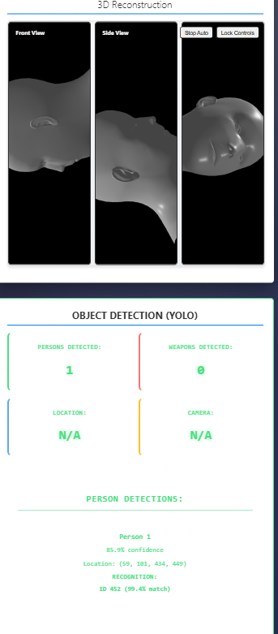
Figure 79. The panel of 3-D reconstruction along with YOLO [47], [104]] object-detection.

Once the events have been accumulated, the Evidence Management Centre (Figure 80) allows reviewing the stored analyses, checking the integrity of files and re-opening the individual cases. Concurrently, the Analytics tab updates the crime-context displays in the preceding Section 6.1 such that the same identities are displayed in CCTV live alerts on the national heatmap and time-trends displays. This means that an analyst can think both vertically (drilling into the appearances of one subject on different cameras) and horizontally (placing the subject in the broader crime patterns).

Figure 80. Evidence uploads and management centre.

6.3 Implication for intelligence-led policing
Theoretically, a unified facial, weapon-detection and crime-trend system would allow focused deployments, focusing on the highest harm suspects, emphasising hotspots of increasing concern and giving additional information to underpin an investigation decision. Nevertheless, this integration also increases risks: any mistake in recognition or unfairly trained data may enter directly into the queue of warnings and predictive maps, which will support the current trends in over-policing. The use of any model would then be subject to very stringent governance, openness regarding model constraints, human-in-loop review, and crime-trend outputs would be seen as one of the many sources of information rather than a set of commands.

7. Assessment of Governance, Ethics and DPIA

7.1 Legal and regulatory context
Facial recognition by police in the UK [12] has been at the boundary between GDPR special category biometric data and the law enforcement directive, as adopted in the Data Protection Act 2018 Part 3. Any practise of deployment should thus achieve high standards of necessity, proportionality and lawfulness as noted in the recent case law regarding live facial recognition. It practically translates to narrowing down the policing rationale (e.g. finding named suspects), proving that less invasive solutions are ineffective, and downplaying retention, functional creep and information dissemination [105].
In this project, the system is clearly established as a pure research prototype on the basis of publicly available benchmark data with no relation to actual operational systems. The pipeline, however, is structured in a way that it would be placed in a DPIA-led system of governance. It would require a complete DPIA to be undertaken by a Data Protection Officer, consultation of stakeholders who will be impacted, a comprehensive retention and deletion schedule, and a description of a legal basis (e.g., the processing regime of the law enforcement, with a specific set of statutory powers justifying it). The simulated DPIA workflow depicted in Figures 83 and 84 is supposed to demonstrate how such assessments might be integrated into the technical stack and not just processed as paperwork.

7.2 Built-in safeguards in design
A number of security measures are incorporated to promote the principle of privacy-by-design, although the system does not interact with actual suspects. The backend uses role-based access control (RBAC), which differentiates between administrative users and analyst-only users, and presumes that evidence, embeddings and crime-context parquet files are encrypted with the envelope encryption of AES-256-GCM with key material held outside. Every operation with high risk, such as logins, watchlist updates, analysis, etc., is logged to hash-chained audit logs, and so any attempt to change them would be visually detected [106]. Such mechanisms are exposed in the simulated DPIA test in Figures 83 and 84, and, with encryption, the audit log and RBAC are automatically validated, prior to an assessment being granted for approval.
Fairness monitoring is considered a first-class signal of governance, but an experiment. A special script (bias_from_images.py) reruns RecognitionNet on the whole FaceScrub [11] dataset on periodical basis, and computes disaggregated block-by-block performance results. The pipeline is loaded with 43,147 images as shown in Figure 81 and makes predictions, and the bias report is summarised in Figure 82: a minor difference between the male and female groups results in a bias score of 0.0051, which is slightly above the illustrative 0.005 threshold and is therefore classed as acceptable fairness, monitoring. The resulting bias score is, in turn, fed into the automated DPIA tool and folded into the risk computation with the other parameters of the algorithm, including inaccurate matches and creep of the functionality (Figures 83 and 84). The same pattern can be generalised in a real system to other characteristics that are protected, and the reconsideration of the DPIA can be automatically re-examined once a policy limit is exceeded by bias variations.
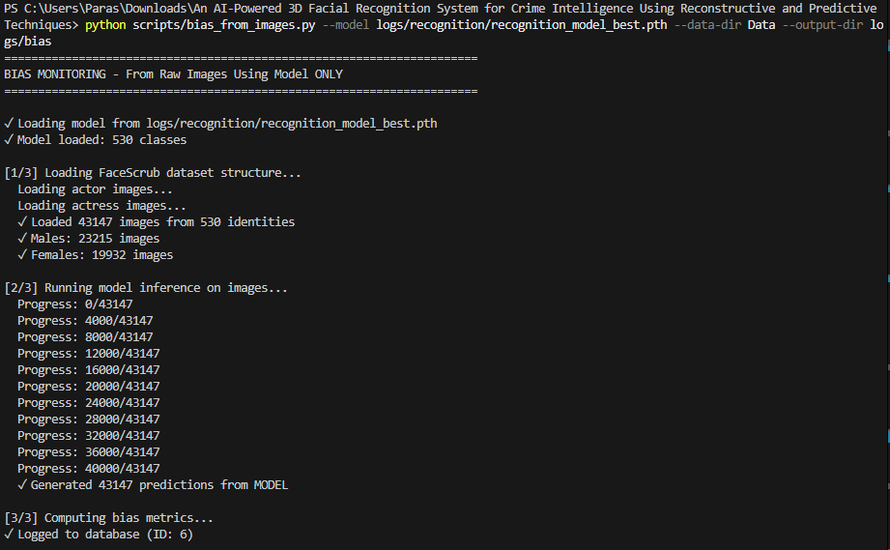
Figure 81. Prejudice tracking pipeline on FaceScrub over RecognitionNet. Output in all command line indicating the loading of the dataset, model inference of 43,147 images, as well as the production of group-wise predictions.
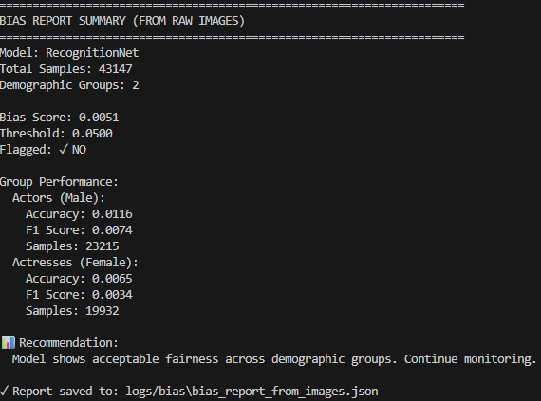
Figure 82. Summary of the bias report of the male and female actors’ group. Shows overall bias, threshold and individual accuracy/F1 of actors and actresses along with the textual message of recommendation.
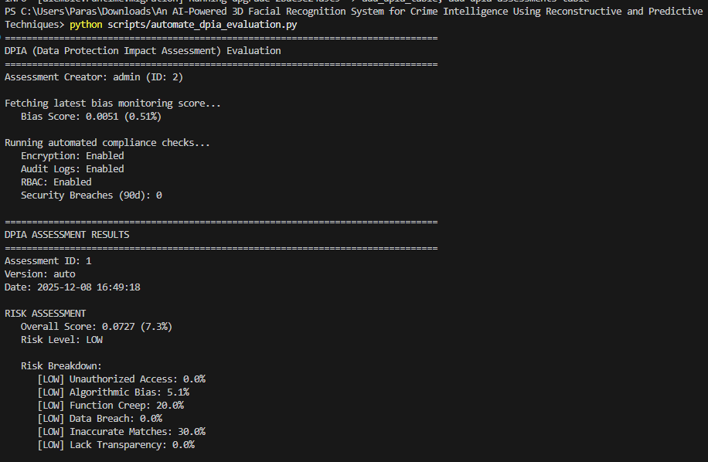
Figure 83. Risk assessment execution of DPIA. The automate_dpia_evaluation.py screenshot to retrieve the latest bias score, audit logs and RBAC, debug the encryption, and calculate the low overall risk level divided by risk category.
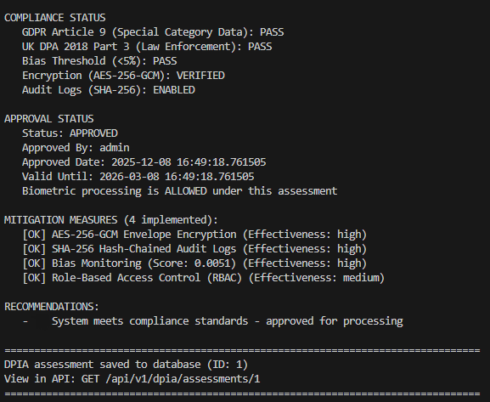
Figure 84. Summary of DPIA compliance and approval. Displays GDPR/UK DPA compliance tests, confirmation of bias threshold and control measure, approval status and mitigation, along with the API endpoint at which the stored assessment is available.

7.3 Bias, fairness and societal risk
In spite of these mitigation measures, the prototype has structural drawbacks of FaceScrub [11]: data about celebrities is biased towards Westerners, and crudely binarised gender. Such training data can be disproportionately low in minority groups, even when the score of aggregate bias seems low and can be used to encode stereotyping. Regular reports of fairness, intersectional error analysis and external auditing would thus be key preconditions to any working deployment. More fundamentally, the introduction of facial recognition combined with crime-trend analytics brings in broader issues to society: false identifications, bias against communities that are already over-policed, and the chilling impacts on lives. The system should thus be interpreted as a place to experiment with design patterns that are cognizant of governance rather than an excuse to engage in unregulated predictive policing [107].

8. Conclusion, Recommendations and Reflection

8.1 Summary of findings
After developing the AI-powered 3-D Facial Recognition Framework of Crime Intelligence, the overall objective of the research was to experiment whether a modular stack comprising landmark detection, 3-D reconstruction, facial recognition, weapon detection and crime analytics may be developed into a coherent crime-intelligence prototype.
The original research question was whether a custom landmark and reconstruction pipeline would be capable of acquiring strong geometry on unconstrained faces. Chapter 5 has demonstrated that LandmarkNet used in achieving stable training curves and competitive CED statistics, along with qualitative examples of correct localisation, were possible with moderate pose and illumination variation. ReconstructionNet, which was trained on AFLW2000-3D [10], fast converged and provided low vertex, parameter error with mesh visuals seeming plausible. A combination of these findings makes it certain that lightweight custom models can be used to deliver identity-preserving 3-D structure that can be used by downstream analytics, without the use of heavyweight commercial APIs.
The second question was the behaviour of a supervised recognition model versus a state-of-the-art embedding like that of Buffalo [103]. RecognitionNet, which was trained with 530 FaceScrub [11] identities, had modest end-to-end classification accuracy, high ROC-based verification performance, and useful embedding geometry, as demonstrated by UMAP/t-SNE visualisations. General comparison in Chapter 5 indicated that our embeddings were much better than Buffalo in k-NN classification within this dataset. When trained to solve a task, can provide embeddings which are competitive (under some cases even better) than generic large-scale features with a given set of identities.
The third question was the incorporation of perception modules with crime forecasting and intelligence dashboards. YOLOv8s [47], [104] was able to be integrated into a fixed detector, which offers person and weapon detections to feed LandmarkNet and RecognitionNet. The forecasting of three-year UK crime data [12] based on the Prophets yielded reasonable national patterns and seasonal elements, which were brought to the surface via REST endpoints and displayed in the Analytics pages. The last research question was concerned with governance and ethics. Chapter7 showed how bias monitoring, automated DPIA cheques, encryption, RBAC and audit logging can be integrated into a dissimilar stack and presented the artefact as an experimentation platform to governance-conscious computer vision instead of a policing system ready to be deployed.
In general, the primary deliverable of the project is not any one of the models, but an entire stack architecture integrating a computer-vision pipeline, time series forecasting, frontend dashboards and governance utilities, into a coherent mix of a crime-intelligence prototype.

8.2 Limitations and recommendations for future work
These findings are characterised by a number of limitations. The core facial model is trained on benchmark data (AFLW2000-3D [10], FaceScrub [11]), which is small in modern standards, as well as external validity, and the synthetic watchlist and crime linkages do not allow emphatic assertions about operational implementation. The Buffalo [103] comparison is likewise restricted to a single dataset and k-NN evaluation protocol.
Crime-forecasting experiments are built on the analytics side based on a single national-level Prophet model with minimal hyperparameter search and not in comparison to other forecasters such as gradient-boosted trees, temporal CNNs or graph-based models, which leverage the spatial structure between LSOAs. Its crime dashboards take in the output of parquet aggregates that are computed offline; it is not fully streaming yet.
The work in future would then focus on:
- Training and assessing on bigger, better curated, and more varied facial data sets, preferably incorporating law-enforcement data under effective governance and systematic fairness audit across several guarded characteristics.
- Investigation in more vigorous recognition goals (margin-based losses, metric learning, self-supervised pre-training) and more effective 3-D reconstruction designs, such as multi-view design or video design.
- Building a better Crime-forecasting pipeline with the interpretability of Prophet and spatial/graph models, testing them on operational analytics.
- Moving to a streaming, event-based backend in which detections, embedding and crime incidents are operated on in real-time, with human review gates on high-risk alerts.
- Making the governance layer formal through external DPIA processes, threat modelling, red-teaming, and transparency reports to the public.

8.3 Personal reflection
The project has greatly enriched my knowledge about the relationship between model performance, usability, and ethics. The process of implementing and debugging the landmark, reconstruction and recognition networks made me consider carefully the metrics that were used to evaluate the success, failure modes, and the boundaries of the benchmark-based development. The construction of the bias-monitoring and DPIA elements indicated that fairness, security, and accountability cannot be applied on the back of the neck; they should be planned along with the main ML code.
On the engineering side, I further improved my deep learning knowledge using PyTorch, data engineering, and experiment management, as well as implemented a production-like REST backend with a modern frontend capable of visualising intricate analytics in a format that could be used by an investigator. In my work with Git, Docker and environment automation, I have a much better understanding of the notion within reproducibility and maintainability.
Most importantly, the project has equipped me for the professional practise of safety-critical AI. I am walking away with a better adult understanding that technical innovation should be accompanied by careful examination, with robust protections, and the willingness to question whether a system should be deployed at all, not just if it can be developed.

References
[1] B. Amirgaliyev, M. Mussabek, T. Rakhimzhanova, and A. Zhumadillayeva, ‘A Review of Machine Learning and Deep Learning Methods for Person Detection, Tracking and Identification, and Face Recognition with Applications’, Sensors, vol. 25, no. 5, p. 1410, Feb. 2025, doi: 10.3390/s25051410. Available: https://www.mdpi.com/1424-8220/25/5/1410. Accessed: Jul. 2, 2025.
[2] S. Chokkadi, S. M. S, S. K. B, and A. Bhandary, ‘A Study on various state-of-the-art of the Art Face Recognition System using Deep Learning Techniques’, 2019, doi: 10.48550/ARXIV.1911.08426. Available: https://arxiv.org/abs/1911.08426. Accessed: Jul. 7, 2025
[3] A. F. Abate, M. Nappi, D. Riccio, and G. Sabatino, ‘2D and 3D face recognition: A survey’, Pattern Recognition Letters, vol. 28, no. 14, pp. 1885–1906, Oct. 2007, doi: 10.1016/j.patrec.2006.12.018. Available: https://www.sciencedirect.com/science/article/abs/pii/S0167865507000189. Accessed: Jul. 9, 2025
[4] S. Singh and S. V. A. V. Prasad, ‘Techniques and Challenges of Face Recognition: A Critical Review’, Procedia Computer Science, vol. 143, pp. 536–543, 2018, doi: 10.1016/j.procs.2018.10.427. Available: https://www.sciencedirect.com/science/article/pii/S1877050918321252. Accessed: Jul. 10, 2025.
[8] FLAME, “DECA Data Repository,” GitHub. [Online]. Available: https://github.com/yfeng95/DECA/tree/master/data. Accessed: Jul. 5, 2025.
[9] T. Li, T. Bolkart, M. J. Black, H. Li, and J. Romero, ‘Learning a model of facial shape and expression from 4D scans’, ACM Trans. Graph., vol. 36, no. 6, pp. 1–17, Dec. 2017, doi: 10.1145/3130800.3130813. Available: https://flame.is.tue.mpg.de/index.html. Accessed: Jul. 12, 2025.
[10] Xiangyu Zhu, Zhen Lei, Xiaoming Liu, Hailin Shi, and Stan Z. Li, “AFLW2000-3D Dataset – Supplementary Material for ‘Face Alignment Across Large Poses: A 3D Solution’,” CBSR, Institute of Automation, Chinese Academy of Sciences. [Online]. Available: http://www.cbsr.ia.ac.cn/users/xiangyuzhu/projects/3DDFA/main.htm. Accessed: Jul. 13, 2025.
[11] FaceScrub. [Online]. Available: https://www.kaggle.com/datasets/rajnishe/facescrub-full. Accessed: Jul. 14, 2025.
[12] DATA.POLICE.UK. [Online]. Available: https://data.police.uk/data/. Accessed: Jul.16, 2025.
[13] A.-N. Ansari and M. Abdel-Mottaleb, ‘3D face modeling using two views and a generic face model with application to 3D face recognition’, in Proceedings of the IEEE Conference on Advanced Video and Signal Based Surveillance, 2003., Miami, FL, USA: IEEE Comput. Soc, 2003, pp. 37–44. doi: 10.1109/AVSS.2003.1217899. Available at: https://ieeexplore.ieee.org/abstract/document/1217899. Accessed: Jul. 17, 2025.
[14] V. Blanz and T. Vetter, ‘A morphable model for the synthesis of 3D faces’, in Proceedings of the 26th annual conference on Computer graphics and interactive techniques - SIGGRAPH ’99, Not Known: ACM Press, 1999, pp. 187–194. doi: 10.1145/311535.311556. Available: https://dl.acm.org/doi/abs/10.1145/3596711.3596730. Accessed: Jul. 18, 2025.
[15] B. Egger et al., ‘3D Morphable Face Models—Past, Present, and Future’, ACM Trans. Graph., vol. 39, no. 5, pp. 1–38, Oct. 2020, doi: 10.1145/3395208. Available: https://dl.acm.org/doi/abs/10.1145/3395208. Accessed: Jul. 19, 2025.
[16] T. Almanie, R. Mirza, and E. Lor, ‘Crime Prediction Based On Crime Types And Using Spatial And Temporal Criminal Hotspots’, 2015, doi: 10.48550/ARXIV.1508.02050. Available: https://arxiv.org/abs/1508.02050. Accessed: Jul. 21, 2025
[17] A. Belesiotis, G. Papadakis, and D. Skoutas, ‘Analyzing and Predicting Spatial Crime Distribution Using Crowdsourced and Open Data’, ACM Trans. Spatial Algorithms Syst., vol. 3, no. 4, pp. 1–31, Dec. 2017, doi: 10.1145/3190345. Available: https://arxiv.org/abs/1508.02050. Accessed: Jul. 22, 2025.
[18] K. W. Bowyer, ‘Face recognition technology: security versus privacy’, IEEE Technol. Soc. Mag., vol. 23, no. 1, pp. 9–19, 2004, doi: 10.1109/MTAS.2004.1273467. Available: https://ieeexplore.ieee.org/abstract/document/1273467. Accessed: Jul. 23, 2025.
[19] K. Bowers and S. Johnson, ‘Facing the Future of Crime: A Framework for Police Use of Technology’, Political Quarterly, vol. 95, no. 3, pp. 480–488, July 2024, doi: 10.1111/1467-923X.13426. Available: https://onlinelibrary.wiley.com/doi/full/10.1111/1467-923X.13426. Accessed: Jul. 24, 2025.
[20] Z. Cheng, X. Zhu, and S. Gong, ‘Surveillance Face Recognition Challenge’, 2018, arXiv. doi: 10.48550/ARXIV.1804.09691. Available: https://arxiv.org/abs/1804.09691. Jul. 26, 2025.
[21] G. Galanakis et al., ‘A Study of 3D Digitisation Modalities for Crime Scene Investigation’, Forensic Sciences, vol. 1, no. 2, pp. 56–85, July 2021, doi: 10.3390/forensicsci1020008. Available: https://www.mdpi.com/2673-6756/1/2/8. Accessed: Aug. 3, 2025.
[22] B. S, A. Kareem, and V. Kumara, ‘Machine Learning Approach for a Novel Facial Recognition System’, in 2023 8th International Conference on Communication and Electronics Systems (ICCES), Coimbatore, India: IEEE, June 2023, pp. 1178–1183. doi: 10.1109/ICCES57224.2023.10192743. Available: https://ieeexplore.ieee.org/abstract/document/10192743. Accessed: Aug. 5, 2025.
[23] M. Adepeju, ‘“stppSim”: A Novel Analytical Tool for Creating Synthetic Spatio-Temporal Point Data’, OJMSi, vol. 11, no. 04, pp. 99–116, 2023, doi: 10.4236/ojmsi.2023.114007. Available: https://e-space.mmu.ac.uk/632825/1/ojmsi_2023101115105555.pdf. Accessed: Aug. 7, 2025.
[24] V. Vakkuri and P. Abrahamsson, ‘The Key Concepts of Ethics of Artificial Intelligence’, in 2018 IEEE International Conference on Engineering, Technology and Innovation (ICE/ITMC), Stuttgart: IEEE, June 2018, pp. 1–6. doi: 10.1109/ICE.2018.8436265. Available: https://ieeexplore.ieee.org/document/8436265. Accessed: Aug. 9, 2025.
[25] V. Blanz and T. Vetter, ‘Face recognition based on fitting a 3D morphable model’, IEEE Trans. Pattern Anal. Machine Intell., vol. 25, no. 9, pp. 1063–1074, Sept. 2003, doi: 10.1109/TPAMI.2003.1227983. Available: https://ieeexplore.ieee.org/abstract/document/1227983. Accessed: Aug. 11, 2025.
[26] V. Blanz and T. Vetter, ‘A Morphable Model For The Synthesis Of 3D Faces’, in Seminal Graphics Papers: Pushing the Boundaries, Volume 2, 1st edn, M. C. Whitton, Ed., New York, NY, USA: ACM, 2023, pp. 157–164. doi: 10.1145/3596711.3596730. Available: https://dl.acm.org/doi/abs/10.1145/3596711.3596730. Accessed: Aug. 13, 2025.
[27] G. Hu et al., ‘Efficient 3D morphable face model fitting’, Pattern Recognition, vol. 67, pp. 366–379, July 2017, doi: 10.1016/j.patcog.2017.02.007. Available: https://www.sciencedirect.com/science/article/abs/pii/S0031320317300481. Accessed: Aug. 15, 2025.
[28] L. Jiang, J. Zhang, B. Deng, H. Li, and L. Liu, ‘3D Face Reconstruction With Geometry Details From a Single Image’, IEEE Trans. on Image Process., vol. 27, no. 10, pp. 4756–4770, Oct. 2018, doi: 10.1109/TIP.2018.2845697. Available: https://ieeexplore.ieee.org/abstract/document/8376005. Accessed Aug. 16, 2025.
[29] W. AbdAlmageed et al., ‘Face recognition using deep multi-pose representations’, in 2016 IEEE Winter Conference on Applications of Computer Vision (WACV), Lake Placid, NY, USA: IEEE, Mar. 2016, pp. 1–9. doi: 10.1109/WACV.2016.7477555. Available: https://ieeexplore.ieee.org/abstract/document/7477555. Accessed: Aug. 18, 2025.
[30] T. Achimba, O. K. Akinyokun, S. Agber, K. Usman, G. Ateata, and S. U. Otor, ‘A Robust Object Detection Model for Real-Time Surveillance and Crime Detection in Public Spaces’, in 2024 IEEE 5th International Conference on Electro-Computing Technologies for Humanity (NIGERCON), Ado Ekiti, Nigeria: IEEE, Nov. 2024, pp. 1–5. doi: 10.1109/NIGERCON62786.2024.10927077. Available: https://ieeexplore.ieee.org/abstract/document/10927077. Accessed: Aug. 19, 2025.
[31] A. Fola-Rose, E. Solomon, K. Bryant, and A. Woubie, ‘A Systematic Review of Facial Recognition Methods: Advancements, Applications, and Ethical Dilemmas’, in 2024 IEEE International Conference on Information Reuse and Integration for Data Science (IRI), San Jose, CA, USA: IEEE, Aug. 2024, pp. 314–319. doi: 10.1109/IRI62200.2024.00070. Available: https://ieeexplore.ieee.org/abstract/document/10703753. Aug. 21, 2025.
[32] A. M. Ali, ‘A 3D-Based Pose Invariant Face Recognition at a Distance Framework’, IEEE Trans.Inform.Forensic Secur., vol. 9, no. 12, pp. 2158–2169, Dec. 2014, doi: 10.1109/TIFS.2014.2362299. Available: https://ieeexplore.ieee.org/abstract/document/6918513. Accessed: Aug. 22, 2025.
[33] M. Turk, ‘Over twenty years of eigenfaces’, ACM Trans. Multimedia Comput. Commun. Appl., vol. 9, no. 1s, pp. 1–5, Oct. 2013, doi: 10.1145/2490824. Available: https://dl.acm.org/doi/abs/10.1145/2490824. Accessed: Aug. 23, 2025.
[34] M. M. Ahsan, Y. Li, J. Zhang, M. T. Ahad, and K. D. Gupta, ‘Evaluating the Performance of Eigenface, Fisherface, and Local Binary Pattern Histogram-Based Facial Recognition Methods under Various Weather Conditions’, Technologies, vol. 9, no. 2, p. 31, Apr. 2021, doi: 10.3390/technologies9020031. Available: https://www.mdpi.com/2227-7080/9/2/31. Accessed: Aug. 25, 2025.
[35] N. Fligstein, ‘Understanding stability and change in fields’, Research in Organizational Behavior, vol. 33, pp. 39–51, Jan. 2013, doi: 10.1016/j.riob.2013.10.005. Available: https://www.sciencedirect.com/science/article/abs/pii/S0191308513000075. Accessed: Aug. 26, 2025.
[36] V. Ganjalizadeh, G. G. Meena, M. A. Stott, A. R. Hawkins, and H. Schmidt, ‘Machine learning at the edge for AI-enabled multiplexed pathogen detection’, Sci Rep, vol. 13, no. 1, p. 4744, Mar. 2023, doi: 10.1038/s41598-023-31694-6. Available: https://www.nature.com/articles/s41598-023-31694-6#citeas. Accessed: Aug. 27, 2025.
[37] A. V. Savin, V. A. Sablina, and M. B. Nikiforov, ‘Comparison of Facial Landmark Detection Methods for Micro-Expressions Analysis’, in 2021 10th Mediterranean Conference on Embedded Computing (MECO), Budva, Montenegro: IEEE, June 2021, pp. 1–4. doi: 10.1109/MECO52532.2021.9460191. Available: https://ieeexplore.ieee.org/abstract/document/9460191. Accessed: Aug. 28, 2025.
[38] S. Lathuiliere, P. Mesejo, X. Alameda-Pineda, and R. Horaud, ‘A Comprehensive Analysis of Deep Regression’, IEEE Trans. Pattern Anal. Mach. Intell., vol. 42, no. 9, pp. 2065–2081, Sept. 2020, doi: 10.1109/TPAMI.2019.2910523. Available: https://ieeexplore.ieee.org/abstract/document/8686063. Accessed: Aug. 29, 2025.
[39] H. Jiang, J. Xue, X. Lan, and K. Lu, ‘One General Plug-In for Facial Heatmap-based Keypoint Detection’, in 2025 IEEE International Conference on Multimedia and Expo (ICME), Nantes, France: IEEE, June 2025, pp. 1–6. doi: 10.1109/ICME59968.2025.11210125. Available: https://ieeexplore.ieee.org/abstract/document/11210125. Aug. 30, 2025.
[40] Zhen-Hua Feng, Guosheng Hu, J. Kittler, W. Christmas, and Xiao-Jun Wu, ‘Cascaded Collaborative Regression for Robust Facial Landmark Detection Trained Using a Mixture of Synthetic and Real Images With Dynamic Weighting’, IEEE Trans. on Image Process., vol. 24, no. 11, pp. 3425–3440, Nov. 2015, doi: 10.1109/TIP.2015.2446944. Available: https://ieeexplore.ieee.org/abstract/document/7126999. Accessed: Aug. 31, 2025.
[41] Z. Bin, L. Yong, L. Xiaoming, L. Dan, L. Zihao, and S. Xinmin, ‘A Review of Research on 3D Face Reconstruction Methods’, in Proceedings of the 2024 9th International Conference on Intelligent Information Technology, Ho Chi Minh City Vietnam: ACM, Feb. 2024, pp. 70–76. doi: 10.1145/3654522.3654534. Available: https://dl.acm.org/doi/abs/10.1145/3654522.3654534. Accessed: Sep. 2, 2025.
[42] X. Chen, M. Mihajlovic, S. Wang, S. Prokudin, and S. Tang, ‘Morphable Diffusion: 3D-Consistent Diffusion for Single-image Avatar Creation’, 2024, arXiv. doi: 10.48550/ARXIV.2401.04728. Available: https://arxiv.org/abs/2401.04728. Accessed: Sep. 4, 2025.
[43] X. Fan, S. Cheng, K. Huyan, M. Hou, R. Liu, and Z. Luo, ‘Dual Neural Networks Coupling Data Regression With Explicit Priors for Monocular 3D Face Reconstruction’, IEEE Trans. Multimedia, vol. 23, pp. 1252–1263, 2021, doi: 10.1109/TMM.2020.2994506. Available: https://ieeexplore.ieee.org/abstract/document/9093203. Accessed: Sep. 6, 2025.
[44] R. Ullah et al., ‘A Real-Time Framework for Human Face Detection and Recognition in CCTV Images’, Mathematical Problems in Engineering, vol. 2022, pp. 1–12, Mar. 2022, doi: 10.1155/2022/3276704. Available: https://onlinelibrary.wiley.com/doi/full/10.1155/2022/3276704. Accessed: Sep. 8, 2025.
[45] L. Tran and X. Liu, ‘Nonlinear 3D Face Morphable Model’, 2018, arXiv. doi: 10.48550/ARXIV.1804.03786. Available at: https://arxiv.org/abs/1804.03786. Accessed: Sep. 10, 2025.
[46] A. Bulat and G. Tzimiropoulos, ‘Super-FAN: Integrated Facial Landmark Localization and Super-Resolution of Real-World Low Resolution Faces in Arbitrary Poses with GANs’, in 2018 IEEE/CVF Conference on Computer Vision and Pattern Recognition, Salt Lake City, UT, USA: IEEE, June 2018, pp. 109–117. doi: 10.1109/CVPR.2018.00019. Available: https://openaccess.thecvf.com/content_cvpr_2018/papers/Bulat_Super-FAN_Integrated_Facial_CVPR_2018_paper.pdf. Accessed: Sep. 12, 2025
[47] M. Hussain, ‘YOLO-v1 to YOLO-v8, the Rise of YOLO and Its Complementary Nature toward Digital Manufacturing and Industrial Defect Detection’, Machines, vol. 11, no. 7, p. 677, June 2023, doi: 10.3390/machines11070677. Available: https://www.mdpi.com/2075-1702/11/7/677. Accessed: Sep. 13, 2025.
[48] S. St et al., ‘Deep learning model for deep fake face recognition and detection’, PeerJ Computer Science, vol. 8, p. e881, Feb. 2022, doi: 10.7717/peerj-cs.881. Available: https://peerj.com/articles/cs-881/#MainContent. Accessed: Sep. 15, 2025.
[49] H. Hanselmann, S. Yan, and H. Ney, ‘Deep fisher faces’, in Procedings of the British Machine Vision Conference 2017, London, UK: British Machine Vision Association, 2017, p. 165. doi: 10.5244/C.31.165. Available: https://publications.rwth-aachen.de/record/713599/files/713599.pdf. Accessed: Sep. 16, 2025.
[50] O. Atalay Franck, Architectural Intelligence in the Age of Artificial Intelligence. in Architekturen, no. 93. Erscheinungsort nicht ermittelbar: transcript Verlag transcript [Imprint], 2025. Available: https://librarysearch.uwtsd.ac.uk/discovery/fulldisplay?docid=alma99100731953402421&context=L&vid=44WHELF_UWTSD:44WHELF_UWTSD_VU1&lang=en&search_scope=Search_ELEC&adaptor=Local%20Search%20Engine&tab=Everything&query=any,contains,Deep%20facial%20recognition%20and%20embeddings&facet=rtype,include,books&offset=0
https://research-ebsco-com.ezproxy.uwtsd.ac.uk/c/onvpsy/search/details/hozwkjupif?db=e001mww. Accessed: Sep. 18, 2025.
[51] K. R. Park, S. Lee, and E. Kim, Eds, Visual and Camera Sensors. Basel, Switzerland: MDPI - Multidisciplinary Digital Publishing Institute, 2021. Available: https://librarysearch.uwtsd.ac.uk/discovery/fulldisplay?docid=cdi_oapen_doabooks_76836&context=PC&vid=44WHELF_UWTSD:44WHELF_UWTSD_VU1&lang=en&search_scope=Search_ELEC&adaptor=Primo%20Central&tab=Everything&query=any,contains,Three-dimensional%20facial%20reconstruction&facet=rtype,include,books&offset=0
https://directory.doabooks.org/handle/20.500.12854/76836. Accessed: Sep. 19, 2025.
[52] F. Farahnakian, J. Heikkonen, and P. Jafarzadeh, Eds, Deep learning and computer vision in remote sensing-II. Basel Beijing Wuhan Barcelona Belgrade Novi Sad Cluj Manchester: MDPI - Multidisciplinary Digital Publishing Institute$, 2023. doi: 10.3390/books978-3-0365-9365-4. Available: https://librarysearch.uwtsd.ac.uk/discovery/fulldisplay?docid=cdi_oapen_doabooks_128789&context=PC&vid=44WHELF_UWTSD:44WHELF_UWTSD_VU1&lang=en&search_scope=Search_ELEC&adaptor=Primo%20Central&tab=Everything&query=any,contains,Landmark%20detection%20methods&facet=rtype,include,books&offset=0.
https://directory.doabooks.org/handle/20.500.12854/128789. Accessed: Sep. 21, 2025.
[53] G.-S. J. Hsu and R. Timofte, Eds, Deep Learning for Facial Informatics. Basel, Switzerland: MDPI - Multidisciplinary Digital Publishing Institute, 2020. Available: https://librarysearch.uwtsd.ac.uk/discovery/fulldisplay?docid=cdi_oapen_doabooks_69112&context=PC&vid=44WHELF_UWTSD:44WHELF_UWTSD_VU1&lang=en&search_scope=Search_ELEC&adaptor=Primo%20Central&tab=Everything&query=any,contains,Evolution%20of%20facial%20recognition&facet=rtype,include,books&offset=0
https://directory.doabooks.org/handle/20.500.12854/69112. Accessed: Sep. 22, 2025.
[54] M. G. Xibilia and S. Graziani, Eds, Innovative Topologies and Algorithms for Neural Networks. Basel, Switzerland: MDPI - Multidisciplinary Digital Publishing Institute, 2021. Available: https://librarysearch.uwtsd.ac.uk/discovery/fulldisplay?docid=cdi_oapen_doabooks_68541&context=PC&vid=44WHELF_UWTSD:44WHELF_UWTSD_VU1&lang=en&search_scope=Search_ELEC&adaptor=Primo%20Central&tab=Everything&query=any,contains,Deep%20facial%20recognition%20and%20embeddings&facet=rtype,include,books&offset=0
https://directory.doabooks.org/handle/20.500.12854/68541. Accessed: Sep. 23, 2025.
[55] J. C. L. Chai, T.-S. Ng, C.-Y. Low, J. Park, and A. B. J. Teoh, ‘Recognizability Embedding Enhancement for Very Low-Resolution Face Recognition and Quality Estimation’, 2023, arXiv. doi: 10.48550/ARXIV.2304.10066. Available at: https://arxiv.org/abs/2304.10066. Accessed: Sep. 24, 2025.
[56] W. Liu, Y. Wen, Z. Yu, M. Li, B. Raj, and L. Song, ‘SphereFace: Deep Hypersphere Embedding for Face Recognition’, 2017, arXiv. doi: 10.48550/ARXIV.1704.08063. Available: https://arxiv.org/abs/1704.08063v4. Accessed: Sep. 25, 2025.
[57] M. Iqbal, M. S. I. Sameem, N. Naqvi, S. Kanwal, and Z. Ye, ‘A deep learning approach for face recognition based on angularly discriminative features’, Pattern Recognition Letters, vol. 128, pp. 414–419, Dec. 2019, doi: 10.1016/j.patrec.2019.10.002. Available: https://www.sciencedirect.com/science/article/abs/pii/S0167865519302740. Accessed: Sep. 26, 2025.
[58] J. Huo, Y. Gao, Y. Shi, W. Yang, and H. Yin, ‘Heterogeneous Face Recognition by Margin-Based Cross-Modality Metric Learning’, IEEE Trans. Cybern., vol. 48, no. 6, pp. 1814–1826, June 2018, doi: 10.1109/TCYB.2017.2715660. Available: https://ieeexplore.ieee.org/abstract/document/7959077. Accessed: Sep. 27, 2025.
[59] J. Huo, Y. Gao, Y. Shi, W. Yang, and H. Yin, ‘Heterogeneous Face Recognition by Margin-Based Cross-Modality Metric Learning’, IEEE Trans. Cybern., vol. 48, no. 6, pp. 1814–1826, June 2018, doi: 10.1109/TCYB.2017.2715660. Available: https://ieeexplore.ieee.org/abstract/document/10255325. Accessed: Sep. 28, 2025.
[60] N. F. Bernich, ‘Design and Analysis of Facial Recognition Algorithms for Home Monitoring’. Available: https://scholars.unh.edu/cgi/viewcontent.cgi?article=1923&context=honors. Accessed: Sep. 29, 2025.
[61] I. P. Pratama and N. K. Ningrum, ‘Face Recognition Using MTCNN Face Detection, ResNetV1 Feature Embeddings, and SVM Classification’, JAIC, vol. 9, no. 5, pp. 2049–2058, Oct. 2025, doi: 10.30871/jaic.v9i5.11016. Available: https://jurnal.polibatam.ac.id/index.php/JAIC/article/view/11016. Accessed: Sep. 30, 2025.
[62] N. Braakmann, A. Chevalier, and T. Wilson, ‘Online appendix for: Expected Returns to Crime and Crime Location’. Available: https://assets.aeaweb.org/asset-server/files/21379.pdf. Accessed: Oct. 1, 2025
[63] U. M. Butt, S. Letchmunan, F. H. Hassan, M. Ali, A. Baqir, and H. H. R. Sherazi, ‘Spatio-Temporal Crime HotSpot Detection and Prediction: A Systematic Literature Review’, IEEE Access, vol. 8, pp. 166553–166574, 2020, doi: 10.1109/ACCESS.2020.3022808. Available: https://ieeexplore.ieee.org/abstract/document/9187772. Accessed: Oct. 3, 2025.
[64] H. Cotton and T. A. Kwembe, ‘Using Data Analytics to Forecast Violent Crime’, in 2021 International Conference on Computational Science and Computational Intelligence (CSCI), Las Vegas, NV, USA: IEEE, Dec. 2021, pp. 301–304. doi: 10.1109/CSCI54926.2021.00122. Available: https://ieeexplore.ieee.org/abstract/document/9799253. Accessed: Oct. 5, 2025.
[65] W. L. Perry, Predictive policing: the role of crime forecasting in law enforcement operations. Santa Monica, CA: RAND, 2013. Available: https://librarysearch.uwtsd.ac.uk/discovery/fulldisplay?docid=alma99100240174502421&context=L&vid=44WHELF_UWTSD:44WHELF_UWTSD_VU1&lang=en&search_scope=Search_ELEC&adaptor=Local%20Search%20Engine&tab=Everything&query=any,contains,Crime%20data%20analytics%20and%20forecasting&facet=rtype,include,books&offset=0
https://www.jstor.org/stable/10.7249/j.ctt4cgdcz. Accessed: Oct. 6, 2025.
[66] A. R. Pathak, M. Pandey, and S. Rautaray, ‘Application of Deep Learning for Object Detection’, Procedia Computer Science, vol. 132, pp. 1706–1717, 2018, doi: 10.1016/j.procs.2018.05.144. Available: https://www.sciencedirect.com/science/article/pii/S1877050918308767. Accessed: Oct. 8, 2025.
[67] M. L. Ali and Z. Zhang, ‘The YOLO Framework: A Comprehensive Review of Evolution, Applications, and Benchmarks in Object Detection’, Computers, vol. 13, no. 12, p. 336, Dec. 2024, doi: 10.3390/computers13120336. Available: https://www.researchgate.net/profile/Zhou-Zhang-10/publication/387054177_The_YOLO_Framework_A_Comprehensive_Review_of_Evolution_Applications_and_Benchmarks_in_Object_Detection/links/675e1205eea8d248be6c4629/The-YOLO-Framework-A-Comprehensive-Review-of-Evolution-Applications-and-Benchmarks-in-Object-Detection.pdf. Accessed: Oct. 10, 2025.
[68] A. A. A. B and A. Bajpai, ‘Attire-Based Anomaly Detection in Restricted Areas Using YOLOv8 for Enhanced CCTV Security’, 2024, arXiv. doi: 10.48550/ARXIV.2404.00645. Available: https://arxiv.org/abs/2404.00645. Accessed: Oct. 12, 2025.
[69] D. Hoiem and S. Savarese, Representations and techniques for 3D object recognition and scene interpretation. in Synthesis lectures on artificial intelligence and machine learning, no. # 15. San Rafael, Calif. (1537 Fourth Street, San Rafael, CA 94901 USA): Morgan & Claypool, 2011. Available: https://librarysearch.uwtsd.ac.uk/discovery/fulldisplay?docid=alma99100376088102421&context=L&vid=44WHELF_UWTSD:44WHELF_UWTSD_VU1&lang=en&search_scope=Search_ELEC&adaptor=Local%20Search%20Engine&tab=Everything&query=any,contains,Object%20detection%20and%20scene%20understanding&facet=rtype,include,books&offset=0
https://ieeexplore.ieee.org/document/6813376. Accessed: Oct. 14, 2025.
[70] C. Fontes and C. Perrone, ‘Ethics of surveillance: harnessing the use of live facial recognition technologies in public spaces for law enforcement’. Available: https://ieai.mcts.tum.de/wp-content/uploads/2021/12/ResearchBrief_December_Fontes-1.pdf. Accessed: Oct. 15, 2025.
[71] J. T. Croker, ‘Facial Recognition Technology by the Metropolitan Police Service’. Available: https://ora.ox.ac.uk/objects/uuid:fae58b36-9ab6-4186-8ba5-7fa6bb8c106d/files/r9306t074v. Accessed: Oct. 17, 2025.
[72] T. Chen, ‘Case-based Analysis of Discrimination in Police Surveillance Scene Regarding Facial Recog’, IOP Conf. Ser.: Mater. Sci. Eng., vol. 914, no. 1, p. 012029, Sept. 2020, doi: 10.1088/1757-899X/914/1/012029. Available: https://iopscience.iop.org/article/10.1088/1757-899X/914/1/012029/meta. Accessed: Oct. 19, 2025.
[73] I. Barkane, ‘Questioning the EU proposal for an Artificial Intelligence Act: The need for prohibitions and a stricter approach to biometric surveillance1’, IP, vol. 27, no. 2, pp. 147–162, July 2022, doi: 10.3233/IP-211524. Available: https://journals.sagepub.com/doi/full/10.3233/IP-211524. Accessed: Oct. 21, 2025.
[74] R. Colman, ‘“POLICE FACIAL RECOGNITION IN PROGRESS”: THE CONSTRUCTION OF THE NOTION OF ACCURACY IN THE LIVE FACIAL RECOGNITION TECHNOLOGY USED BY THE MET POLICE IN LONDON’. Available: https://www.lse.ac.uk/media-and-communications/assets/documents/research/msc-dissertations/2020/255-Colman.pdf. Accessed: Oct. 23, 2025.
[75] D. E. Bromberg, É. Charbonneau, and A. Smith, ‘Public support for facial recognition via police body-worn cameras: Findings from a list experiment’, Government Information Quarterly, vol. 37, no. 1, p. 101415, Jan. 2020, doi: 10.1016/j.giq.2019.101415. Available: https://www.sciencedirect.com/science/article/abs/pii/S0740624X19300449. Accessed: Oct. 24, 2025.
[76] P. J. Brantingham, M. Valasik, and G. O. Mohler, ‘Does Predictive Policing Lead to Biased Arrests? Results From a Randomized Controlled Trial’, Statistics and Public Policy, vol. 5, no. 1, pp. 1–6, Jan. 2018, doi: 10.1080/2330443X.2018.1438940. Available: https://www.tandfonline.com/doi/full/10.1080/2330443X.2018.1438940#abstract. Accessed: Oct. 26, 2025.
[77] M. d’Aquin, P. Troullinou, N. E. O’Connor, A. Cullen, G. Faller, and L. Holden, ‘Towards an “Ethics by Design” Methodology for AI Research Projects’, in Proceedings of the 2018 AAAI/ACM Conference on AI, Ethics, and Society, New Orleans LA USA: ACM, Dec. 2018, pp. 54–59. doi: 10.1145/3278721.3278765. Available: https://dl.acm.org/doi/abs/10.1145/3278721.3278765. Accessed: Oct. 27, 2025.
[78] D. Leslie, ‘Understanding bias in facial recognition technologies’, Zenodo, Sept. 2020. doi: 10.5281/ZENODO.4050457. Available: https://arxiv.org/abs/2010.07023. Accessed: Oct. 29, 2025.
[79] A. Al-Shaikh et al., ‘Using Artificial Intelligence Techniques in Law Enforcement: A Survey’, in 2024 25th International Arab Conference on Information Technology (ACIT), Zarqa, Jordan: IEEE, Dec. 2024, pp. 1–7. doi: 10.1109/ACIT62805.2024.10877081. Available: https://ieeexplore.ieee.org/abstract/document/10877081. Accessed: Oct. 30, 2025.
[80] A. Dubois and L.-E. Gadde, ‘“Systematic combining”—A decade later’, Journal of Business Research, vol. 67, no. 6, pp. 1277–1284, June 2014, doi: 10.1016/j.jbusres.2013.03.036. Available: https://www.sciencedirect.com/science/article/abs/pii/S014829631300132X. Accessed: Oct. 31, 2025.
[81] E. N. Bal and A. Yalcin Saribey, ‘Artificial Intelligence in Forensic Science: Applications, Legal Framework and Criminal Liability Regime’, in 2025 International Conference on Artificial Intelligence, Computer, Data Sciences and Applications (ACDSA), Antalya, Turkiye: IEEE, Aug. 2025, pp. 1–7. doi: 10.1109/ACDSA65407.2025.11165965. Available: https://ieeexplore.ieee.org/abstract/document/11165965. Accessed: Nov. 1, 2025.
[82] S. Muvva, ‘Ethical AI and Responsible Data Engineering: A Framework for Bias Mitigation and Privacy Preservation in Large-Scale Data Pipelines’, IJSREM, vol. 09, no. 01, pp. 1–8, Jan. 2025, doi: 10.55041/IJSREM10633. Available: https://www.researchgate.net/profile/Sainath-Muvva/publication/388332736_Ethical_AI_and_Responsible_Data_Engineering_A_Framework_for_Bias_Mitigation_and_Privacy_Preservation_in_Large-Scale_Data_Pipelines/links/67b7a71c645ef274a48aa90f/Ethical-AI-and-Responsible-Data-Engineering-A-Framework-for-Bias-Mitigation-and-Privacy-Preservation-in-Large-Scale-Data-Pipelines.pdf. Accessed: Nov. 2, 2025.
[83] T. M. Chettier and V. A. K. Boyina, ‘Integrating Machine Learning with Fullstack Development Using ML.NET’, 2025. Available: https://www.researchgate.net/profile/Thiyagarajan-Mani-Chettier/publication/390300770_Integrating_Machine_Learning_with_Fullstack_Development_Using_MLNET/links/67e8136695231d5ba59f3ad1/Integrating-Machine-Learning-with-Fullstack-Development-Using-MLNET.pdf. Accessed: Nov. 3, 2025.
[84] Z. Dong and Z. Zhang, ‘Enhancing Bloodstain Analysis Through AI-Based Segmentation: Leveraging Segment Anything Model for Crime Scene Investigation’, 2023, arXiv. doi: 10.48550/ARXIV.2308.13979. Available at: https://arxiv.org/abs/2308.13979. Accessed: Nov. 4, 2025.
[85] MBA in Business Analytics, Southern New Hampshire University, New Hampshire USA, M. Akter, S. P. Kudapa, and Stevens Institute of Technology, New Jersey, USA, ‘A COMPARATIVE ANALYSIS OF ARTIFICIAL INTELLIGENCE-INTEGRATED BI DASHBOARDS FOR REAL-TIME DECISION SUPPORT IN OPERATIONS’, IJSIR, vol. 05, no. 02, pp. 158–191, June 2024, doi: 10.63125/47jjv310. Available: https://www.academia.edu/144590984/A_COMPARATIVE_ANALYSIS_OF_ARTIFICIAL_INTELLIGENCE_INTEGRATED_BI_DASHBOARDS_FOR_REAL_TIME_DECISION_SUPPORT_IN_OPERATIONS. Accessed: Nov. 5, 2025.
[86] K. Kayaalp and B. Bayraktar, ‘MOBILE-BASED INTELLIGENT ELECTRONIC IDENTIFICATION SYSTEM: INTEGRATED OCR, COLOR-CODED RESISTOR VALUE DETECTION, AND YOLOV8-ASSISTED COMPONENT CLASSIFICATION’, International Journal of Engineering and Innovative Research, vol. 7, no. 2, pp. 100–119, Dec. 2025, doi: 10.47933/ijeir.1725387. Available: https://dergipark.org.tr/en/pub/ijeir/article/1725387?issue_id=95896. Accessed: Nov. 6, 2025.
[87] I. Adjabi, A. Ouahabi, A. Benzaoui, and A. Taleb-Ahmed, ‘Past, Present, and Future of Face Recognition: A Review’, Electronics, vol. 9, no. 8, p. 1188, July 2020, doi: 10.3390/electronics9081188. Available at: https://www.mdpi.com/2079-9292/9/8/1188. Accessed: Nov. 7, 2025.
[88] M. Stonebraker and L. A. Rowe, ‘The design of POSTGRES’, in Proceedings of the 1986 ACM SIGMOD international conference on Management of data - SIGMOD ’86, Washington, D.C., United States: ACM Press, 1986, pp. 340–355. doi: 10.1145/16894.16888. Available: https://dl.acm.org/doi/10.1145/16894.16888?utm_source=chatgpt.com. Accessed: Nov. 8, 2025.
[89] T. Batista, E. Cavalcante, K. Costa, S. Loss, F. Lopes, and N. Cacho, ‘Harnessing Edge Computing and Artificial Intelligence for Real-Time Video Analytics in Disaster Management’, in Companion of the 2025 ACM International Joint Conference on Pervasive and Ubiquitous Computing, Espoo Finland: ACM, Oct. 2025, pp. 793–798. doi: 10.1145/3714394.3756179. Available: https://dl.acm.org/doi/abs/10.1145/3714394.3756179. Accessed: Nov. 9, 2025
[90] O. Z. Apene, N. V. Blamah, G. I. O. Aimufua, M. Olalere, and B. A. Ajayi, ‘Real-Time Crime Detection System for Public Safety Based on YOLO Model and Transfer Learning’, in 2024 IEEE SmartBlock4Africa, Accra, Ghana: IEEE, Sept. 2024, pp. 1–9. doi: 10.1109/SmartBlock4Africa61928.2024.10779544. Available: https://ieeexplore.ieee.org/abstract/document/10779544. Accessed: Nov. 10, 2025.
[91] W. Guo, L. Vân Tran Ha, J. C. Davies, E. Grinspun, and L. A. Kahrs, ‘Facial Landmark Detection and Head Pose Estimation of Occluded Faces Based on Stable Diffusion Image Completion’, IEEE Access, vol. 13, pp. 167196–167212, 2025, doi: 10.1109/ACCESS.2025.3612890. Available: https://ieeexplore.ieee.org/abstract/document/11175374. Accessed: Dec. 1, 2025.
[92] H. He, G. Li, Z. Ye, A. Mao, C. Xian, and Y. Nie, ‘Data-driven 3D human head reconstruction’, Computers & Graphics, vol. 80, pp. 85–96, May 2019, doi: 10.1016/j.cag.2019.03.008. Available: https://www.sciencedirect.com/science/article/abs/pii/S0097849319300317. Accessed: Dec. 2, 2025.
[93] Munawarah, T. F. Abidin, and K. Muchtar, ‘Performance Analysis of Face Verification through the Decision Fusion using Several Face Recognition Models’, in 2023 Eighth International Conference on Informatics and Computing (ICIC), Manado, Indonesia: IEEE, Dec. 2023, pp. 1–6. doi: 10.1109/ICIC60109.2023.10381943. Available: https://ieeexplore.ieee.org/abstract/document/10381943. Accessed: Dec. 5, 2025.
[94] H. S. Bhatt, R. Singh, and M. Vatsa, ‘On Recognizing Faces in Videos Using Clustering-Based Re-Ranking and Fusion’, IEEE Trans.Inform.Forensic Secur., vol. 9, no. 7, pp. 1056–1068, July 2014, doi: 10.1109/TIFS.2014.2318433. Available: https://ieeexplore.ieee.org/abstract/document/6802347. Accessed: Dec. 7, 2025.
[95] D. Cook, R. Weir, and L. Humphreys, ‘Improving police recorded crime data for domestic violence and abuse through natural language processing’, Front. Sociol., vol. 10, p. 1686632, Nov. 2025, doi: 10.3389/fsoc.2025.1686632. Available: https://pmc.ncbi.nlm.nih.gov/articles/PMC12682816/. Accessed: Dec. 8, 2025.
[96] D. J.-L. Lee et al., ‘Lux: Always-on Visualization Recommendations for Exploratory Dataframe Workflows’, 2021, arXiv. doi: 10.48550/ARXIV.2105.00121. Available at: https://arxiv.org/abs/2105.00121. Accessed: Dec. 9, 2025.
[97] E. Armah and L. A. Bannning, ‘Towards a Proactive Autoscaling Framework for Data Stream Processing at the Edge using GRU and Transfer Learning’, 2025, arXiv. doi: 10.48550/ARXIV.2507.14597. Available: https://arxiv.org/pdf/2507.14597. Accessed: Dec. 10, 2025.
[98] H. Köhler and S. Link, ‘SQL Schema Design: Foundations, Normal Forms, and Normalization’, in Proceedings of the 2016 International Conference on Management of Data, San Francisco California USA: ACM, June 2016, pp. 267–279. doi: 10.1145/2882903.2915239. Available: https://dl.acm.org/doi/abs/10.1145/2882903.2915239. Accessed: Dec. 11, 2025.
[99] N. Qazi, B. L. W. Wong, N. Kodagoda, and R. Adderley, ‘Associative search through Formal Concept Analysis in Criminal Intelligence Analysis’, in 2016 IEEE International Conference on Systems, Man, and Cybernetics (SMC), Budapest, Hungary: IEEE, Oct. 2016, pp. 001917–001922. doi: 10.1109/SMC.2016.7844519. Available: https://ieeexplore.ieee.org/abstract/document/7844519. Accessed: Dec. 13, 2025.
[100] C. Pasomsup and Y. Limpiyakorn, ‘HT-RBAC: A Design of Role-based Access Control Model for Microservice Security Manager’, in 2021 International Conference on Big Data Engineering and Education (BDEE), Guiyang, China: IEEE, Aug. 2021, pp. 177–181. doi: 10.1109/BDEE52938.2021.00038. Available: https://ieeexplore.ieee.org/abstract/document/9626304. Accessed: Dec. 14, 2025.
[101] M. Bar-Sinai, L. Sweeney, and M. Crosas, ‘DataTags, Data Handling Policy Spaces and the Tags Language’, in 2016 IEEE Security and Privacy Workshops (SPW), San Jose, CA: IEEE, May 2016, pp. 1–8. doi: 10.1109/SPW.2016.11. Available: https://ieeexplore.ieee.org/abstract/document/7527746. Accessed. Dec. 15, 2025.
[102] S. Agrawal and D. Singh, ‘Study Containerization Technologies like Docker and Kubernetes and their Role in Modern Cloud Deployments’, in 2024 IEEE 9th International Conference for Convergence in Technology (I2CT), Pune, India: IEEE, Apr. 2024, pp. 1–5. doi: 10.1109/I2CT61223.2024.10543986. Available: https://ieeexplore.ieee.org/abstract/document/10543986. Accessed: Dec. 16, 2025.
[103] DeepInsight, “Buffalo Models (InsightFace Releases),” Github. [Online]. Available: https://github.com/deepinsight/insightface/releases. Accessed: Dec. 17, 2025.
[104] Explore Ultralytics YOLOv8. A computer vision model architecture for detection, classification, segmentation, and more. [Online]. Available: https://yolov8.com/. Accessed: Dec. 17, 2025.
[105] L. Urquhart and D. Miranda, ‘Policing faces: the present and future of intelligent facial surveillance’, Information & Communications Technology Law, vol. 31, no. 2, pp. 194–219, May 2022, doi: 10.1080/13600834.2021.1994220. Available: https://www.tandfonline.com/doi/epdf/10.1080/13600834.2021.1994220?needAccess=true. Accessed: Dec. 18, 2025.
[106] C. Del-Real, E. De Busser, and B. Van Den Berg, ‘Shielding software systems: A comparison of security by design and privacy by design based on a systematic literature review’, Computer Law & Security Review, vol. 52, p. 105933, Apr. 2024, doi: 10.1016/j.clsr.2023.105933. Available: https://www.sciencedirect.com/science/article/pii/S0267364923001437. Accessed: Dec. 19, 2025.
[107] M. Gwilliam, S. Hegde, L. Tinubu, and A. Hanson, ‘Rethinking Common Assumptions to Mitigate Racial Bias in Face Recognition Datasets’, 2021, arXiv. doi: 10.48550/ARXIV.2109.03229. Available: https://arxiv.org/abs/2109.03229. Accessed: Dec. 20, 2025.

Appendix I – Project Timeline
This project is running from 5 October 2025 to 6 January 2026. The early stage is in the literature review, framework design, and planning of experimental methods. These tasks include reviewing facial modelling, embedding techniques and crime data analytics.
The next phase is the preparation of the datasets. This includes FaceScrub, converting the UK Police crime records, and organising AFLW2000-3D annotations. Individual datasets are prepared for use in the planned experiments.
Model development follows. The work consists of landmark detection, 3-D reconstruction and facial recognition training. Object detection and time-series forecasting are also analysed in this stage. Each model is tested and independently used before being tested in combination experiments.
The evaluation phase occurs throughout the project. It entails the embedding analysis, recognition tests and comparison with the baseline models. Ethical checks and bias checks are also conducted in this stage
The last stage was about documentation, results interpretation and submission preparation. The complete Gantt chart is given in Figure 85. Each task is colour-coded to indicate the phase and the type of work involved.
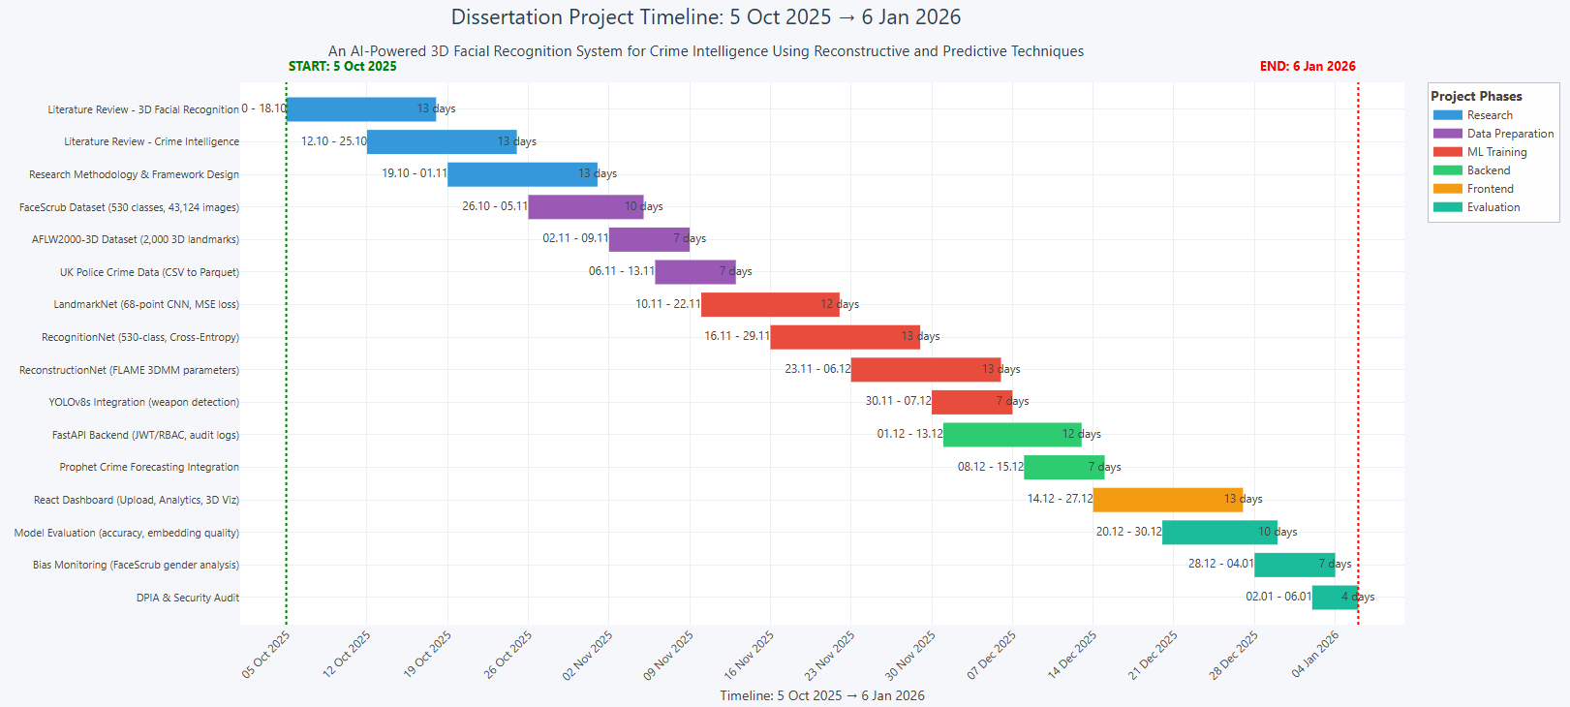
Figure 85. Project Timeline.

Appendix II – An AI-Powered 3-D Facial Recognition Framework for Crime Intelligence Using Reconstructive and Predictive Techniques GitHub Repository
Link to repository: https://github.com/CParaschivDev/AI-Powered-3D-Facial-Recognition-for-Crime-Intelligence-via-Reconstructive-and-Predictive-Methods/tree/main.

