

Task 1 – Reading Task Template
Upload your photo of your A3 in-class notes here:
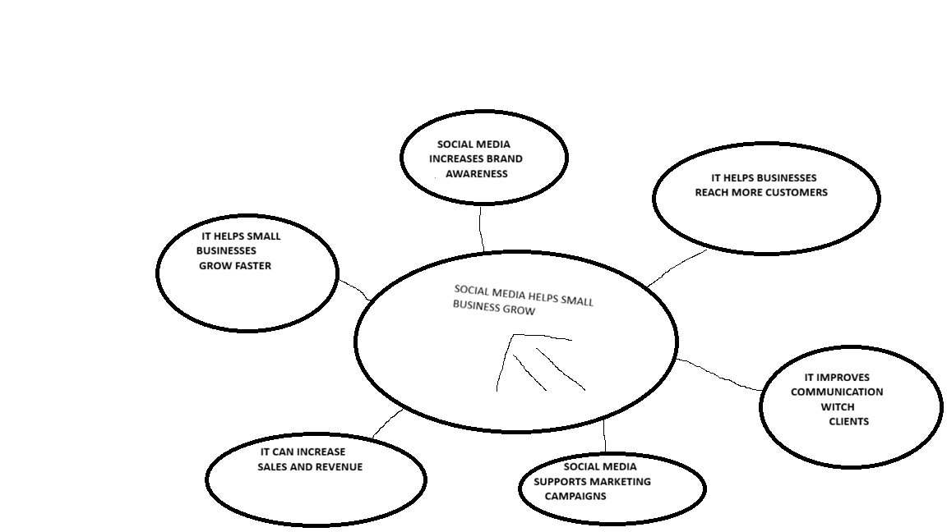

1. Answer these questions using the sentence starters below
a. What is the main idea of the text?
The main idea is that social media can help small businesses grow.
b. What are two key points?
One key point is that businesses can get more customers through social media.
Another key point is that they can talk to customers more easily.
c. What part of the text did you find most important? Why?
The most important part is that social media can help businesses become more popular because more people can see them.
d. Was anything unclear or difficult to understand?
I was not sure about some marketing words in the text.
e. How did your group help you understand the text better?
My group helped me by talking about the text and explaining some parts.
3. One sentence reflection
Question: What did you find challenging about this task?
The hardest part was choosing the most important information from the text

