Communication Report
Student name: Kalina Matharoo
Student ID: (2125136)
University Name: UWTSD

Executive Summary
This report is based on the case study of Pedro and Maria which is an example of poor communication technology. The top three models of communication are described here and the case study is also aligned with them. The importance of effective communication and necessary data on workplace communication is also provided here. The advantages and disadvantages of communication technology with various communication tools are also implemented here. Some examples of poor workplace communication and effective strategies for communication are also briefly described here.

Table of Contents
1. Introduction 3
2. Models of Communication 3
2.1 Shannon and Weaver Model of Communication 3
2.2 The Schramm Model of Communication 4
2.3 Helical Model of Communication 5
3. Communication skills 6
4. Advantages and disadvantages of communication technology 6
4.1 Advantages of communication technology 6
4.2 Disadvantage of communication technology 8
5. Poor communication example in the workplace 9
6. Suggestions to improve communication skills 10
7. Conclusion 11
References 12
Books and Journals 12
Websites 12

1. Introduction
The aim of this report is to identify the importance of communication in organisations with the help of provided case study. The report will include three different types of communication models and their importance in the provided case study. The importance of effective communication skills and the key skills will be also briefly described here. Apart from that, the report will also focus on the advantages and disadvantages of communication technology. Examples of poor communication in the workplace and proper suggestions for them will be also implemented here.

2. Models of Communication

2.1 Shannon and Weaver Model of Communication
Shannon-Weaver communication model is a mathematical theory of communication. This model is a linear model which is designed to create effective communication between the sender and receiver. There are various elements in the channel and these elements are affected by noise which creates issues between sender and receiver (Kubota, 2019). This model is very effective to improve the digital communication process. The five elements are information source, transmitter, channel, reception and destination. Communication is made through these elements and the noise effect on the channel. Effective communication enables the positive feedback process. As per the case study of Pedro and Maria noise affects the channel but due to poor technology proper messages are not provided to the receiver. The sender was Maria, the receiver was Pedro, the channel was cable and the distraction of voice plays the role of noise in this case study (Kubota, 2019).
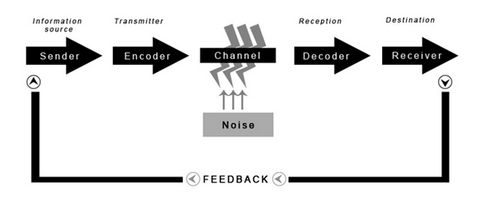
Figure 1: Shannon-Weaver’s Model of Communication
(Source: Communication Theory, 2022)

2.2 The Schramm Model of Communication
The Schramm Model of communication elaborates the view of Shannon-Weaver’s Communication model with some other components. This model defines two circles, one that includes the source and the encoder and the other circle includes the decoder and destination. Both of the circles are connected with the signal which carries the message (Kuznar and Yager, 2020). The messages are encoded by the sender and on the other part the receiver decodes the message and sends the feedback through the channel. Wilbur Schram also includes the concept of noise and the concert of interference in his model (Kuznar and Yager, 2020). This is a circular model and it is also an effective example for this case study. The noise affects the message of Maria and the receiver decodes the wrong message for Pedro.
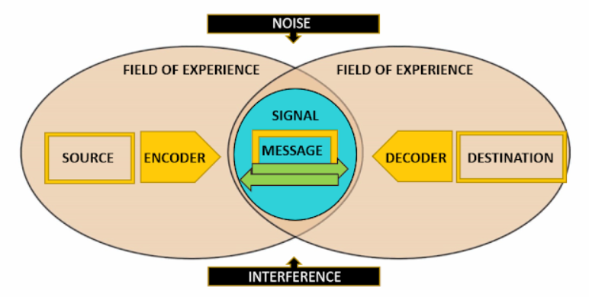
Figure 2: Schramm’s Model of Communication
(Source: Michelle Mathias fsp, 2020)

2.3 Helical Model of Communication
The helical model of communication is different from the other two communication models. Frank Dance provided his model in 1967 which is based on a helix. The name of this theory is also inspired by the helix as well. Other theories were based on a particular line of communication but this model does not provide any line for communication and also recognised communication as a non-linear and dynamic process (Communication theory, 2022). The helix structure of communication is a time-consuming process but it clearly defines every step of communication. This model basically works for personal relations as the communicators first share small information among their relations and it is gradually enhanced in the next levels. The final level of communication expands its boundaries with time.

3. Communication skills
Communication skill basically includes other interpersonal skills such as active listening, self-confidence, open mind, adaptation skill and many more. Communication skills can be divided into three basic parts: verbal communication, written communication and visual communication. Based on the reports 93% of organisational communication is non-verbal (Haiilo, 2022). Body language, eye contact, voice tones and attitudes define non-verbal communication. Another 7% of the organisational communication is verbal whereas most organisations encourage their employees to use effective communication. Every business organisation always gives first priority to communication skills while hiring new candidates. According to various reports, 98% of employees denote that communication skill is one of the top skills for management and sales profile (Haiilo, 2022). On the other hand, poor communication can affect the company's revenue as the company can lose £62.4 on average due to poor communication between the employees (Haiilo, 2022).

4. Advantages and disadvantages of communication technology

4.1 Advantages of communication technology
Improve organisational communication: An effective environment of proper information sharing can be developed in an organisation through communication technology. Every profit and non-profit organisation uses a centralised data storage system. Structured and organised information allows all the employees to access the data whenever they need it (Yang, 2018). The communication tools including email or phone calls make it easy for the lower-level employees to communicate with the managers.
Fast information sending: Communication technology has various tools which help to deliver information faster. Various communication tools such as e-mail, text messaging and others are very helpful to share information between other members through the commuting systems (Clement and Murugavel, 2018). Sharing is very easy with these tools because there is a whole database which controls and manages all data and information for an organisation.
Fast decision-making: Online Analytical Processing (OLAP) is a very useful communication tool for employees. They can ask any queries to the system and get quick responses which help them to make fast decisions. As per the view of Use of technology, (2022), implementing advanced communication technology in the workplace creates a faster decision-making process for the employees and management. The team members can easily communicate with each other and solve the problem in a short time.
Expanded market: Web conferences or other social networking sites help organisations to connect with global customers and employees from various locations. Currently, various UK organisations use hybrid work cultures and the online platforms provide various communication technologies to the organisations (Yang, 2018). Video conferences are a very effective way to communicate with remote workers. The employees also can communicate with other team members through advanced communication technologies.
Structured Organisational life: Communication technology basically works in digital methods so, there is no need to use pens and paper for communication (Clement and Murugavel, 2018). The employees can organise their professional data and information and also can get easy access to the information through an organised system. Less paperwork also makes professional and academic life easier (Use of technology, 2022). The UK organisations focus on their employee development and other sections in which time is saved by using communication technology.
Remove stereotypical classifications: Stereotypical defines the negative category of employees who reduce the productivity of other employees through face-to-face communication. The digitalisation of communication helps to reduce this challenge and the employees also can work in a more focused way.
Increase organisational participation: Communication technology helps the employees to reach their higher authority through e-mail or text messaging. Some employees sometimes feel shy or hesitate to ask for help with their problems. Direct communication increases their professional perception in the workplace. Apart from that, the employees also take effective participation in the creative thinking and decision-making processes.

4.2 Disadvantage of communication technology
Expensive system: Communication technology basically works through a centralised system. Implementing this technology in a large organisation can be very expensive for the company (Simpplr, 2021). The organisation also needs to create a strong database to collect all the data and information for the company. A strong database also increases the cost of the company. Implementing an updated computer-based system for every employee can easily increase their maintenance cost.
Lack of safety: Every digital technology requires high security and communication technology is not different also. All information of an organisation is included under a c4entralised technology system which can crash at any time. Various important data will be cleared out then and it can be an issue for the organisation (Clement and Murugavel, 2018). On the other hand, cyber-attacks are also very common on digital platforms. Attacks by hackers or viruses also can affect the personal data of the employees and organisation.
Poor substitute option: Face-to-face communication has its own impact on any organisation. Digital platforms and other communication tools increase productivity and reduce the miscommunication between employees but the employees also face problems due to a lack of knowledge about their colleagues. The shy employees get benefitted from using communication tools but they cannot improve their social skills (Koprowska, 2020). Overusing communication tools also can be distracting for the employees.
Difficult training system: The organisation is not only responsible for implementing the tools and technology in the workplace but they also need to train their employees in new technology. The training process does not work properly for all employees. Especially the senior or aged employees cannot adopt the new technologies faster and as a result, they prefer to resign from their job. The organisations also need to pay extra expenditure for the training system.

5. Poor communication example in the workplace
Unclear tasks: Poor communication in the workplace leads to unclear goals and objectives which also affect the required tasks of the employees (Koprowska, 2020). Lack of attention and unproductiveness also appears due to poor communication. Some medium companies in the UK face different issues due to poor communication in their organisations. Poor communication affects the management system of the company as well as the employees. Managers and leaders fail to provide proper direction or guidance and it creates a lot of confusion among the employees.
Limited feedback: Lack of communication is the cause of limited feedback in the workplace. Some SMEs face these issues in their workplace. Effective feedback always focuses on the employee's growth and also helps them to improve their weak areas (Coffelt et al., 2019). Due to a lack of communication, the leaders and seniors cannot provide proper feedback to their juniors (Simpplr, 2021).
Cultural diversity: Cultural diversity is one of the key elements of a successful organisation in the UK. Diverse work culture provides opportunities to employees of different backgrounds. Lack of effective communication increases the issues between various cultural backgrounds. Some UK medium organisations are currently focusing to improve their internal communication process which will be helpful for the diverse culture.
Low morale: Poor communication in the workplace also affects the employee morale of the organisation. Employees cannot properly understand the guidelines and face issues with deadlines (Coffelt et al., 2019). It also reduces their productivity and affects their self-esteem. Low workplace morale not only affects the employees but also can reduce the business growth of the company.

6. Suggestions to improve communication skills
Using intranet system: Using intranet for the workplace is very effective in today's work culture. Most of the employees are now connected through social platforms and organisations can use their personal intranet systems for promoting effective communication. Intranet system not only connects the employee's but it will also provide faster data and information sharing option to the management.
Video conferences: The management of the organisations can use video conference systems for their employees. A hybrid work culture increases the video conferencing platform as employees from anywhere can easily connect with the workplace (Predictive index, 2022). Implementing various video conferencing platforms will increase the response system of the organisations.
Improve company culture: The management also needs to focus on the company culture which is also essential for organisational communication. Organisational culture is one of the most important factors of an organisation as well as for the employees. Promoting each employee's innovation and ideas improves the communication system of the company.

7. Conclusion
The above report is focusing on the key models of communication including Shannon-Weaver’s model of communication, helical model of communication and Schramm’s model of communication. All of the models are aligned with the case study of Pedro and Maria. Various importance of effective communication skills is also implemented here with proper data and information. The advantages and disadvantages of communication technology in the workplace are briefly discussed in this report. UK organisations can suffer due to poor communication systems in the workplace. Various examples and effective strategies or suggestions are also evaluated here with proper explanation.

References

Books and Journals
Clement, A. and Murugavel, T., (2018). English for the workplace: The importance of English language skills for effective performance. The English Classroom, 20(1), pp.1-15.
Coffelt, T.A., Grauman, D. and Smith, F.L., (2019). Employers’ perspectives on workplace communication skills: The meaning of communication skills. Business and Professional Communication Quarterly, 82(4), pp.418-439.
Koprowska, J., (2020). Communication and interpersonal skills in social work. Sage.
Kubota, M., (2019). What is “Communication”?―Beyond the Shannon & Weaver’s Model―. International Journal, 13(1), pp.54-65.
Kuznar, L.A. and Yager, M., (2020). The Development of Communication Models, Quick Look. Joint Staff J39, Strategic Multi-layer Assessment Washington, DC United States.
Yang, Y.K., (2018). Influences of communication skill and interpersonal ability on clinical competence of nursing students. Journal of Korean Academy of Fundamentals of Nursing, 25(2), pp.99-108.

Websites
Communication theory, (2022). Helical Model of Communication Available at: https://www.communicationtheory.org/helical-model-of-communication/ [Accessed 19 July 2022]
Communication theory, (2022). Shannon and Weaver Model of Communication Available at: https://www.communicationtheory.org/shannon-and-weaver-model-of-communication/ [Accessed 19 July 2022]
Haiilo, (2022). Top 5 Communication Skills and How to Improve Them Available at: https://haiilo.com/blog/top-5-communication-skills-and-how-to-improve-them/ [Accessed 19 July 2022]
Michelle Mathias fsp, (2020). Schramm’s Model of Communication- An Interactional Model Available at: https://michellemathiasfsp.blogspot.com/2020/12/schramms-model-of-communication.html [Accessed 19 July 2022]
Predictive index, (2022). Five steps to improving organizational communication Available at: https://www.predictiveindex.com/blog/five-steps-to-improving-organizational-communication/ [Accessed 19 July 2022]
Simpplr, (2021). The Causes & Effects of Poor Communication in the Workplace Available at: https://www.simpplr.com/blog/2021/causes-effects-poor-communication-workplace/ [Accessed 19 July 2022]
Use of technology, (2022). Advantages and Disadvantages of Communication Technology in an Organization Available at: https://useoftechnology.com/advantages-disadvantages-communication-technology-organization/ [Accessed 19 July 2022]

