University of Wales Trinity Saint David

TRAVEL BLOG:
Travel in The Word

Module: LCBB4004 Marketing Fundamentals
Ze Zook

Irena Azgorova 1812800
Neli Atanasova 1813125
Vasil Kalachev 1813111
INTRODUCTION

We are Irena, Nelly and Vasil. We are travel connoisseurs who want to share their passion for travelling with you. In our blog you can find lots of good travel tips based on our personal experience.
Travel in the World is a blog which is created to promote tourism around the world. Posting blogs related to different places increases the interest of people to daily visit the blog, showing the specialty of different places like mosques In Istanbul, buildings in Barcelona, beaches in Punta Cana, etc.

Link to the Blog:
https://uwtsd201920.wixsite.com/mysite?fbclid=IwAR2OZ3Jge_qGxS8ugCJAVaAmH2xtdr8I-d3BmfHmI7YQ0Q_kp3Ei6S7bbR8

Barcelona

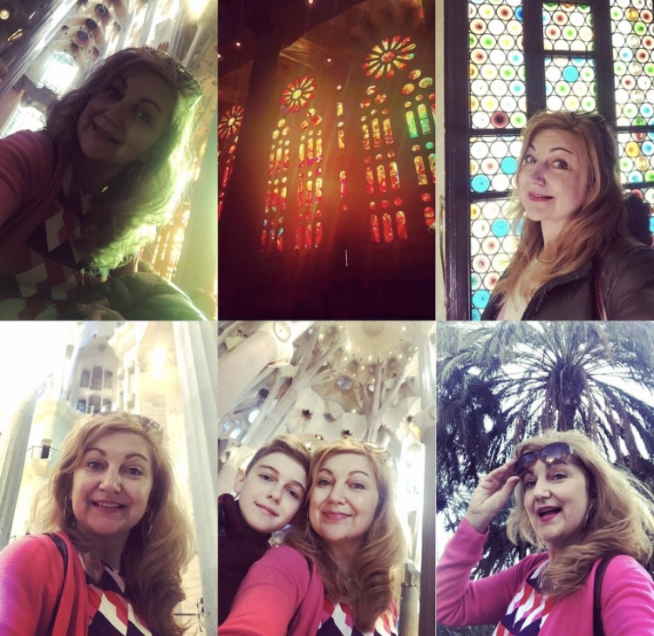

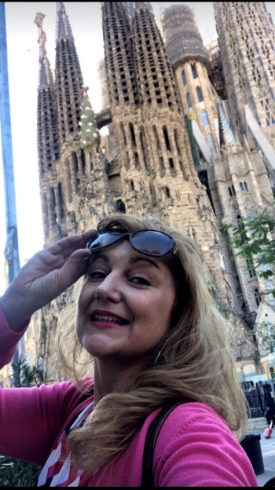
This year of the middle of April was special not only because it was my birthday, but also because we both with my son and I decided to spend some time together and travel to Spain and we chose Barcelona.

We had no expectations, we just wanted to be together and explore the city as much as we can.
We were staying in a small but nice and cheap hotel in the heart of the town center - hotel Medicis.

Casa Mila, also known as La Pedrera was built by Gaudi was our first attraction. Exactly in his style, Casa Mila surprised us with its uniqueness and artistic value.
La Sagrada Familia

One of the most popular building and Gaudi's greatest is “La Sagrada Familia”. The construction of the church started in 19th century and continues. Anyway, the size and all the details, which Gaudi created are breathtaking.
From Casa Mila to La Sagrada Familia - 18 min by foot.

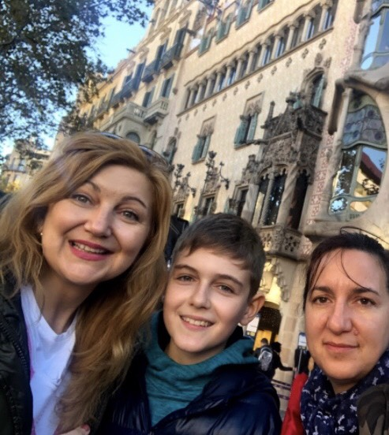
Casa Battlo is also created by the talented architect Gaudi. The walls of the building are covered by very small broken ceramic tiles, which create a colorful mosaic. Because of the long line in front of the gate we didn’t have a chance to get inside. If you plan to visit Barcelona, don’t miss it! Get your tickets in advance here.

Casa Battlo
From La Sagrada Familia to Casa Batllo - 25 min by foot.

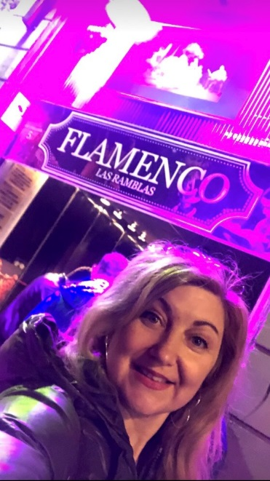
Las Ramblas is the most crowded street in the heart of Barcelona. You can go shopping, have lunch, drink a cocktail or just look the street entertainments. My mom and I didn’t spend so much time there, because of all the people around us. Las Ramblas is one of the most popular places to get pick – pocketed. Better to be careful walking through it.
From Casa Battlo to Las Ramblas - 17 min by foot.
The main street Las Ramblas is very close to The Gothic Quarter. You can spend an hour walking around this area and exploring the amazing buildings and tight streets between them. Here you can stop for a lunch and try the typical Tapas, which are small appetizers and can be served hot or cold. The one we ate was tortillas with guacamole. I loved them, but if you are not really into Spanish cuisine, I suggest you try paella – rice dish with seafood. Flamenco in The Las Ramblas
From Las Ramblas to Gothic Quarter - 6 min by foot.

For evening activities, I suggest you visit the dancing fountains or to watch a Flamenco show. They are lovely guitarists and passion dancers – amazing one and a half hours program.
Park Guell is another Gaudi’s work which is a large park with many attractions inside. The most interesting things there are the main terrace area and mosaic bench. The place where Gaudi spent his last 20 years of his life is also inside the park. You can take a walk around the park for free, but if you want to reach the key attractions, they do require a ticket. The best way to have it is to order online here.
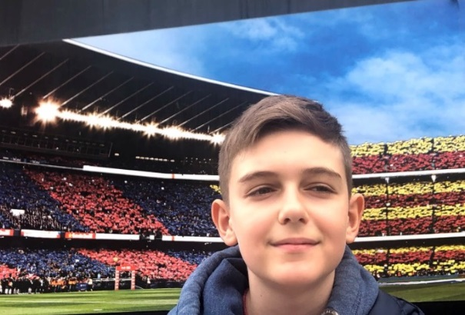
Everybody knows that Barcelona has good football team and my son is a fan. I recommend you visit Camp Nou – the home stadium of FC Barcelona. We took a lot of pictures and went to the shop and I bought a special footballs shoes for my son on special discount.

Camp Nou
By buying a Barcelona Pass you will find that it comes with free bike tour. Even that Barcelona is a big city it is super easy to move around. Bus and metro are widely available and thankfully to the great sightseeing locations you can even walk between them.

References:
Ticket for Park Guell - http://www.parkguelltickets.org/?gclid=CjwKCAjwqZPrBRBnEiwAmNJsNuCj3cS_gfhy12EuqiMK1AfVAqil0a1BxCFdRnU-WXOcgF1cvUpx-BoCaKUQAvD_BwE&utm_expid=.cxXHx0QVTNiXAHe5VhTiLw.0&utm_referrer=https%3A%2F%2Fwww.google.com%2F
Ticket for Casa Batllo https://www.tiqets.com/en/barcelona-c66342/casa-batll-l141895?&utm_source=google&utm_medium=cpc&utm_campaign=1407469560&utm_content=62921295739&gclid=EAIaIQobChMI_ICsy-qh5AIVV-DtCh14QghgEAAYASAAEgK1CPD_BwE&gclsrc=aw.ds
Barcelona Pass - https://www.barcelonapass.com/

by Nelly Atanasova

https://uwtsd201920.wixsite.com/mysite/post/barcelona-presented-by-neli-atanasova?fbclid=IwAR2WOy5gZxMFtvvuYsGlS1F6nP2jHgloMBwkKB09S8BDnoFHlE6SDEaULCk

The Seven Rila Lakes

Bulgaria is famous for very beautiful nature and energetics places. If someone asks me what the nature of Bulgaria looks like, the first things coming out of my mind are the beautiful mountains.

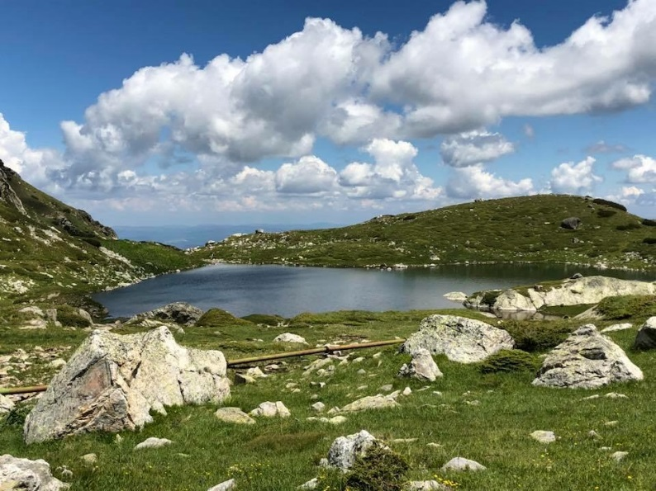
The Rila mountain is one of the most beautiful mountains in the Balkans. It has really energetics place named Seven Rila Lakes. They are a group of glacial lakes situated in the northwestern Rila Mountains. With crystal clear water, their beauty touches thousands of Bulgarian and international visitors. Based on the shapes, each lake has its own name.
The highest lake which you can reach by foot from the lift is the Tear Lake and it is located at 2,535 meters above the sea level. The next one, Eye Lake, is the deepest one with a depth of 37,5 meters. A little bit lower than the Eye Lake, you can find the Kidney Lake, named after its kidney shape. This lake stole my heart. It is so peaceful. It is one of those places you don’t want to leave after visiting them. The next lake is called the Twins Lake.
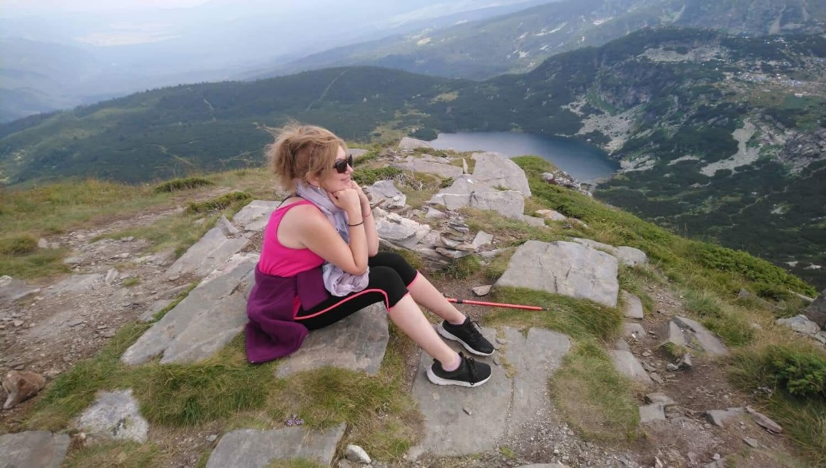
The Tear Lake
It is interesting that this lake looks like one huge lake with a thin source in the middle. It looks like there are two twin lakes, connected with a fine river. It is known that during dry years, the fine river dries off and the lake becomes two separate lakes. The other lakes are Three-leafed Lake and Fish Lake. The lowest lake is named Lower Lake. It is interesting that the lakes are all connected by narrow streams.
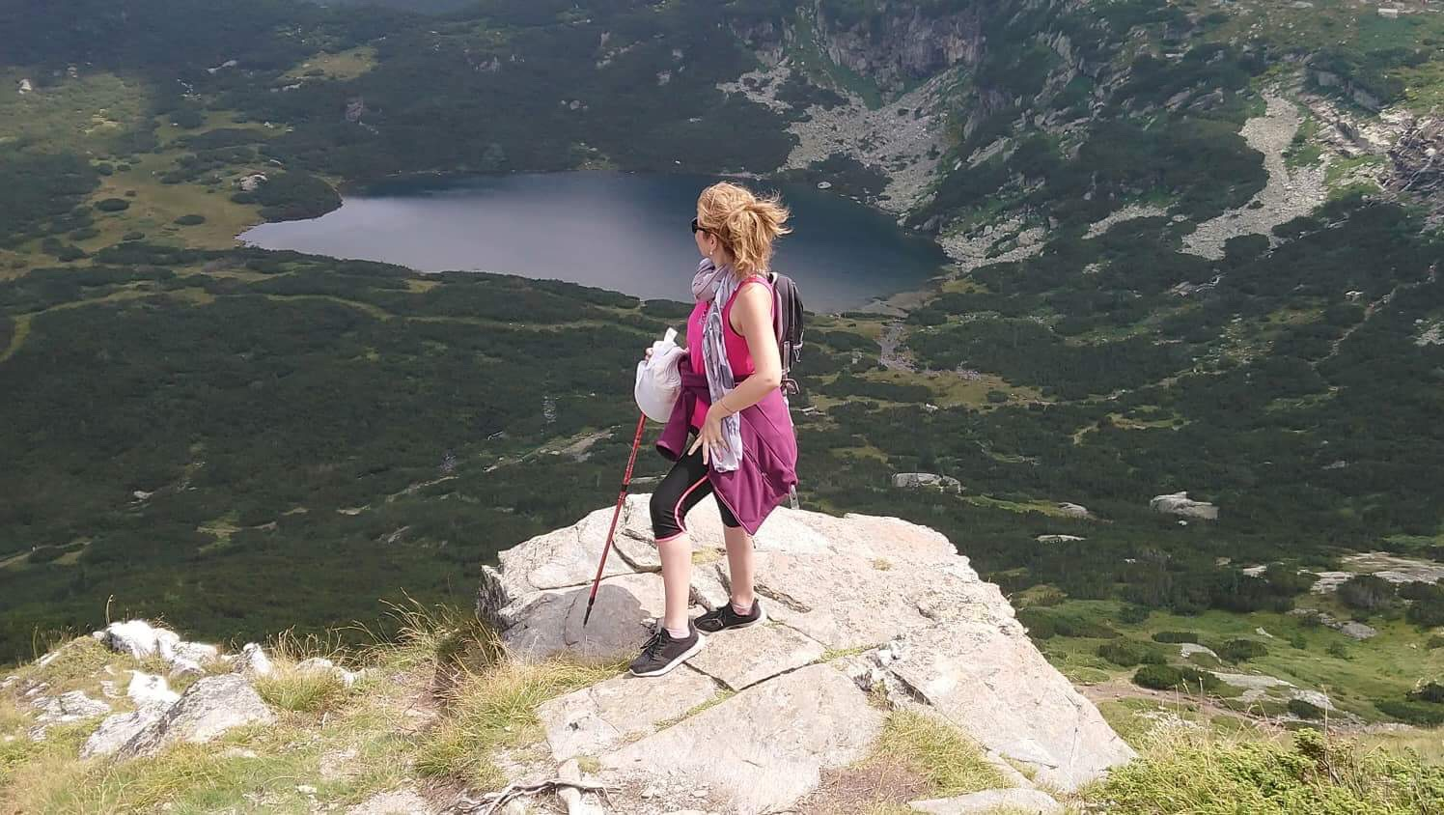
Once has three options to get to Sapareva banya – small town at foot of the Rila mountain – by car, by bus or by taxi. From the capital of Bulgaria Sofia, you can reach The Seven Rila Lakes with a car when driving to Sapareva Banya for approximately 2 hours. Once you get to the city, you can easily find the entrance of Rila National Park by following the signs.
There is a shuttle bus from Sapareva banya to the Pionerska hut and back. The timetable.
When you enter the National Park, you have three options for reaching:
• By foot, which will take you around an hour and a half. Make sure you have good equipment and comfy shoes because the displacement is around 500m.
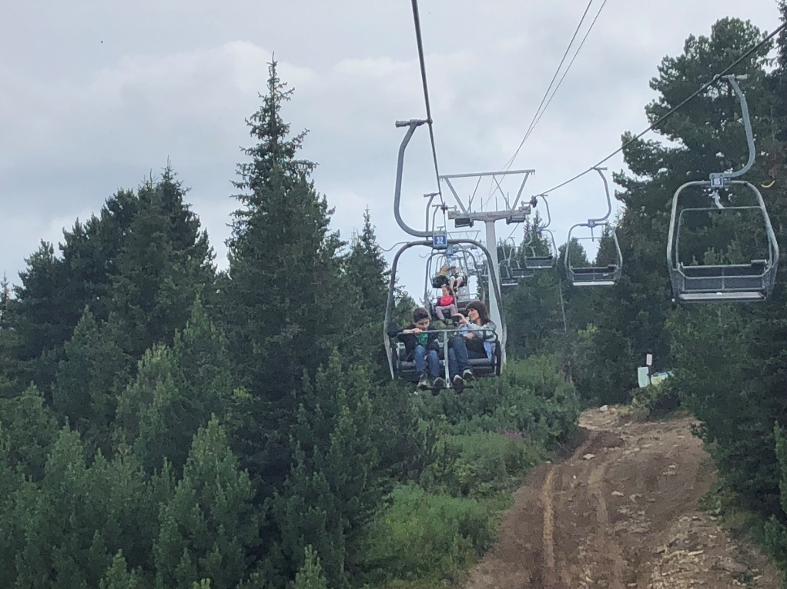
By lift to The Seven Rila Lakes
• By using the lift, you can reach the cabin in 20 minutes. The price of the lift ticket is 10 lv per person and during the transport, you can enjoy the beautiful mountain nature from above.
• In case the lift is not working yet, you can take a 4x4 vehicle and enjoy an adrenaline mountain ride for 20 minutes on the highest rocks. The price per person is the same – 10 leva.
Once you reach the cabin, you can start hiking. For approximately 4-5 hours, you will reach the highest point, from where you will be able to see all the Seven Lakes. The atmosphere up there is stunning and you can`t control your tears coming down...
The Seven Lakes area is a very attractive place not only for foreign tourists but also for Bulgarians. With its charm of a place away from the civilization, high up in the mountains, an extraordinary beauty of the crystal-clear water lakes, and spiritual sense, this place is one of the Bulgarian miracles.

References:
https://bgstay.com/en-t-119-hotels-in-sapareva_banya-bulgaria
https://rilskiezera.bg/en/
https://www.bulgariatravel.org/en/Article/Details/2047/Mountain%20Ski%20Tourism#map=6/42.750/25.380
by Nelly Atanasova
https://uwtsd201920.wixsite.com/mysite/post/the-seven-rila-lakes-by-nelly-atanasova?fbclid=IwAR2OZ3Jge_qGxS8ugCJAVaAmH2xtdr8I-d3BmfHmI7YQ0Q_kp3Ei6S7bbR8

Lefkada
When you go to Lefkada for the first time, you will fall in love with this island. Let me show you why…
Lefkada can offer you some of the most amazing sandy beaches with turquoise water:

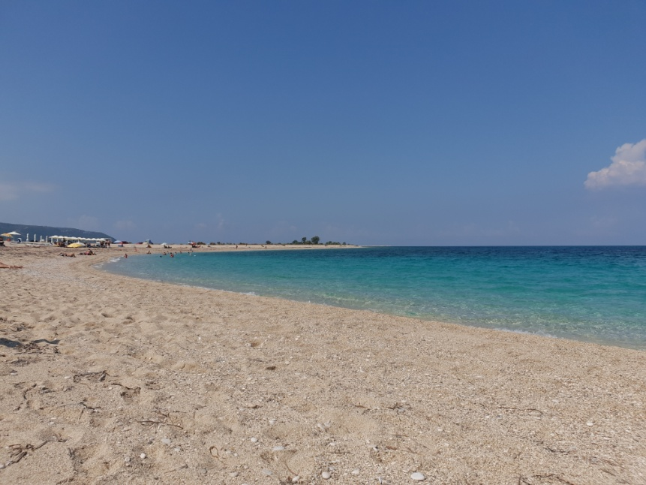
Lefkada town beach
Porto Katsiki Beach - the most famous and beach that connects to the island. It was once accessible only by goats. It is famous for its landscape and crystal clear and blue water.
Egremni Beach - is one of the most beautiful on the island and is one of the most famous tourist destinations in Greece and throughout Europe as a whole. It is famous for its remarkable blue and clear water and its long sandy strip. Today it is accessible only by water.
Kalamitsi Beach (Kavalikefta beach) - lovely and small with crystal clear water. Perfect for swimming, water jumps and snorkeling.
Kathisma Beach - one of the longest in Lefkada with sandy strip, glittering waters and incredible turquoise water. Ideal for a variety of water sports and especially parachute jumping. Here you can also find quite stormy sea and big waves.
6 Things to Do in Lefkada:
• Explore the island with a scooter.
• Take a day tour to some of the neighboring islands.
• Rent a boat and explore some hidden beach that is inaccessible by land.
• Go and try some of the most popular sports on the island for windsurfing, kitesurfing and parachuting.
• Jump into the water from a rock or boat.
• Eat fresh fish at a local restaurant.

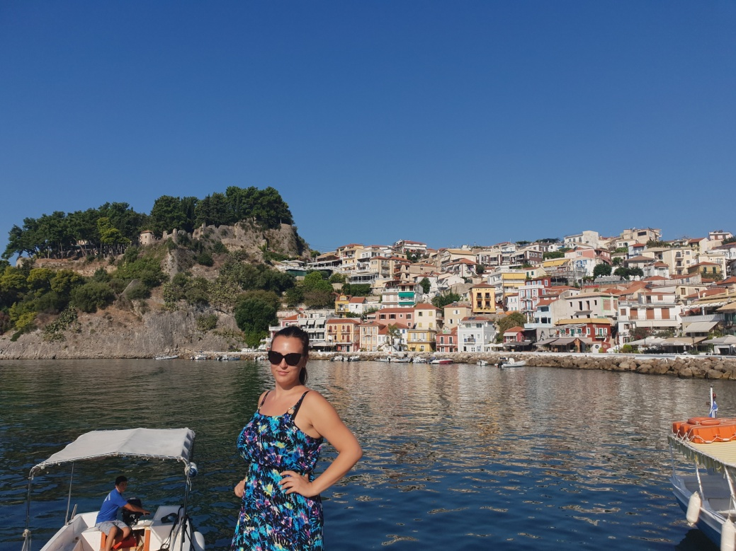
Parga
The seven best beaches in Lefkada are on the west side of the island. Here are some of them:
Porto Katsiki
One of Lefkada's main beaches and one of the seven best beaches in Lefkada. It is located 45 kilometers southwest of the island's capital and near the village of Atani. The white rocks form a wild but magnificent backdrop and unique harmony with the deep blue waters of the Ionian Sea. A few steps will take you directly to the beach. At the top of the stairs there is a car and motorcycle parking, as well as a bar with unique views.

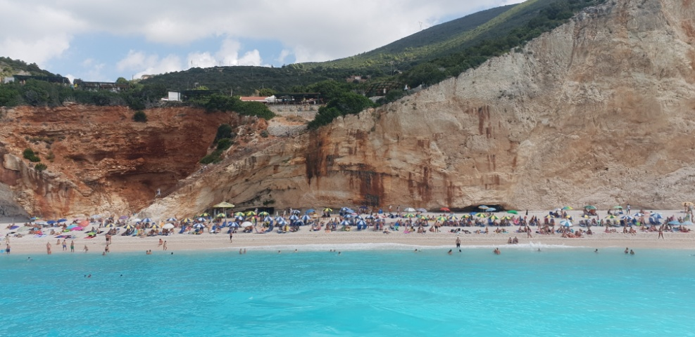
Porto Katsiki
Egremni
Beautiful beach located 40 kilometers southwest of Lefkada. It is surrounded by impressive white rocks that create a magnificent backdrop.
Kathisma
Beautiful long beach covered with sand. Located 15 kilometers southwest of the capital, near the village of Agios Nikitas. It is very preferred among young people and is also a very popular destination for water sports and parachuting. Numerous lounge chairs and umbrellas cover the huge beach, and at the end there are rocks to jump from. There are quite a few lodgings nearby.
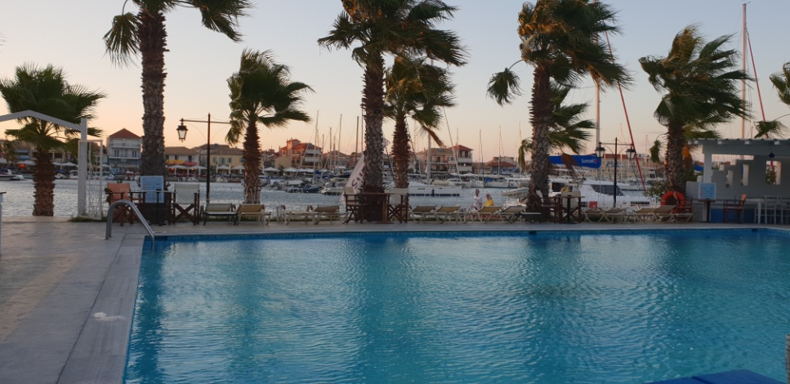
Lefkada Marina
Kalamitzi (Kavalikefta)
One of my favorite beaches, located 15 kilometers southwest of the capital Lefkada. It is very small and rocky. These rocks give it a special charm and provide privacy. They are great for jumping. The sea is turquoise and the coast is gravelly. The sunsets here are incredible. Many people do not know about him or prefer beaches with a long strip and for that he is calm. There is a small café providing fresh drinks.
Pefkoulia
A very beautiful beach just 1.5 km from Agios Nikitas village. It is mostly covered with sand, but in some parts you will also find small rocks. Near it you can find hotels, restaurants and taverns. There is plenty of parking just 50 meters away (near the main road), most of which are free.
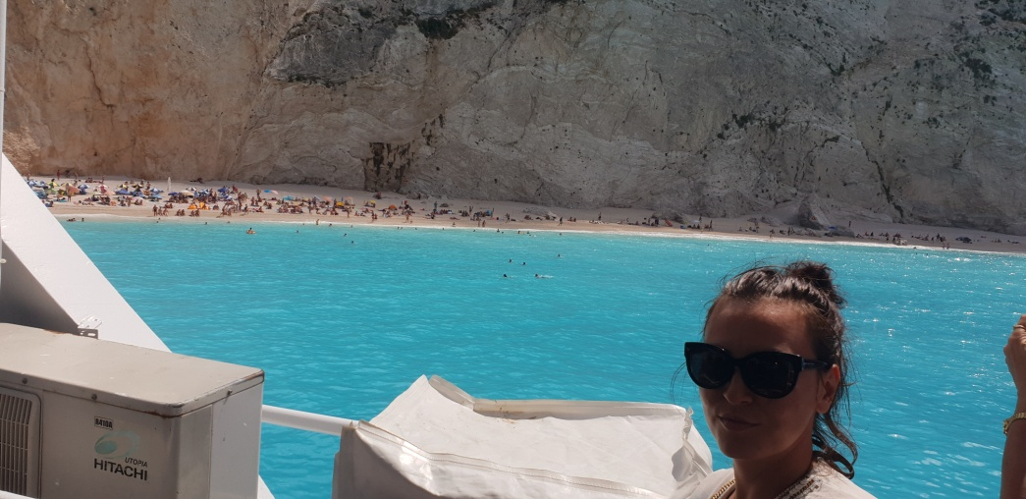
Pefkoulia beach
Mikros Gialos
It is located 30 km south of the capital, near the village of Poros. The beach has sun beds, umbrellas, tavernas and snack bars. It has gravel on both the shore and in the water, so it is good to have beach shoes for safe and comfortable walking. It is located in the bay, and the sea is always calm, there is no wind and waves. The water depth is gradual. Boats and kayaks can be rented on the beach. It is excellent for diving.
Ammoussa
The beach is small and is located 35 km from Lefkada, 22 km from Nidri

References:
https://vsichkioferti.bg/blog/10-ot-nay-dobrite-plazhove-na-o-lefkada/
https://www.feelgreece.com/bg/blog/top-beaches-lefkada
(presented by: Irena Azgorova)

https://uwtsd201920.wixsite.com/mysite/post/lefkada?fbclid=IwAR2OZ3Jge_qGxS8ugCJAVaAmH2xtdr8I-d3BmfHmI7YQ0Q_kp3Ei6S7bbR8

Punta Cana
Punta Cana is one of the most beautiful places on earth and an extremely popular destination in the Caribbean. Here you will enjoy tropical climate, white sandy beaches with crystal clear waters and beautiful coral reefs
I have prepared 5 reasons for you to collect your suitcases today.
1. In general, the temperature in the Dominican Republic is relatively high throughout the year. Punta Cana, located in its eastern part, has a tropical climate of two seasons - dry and humid. The average annual temperature is 26 ° C. The wet season lasts from May to October, and the daily temperature during these months can reach 35 ° C. During the dry season, November through April, daytime temperatures are around 28 ° C and nighttime temperatures are down to 20 ° C. The most appropriate month for swimming in the sea is in August, when the average water temperature is 29 ° C.
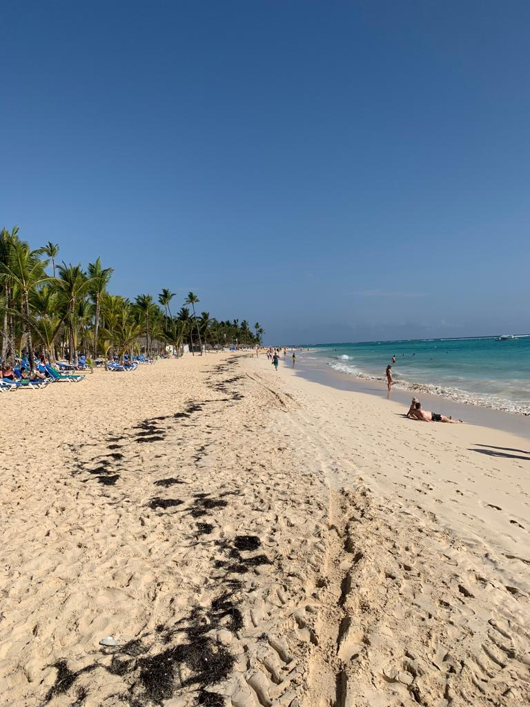
Bavaro beach
2. The beaches
The Dominican Republic has huge beach areas and the most popular among tourists are those in the Punta Cana area. Turquoise waters and white sands are the main magnet for lovers of fascinating seascapes. There you will find a 35 km long beach with 8 main beaches.
Bavaro beach
Several of the beaches rank among the best in the world and have been awarded the Blue Flag Award. In fact, the Dominican Republic has the most Blue Flag beaches of all the Caribbean islands. One of the most famous is the Bavaro with pearl white sand and coconut palms. There are bars and discos here filled with American and Canadian youth during the spring break days. Diving particularly interesting here will be the coral reefs and the underwater caves.

- The Dominicans are friendly and welcoming

One of the most welcoming destinations is Punta Cana. Since about 80% of the economy of the Dominican Republic relies on tourism, absolutely everyone likes tourists - something you will rarely see elsewhere. The attitude of the Dominicans is always positive and warm. The hotel staff is ready to make every visitor feel at home. There they will take care of you from the first to the last day of the holiday.
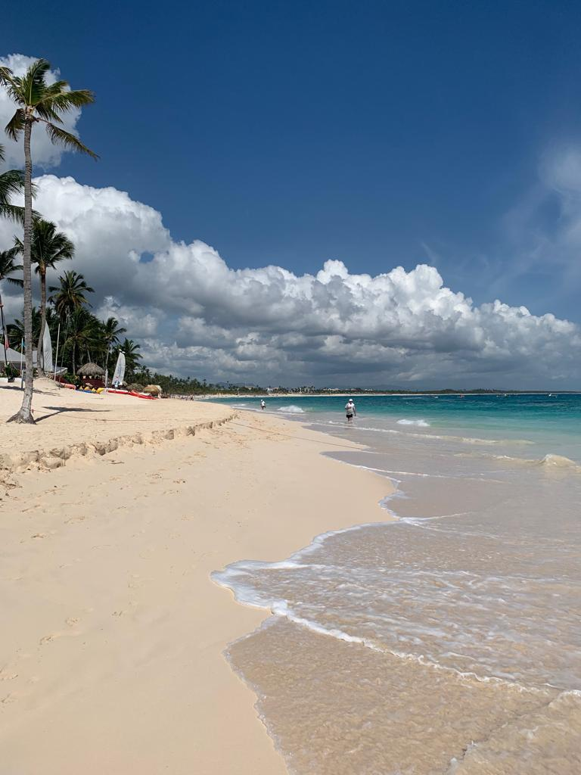
Riu Palace Punta Cana
2. Entertainment
Punta Cana is a place you will always have something to do. From snorkeling or kayaking to ATV walks - there is everything for everyone. Romantics can enjoy horseback riding on one of the beaches while enjoying the endless sea. For adventurers, a zip line is offered in the forests of Punta Cana. And for the fans of the animals, swimming is organized with the intelligent and friendly mammals - the dolphins.

References:
https://blog.bohemia.bg/пунта-кана-диамантът-на-доминиканск/
https://cvetybaby.com/punta-cana-dominican-republic/

(presented by Irena Azgorova)

https://uwtsd201920.wixsite.com/mysite/post/punta-cana?fbclid=IwAR2OZ3Jge_qGxS8ugCJAVaAmH2xtdr8I-d3BmfHmI7YQ0Q_kp3Ei6S7bbR8

Istanbul
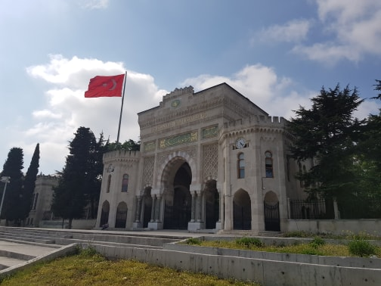
Surrounded by the Bosporus, a natural strait separating Europe and Asia, Istanbul is a two-city tale. On the European side of this throbbing metropolis are some of the city's iconic landmarks, such as the Blue Mosque and Saint Sophia - remarkable features that give this part of Istanbul a fair share of international fame. Go to the Asian part of Istanbul and things are more relaxed - local cafes and micro-businesses blurring give this part of the city a vintage and homey feel when compared to the fiercer nature of your European counterpart.
What to do in the European part of Istanbul?
The most iconic landmarks of the European part of Istanbul are near one another and can be easily seen throughout the day if you dive into the details. However, if the weather is not on your side, you can easily scroll through the main sights of the Sultanahmet area in half a day or less.
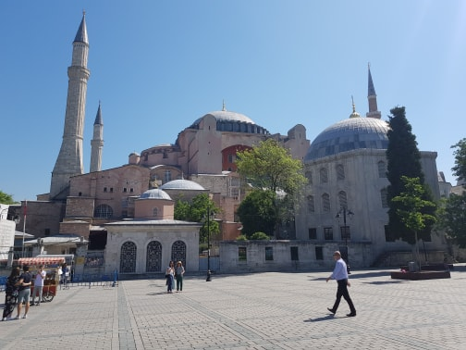
Clear your world history in Sultanahmet In the Sultanahmet district of Fatih there are the Blue Mosque, the Church of Saint Sofia and the rich Topkapi Palace, which are connected by spacious, green gardens. Start at the iconic Blue Mosque (so called because of the handmade blue ceramic tiles in the interior). 200 stained glass windows and over 20,000 tiles and hundreds of square meters of soft red carpet knitted with mysterious symbols like tulips await in the mosque's richly decorated interior. Keep your eyes open for ostrich eggs placed on rooftop chandeliers - an age-old spider web repellent system that keeps mosque spiders from enjoying them. As you recreate the vivid impressions of the Blue Mosque, make your way to the only building that can rival it about a kilometer away - St. Sofia, which is less than 10 minutes' walk away.
Saint Sophia began as a church around 360 AD, when it was known as the Magna Ecclesia (Grand Church), before being plundered in 1453 by Ottoman forces who destroyed Constantinople (now Istanbul). The Sultan of the Ottoman Empire, Mehmed II, put an end to the robberies and turned the church into a mosque, a status that remained until 1934. While in this village museum, watch the clash of religious ties that have left their mark on its architecture - from defiled crosses to pagan installations like the pillar of desire: a small hole in which you can stick your hand and rotate your palm 360 degrees while making a wish. Complete the tour of emblematic coins from the Sultanahmet area with a tour of Topkapi Palace, the imperial residence of the Ottoman sultans for almost 400 years. Much of the complex remains outside the public, but you can still get into the harem - an interior space reserved for wives, concubines and female servants.
Get lost in the bazaar.
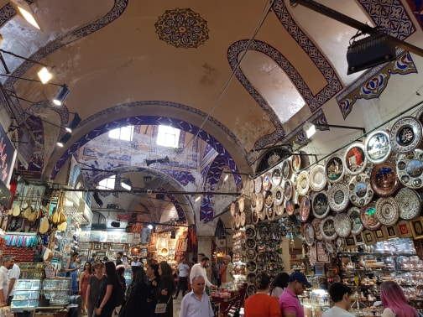
Stretch your legs and head for the Kapal Charshi, which you will find a mile from Topkapi Palace, which is still in Fatih. Situated inside a fenced-in city, it is one of the oldest covered markets in the world, spanning over 61 covered streets with more than 4,000 stores.
Truffles and all kinds of spices, lanterns and other goods, alleys have been collected here. Take a deep breath and bring your market agreement to make the transition through these ancient passages.
What to do in the Asian part of Istanbul?
The Asian part of Istanbul is less grandiose than its European counterpart and can be seen on a peaceful day. Not so much the sites that define it as the local atmosphere and cozy feel, underscored by the friendly nature of the people in this part of the city.
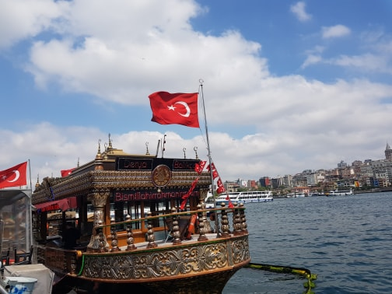
The Kadikoy area is the perfect counter to the more visited landmarks of the European part of Istanbul. The marble sea views along the coast and the many restaurants, cafes and small markets give Kadikoy a warm and welcoming feel, which is only emphasized by the attractive culture of the people of Istanbul who visit the area frequently.
Sit down at one of the many establishments, order Turkish coffee and let it all sink. While here - swing at Haydarpaşa terminal, where services are currently paused indefinitely to look at the historic icon of the Orient.

Try traditional yogurt at Kanlıca.
Kanlıca is home to numerous beachfront cafés serving creamy yoghurt covered with a rich sprinkle of castor sugar. Beyond the wonderful dairy, enjoy the tranquility of this quiet pocket of Asian Istanbul and a drop from the Kanlıca Cemetery on the hill overlooking the Bosphorus for some great views.

Take a Bosphorus Boat Tour Any trip to the economic and cultural epicenter of Turkey, Istanbul, would be incomplete without getting to a Bosphorus boat. This natural waterway at the top of continental Europe and Asia connects the Black Sea with the Marble Sea and beyond it the Aegean Sea and the Mediterranean Sea.

by Vasil Kalachev
https://uwtsd201920.wixsite.com/mysite/post/istanbul?fbclid=IwAR2OZ3Jge_qGxS8ugCJAVaAmH2xtdr8I-d3BmfHmI7YQ0Q_kp3Ei6S7bbR8

Bologna
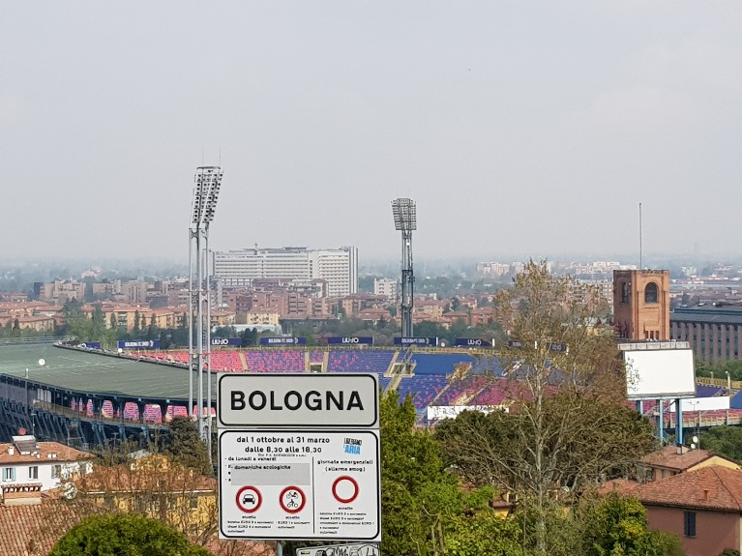
Bologna is one of the most beautiful and wealthy cities in Italy that will welcome you and enthrall you with an authentic feeling that you will not find anywhere else.
The fertile lands were the reason for the settlement to emerge here as early as 534 BC. The city is known not only for its rich history, beautiful architecture, the university, but also for its endless delicious specialties and wines. Many of the traditional Italian dishes are born here. It's no secret that Italians turn food into art and ritual, and the Bolognesians are no exception. It is no accident that they often call the town "Fat Bologna".

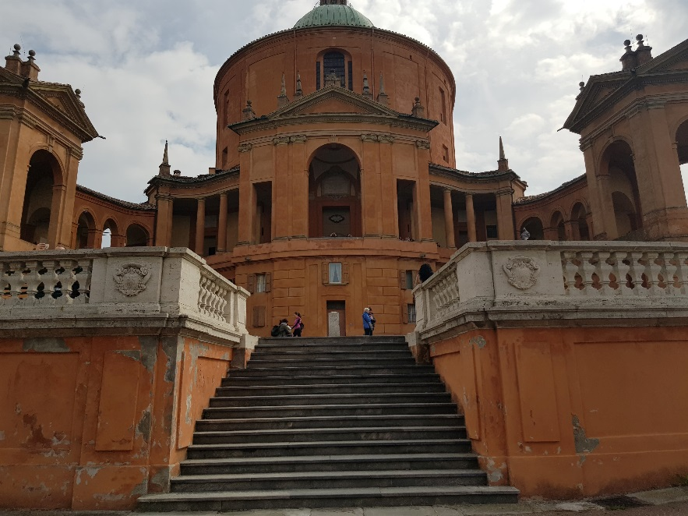
The two towers of Garisenda and Azinelli (Le due torri Garisenda e Asinelli) are known as the towers of Bologna and are the symbol of the city. They were built in the early 12th century, when it was widespread practice to build towers of any known family. Thus they displayed their power, prestige and wealth. There were over 170 towers in medieval Bologna, but only a few have survived to this day.
Gorizenda and Azinelli are the most famous.

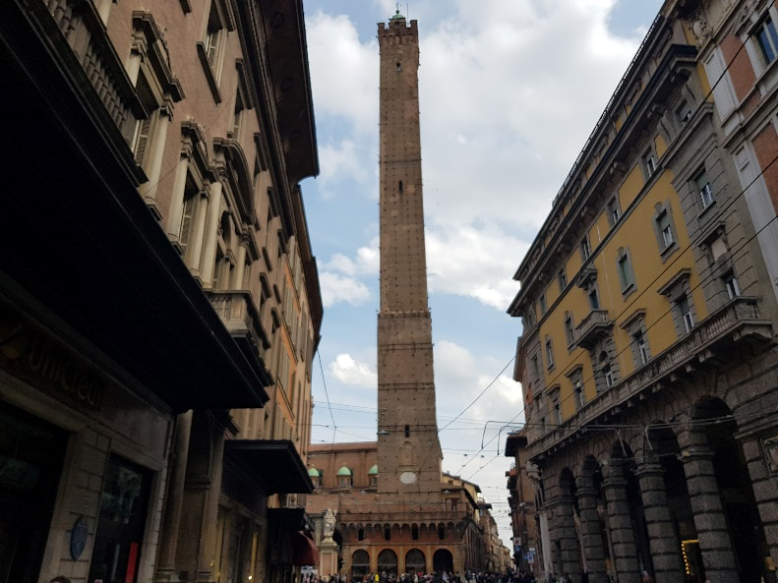
Gorizenda is 49 meters high but was originally higher. Unhealthy foundations cause the tower to slope 3.2 meters as far back as 1360, and its top is collapsed for safety reasons. Garisenda has since been closed to visitors. However, the Azinelli family manage to build their tower up to an impressive 97 meters. It also has a slight slope but is open to visitors. Azinelli is not just a tourist attraction but a real adventure.
The Archiginnasio di Bologna is the first seat of the University of Bologna (Alma Mater Studiorum), the oldest university in the Western world opened in 1088 when Bologna was rich and independent. Before Arkiginasio was built between 1562 and 1563, lectures were held in private homes or rented houses, religious buildings and even squares.

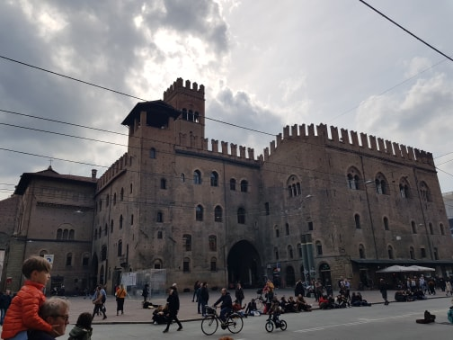
Via Indipendenza is a street you can't miss while strolling through Bologna. It is the main shopping street that will take you straight to the heart of the city. But here, besides the shops, you will find other interesting things along the way. Right at the beginning of the street is one of the old city gates - the Porta Galliera. You can stop by for an extra stroll at the largest city park, Montcoyola. On the same street is the Arena del Sol Sole, as well as the equestrian statue of Giuseppe Garibaldi.

Piazza Maggiore is the main square in Bologna, and as we know the piazza is the social center of every Italian city. If you want to enjoy it real, do it at sunset and / or at night. Really stunning. Walk slowly across the square and sit down at one of the cafes or some of the last rows of stairs in front of San Petronio Church. To be even more romantic, take a stroll along the Piazza Santo Stefano. Compared to Piazza Maggiore, Santo Stefano is smaller, but just as emotional - and definitely more intimate. Just enjoy it.
Quadrilatero - Tour the streets of Quadrilatero, a medieval marketplace where you can see stalls and old shops selling different types of delicacies. Here is where you can buy all these famous Bolognese and Italian specialties: tortellini, tagliatelle and other handmade pasta, mortadella, Parmigiano Reggio, the distinctive Bolognese Ragu sauce, and the local wines Pinioletto, Lambrusco and Sangiovese. A stroll through the narrow streets and the market will take you back to true medieval Bologna.
The Basilica di San Domenico, which is said to be a treasure trove of art, was built in the 13th century. Here you can see works by the young Michelangelo, Nicolas Pisano, Arnolfo di Cambio, Filipino Lippi and more. The founder of the Catholic Order - San Dominic - is buried in the basilica.

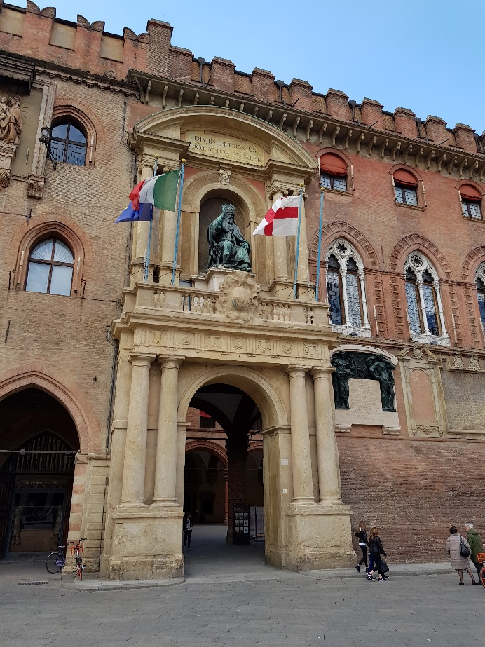
Bolognese specialties - One of the must do things in Bologna is to try all their specialties. The city is the birthplace of tortellini and Bolognese sauce. Try tortellini with sage and butter, tagliatelle with ragu sauce (bolognese), mortadella, crescini with sausage, crackin and squash. All this should be accompanied by the local white wine Piniolet or red Lambrusco. Via Pescherie Vecchie is the place where gourmets will find their paradise amidst fine cheeses and ham from the Emilia-Romagna region.
Peak San Luca is the perfect way to burn calories from Bologna food, though each one is well worth it. You will climb to it below the longest portico in the world - 3.8 km and 666 arcades. The prize is the beautiful sanctuary of the Basilica of San Luca on the top of the hill.

Aperitif - The best way to end the day is with an aperitif at one of the many bars downtown. To make it like the Bolognesians, order a syringe (spritz) - a drink made by Proseco and Aperol (the more bitter version is prepared with Campari instead of Aperol). What makes Aperitivo so special is that when you order it, you also get access to a buffet full of food. Typically, the bars open about 19 hours.

by Vasil Kalachev

https://uwtsd201920.wixsite.com/mysite/post/bologna?fbclid=IwAR2OZ3Jge_qGxS8ugCJAVaAmH2xtdr8I-d3BmfHmI7YQ0Q_kp3Ei6S7bbR8

