Critical Evaluation of Marketing Activities of Apple Inc.

NAME | Sadia Anjum
STUDENT NUMBER | 1708775
PROGRAM | Masters of Business Administration
MODULE | Marketing Management
MODULE CODE | LCMB7001_BIRM
LECTURER | Dr Olu Adegbite

Executive summary:
Apple is an information technology company with a wide range od products and services. Evidently it is a very profitable company. They increase their revenue by innovations and impressive customer service for their loyal customers. Apple company was established in 1976. At the beginning, they struggled to make profit but slowly they started the trend of innovation and specific target market.
Apple competes with other information technology companies such as: Samsung, Google, Microsoft, etc. but Apple is always ahead of them with their innovation and high-end and high-priced products. They have effective marketing strategy which enables them to scan the competitions, the internal organisational environment and external environment and identify issues which can have impact on their market. Apple apply MKIS and STO marketing model for their marketing strategy.
They investigate their marketing mix to find what consumer demands are, what their stronger and weaker demographics and geographics. Their success is measured by the statistics of their sales, revenue, profit margin, etc.
This report has investigated the marketing activities of Apple Inc. and found some short-comings and weaknesses that the company has and has made some recommendations for Apple Inc. regarding their future strategies.
Contents
List of figures: 4
1.0 Introduction: 5
2.0 Company overview: 6
3.0 Environment scanning for marketing information system: 7
3.1 Internal and external environment analysis: 8
4.0 Marketing information System: 9
5.0 STP marketing model: 11
5.1 Segmentation: 11
5.2 Target market: 12
5.3 Positioning: 13
6.0 Marketing mix: 14
6.1 Product: 14
6.2 Place: 16
6.3 Price: 16
6.4 Promotion: 17
6.5 Media: 17
7.0 Measure success: 18
8.0 Conclusion: 19
9.0 Recommendations: 20
Reference list: 21
Appendix 1: SWOT analysis of Apple Inc. 24
Appendix 2: PESTEL analysis of Apple Inc. 24
Appendix 3: Apple Inc. total revenue and net income 25
Appendix 4: Apple Inc. balance sheet part 1 26
Appendix 5: Apple Inc. balance sheet part 2 26

List of figures:
- Figure 1: Kotler’s model of information system
- Figure 2: List of Apple Products

1.0 Introduction:
To ensure the success and long-term survival of an organisation, one of the deciding factors is their marketing strategy (McDonald and Meldrum, 2013). Studies have shown that performance of organisations with stronger marketing strategies is much better than other organisations (Vorhies and Morgan, 2005). The current dynamic of the market is such that organisations are having to constantly revise, change and update their marketing strategies. Marketing for organisations today is different from what it was yesterday and will change to something different again tomorrow (Carson, 2001).
Marketing is a social and managerial process which enables individuals and organisations to create, communicate, and exchange value for what they want and need with others (Kotler et al., 2017). The main two goals of marketing are to offer preferable value to customers and to grow customer base (Kotler et al., 2008). Others describe marketing as the knowledge and understanding of the consumers which ensures that the product or service meets their needs (Drucker, 2011). So, in short, marketing is managing profitable customer relationship (Porral and Stanton, 2017).
This report will critically evaluate the marketing activities of Apple Inc. using various tool such as: environmental scanning, marketing mix, marketing information system, etc.

2.0 Company overview:
World economy has shifted through history by events and factors, the 17th century was influenced by agriculture revolution which paved the way for the industrial revolution in the 18th century. In the brink of the technological revolution era, technological innovation plays a major role in shaping the world economy and society (Landau and Rosenberg, 1989). Information and technology (IT) companies are innovating new services and product to meet the demands of the consumers. Now-a-days, organisations have to adopt new technologies and adapt to new systems to be able to keep up in this competitive market (Mühleisen, 2018). During the challenging time of Covid-19 pandemic, organisations which used technology more effectively and were quick to adapt, were able to survive better.
Apple is the largest technological company in the world. In 2020 their total revenue was $274.5 billion and the recent quarterly report stated that their September Quarter revenue is $83.4 billion, which is up by 29% (Apple Reports Fourth Quarter Results, 2021). Apple Inc. was established in 1977 and their corporate headquarter is in California, United States. The company designs, manufactures and markets smartphones, personal computers, tablets, wearables and accessories, and sells a variety of related services (Apple Annual Report, 2020). For over 30 years, Apple was mainly manufacturing personal computers. They were struggling to flourish in their sales which caused low market share. In 1997, they bought another computer and software company, NeXT which was founded my Steve Jobs, a former partner of Apple. In 1998, Steve Jobs became the interim CEO of the company and later his position was permanent. He introduced a new corporate philosophy of simple design and recognizable products. They introduced original iMac in 1998 and then in 2001, iPod music player, in 2003 iTunes Music Store and so on (O'Grady, 2009). On the 30th of June 2015, Apple Inc. was declared to be the largest publicly traded corporation in the world by market capitalization (Hill, 2015). In 2018 they were declared to be the first public company worth $1 trillion (Johnston, 2018).

3.0 Environment scanning for marketing information system:
In today’s market, organisations are facing constant challenges and changes. If they can not keep up with trends of their external environments, they are more likely to fall behind (Albright, 2004). If an organisation does not respond quickly and effectively when a change occurs in their business environment, most likely they will not be able to survive and go out of business. On the other hand, actively scanning and detecting changes and dealing with those changes appropriately will an organisation success. During the Covid-19 pandemic, a number of organisations had to close down because they failed to adopt appropriate strategies to enable them to carry out their businesses where a lot of other organisations saw this as an opportunity to make effective changes in their businesses.
Organisations can get accurate market and industry insights which can improve their customer services, develop and market new products/ services successfully and explore new market segments through thorough environment scanning (Ahituv, Zif, & Machlin, 1998; Kohn, 2005).
In this report, SWOT and Pestel will be used to scan the internal and external environment of Apple inc.

3.1 Internal and external environment analysis:
A SWOT analysis is a tool used by organisations to identify issues from their environment which are most likely to impact on their strategic development (Johnson, Scholes, and Whittington, 2005). Thus, strengths and weaknesses are part of business internal environment while opportunities and threats are from external business environment (Fred R. David). The weaknesses and short-comings of Apple Inc. can be identified with SWOT analysis (Appendix 1).
PESTEL is done to identify how the external factors affect the organisation (Feys and Probert, 2015). This tool can help an organisation to create its marketing and organisational strategies, taking into account of the impact the external environment has on the organisation. Apple PESTEL analysis (Appendix: 2) reveals the external issues that can have an impact on the company's progress in the future. It also identifies the factors that can help them to achieve their goals and widen their scope.

4.0 Marketing information System:
In today’s competitive market, organisations are using different types of marketing information system (MKIS) to ensure success. Marketing information system is a structure made of people, equipment, and procedures and is used to gather, sort, analyse, evaluate, and distribute information so that the marketing managers can make precise, necessary decisions on time (Kotler & Keller, 2006). Marketing information systems (MKIS) use data from other information system to make decisions in marketing sector (Li, Raymond McLeod, & Rogers, 2001), (Ying & Peters, 2011) and (Hess, Rubin, & West, 2004), mainly for designing marketing campaigns and promotions (Lin & Hong, 2009; Lee, Lee, & Park, 2009). Therefore, a comprehensive and systematic framework for marketing information system is essential for organisations to meet marketing objectives.
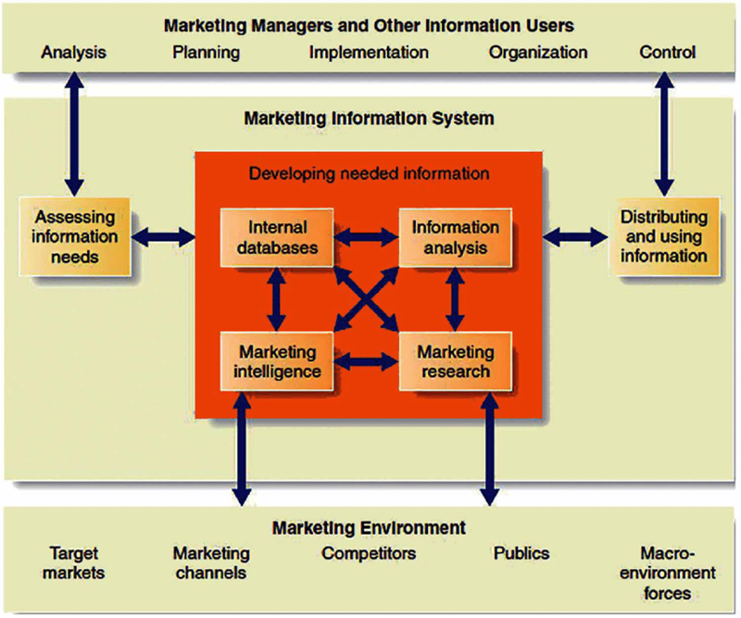
Figure 1: Kotler’s model of information system Source: Researchgate.net

Apple Inc. is known to be an innovative company; they utilise their resources timely and effectively. Their marketing information system is very powerful and effective. Apple, just as the other technological companies (such as Google, Microsoft, Samsung) constantly collects data from their sales all over the world. They study this data to recognise the current trends, customer demands and needs and then pass this information to the right people at the right time. This also enables them to identify their short comings and weaknesses and find ways to rectify them.
An important element of their MKIS is their customer feedback system. In 2011, Apple began a market research campaign called “Apple Customer Pulse”. It is focused ongoing research which targets selective Apple customers to participate in surveys (Ong, 2011). On the official Apple website, there has been a system established specifically to communicate with customers about issues and suggestions on Apple products. The page is called “Apple user groups”. The company can learn about the popular and most used features of each product and level of satisfaction with the products in different demographics all over the world. These surveys are then used extensively by the company for marketing purposes.

5.0 STP marketing model:
In today’s market, marketing model STP is the most effective and commonly used modern strategic approach. STP stands for:
- Segmentation
- Targeting
- Positioning (Kotler, 1998).
According to Kumar (2010), STP model can be defined as the process of segmenting the market, targeting the most attractive markets and positioning the firm’s product to the market segments.

5.1 Segmentation:
Segmentation is division of market population into smaller groups bases on specific characteristics (Kotler, 2012). To use these segments for marketing purposes, they need to be measurable, accessible, sustainable and actionable (Kotler et al., 2005). Customer segmentation can be classified into four categories (Kotler, Wong, Saunders, & Armstrong, 2005):
- Demographic: division based on age, gender, occupation, education level, etc.
- Geographic: division based on country, region, state, etc.
- Socio-cultural/ Behavioural: division based on knowledge, attitude, use and respond to a product, etc.
- Psychographic: division based on social class, life-style or personal characteristics.

5.2 Target market:
For a market to be termed as a target market, it has to meet some specific requirements (Technikon Sa, National Property Education Committee, 1996):
- People: sufficient number of people are interested in the market
- People with needs/ demands: there should be a need or demand to buy a specific product
- People with buying power: people should have enough buying power to satisfy their need/ desire
- People who are willing to buy: they are willing to spend their money in exchange for the product
- People who are eligible to buy: people are legally and morally eligible to buy the product
- People who are most attracted to the offers the company is making: when the company produces something for specific needs or desires of a specific target market.
Apple Inc has a wide range of products and the products are innovative, creative and excellent quality technology. They have over 1.65 billion users and every year their market is expanding with new products (Kastrenakes, 2021). iPhone is mostly popular to users aged between 16-24 (44%) and 51% iPhone users are female. Apple stores all around the world receive more than one million visitors per day (Galov, 2021).
Apple targets a specific consumer market instead of a diverse one. Apple target customer segment comprises of well-off people who are willing to pay extra for their desired technology products and services. Their expectations of the product are high, with advanced design, functions and capabilities, they want a high-tech experience. They desire high-end design, quality and performance of technology products and services over their prices.

5.3 Positioning:
Positioning is to set a product in a clear, distinctive and desirable place apart from a competitive product in the minds of target consumers (Kotler et al, 2005). Positioning is done after the target group has been identified by segmentation and targeting. Positioning can also be defined as a combination of marketing actions to meet the needs and wants of each target (Cravens, 1997).
The strategies of positioning are:
- Product attribute: according to the competitive and desirable attributes of the product
- Benefits offered: according to the needs of the consumers, highlighting these needs against other competitive products in the market
- Unique selling proposition: according to the uniqueness of the product and its promotion.
The late Steve Jobs concentrated in appealing to the needs and desires of the high-end customer segment by mainly using mono-segment type of positioning. As the new CEO, Tim Cook focused on shifting from mono-segment positioning to multi-segment positioning by consistently increasing its product ranges. Multi-segment positioning targets different customer segments at the same time with different products or services. Even with new products coming out every year, Apple also keeps a line of older products to fill every niche and price range (Marx, 2019).

6.0 Marketing mix:
The marketing mix of an organisation is a set of tools used to implement its marketing strategy (Riaz, 2011). These tools are classified into 4 categories, which are known as the 4Ps of marketing, Product, Price, Promotion and Place (Gronholm, 2012). Marketing mix offers the best combination of marketing ingredients which enables companies to realise goals for profit, sales volume, market share, return on investment, etc. (Singh, 2012).
While Apple satisfies the needs of the consumers, the company makes decisions related to the product, its price, distribution / place and promotion by using market mix.

6.1 Product:
Product is defined as a physical product or service for which consumers are willing to pay. These can be tangible products which are material goods or intangible products, such as services (Singh, 2016). Product is one of the key elements of marketing (Savitri, Krisnatuti and Hannan, 2020). According to Kotler and Armstrong, product can be offered to the market, to get attention and can satisfy the consumer wants or needs (Armstrong and Kotler, 2010).

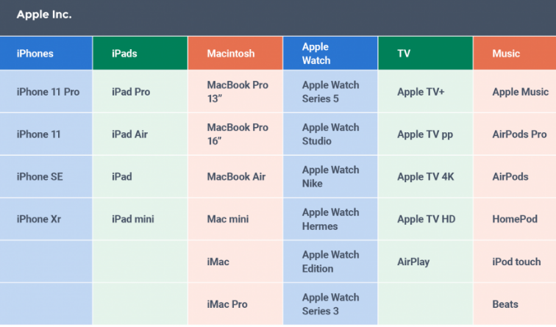
Figure 2: List of Apple Products Source: Smartsheet.com
Apple’s product mix includes a wide range of goods and. As the company is growing and it is adding new products every year, its product mix is constantly expanding. Apple Inc.’s main product lines are as follows:

- Mac
- iPhone
- iPad
- iPod
- Apple Watch
- Apple TV
- Digital content
- Software
- Accessories
- Cloud services

The company’s product line also includes products based on cloud technology, which allows customers to store and access their data, and use software as a service (SaaS), such as iWork for iCloud. This shows that Apple Inc. is a diversified business and has evolved from a computer technology company to an information technology company.

6.2 Place:
Another element of marketing mix is distribution or place. It is the process of the product or service reaching the customers. The organisation can choose to sell the products to the customers directly (Burnett, 2008) or through distributing network which is consist of third-party organisations like distributors, wholesalers and retailers (Singh, 2012). It also involves the selection of appropriate places or venues where the products can be distributed from.
Apple Inc. is a multinational company; their products get distributed all over the world. The following places are included in Apple’s distribution strategy:
- Apple Store locations
- Company-owned website and online stores for desktop and mobile
- Authorized sellers
- Telecommunications companies

6.3 Price:
Another element of marketing mix is the price, it is the value charged for the product or service (Borden and Marshall, 1959). When marketers fix the price for a product, they have to take a few factors into consideration such as: demand for the product, cost of the product, target customers’ ability, government restrictions, pricing of similar products by other company, etc. (Singh, 2012).
Apple is a high-end brand; the products are luxury devices. The company objective was never to sell a cheap product but to produce high quality product which can provide a great experience. Apple uses a MAP (minimum advertised price) strategy for retailing their products. With the MAP policies, resellers or dealers cannot advertise a manufacturer’s products below a certain minimum price (Nielson, 2020). The prices of Apple products are comparatively a lot higher than the other competitive brands’ products.

6.4 Promotion:
Promotion is one of the strongest elements in the marketing mix. This is the way the company decides how to reach their target market. Sales promoting actions are publicity to promote products or services (Burnett, 2008). Promotion is an effective way to encourage customers to purchase products. Advertising is a strong element of promotion (Singh, 2012).
Apple focuses on some core factors when promoting and thus has remained an excellent marketer for over a decade.
- Focus on customer experience
- Focus on innovation
- Focus on the customers rather than the products
- Control pricing
- Focus on the simplicity of product

6.5 Media:
Apple promotes their products through TV commercials and printed advertisements on newspapers and magazines, focusing on uniqueness of their products, how they are different than the competitive products. They use multiple numbers of social media platforms like Facebook, Twitter, Instagram, YouTube, etc. Apple also has their own newsroom where they post news about their products and services.

7.0 Measure success:
On the 27th of July 2021, Apple announced financial results for its fiscal 2021 third quarter which ended on June 26, 2021. They posted that June quarter revenue was $81.4 billion which went up by 36% year over year, and quarterly earnings of $1.30 per share. Apple’s board of directors has declared a cash dividend of $0.22 per share of the Company’s common stock share (Apple Newsroom, 2021).
In September 2021, Apple retail employees were promised to receive bonus up to $1,000 near the end of this year (Wituschek, 2021).
Apple Inc. is a profitable company. Even during the Covid-19 pandemic when most of the companies struggled to make profit, Apple has managed to increase sales to $90 billion. The revenue went up by 54% in the first three months of 2021 (Canon & Jolly, 2021).
From the financial statements and financial performance graph (Appendix 3, 4, 5) and the other measures of success mentioned above, it is evident that Apple inc. is a successful company in terms of revenue and profit.

8.0 Conclusion:
Even though evidently, Apple Inc. is a successful and profitable company, they still have some weaknesses and short-comings. First of all, the high prices of the products make them only accessible to rich people. Because of low affordability by a huge segment of population, Apple devices are struggling to reach some demographics and geographic areas. Apple sells their new products with a high price where other companies introduce their new products with introductory offers. Other competitive companies reduce prices for their older and refurbished products, but Apple’s older or refurbished products are still sold for a higher price.
Apple products are designed in US but mostly assembled in factories in China, Malaysia, Thailand, Czech Republic, etc. The working condition in these factories are very poor. Back in 2010, Apple was under scrutiny because of suicide committed by 14 factory workers in China (Berg, 2018). Even in recent days, Apple had to face a lot of criticism due to their low pay, long working hours and poor working environment for the factory workers (Merchant, 2017 and Albergotti, 2019).
Apple products are generally popular for their high quality and design, but they could improve on their short battery life and product life. These products are also only compatible with other Apple products and services, such as: only certain apps are usable in Apple devices. Customers have to buy Apple apps or accessories to continue using their Apple products.
Apple has faced 60 law-suits since December the 21st, 2017. Apple announced that they purposefully reduce CPU performance on iPhone models with older and degraded batteries. Customers were very upset with this announcement and Apple lost a lot of their loyal customers. The first law-suit alleged that Apple’s actions affected the resale value of their products but also forced its users to upgrade to newer versions prematurely.
Apple is one of the 100 companies who responsible for over 70% of world emissions (Antonia, 2021). The company has been criticized for its negative environmental impact for a long time. A lot of their loyal customers are feeling more and more uncomfortable to use their products when their sustainability is being questioned.

9.0 Recommendations:
Apple Inc. has 515 stores all over the world (McCarthy, 2021). With the growing demand of Apple products, the company will benefit if they increase the number of their retail stores, especially in places where there are not many Apple stores. They can also make partnership with cellular network providers in other countries so that the consumers can easily access their products.
Apple Inc. should increase their target market by reducing their product prices. They can get more loyal customers if they improve their battery life and product life.
The factories in China and other places should have better working condition including higher pay and shorter working hours. The workers should also have access to deal with their physical and mental health issues. Apple products can be modified so that they are compatible with other branded products and services.
Apple was criticised for their carbon foot print; they should take action to reduce their carbon foot printing by designing low carbon materials. They should focus on using recycled material and make their products more sustainable.

Reference list:
- Ahituv, N., Zif, J., & Machlin, I. (1998). Environmental scanning and information systems in relation to success in introducing new products. Information and Management, 33(4), 201-211.
- Albergotti, R. (2019). Apple accused of worker violations in Chinese factories. The Washington Post. [online] 9 Sep. Available at: https://www.washingtonpost.com/technology/2019/09/09/apple-accused-worker-violations-chinese-factories-by-labor-rights-group/.
- Albright, K. S. (2004). Environmental Scanning: Radar for Success. Information Management Journal, 38(3), 38-45.
- Annualreport.stocklight.com. 2021. Apple Annual Report 2020. [online] Available at: https://annualreport.stocklight.com/NASDAQ/AAPL/201273977.pdf [Accessed 2 November 2021].
- Antonia (2021). Apple 2021 Environmental Report: What Progress Is Apple Making On Its Sustainability Journey? Compare and Recycle. [online] Available at: https://www.compareandrecycle.co.uk/blog/apple-2021-environmental-report-what-progress-is-apple-making-on-its-sustainability
- Apple Newsroom (United Kingdom). (2021). Apple Reports Third Quarter Results. [online] Available at: https://www.apple.com/uk/newsroom/2021/07/apple-reports-third-quarter-results/.
- Apple Newsroom. (2020). 13 new innovative technologies and features unveiled at WWDC20. [online] Available at: https://www.apple.com/uk/newsroom/2020/06/13-new-innovative-technologies-and-features-unveiled-at-wwdc20/ [Accessed 21 Oct. 2020].
- Apple Newsroom. 2021. Apple Reports Fourth Quarter Results. [online] Available at: <https://www.apple.com/newsroom/2021/10/apple-reports-fourth-quarter-results/> [Accessed 2 November 2021].
- Armstrong, G. and Kotler, P., 2010. Principles of marketing. 5th ed. New Jersey: Pearson Prentice Hall, pp.72-77.
- Berg, S.W. (2018). The human cost of an iPhone. The Washington Post. [online] 2 Mar. Available at: https://www.washingtonpost.com/outlook/the-human-cost-of-an-iphone/2018/03/02/5d76555e-0b7e-11e8-8890-372e2047c935_story.html.
- Borden, N., & Marshall, M. (1959). Advertising Management: Text and Cases. Homewood, III, Richard D. Irwin.
- Burnett, J. (2008). Core Concepts of Marketing. Zurich, Switzerland: Jacobs Foundation.
- Canon, G. and Jolly, J. (2021). Apple sales rise to $90bn amid Covid buying surge. the Guardian. [online] Available at: https://www.theguardian.com/technology/2021/apr/28/apple-quarterly-earnings-covid-sales [Accessed 2 May 2021].
- Carson, D. (2001). Qualitative marketing research. London; Thousand Oaks, Calif.: Sage.
- Cook, T., 2020. Apple’s COVID-19 Response. [online] Apple Newsroom (United Kingdom). Available at: https://www.apple.com/uk/newsroom/2020/03/apples-covid-19-response/ [Accessed 3 November 2021].
- Drucker, P. (2011). Management: tasks, responsibilities, practices. London Etc.: Routledge, Cop. Pp.12-27.
- Feys, B. and Probert, C. (2015). PESTLE analysis. 50Minutes.pp. 5-8.
- Galov, N., 2021. 33+ Amazing Apple Statistics to Sink Your Teeth Into in 2021. [online] HostingTribunal. Available at: <https://hostingtribunal.com/blog/apple-statistics/#gref> [Accessed 4 November 2021].
- Gaus, A., 2019. For Apple, a Recession Could Prove Especially Painful. The Street, [online] Available at: https://www.thestreet.com/investing/how-apple-would-fare-in-a-recession-15069940 [Accessed 3 November 2021].
- Gronholm, T. (2012). Marketing concepts in practice. Lahti university of applied sciences. Degree programme in International Business Bachelor’s thesis.
- Hess, R. L., Rubin, R. S., & West, L. A. (2004). Geographic information systems as a marketing information system technology. Decision Support Systems, 197 – 212.
- Hill, A., 2015. How a subscription model could benefit your business. Financial Times, [online] Available at: <https://www.ft.com/content/98618ef4-150e-11e5-a587-00144feabdc0> [Accessed 2 November 2021].
- Johnson, G., Scholes, K. and Whittington, R. (2005). Exploring corporate strategy. Harlow: Financial Times/Prentice Hall.pp.53-65.
- Johnston, C. (2018). Apple is first public company worth $1 trillion. BBC News. [online] 2 Aug. Available at: https://www.bbc.co.uk/news/business-45050213.
- Kastrenakes, J., 2021. Apple says there are now over 1 billion active iPhones. [online] The Verge. Available at: <https://www.theverge.com/2021/1/27/22253162/iphone-users-total-number-billion-apple-tim-cook-q1-2021> [Accessed 4 November 2021].
- Kohn, K. (2005). Idea generation in new product development through business environmental scanning: the case of XCar. Marketing Intelligence & Planning, 23(6/7), 688-704.
- Kotler, P. (1998). Marketing Management: Analysis, Planning, Implementation and Control. Englewood Cliffs: Prentice Hall.
- Kotler, P., Wong, V., Saunders, J., & Armstrong, G. (2005). Principles of Marketing (4 ed.). Spain: Pearson Education.
- Kumar, P. (2010). Marketing for hospitality and tourism services. New Dehli: Tata McGraw Hill.
- Landau, R. and Rosenberg, N., 1989. The positive sum strategy. 2nd ed. Washington D.C.: National Academy Press, pp.17-20.
- Lee, M. J., Lee, J. H., & Park, S. C. (2009). Intelligent information deriving using network panel data management system in marketing research. Expert Systems with Applications, 1410–1422.
- Li, E. Y., Raymond McLeod, J., & Rogers, J. C. (2001). Marketing information systems in Fortune 500 companies: a longitudinal analysis of 1980, 1990, and 2000. Information & Management, 307-322.
- Lin, C., & Hong, C. (2009). Development of a marketing information system for supporting sales in a Teabeverage market. Expert Systems with Applications, 5393–5401.
- Marx, P. (2019) “Apple’s Product Line Is a Mess” Medium, Available at: https://medium.com/s/story/apples-product-line-is-a-mess-5a9a5730cafa
- McCarthy, N. (2021). 20 Years On: The Global Apple Store Empire [Infographic]. [online] Forbes. Available at: https://www.forbes.com/sites/niallmccarthy/2021/05/14/20-years-on-the-global-apple-store-empire-infographic/?sh=1d1a65be4b26 [Accessed 5 Nov. 2021].
- Merchant, B. (2017). Life and death in Apple’s forbidden city. [online] The Guardian. Available at: https://www.theguardian.com/technology/2017/jun/18/foxconn-life-death-forbidden-city-longhua-suicide-apple-iphone-brian-merchant-one-device-extract.
- Merchant, B. (2017). Life and death in Apple’s forbidden city. [online] The Guardian. Available at: https://www.theguardian.com/technology/2017/jun/18/foxconn-life-death-forbidden-city-longhua-suicide-apple-iphone-brian-merchant-one-device-extract.
- Mühleisen, M. (2018). Money, Transformed. Finance & Development, 55(2), pp.6–7.
- Murphy, S. (2020). Apple closes all stores around world outside China due to Covid-19. The Guardian. [online] 14 Mar. Available at: https://www.theguardian.com/world/2020/mar/14/apple-closes-all-stores-across-world-outside-china-due-to-covid-19.
- Nielson, S. (2020). Apple’s premium pricing strategy and product differentiation - Market Realist. [online] Market Realist. Available at: https://marketrealist.com/2014/02/apples-premium-pricing-strategy-product-differentiation/.
- O'Grady, J., 2009. Apple Inc. Westport: Greenwood Press, pp.1-16.
- Ong, J., 2011. Apple initiating "Customer Pulse" market research focus group. [online] AppleInsider. Available at: https://appleinsider.com/articles/11/05/05/apple_initiates_customer_pulse_market_research_focus_group [Accessed 4 November 2021].
- P. Kotler, Marketing Management: Analysis, Planning, and Control, 9th ed., Prentice-Hall, Upper Saddle River, NJ, 1997. Pp. 17.
- Porral, C. and Stanton, J. (2017). Principles of marketing. Mdrid: Esic Editorial, pp.19–22.
- Riaz, W. (2011). Marketing Mix, Not Branding. Asian Journal of Business and Management Sciences. 2011, Vol. 1 No. 11, p.p. 43-52.
- Singh, M. (2012). Marketing mix of 4p’s for competitive advantage. IOSR Journal of Business and Management, 3(6), pp.40-45.
- Technikon Sa, National Property Education Committee (South Africa and South Africa. Estate Agents Board (1996). Introduction to property marketing. Florida: Technikon Sa.
- Vorhies, Douglas, & Morgan, Neil (2003). A configuration theory assessment of marketing organization fit with business strategy and its relationship with market performance. Journal of Marketing,67(1), 100−115.
- Wituschek, J. (2021). Apple retail employees to receive up to $1000 bonus next month. iMore. [online] Available at: https://www.imore.com/apple-retail-employees-receive-1000-bonus-next-month [Accessed 5 Nov. 2021].
- Ying, L., & Peters, M. (2011). Setting up The Tourism Engineering Marketing Information System of China. Systems Engineering Procedia, 301–308.

Appendix 1: SWOT analysis of Apple Inc.
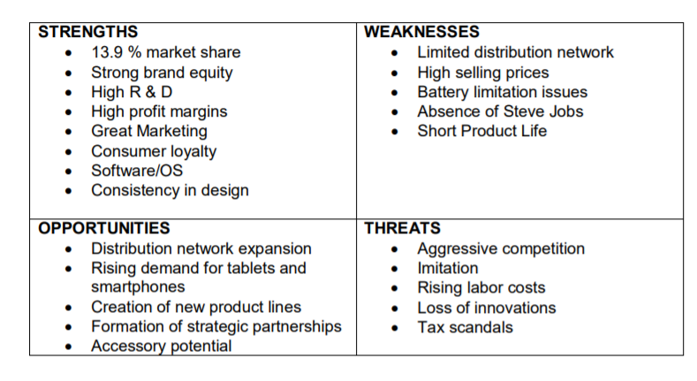

Appendix 2: PESTEL analysis of Apple Inc.

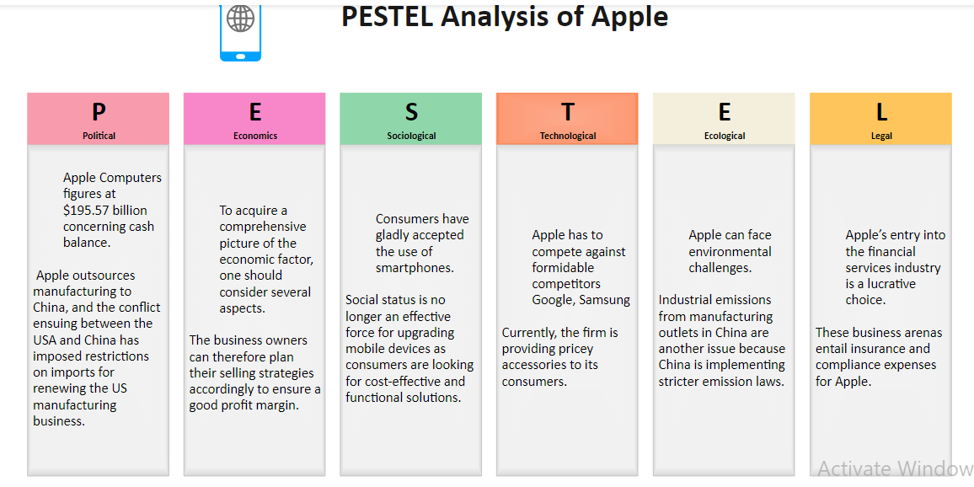

Appendix 3: Apple Inc. total revenue and net income

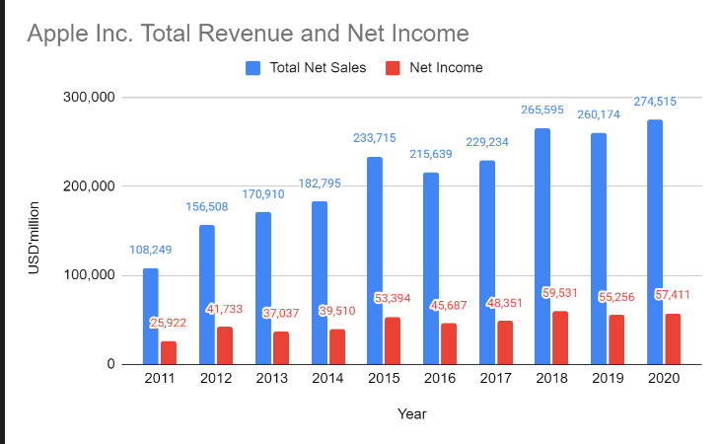

Appendix 4: Apple Inc. balance sheet part 1

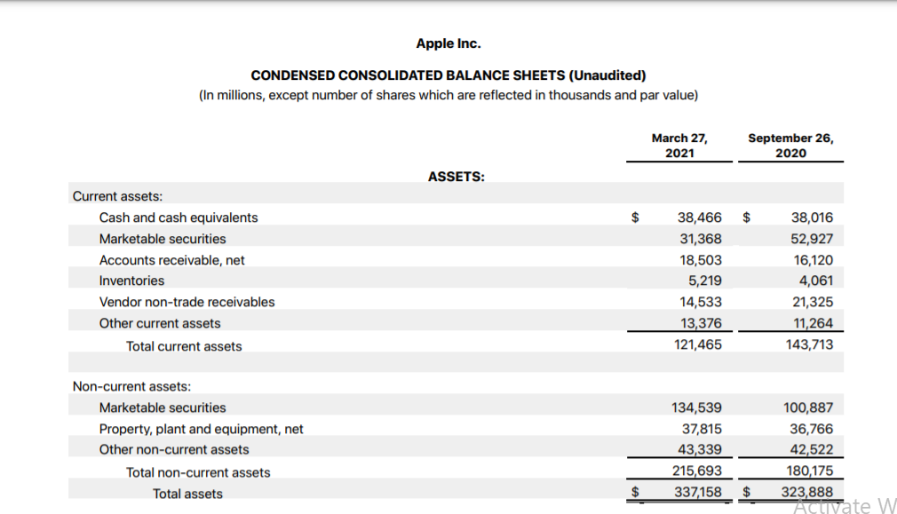

Appendix 5: Apple Inc. balance sheet part 2


